Aditya Pankaj Mathpal
230905232
CSE C2 Roll No. 37

WP Lab 2

Home Assignments:
1. Design a webpage. The page contains:
a. Dropdown list with HP, Nokia, Samsung, Motorola, Apple as items.
b. Checkbox with Mobile and Laptop as items.
Textbox where you enter quantity.
c. There is a button with text as ‘Produce Bill’.
On Clicking Produce Bill button, alert should be displayed with total amount.

Code:
<html>
<head>
<title>Tech Store</title>

<script src="../../jquery-3.7.1.min.js"></script>

<style>
body {
font-family: Arial;
}

select,
input[type="text"] {
width: 200px;
margin-bottom: 10px;
}

#receipt {
margin-top: 20px;
padding: 10px;
width: 300px;
border: 1px solid black;
}
</style>
</head>

<body>

<h3>Product Selection</h3>

Brand:
<br>
<select id="brand">
<option>HP</option>
<option>Nokia</option>
<option>Samsung</option>
<option>Motorola</option>
<option>Apple</option>
</select>

<br><br>

Product Type:
<br>
<input type="checkbox" class="item" value="Mobile"> Mobile
<br>
<input type="checkbox" class="item" value="Laptop"> Laptop

<br><br>

Quantity:
<br>
<input type="text" id="qty">

<br><br>

<button id="bill">Produce Bill</button>

<div id="receipt"></div>

<script>
$(function () {
$("#bill").click(function () {

let brand = $("#brand").val();
let quantity = parseInt($("#qty").val());
let total = 0;

let prices = {
"HP": { "Mobile": 15000, "Laptop": 55000 },
"Nokia": { "Mobile": 12000, "Laptop": 45000 },
"Samsung": { "Mobile": 40000, "Laptop": 80000 },
"Motorola": { "Mobile": 13000, "Laptop": 48000 },
"Apple": { "Mobile": 80000, "Laptop": 90000 }
};

let receipt = "<b>Bill Receipt</b><br>";
receipt += "Brand: " + brand + "<br>";

$(".item:checked").each(function () {
let item = $(this).val();
let price = prices[brand][item];
receipt += item + " : " + price;
receipt += " x" + quantity + "<br>";
total += price;
});

total = total * quantity;

receipt += "<br><b>Total Amount: " + total + "</b>";

$("#receipt").html(receipt);
});
});
</script>

</body>
</html>

output:
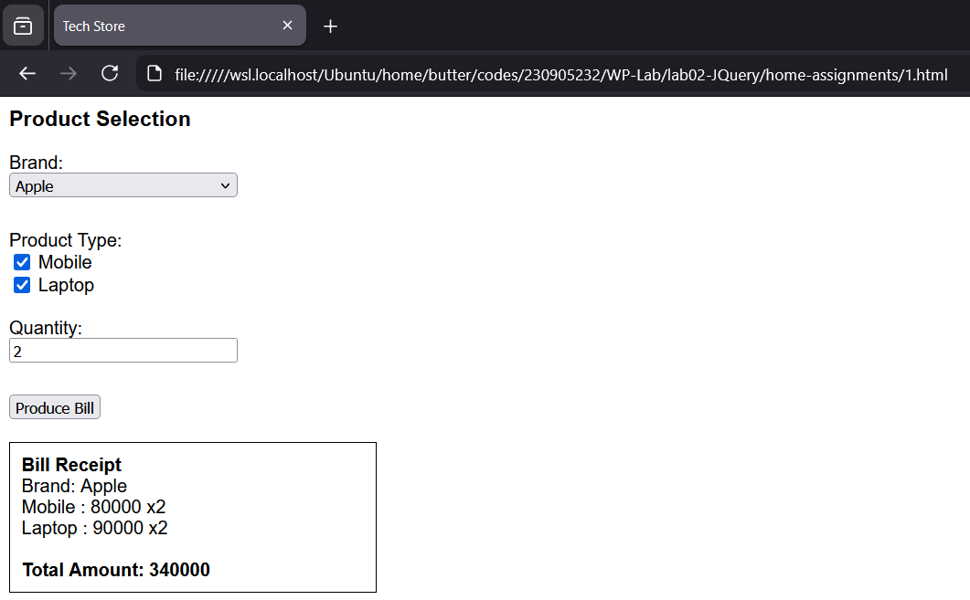
2. Implement the bouncing ball using animate() function.

Code:
<html>
<head>
<title>Bouncing Ball</title>

<script src="../../jquery-3.7.1.min.js"></script>

<style>
#container {
width: 400px;
height: 300px;
border: 2px solid black;
position: relative;
overflow: hidden;
}

#ball {
width: 40px;
height: 40px;
background-color: red;
border-radius: 50%;
position: absolute;
top: 0;
left: 180px;
}
</style>
</head>

<body>

<div id="container">
<div id="ball"></div>
</div>

<script>
$(function () {

let ground = 260;
let height = 260;
let damping = 0.7;
let time = 600;

function fall() {
$("#ball").animate(
{ top: ground + "px" },
time,
"swing",
rise
);
}

function rise() {
height = height * damping;

if (height < 10) {
return;
}

$("#ball").animate(
{ top: (ground - height) + "px" },
time,
"swing",
fall
);
}

fall();

});
</script>

</body>
</html>

output:
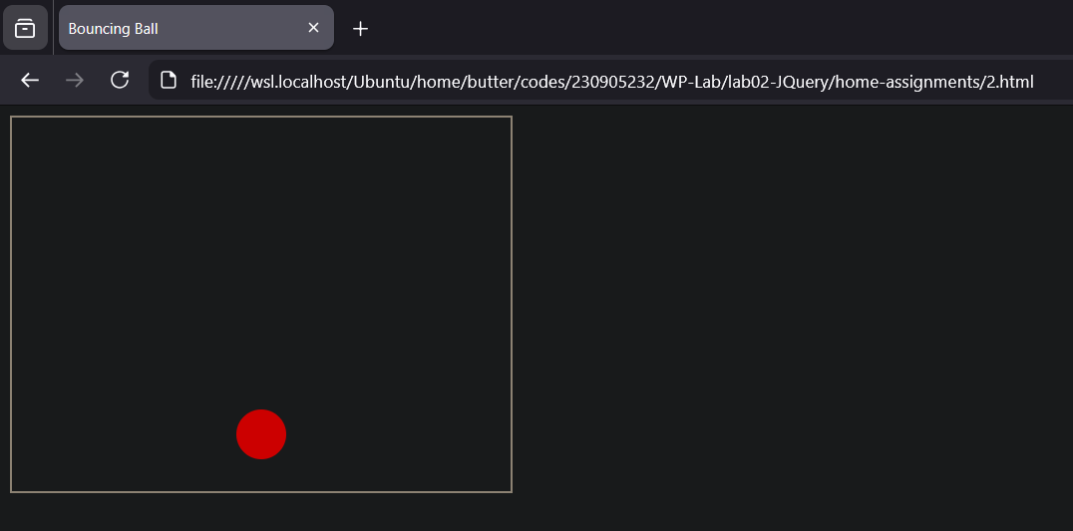
3. Write a web page which displays image and show the sliding text on the image.

Code:
<html>
<head>
<title>Sliding Text on Image</title>

<script src="../../jquery-3.7.1.min.js"></script>

<style>
#container {
width: 400px;
position: relative;
}

#container img {
width: 330px;
}

#text {
position: absolute;
top: 100px;
left: 200px;
color: white;
font-size: 12px;
font-weight: bold;
background-color: rgba(0, 0, 0, 0.7);
padding: 10px;
}
</style>
</head>

<body>

<div id="container">
<img src="../cat.jpeg">
<div id="text">Welcome to My Page</div>
</div>

<script>
$(function () {

function slideText() {
$("#text").animate(
{ left: "0px" },
2000,
function () {
$("#text").delay(1000).animate(
{ left: "200px" },
2000,
slideText
);
}
);
}

slideText();

});
</script>

</body>
</html>

output:
