Aditya Pankaj Mathpal
230905232
CSE C2 Roll No. 37

WP Lab 2
Lab Assignments:
1. Write a web page which contains table with 3 X 3 dimensions (fill some data) and one
image. Style the rows with alternate color. Move the table and image together from right
to left when button is clicked.

code:
<html>
<head>
<title>Table and Image Move</title>

<script src="../jquery-3.7.1.min.js"></script>

<style>
table {
border-collapse: collapse;
width: 300px;
}

table, th, td {
border: 1px solid black;
padding: 10px;
text-align: center;
}

tr:nth-child(even) {
background-color: #d9ead3;
}

tr:nth-child(odd) {
background-color: #fce5cd;
}

#container {
position: relative;
left: 500px;
display: inline-block;
}

img {
width: 150px;
display: block;
margin-top: 20px;
}
</style>
</head>

<body>

<button id="moveBtn">Move Left</button>

<br><br>

<div id="container">
<table>
<tr>
<td>1</td>
<td>2</td>
<td>3</td>
</tr>
<tr>
<td>4</td>
<td>5</td>
<td>6</td>
</tr>
<tr>
<td>7</td>
<td>8</td>
<td>9</td>
</tr>
</table>

<img src="./cat.jpeg">
</div>

<script>
$(function () {
$("#moveBtn").click(function () {
$("#container").animate({ left: "0px" }, 1000);
});
});
</script>

</body>
</html>

output:
before:
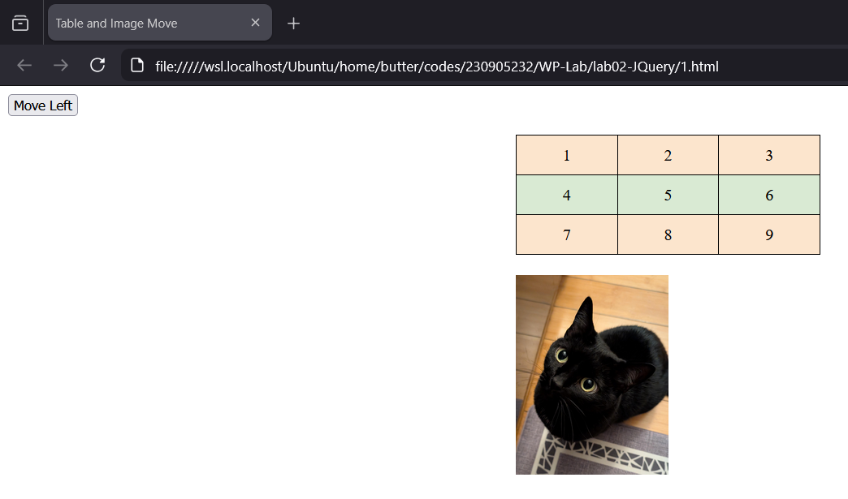
after:
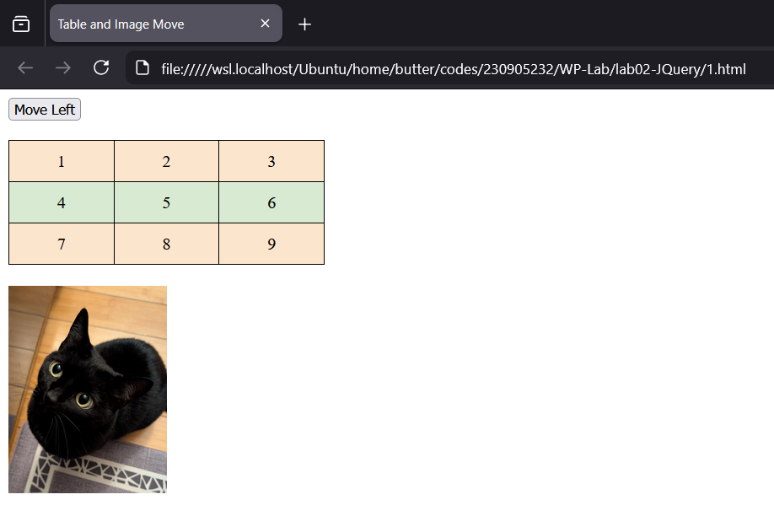
2. Design a calculator to perform basic arithmetic operations. Use textboxes and buttons to
design web page.

code:
<html>
<head>
<title>Calculator</title>

<script src="../jquery-3.7.1.min.js"></script>

<style>
input[type="text"] {
width: 150px;
height: 30px;
margin: 5px;
text-align: right;
}

button {
width: 50px;
height: 40px;
margin: 5px;
font-size: 18px;
}
</style>
</head>

<body>

<input type="text" id="num1">
<input type="text" id="num2">
<br>
<input type="text" id="result" readonly>
<br><br>

<button id="add">+</button>
<button id="sub">-</button>
<button id="mul">*</button>
<button id="div">/</button>

<script>
$(function () {

$("#add").click(function () {
let a = parseFloat($("#num1").val());
let b = parseFloat($("#num2").val());
$("#result").val(a + b);
});

$("#sub").click(function () {
let a = parseFloat($("#num1").val());
let b = parseFloat($("#num2").val());
$("#result").val(a - b);
});

$("#mul").click(function () {
let a = parseFloat($("#num1").val());
let b = parseFloat($("#num2").val());
$("#result").val(a * b);
});

$("#div").click(function () {
let a = parseFloat($("#num1").val());
let b = parseFloat($("#num2").val());
$("#result").val(a / b);
});

});
</script>

</body>
</html>

output:
(multiplication)
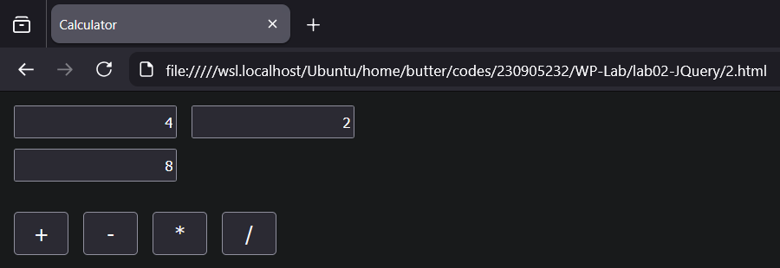
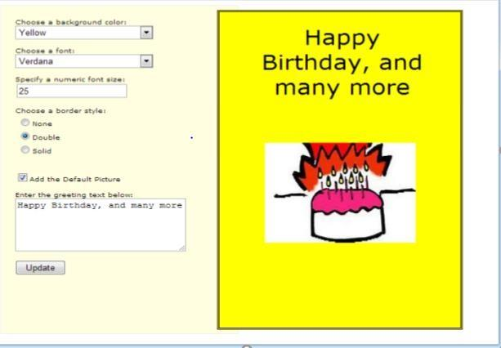
3. Create a web page to design a birthday card shown below
code:
<html>
<head>
<title>Birthday Card</title>

<script src="../jquery-3.7.1.min.js"></script>

<style>
body {
font-family: Arial;
background-color: #FFFEE0;
}

#main {
display: flex;
gap: 20px;
}

#controls {
width: 300px;
}

#card {
width: 400px;
height: 500px;
border: 4px solid black;
text-align: center;
}

#card img {
width: 200px;
margin-top: 100px;
}

#greeting {
margin-left: 100px;
margin-right: 100px;
}

select,
input[type="text"],
textarea {
width: 100%;
margin-bottom: 10px;
}

input[type="radio"],
input[type="checkbox"] {
width: auto;
margin-right: 5px;
}

</style>
</head>

<body>

<div id="main">

<div id="controls">
Choose a background color:
<select id="bgcolor">
<option value="yellow">Yellow</option>
<option value="pink">Pink</option>
<option value="lightblue">Light Blue</option>
</select>

Choose a font:
<select id="font">
<option value="Verdana">Verdana</option>
<option value="Arial">Arial</option>
<option value="Times New Roman">Times New Roman</option>
</select>

Specify a numeric font size:
<input type="text" id="fontsize" value="25">

Choose a border style:<br>
<input type="radio" name="border" value="none" checked> None <br>
<input type="radio" name="border" value="double"> Double <br>
<input type="radio" name="border" value="solid"> Solid <br>
<br>

<input type="checkbox" id="picture" checked> Add the Default Picture
<br><br>

Enter the greeting text below:
<textarea id="message">Happy Birthday, and many more</textarea>

<br>
<button id="update">Update</button>
</div>

<div id="card">
<h1 id="greeting">Happy Birthday, and many more</h1>
<img id="cake" src="./cake.png">
</div>

</div>

<script>
$(function () {

$("#update").click(function () {

$("#card").css("background-color", $("#bgcolor").val());
$("#greeting").css("font-family", $("#font").val());
$("#greeting").css("font-size", $("#fontsize").val() + "px");

let b = $("input[name='border']:checked").val();
if (b === "none") $("#card").css("border", "none");
if (b === "solid") $("#card").css("border", "4px solid black");
if (b === "double") $("#card").css("border", "4px double black");

$("#greeting").text($("#message").val());

if ($("#picture").is(":checked")) {
$("#cake").show();
} else {
$("#cake").hide();
}
});

});
</script>

</body>
</html>
output:
