230905232
Aditya Pankaj Mathpal
Roll No. 37

WPL Week 4

Lab Assignments

1. Write a python program to reverse a content a file and store it in another file.

Code:
with open('input.txt', 'r') as file:
contents = file.read()

with open('output.txt', 'w+') as file:
file.write(contents[::-1])

input file (input.txt):
this is a test file, the outputs will be reversed

tuptuo eht ni elbadaer si trap siht

output file (output.txt):
this part is readable in the output

desrever eb lliw stuptuo eht ,elif tset a si siht

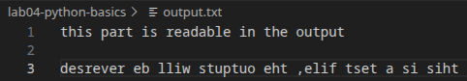
2. Write a python program to implement binary search with recursion.

Code:
def bin_search(arr, l, r, key):
if l > r: return -1
n = (l+r)//2
if arr[n] > key:
return bin_search(arr, l, n-1, key)
elif arr[n] < key:
return bin_search(arr, n+1, r, key)
else:
return n

n = int(input("Enter size of array: "))
arr = [0] * n
arr = sorted(list(map(int, input("Enter elements of array: ").split())))
print("sorted array: ", arr)
key = int(input("Enter element to find: "))
res = bin_search(arr, 0, len(arr)-1, key)
if res == -1:
print("Element not in array")
else:
print("Element at index", res)

output:
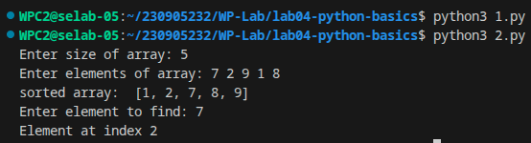

3. Write a python program to sort words in alphabetical order.
Code:
def merge(l, r):
res = []
i = j = 0

while i < len(l) and j < len(r):
if l[i] < r[j]:
res.append(l[i])
i += 1
else:
res.append(r[j])
j += 1

res.extend(l[i:])
res.extend(r[j:])
return res

def sort_words(arr):
n = len(arr)
if n <= 1:
return arr
if n == 2:
if arr[0] > arr[1]:
arr[0], arr[1] = arr[1], arr[0]
return arr

left = sort_words(arr[:n//2])
right = sort_words(arr[n//2:])

return merge(left, right)

print("Enter words to sort:")
strings = list(input().split())
strings = sort_words(strings)
print("Sorted words: ", strings)

output:
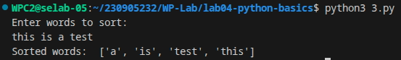
4. Write a Python class to get all possible unique subsets from a set of distinct
integers
Input:[4,5,6]
Output : [[], [6], [5], [5, 6], [4], [4, 6], [4, 5], [4, 5, 6]]

code:
def subsets(arr):
res = []

def backtrack(curr, i):
if i == len(arr):
res.append(curr.copy())
return

backtrack(curr, i+1)

curr.append(arr[i])
backtrack(curr, i+1)
curr.pop()

backtrack([], 0)
return res

arr = list(map(int, input("Enter elements of the array to generate all possible subsets:\n").split()))
print(subsets(arr))

output:
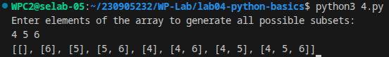
5. Write a Python class to find a pair of elements (indices of the two numbers)
from a given array whose sum equals a specific target number.
Input: numbers= [10,20,10,40,50,60,70], target=50
Output: 2, 3.

code:
class TwoSum:
def __init__(self, arr, target):
self.arr = arr
self.target = target

def find_pair(self):
seen = {}
for idx, num in enumerate(self.arr):
n = self.target - num
if n in seen:
return (seen[n], idx)
seen[num] = idx
return None

ts = TwoSum([], 0)

ts.arr = list(map(int, input("Enter elements of the array: ").split()))
ts.target = int(input("Enter target: "))

print("Elements at indices", ts.find_pair())

output:
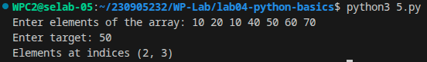

6. Write a Python class to implement pow(x, n).

code:
import math

class Power:
@staticmethod
def pow(x, n):
if n == 0: return 1
if x == 0 or x == 1: return int(x)
if n == 1: return x if not float(x).is_integer() else int(x)
n_neg_flag = 0
x_neg_flag = 0
original_n = n
original_x = x
if n == 0: return 1
if n < 0:
n *= -1
n_neg_flag = 1
if x < 0:
x_neg_flag = n%2
x = -x
res = math.exp(n * math.log(x))
if n_neg_flag: res = 1/res
if x_neg_flag: res *= -1
if float(original_n).is_integer() and float(original_x).is_integer() and not n_neg_flag:
return int(round(res, 0))
return res

x, n = list(map(float, input("Enter x and n: ").split()))
res = Power.pow(x,n)
if float(n).is_integer() and float(x).is_integer():
x, n = int(x), int(n)
print(f"pow({x}, {n}) = {round(res, 6)}")

output:
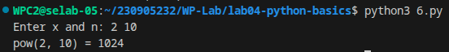
7. Write a Python class which has two methods get_String and print_String. The
get_String accept a string from the user and print_String print the string in upper
case.

Code:
class String:
def get_String(self):
self.str = input("Enter string: ")
def print_String(self):
print(self.str.upper())

s = String()
s.get_String()
s.print_String()

output:
