Aditya Pankaj Mathpal

230905232

CSE C2 Roll No. 37

WP Lab 1 Assignments

1. Write a simple poem and represent it as a web page. Give a title for the poem.
Make rhyming words in the poem as bold.

code:
<html>
<head>
<title>
Poem
</title>
</head>
<body>
I am a <b>cat</b>,<br>
I sleep on the <b>mat</b>,<br>
I knocked a pot,<br>
Off the <b>table</b>,<br>
I also chewed,<br>
On a <b>cable</b><br>
</body>
</html>

output:
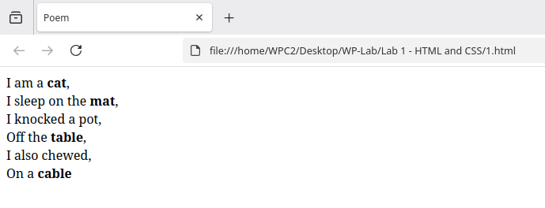
2. Assume you have brought a new car. Write down the list of additional accessories you
need for the car as an unordered list in HTML. Also, list the travel plans on the car as an
ordered list.

Code:
<html>
<head>
<title>
Car stuff
</title>
</head>
<body>
<h3>Additional accessories</h3>
<ul>
<li>Floor mats</li>
<li>Seat covers</li>
<li>Phone mount</li>
<li>Dash cam</li>
<li>Trunk organizer</li>
<li>Emergency kit</li>
<li>Sunshade</li>
<li>Steering wheel cover</li>
<li>Tire pressure gauge</li>
<li>Car cover</li>
<li>Blind spot mirrors</li>
<li>Bluetooth car adapter</li>
<li>Air freshener</li>
<li>Portable vacuum cleaner</li>
<li>Window tint</li>
</ul>
<h3>Travel plans</h3>
<ol>
<li>Mumbai</li>
<li>Pune</li>
<li>Nashik</li>
</ol>
</body>
</html>

output:
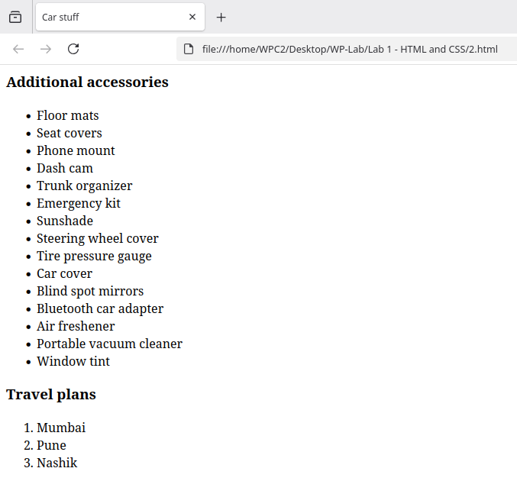
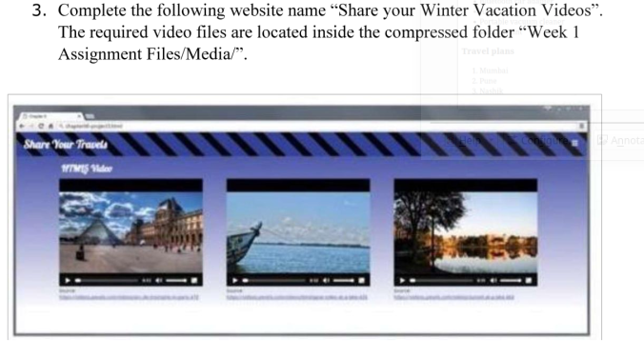
code:
<html>
<head>
<title>Winter Vacation Videos</title>
<style>
body {
height: 100vh;
margin: 0;
background: linear-gradient(to bottom, #0000FF, #FFFFFF);
}
.video-row {
display: flex;
gap: 100px;
justify-content: center;
align-items: flex-start;
}
.video-row > video {
margin-top: 40px;
}

.video-column {
display: flex;
flex-direction: column;
}
.video-column h2 {
margin: 0 0 10px 0;
height: 31px;
}

video {
width: 500px;
border: 2px solid #ccc;
}
</style>
</head>
<body>
<h1 style="background-color: #202cb3; color: white; font-family: '', cursive;">Share Your Travels</h1>
<div class="video-row">

<div class="video-column">
<h2 style="color: white; font-family: '', cursive;">Videos</h2>
<video controls>
<source src="paris1.mp4" type="video/mp4">
</video>
</div>

<video controls>
<source src="paris2.mp4" type="video/mp4">
</video>

<video controls>
<source src="paris3.mp4" type="video/mp4">
</video>
</div>
</body>
</html>

output:
