Aditya Pankaj Mathpal

230905232

CSE C2 Roll No. 37

WP Lab 1 Home Assignments

1
code:
<html>
<head>
<style>
table, th, td {
border: 1px solid black;
border-collapse: collapse;
}
td {
text-align: right;
}
</style>
<title>
Table
</title>
</head>
<body>
<table>
<colgroup>
<col style="background-color:#FFE792; width:100px">
<col style="background-color:#8FA8E0; width:150px">
<col style="background-color:#AAD18E; width:125px">
</colgroup>
<tr style="background-color: #F80202;">
<th>Country</th>
<th colspan=2>Population (in Crores)</th>
</tr>
<tr>
<th rowspan=3>INDIA</th>
<td>1998</td>
<td>85</td>
</tr>
<tr>
<td>1999</td>
<td>90</td>
</tr>
<tr>
<td>2000</td>
<td>100</td>
</tr>
<tr>
<th rowspan=3>USA</th>
<td>1998</td>
<td>30</td>
</tr>
<tr>
<td>1999</td>
<td>35</td>
</tr>
<tr>
<td>2000</td>
<td>40</td>
</tr>
<tr>
<th rowspan=3>UK</th>
<td>1998</td>
<td>25</td>
</tr>
<tr>
<td>1999</td>
<td>30</td>
</tr>
<tr>
<td>2000</td>
<td>35</td>
</tr>
</table>
</body>
</html>

output:
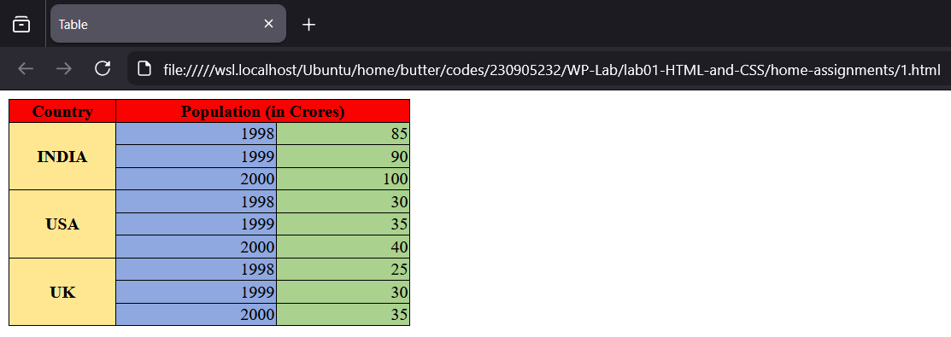
2
code:
<html>
<head>
<style>
table, th, td {
border: 1px solid black;
border-collapse: collapse;
}
td {
text-align: right;
}
</style>
<title>
Table
</title>
</head>

<script>
const populationData = [
{ country: "INDIA", year: 1998, population: 85 },
{ country: "INDIA", year: 1999, population: 90 },
{ country: "INDIA", year: 2000, population: 100 },

{ country: "USA", year: 1998, population: 30 },
{ country: "USA", year: 1999, population: 35 },
{ country: "USA", year: 2000, population: 40 },

{ country: "UK", year: 1998, population: 25 },
{ country: "UK", year: 1999, population: 30 },
{ country: "UK", year: 2000, population: 35 }
];
</script>

<table id="populationTable">
<colgroup>
<col style="background-color:#FFE792; width:100px">
<col style="background-color:#8FA8E0; width:150px">
<col style="background-color:#AAD18E; width:125px">
</colgroup>
<tr style="background-color: #F80202;">
<th>Country</th>
<th colspan=2>Population (in Crores)</th>
</tr>
<tbody>

</tbody>
</table>

<script>
const countryCounts = {};

populationData.forEach(item => {
countryCounts[item.country] = (countryCounts[item.country] || 0) + 1;
});

const tableBody = document.querySelector("#populationTable tbody");

let lastCountry = null;

populationData.forEach(item => {
const row = document.createElement("tr");

if (item.country !== lastCountry) {
row.innerHTML = `
<th rowspan="${countryCounts[item.country]}">${item.country}</th>
<td>${item.year}</td>
<td>${item.population}</td>
`;
lastCountry = item.country;
} else {
row.innerHTML = `
<td>${item.year}</td>
<td>${item.population}</td>
`;
}

tableBody.appendChild(row);
});
</script>

</html>
output:
