230905232

Aditya Pankaj Mathpal

CSE C2 37

Lab 8: Form Processing using Django – Part II

Lab Assignments

urls.py (common):
from django.contrib import admin
from django.urls import path, include

urlpatterns = [
path('cgpa/', include('cgpa.urls')),
path('survey/', include('survey.urls')),
path('register/', include('register.urls')),
path('admin/', admin.site.urls),
]

1) Create a Register page and Success page with the following requirements:
i. Register page should contain four input TextBoxes for UserName, Password,
Email id and Contact Number and also a button to submit. Make the username as
compulsory field and other fields as optional.
ii. On button click, Success page is displayed with message "Welcome
{UserName}" and also his Email and Contact Number has to be displayed.
iii. Use secure technique to send details to the Success page (Hint: use csrftoken) 4)
Design a website with two pages.

forms.py:
from django import forms

class RegisterForm(forms.Form):
username = forms.CharField(
label="User Name",
max_length=100,
required=True
)

password = forms.CharField(
label="Password",
widget=forms.PasswordInput,
required=False
)

email = forms.EmailField(
label="Email",
required=False
)

contact = forms.CharField(
label="Contact Number",
max_length=10,
required=False
)

views.py:
from django.shortcuts import render
from .forms import RegisterForm

# Create your views here.

def register(request):
if request.method == "POST":
form = RegisterForm(request.POST)
if form.is_valid():
username = form.cleaned_data['username']
email = form.cleaned_data.get('email')
contact = form.cleaned_data.get('contact')

context = {
'username': username,
'email': email,
'contact': contact
}

return render(request, "success.html", context)
else:
form = RegisterForm()

return render(request, "register.html", {'form': form})

urls.py:
from django.urls import path
from . import views

urlpatterns = [
path('', views.register, name='register'),
]

register.html:
<!DOCTYPE html>
<html>
<head>
<title>Register</title>
</head>
<body>

<form method="POST">
{% csrf_token %}

<p>
{{ form.username.label_tag }}<br>
{{ form.username }}
</p>

<p>
{{ form.password.label_tag }}<br>
{{ form.password }}
</p>

<p>
{{ form.email.label_tag }}<br>
{{ form.email }}
</p>

<p>
{{ form.contact.label_tag }}<br>
{{ form.contact }}
</p>

<button type="submit">Submit</button>

</form>

</body>
</html>

success.html:
<!DOCTYPE html>
<html>
<head>
<title>Success</title>
</head>
<body>

<h3>Welcome {{ username }}</h3>

{% if email %}
<p>Email: {{ email }}</p>
{% endif %}

{% if contact %}
<p>Contact Number: {{ contact }}</p>
{% endif %}

</body>
</html>

output:
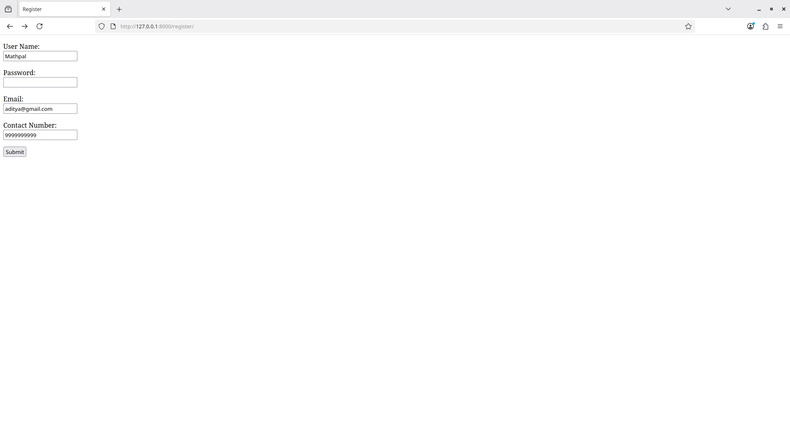
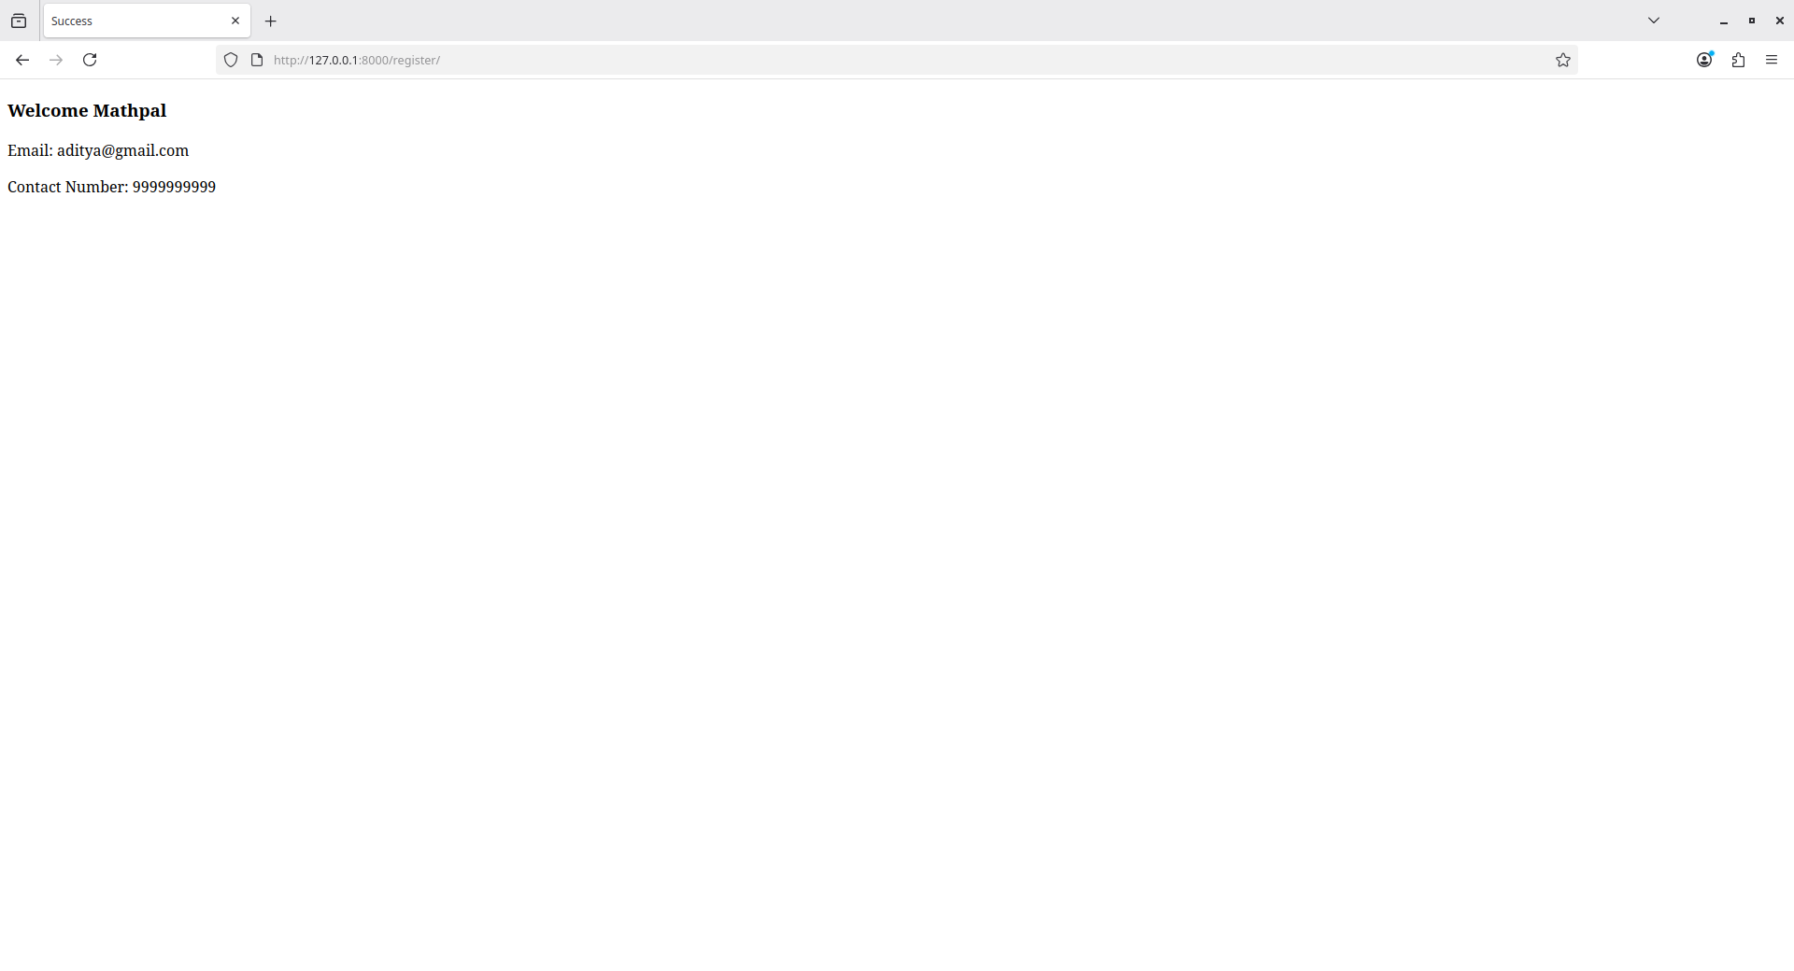

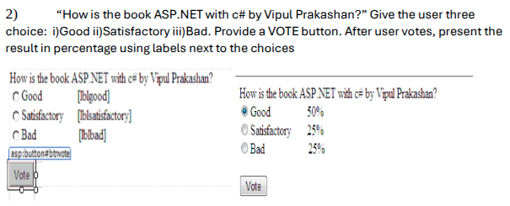

forms.py:
from django import forms

class SurveyForm(forms.Form):
CHOICES = [
('good', 'Good'),
('satisfactory', 'Satisfactory'),
('bad', 'Bad'),
]

choice = forms.ChoiceField(
label="How is the book ASP.NET with C# by Vipul Prakashan?",
choices=CHOICES,
widget=forms.RadioSelect,
required=True
)

views.py:
from django.shortcuts import render, redirect
from .forms import SurveyForm

# Create your views here.

good_votes = 0
satisfactory_votes = 0
bad_votes = 0

def survey(request):
global good_votes, satisfactory_votes, bad_votes

if request.method == "POST":
form = SurveyForm(request.POST)

if form.is_valid():
choice = form.cleaned_data['choice']

if choice == "good":
good_votes += 1
elif choice == "satisfactory":
satisfactory_votes += 1
elif choice == "bad":
bad_votes += 1

return redirect('result')
else:
form = SurveyForm()

return render(request, "vote.html", {"form": form})

def result(request):
total = good_votes + satisfactory_votes + bad_votes

good_percent = (good_votes / total) * 100
satisfactory_percent = (satisfactory_votes / total) * 100
bad_percent = (bad_votes / total) * 100

context = {
"good": good_percent,
"satisfactory": satisfactory_percent,
"bad": bad_percent,
}

return render(request, "result.html", context)

urls.py:
from django.urls import path
from . import views

urlpatterns = [
path('', views.survey, name='survey'),
path('result/', views.result, name='result'),
]

vote.html:
<!DOCTYPE html>
<html>
<head>
<title>Survey</title>
</head>
<body>

<form method="POST">
{% csrf_token %}

{{ form.as_p }}

<button type="submit">Vote</button>
</form>

</body>
</html>

result.html:
<!DOCTYPE html>
<html>
<head>
<title>Survey Result</title>
</head>
<body>

<h3>How is the book ASP.NET with C# by Vipul Prakashan?</h3>

<p>Good: {{ good|floatformat:0 }}%</p>
<p>Satisfactory: {{ satisfactory|floatformat:0 }}%</p>
<p>Bad: {{ bad|floatformat:0 }}%</p>

<br>
<a href="{% url 'survey' %}">Return to Survey</a>

</body>
</html>

output:
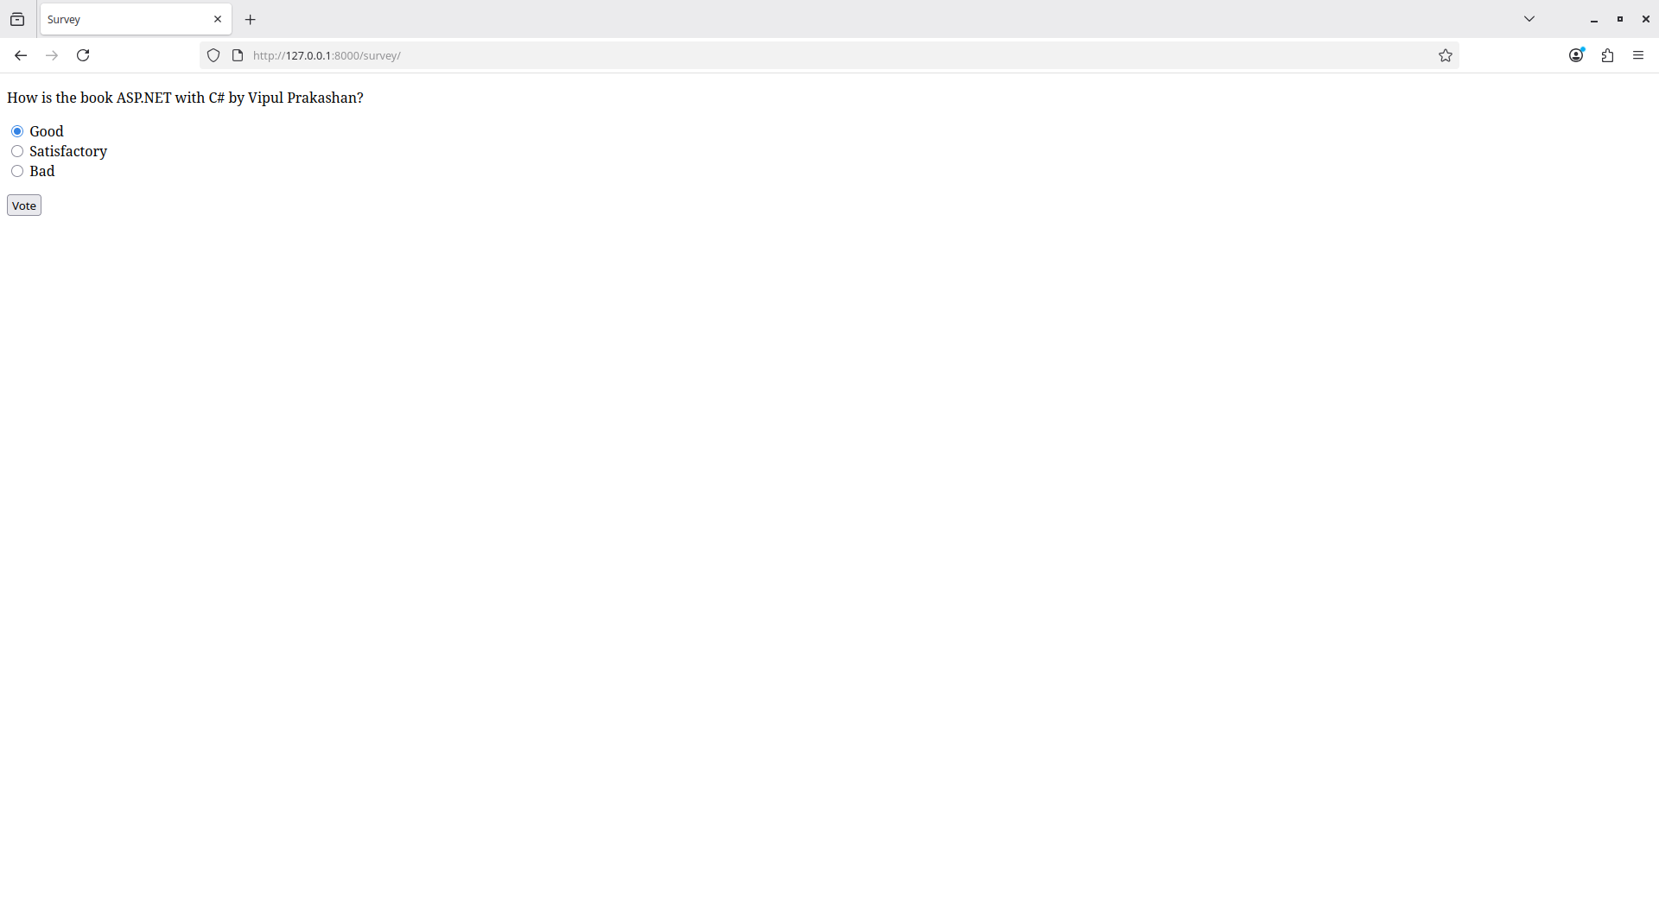
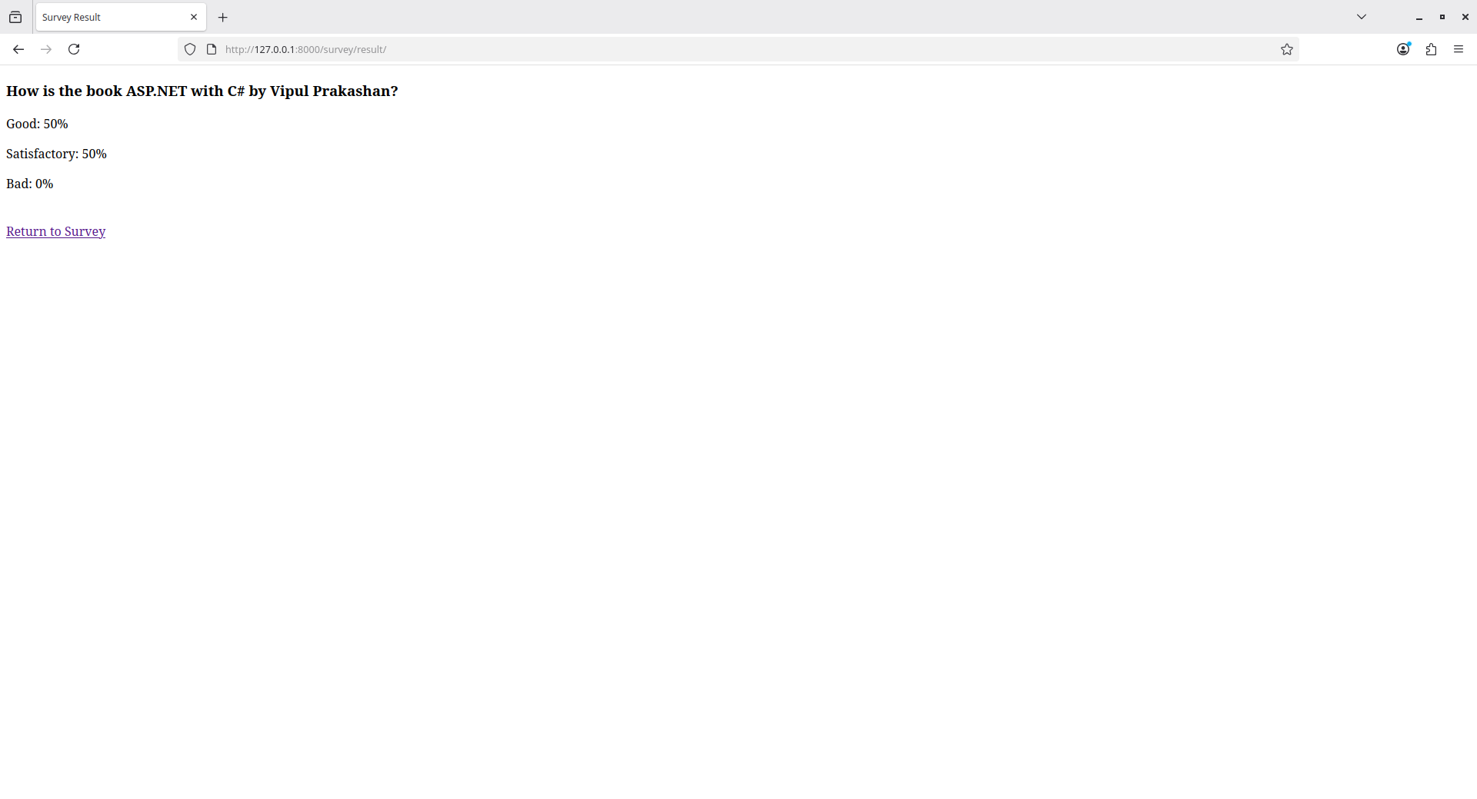

3) Create a website with two pages. Page 1 has two TextBoxes (name and total
marks) and one ‘Calculate’ Button as shown in the figure. On clicking the ‘Calculate’
Button, CGPA (total marks/50) along with the name should be displayed in the Page
2. Use Django sessions to store the information.

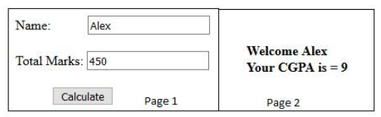
forms.py:
from django import forms

class CGPAForm(forms.Form):
name = forms.CharField(
label="Name",
max_length=100,
required=True
)

total_marks = forms.FloatField(
label="Total Marks",
required=True
)

views.py:
from django.shortcuts import render, redirect
from .forms import CGPAForm

def page1(request):
if request.method == "POST":
form = CGPAForm(request.POST)

if form.is_valid():
name = form.cleaned_data['name']
total_marks = form.cleaned_data['total_marks']

cgpa = total_marks / 50

request.session['name'] = name
request.session['cgpa'] = cgpa

return redirect('page2')
else:
form = CGPAForm()

return render(request, "page1.html", {"form": form})

def page2(request):
name = request.session.get('name')
cgpa = request.session.get('cgpa')

context = {
"name": name,
"cgpa": cgpa
}

return render(request, "page2.html", context)

urls.py:
from django.urls import path
from . import views

urlpatterns = [
path('page1/', views.page1, name='page1'),
path('page2/', views.page2, name='page2'),
]

page1.html:
<!DOCTYPE html>
<html>
<head>
<title>Page 1</title>
</head>
<body>

<form method="POST">
{% csrf_token %}

<p>
{{ form.name.label_tag }}
{{ form.name }}
</p>

<p>
{{ form.total_marks.label_tag }}
{{ form.total_marks }}
</p>

<button type="submit">Calculate</button>

</form>

</body>
</html>

page2.html:
<!DOCTYPE html>
<html>
<head>
<title>Page 2</title>
</head>
<body>

{% if name and cgpa %}
<h2>Welcome {{ name }}</h2>
<h3>Your CGPA is = {{ cgpa|floatformat:2 }}</h3>
{% else %}
<p>No session data found.</p>
{% endif %}

<br>
<a href="{% url 'page1' %}">Go Back</a>

</body>
</html>

output:
