230905232

Aditya Pankaj Mathpal

CSE C2 37

Lab 8: Form Processing using Django – Part II

Home Assignments

urls.py (common):
from django.contrib import admin
from django.urls import path, include

urlpatterns = [
path('', include('feedback.urls')),
path('', include('billing.urls')),
]

1. Create a website with two pages.First page contains:
RadioButton with HP, Nokia, Samsung, Motorola, Apple as options.
CheckBox with Mobile and Laptop as items. TextBox to enter quantity.
There is a button with text as "Produce Bill".
On Clicking Produce Bill button, item should be displayed with total amount on another
page.

forms.py:
from django import forms

class BillingForm(forms.Form):

BRAND_CHOICES = [
('HP', 'HP'),
('Nokia', 'Nokia'),
('Samsung', 'Samsung'),
('Motorola', 'Motorola'),
('Apple', 'Apple'),
]

ITEM_CHOICES = [
('Mobile', 'Mobile'),
('Laptop', 'Laptop'),
]

brand = forms.ChoiceField(
choices=BRAND_CHOICES,
widget=forms.RadioSelect,
required=True
)

items = forms.MultipleChoiceField(
choices=ITEM_CHOICES,
widget=forms.CheckboxSelectMultiple,
required=True
)

quantity = forms.IntegerField(
min_value=1,
required=True
)

views.py:
from django.shortcuts import render, redirect
from .forms import BillingForm

PRICE_LIST = {
'HP': {'Mobile': 20000, 'Laptop': 50000},
'Nokia': {'Mobile': 15000, 'Laptop': 40000},
'Samsung': {'Mobile': 25000, 'Laptop': 55000},
'Motorola': {'Mobile': 18000, 'Laptop': 42000},
'Apple': {'Mobile': 60000, 'Laptop': 100000},
}

def billing_page(request):
if request.method == "POST":
form = BillingForm(request.POST)

if form.is_valid():
brand = form.cleaned_data['brand']
items = form.cleaned_data['items']
quantity = form.cleaned_data['quantity']

total = 0
for item in items:
total += PRICE_LIST[brand][item] * quantity

request.session['brand'] = brand
request.session['items'] = items
request.session['quantity'] = quantity
request.session['total'] = total

return redirect('bill_result')
else:
form = BillingForm()

return render(request, "billing.html", {"form": form})

def bill_result(request):
context = {
"brand": request.session.get('brand'),
"items": request.session.get('items'),
"quantity": request.session.get('quantity'),
"total": request.session.get('total'),
}

return render(request, "bill_result.html", context)

urls.py:
from django.urls import path
from . import views

urlpatterns = [
path('billing/', views.billing_page, name='billing'),
path('billing/result/', views.bill_result, name='bill_result'),
]

billing.html:
<!DOCTYPE html>
<html>
<body>

<form method="POST">
{% csrf_token %}

{{ form.as_p }}

<button type="submit">Produce Bill</button>
</form>

</body>
</html>

bill_result.html:
<!DOCTYPE html>
<html>
<body>

<p>Brand: {{ brand }}</p>

<p>Items:</p>
<ul>
{% for item in items %}
<li>{{ item }}</li>
{% endfor %}
</ul>

<p>Quantity: {{ quantity }}</p>

<p>Total Amount: {{ total }}</p>

<a href="{% url 'billing' %}">Go Back</a>

</body>
</html>

output:
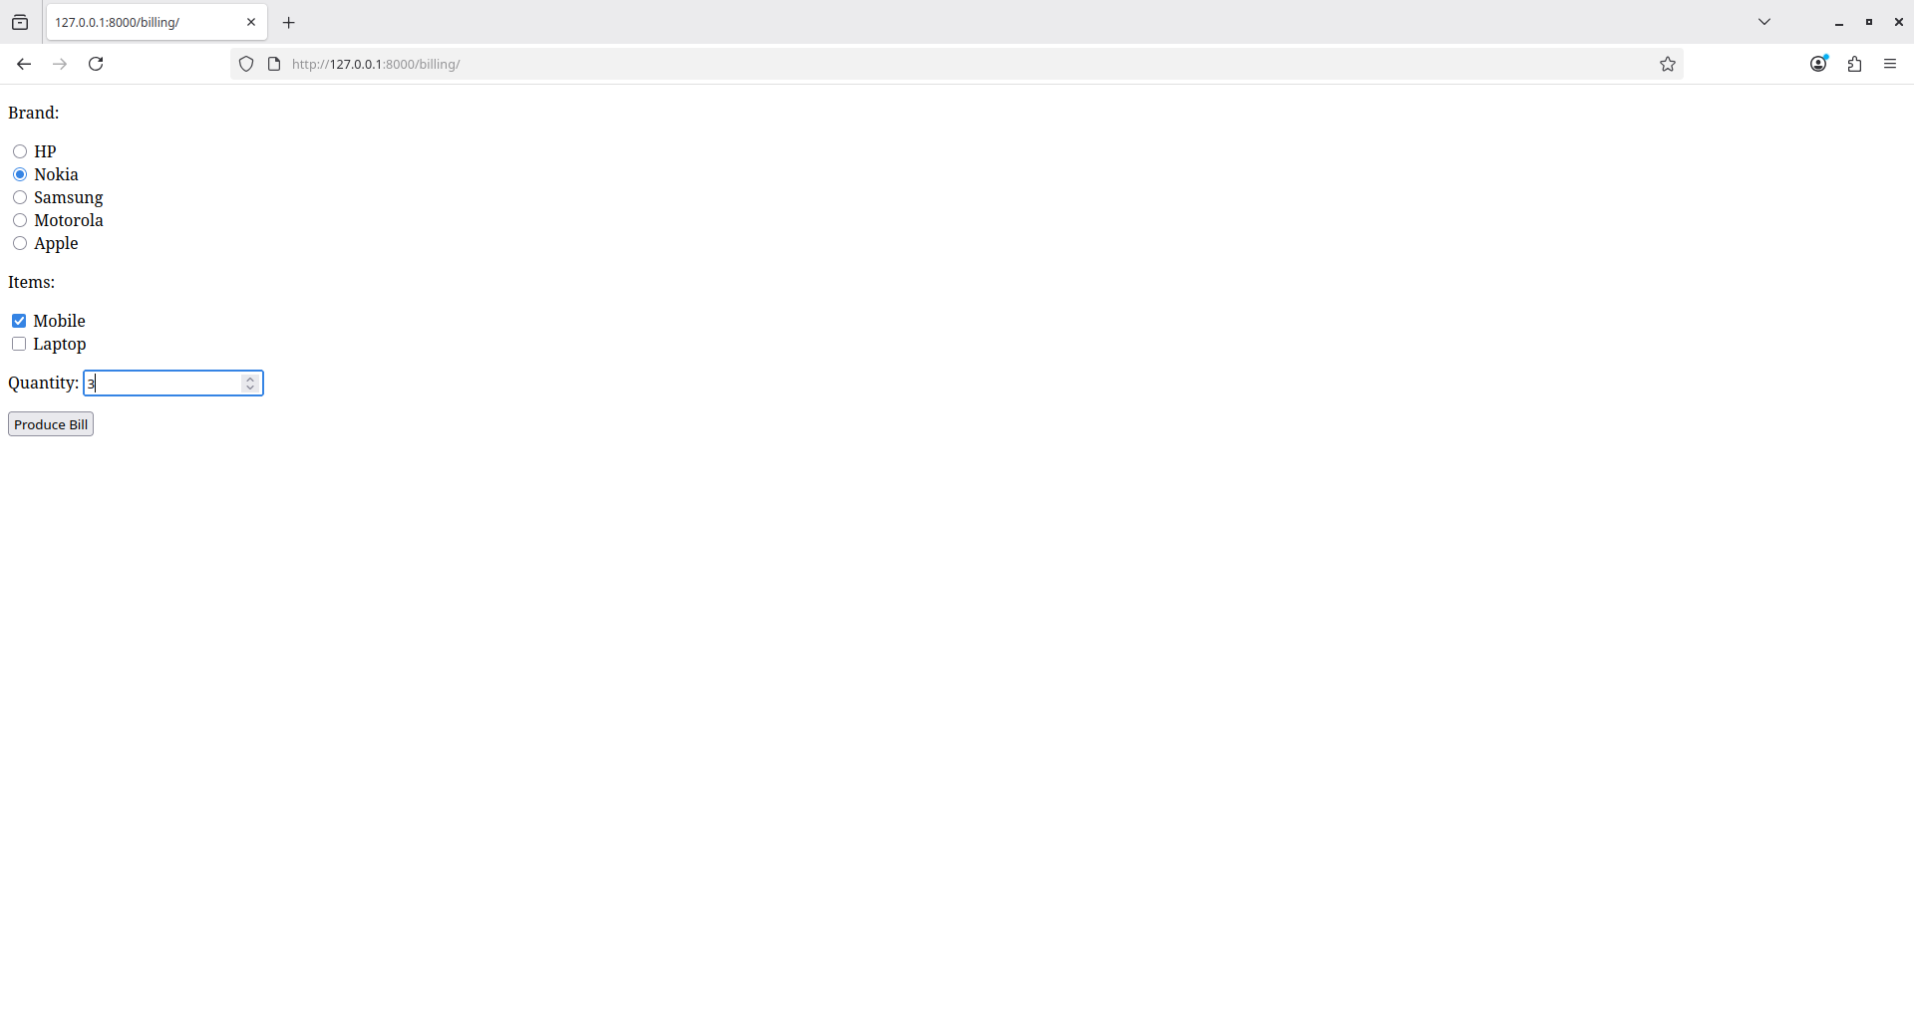

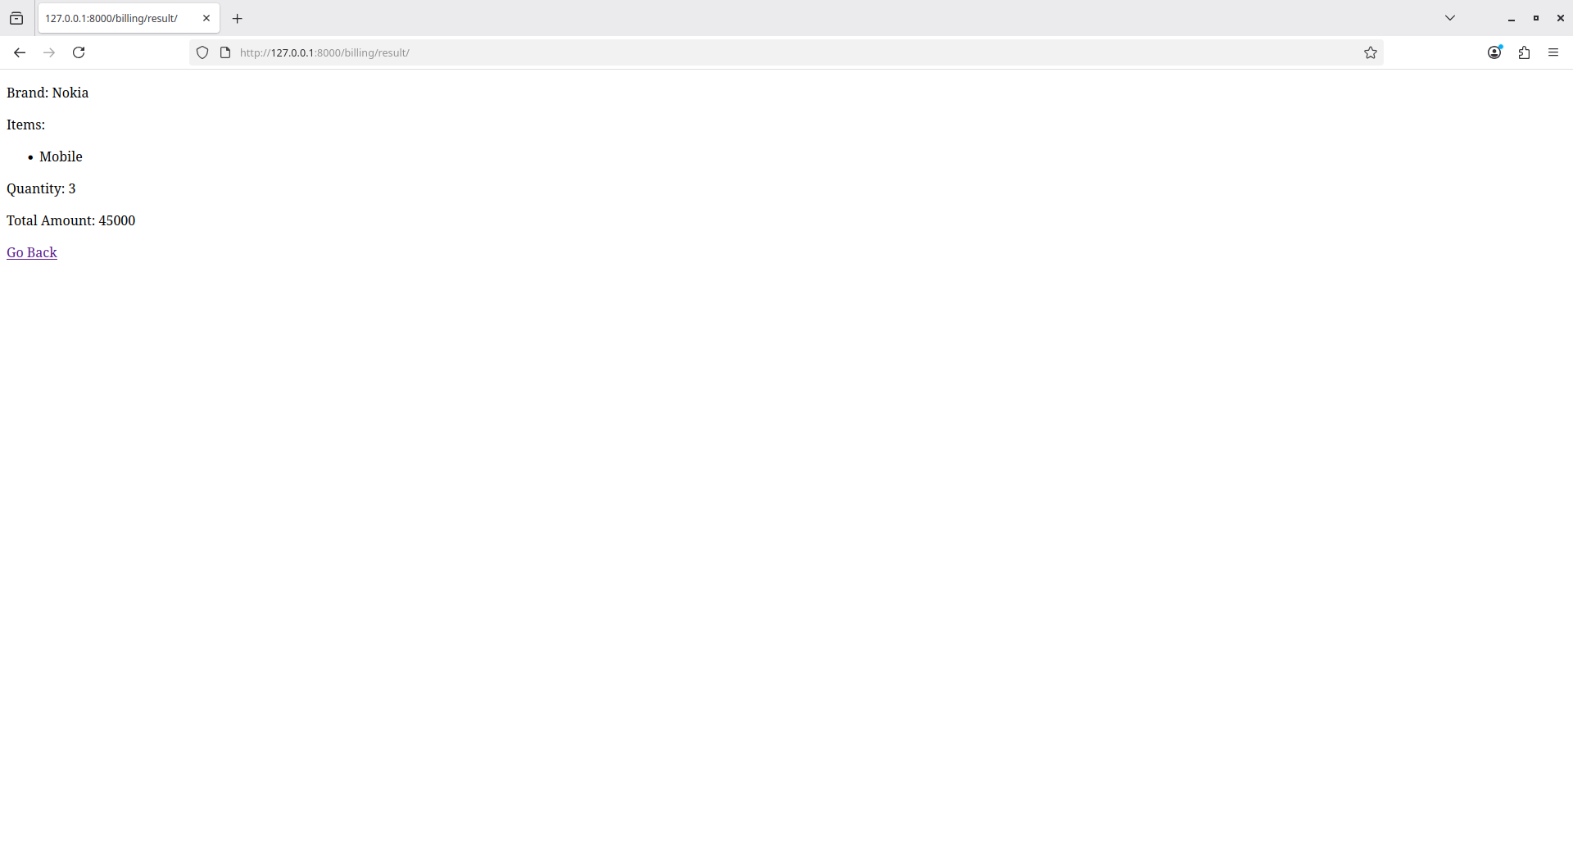

2. Write a program to display the following feedback form. The different options for the
list box must be ASP-XML, DotNET, JavaPro and Unix,C,C++. When the Submit Form button is
clicked after entering the data, a message as seen in the last line of the above figure must be
displayed.

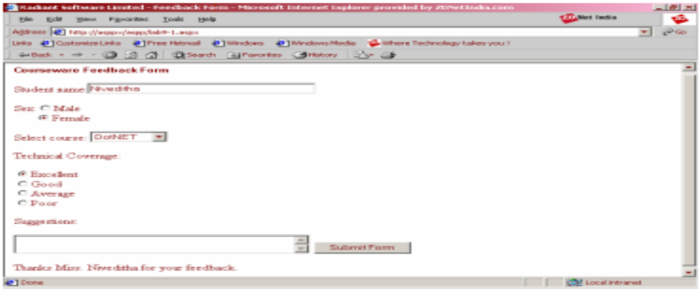

forms.py:
from django import forms

class FeedbackForm(forms.Form):

GENDER_CHOICES = [
('Male', 'Male'),
('Female', 'Female'),
]

COURSE_CHOICES = [
('ASP-XML', 'ASP-XML'),
('DotNET', 'DotNET'),
('JavaPro', 'JavaPro'),
('Unix,C,C++', 'Unix,C,C++'),
]

COVERAGE_CHOICES = [
('Excellent', 'Excellent'),
('Good', 'Good'),
('Average', 'Average'),
('Poor', 'Poor'),
]

name = forms.CharField(max_length=100, required=True)

gender = forms.ChoiceField(
choices=GENDER_CHOICES,
widget=forms.RadioSelect,
required=True
)

course = forms.ChoiceField(
choices=COURSE_CHOICES,
widget=forms.Select,
required=True
)

coverage = forms.ChoiceField(
choices=COVERAGE_CHOICES,
widget=forms.RadioSelect,
required=True
)

suggestion = forms.CharField(
widget=forms.Textarea,
required=False
)

views.py:
from django.shortcuts import render
from .forms import FeedbackForm

def feedback_page(request):
message = None

if request.method == "POST":
form = FeedbackForm(request.POST)

if form.is_valid():
name = form.cleaned_data['name']
gender = form.cleaned_data['gender']

if gender == "Male":
prefix = "Mr"
else:
prefix = "Ms"

message = f"Thanks {prefix} {name} for your feedback."
else:
form = FeedbackForm()

return render(request, "feedback.html", {
"form": form,
"message": message
})

urls.py:
from django.urls import path
from . import views

urlpatterns = [
path('feedback/', views.feedback_page, name='feedback'),
]

feedback.html:
<!DOCTYPE html>
<html>
<body>

<form method="POST">
{% csrf_token %}

<p>
Student name:
{{ form.name }}
</p>

<p>
Sex:
{{ form.gender }}
</p>

<p>
Select course:
{{ form.course }}
</p>

<p>
Technical Coverage:
{{ form.coverage }}
</p>

<p>
Suggestion:<br>
{{ form.suggestion }}
</p>

<button type="submit">Submit Form</button>

</form>

{% if message %}
<p>{{ message }}</p>
{% endif %}

</body>
</html>

output:
