230905232
Aditya Pankaj Mathpal
WPL Week 3

1. Design the student bio-data form using button, label, textbox, radio button, table
and checkbox.

Code:
<!DOCTYPE html>
<html lang="en">
<head>
<meta charset="UTF-8">
<meta name="viewport" content="width=device-width, initial-scale=1.0">
<link rel="stylesheet" href="https://maxcdn.bootstrapcdn.com/bootstrap/4.4.1/css/bootstrap.min.css">
<script src="https://ajax.googleapis.com/ajax/libs/jquery/3.4.1/jquery.min.js"></script>
<script src="https://cdnjs.cloudflare.com/ajax/libs/popper.js/1.16.0/umd/popper.min.js"></script>
<script src="https://maxcdn.bootstrapcdn.com/bootstrap/4.4.1/js/bootstrap.min.js"></script>
<title>Student Bio-Data</title>
</head>
<body>
<div class="container mt-4">
<h2>Student Bio-Data Form</h2>
<form id="biodataForm">
<div class="form-group">
<label for="name">Name:</label>
<input type="text" id="name" class="form-control" required>
</div>
<div class="form-group">
<label>Gender:</label><br>
<input type="radio" name="gender" value="Male" id="male" required>
<label for="male">Male</label><br>
<input type="radio" name="gender" value="Female" id="female">
<label for="female">Female</label><br>
<input type="radio" name="gender" value="Other" id="other">
<label for="other">Other</label>
</div>
<div class="form-group">
<label>Hobbies:</label><br>
<input type="checkbox" id="reading" value="Reading">
<label for="reading">Reading</label><br>
<input type="checkbox" id="sports" value="Sports">
<label for="sports">Sports</label><br>
<input type="checkbox" id="music" value="Music">
<label for="music">Music</label>
</div>
<button type="submit" class="btn btn-primary">Submit</button>
</form>

<h4 class="mt-4">Student Data</h4>
<table class="table table-bordered" id="studentTable">
<thead>
<tr>
<th>Name</th>
<th>Gender</th>
<th>Hobbies</th>
</tr>
</thead>
<tbody>
</tbody>
</table>
</div>

<script>
$('#biodataForm').submit(function(event){
event.preventDefault();
var name = $('#name').val();
var gender = $('input[name="gender"]:checked').val();
var hobbies = [];
$('input[type="checkbox"]:checked').each(function(){
hobbies.push($(this).val());
});
var row = '<tr><td>' + name + '</td><td>' + gender + '</td><td>' + hobbies.join(', ') + '</td></tr>';
$('#studentTable tbody').append(row);
this.reset();
});
</script>
</body>
</html>

output:
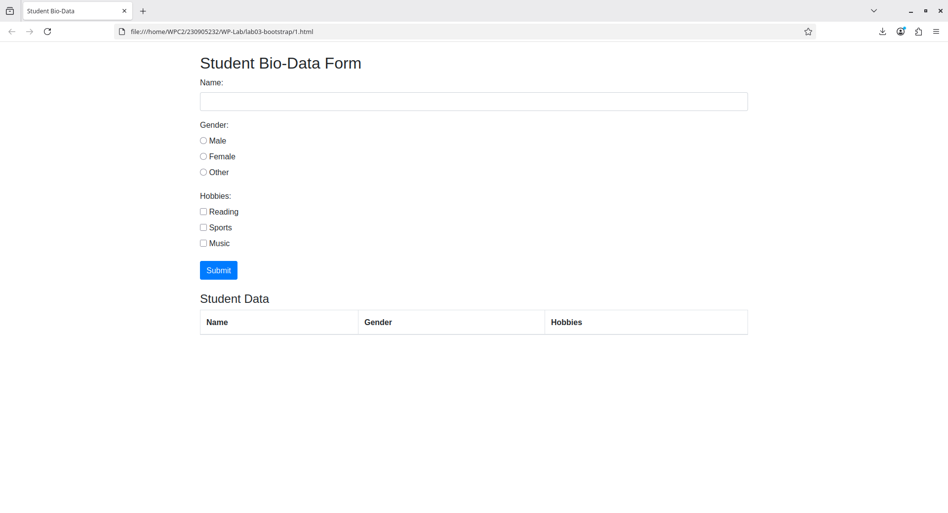
2. Design a web page which shows the database-oriented CRUD operation. Consider
Employee data.

Code:
<!DOCTYPE html>
<html lang="en">
<head>
<meta charset="UTF-8">
<meta name="viewport" content="width=device-width, initial-scale=1.0">
<link rel="stylesheet" href="https://maxcdn.bootstrapcdn.com/bootstrap/4.4.1/css/bootstrap.min.css">
<script src="https://ajax.googleapis.com/ajax/libs/jquery/3.4.1/jquery.min.js"></script>
<script src="https://cdnjs.cloudflare.com/ajax/libs/popper.js/1.16.0/umd/popper.min.js"></script>
<script src="https://maxcdn.bootstrapcdn.com/bootstrap/4.4.1/js/bootstrap.min.js"></script>
<title>CRUD</title>
</head>
<body>
<div class="container mt-4">
<h2>Employee CRUD Form</h2>
<form id="employeeForm">
<div class="form-group">
<label for="empName">Name:</label>
<input type="text" id="empName" class="form-control" required>
</div>
<div class="form-group">
<label for="empDept">Department:</label>
<input type="text" id="empDept" class="form-control" required>
</div>
<div class="form-group">
<label for="empSalary">Salary:</label>
<input type="number" id="empSalary" class="form-control" required>
</div>
<button type="submit" class="btn btn-primary">Add / Update</button>
</form>

<h4 class="mt-4">Employee Data</h4>
<table class="table table-bordered" id="employeeTable">
<thead>
<tr>
<th>Name</th>
<th>Department</th>
<th>Salary</th>
<th>Actions</th>
</tr>
</thead>
<tbody>
</tbody>
</table>
</div>

<script>
let editIndex = null;

$('#employeeForm').submit(function(event){
event.preventDefault();

var name = $('#empName').val();
var dept = $('#empDept').val();
var salary = $('#empSalary').val();

if(editIndex === null){
var row = '<tr><td>' + name + '</td><td>' + dept + '</td><td>' + salary + '</td>' +
'<td><button class="btn btn-sm btn-info editBtn">Edit</button> ' +
'<button class="btn btn-sm btn-danger deleteBtn">Delete</button></td></tr>';
$('#employeeTable tbody').append(row);
} else {
let row = $('#employeeTable tbody tr').eq(editIndex);
row.find('td:eq(0)').text(name);
row.find('td:eq(1)').text(dept);
row.find('td:eq(2)').text(salary);
editIndex = null;
}

this.reset();
});

$('#employeeTable').on('click', '.deleteBtn', function(){
$(this).closest('tr').remove();
});

$('#employeeTable').on('click', '.editBtn', function(){
let row = $(this).closest('tr');
editIndex = row.index();
$('#empName').val(row.find('td:eq(0)').text());
$('#empDept').val(row.find('td:eq(1)').text());
$('#empSalary').val(row.find('td:eq(2)').text());
});
</script>
</body>
</html>

output:
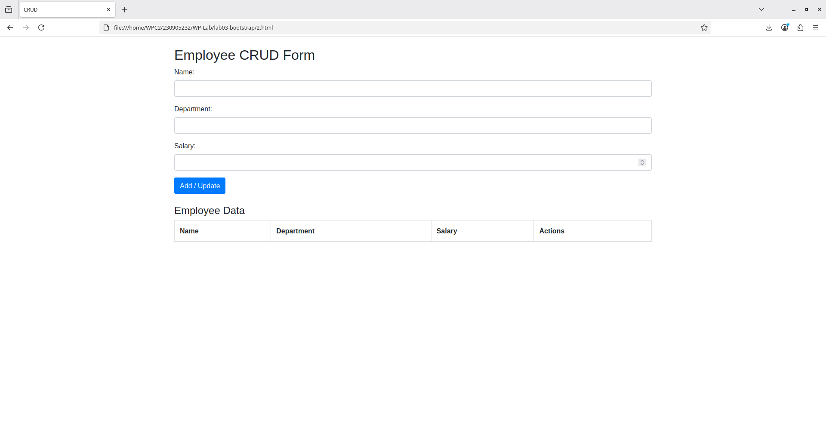
3. Create a web page using bootstrap as mentioned. Divide the page into 2 parts top
and bottom, then divide the bottom into 3 parts and design each top and bottom part using
different input groups, input, badges, buttons and button groups. Make the design more
attractive.

Code:
<!DOCTYPE html>
<html lang="en">
<head>
<meta charset="UTF-8">
<meta name="viewport" content="width=device-width, initial-scale=1.0">
<title>Balanced Split Layout</title>
<link rel="stylesheet" href="https://maxcdn.bootstrapcdn.com/bootstrap/4.4.1/css/bootstrap.min.css">
<script src="https://ajax.googleapis.com/ajax/libs/jquery/3.4.1/jquery.min.js"></script>
<script src="https://cdnjs.cloudflare.com/ajax/libs/popper.js/1.16.0/umd/popper.min.js"></script>
<script src="https://maxcdn.bootstrapcdn.com/bootstrap/4.4.1/js/bootstrap.min.js"></script>
<style>
.half-height {
height: 50vh;
display: flex;
align-items: center;
}
</style>
</head>
<body>

<div class="container-fluid vh-100 d-flex flex-column">

<div class="row half-height px-lg-5">
<div class="col-12">
<div class="p-4 bg-white border rounded shadow-sm">
<h5 class="mb-3 text-primary">Top Half Container</h5>

<div class="form-row align-items-center mb-3">
<div class="col-md-5 mb-2 mb-md-0">
<input type="search" class="form-control form-control-lg" placeholder="Search something...">
</div>
<div class="col-md-3 mb-2 mb-md-0">
<select class="custom-select custom-select-lg">
<option selected>Category</option>
<option>Files</option>
<option>Users</option>
</select>
</div>
<div class="col-md-4">
<div class="btn-toolbar w-100">
<button class="btn btn-primary btn-lg mr-2 flex-fill">Go</button>
<button class="btn btn-outline-dark btn-lg flex-fill">Filters</button>
</div>
</div>
</div>

<div>
<span class="badge badge-success badge-pill px-3 py-2">Active</span>
<span class="badge badge-dark badge-pill px-3 py-2">Lab Node</span>
<span class="badge badge-light border px-3 py-2">3 Alerts</span>
</div>
</div>
</div>
</div>

<hr class="m-0 border-primary" style="border-width:2px; opacity:.25;">

<div class="row flex-grow-1 px-lg-5 py-4">

<div class="col-md-4 mb-4 mb-md-0">
<div class="p-4 bg-white border h-100 rounded d-flex flex-column justify-content-center">
<h6 class="font-weight-bold mb-3">Profile Info</h6>

<div class="mb-3">
<label class="small text-muted">Username</label>
<input type="text" class="form-control form-control-lg" placeholder="@username">
<small class="form-text text-muted">Public display name</small>
</div>

<button class="btn btn-primary btn-block mb-2">Update Profile</button>
<button class="btn btn-outline-secondary btn-block">Clear</button>
</div>
</div>

<div class="col-md-4 mb-4 mb-md-0">
<div class="p-4 bg-white border h-100 rounded d-flex flex-column justify-content-center">
<h6 class="font-weight-bold mb-3">Financials</h6>

<div class="form-row mb-3">
<div class="col-8">
<input type="number" class="form-control form-control-lg" placeholder="Amount">
</div>
<div class="col-4">
<select class="custom-select custom-select-lg">
<option>USD</option>
<option>EUR</option>
<option>INR</option>
</select>
</div>
</div>

<div class="d-flex justify-content-between align-items-center">
<button class="btn btn-outline-success btn-lg px-4">Proceed</button>

<div class="btn-group btn-group-toggle" data-toggle="buttons">
<label class="btn btn-secondary btn-sm active">
<input type="radio" name="currency"> Card
</label>
<label class="btn btn-outline-secondary btn-sm">
<input type="radio" name="currency"> Wallet
</label>
</div>
</div>
</div>
</div>

<div class="col-md-4">
<div class="p-4 bg-white border h-100 rounded d-flex flex-column justify-content-center">
<h6 class="font-weight-bold mb-3">System Updates</h6>

<div class="form-row mb-4">
<div class="col-7">
<input type="text" class="form-control" placeholder="Recipient name">
</div>
<div class="col-5">
<select class="custom-select">
<option>@mail.com</option>
<option>@work.org</option>
</select>
</div>
</div>

<div class="custom-control custom-switch mb-2">
<input type="checkbox" class="custom-control-input" id="emailSwitch">
<label class="custom-control-label" for="emailSwitch">Email Notifications</label>
</div>
<div class="custom-control custom-switch">
<input type="checkbox" class="custom-control-input" id="smsSwitch">
<label class="custom-control-label" for="smsSwitch">SMS Alerts</label>
</div>
</div>
</div>

</div>

</div>

</body>
</html>

output:
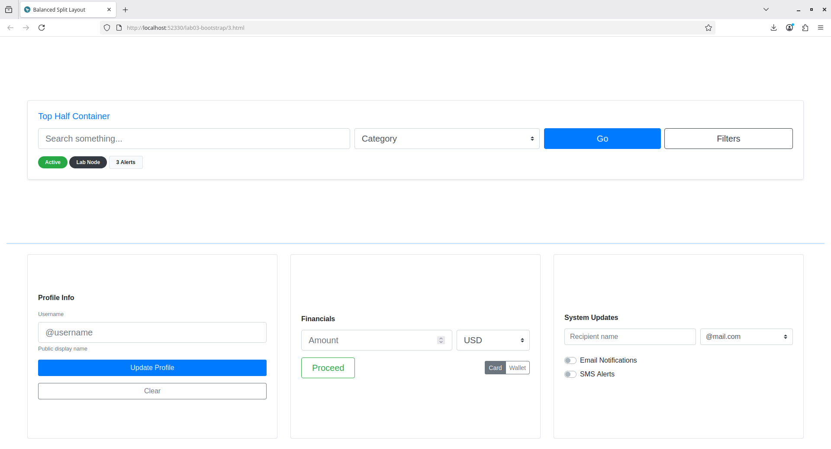

4. Design your class timetable using bootstrap table and carousel.

Code:
<!DOCTYPE html>
<html lang="en">
<head>
<meta charset="UTF-8">
<meta name="viewport" content="width=device-width, initial-scale=1.0">
<link rel="stylesheet" href="https://maxcdn.bootstrapcdn.com/bootstrap/4.4.1/css/bootstrap.min.css">
<script src="https://ajax.googleapis.com/ajax/libs/jquery/3.4.1/jquery.min.js"></script>
<script src="https://cdnjs.cloudflare.com/ajax/libs/popper.js/1.16.0/umd/popper.min.js"></script>
<script src="https://maxcdn.bootstrapcdn.com/bootstrap/4.4.1/js/bootstrap.min.js"></script>
<title>Time Table</title>
</head>
<body>
<div class="container mt-4">

<style>
table {
table-layout: fixed;
width: 100%;
}

.carousel-control-prev,
.carousel-control-next { width: 5%; }

.carousel-control-prev { left: -200px; }
.carousel-control-next { right: -200px; }

.carousel-control-prev-icon,
.carousel-control-next-icon {
background-color: black;
border-radius: 50%;
padding: 18px;
}
</style>

<div id="timetableCarousel" class="carousel slide" data-interval="false">
<div class="carousel-inner">

<div class="carousel-item active">
<h4 class="text-center">Monday</h4>
<table class="table table-bordered text-center">
<tr>
<th>Time</th>
<th>8-9</th><th>9-10</th><th>10-10:30</th><th>10:30-11:30</th>
<th>11:30-12:30</th><th></th><th>1-2</th><th>2-3</th><th>3-3:30</th><th>3:30-4:30</th>
</tr>
<tr>
<th>Class</th>
<td>GT</td><td>PCAP</td><td></td><td>CD</td>
<td>OR</td><td></td><td></td><td></td><td></td><td></td>
</tr>
</table>
</div>

<div class="carousel-item">
<h4 class="text-center">Tuesday</h4>
<table class="table table-bordered text-center">
<tr>
<th>Time</th>
<th>8-9</th><th>9-10</th><th>10-10:30</th><th>10:30-11:30</th>
<th>11:30-12:30</th><th></th><th>1-2</th><th>2-3</th><th>3-3:30</th><th>3:30-4:30</th>
</tr>
<tr>
<th>Class</th>
<td colspan="4">CDL (C1)</td>
<td></td><td></td>
<td>TSA</td>
<td>EEFM</td>
<td colspan="2">Placement</td>
</tr>
</table>
</div>

<div class="carousel-item">
<h4 class="text-center">Wednesday</h4>
<table class="table table-bordered text-center">
<tr>
<th>Time</th>
<th>8-9</th><th>9-10</th><th>10-10:30</th><th>10:30-11:30</th>
<th>11:30-12:30</th><th></th><th>1-2</th><th>2-3</th><th>3-3:30</th><th>3:30-4:30</th>
</tr>
<tr>
<th>Class</th>
<td>TSA</td><td>EEFM</td><td></td><td>GT</td>
<td>PCAP</td><td></td><td></td>
<td colspan="3">WPL (C1)</td>
</tr>
</table>
</div>

<div class="carousel-item">
<h4 class="text-center">Thursday</h4>
<table class="table table-bordered text-center">
<tr>
<th>Time</th>
<th>8-9</th><th>9-10</th><th>10-10:30</th><th>10:30-11:30</th>
<th>11:30-12:30</th><th></th><th>1-2</th><th>2-3</th><th>3-3:30</th><th>3:30-4:30</th>
</tr>
<tr>
<th>Class</th>
<td></td>
<td colspan="3">PPL (C2)</td>
<td></td><td></td>
<td>CD</td>
<td>OR</td>
<td colspan="2">Placement</td>
</tr>
</table>
</div>

<div class="carousel-item">
<h4 class="text-center">Friday</h4>
<table class="table table-bordered text-center">
<tr>
<th>Time</th>
<th>8-9</th><th>9-10</th><th>10-10:30</th><th>10:30-11:30</th>
<th>11:30-12:30</th><th></th><th>1-2</th><th>2-3</th><th>3-3:30</th><th>3:30-4:30</th>
</tr>
<tr>
<th>Class</th>
<td>CD</td><td>OR</td>
<td></td>
<td>TSA</td>
<td>EEFM</td><td></td>
<td colspan="4">PPL (C1) | CDL (C2)</td>
</tr>
</table>
</div>

<div class="carousel-item">
<h4 class="text-center">Saturday</h4>
<table class="table table-bordered text-center">
<tr>
<th>Time</th>
<th>8-9</th><th>9-10</th><th>10-10:30</th><th>10:30-11:30</th>
<th>11:30-12:30</th><th></th><th>1-2</th><th>2-3</th><th>3-3:30</th><th>3:30-4:30</th>
</tr>
<tr>
<th>Class</th>
<td colspan="4">WPL (C2)</td>
<td></td><td></td>
<td>GT</td><td>PCAP</td><td></td><td></td>
</tr>
</table>
</div>

</div>

<a class="carousel-control-prev" href="#timetableCarousel" role="button" data-slide="prev">
<span class="carousel-control-prev-icon"></span>
</a>
<a class="carousel-control-next" href="#timetableCarousel" role="button" data-slide="next">
<span class="carousel-control-next-icon"></span>
</a>

</div>
</div>

</body>
</html>

output:
