230905232

Aditya Pankaj Mathpal

CSE C2 Roll No. 37

WPL Week 3

Home Assignments

1. Design an attractive ‘train ticket booking form’ using different bootstrap elements.

Code:
<!DOCTYPE html>
<html lang="en">
<head>
<meta charset="UTF-8">
<meta name="viewport" content="width=device-width, initial-scale=1.0">
<link rel="stylesheet" href="https://maxcdn.bootstrapcdn.com/bootstrap/4.4.1/css/bootstrap.min.css">
<script src="https://ajax.googleapis.com/ajax/libs/jquery/3.4.1/jquery.min.js"></script>
<script src="https://cdnjs.cloudflare.com/ajax/libs/popper.js/1.16.0/umd/popper.min.js"></script>
<script src="https://maxcdn.bootstrapcdn.com/bootstrap/4.4.1/js/bootstrap.min.js"></script>
<title>Train Ticket Booking Form</title>
</head>
<body class="bg-light">

<nav class="navbar navbar-dark bg-primary">
<a class="navbar-brand" href="#">Train Ticket Booking</a>
</nav>

<div class="container mt-5">
<div class="card shadow">
<div class="card-header bg-info text-white">
Passenger Details
</div>

<div class="card-body">
<form>
<div class="form-group">
<label>Full Name</label>
<input type="text" class="form-control" placeholder="Enter your name">
</div>

<div class="form-group">
<label>Email address</label>
<input type="email" class="form-control" placeholder="Enter email">
</div>

<div class="form-row">
<div class="form-group col-md-6">
<label>From</label>
<input type="text" class="form-control" placeholder="Departure city">
</div>
<div class="form-group col-md-6">
<label>To</label>
<input type="text" class="form-control" placeholder="Destination city">
</div>
</div>

<div class="form-row">
<div class="form-group col-md-6">
<label>Travel Date</label>
<input type="date" class="form-control">
</div>

<div class="form-group col-md-6">
<label>Class</label>
<select class="form-control">
<option>All Classes</option>
<option>Anubhuti Class (EA)</option>
<option>AC First Class (1A)</option>
<option>Vistadome AC (EV)</option>
<option>Exec. Chair Car (EC)</option>
<option>AC 2 Tier (2A)</option>
<option>First Class (FC)</option>
<option>AC 3 Tier (3A)</option>
<option>AC 3 Economy (3E)</option>
<option>Vistadome Chair Car (VC)</option>
<option>AC Chair Car (CC)</option>
<option>Sleeper (SL)</option>
<option>Vistadome Non AC (VS)</option>
<option>Second Sitting (2S)</option>
</select>
</div>
</div>

<div class="form-group">
<label>Gender</label><br>
<div class="form-check form-check-inline">
<input class="form-check-input" type="radio" name="gender">
<label class="form-check-label">Male</label>
</div>
<div class="form-check form-check-inline">
<input class="form-check-input" type="radio" name="gender">
<label class="form-check-label">Female</label>
</div>
<div class="form-check form-check-inline">
<input class="form-check-input" type="radio" name="gender">
<label class="form-check-label">Other</label>
</div>
</div>

<div>
<div class="form-check form-check-inline">
<input type="checkbox" class="form-check-input">
<label class="form-check-label">Person With Disability Concession</label>
</div>
<div class="form-check form-check-inline">
<input type="checkbox" class="form-check-input">
<label class="form-check-label">Flexible With Date</label>
</div>
<div class="form-check form-check-inline">
<input type="checkbox" class="form-check-input">
<label class="form-check-label">Railway Pass Concession</label>
</div>
</div>
<br>

<button type="submit" class="btn btn-success">Search Trains</button>
</form>
</div>
</div>
</div>

</body>
</html>

output:
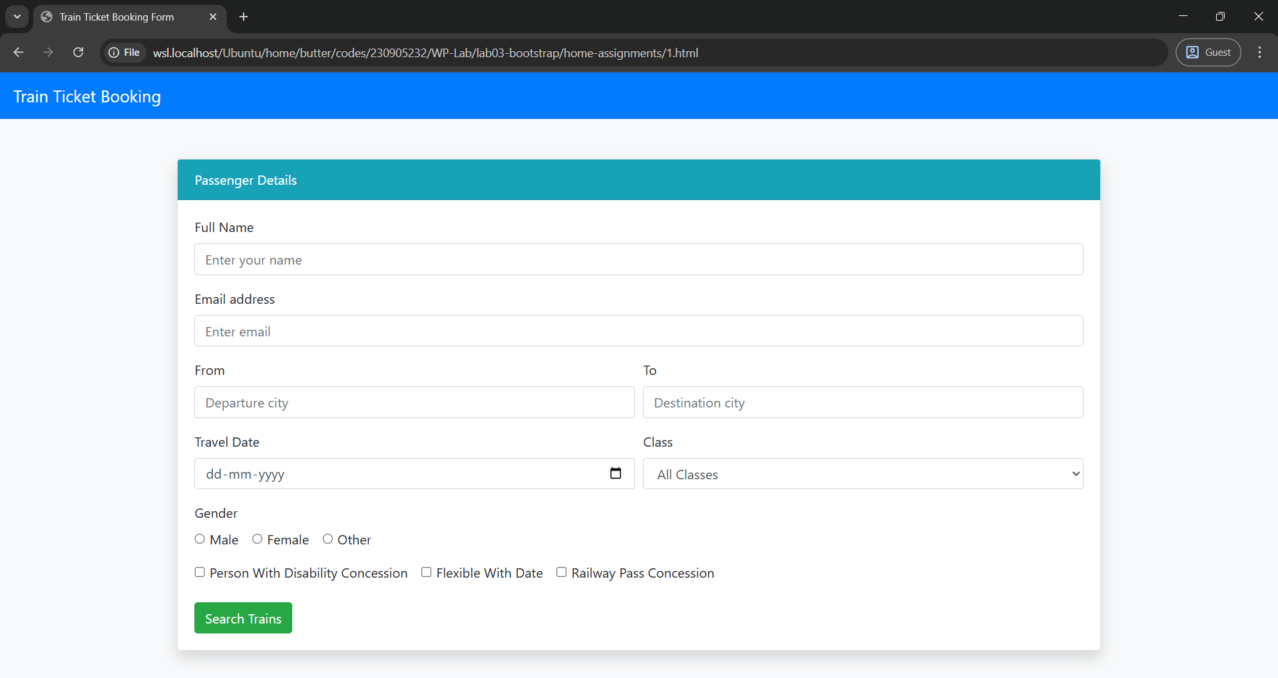
2. Design an attractive ‘magazine cover page’ using different bootstrap elements.

Code:
<!DOCTYPE html>
<html lang="en">
<head>
<meta charset="UTF-8">
<meta name="viewport" content="width=device-width, initial-scale=1.0">
<link rel="stylesheet" href="https://maxcdn.bootstrapcdn.com/bootstrap/4.4.1/css/bootstrap.min.css">
<script src="https://ajax.googleapis.com/ajax/libs/jquery/3.4.1/jquery.min.js"></script>
<script src="https://cdnjs.cloudflare.com/ajax/libs/popper.js/1.16.0/umd/popper.min.js"></script>
<script src="https://maxcdn.bootstrapcdn.com/bootstrap/4.4.1/js/bootstrap.min.js"></script>
<title>Magazine Cover</title>
</head>

<body class="bg-dark text-white">

<div class="container mt-4">

<div class="card bg-secondary text-white text-center shadow-lg">
<div class="card-body">

<h5 class="text-warning">January 2026 Edition</h5>
<h1 class="display-3 font-weight-bold">TECH WORLD</h1>
<p class="lead">The Future is Here</p>

<img src="tech.jpg" width="25%" class="img-fluid rounded mt-3 mb-3">

<div class="row text-left mt-4">
<div class="col-md-6">
<h5>Inside This Issue</h5>
<ul class="list-group">
<li class="list-group-item">AI Changing Everyday Life</li>
<li class="list-group-item">Top 10 Gadgets of the Year</li>
<li class="list-group-item">Cybersecurity Basics</li>
</ul>
</div>

<div class="col-md-6">
<h5>Special Features</h5>
<ul class="list-group">
<li class="list-group-item">Interview with a Tech CEO</li>
<li class="list-group-item">Future of Space Travel</li>
<li class="list-group-item">Coding for Beginners</li>
</ul>
</div>
</div>

<button class="btn btn-warning btn-lg mt-4">Subscribe Now</button>

</div>
</div>

</div>

</body>
</html>

output:
