Aditya Pankaj Mathpal
230905232
CSE C2 37

WPL Week 10: Databases - Part II

1. There are three tables in the database an author table has a first name, a last name and
an email address. A publisher table has a name, a street address, a city, a state/
province, a country, and a Web site. A book table has a title and a publication date. It
also has one or more authors (a many-to-many relationship with authors) and a single
publisher (a one-to-many relationship - aka foreign key - to publishers). Design a
form which populates and retrieves the information from the above database using
Django.

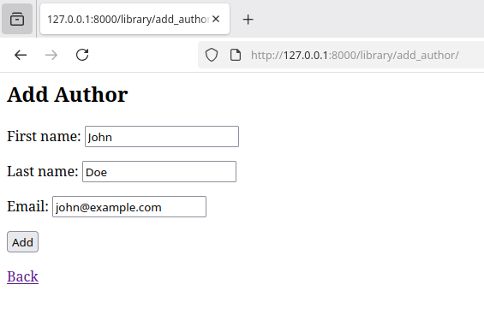

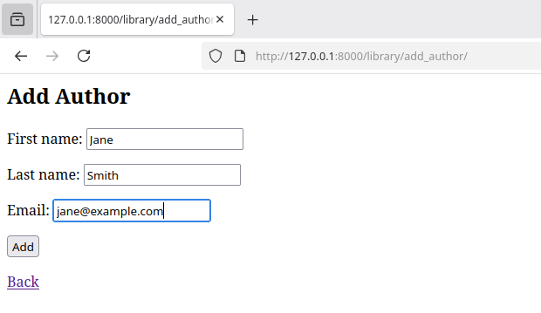
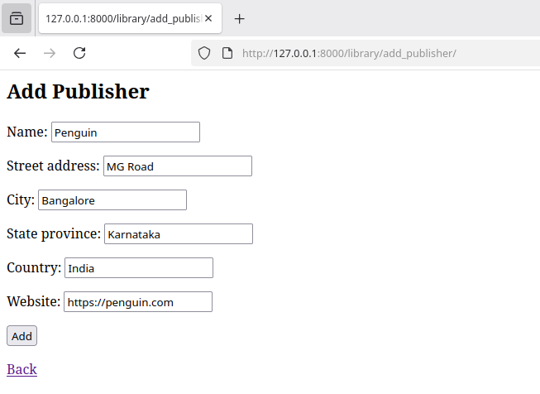

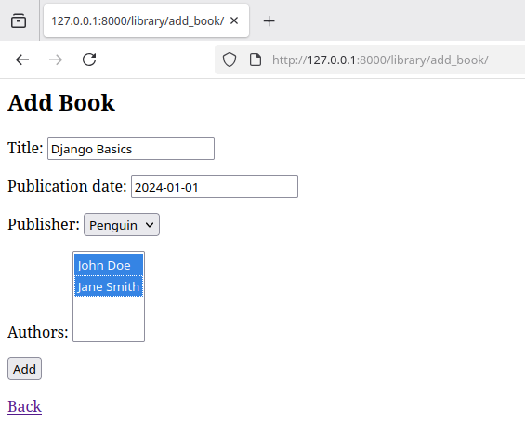
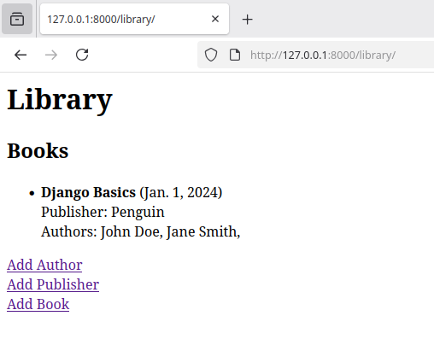
2. Create a Django Page for entry of a Product information (title, price and description)
and save it into the db. Create the index page where you would view the product
entries in an unordered list.

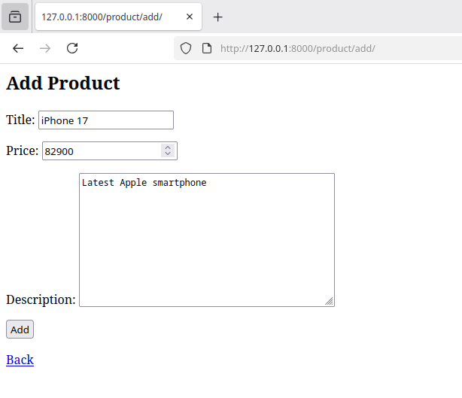
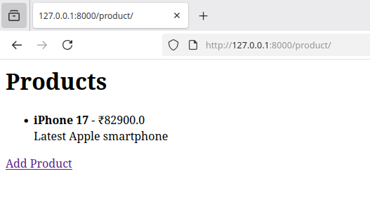

3. Create a web page with DropDownList, Textboxes and Buttons. Assume the table
‘Human’ with First name, Last name, Phone, Address and City as fields.
When the page is loaded, only first names will be displayed in the drop-down list. On
selecting the name, other details will be displayed in the respective TextBoxes. On
clicking the update button, the table will be updated with new entries made in the text
box. On clicking the delete button, the selected record will be deleted from the table,
and the DropDownList is refreshed.

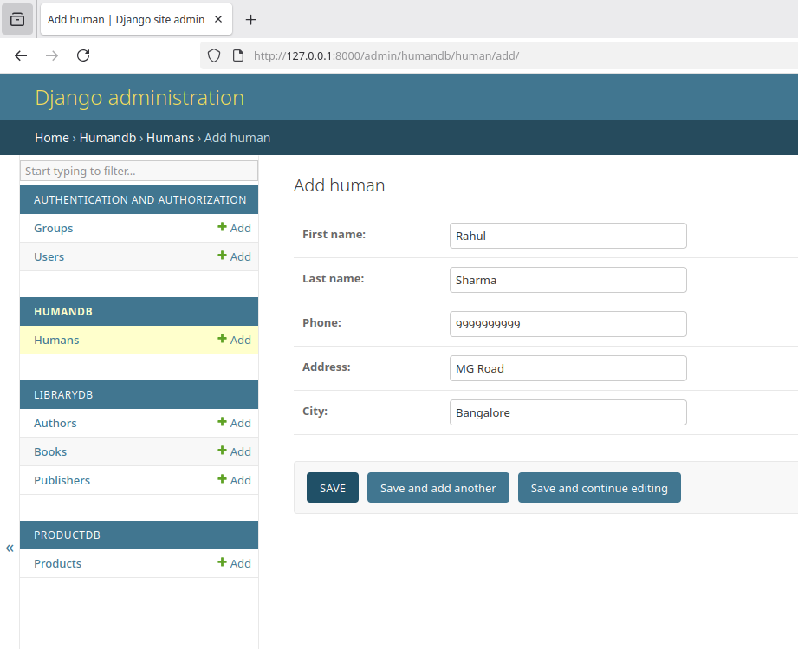
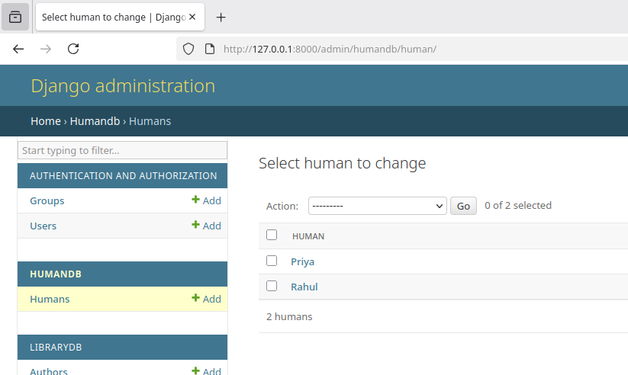

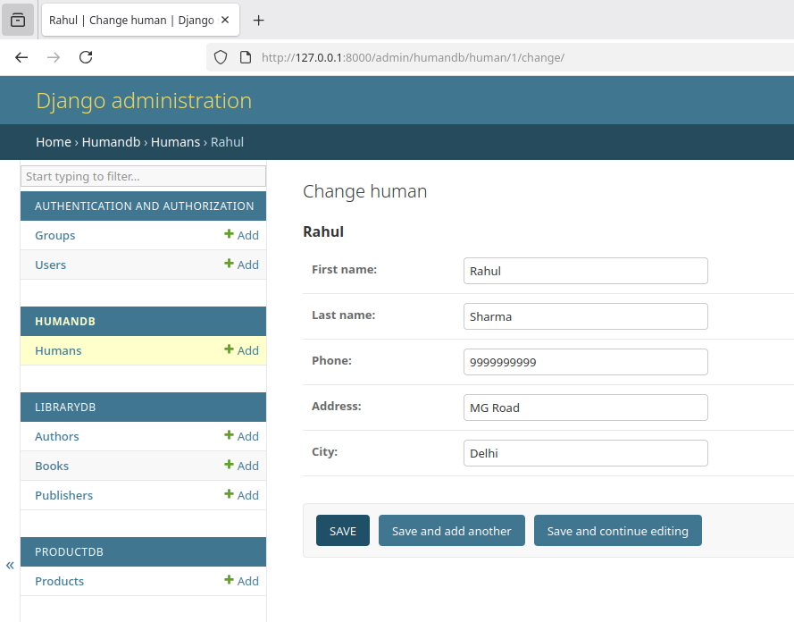
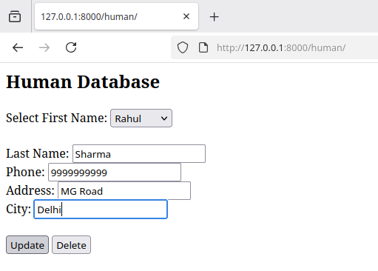
db entry updated:

