PRISM
Predictive Relocation & Infrastructure Safety Matrix
SYSTEM ARCHITECTURE SPECIFICATION v1.0
From unified data contracts to an implementable software architecture

Document Attribute | Value
System | PRISM — Predictive Relocation & Infrastructure Safety Matrix
Problem Statement | SIH 26191 — Intelligent Identification of Hazard-Based Red Zones, Carrying Capacity Assessment, and Immediate Relocation Needs for Vulnerable Habitations
Document purpose | Translate the Unified Data Model and six engine R&D packages into a coherent software architecture and prototype build specification.
Status | Draft v1.0 — engineering baseline for prototype construction
Architecture posture | Software-first, modular monolith, PostgreSQL/PostGIS, Python/FastAPI, React/Next.js, human-in-the-loop
Decision authority | PRISM is decision support; authorized authorities retain final operational control.
Scope | Prototype architecture; production-scale resilience, governance and deployment remain future extensions.

Architecture rule
The system must preserve the chain HAZARD → HUMAN → PRIORITY → CAPACITY → RELOCATION → ACTION without allowing any engine to silently absorb another engine’s domain responsibility.

Document Map
Section | Purpose
1. Architecture Objectives | What the architecture must achieve
2. Architectural Principles | Non-negotiable design rules
3. System Context | External actors, data sources and boundaries
4. Logical Architecture | Major software layers and modules
5. Engine Architecture | Implementation boundary for Engines 1–6
6. Deployment Architecture | How the prototype runs
7. Data Architecture | Database, canonical entities and read models
8. GIS Architecture | Spatial storage, processing and routing data
9. Temporal & State Architecture | Snapshots, validity, freshness and scenario state
10. API Architecture | Synchronous and asynchronous interfaces
11. Event & Orchestration Architecture | Propagation, dependency execution and idempotency
12. Engine Execution Specifications | Runtime responsibilities of E1–E5
13. Dashboard / UX Architecture | Authority-facing command interface
14. Security, Privacy & Human Oversight | Access control, household privacy and overrides
15. Failure & Degraded Modes | What happens when data or engines fail
16. Observability & Audit | Technical, data and decision health
17. Testing & Validation Architecture | How the system is proven correct
18. Prototype Scope & Demo Architecture | What is actually built for SIH
19. Repository & Code Organization | Recommended implementation structure
20. Build Sequence | Ordered engineering plan
21. Architecture Decisions & Open Choices | Frozen, configurable and unresolved decisions
22. Architecture Acceptance Criteria | Conditions for moving to build
23. Handoff to Master AI Build Specification | What this document supplies to the final prompt

1. Architecture Objectives
The architecture specification converts the PRISM research packages and unified data contracts into a buildable software system. It is not a second research dossier. It defines the structural boundaries, runtime responsibilities, technology posture, state handling, interfaces and implementation sequence required for a credible prototype.
- Preserve one coherent hazard-to-relocation decision chain across all engines.
- Keep domain logic separated: E1 hazard, E2 human vulnerability/priority, E3 destination/capacity, E4 routing/allocation, E5 scenario/adaptation, E6 data/GIS/integration.
- Make spatial and temporal context first-class so downstream decisions are not built from mismatched states.
- Make uncertainty, freshness, data quality and provenance visible rather than silently converting missing information into safe assumptions.
- Support both normal recalculation and scenario-based what-if analysis without overwriting the operational baseline.
- Provide explainable outputs suitable for human review and override.
- Prefer a small, testable prototype architecture over unnecessary distributed infrastructure.
- Leave empirically unresolved model choices configurable until prototype validation supplies evidence.

1.1 Architectural success condition
Success condition
A synthetic hazard change must be able to propagate from updated hazard state through affected people, priority, destination capacity, route/allocation and dashboard state, while preserving snapshot identity, provenance, reason codes and baseline/scenario separation.

2. Architectural Principles
Principle | Architectural implication
Canonical meaning before implementation convenience | One semantic definition for each shared entity, status and relationship.
Modular monolith first | Keep engine boundaries explicit inside one deployable backend before introducing distributed services.
Single canonical state | Do not maintain incompatible copies of households, destinations, roads or hazard state inside separate engines.
Engine ownership is explicit | An engine may consume another engine’s output but should not silently recreate the same domain decision.
GIS is computational infrastructure | Spatial operations are part of decision logic, not merely visualization.
Time is first-class | Observed, issued, valid, ingested, updated and scenario times remain distinguishable.
Quality is not confidence | Data quality, model confidence, operational status and scenario state remain separate.
Snapshot every decision context | Major derived results reference the exact state context used.
No unsafe defaults | UNKNOWN/STALE data cannot silently become safe/available.
Failed and infeasible outcomes are valid | The system may return NO_VIABLE_ALLOCATION or blocked recommendations.
Human authority remains explicit | Recommendations are reviewable; PRISM does not autonomously issue evacuation commands.
Prototype simplicity | Use only infrastructure justified by the demonstrated workflow.

3. System Context
PRISM sits between heterogeneous disaster/geospatial information and authorized decision-makers. It does not replace official alerting, rescue command, emergency services, government source systems or field operations.
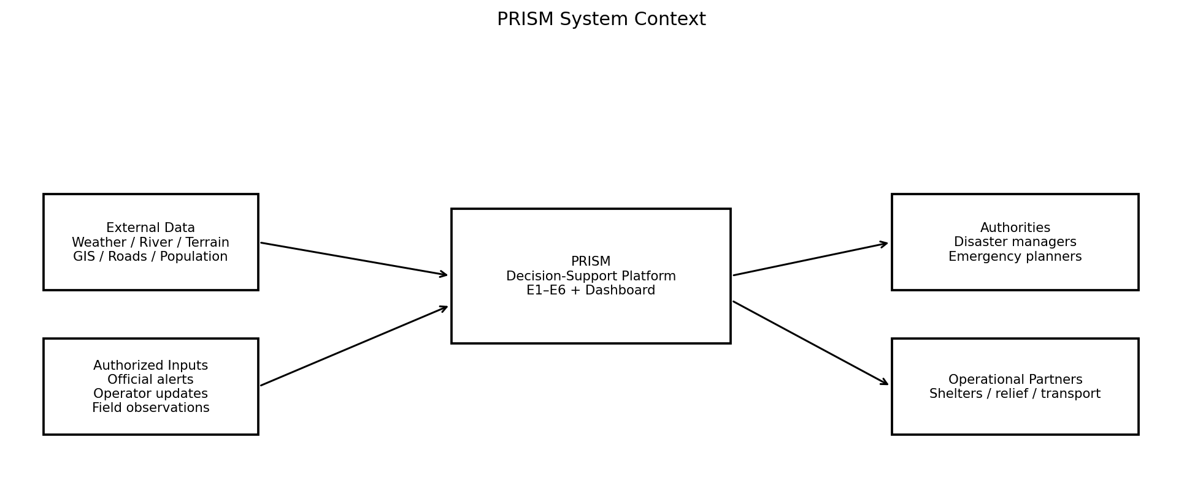
PRISM consumes information and produces explainable decision-support outputs; it does not become the source of operational authority.

3.1 External boundaries
Boundary | PRISM responsibility | Not PRISM responsibility
Official alerts | Ingest, contextualize and propagate authorized alert information. | Replacing the official alerting authority.
Weather/hydrology | Normalize and use observations/forecasts supplied by sources. | Owning national weather or hydrology infrastructure.
Remote sensing | Ingest selected products or derived evidence where useful. | Operating satellite/drone infrastructure.
Road network | Maintain prototype routing representation and operational state. | Guaranteeing field-level road truth without current evidence.
Shelters/destinations | Represent safety, resources and effective capacity supplied/derived from data. | Physically managing shelters.
Emergency operations | Provide decision-support recommendations and explanations. | Autonomous rescue command or evacuation orders.

4. Logical Architecture
The logical architecture has four major software layers: presentation, application/API, domain engines, and shared data/integration infrastructure. E6 is a platform backbone, not a hidden decision engine.
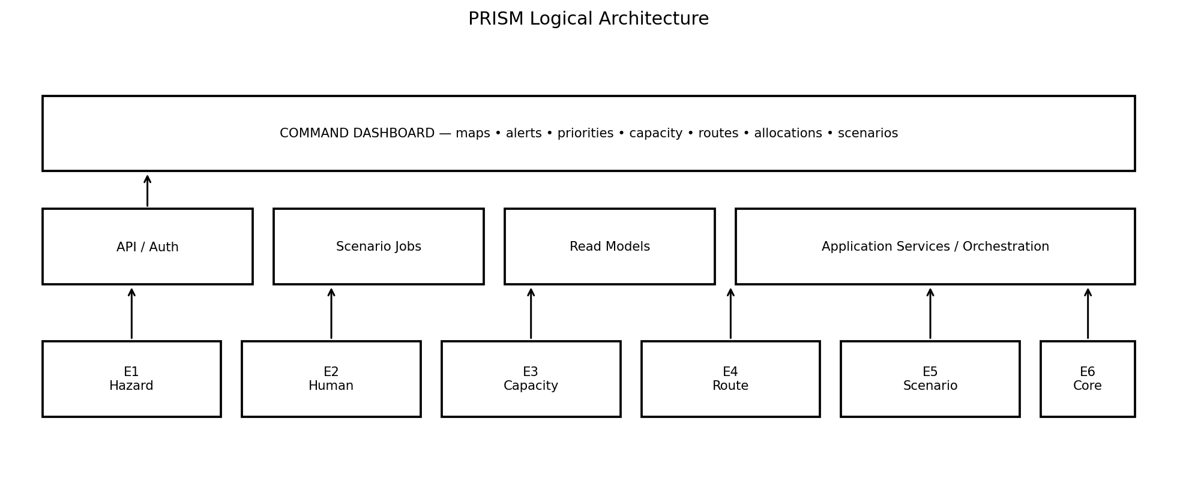
Logical layers; the final physical deployment may collapse several boxes into the same application process for the prototype.

4.1 Major modules
Module | Owns | Primary technology posture
Web application | Dashboard views, maps, filters, forms, scenario controls, authority review. | React / Next.js + map library; exact map library configurable.
API layer | Authentication, validation, request routing, response contracts. | Python / FastAPI + OpenAPI.
Engine modules | Domain computation for E1–E5. | Python modules with strict service interfaces.
Integration core | Canonical state, contracts, events, snapshots, provenance, job execution. | E6 services + PostgreSQL/PostGIS.
Database | Canonical relational/spatial state and derived read models. | PostgreSQL + PostGIS.
Background execution | Scenario runs and heavier calculations. | Lightweight background jobs/queue; broker not mandatory for prototype.
Asset storage | Large raster/imagery assets. | Filesystem/object storage; optional STAC catalog.

5. Engine Architecture & Boundaries
Engine | Consumes | Produces | Must not own
E1 — Multi-Hazard Intelligence & Prediction | Meteorological, hydrological, terrain, historical, satellite/geospatial inputs; normalized E6 state. | HazardState, HazardPrediction, RedZone, evidence, confidence/quality. | Household vulnerability, relocation priority, shelter capacity, route allocation.
E2 — Habitation/Household Vulnerability + Priority | E1 hazard/exposure context; habitation/household data; assistance information. | ExposureAssessment, VulnerabilityProfile, PriorityAssessment/Record, reason codes. | Hazard forecasting, destination capacity, route optimization.
E3 — Safe Destination + Dynamic Capacity | Hazard context, destinations, resources, population demand, accessibility. | DestinationAssessment, resource states, effective/remaining capacity, bottleneck, suitability/readiness. | Household vulnerability, route selection, final allocation.
E4 — Safe Route + Relocation Optimization | E1 hazard/road context, E2 priority/group needs, E3 destinations/capacity. | RoutePlan, route segments/risk, RelocationAllocation, unmet demand. | Hazard model, vulnerability scoring, destination capacity calculation.
E5 — Predictive Simulation + Adaptation | Baseline snapshot, scenario parameters, dependency graph, engine contracts. | ScenarioRun, affected dependency set, baseline-vs-scenario deltas, replanning triggers/results. | Becoming a second hazard/priority/capacity/routing model.
E6 — Data/GIS + Integration | All accepted external/internal data and engine outputs. | Canonical state, spatial services, contracts, events, snapshots, provenance, orchestration context. | Domain decision logic of E1–E5.

5.1 Engine interface rule
Rule
An engine receives typed canonical inputs and returns typed canonical outputs. Internal implementation can change without changing the semantic contract unless the contract version is explicitly changed.

6. Deployment Architecture
For the SIH prototype, the recommended deployment is a modular monolith with one web/API application, one PostgreSQL/PostGIS database and a lightweight background worker. This keeps the system simple while preserving module boundaries that can later be extracted.
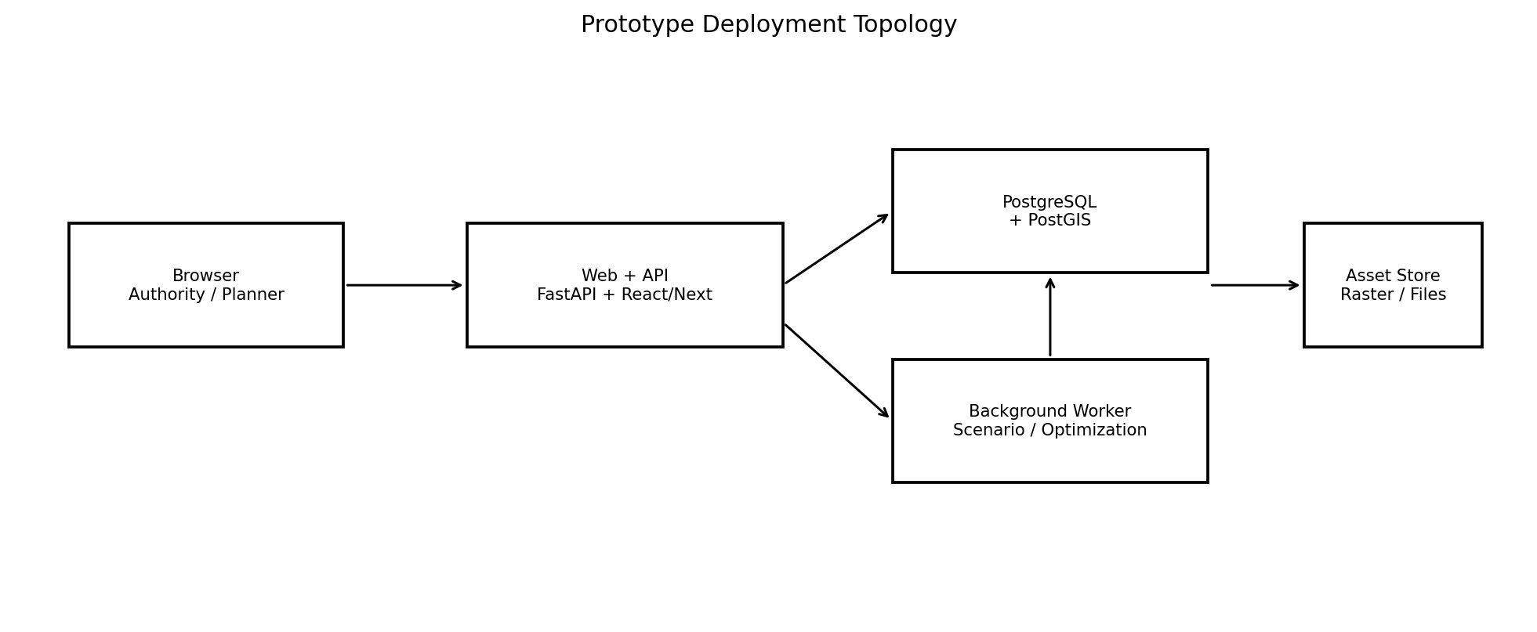
Prototype deployment: keep infrastructure minimal; isolate modules in code before considering distributed services.

6.1 Production evolution path
- Separate background workers when scenario/optimization workloads justify it.
- Introduce a message broker only if event volume, reliability or multi-instance execution requires it.
- Introduce object storage/CDN for larger raster and imagery assets.
- Introduce centralized identity/MFA and stronger policy enforcement for real operational deployments.
- Consider service extraction only after measured scaling or governance requirements justify it.

7. Data Architecture
The unified data model is the semantic source of truth. The physical database should separate relatively stable reference entities from time-varying state and derived assessments.
Domain | Representative tables/modules | Primary relationships
Source/provenance | data_sources, datasets, source_records, provenance_links, audit_events | source → observation/asset → derived output
Hazard | hazards, hazard_observations, hazard_states, hazard_predictions, red_zones, hazard_evidence | hazard → state/prediction/red zone
People/place | habitations, households, vulnerability_profiles, exposure_assessments, priority_assessments | habitation → household → assessment
Destination | destinations, destination_resources, destination_assessments, capacity_states | destination → resources → effective capacity
Network | road_segments, road_states, route_plans, route_segments | network → operational state → route
Relocation | relocation_groups, relocation_allocations, assistance_resources, assistance_assignments | group → destination/route/allocation
Scenario/state | scenarios, scenario_runs, state_snapshots, snapshot_members | scenario → run → snapshot
Recommendation | recommendations, reason_codes, recommendation_reasons | recommendation → reasons + provenance
Integration | engine_runs, events, event_deliveries, schema_versions, contract_versions, jobs | run/event → engine execution/state change

7.1 Physical design rules
- Use stable UUID-like internal identifiers for canonical entities.
- Use foreign keys for semantic relationships where relational integrity is appropriate.
- Use PostGIS geometry columns for canonical spatial entities.
- Use explicit validity intervals for time-varying records.
- Prefer append-only or versioned records for observations, derived assessments and audit events rather than destructive overwrites.
- Use JSON/JSONB only where structure is genuinely variable or source payload preservation is needed; core decision fields remain typed relational columns.
- Index spatial columns with workload-appropriate GiST/SP-GiST strategies and index temporal/status fields used in frequent filters.
- Keep large raster/imagery assets outside core relational tables when practical and store catalog/provenance metadata in the database.

8. GIS Architecture
GIS is part of the computational architecture. PRISM repeatedly needs spatial intersection, proximity, containment, network traversal and spatial-temporal joins.
GIS capability | Prototype implementation
Canonical storage | PostGIS
Python spatial analysis | GeoPandas + Shapely where useful
API interchange | GeoJSON or documented map-ready formats; RFC 7946 semantics for GeoJSON
CRS | Explicit SRID on stored geometry; one study-area projected CRS may be used for prototype metrics, with transformation at API boundaries where needed.
Hazard intersection | PostGIS spatial operations / raster-vector workflows as appropriate
Exposure | Habitation/household geometry intersected with current/predicted hazard state
Destination accessibility | Network/routing calculations plus spatial proximity/service constraints
Road hazard exposure | Route edge geometry intersected with hazard state at relevant planning time
Large raster assets | External file/object storage with database metadata; optional catalog
Spatial quality | Geometry validation, CRS checks, bounds checks and quarantine of invalid features

Spatial safety rule
Never assume two geometries are comparable merely because they have latitude/longitude values. CRS, geometry validity, resolution and spatial tolerance must be explicit.

9. Temporal, State & Snapshot Architecture
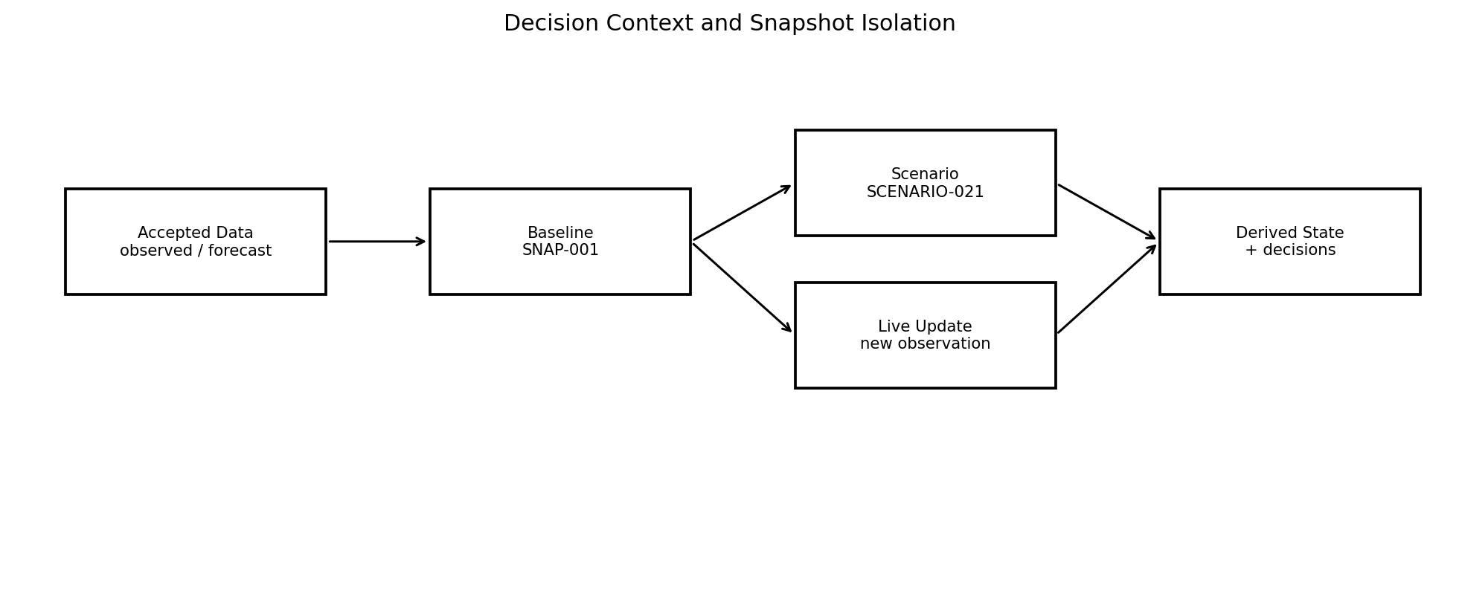
Baseline state remains intact while scenarios and subsequent live updates carry explicit context.

9.1 Required state dimensions
Dimension | Values / meaning
state_type | OBSERVED | FORECAST | DERIVED | SCENARIO | OVERRIDE
operational_status | AVAILABLE | LIMITED | DEGRADED | RESTRICTED | UNAVAILABLE | UNKNOWN | STALE
data quality | Completeness, timeliness, spatial quality, consistency or composite quality state
model confidence | Confidence associated with a derived prediction/assessment; not a data-quality score
scenario state | Baseline or scenario context identified by scenario_id
snapshot | Exact data context identified by snapshot_id
validity | valid_from / valid_to interval describing applicability

9.2 Snapshot creation
- Select the accepted records required for the decision context.
- Validate that required dependencies are available and not silently substituted.
- Record dataset/version references and relevant engine output versions.
- Create immutable snapshot_id and snapshot manifest.
- Run the decision or scenario against that context.
- Attach snapshot_id to major derived outputs.
- Persist run/correlation identifiers for replay and audit.

10. API Architecture
The API layer exposes stable semantic contracts rather than leaking internal database tables. OpenAPI should describe the HTTP surface. Exact request/response schemas are derived from the unified data model and contract version.
Endpoint family | Purpose | Mode
/api/v1/hazards/* | Current state, predictions, Red Zones, evidence | Sync/query
/api/v1/habitations/* | Habitation and exposure views | Sync/query
/api/v1/households/* | Consent-aware household views | Sync/query
/api/v1/priorities/* | Priority records and reason codes | Sync/query
/api/v1/destinations/* | Destination safety/resources/capacity | Sync/query
/api/v1/routes/* | Candidate routes and route status | Sync or job-backed
/api/v1/relocation/* | Allocation and relocation plans | Job-backed for optimization
/api/v1/scenarios/* | Create, validate, run and compare scenarios | Job-backed
/api/v1/snapshots/* | Inspect/replay decision context | Sync/query
/api/v1/dashboard/* | Pre-joined read models for UI | Sync/query
/api/v1/admin/* | Source, contracts, jobs and authorized overrides | Restricted

10.1 API rules
- Version public API contracts explicitly, starting with /v1.
- Validate request schema before domain execution.
- Return structured errors containing code, message, field/context where relevant, correlation_id and remediation guidance where possible.
- Use idempotency keys for mutating requests that can be retried.
- Use asynchronous job endpoints for scenario execution and expensive optimization rather than blocking HTTP requests.
- Do not expose restricted household fields to roles that do not require them.
- Return snapshot_id, scenario_id, freshness and reason context with decision-support responses where applicable.

11. Event & Orchestration Architecture
The prototype may use an in-process dispatcher and database-backed job records. The semantic event model should remain independent of the transport mechanism.
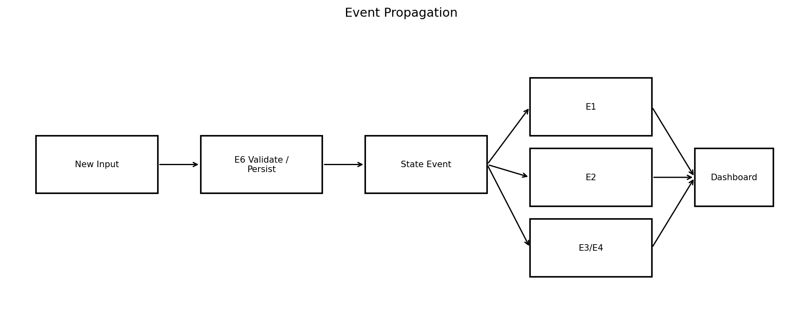
Semantic event flow; actual transport may be in-process for the prototype.
Event | Typical trigger | Downstream effect
HAZARD_STATE_UPDATED | New hazard observation/derived state | Recompute affected exposure/prediction dependencies
PREDICTION_UPDATED | New forecast/prediction | Re-evaluate future exposure and destination/route safety
RED_ZONE_UPDATED | Operational hazard boundary changed | Find affected habitations and road/destination intersections
PRIORITY_UPDATED | Priority factors changed | Re-check relocation demand and allocation
DESTINATION_STATE_UPDATED | Safety/resource/readiness changed | Recalculate capacity and destination feasibility
CAPACITY_UPDATED | Resource bottleneck changed | Re-run affected allocation
NETWORK_STATE_UPDATED | Road/bridge status changed | Invalidate/recalculate affected routes
ROUTE_INVALIDATED | Previously selected route no longer viable | Re-route and potentially reallocate
SCENARIO_RUN_COMPLETED | What-if execution finished | Publish baseline-vs-scenario delta

12. Engine Execution Specifications

12.1 E1 — Multi-Hazard Intelligence & Prediction
- Input through E6-normalized observations, terrain, hydrology, meteorology, historical/geospatial evidence and authorized feeds.
- Produce current hazard state and operational Red Zone using hazard-specific evidence and configured criteria.
- Produce future hazard extent/prediction with horizon, confidence/uncertainty, evidence and freshness.
- Keep hazard intensity, hazard extent, exposure and vulnerability distinct.
- Use hazard-specific methods; multi-hazard fusion occurs through controlled interfaces rather than blindly adding hazard scores.
- Support dynamic updates and retain the input snapshot used for each derived result.
- Prototype emphasis: demonstrate a complete flood scenario and optionally a second hazard if data supports it.

12.2 E2 — Habitation, Household Vulnerability & Priority
- Consume E1 current/predicted hazard state and habitation/household information.
- Compute exposure separately from vulnerability.
- Build vulnerability profiles from available demographic/functional/assistance/mobility information.
- Treat household registration as optional; absence of registration must not imply absence of vulnerability.
- Produce explainable priority with contributing factors/reason codes.
- Support Immediate / Short-Term / Medium-Term classes while keeping scoring/weights configurable.
- Preserve uncertainty and data-quality limitations through the result.

12.3 E3 — Safe Destination & Dynamic Capacity
- Apply hard safety constraints before soft suitability ranking.
- Represent destination resource capacities separately.
- Compute effective capacity from relevant resource bottlenecks rather than assuming physical shelter beds are sufficient.
- Track operational states including UNKNOWN/STALE.
- Expose occupied, remaining, bottleneck and resource breakdown.
- Recalculate when safety, resource availability, demand or infrastructure changes.
- Support destination suitability using configurable safety, capacity, accessibility, service and travel-time factors.

12.4 E4 — Safe Route & Relocation Optimization
- Represent the road/path network as a graph over a relatively stable base network plus dynamic operational state.
- Apply hard exclusions for CLOSED or otherwise unacceptable routes before optimization.
- Consider time-dependent hazard exposure at estimated arrival time.
- Respect mobility/accessibility and assistance requirements.
- Allocate groups to destinations under effective-capacity and safety constraints.
- Do not split households arbitrarily; support explicit UNASSIGNED / NO_VIABLE_ALLOCATION.
- Use rolling-horizon replanning when hazard, road or destination state changes.

12.5 E5 — Predictive Simulation & Adaptation
- Load a baseline snapshot.
- Apply scenario parameters without mutating baseline.
- Determine affected dependency closure.
- Recompute only affected components where safe.
- Compare baseline and scenario outputs using interpretable deltas.
- Preserve assumptions, source/forecast/scenario distinction, confidence/uncertainty and provenance.
- Do not silently promote scenario outputs into operational state.

12.6 E6 — Data/GIS + System Integration
- Own ingestion, normalization, validation, canonical persistence, provenance, contracts, events, snapshots and execution context.
- Provide shared spatial and temporal semantics.
- Maintain source registry and data quality/freshness state.
- Expose read models and integration APIs.
- Record engine runs, correlation IDs and event processing.
- Never replace E1–E5 domain logic with generic orchestration heuristics.

13. Dashboard / UX Architecture
The dashboard is an authority-facing decision-support surface. It should answer the PRISM chain in operational order rather than presenting disconnected analytics.
View | Primary question | Key data
Situation Map | Where is the hazard now and where may it go? | Current/predicted Red Zones, intensity, evidence, timestamps
Vulnerable Population | Who is affected and why? | Habitations, households/groups, exposure, vulnerability, priority, reason codes
Destinations | Where can people safely go? | Safety, effective capacity, bottleneck, readiness, services, freshness
Relocation Plan | Who goes where? | Allocation, destination, group size, unmet demand
Routes | How do they get there safely? | Primary/alternative routes, ETA, risk, hazard intersections, status
Scenario Lab | What changes if conditions change? | Scenario parameters, baseline-vs-scenario delta, invalidations, reallocation
Data Health | Can I trust the current picture? | Source freshness, stale/unknown data, conflicts, coverage gaps
Review / Override | What did the system recommend and what changed? | Recommendation, reasons, model output, authorized override, audit trail

13.1 UI safety rules
- Show timestamps and freshness beside time-sensitive operational information.
- Show uncertainty/data-quality warnings instead of hiding them.
- Never visually imply that a model recommendation is an automatic command.
- Show reason codes for priority and recommendation changes.
- Show baseline and scenario states separately.
- Show NO_VIABLE_ALLOCATION / UNASSIGNED explicitly.
- Allow authorized human override with reason and attribution.

14. Security, Privacy & Human Oversight
Area | Prototype baseline | Production extension
Authentication | Controlled accounts / role-based login | Central identity, MFA/federation where required
Authorization | RBAC: authority/planner/viewer/admin | Fine-grained policy/dataset controls
Household data | Data minimization, consent, approximate location where sufficient | Retention, deletion, purpose limitation, stronger PII separation
API | HTTPS, validation, authorization | Rate limits, gateway/WAF, secrets management
Database | Restricted views/tables and role permissions | Row-level security, encryption and formal threat model
Audit | Operator changes and significant system events | Immutable audit storage and formal retention policy
Exports | Authorized, minimized exports | Formal sharing/licensing controls
Overrides | Attributable, reasoned, reversible where possible | Governance workflow and stronger audit controls

Human-in-the-loop rule
PRISM recommendations must remain reviewable. An authorized human may override a recommendation, but the system should preserve the model result, override actor, time and reason rather than silently replacing history.

15. Failure & Degraded Modes
Failure | Required behavior | Dashboard implication
Source unavailable | Retain last known state with freshness/status metadata or mark unavailable per policy. | Show STALE/UNKNOWN warning.
Conflicting sources | Retain provenance; apply only defined precedence policy; surface conflict. | Show conflict indicator.
Invalid geometry | Quarantine input; do not silently use it. | Affected layer marked incomplete.
Engine output missing | Mark dependency unavailable and block/degrade downstream result according to configured policy. | Explain blocked dependency.
Closed destination | Hard exclude from allocation. | Destination unavailable.
Unknown road state | Do not silently treat as safe; apply configured uncertainty policy. | Route warning or exclusion.
No feasible allocation | Return explicit UNASSIGNED / NO_VIABLE_ALLOCATION. | Show unmet demand.
Scenario failure | Keep baseline unchanged; scenario run FAILED with provenance/error. | Scenario failure visible.
Duplicate event | Idempotency prevents duplicate effect. | No duplicate decision.
Operator override conflict | Preserve model and override as separate records. | Show override attribution.

16. Observability & Audit Architecture
Layer | Examples | Primary identifiers
Technical health | API latency, failed jobs, database errors, queue backlog | request_id, job_id
Data health | Freshness, validation failures, coverage gaps, source conflicts | source_id, dataset_id
Engine health | Run duration, status, input/output counts | engine_run_id
Decision health | Blocked dependencies, route invalidations, reduced capacity, unmet demand | recommendation_id, allocation_id
Scenario health | Scenario status, recomputation set, delta size | scenario_id, scenario_run_id
Audit | Operator change, override, approval/review | audit_event_id, actor_id
Traceability | End-to-end request/event chain | correlation_id

Every significant engine execution should produce a run record containing engine name/version, input snapshot, output references, status, timing, errors/warnings and correlation context.

17. Testing & Validation Architecture
Test layer | Examples
Unit | Scoring components, capacity bottleneck calculation, route edge-cost calculation, reason-code generation.
Schema/contract | Required fields, enum values, version compatibility, payload validation.
Spatial | CRS transformations, geometry validity, hazard intersection, proximity and network topology.
Temporal | Valid-time selection, stale-data handling, out-of-order inputs.
Snapshot | Reproduce a prior decision from its snapshot manifest.
Engine integration | E1→E2→E3→E4 chain with consistent snapshot/scenario context.
Eventing | Duplicate/retry behavior, ordering where required, failed consumer handling.
Scenario | Baseline unchanged; only affected dependencies recompute; deltas correct.
Optimization | Capacity conservation, assignment constraints, infeasibility handling.
Security | Role matrix, restricted household access, override authorization.
Performance | Measured demo dataset response/job time; no invented performance claims.
Human review | Authority can understand reasons, uncertainty, data freshness and overrides.

17.1 Core acceptance scenario
- Load a synthetic study area containing hazard inputs, habitations, households/groups, destinations/resources and road network.
- Create a baseline snapshot.
- Run E1 and verify current/predicted hazard and Red Zone outputs.
- Run E2 and verify exposure/priority results reference the same decision context.
- Run E3 and verify destination effective capacity and bottleneck.
- Run E4 and verify route and allocation outputs.
- Introduce a rainfall increase, bridge closure and destination water-capacity reduction.
- Run E5 scenario.
- Verify affected E1→E2→E3→E4 components recompute and baseline remains unchanged.
- Verify invalidated route, changed allocation and unmet demand are visible with reasons.

18. Prototype Scope & Demo Architecture
The SIH prototype should prove one strong end-to-end flood-driven relocation workflow rather than attempting nationwide operational capability.
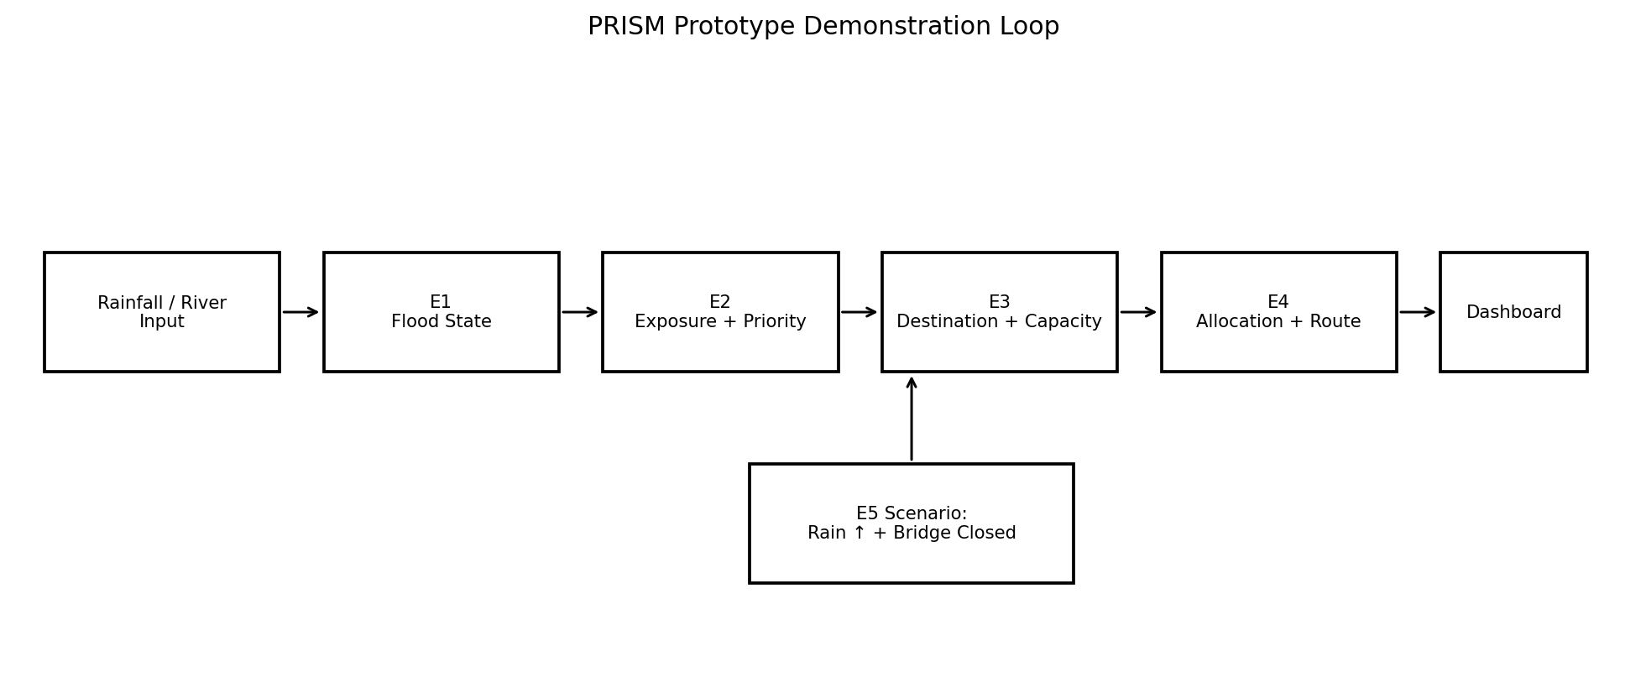
The demo should visibly show a decision-changing scenario, not merely a static map.

18.1 Prototype inclusion
- One synthetic/public study area with realistic spatial relationships.
- Flood hazard current/predicted state and Red Zone.
- Habitation and household/group vulnerability representation.
- Explainable priority classes.
- Three or more candidate destinations with resource-level capacity and at least one bottleneck change.
- Road graph with at least one bridge/road segment whose status can change.
- Capacity-constrained allocation and safe route selection.
- Scenario execution showing reallocation after a compound change.
- Dashboard showing map + priority + capacity + route + scenario delta.
- Data quality/freshness indicators and human-reviewable reasons.

18.2 Prototype exclusions
- National-scale operational forecasting.
- Autonomous evacuation commands.
- Full traffic simulation.
- Full hydrodynamic flood simulation unless data/time explicitly supports it.
- High-fidelity agent-based human behavior simulation.
- Distributed microservice infrastructure without a demonstrated need.
- Guaranteed real-time government integration.
- Claims of real-world accuracy without validation.

19. Recommended Repository & Code Organization
prism/
├── apps/
│ ├── api/ # FastAPI entrypoint and API routers
│ └── web/ # React/Next.js dashboard
├── backend/
│ ├── core/ # config, auth, errors, logging
│ ├── integration/ # E6: contracts, snapshots, events, provenance
│ ├── gis/ # spatial utilities and map services
│ ├── engines/
│ │ ├── e1_hazard/
│ │ ├── e2_people/
│ │ ├── e3_destination/
│ │ ├── e4_relocation/
│ │ └── e5_scenario/
│ ├── models/ # canonical domain models
│ ├── repositories/ # database access
│ ├── jobs/ # async/background execution
│ └── services/ # application-level orchestration
├── db/
│ ├── migrations/
│ ├── seeds/
│ └── fixtures/
├── data/
│ ├── synthetic/
│ └── external_metadata/
├── tests/
│ ├── unit/
│ ├── contract/
│ ├── spatial/
│ ├── integration/
│ ├── scenario/
│ └── security/
├── docs/
│ ├── architecture/
│ └── api/
└── scripts/ # ingestion, seed, validation and demo runners
This structure is a recommended prototype organization, not a mandatory production repository layout. The critical requirement is that E1–E6 remain separable in code and testable through contracts.

20. Build Sequence
Phase | Build | Exit condition
Foundation | Freeze canonical enums, identifiers, metadata envelope and error model. | No domain engine code yet.
Database | Create PostgreSQL/PostGIS schema, migrations, seed fixtures and spatial indexes. | Validate spatial/temporal constraints.
E6 ingestion | Implement source registry, normalization, validation, provenance and snapshot creation. | Prove no raw source bypasses canonical model.
E1 | Implement prototype hazard/current Red Zone + prediction path. | Flood-first; keep model configurable.
E2 | Implement exposure, vulnerability and explainable priority. | Test registered and unregistered households.
E3 | Implement destination safety, resource capacities and effective capacity. | Test bottleneck changes.
E4 | Implement route graph, safety filtering, allocation and unmet demand. | Test closure/reallocation.
E5 | Implement scenario state, dependency closure and baseline-vs-scenario comparison. | Test compound scenario.
Dashboard | Build command views/read models. | Every recommendation exposes context/reasons.
Validation | Run contract, spatial, scenario, failure and security tests. | Do not claim real-world validation.
Demo hardening | Seed deterministic scenario and scripted transitions. | Ensure reproducible presentation.

21. Architecture Decisions, Configurable Choices & Open Questions
This section prevents provisional research choices from accidentally becoming hidden requirements.
Decision | Status | Current position
Overall architecture | FROZEN FOR PROTOTYPE | Modular monolith with strong engine boundaries.
Backend | FROZEN FOR PROTOTYPE | Python + FastAPI.
Database | FROZEN FOR PROTOTYPE | PostgreSQL + PostGIS.
Frontend | FROZEN FOR PROTOTYPE | React / Next.js family; exact app structure can be refined.
Event transport | CONFIGURABLE | In-process dispatcher for prototype; broker only if justified.
Routing engine | CONFIGURABLE | OSM-derived network + routing component; exact library selected during implementation validation.
Optimization solver | CONFIGURABLE | Constraint-based Python OR tooling; exact solver based on prototype needs.
Hazard prediction method | CONFIGURABLE | Data- and validation-dependent; do not hard-code a model without evidence.
Priority scoring weights | CONFIGURABLE | Transparent and research-backed; calibrate/validate.
Destination suitability weights | CONFIGURABLE | Hard safety constraints first; soft weights configurable.
Capacity conversion models | OPEN | Resource-specific people-supported capacity needs domain assumptions/data.
Snapshot manifest minimum | OPEN | Must be finalized before reproducibility testing.
Freshness policy | OPEN | Must be defined per dataset/use case.
Conflicting-source precedence | OPEN | Must be explicit; source authority and data quality should remain separate.
Spatial affected-area tolerance | OPEN | Validate using study-area geometry/data resolution.
Offline operation | OPEN / FUTURE | Prototype may assume connectivity unless demo requires degraded mode.
Production identity/MFA | FUTURE | Not necessary for basic SIH prototype but required for operational deployment.
STAC | OPTIONAL | Useful for remote-sensing cataloging; not mandatory for core prototype.

22. Architecture Acceptance Criteria
- A developer can identify the owner of every canonical entity and decision.
- E1–E5 can be implemented as independent modules with explicit input/output contracts.
- E6 can store and reproduce the state context of a major recommendation.
- No major result can silently mix incompatible snapshots or scenario contexts.
- Spatial entities have explicit geometry semantics and CRS/SRID handling.
- UNKNOWN and STALE states are represented and cannot silently become safe/available.
- Scenario runs cannot overwrite baseline state.
- The system can represent infeasible outcomes without forcing an unsafe allocation.
- Priority and recommendation outputs contain interpretable reason codes.
- Household data access is role-controlled and privacy-minimized.
- A compound synthetic scenario can propagate through E1→E2→E3→E4 and return a visible delta.
- All major engine runs are traceable through run/correlation IDs and provenance.
- The prototype can be built without introducing unnecessary distributed infrastructure.

23. Handoff to the Master AI Build Specification
This architecture document is the next input to the final Master AI Build Specification. The master specification should not merely repeat this document; it should convert it into an executable construction brief.

23.1 Information now available to the final build prompt
- Problem and PRISM system purpose.
- Six-engine domain boundaries and responsibilities.
- Unified canonical entities and relationships.
- Cross-engine data contracts.
- Temporal, spatial, quality, confidence and scenario semantics.
- Database and GIS architecture.
- API and event architecture.
- Deployment posture.
- Security/privacy and human-in-loop requirements.
- Failure and infeasibility behavior.
- Testing/validation architecture.
- Prototype scope and deterministic demo scenario.
- Recommended repository structure and build sequence.
- Explicitly frozen, configurable and unresolved decisions.

23.2 What the next document must add
- Exact implementation specifications for the chosen prototype algorithms.
- Concrete database schema/DDL-level design.
- Exact API request/response schemas and error contracts.
- Exact routing/optimization library selection after validation.
- Frontend screen-by-screen specifications and component behavior.
- Seed dataset specification and synthetic data generation rules.
- Scenario script and expected outputs.
- Environment/configuration files and run commands.
- Definition of done for every module.
- AI-agent instructions for coding, testing and iterative verification.

23.3 Final architectural chain
PRISM system chain
HAZARD → HUMAN → PRIORITY → CAPACITY → RELOCATION → ACTION
E1 identifies and predicts hazard conditions.
E2 determines exposure, vulnerability and relocation priority.
E3 determines safe destinations and effective carrying capacity.
E4 determines allocation and safest viable routes.
E5 asks what changes and triggers adaptive recalculation.
E6 makes the entire chain spatially coherent, temporally consistent, traceable and reproducible.

Appendix A — Source Basis
This architecture specification is derived primarily from the PRISM internal R&D packages and the Unified Data Model & Cross-Engine Interface Specification. It intentionally preserves unresolved choices rather than silently replacing them with external assumptions.
Source | Role in this specification
PRISM — Engine 1: Multi-Hazard Intelligence & Prediction | Hazard/prediction boundary, uncertainty, Red Zone and dynamic update requirements.
PRISM — Engine 2: Habitation & Household Vulnerability + Priority | Exposure/vulnerability separation, priority explainability, registration/privacy and assistance.
PRISM — Engine 3: Safe Destination & Dynamic Capacity | Hard safety constraints, bottleneck/effective capacity, destination suitability and dynamic state.
PRISM — Engine 4: Safe Route Intelligence & Relocation Optimization | Graph model, route states, time-dependent risk, allocation, infeasibility and replanning.
PRISM — Engine 5: Predictive Simulation & Adaptation | Scenario isolation, dependency closure, baseline-vs-scenario deltas and adaptive recalculation.
PRISM — Engine 6: Data/GIS + System Integration | Canonical integration backbone, temporal/state semantics, provenance, snapshots, APIs and prototype stack.
PRISM — Cross-Engine Synthesis v1.0 | System chain, shared entities and cross-engine responsibility relationships.
PRISM — Unified Data Model & Cross-Engine Interface Specification v1.0 | Canonical entities, interface contracts, metadata, events and snapshot semantics used as the immediate architecture baseline.
SIH PS 26191 / MHA | Problem framing and prototype context.

Appendix B — Document Status
Status
READY FOR TECHNICAL SPECIFICATION / MASTER BUILD PROMPT PREPARATION, subject to the explicit open decisions in Section 21. This document should be treated as the architecture baseline, not as a claim that PRISM has been validated for real-world emergency operations.

