**SQL Project – Workbook**

# Initial understanding of data

* In Data set we have 7 columns and 73 rows
* We have nine unique restaurants
* Over 82.5% orders were made by promocode
* There is approx. equal distribution of orders when it comes to cuisine type.
* Out 73 orders 72 were delivered 1 was cancelled

Query Used –

# Answering the Questions

## Find top 3 outlets by cuisine type without limit and top function

## Find the daily new customer count from launch date (Every day how many customers we are acquiring?)

Count all users who were acquired in Jan 2025 and only placed one order in Jan and did not place any other order

## List all the customer with no orders in last seven days but where acquired one month ago with their order on promo

## Growth team is planning to create a trigger that will target customers after their every third order with personalized communication and they have asked you to create query for this

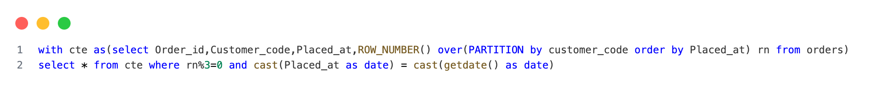

## list all customer who made more than one order all orders on promo only

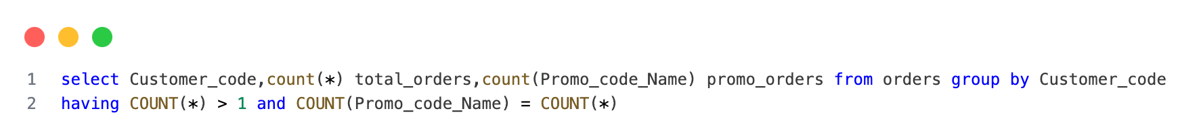

## What percentage of customer where organically required in Jan 2025. (Placed their first order without any promo code)

