Creating Repo
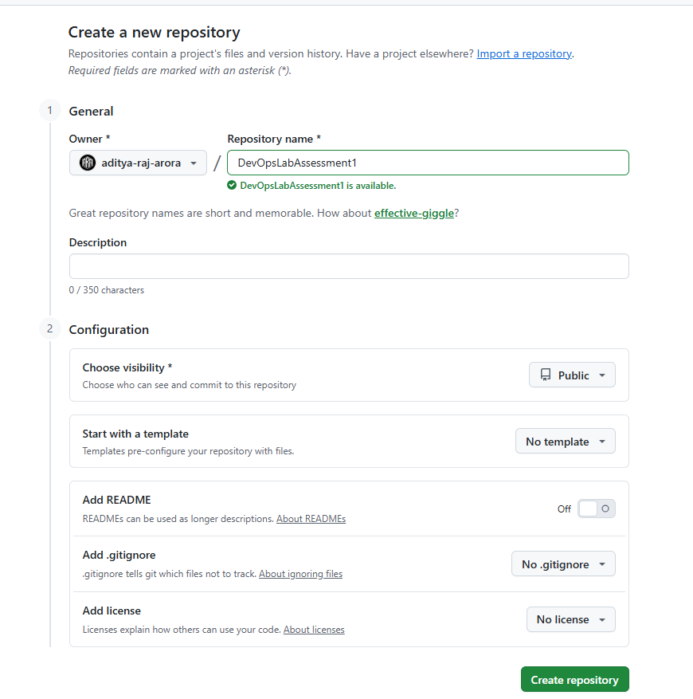

Program 1

Code
class Order():
def __init__(self, name, item, quan, price):
self.name=name
self.item=item
self.quan=quan
self.price=price
self.cost=quan*price
def printBill(self):
print("="*59)
print(f"{'Order for '+self.name:^59}")
print("-"*59)
print(f"{'Item Name':<20} | {'Quantity':<10} | {'Price':<10} | {'Cost':<10}")
print("-"*59)
print(f"{self.item:<20} | {self.quan:<10} | {self.price:<10} | {self.cost:<10}")
print("="*59)
def main():
inputs=[
["John Doe", "Breaad", 15, 30],
["Jane Doe", "Maggi", 5, 80]
]
m=0
d={}
t=0
l=[]
for inp in inputs:
o=Order(inp[0],inp[1], inp[2], inp[3])
o.printBill()
if m<o.cost:
m=o.cost
M=o
if o.item not in d:
d[o.item]=1
else:
d[o.item]+=1
t+=o.cost
l.append((o.cost,o))
l.sort()
print("\nTotal Cost:", t)
print("\nMost Expensive Order:")
M.printBill()
print("\nSorted Orders:")
for i in l:
i[1].printBill()

if __name__=="__main__":
main()

Output
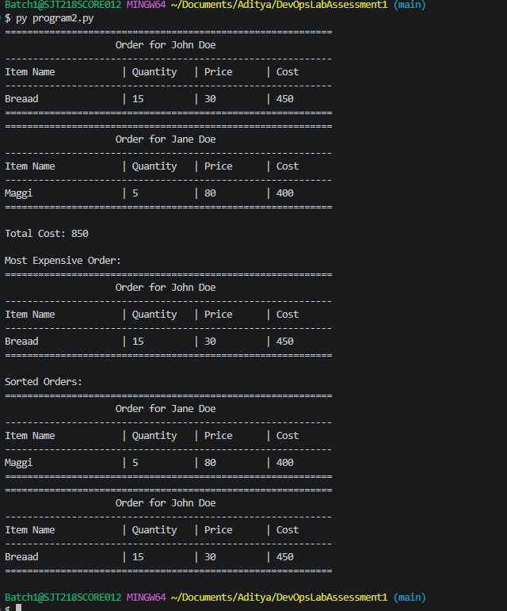

Git
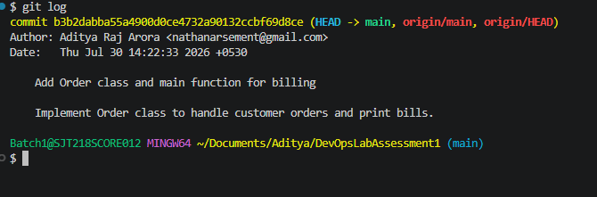
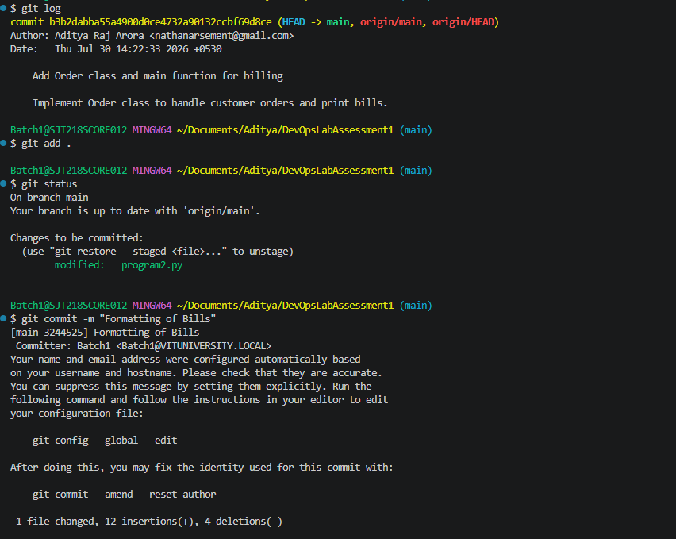

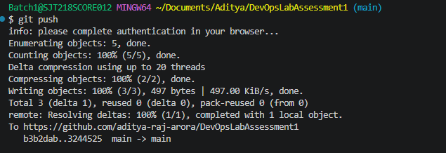
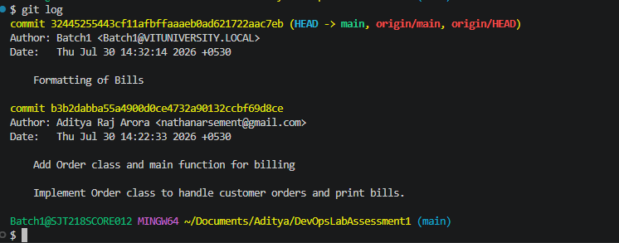
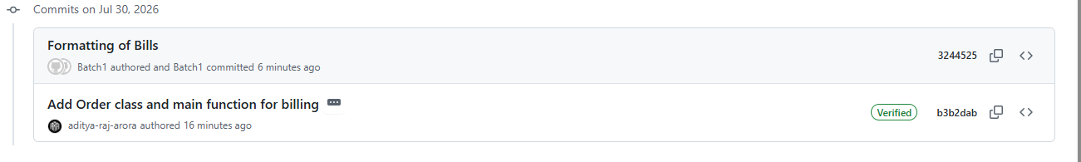

Jenkins Configuration
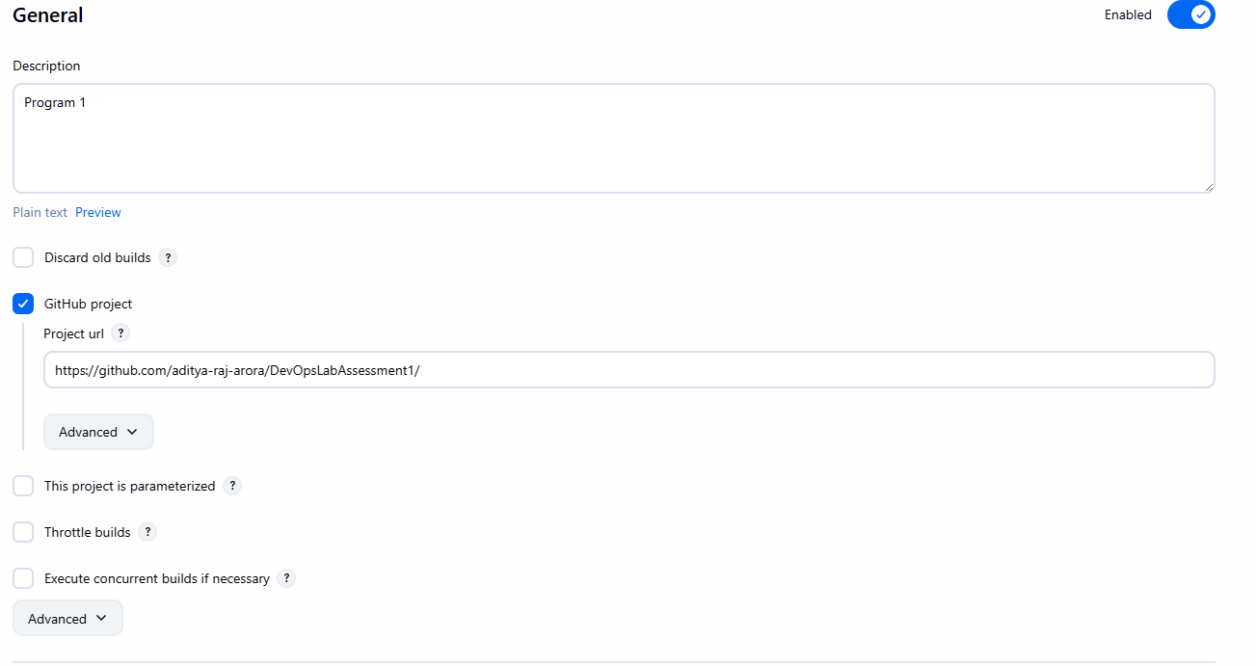
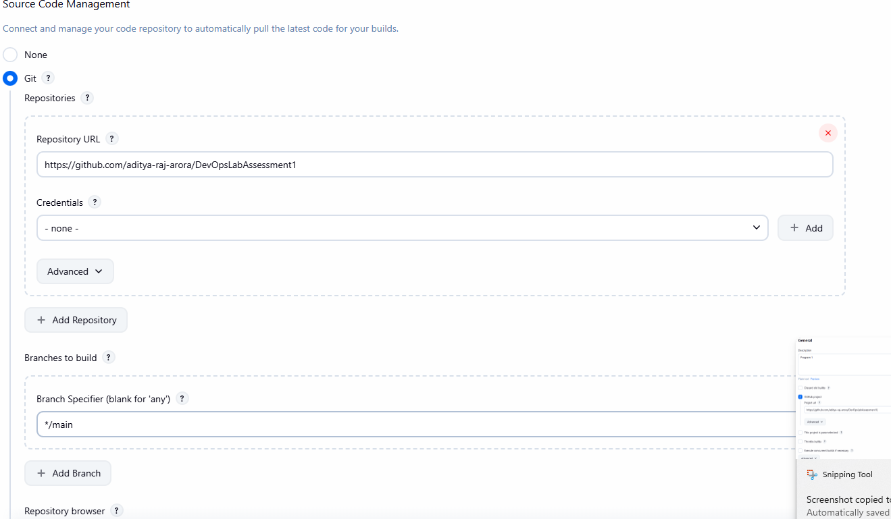

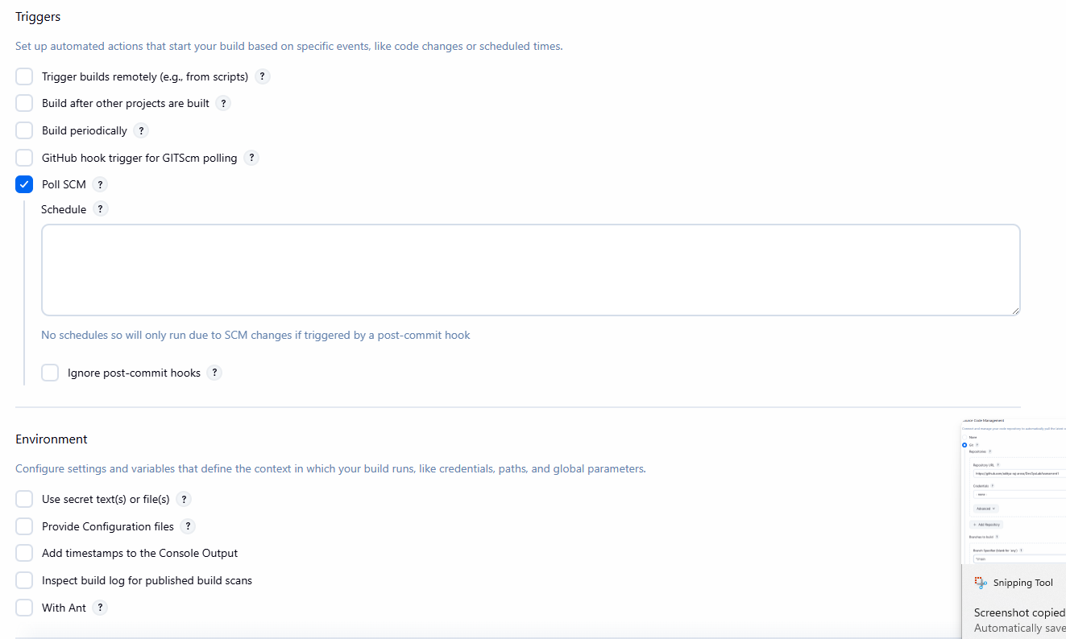
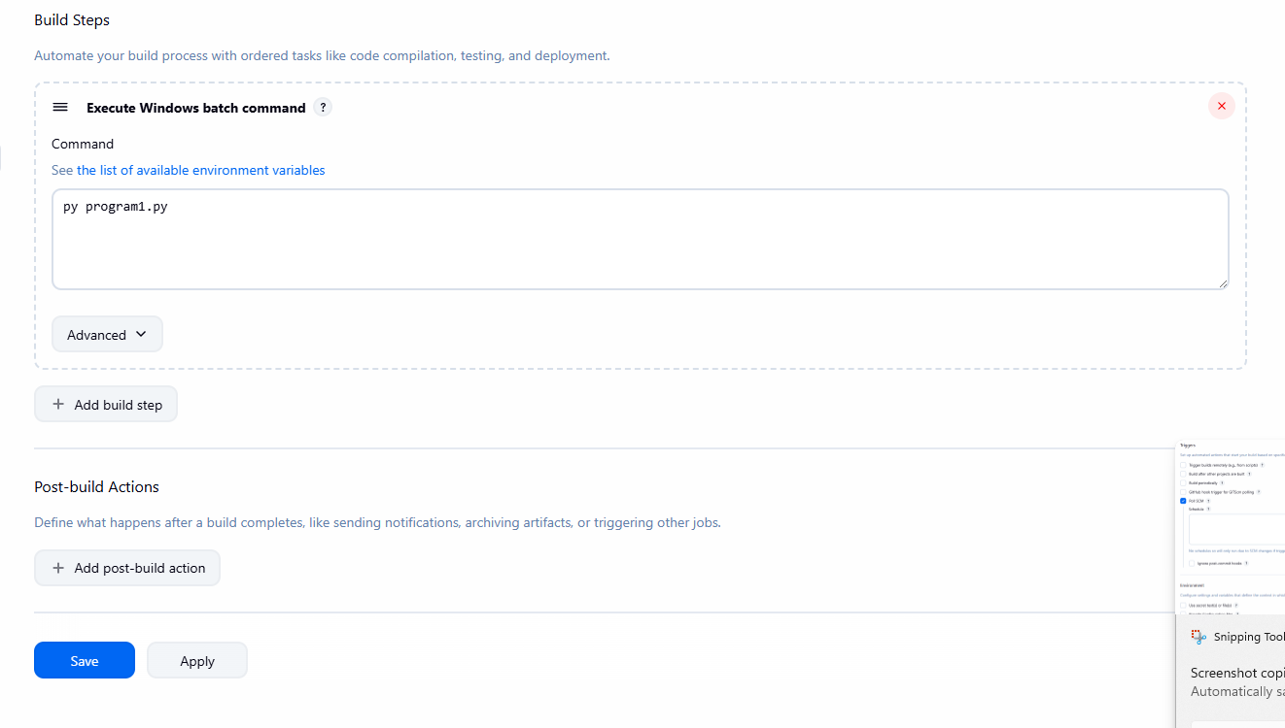

Jenkins Output
Started by user admin
Running as SYSTEM
Building in workspace C:\ProgramData\Jenkins\.jenkins\workspace\aditya-prog-1
The recommended git tool is: NONE
No credentials specified
> git.exe rev-parse --resolve-git-dir C:\ProgramData\Jenkins\.jenkins\workspace\aditya-prog-1\.git # timeout=10
Fetching changes from the remote Git repository
> git.exe config remote.origin.url https://github.com/aditya-raj-arora/DevOpsLabAssessment1 # timeout=10
Fetching upstream changes from https://github.com/aditya-raj-arora/DevOpsLabAssessment1
> git.exe --version # timeout=10
> git --version # 'git version 2.52.0.windows.1'
> git.exe fetch --tags --force --progress -- https://github.com/aditya-raj-arora/DevOpsLabAssessment1 +refs/heads/*:refs/remotes/origin/* # timeout=10
> git.exe rev-parse "refs/remotes/origin/main^{commit}" # timeout=10
Checking out Revision e2f5b470e1a4d998b9178f8715dc1c030939227f (refs/remotes/origin/main)
> git.exe config core.sparsecheckout # timeout=10
> git.exe checkout -f e2f5b470e1a4d998b9178f8715dc1c030939227f # timeout=10
Commit message: "Outage Record"
> git.exe rev-list --no-walk e2f5b470e1a4d998b9178f8715dc1c030939227f # timeout=10
[aditya-prog-1] $ cmd /c call C:\WINDOWS\TEMP\jenkins14286746045621012390.bat

C:\ProgramData\Jenkins\.jenkins\workspace\aditya-prog-1>py program1.py
===========================================================
Order for John Doe
-----------------------------------------------------------
Item Name | Quantity | Price | Cost
-----------------------------------------------------------
Breaad | 15 | 30 | 450
===========================================================
===========================================================
Order for Jane Doe
-----------------------------------------------------------
Item Name | Quantity | Price | Cost
-----------------------------------------------------------
Maggi | 5 | 80 | 400
===========================================================

Total Cost: 850

Most Expensive Order:
===========================================================
Order for John Doe
-----------------------------------------------------------
Item Name | Quantity | Price | Cost
-----------------------------------------------------------
Breaad | 15 | 30 | 450
===========================================================

Sorted Orders:
===========================================================
Order for Jane Doe
-----------------------------------------------------------
Item Name | Quantity | Price | Cost
-----------------------------------------------------------
Maggi | 5 | 80 | 400
===========================================================
===========================================================
Order for John Doe
-----------------------------------------------------------
Item Name | Quantity | Price | Cost
-----------------------------------------------------------
Breaad | 15 | 30 | 450
===========================================================

C:\ProgramData\Jenkins\.jenkins\workspace\aditya-prog-1>exit 0
Finished: SUCCESS

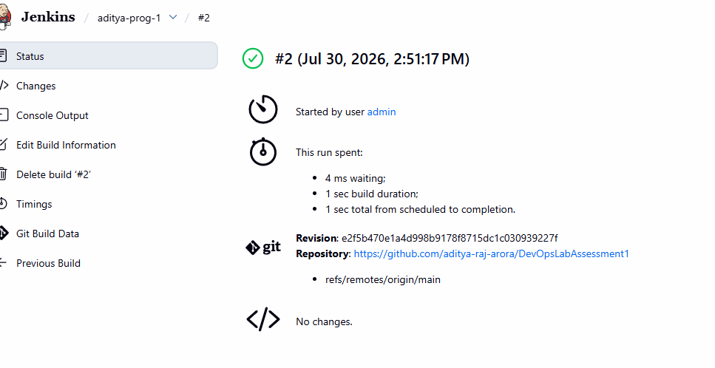

Program 2

Code
class Record():
def __init__(self, region, hours, affect):
self.region=region
self.hours=hours
self.affect=affect
def printBill(self):
print("="*43)
print(f"{'Outage Records for '+self.region:^43}")
print("-"*43)
print(f"{'Hours':<20} | {'Affected People':<20}")
print("-"*43)
print(f"{self.hours:<20} | {self.affect:<20}")
print("="*43)
def main():
inputs=[
["Region A", 5, 6000],
["Region B", 3, 4000],
]
t=0
d=0
l=[]
L=[]
records = [Record(inp[0], inp[1], inp[2]) for inp in inputs]
for record in records:
if t<record.hours:
t=record.hours
T=record
d+=record.hours
if record.affect>5000:
l.append(record)
L.append((record.hours,record))
# record.printBill()
print("\nRegion with Longest Outage:")
T.printBill()
print(f"\nTotal Hours of Outage: {d}")
print("\nRegions with More than 5000 Affected People:")
for record in l:
record.printBill()
print("\nAverage Hours of Outage:", d/len(records) if records else 0)
print("\nSorted Records by Hours of Outage:")
L.sort()
for i in L:
i[1].printBill()

if __name__=="__main__":
main()

Output
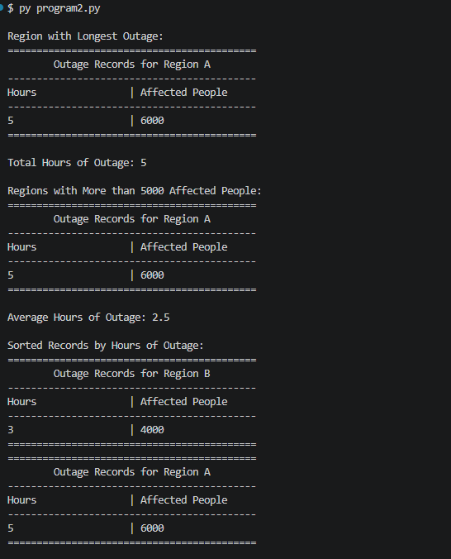

Git
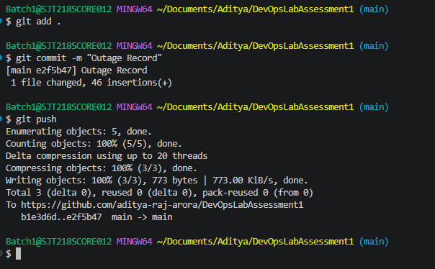

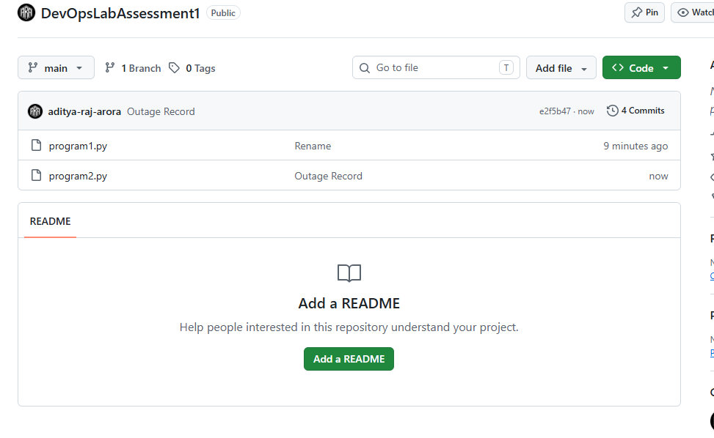

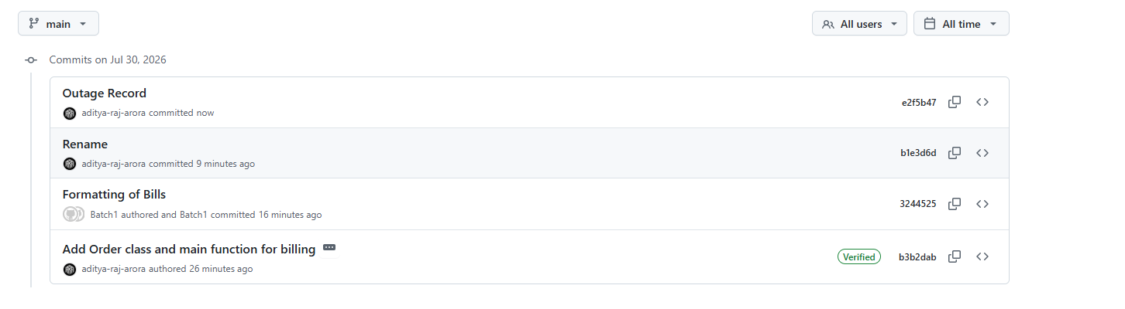

Jenkins Configuration
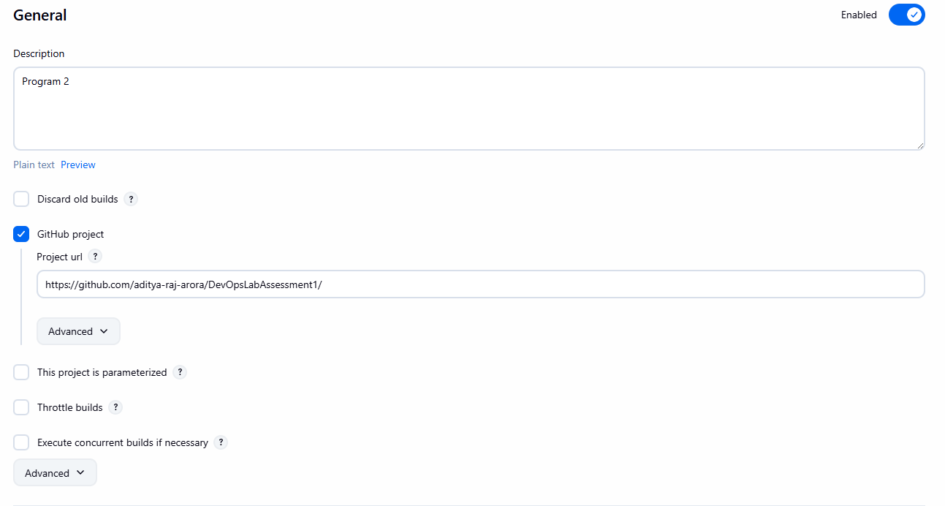

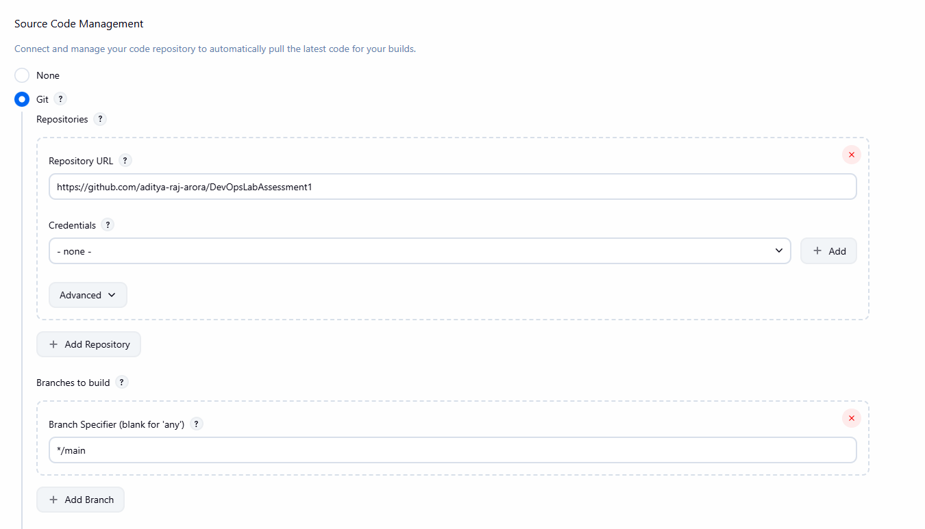
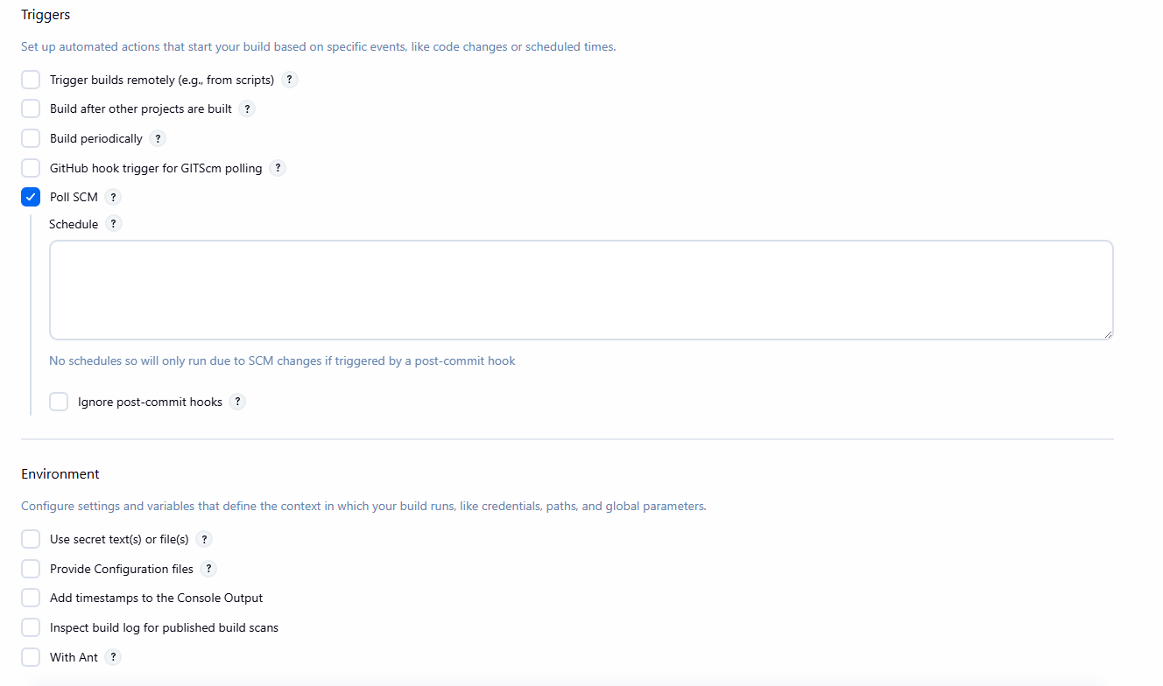
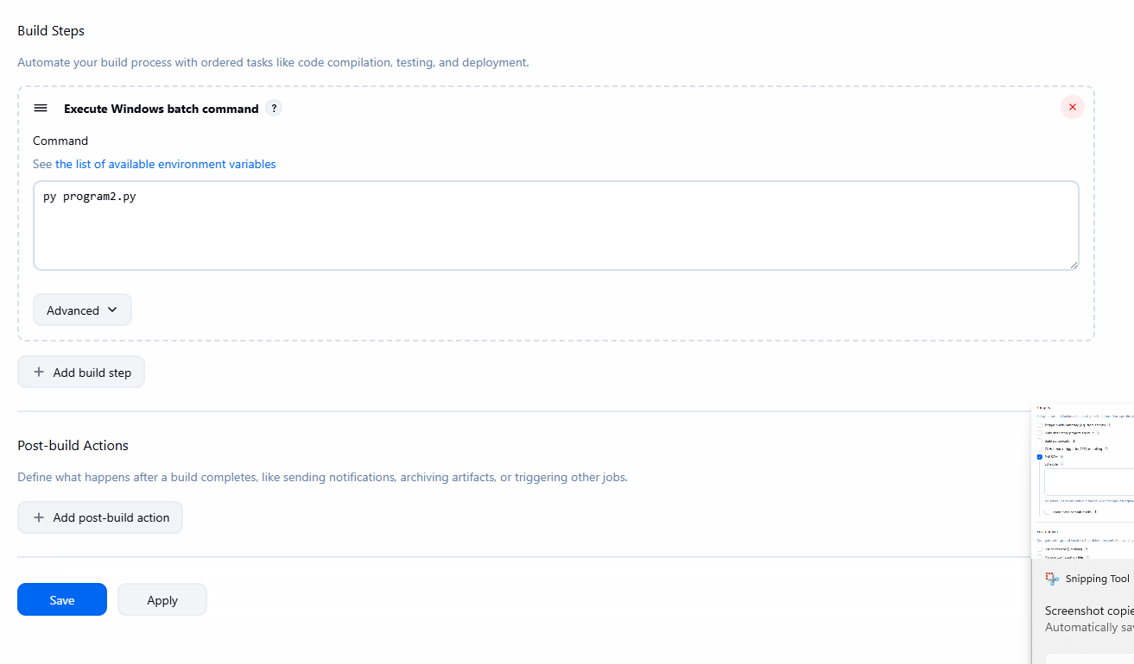

Jenkins Log
Started by user admin
Running as SYSTEM
Building in workspace C:\ProgramData\Jenkins\.jenkins\workspace\aditya-prog-2
The recommended git tool is: NONE
No credentials specified
Cloning the remote Git repository
Cloning repository https://github.com/aditya-raj-arora/DevOpsLabAssessment1
> git.exe init C:\ProgramData\Jenkins\.jenkins\workspace\aditya-prog-2 # timeout=10
Fetching upstream changes from https://github.com/aditya-raj-arora/DevOpsLabAssessment1
> git.exe --version # timeout=10
> git --version # 'git version 2.52.0.windows.1'
> git.exe fetch --tags --force --progress -- https://github.com/aditya-raj-arora/DevOpsLabAssessment1 +refs/heads/*:refs/remotes/origin/* # timeout=10
> git.exe config remote.origin.url https://github.com/aditya-raj-arora/DevOpsLabAssessment1 # timeout=10
> git.exe config --add remote.origin.fetch +refs/heads/*:refs/remotes/origin/* # timeout=10
Avoid second fetch
> git.exe rev-parse "refs/remotes/origin/main^{commit}" # timeout=10
Checking out Revision e2f5b470e1a4d998b9178f8715dc1c030939227f (refs/remotes/origin/main)
> git.exe config core.sparsecheckout # timeout=10
> git.exe checkout -f e2f5b470e1a4d998b9178f8715dc1c030939227f # timeout=10
Commit message: "Outage Record"
First time build. Skipping changelog.
[aditya-prog-2] $ cmd /c call C:\WINDOWS\TEMP\jenkins11977941441617314988.bat

C:\ProgramData\Jenkins\.jenkins\workspace\aditya-prog-2>py program2.py

Region with Longest Outage:
===========================================
Outage Records for Region A
-------------------------------------------
Hours | Affected People
-------------------------------------------
5 | 6000
===========================================

Total Hours of Outage: 5

Regions with More than 5000 Affected People:
===========================================
Outage Records for Region A
-------------------------------------------
Hours | Affected People
-------------------------------------------
5 | 6000
===========================================

Average Hours of Outage: 2.5

Sorted Records by Hours of Outage:
===========================================
Outage Records for Region B
-------------------------------------------
Hours | Affected People
-------------------------------------------
3 | 4000
===========================================
===========================================
Outage Records for Region A
-------------------------------------------
Hours | Affected People
-------------------------------------------
5 | 6000
===========================================

C:\ProgramData\Jenkins\.jenkins\workspace\aditya-prog-2>exit 0
Finished: SUCCESS

