LOW-LEVEL DESIGN DOCUMENT
ORCA
Marine EcOsystem Reasoning with Collaborative Agents
An Agentic AI Marine Intelligence Platform
Problem Statement ID: SIH26176
Organization: Indian Space Research Organisation (ISRO)
Theme: Disaster Management
Document Version: 1.0
Reference: ORCA SRS v1.1; ORCA HLD v1.0
Prepared by: Aditya Raj Arora

Document Control

Revision History
Version | Date | Author | Description of Change
1.0 | 29 Aug 2026 | Aditya Raj Arora | Initial Low-Level Design, developed against HLD v1.0.

Purpose of This Document
This Low-Level Design (LLD) specifies internal module structure, class/function-level contracts, algorithms, and database schema for each component defined in the ORCA High-Level Design (HLD v1.0). It is the direct reference for implementation during Sprints 1–4 (SRS v1.1, Section 6.5).

Table of Contents
(Right-click below and select "Update Field" in Microsoft Word to populate the table of contents.)
Document Control 2
Revision History 2
Purpose of This Document 2
Table of Contents 3
1. Introduction 4
1.1 Purpose 4
1.2 References 4
2. Module-Level Design 5
2.1 Bhashini Integration Module 5
2.2 Planner Agent 5
2.3 Weather Agent 6
2.4 Ocean Agent 6
2.5 Geofencing Agent 7
2.6 Risk / Safety Agent 7
2.7 Synthesis Agent 7
2.8 FastAPI Gateway 8
2.9 Data Access Layer (Adapters) 8
3. Database Schema 10
4. Core Algorithms 11
4.1 Planner Agent — Query Decomposition 11
4.2 Risk / Safety Agent — Verdict Combination 12
4.3 Ocean Agent — Nearest-PFZ Distance Calculation 13
5. Detailed API Design 14
5.1 POST /api/v1/session 14
5.2 WS /ws/v1/query/{session_id} 14
5.3 POST /api/v1/query/{session_id} 14
6. Error Handling and Resilience 15
7. Traceability to HLD Components 16
8. Document Sign-off 16

1. Introduction

1.1 Purpose
This document translates each HLD component into implementable detail: class responsibilities, method signatures, request/response payloads, database DDL, and the two core decision algorithms (query decomposition and risk-verdict combination) that most directly determine correct system behaviour.

1.2 References
- ORCA Software Requirements Specification, Version 1.1.
- ORCA High-Level Design, Version 1.0.

2. Module-Level Design

2.1 Bhashini Integration Module
Implements FR-LANG-1 to FR-LANG-6
Wraps the Bhashini API to provide ASR, language identification, and TTS behind a single internal interface, isolating the rest of the system from Bhashini-specific request/response formats.
class BhashiniClient:
def transcribe(audio_bytes: bytes) -> TranscriptResult:
"""Returns transcript text + detected language code."""

def synthesize(text: str, language: str) -> bytes:
"""Returns TTS audio bytes in the given language."""

def detect_language(text: str) -> str:
"""Used when input is typed text rather than voice."""

@dataclass
class TranscriptResult:
text: str
language_code: str
confidence: float

Method | Description
transcribe() | Sends raw audio to Bhashini ASR endpoint; returns TranscriptResult. On failure, raises BhashiniUnavailableError, caught by the Gateway to trigger the FR-LANG-6 fallback message.
synthesize() | Sends final response text + target language to Bhashini TTS endpoint; returns playable audio bytes.
detect_language() | Used for typed-text queries where ASR is not involved; still required so FR-LANG-2 holds for both input modes.

Design note: BhashiniClient is the only module permitted to import the Bhashini SDK/HTTP client directly (Data Access Layer principle, HLD Section 2.1) — no agent calls Bhashini directly.

2.2 Planner Agent
Implements FR-PLAN-1 to FR-PLAN-5
Decomposes a query into sub-tasks, determines which specialist agent(s) to invoke, and maintains multi-turn context. See Section 4.1 for the full decomposition algorithm and Figure 1 for its flowchart.
class PlannerAgent:
def plan(query: NormalizedQuery, context: ConversationContext) -> ExecutionPlan:
"""Returns ordered list of agent invocations to perform."""

def extract_entities(query: NormalizedQuery) -> QueryEntities:
"""Extracts location, time window, and intent keywords."""

@dataclass
class ExecutionPlan:
invocations: list[AgentInvocationRequest]
trace: list[str] # human-readable decisions, for FR-PLAN-4

Method | Description
plan() | Core entry point; implements the decision tree in Section 4.1. Reads/updates ConversationContext so follow-up queries (FR-PLAN-5) resolve pronouns/omitted location against prior turns.
extract_entities() | Uses the LLM provider (function-calling) to extract structured entities from free-text query; low-confidence extractions trigger a clarifying question rather than a guess.

2.3 Weather Agent
Implements FR-WX-1 to FR-WX-4
Retrieves current conditions, forecasts, and active alerts for a location/time window via the Data Access Layer.
class WeatherAgent:
def get_conditions(location: LatLon, window: TimeWindow) -> WeatherResult:
"""Returns wind, wave height, precipitation, visibility, and any active alerts."""

@dataclass
class WeatherResult:
wind_speed_kmh: float
wave_height_m: float
active_alerts: list[str]
data_timestamp: datetime
status: Literal['ok', 'unavailable']

Method | Description
get_conditions() | Delegates the actual HTTP call to WeatherDataAdapter (Section 2.9); on adapter failure, returns status='unavailable' rather than raising, per FR-WX-4.

2.4 Ocean Agent
Implements FR-OCEAN-1 to FR-OCEAN-4
Retrieves Potential Fishing Zone and oceanographic data via the Data Access Layer, and computes proximity to the queried location.
class OceanAgent:
def get_nearest_pfz(location: LatLon) -> PFZResult:
"""Returns nearest PFZ centroid, distance_km, bearing_deg, and data age."""

def get_ocean_parameters(location: LatLon) -> OceanParams:
"""Returns SST and chlorophyll concentration where published."""

@dataclass
class PFZResult:
centroid: LatLon
distance_km: float
bearing_deg: float
data_timestamp: datetime
is_stale: bool # FR-OCEAN-4

Method | Description
get_nearest_pfz() | Uses the haversine formula (Section 4.3) against all currently published PFZ centroids to find the minimum-distance zone.
get_ocean_parameters() | Returns None fields (not fabricated values) for any parameter not published for the queried region.

2.5 Geofencing Agent
Implements FR-GEO-1 to FR-GEO-4
Checks a location against IMBL proximity and MPA boundaries. This agent's output is treated as non-negotiable by the Risk/Safety Agent (see Figure 2 and Section 2.6).
class GeofencingAgent:
def check(location: LatLon) -> GeofenceResult:
"""Returns boundary/MPA violation status; never suppressed."""

@dataclass
class GeofenceResult:
within_imbl_buffer: bool
imbl_distance_km: float
within_mpa: bool
mpa_name: str | None

Method | Description
check() | Uses a point-in-polygon test (Shapely) against cached GeofenceBoundary geometry (Section 3) for MPA checks, and a haversine distance against the IMBL polyline for the buffer check. Buffer threshold is a configurable constant (default 5 km), not hardcoded inline.

2.6 Risk / Safety Agent
Implements FR-RISK-1 to FR-RISK-3
Combines Weather, Ocean, and Geofencing outputs into one composite, explainable verdict. See Section 4.2 for the full decision algorithm and Figure 2 for its flowchart.
class RiskSafetyAgent:
def evaluate(weather: WeatherResult | None,
geofence: GeofenceResult | None,
ocean: OceanResult | None) -> RiskVerdict:
"""Returns verdict + rationale. Never defaults to SAFE on missing data."""

@dataclass
class RiskVerdict:
verdict: Literal['SAFE', 'CAUTION', 'UNSAFE', 'INSUFFICIENT_DATA']
rationale: str
contributing_factors: list[str]

Method | Description
evaluate() | Pure function (no external I/O) implementing the decision tree in Figure 2. Deterministic and independently unit-testable against fixed input fixtures — critical given this is the safety-facing component.

2.7 Synthesis Agent
Implements FR-SYN-1 to FR-SYN-3
Composes all invoked agents' outputs into one coherent, cited natural-language response.
class SynthesisAgent:
def compose(plan: ExecutionPlan,
results: dict[str, AgentResult],
language: str) -> ComposedResponse:
"""Returns final text, citations, and map/visual payload."""

@dataclass
class ComposedResponse:
text: str
citations: list[Citation] # source + timestamp per claim
map_payload: MapPayload
trace: list[str]

Method | Description
compose() | Uses the LLM provider to generate natural language constrained to only the facts present in `results`; a post-generation citation-coverage check (each sentence must map to a citation) rejects and regenerates any uncited claim before it reaches the user.

2.8 FastAPI Gateway
Supports all FR groups; implements session/endpoint contracts from HLD Section 5.1
Single entry point for REST/WebSocket traffic; owns session lifecycle and routes normalized queries into the Orchestration Layer.
@app.post('/api/v1/session')
def create_session() -> SessionResponse: ...

@app.websocket('/ws/v1/query/{session_id}')
async def query_socket(websocket: WebSocket, session_id: str): ...

@app.post('/api/v1/query/{session_id}')
def query_sync(session_id: str, body: QueryRequest) -> QueryResponse: ...

Method | Description
create_session() | Creates a Session row (Section 3) and returns session_id to the client.
query_socket() | Streams ASR partials, the agent trace, and the final composed response back to the client over the same connection.
query_sync() | Non-streaming fallback for text-only queries (HLD Section 5.1).

2.9 Data Access Layer (Adapters)
Supports FR-WX, FR-OCEAN, FR-GEO; directly addresses SRS RISK-1
One adapter per external data category, each behind a common interface so a provider swap or an added fallback source touches only this layer.
class DataSourceAdapter(Protocol):
def fetch(self, params: dict) -> AdapterResult: ...

class WeatherDataAdapter(DataSourceAdapter): ...
class INCOISAdapter(DataSourceAdapter): ...
class GISBoundaryAdapter(DataSourceAdapter): ...

@dataclass
class AdapterResult:
data: dict | None
fetched_at: datetime
status: Literal['ok', 'unavailable', 'stale']

Method | Description
fetch() | Every adapter implementation must return AdapterResult rather than raising on a data-unavailable condition, so agents can implement FR-WX-4 / FR-OCEAN-4 uniformly.

Design note: this is the seam identified in HLD Section 9 for future fallback/cache insertion (RISK-1). Adding a cached-snapshot fallback later means adding a decorator around fetch(), not modifying any agent.

3. Database Schema
Schema for the four entities defined in HLD Section 4.1. All timestamps are stored in UTC; the client is responsible for localisation.
CREATE TABLE session (
session_id UUID PRIMARY KEY DEFAULT gen_random_uuid(),
created_at TIMESTAMPTZ NOT NULL DEFAULT now(),
language VARCHAR(10),
client_metadata JSONB
);

CREATE TABLE conversation_turn (
turn_id UUID PRIMARY KEY DEFAULT gen_random_uuid(),
session_id UUID NOT NULL REFERENCES session(session_id),
role VARCHAR(10) NOT NULL CHECK (role IN ('user','system')),
text TEXT NOT NULL,
detected_language VARCHAR(10),
created_at TIMESTAMPTZ NOT NULL DEFAULT now()
);

CREATE TABLE agent_invocation (
invocation_id UUID PRIMARY KEY DEFAULT gen_random_uuid(),
turn_id UUID NOT NULL REFERENCES conversation_turn(turn_id),
agent_name VARCHAR(30) NOT NULL,
input_payload JSONB NOT NULL,
output_payload JSONB,
data_timestamp TIMESTAMPTZ,
status VARCHAR(15) NOT NULL DEFAULT 'pending',
created_at TIMESTAMPTZ NOT NULL DEFAULT now()
);

CREATE TABLE geofence_boundary (
boundary_id UUID PRIMARY KEY DEFAULT gen_random_uuid(),
type VARCHAR(10) NOT NULL CHECK (type IN ('IMBL','MPA')),
name VARCHAR(100),
geometry GEOMETRY(Geometry, 4326) NOT NULL,
source VARCHAR(100),
last_updated TIMESTAMPTZ NOT NULL DEFAULT now()
);

CREATE INDEX idx_turn_session ON conversation_turn(session_id);
CREATE INDEX idx_invocation_turn ON agent_invocation(turn_id);
CREATE INDEX idx_boundary_geom ON geofence_boundary USING GIST (geometry);
Note: geofence_boundary uses PostGIS's GEOMETRY type with a GIST index for efficient point-in-polygon and distance queries (Section 2.5); this requires the PostGIS extension enabled on the PostgreSQL instance.

4. Core Algorithms

4.1 Planner Agent — Query Decomposition
The Planner uses a deterministic decision tree (not a free-form LLM decision) to determine which agents to invoke, so behaviour is predictable and testable. Entity extraction (location/time/intent keywords) uses the LLM; routing itself does not.
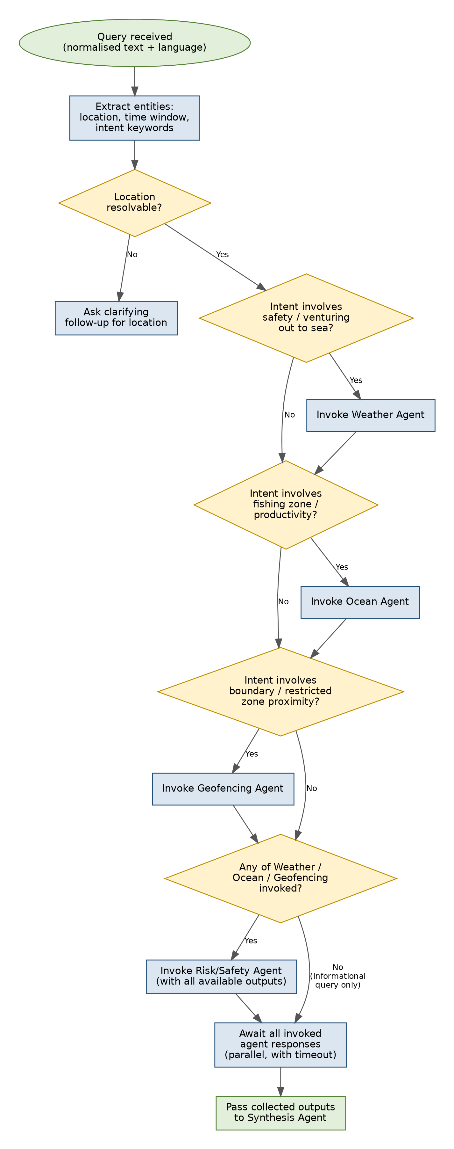
Figure 1: Planner Agent decomposition and routing logic.

4.2 Risk / Safety Agent — Verdict Combination
The verdict-combination logic is intentionally a plain decision tree rather than a learned model, so that the safety-critical output is fully explainable and auditable — directly satisfying FR-RISK-2 and the SRS's safety-first design principle.
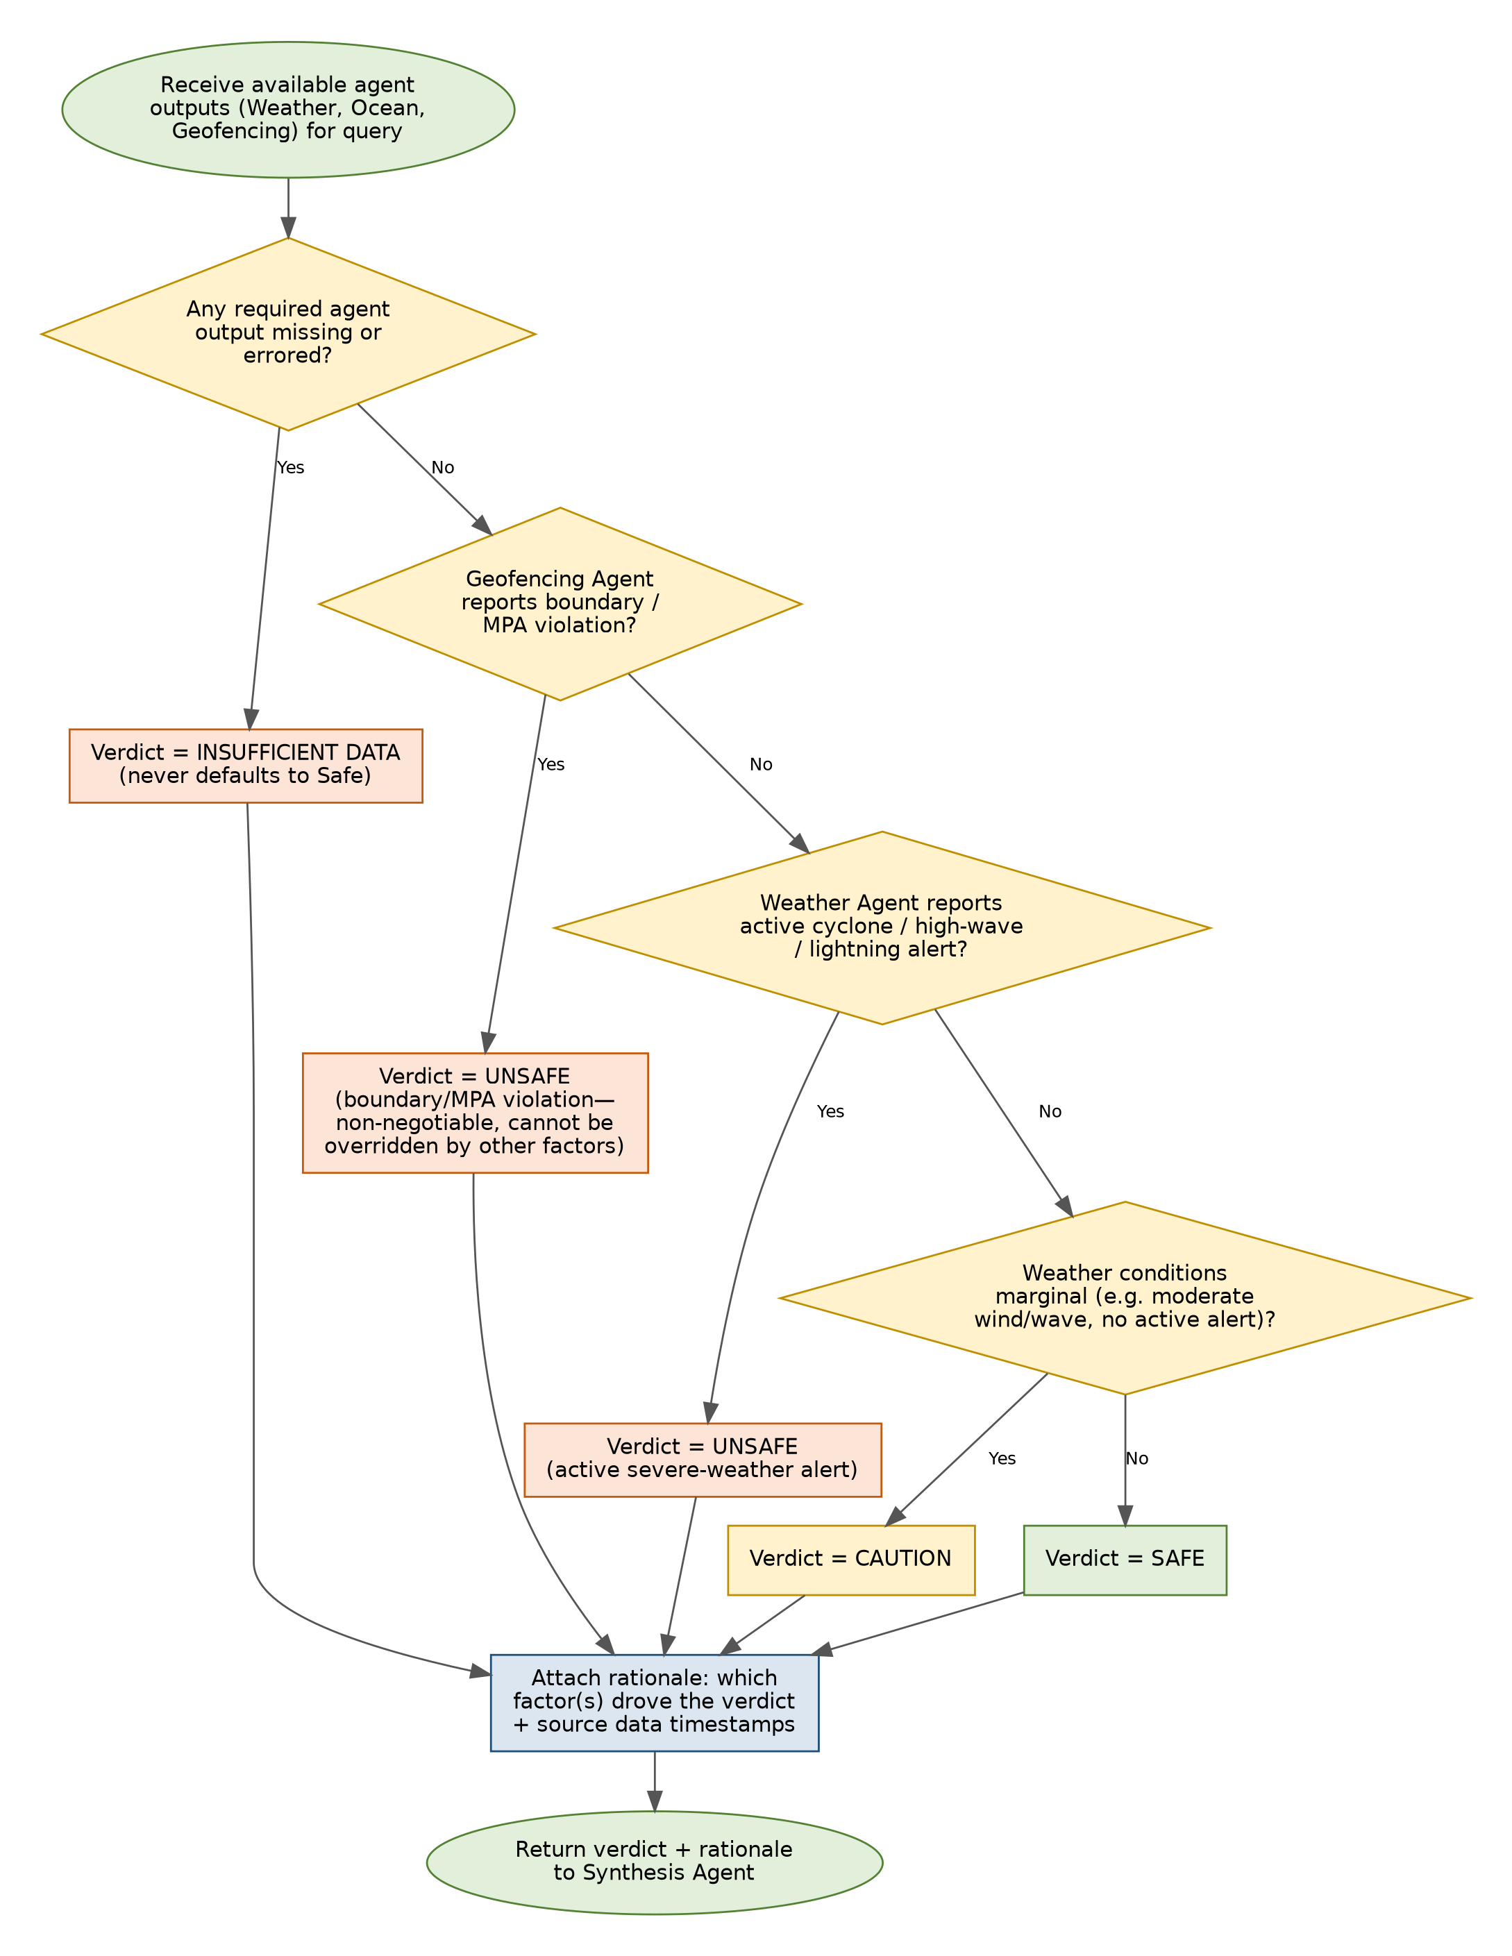
Figure 2: Risk / Safety Agent verdict-combination logic. Geofencing violations and active severe-weather alerts are non-negotiable and cannot be downgraded by favourable data from other agents.

4.3 Ocean Agent — Nearest-PFZ Distance Calculation
Distance from the queried location to each published PFZ centroid is computed using the haversine formula, and the minimum is selected.
def haversine_km(lat1, lon1, lat2, lon2) -> float:
R = 6371.0 # Earth radius in km
phi1, phi2 = radians(lat1), radians(lat2)
d_phi = radians(lat2 - lat1)
d_lambda = radians(lon2 - lon1)
a = sin(d_phi/2)**2 + cos(phi1) * cos(phi2) * sin(d_lambda/2)**2
return 2 * R * asin(sqrt(a))

def get_nearest_pfz(location, all_pfz_centroids):
distances = [
(pfz, haversine_km(location.lat, location.lon, pfz.lat, pfz.lon))
for pfz in all_pfz_centroids
]
nearest, dist_km = min(distances, key=lambda pair: pair[1])
return PFZResult(centroid=nearest, distance_km=dist_km, ...)

5. Detailed API Design

5.1 POST /api/v1/session
Request: (empty body)
Response 200:
{
"session_id": "b3f1c2a4-...",
"created_at": "2026-08-29T10:15:00Z"
}

5.2 WS /ws/v1/query/{session_id}
Client → Server message:
{
"type": "query",
"mode": "voice" | "text",
"audio_base64": "...", // present if mode == voice
"text": "...", // present if mode == text
"location_hint": {"lat": 9.93, "lon": 76.26} // optional
}
Server → Client messages (streamed):
{ "type": "trace_update", "step": "Planner: invoking Weather, Ocean, Geofencing" }
{ "type": "trace_update", "step": "Weather Agent: data received (t=2026-08-29T10:15:03Z)" }
{ "type": "final_response",
"text": "...", "language": "ml",
"audio_base64": "...",
"verdict": "CAUTION",
"citations": [ {"source": "INCOIS", "timestamp": "..."}, ... ],
"map_payload": { "markers": [...], "zones": [...] } }

5.3 POST /api/v1/query/{session_id}
Non-streaming equivalent of Section 5.2, for text-only clients; request and final response bodies follow the same schema as the WebSocket "query" and "final_response" messages above.

6. Error Handling and Resilience
Condition | Handling
Bhashini API unreachable | Gateway catches BhashiniUnavailableError; returns a clear, user-visible error in the last-known-working language if available, else English (FR-LANG-6).
Weather / INCOIS / GIS adapter failure | Adapter returns AdapterResult(status='unavailable'); the owning agent returns a result with status='unavailable' rather than raising; Risk/Safety Agent treats this as "required agent output missing" (Figure 2) and returns INSUFFICIENT_DATA, never SAFE (NFR-REL-2).
LLM provider timeout during entity extraction | Planner falls back to a simpler keyword-matching extraction for intent classification; if location still cannot be resolved, asks the clarifying follow-up (Figure 1).
Partial agent timeout during a multi-agent query | Planner's "await all invoked agent responses" step (Figure 1) uses a bounded timeout per agent; a timed-out agent is treated identically to an errored one for Risk/Safety purposes.

7. Traceability to HLD Components
HLD Component | LLD Section
Bhashini Integration Module | 2.1
Planner Agent | 2.2, 4.1 (Figure 1)
Weather Agent | 2.3
Ocean Agent | 2.4, 4.3
Geofencing Agent | 2.5
Risk / Safety Agent | 2.6, 4.2 (Figure 2)
Synthesis Agent | 2.7
FastAPI Gateway | 2.8, 5
Data Access Layer | 2.9
Persistence (PostgreSQL) | 3

8. Document Sign-off
This LLD is the direct implementation reference for Sprints 1–4 (SRS v1.1, Section 6.5). Any deviation discovered during implementation (e.g. a changed method signature) should be reflected back into this document to keep it accurate for testing and for the final project report.

Role | Name | Signature / Date
Prepared by | Aditya Raj Arora
Reviewed by
Approved by (Faculty Mentor)

