Experiment: 8

Student Name: Aditya Raj Bhakta UID:24BAI70782
Branch: CSE Section/Group: AIT-KRG-GP2
Semester: 4th Date of Performance:31/03/2026
Subject Name: DBMS

- Aim of the practical: To create and execute a stored procedure that retrieves employee data and calculates bonus dynamically using input parameters, demonstrating the use of functions and procedural logic in PostgreSQL.

2. Tool Used:

● Database Management System:

○ PostgreSQL

● Database Administration Tool:

○ pgAdmin

- Objective:

To write and execute a PL/SQL stored procedure that dynamically accepts gender as an argument and computes the employee count corresponding to the given gender.

- Practical / Experimental Steps

Step 1: Create the base table employees with attributes such as emp_id, emp_name, salary, and department.

Step 2: Insert sample records into the employees table to simulate real-world employee data.

Step 3: Define and create a stored procedure (function) GET_BONUS that accepts employee ID as an input parameter.

Step 4: Implement logic inside the procedure to retrieve the employee’s salary and calculate the bonus using a percentage formula.

Step 5: Execute the stored procedure by passing dynamic input values using a DO block.

Step 6: Display the output using RAISE NOTICE to show employee ID and calculated bonus.

Step 7: Verify the correctness of the output and analyze how the procedure handles dynamic inputs and returns computed results.

- I / O Analysis
- Create Table

CREATE TABLE employees (

emp_id INT PRIMARY KEY,

emp_name VARCHAR(100) NOT NULL,

salary NUMERIC(10,2) NOT NULL,

department VARCHAR(50)

);

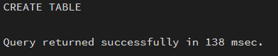

- Insert Sample Data

INSERT INTO employees (emp_id,emp_name, salary, department) VALUES

(1,'Alice', 50000, 'HR'),

(2,'Bob', 60000, 'IT'),

(3,'Charlie', 55000, 'Finance');

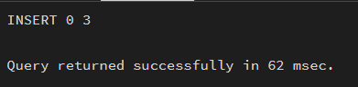

- Functions and Their Output

CREATE OR REPLACE PROCEDURE get_Employee_Count_BY_Gender(IN P_GEN VARCHAR(20), OUT COUNT_EMP INT, INOUT STATUS VARCHAR)

AS

$$

BEGIN

SELECT COUNT(*) INTO COUNT_EMP FROM EMPLOYEES WHERE GENDER=P_GEN;

STATUS:='SUCCESS';

END;

$$ LANGUAGE PLPGSQL

DO

$$

DECLARE

GEN VARCHAR(20):='Male';

COUNT_BY_GEN INT;

STATUS VARCHAR(20):='Fail';

BEGIN

CALL get_Employee_Count_BY_Gender(GEN,COUNT_BY_GEN,STATUS);

RAISE NOTICE 'GENDER IS % YOUR COUNT IS % AND STATUS IS %',GEN,COUNT_BY_GEN,STATUS;

END;

$$

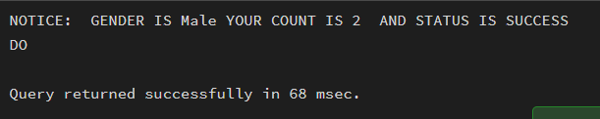

CREATE OR REPLACE FUNCTION Get_Data()

RETURNS TABLE(name_emp VARCHAR(10), emp_salary NUMERIC(10,2))

AS

$$

BEGIN

RETURN QUERY SELECT emp_name, salary FROM employees;

END;

$$ LANGUAGE PLPGSQL;

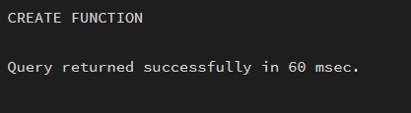

SELECT * FROM Get_Data();

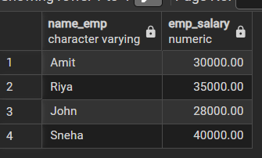

- Learning outcomes (What I have learnt):
- Understand the structure and components of a stored procedure.
- Implement IN and OUT parameters in PL/SQL procedures.
- Pass dynamic input values to stored procedures.
- Apply aggregate functions within procedures for data analysis.
- Develop reusable database logic for real-world business scenarios used in companies like CData and Toddle.

