Aim: **Design automatic led Diwali lights (consisting of 6 led’s) such that it only works during night and can generate two patterns which can be toggled with switch. a. Pattern 1 – led blinks with a freq. of 500 msec. b. Pattern 2 – led blinks with a freq. of 1 sec.**

Apparatus: Breadboard, Connecting Wires, Resistances, LDR, SWITCH.

Theory:

What is a LDR?

A Light Dependent Resistor (**LDR**) or a photo resistor is a device whose resistivity is a **function** of **the** incident electromagnetic radiation. Hence, they are light sensitive devices. They are also called as photo conductors, photo conductive cells or simply photocells

CIRCUIT DIGRAM:

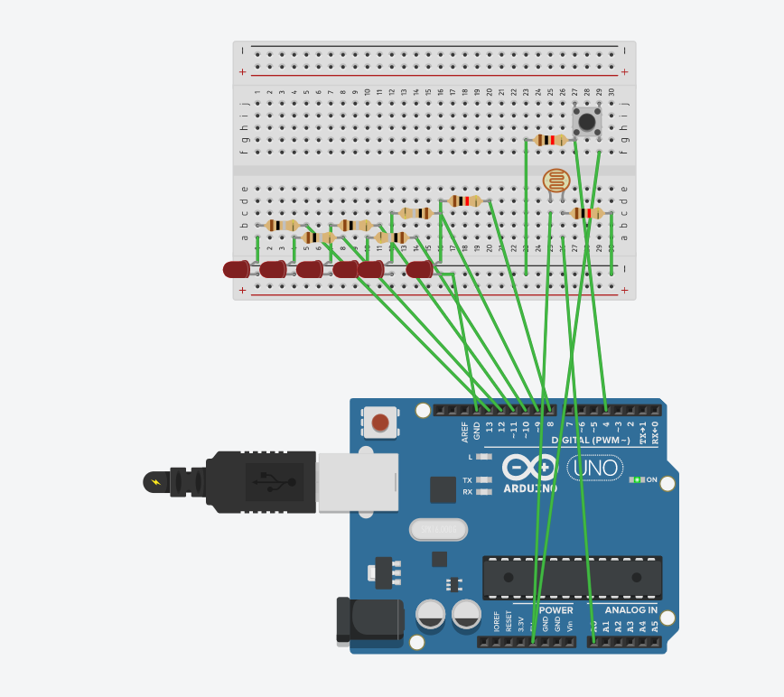

PRECAUTION:

1.CHECK THE LED BEFORE CONNECTING TO ARDUINO.

2: Port should be connected properly.

3: Programme should be correct.

**Learning Outcomes:**

1: I learn about LDR, how it works.

2.i learn to connect LDR to Arduino.

3.learn to make a light that can glow automatically, when light intensity is low.

CODE:

void setup()

{

Serial.begin(9600);

for(int i=8;i<=13;i++)

{

pinMode(i,OUTPUT);}

pinMode(A0,INPUT);

pinMode(4,INPUT);

}

void loop()

{

int j=analogRead(A0);

if(j<=300)

{

for(int i=8;i<=13;i++)

{

digitalWrite(i,HIGH);}

int k=digitalRead(4);

if(k==HIGH)

{for(int i=8;i<=13;i++)

{

digitalWrite(i,LOW);}

delay(500);

for(int i=8;i<=13;i++){

digitalWrite(i,HIGH);

}

}

else

{

for(int i=8;i<=13;i++)

{

digitalWrite(i,LOW);

}

}

}

else

{

for(int i=8;i<=13;i++)

{

digitalWrite(i,LOW);}

}}