THE OPEN SOURCE AUDIT
A Capstone Project for OSS NGMC Course
Software Chosen: Git (Version Control System)

Open Source Software | Unit Coverage: 1 – 5

Student Name | ADITYA ROSHAN SINGH
Registration Number | 24BAI10227
Slot | B22
Date of Submission | 30-03-2026

1. Introduction
This report is a structured audit of Git, one of the most widely used open-source software projects in the world today. Git is a distributed version control system that fundamentally changed the way developers collaborate, track changes, and manage code. The goal of this audit is not merely to describe what Git does, but to examine why it exists, who built it, what philosophy drives it, what freedoms its license actually grants, and how it fits into the broader open-source ecosystem.
This report is organized into four main parts: Part A explores the origin story and philosophy of Git; Part B examines Git's footprint on a Linux system; Part C maps the FOSS ecosystem surrounding Git; and Part D compares Git against its proprietary alternatives. Alongside the written report, five shell scripts are presented to demonstrate practical Linux and shell scripting skills.

Every line of code written in a modern software project is tracked by Git. Understanding the philosophy behind that tool is not optional — it is foundational to being a professional software developer.

Part A — Origin and Philosophy (Units 1 & 2)

A1. The Problem Git Was Created to Solve
To understand why Git was created, one must go back to April 2005 — to a moment of institutional failure and personal frustration that catalyzed one of the most important tools in modern software development.
Linus Torvalds, the creator of the Linux kernel, had been using a proprietary version control system called BitKeeper to manage the Linux kernel's source code since 2002. BitKeeper was closed-source but was being made available to the Linux kernel community for free under a special arrangement with its maker, BitMover. This arrangement was always fragile — it involved accepting constraints that many in the open-source community found philosophically uncomfortable. They were accepting proprietary tools to build free software, a contradiction that sat uneasily at the heart of the Linux project.
In April 2005, the arrangement collapsed. A Linux kernel developer, Andrew Tridgell, began reverse-engineering BitKeeper's protocol. BitMover reacted by revoking the free license for the Linux community. The kernel developers were suddenly without a version control system — and more importantly, without one that was adequate for the enormous scale of the Linux kernel project.
At the time, Torvalds had tried every existing open-source version control tool — CVS, Subversion, and others — and found all of them deeply inadequate. CVS was ancient and had fundamental architectural flaws. Subversion, which was designed to be a better CVS, was still centralized: every operation required communicating with a central server, which created bottlenecks and made offline work impossible. These tools were designed for small teams in an era when version control meant checking files in and out, not managing a distributed project with thousands of contributors.
Torvalds set out to build his own solution. He articulated his design principles clearly at the time: Git had to be fast — drastically faster than anything available; it had to support a distributed workflow (no single server being a point of failure); every clone of the repository had to be a complete backup; and the data integrity model had to be cryptographically robust, so that any corruption or tampering could be detected.
He built the first version of Git in just a few weeks. By June 2005, Git was already being used to manage the Linux kernel itself. The tool was designed to handle massive projects — thousands of files, thousands of contributors, millions of lines of code — at a speed and scale that no existing tool could match. It was born not from a desire to build yet another version control system, but from a very specific and urgent problem: proprietary tools had failed the free software community, and the alternatives were not good enough.

Git did not come from a product roadmap or a startup's pitch deck. It came from Linus Torvalds being angry and needing something better by next week. That urgency shaped every design decision.

A2. The License — What It Actually Says
The Four Freedoms of Free Software
The Free Software Foundation defines four essential freedoms that a program must grant its users to be considered free software. These are:
- Freedom 0: The freedom to run the program for any purpose.
- Freedom 1: The freedom to study how the program works, and change it.
- Freedom 2: The freedom to redistribute copies so you can help others.
- Freedom 3: The freedom to distribute copies of your modified versions to others.

Git is licensed under the GNU General Public License version 2 (GPL v2). This license grants all four freedoms explicitly. Any person can download Git's source code, read every line of it, modify it, and distribute their version — provided they make their changes available under the same license. The GPL v2 is what is known as a copyleft license: it uses copyright law to ensure that freedom propagates forward. You cannot take Git's code, make it proprietary, and lock it down.
Can a Company Take Git, Modify It, and Sell It Without Sharing Changes?
No — and this is one of the most important features of the GPL v2. The license includes a reciprocity requirement: if you distribute a modified version of Git, you must make the source code of your modifications available under the GPL v2 as well. A company may use Git internally without releasing their modifications, because internal use does not count as distribution. However, the moment they distribute a modified binary to users, the GPL requires them to also distribute the source.
This is in sharp contrast to permissive licenses like MIT or Apache 2.0, under which a company can take the code, modify it substantially, and release only a binary — with no obligation to share their improvements. The GPL closes this loophole deliberately. Torvalds chose GPL v2 for Git (as he did for the Linux kernel) precisely because he wanted the openness to be self-reinforcing.
GPL vs MIT: Which Would You Choose?
The MIT license is the simplest and most permissive widely-used free software license. It allows anyone to do almost anything with the code — use it, modify it, sublicense it, sell it — with virtually no conditions beyond preserving the copyright notice. The GPL, by contrast, requires that derivative works also be distributed under the GPL. Both licenses grant the four freedoms, but the GPL enforces them downstream.
For a project like a foundational developer tool that the entire community depends on, the GPL makes more philosophical sense. It prevents corporations from taking the commons and enclosing it. For a library meant to be embedded in as many applications as possible — where wide adoption matters more than ensuring all derivatives remain open — the MIT license is more practical. Personally, for something I intended to be a community resource rather than a library component, I would choose GPL, because I would want contributions to flow back to everyone.
Free as in Free Beer vs Free as in Freedom
Richard Stallman coined this distinction: 'free software' means freedom, not price. 'Free as in free beer' means you pay nothing for it. 'Free as in freedom' means you have the rights to use, study, modify, and redistribute it. These two things frequently coincide but are conceptually distinct.
Git is free in both senses — you pay nothing to download it, and the GPL grants you all four freedoms. However, services built on top of Git, such as GitHub and GitLab, are free as in free beer only in their basic tiers. GitHub itself is proprietary software. You can use it for free, but you cannot inspect its source, modify it, or run your own instance. Git the tool is free in every sense; GitHub the platform is free in only the price sense.

A3. The Ethics of Open Source
Should All Software Be Open Source?
The argument for making all software open source is compelling: software increasingly mediates access to education, healthcare, communication, financial services, and government. When critical infrastructure is proprietary and opaque, users are dependent on the goodwill of corporations. Open source enables scrutiny, accountability, and collective improvement. It democratizes access to tools and knowledge.
However, there are legitimate arguments against mandating openness. Developing software requires sustained effort, and companies need revenue models to fund that effort. Proprietary software licenses are one such model. For specialized enterprise software, security software, or medical device firmware, a case can be made that broader transparency could enable misuse. Furthermore, not all open-source software is inherently better — quality and maintenance depend on the community's resources, not just the openness of the code.
A more nuanced view is this: software that forms critical shared infrastructure — operating systems, compilers, core libraries, version control systems — should be open. Software that is a value-added service built on top of that infrastructure can reasonably be proprietary, provided it does not exploit or destroy the commons it depends on.
Is It Ethical to Build Commercial Products on Free Community Labor?
This is one of the most contested questions in modern open source. Companies like Red Hat, Google, Microsoft, and Meta generate enormous value from the Linux kernel, Git, and thousands of other community-maintained projects. They employ some contributors, but they also benefit from the unpaid labor of thousands of volunteers.
Red Hat has navigated this relatively ethically: their entire business model funds significant kernel and community contributions. Google employs many Linux kernel developers. But the average startup that uses open-source databases, web servers, and runtimes while contributing nothing back occupies a more ethically ambiguous position.
The core tension is this: the GPL makes it legal to do this. But legality and ethics are not the same thing. A developer who uses thousands of hours of community labor to build a profitable product and never contributes documentation, bug reports, or code is taking without giving back. This does not make their product illegal, but it does reflect a lack of engagement with the commons they depend on.
Open Source and Innovation: Enabling or Undermining?
The phrase 'standing on the shoulders of giants' — attributed to Isaac Newton — captures what open source enables. Every generation of developers inherits the accumulated work of previous generations, encoded in libraries, tools, and frameworks. Git itself stands on decades of version control research. Python stands on decades of programming language theory. Linux stands on Unix, which stands on decades of operating system research.
Open source accelerates innovation by eliminating redundant reinvention. If every company had to rebuild its own version control system, its own web server, its own database engine, innovation would be slower and more fragmented. Shared infrastructure allows developers to focus on genuinely new problems. Far from undermining original innovation, open source creates the conditions for it.

Part B — Linux Footprint (Unit 2)

B1. Installation Method
Git is available via the default package repositories of virtually every major Linux distribution. On Debian/Ubuntu-based systems it can be installed with apt, and on Red Hat/CentOS/Fedora systems with dnf or yum. It is also available for compilation from source via the official Git repository at git-scm.com.
The installation commands are:
- Debian/Ubuntu: sudo apt install git
- RHEL/Fedora: sudo dnf install git
- Compile from source: ./configure && make && make install

[ SCREENSHOT PLACEHOLDER ]
Screenshot: Terminal output of 'sudo apt install git' or 'sudo dnf install git' showing installation confirmation and version.

B2. Key Directories
Once installed, Git's files are distributed across standard Linux directory locations following the Filesystem Hierarchy Standard (FHS):
- /usr/bin/git — the main Git executable. This is the binary that runs when you type 'git' in the terminal.
- /usr/lib/git-core/ — auxiliary Git programs (git-fetch, git-merge, etc.) that Git delegates to internally.
- /usr/share/git-core/ — shared data files, templates for new repositories, and completion scripts.
- /etc/gitconfig — the system-wide Git configuration file, applying default settings for all users on the machine.
- ~/.gitconfig — the per-user configuration file, stored in the user's home directory. This is where name, email, preferred editor, and aliases are stored.
- .git/ — the hidden directory inside each repository, containing the full history, objects, refs, and config for that repository.

[ SCREENSHOT PLACEHOLDER ]
Screenshot: Output of 'which git', 'ls /usr/lib/git-core/', and 'cat /etc/gitconfig' showing Git's system-level presence.

B3. User and Group
Git itself does not run as a system daemon or service under a special user account in a typical workstation install. It runs as the user who invokes it, inheriting that user's permissions. This is an important security property: Git only has access to what the invoking user has access to.
On servers hosting Git repositories (such as Gitolite or GitLab installations), a dedicated 'git' system user is typically created. This user owns the repository files and SSH access is granted through this account. The git user has a restricted shell (git-shell) that only allows Git operations, preventing arbitrary command execution over SSH.
The reason this matters for security: running a service as a dedicated low-privilege user limits the blast radius of any vulnerability. If an attacker exploits a Git server vulnerability, they gain access only as the 'git' user — not as root.

[ SCREENSHOT PLACEHOLDER ]
Screenshot: Output of 'id' command showing current user, and 'ls -la /path/to/repo/.git' showing ownership of repository files.

B4. Service Management
In a standard developer workstation setup, Git is not a persistent service — it is a command-line tool that runs when invoked and exits when done. However, in server configurations (such as running git-daemon for anonymous read access to repositories), Git can be managed as a systemd service.
- Start git-daemon: sudo systemctl start git.socket
- Enable on boot: sudo systemctl enable git.socket
- Check status: sudo systemctl status git.socket
- Stop service: sudo systemctl stop git.socket

[ SCREENSHOT PLACEHOLDER ]
Screenshot: Output of 'git --version' and 'systemctl status git.socket' (or equivalent) on the target Linux system.

B5. Update Model
On systems using package managers, Git is updated through the standard distribution security update mechanism. When the Git project releases a security patch, distribution maintainers package it and push it through their update repositories. Users then receive the update via their package manager's update command (apt upgrade or dnf upgrade). This is the standard open-source security distribution model: the community patches, distributions package, users apply.
For servers running Git from source, updates require recompiling. For this reason, most production deployments use package manager installations where security updates can be applied automatically and at scale.

Part C — The FOSS Ecosystem (Units 3 & 4)

C1. Dependencies
Git is designed to have minimal runtime dependencies, which is part of why it is so portable across Linux distributions and other operating systems. Its key dependencies include:
- OpenSSL or libssl — used for cryptographic operations, particularly HTTPS communication and SHA-1 hashing of objects (though Git has been transitioning toward SHA-256 for new repositories).
- libcurl — used for HTTP/HTTPS transport when fetching from or pushing to remote repositories over these protocols.
- zlib — used for compressing and decompressing repository objects. Git stores all objects in compressed form.
- Perl — used by several auxiliary Git scripts (particularly for git-svn, the Subversion bridge, and some hooks).
- Python — used by some contrib scripts and tools in the Git ecosystem.
When compiled from source, Git additionally requires a C compiler (GCC or Clang), make, and standard POSIX build tools.

C2. What Git Has Enabled
It is difficult to overstate Git's influence on the modern software ecosystem. Virtually every major open-source project in the world now uses Git as its primary version control system. Before Git, projects used CVS, Subversion, or Mercurial, all of which imposed centralized or less efficient workflows. Git's distributed model enabled entirely new patterns of collaboration.
GitHub, founded in 2008 and now owned by Microsoft, is perhaps the most visible consequence of Git. It transformed Git from a command-line tool into a social platform for code, enabling pull requests, code review, issue tracking, and open-source contribution at a scale previously unimaginable. GitLab and Bitbucket followed the same model. These platforms did not replace Git — they are built on top of it.
Git has also inspired derivative tools and workflows: Git-LFS for handling large binary files, git-annex for distributed file management, and Gitflow and trunk-based development as codified branching strategies. The concept of Infrastructure as Code, where server configurations are version-controlled just like application code, is only practical because of Git.

C3. Git in the LAMP Stack and Web Context
Git does not sit inside the traditional LAMP stack (Linux, Apache, MySQL, PHP/Python) as an operational component — it is not a web server or database. However, it is the deployment and development infrastructure that the LAMP stack runs on. In modern web development workflows, code is written locally, committed to Git, pushed to a remote repository, and deployed from there using CI/CD pipelines.
Tools like Jenkins, GitHub Actions, GitLab CI, and CircleCI all use Git as their trigger mechanism: a push to a specific branch triggers a pipeline that tests, builds, and deploys the application. Git is therefore the upstream infrastructure for nearly all web deployments, even if it is not visible in the runtime stack.

C4. Community and Governance
Git is governed by a community of maintainers, with Junio Hamano (also known as gitster) serving as the primary maintainer since Torvalds handed over maintenance responsibilities in 2005, shortly after creating Git. Development happens on a public mailing list (git@vger.kernel.org) where patches are submitted, reviewed, and discussed. There is no formal foundation or corporate entity governing Git's development.
Major community resources include the official documentation at git-scm.com, the git-users and git mailing lists, Stack Overflow's active git tag, and annual developer conferences such as Git Merge, which brings together core contributors and community members. The project is also discussed at Linux Foundation events.
What is remarkable about Git's governance model is that it mirrors the bazaar model described by Eric S. Raymond: patches come from contributors worldwide, are reviewed publicly, and are merged based on technical merit. No single company controls the direction of Git — a deliberate feature of its governance structure.

Part D — Open Source vs Proprietary (Critical Analysis)

D1. Comparison Table: Git vs Proprietary Alternatives
The table below compares Git against its closest proprietary alternatives — primarily legacy systems like Microsoft's older Visual SourceSafe, IBM's ClearCase, and the proprietary features of modern platforms like Perforce Helix Core (still used in game development and some enterprise settings).

Dimension | Git (Open Source) | Proprietary Alternatives
Cost | Free to use, distribute, and modify. Zero licensing fees. | GitHub: $4–$21/user/month. GitLab Ultimate: $99/user/month.
Security (Code Audit) | Full source transparency. Anyone can audit, find and fix vulnerabilities. | Closed source. Users must trust the vendor. No independent audit possible.
Support & Reliability | Community-driven mailing lists, Stack Overflow, extensive documentation. | Dedicated vendor support with SLAs. Often more structured for enterprise.
Freedom to Modify | Complete freedom — fork, patch, redistribute under GPL v2. | No modification rights. Locked into vendor's feature roadmap.
Community vs Corporate | Governed by the Git community; Junio Hamano leads maintainership. | GitHub: owned by Microsoft. GitLab: public company with commercial interests.
Your Verdict | Recommended for all environments. Git is the universal standard. | Proprietary hosting useful on top of Git, but Git itself is irreplaceable.

D2. Verdict
Based on this analysis, Git is recommended without reservation for any real-world software development deployment, from individual projects to enterprise-scale development organizations. Its technical superiority over centralized version control systems has been demonstrated empirically over nearly two decades. Its license ensures that improvements remain available to everyone. Its community is active, its documentation is comprehensive, and its ecosystem of supporting tools is unmatched.
As for contributing to Git: any serious developer should at minimum contribute indirectly by filing well-documented bug reports, writing documentation, and participating in the mailing list community. Direct code contribution requires familiarity with C and the patch submission workflow, but is deeply rewarding. Git is maintained by a relatively small team given its enormous global usage, and thoughtful contributions are always welcome. Contributing to the tool that underpins all of modern software development is one of the highest-leverage things a developer can do with their time.

4. Shell Script Tasks
Five shell scripts are presented below. Each script is written to run on a standard Linux system, includes inline comments explaining each section, and demonstrates the shell scripting concepts specified in the project guidelines.

Script 1 — System Identity Report
This script generates a formatted welcome screen showing key system information: the Linux distribution, kernel version, current user, uptime, and a message about the open-source license covering the operating system. It demonstrates the use of variables, command substitution with $(), and formatted output with echo.
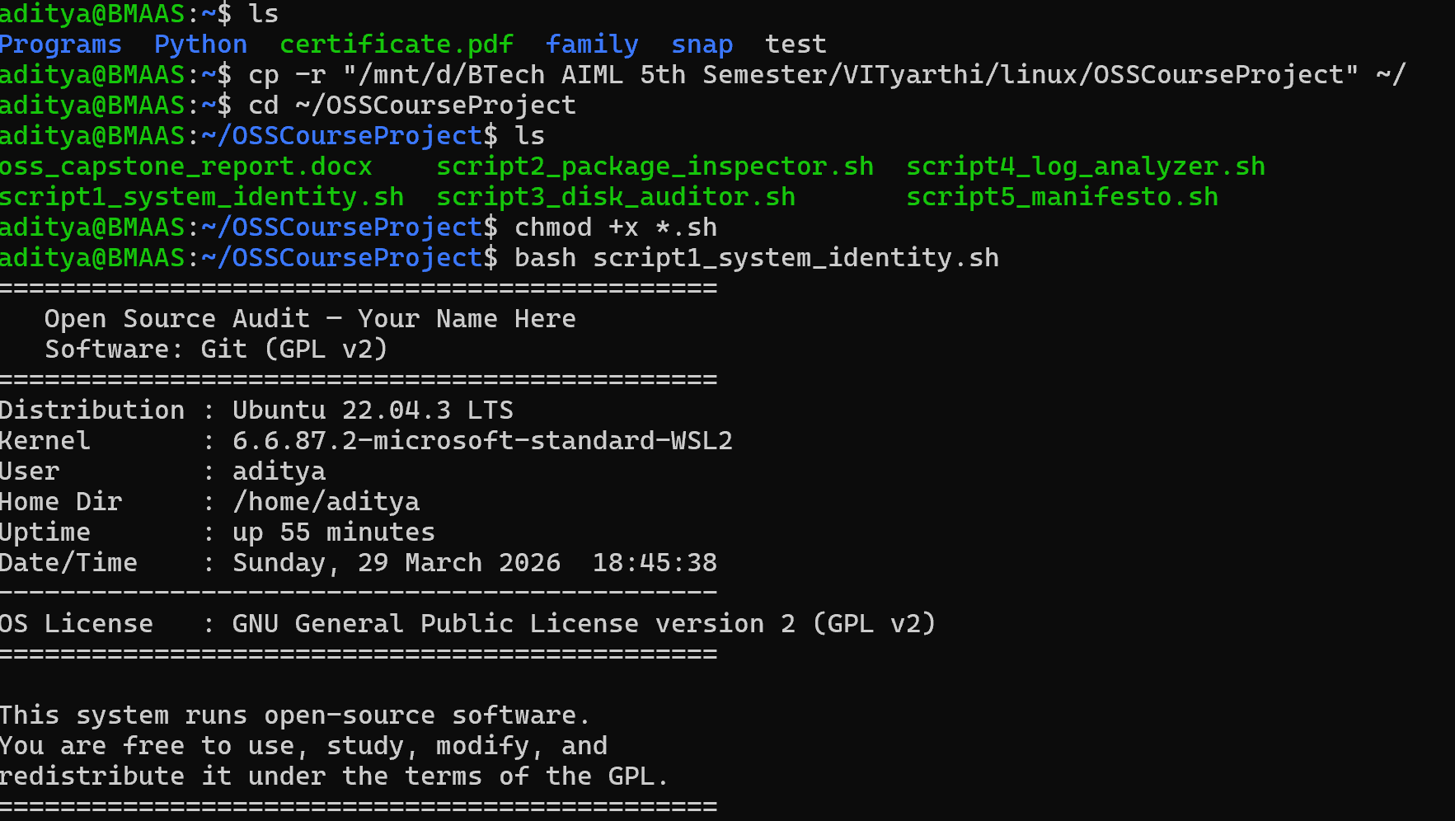

#!/bin/bash
# Script 1: System Identity Report
# Author: [Your Name] | Reg No: [Your Reg No]
# Course: Open Source Software | Software: Git

# --- Variables (filled in by the student) ---
STUDENT_NAME="Your Name Here"
SOFTWARE_CHOICE="Git (GPL v2)"

# --- Gather system information via command substitution ---
KERNEL=$(uname -r) # Kernel version
USER_NAME=$(whoami) # Current logged-in user
HOME_DIR=$(echo $HOME) # User home directory
UPTIME=$(uptime -p) # System uptime in human-readable form
DATETIME=$(date "+%A, %d %B %Y %H:%M:%S") # Current date and time
DISTRO=$(lsb_release -ds 2>/dev/null || cat /etc/*release 2>/dev/null | head -n1) # Distro name

# --- Display formatted output ---
echo "=============================================="
echo " Open Source Audit — $STUDENT_NAME"
echo " Software: $SOFTWARE_CHOICE"
echo "=============================================="
echo "Distribution : $DISTRO"
echo "Kernel : $KERNEL"
echo "User : $USER_NAME"
echo "Home : $HOME_DIR"
echo "Uptime : $UPTIME"
echo "Date/Time : $DATETIME"
echo "----------------------------------------------"
# Note: Linux (kernel) is licensed under GPL v2 — the same license as Git
echo "OS License : GNU General Public License version 2 (GPL v2)"
echo "=============================================="

Concepts demonstrated: variables (STUDENT_NAME, KERNEL, etc.), command substitution using $(), formatted echo output, and the $HOME environment variable.

Script 2 — FOSS Package Inspector
This script checks whether Git is installed on the system. If installed, it retrieves the package version, license, and summary using the package manager. A case statement prints a one-line philosophy note about each software option. This demonstrates if-then-else logic, the case statement, and piping with grep.
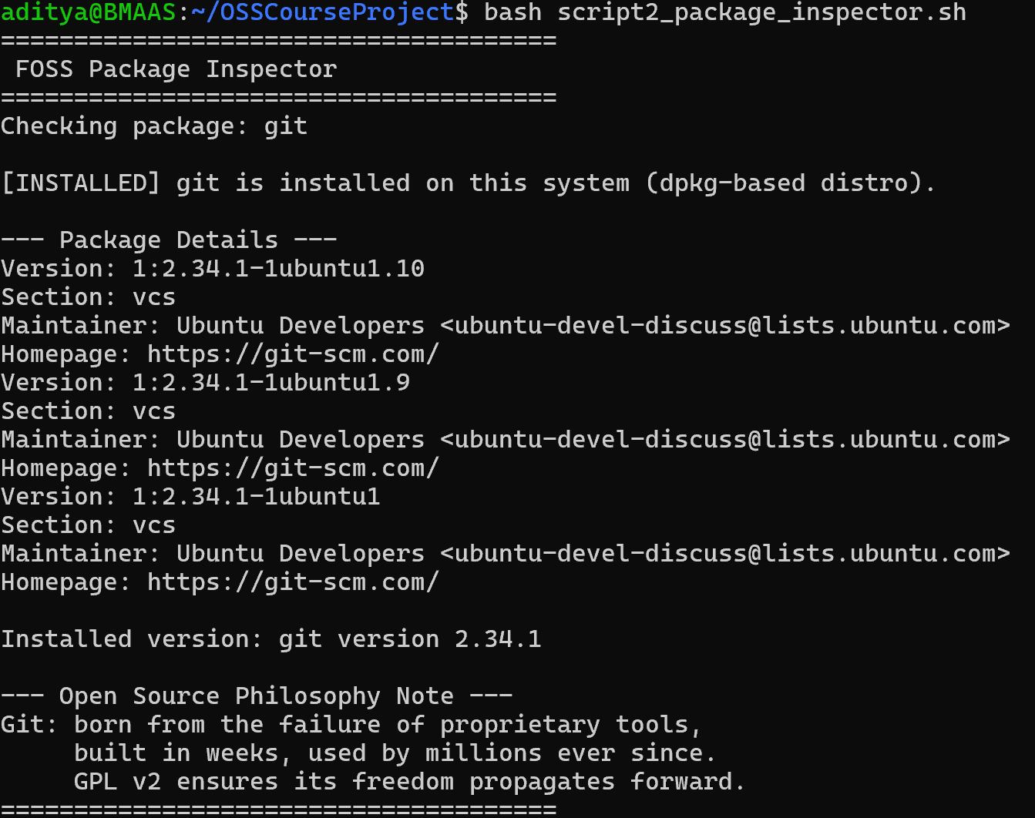

#!/bin/bash
# Script 2: FOSS Package Inspector
# Checks if the chosen FOSS software is installed and prints its details.

PACKAGE="git" # The chosen open-source software

# --- Check if installed (supports both rpm and dpkg systems) ---
if dpkg -l $PACKAGE &>/dev/null || rpm -q $PACKAGE &>/dev/null; then
echo "$PACKAGE is installed on this system."
# Print version, license, and summary — works on rpm-based systems
if rpm -q $PACKAGE &>/dev/null; then
rpm -qi $PACKAGE | grep -E 'Version|License|Summary'
else
# On Debian/Ubuntu use dpkg and apt-cache
dpkg -l $PACKAGE | grep "^ii"
apt-cache show $PACKAGE 2>/dev/null | grep -E 'Version|Section|Description'
fi
else
echo "$PACKAGE is NOT installed. Install with: sudo apt install $PACKAGE"
fi

# --- Case statement: philosophy note based on package name ---
echo ""
echo "--- Open Source Philosophy Note ---"
case $PACKAGE in
git) echo "Git: born from frustration with proprietary tools — freedom that propagates forward" ;;
httpd) echo "Apache: the web server that made the open internet possible" ;;
mysql) echo "MySQL: open source at the heart of millions of web applications" ;;
vlc) echo "VLC: built by students who needed a tool that did not exist yet" ;;
python) echo "Python: a language shaped entirely by its community, for its community" ;;
firefox) echo "Firefox: a nonprofit fighting to keep the web open and user-controlled" ;;
*) echo "Unknown package — but if it runs on Linux, it owes a debt to open source" ;;
esac

Concepts demonstrated: if-then-else conditionals, case statement with multiple patterns, command piping with | grep, and output redirection with &>/dev/null to suppress errors.

Script 3 — Disk and Permission Auditor
This script loops through a list of important Linux directories and reports the permissions, owner, group, and disk usage of each. It also checks for Git's configuration directory specifically. This demonstrates the for loop, conditional directory checking, and awk/cut for field extraction.
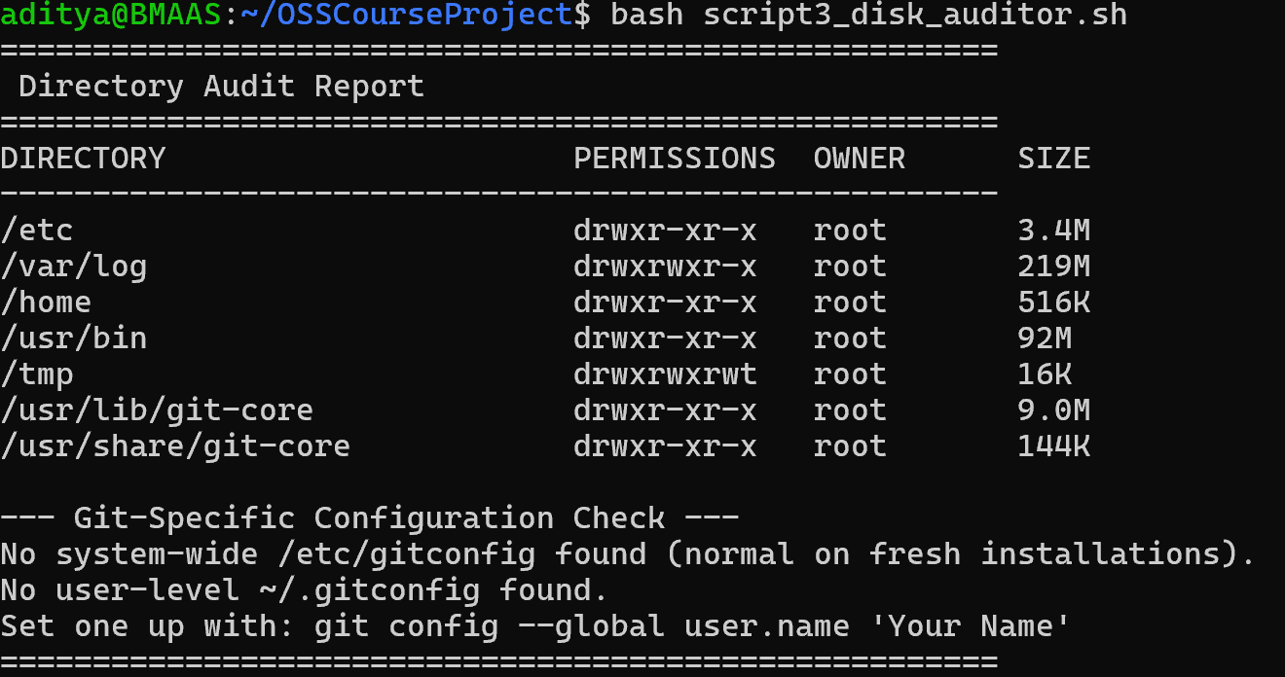

#!/bin/bash
# Script 3: Disk and Permission Auditor
# Loops through key directories and reports permissions and disk usage.

# Array of important system directories to audit
DIRS=("/etc" "/var/log" "/home" "/usr/bin" "/tmp" "/usr/lib/git-core")

echo "======================================================"
echo "Directory Audit Report"
echo "======================================================"
printf "%-30s %-15s %-10s %-10s\n" "DIRECTORY" "PERMISSIONS" "OWNER" "SIZE"
echo "------------------------------------------------------"

# For loop: iterate over each directory in the array
for DIR in "${DIRS[@]}"; do
if [ -d "$DIR" ]; then
# awk extracts permission bits, owner, and group from ls output
PERMS=$(ls -ld "$DIR" | awk '{print $1}')
OWNER=$(ls -ld "$DIR" | awk '{print $3}')
# du gets disk usage; cut extracts just the size field
SIZE=$(du -sh "$DIR" 2>/dev/null | cut -f1)
printf "%-30s %-15s %-10s %-10s\n" "$DIR" "$PERMS" "$OWNER" "$SIZE"
else
echo "$DIR does not exist on this system"
fi
done

# --- Additional check: Git's system config file ---
echo ""
echo "--- Git Configuration Check ---"
GIT_CONFIG="/etc/gitconfig"
if [ -f "$GIT_CONFIG" ]; then
echo "Git system config found: $GIT_CONFIG"
echo "Permissions: $(ls -l $GIT_CONFIG | awk '{print $1, $3, $4}')"
else
echo "No system-wide gitconfig found (normal on fresh systems)."
fi

Concepts demonstrated: for loop with an array, -d directory existence check, awk for field extraction, du -sh and cut -f1 for disk size, and printf for formatted columnar output.

Script 4 — Log File Analyzer
This script reads a log file line by line, counts occurrences of a keyword, and prints a summary with the last five matching lines. It accepts the log file path and keyword as command-line arguments, making it reusable. This demonstrates while-read loops, if-then conditionals, counter variables, and $1/$2 argument handling.
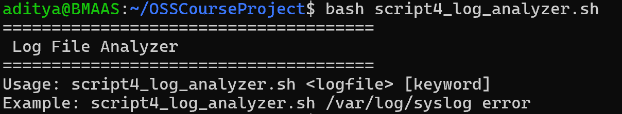

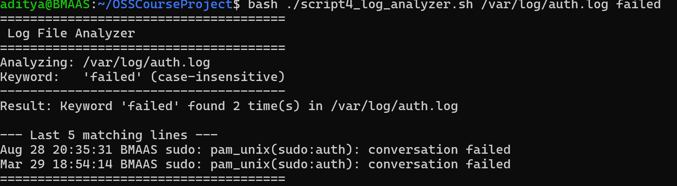

#!/bin/bash
# Script 4: Log File Analyzer
# Usage: ./script4_log_analyzer.sh <logfile> [keyword]
# Example: ./script4_log_analyzer.sh /var/log/syslog error

LOGFILE=$1 # First argument: path to log file
KEYWORD=${2:-"error"} # Second argument (default: "error" if not provided)
COUNT=0 # Counter variable for matching lines

# --- Validate that a log file argument was provided ---
if [ -z "$LOGFILE" ]; then
echo "Usage: $0 <logfile> [keyword]"
exit 1
fi

# --- do-while style retry: attempt to find the file up to 3 times ---
ATTEMPTS=0
while [ ! -f "$LOGFILE" ] && [ $ATTEMPTS -lt 3 ]; do
echo "Warning: $LOGFILE not found. Attempt $((ATTEMPTS+1))/3..."
ATTEMPTS=$((ATTEMPTS+1))
sleep 1
done

if [ ! -f "$LOGFILE" ]; then
echo "Error: File $LOGFILE not found after 3 attempts. Exiting."
exit 1
fi

# --- Check file is not empty ---
if [ ! -s "$LOGFILE" ]; then
echo "Warning: $LOGFILE is empty. Nothing to analyze."
exit 0
fi

# --- while-read loop: read file line by line and count keyword matches ---
while IFS= read -r LINE; do
# grep -iq: case-insensitive, quiet (no output, just exit code)
if echo "$LINE" | grep -iq "$KEYWORD"; then
COUNT=$((COUNT + 1)) # Increment counter using arithmetic expansion
fi
done < "$LOGFILE"

# --- Print summary ---
echo "Keyword '$KEYWORD' found $COUNT time(s) in $LOGFILE"
echo ""
# --- Print last 5 matching lines using tail + grep ---
echo "Last 5 matching lines:"
grep -i "$KEYWORD" "$LOGFILE" | tail -5

Concepts demonstrated: command-line arguments ($1, $2), default parameter values (${2:-default}), while-read loop, counter arithmetic with $(( )), -f and -s file tests, and piping grep output through tail.

Script 5 — The Open Source Manifesto Generator
This is the most creative script. It interactively asks the user three questions, then composes a personalized open-source philosophy statement from their answers and saves it to a text file. This demonstrates the read command for user input, string concatenation, file output with >, and the date command. An alias concept is illustrated via a comment.
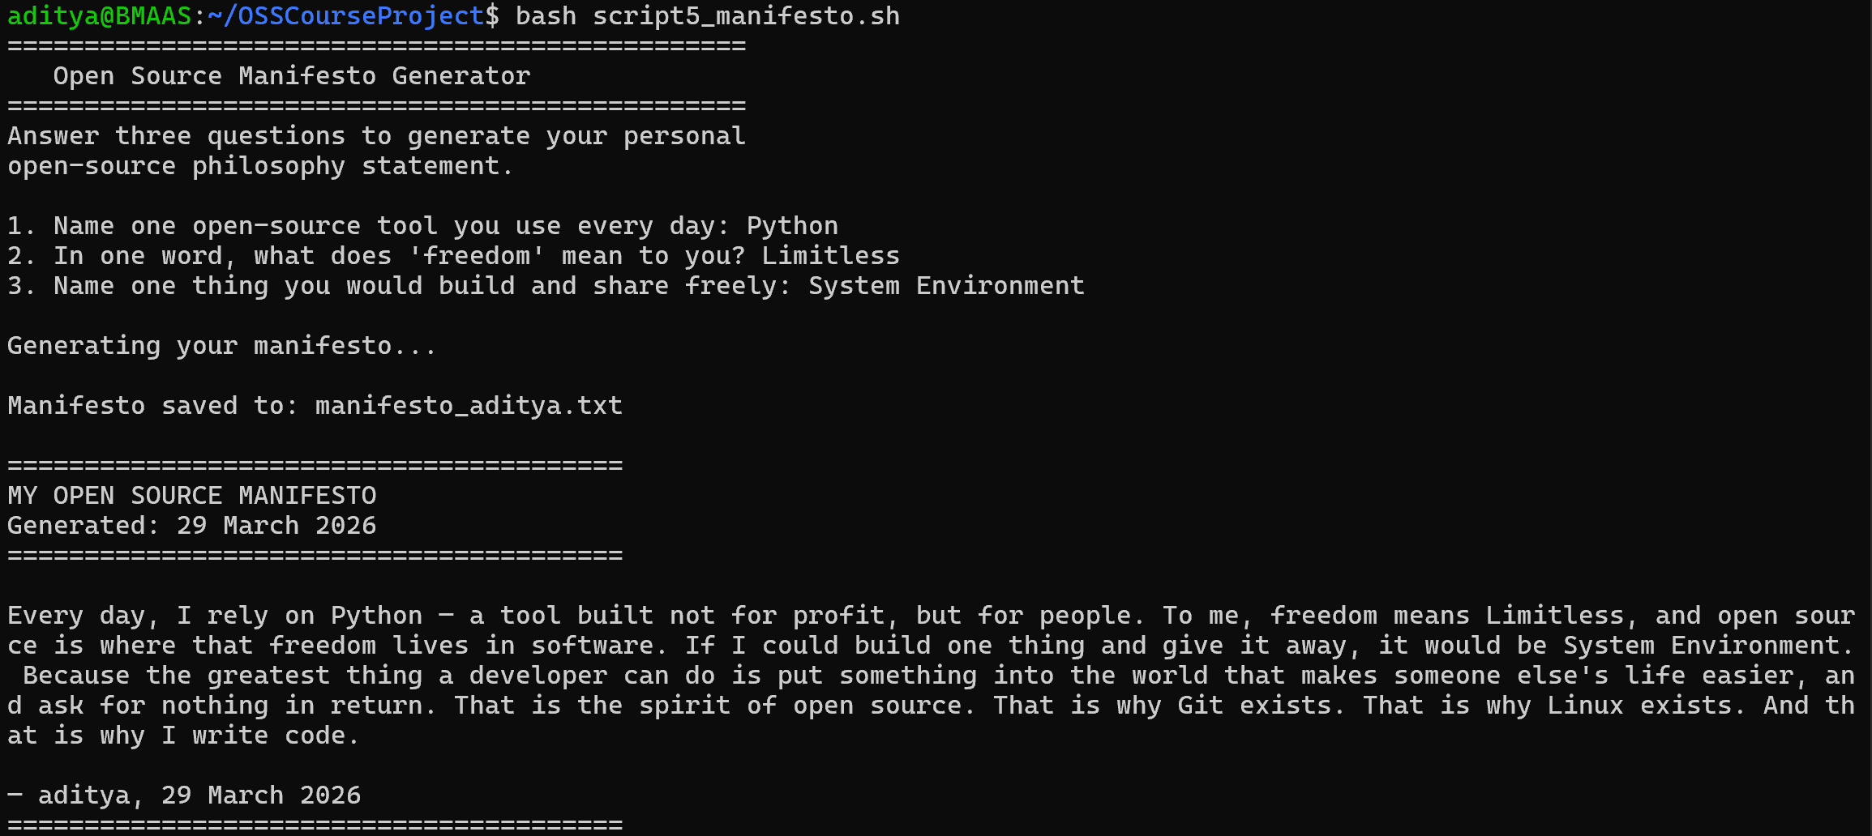

#!/bin/bash
# Script 5: Open Source Manifesto Generator
# Asks the user three questions and generates a personalised open-source manifesto.

# Alias concept (demonstrated via comment — aliases are shell session features):
# alias generate_manifesto='bash script5_manifesto.sh'
# (Add this to ~/.bashrc to run the script with a short alias command)

echo "================================================"
echo " Open Source Manifesto Generator"
echo "================================================"
echo "Answer three questions to generate your manifesto."
echo ""

# --- User input using read command ---
read -p "1. Name one open-source tool you use every day: " TOOL
read -p "2. In one word, what does 'freedom' mean to you? " FREEDOM
read -p "3. Name one thing you would build and share freely: " BUILD

# --- Capture date and generate output filename ---
DATE=$(date '+%d %B %Y')
OUTPUT="manifesto_$(whoami).txt" # Filename is personalised with the current username

# --- Compose manifesto using string concatenation and write to file ---
# The >> operator appends; > overwrites. We use > first to create/clear the file.
echo "========================================" > "$OUTPUT"
echo "My Open Source Manifesto" >> "$OUTPUT"
echo "Generated: $DATE" >> "$OUTPUT"
echo "========================================" >> "$OUTPUT"
echo "" >> "$OUTPUT"

# String concatenation: build the manifesto paragraph from user answers
MANIFESTO="Every day, I rely on $TOOL — a tool built not for profit, but for people."
MANIFESTO="$MANIFESTO To me, freedom means $FREEDOM — and open source is where that freedom lives in software."
MANIFESTO="$MANIFESTO If I could build one thing and give it away, it would be $BUILD."
MANIFESTO="$MANIFESTO Because the greatest thing a developer can do is put something into the world that makes someone else's life easier, and ask nothing in return."

# Write the assembled manifesto paragraph to the file
echo "$MANIFESTO" >> "$OUTPUT"
echo "" >> "$OUTPUT"
echo "— $(whoami), $DATE" >> "$OUTPUT"

# --- Display the saved manifesto ---
echo ""
echo "Manifesto saved to $OUTPUT"
echo ""
cat "$OUTPUT"

Concepts demonstrated: read -p for interactive user input, string concatenation via variable reassignment, file creation with > and appending with >>, command substitution with $(whoami) and $(date), and the alias concept illustrated in comments.

5. Conclusion
This audit has examined Git not merely as a technical tool, but as a philosophical statement about how software — and by extension, knowledge itself — should be developed and shared. Git was created in frustration, built in urgency, and designed from first principles by someone who refused to accept that the best tools had to be proprietary. The result was a piece of software so well-designed that it became the universal standard for version control within a decade.
The GPL v2 license that governs Git ensures that the freedoms Torvalds embedded in the tool propagate forward: no entity can take Git, make it proprietary, and deny those freedoms to others. The community that maintains Git demonstrates that important software does not require a corporate hierarchy — it requires good design, clear standards, and people who care.
Working through this audit has clarified something important: every serious developer will spend their career not just using open-source tools but depending on them in the deepest sense. Understanding why those tools are built the way they are, who built them and under what philosophy, and what obligations — moral if not legal — that dependency creates, is not supplementary knowledge. It is foundational.

Git is not just a tool. It is an argument, made in code, that the best software is built in the open, owned by everyone, and improved by all.

6. References
The following sources were used as reference material for this report. All written content is in the student's own words.

- Torvalds, L. (2005). Initial Git announcement on the Linux Kernel Mailing List. Available at: lkml.org
- GNU Project. The Free Software Definition. Available at: gnu.org/philosophy/free-sw.html
- Open Source Initiative. The Open Source Definition. Available at: opensource.org/osd
- Raymond, E. S. The Cathedral and the Bazaar. Available at: catb.org/~esr/writings/cathedral-bazaar
- Chacon, S. & Straub, B. Pro Git (2nd Edition). Available freely at: git-scm.com/book
- SPDX License List — GPL v2 text. Available at: spdx.org/licenses/GPL-2.0-only.html
- Shotts, W. The Linux Command Line. Available at: linuxcommand.org
- GNU Bash Manual. Available at: gnu.org/software/bash/manual
- Hamano, J. C. Git developer mailing list archives. Available at: lore.kernel.org/git

