**Mini dragon spawn and control AR app**

I made this AR app using unity software. Using this app if you show a reference image, which is a picture of a mountain, to the device camera (Android Devices only) a dragon will appear which can be controlled and moved around live using the joystick provided within the app. The mini dragon and joystick were free assets provided by unity. To make this AR app for android, I used AR foundation and google AR core from the unity registry. To spawn the prefab(dragon) I wrote a script to obtain it from the referencing image and to position it accordingly. I adjusted the spawn size and angles, re-adjusted the assets animations. For the joystick controller, I used a script that can capture the rigid body component of GameObject during initialization. Defined methods to control the dragon’s movement and rotation. Also defined a method to find the component of a specified type in the screen this provides a way to locate the necessary objects. That was about it for developing the app. To use this app, you can download the apk on your mobile device, display the mountain image, spawn the dragon and fly it around with the joystick.

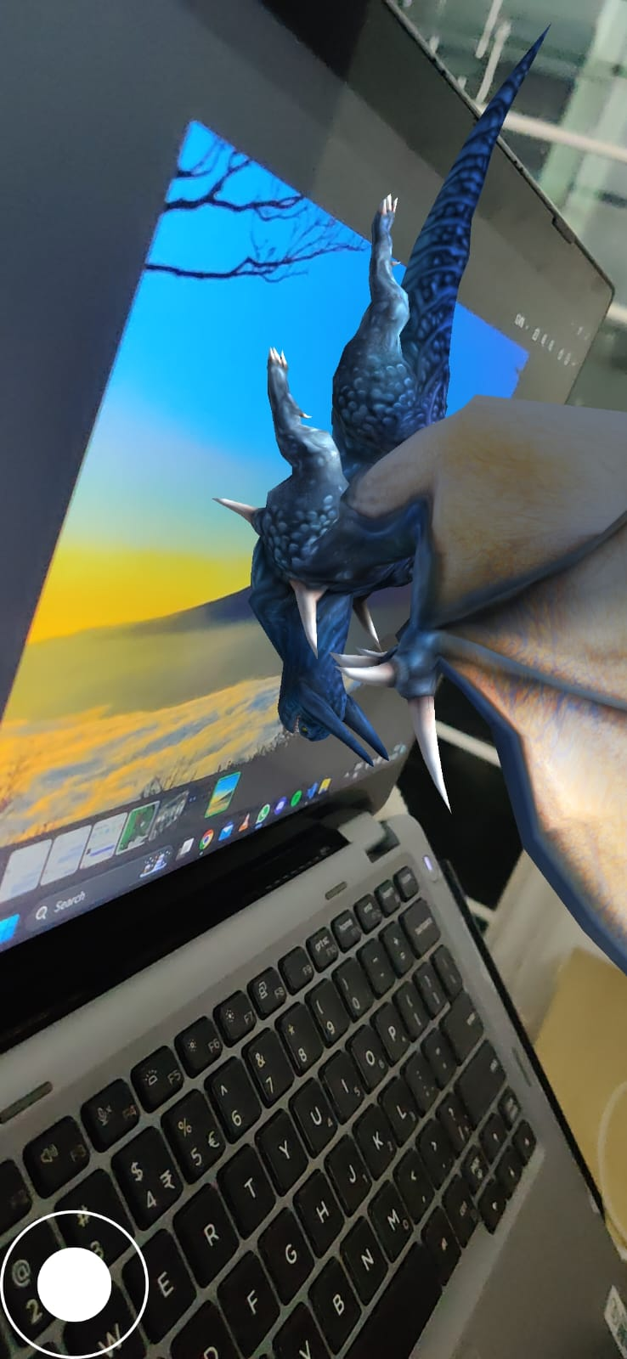

Aditya Sake

SE20UARI006