**A comprehensive benchmarking of WGS-based structural variant callers**

Varuni Sarwal1,2, Sebastian Niehus3,4,Ram Ayyala1,Sei Chang1, Angela Lu1, Nicholas Darci-Maher1, Russell Littman1, Emily Wesel1, Jacqueline Castellanos1, Rahul Chikka1, Margaret G. Distler5, Eleazar Eskin1,6,7, Jonathan Flint5†, Serghei Mangul8,9*†

# **Supplementary Materials**

### 

### **Running SV-detection tool**

Commands required to run each of the tools and the installation details are available in Supplemental Table S5. Matchclips produces two output files with extensions .bam.bp and .bam.bp.weak. We use the files with extension .bam.bp. LUMPY94 was run using smoove, as was recommended by developers of the tool. BioGraph was run by developers of the tool, based on the provided BAM files.

## **Convert the output of the SV-detection tool to a universal format**

We have adopted the VCF format proposed by VCFv4.2, as the universal format used in this study. Custom format of SV-detection tools were converted to VCFv4.2. Description of custom formats is provided in Supplemental Table S6. Scripts to convert custom formats of SV-detection tools to VCFv4.2 are provided at <https://github.com/Mangul-Lab-USC/benchmarking-sv-callers-paper>

## **Compare deletion inferred from WGS data with the gold standard**

We compared the deletions inferred from SV callers from WGS data (inferred deletions) with the molecular-based gold standard (true delations). Start and end position of the deletion were considered when comparing true deletions and inferred deletions. Inferred deletion was considered correctly predicted if the distance of right and left coordinates are within the resolution threshold τ from the coordinates of true deletion. We consider the following values for resolution threshold τ: 0 bp, 10 bp, 100 bp, 1000 bp,10000 bp. Correctly predicted deletions are defined as true positives (TP). In case an inferred deletion matches several true deletions, we randomly choose one of them. Similarly, in case true deletion matches several inferred deletions we randomly choose one of them. The deletion predicted by the SV caller but not present in the golden standard was defined as false positives (FP). Similarly, each deletion present in the gold standard was matched with only one deletion predicted by the software. The SV that was not predicted by the SV caller were defined as false negatives (FN). SV detection accuracy was assessed using various detection thresholds (τ). The accuracy at threshold τ is defined as the percentage of SVs with an absolute error of deletion coordinates smaller or equal to τ. To compute specificity, we have defined non-deletions calls as regions of the genome not containing deletions. We have generated the true set of non-deletions based on the gold standard. Start and end position of the non-deletion were considered when comparing true non-deletions and inferred non-deletions. Inferred non-deletion was considered correctly predicted if the distance of right and left coordinates are within the resolution threshold τ from the coordinates of true non-deletion. We consider the following values for resolution threshold τ: 0 bp, 10 bp, 100 bp, 1000 bp,10000 bp. Correctly predicted non-deletions are defined as true positives (TN).

We have used the following measured to compare the accuracy of SV- allers:

* Sensitivity=TP/(TP+FN)
* Precision=TP/(TP+FP)
* F-score=2*Sensitivity*Precision/(Sensitivity+Precision)
* Specificity= TN/(TN+FP)

The scripts to compare the deletions inferred by the SV caller versus the true deletions is available at <https://github.com/Mangul-Lab-USC/benchmarking-sv-callers-paper>.

**Compare computational performance of SV callers**

The CPU time and RAM of each tool was measured to determine it’s computational performance. The statistics were measured for 1x coverage and full coverage bam files, with samples A_J and BALB_cJ for mouse data. The CPU time was computed using either the GNU time program that is inbuilt in make bash terminals or the Hoffman2 Cluster qsub command. For GNU time, we used this specific command /usr/bin/time -f "%e\t%U\t%S\t%M" which we either had to run manually on an interactive qsub session or through another method that wasn’t a qsub. This GNU time command would output one line containing Wallclock time in seconds, user-time in seconds, kernel-space time in seconds, and peak memory consumption of the process in kilobytes. CPU-time was calculated by adding user-time and kernel-space time. RAM usage was equivalent to peak memory consumption in the case of this command. For qsubs on the Hoffman2 Cluster, we used the command qsub -m e which would email the user a full list of records when the tool finished running. This list included CPU-time and Max Vmem which was designated as RAM usage for each tool.

## **Downsampling the WGS samples**

We have used custom script to downsample the full coverage BAM file to desired coverage. Existing tools (e.g., samtools) are not suitable for this purpose as they treat each read form a read pair independently, resulting in singletons reads in the downsample BAM file.

# **Supplementary Tables**

|  |  |  |  |  |  |  |  |
| --- | --- | --- | --- | --- | --- | --- | --- |
| **ID** | **Tool name** | **Version** | **Year** | **Webpage of the tool** | **Github issue/Email** | **Log file** | **Bioconda** |
|  | 1-2-3SVN/A | N/A | 2012 | [https://github.com/Vityay/1-2-3-SV/](https://github.com/Vityay/1-2-3-SV/issues/1) | <https://github.com/Vityay/1-2-3-SV/issues/1> | [Log](https://github.com/Mangul-Lab-USC/benchmarking-sv-callers-paper/blob/master/installation.logs/1-2-3-SV.txt) | no |
|  | inGAP-sv[41](https://paperpile.com/c/0FJ1wf/2rZ6Y) | 3.1.1 | 2011 | http://ingap.sourceforge.net/ | <https://sourceforge.net/p/ingap/discussion/966200/thread/599197bd71/> | [Log](https://github.com/Mangul-Lab-USC/benchmarking-sv-callers-paper/blob/master/installation.logs/inGAP_logFile.txt) | no |
|  | CNVer[42](https://paperpile.com/c/0FJ1wf/BLtA) | 0.8.1 | 2010 | <http://compbio.cs.toronto.edu/cnver> | [brudno@cs.toronto.edu](mailto:brudno@cs.toronto.edu) | [Log](https://github.com/Mangul-Lab-USC/benchmarking-sv-callers-paper/blob/master/installation.logs/CNVer_logFile.txt) | no |
|  | PRISM[43](https://paperpile.com/c/0FJ1wf/bx5c) | 1.1.6 | 2012 | <http://compbio.cs.toronto.edu/prism/> | [yue.jiang.hit@gmail.com](mailto:yue.jiang.hit@gmail.com) | [Log](https://github.com/Mangul-Lab-USC/benchmarking-sv-callers-paper/blob/master/installation.logs/PRISM_logFile.txt) | no |
|  | Splitread[44](https://paperpile.com/c/0FJ1wf/op6z) | 0.1 | 2011 | <http://splitread.sourceforge.net/> | <https://sourceforge.net/p/splitread/discussion/> | [Log](https://github.com/Mangul-Lab-USC/benchmarking-sv-callers-paper/blob/master/installation.logs/SplitRead_logFile.txt) | no |
|  | NovelSeq[45](https://paperpile.com/c/0FJ1wf/eRJV) | 1.0.2 | 2010 | <http://novelseq.sourceforge.net/Home#hn_Resources> | [cenk@cs.sfu.ca](mailto:cenk@cs.sfu.ca) | [Log](https://github.com/Mangul-Lab-USC/benchmarking-sv-callers-paper/blob/master/installation.logs/logfile_NovelSeq.txt) | no |
|  | Meerkat[46](https://paperpile.com/c/0FJ1wf/Q7eT) | 0.189 | 2013 | <http://compbio.med.harvard.edu/Meerkat/> | [ylixing@gmail.com](mailto:ylixing@gmail.com) | [Log](https://github.com/Mangul-Lab-USC/benchmarking-sv-callers-paper/blob/master/installation.logs/meerkat_logFile.txt) | no |
|  | MoDIL[47](https://paperpile.com/c/0FJ1wf/hmZ1) | 1.1 | 2009 | <http://compbio.cs.toronto.edu/modil/> | [brudno@cs.toronto.edu](mailto:brudno@cs.toronto.edu) | [Log](https://github.com/Mangul-Lab-USC/benchmarking-sv-callers-paper/blob/master/installation.logs/MoDIL_logFile.txt) | no |
|  | PEMer[48](https://paperpile.com/c/0FJ1wf/yX7G) | N/A | 2009 | <http://sv.gersteinlab.org/pemer/> | [korbel@embl.de](mailto:korbel@embl.de) | [Log](https://github.com/Mangul-Lab-USC/benchmarking-sv-callers-paper/blob/master/installation.logs/PEMer_logFile.txt) | no |
|  | SV-Bay[49](https://paperpile.com/c/0FJ1wf/hAUU) | N/A | 2016 | <https://github.com/InstitutCurie/SV-Bay> | N/A | [Log](https://github.com/Mangul-Lab-USC/benchmarking-sv-callers-paper/blob/master/installation.logs/SV-Bay_logFile.log) | no |
|  | iSVP[50](https://paperpile.com/c/0FJ1wf/6eev) | N/A | 2013 | http://nagasakilab.csml.org/en/isvp | N/A | [Log](https://github.com/Mangul-Lab-USC/benchmarking-sv-callers-paper/blob/master/installation.logs/logfile_isvp.txt) | no |
|  | piCALL[51](https://paperpile.com/c/0FJ1wf/TycV) | .01 | 2011 | <https://sites.google.com/site/vibansal/software/picall> | N/A | [Log](https://github.com/Mangul-Lab-USC/benchmarking-sv-callers-paper/blob/master/installation.logs/piCALL_logFile.log) | no |
|  | Dindel[52](https://paperpile.com/c/0FJ1wf/VG9fv) | 1.01 | 2011 | <https://github.com/genome/dindel-tgi> | N/A | [Log](https://github.com/Mangul-Lab-USC/benchmarking-sv-callers-paper/blob/master/installation.logs/dindel_logfile.txt) | no |
|  | SoftSV[53](https://paperpile.com/c/0FJ1wf/1pVhF) | 1.4.2 | 2016 | https://sourceforge.net/projects/softsv/ | https://sourceforge.net/p/softsv/discussion/ | [Log](https://github.com/Mangul-Lab-USC/benchmarking-sv-callers-paper/blob/master/installation.logs/logfile_SoftSV.txt) | no |
|  | SeqSeq[54](https://paperpile.com/c/0FJ1wf/ChtCc) | N/A | 2012 | N/A | [sd_bao@sina.com](mailto:sd_bao@sina.com) | [Log](https://github.com/Mangul-Lab-USC/benchmarking-sv-callers-paper/blob/master/installation.logs/logfile_SeqSeq.txt) | no |
|  | ClipCrop[55](https://paperpile.com/c/0FJ1wf/yC7Vg) | N/A | 2011 | https://github.com/shinout/clipcrop | N/A | [Log](https://github.com/Mangul-Lab-USC/benchmarking-sv-callers-paper/blob/master/installation.logs/logfile_ClipCrop.txt) | no |
|  | SplazerS[56](https://paperpile.com/c/0FJ1wf/Pdyu4) | 2.4.0 | 2012 | <https://github.com/seqan/seqan/tree/master/apps/splazers> | [emde@inf.fu-berlin.de](mailto:emde@inf.fu-berlin.de) | [Log](https://github.com/Mangul-Lab-USC/benchmarking-sv-callers-paper/blob/master/installation.logs/SplazerS_logFile.txt) | no |
|  | TIGRA[57](https://paperpile.com/c/0FJ1wf/bnIY9) | 0.4.0 | 2014 | http://odin.mdacc.tmc.edu/~kchen3/tigra/tigra-0.4.0.tar.gz | [kchen3@mdanderson.org](mailto:kchen3@mdanderson.org) | [Log](https://github.com/Mangul-Lab-USC/benchmarking-sv-callers-paper/blob/master/installation.logs/tigra_logFile.txt) | no |
|  | Read-Depth (CND)[58](https://paperpile.com/c/0FJ1wf/3TJ8K) | N/A | 2010 | N/A | [rd@sanger.ac.uk](mailto:rd@sanger.ac.uk) | [Log](https://github.com/Mangul-Lab-USC/benchmarking-sv-callers-paper/blob/master/installation.logs/Read-Depth(CND)_logfile.txt) | no |
|  | JointSLM[59](https://paperpile.com/c/0FJ1wf/9aE4P) | N/A | 2011 | https://omictools.com/jointslm-tool | [albertomagi@gmail.com](mailto:albertomagi@gmail.com) | [Log](https://github.com/Mangul-Lab-USC/benchmarking-sv-callers-paper/blob/master/installation.logs/logfile_JointSLM.txt) | no |
|  | CNAseg[60](https://paperpile.com/c/0FJ1wf/M9paB) | 1.0 | 2010 | [Broken Link](http://www.compbio.group.cam.ac.uk/software.html) | [Sergii.Ivakhno@cancer.org.uk](mailto:Sergii.Ivakhno@cancer.org.uk) | [Log](https://github.com/Mangul-Lab-USC/benchmarking-sv-callers-paper/blob/master/installation.logs/CNAseg_logFile.txt) | no |
|  | GASVPro[61](https://paperpile.com/c/0FJ1wf/sQBSA) | 0.9 | 2012 | https://storage.googleapis.com/google-code-archive-downloads/v2/code.google.com/GASV/GASVProVersion0.9.tar.gz | [Suzanne_Sindi@Brown.edu](mailto:Suzanne_Sindi@Brown.edu) | [Log](https://github.com/Mangul-Lab-USC/benchmarking-sv-callers-paper/blob/master/installation.logs/gasv-pro_logFile.txt) | no |
|  | SVMerge[62](https://paperpile.com/c/0FJ1wf/bdLGO) | 1.2r37 | 2010 | https://sourceforge.net/projects/svmerge/files/latest/download?source=files | <https://sourceforge.net/p/svmerge/discussion/1199306/thread/1e781e3143/> | [Log](https://github.com/Mangul-Lab-USC/benchmarking-sv-callers-paper/blob/master/installation.logs/SVMerge_logFile.txt) | no |
|  | BIC-seq2[63](https://paperpile.com/c/0FJ1wf/ZKswl) | 0.2.4  0.7.2 | 2016 | <http://compbio.med.harvard.edu/BIC-seq/NBICseq-norm_v0.2.4.tar.gz/>  http://compbio.med.harvard.edu/BIC-seq/NBICseq-seg_v0.7.2.tar.gz | [peter_park@harvard.edu](mailto:peter_park@harvard.edu) | [Log](https://github.com/Mangul-Lab-USC/benchmarking-sv-callers-paper/blob/master/installation.logs/BIC-seq_logFile.txt) | no |
|  | SVM2[64](https://paperpile.com/c/0FJ1wf/1vyaB) | 1.2 | 2012 | <https://www.ncbi.nlm.nih.gov/pmc/articles/PMC3467043/> | N/A | [Log](https://github.com/Mangul-Lab-USC/benchmarking-sv-callers-paper/blob/master/installation.logs/SVM2_logfile.txt) | no |
|  | Bellerophon[65](https://paperpile.com/c/0FJ1wf/d0lmN) | N/A | 2013 | <http://cbc.case.edu/Bellerophon/> | [jingli@case.edu](mailto:jingli@case.edu) | [Log](https://github.com/Mangul-Lab-USC/benchmarking-sv-callers-paper/blob/master/installation.logs/bellerophon_logfile.txt) | no |
|  | SMUFIN[66](https://paperpile.com/c/0FJ1wf/TsRD) | 0.9.4 | 2014 | http://cg.bsc.es/smufin/ | <http://cg.bsc.es/smufin/> | [Log](https://github.com/Mangul-Lab-USC/benchmarking-sv-callers-paper/blob/master/installation.logs//SMuFin_logfile.txt) | no |
|  | falconN/A | 2018.31.08-03.06-py2.7-ucs4-beta | 2015 | https://github.com/PacificBiosciences/FALCON | N/A | [Log](https://github.com/Mangul-Lab-USC/benchmarking-sv-callers-paper/blob/master/installation.logs/falcon_logfile.txt) | yes |
|  | modSaRa  New version[67](https://paperpile.com/c/0FJ1wf/fclbL) | 1.0 | 2017 | https://publichealth.yale.edu/c2s2/software/modSaRa/ | [heping.zhang@yale.edu](mailto:heping.zhang@yale.edu) | [Log](https://github.com/Mangul-Lab-USC/benchmarking-sv-callers-paper/blob/master/installation.logs/modSaRa_logFile.txt) | no |
|  | readDepth[68](https://paperpile.com/c/0FJ1wf/MQtn) | 0.9.8.4 | 2015 | https://github.com/chrisamiller/readDepth | N/A | [Log](https://github.com/Mangul-Lab-USC/benchmarking-sv-callers-paper/blob/master/installation.logs/readDepth_logfile.txt) |  |
|  | freec[21](https://paperpile.com/c/0FJ1wf/mfJCc) | 11.5 | 2016 | https://github.com/BoevaLab/FREEC | N/A | [Log](https://github.com/Mangul-Lab-USC/benchmarking-sv-callers-paper/blob/master/installation.logs/freec_logfile.txt) |  |
|  | ioncopy[69](https://paperpile.com/c/0FJ1wf/bnsB) | 2.1.1 | 2018 | https://cran.r-project.org/web/packages/ioncopy/index.html | <https://github.com/cran/ioncopy/issues/1> | [Log](https://github.com/Mangul-Lab-USC/benchmarking-sv-callers-paper/blob/master/installation.logs/Ioncopy_logFile.txt) | no |
|  | SVmine[70](https://paperpile.com/c/0FJ1wf/dfOKx) | 2.0 | 2017 | https://github.com/xyc0813/SVmine | https://github.com/xyc0813/SVmine/issues/2 | [Log](https://github.com/Mangul-Lab-USC/benchmarking-sv-callers-paper/blob/master/installation.logs/SVmine.txt) | no |
| 34. | genomeSTRIP[71](https://paperpile.com/c/0FJ1wf/DNKHe) | 2.0 | 2015 | http://software.broadinstitute.org/software/genomestrip/ |  | [Log](https://github.com/Mangul-Lab-USC/benchmarking-sv-callers-paper/blob/master/installation.logs/genomestrip_LogFile.txt) | Yes |
| 35. | CNVnator[72](https://paperpile.com/c/0FJ1wf/T59SF) | 0.4.1 | 2014 | <https://github.com/abyzovlab/CNVnator> | N/A | [Log](https://github.com/Mangul-Lab-USC/benchmarking-sv-callers-paper/blob/master/installation.logs/CNVnator_logfile.txt) | No |
| 36. | Hydra-Multi[73](https://paperpile.com/c/0FJ1wf/W4e3) | 0.5.2 | 2015 | <https://github.com/arq5x/Hydra> | N/A | [Log](https://github.com/Mangul-Lab-USC/benchmarking-sv-callers-paper/blob/master/installation.logs/hydra-sv_logFile.txt) | No |
| 37. | cnmops[74](https://paperpile.com/c/0FJ1wf/IYSjt) | 1.26.0 | 2012 | http://www.bioinf.jku.at/software/cnmops/ | N/A | [Log](https://github.com/Mangul-Lab-USC/benchmarking-sv-callers-paper/blob/master/installation.logs/cn.MOPS_logFile.txt) | Yes |
| 38. | breakseek[75](https://paperpile.com/c/0FJ1wf/PcEUt) | 1.2 | 2015 | <https://sourceforge.net/projects/breakseek/> | <https://sourceforge.net/p/breakseek/discussion/general/thread/4cc99d0a/> | [Log](https://github.com/Mangul-Lab-USC/benchmarking-sv-callers-paper/blob/master/installation.logs/breakseek_logfile.txt) | no |
| 39. | fermikit[76](https://paperpile.com/c/0FJ1wf/Rf5qo) | 0.13 | 2015 | <https://github.com/lh3/fermikit/> | <https://github.com/lh3/fermikit/issues/20> | [Log](https://github.com/Mangul-Lab-USC/benchmarking-sv-callers-paper/blob/master/installation.logs/logfile_FermiKit.txt) | yes |
| 40. | breakseq[77](https://paperpile.com/c/0FJ1wf/eHkEP) | 1.3 | 2009 | <http://sv.gersteinlab.org/breakseq/> | N/A | [Log](https://github.com/Mangul-Lab-USC/benchmarking-sv-callers-paper/blob/master/installation.logs/breakseq_logFile.txt) | No |
| 42. | tardis[78](https://paperpile.com/c/0FJ1wf/ECht) | 1.0.19 | 2018 | https://github.com/BilkentCompGen/tardis | N/A | [Log](https://github.com/Mangul-Lab-USC/benchmarking-sv-callers-paper/blob/master/installation.logs/tardis_logfile.txt) | Yes |
| 43. | CREST[79](https://paperpile.com/c/0FJ1wf/hy1be) | 1.0 | 2011 | https://www.stjuderesearch.org/site/lab/zhang | n/a | [Log](https://github.com/Mangul-Lab-USC/benchmarking-sv-callers-paper/blob/master/installation.logs/crest_logfile.txt) | No |

## 

## **Table S1.** Existing methods to detect structural variants which failed to be installed. If github was available, we have opened the issue. Otherwise, email was sent to the corresponding authors of the paper.

# 

|  |  |  |  |  |
| --- | --- | --- | --- | --- |
| **Strain name** | **Total number of gold standard deletions** | **Average deletion length** | **Minimum deletion length** | **Maximum**  **deletion length** |
| A/J | 533 | 1968 | 15 | 239572 |
| AKR/J | 504 | 1400 | 13 | 24301 |
| BALB/cJ | 545 | 1947 | 15 | 239572 |
| C3H/HeJ | 539 | 1993 | 15 | 239572 |
| DBA/2J | 609 | 1301 | 16 | 24301 |
| LP/J | 483 | 1534 | 13 | 24301 |
| CBA/J | 586 | 1330 | 24 | 24301 |

## Table S2. Gold standard deletion calls from chromosome 19 from 7 inbred mouse strains.

|  |  |  |  |  |  |  |
| --- | --- | --- | --- | --- | --- | --- |
| **Strain name** | **Total number PE reads** | **Number of reads mapped reads** | **Number of reads mapped to chr 19** | **Number of discordant reads (chr19)** | **Number of multi-mapped reads (chr19)** | **Average coverage (chr19)** |
| A_J | 691798369 | 15097330 | 14903814 | 97469 | 14765316 | 48.52 |
| AKR_J | 758992189 | 16205276 | 15814814 | 66938 | 16205276 | 51.49 |
| BALB_cJ | 828502183 | 17292403 | 17093309 | 106915 | 17292403 | 55.65 |
| C3H_HeJ | 828898555 | 17293104 | 17093572 | 77254 | 17293104 | 55.65 |
| CBA_J | 736613128 | 15517147 | 15343318 | 67076 | 15517147 | 49.95 |
| DBA_2J | 738506916 | 14860907 | 14690187 | 72075 | 14860907 | 47.83 |
| LP_J | 703108275 | 14331024 | 14176319 | 60233 | 14331024 | 46.15 |
| Total | 5286419615 | 110597191 | 109,115,333 | 547960 | 110265177 | 50.75 |

## **Table S3.** Information about WGS data obtained for seven inbred mouse strains.

|  |  |  |  |  |  |
| --- | --- | --- | --- | --- | --- |
| **S.No** | **Tool name** | **Version** | **Year** | **Webpage** | **Reason the tools was excluded** |
| 1. | GATK[90](https://paperpile.com/c/0FJ1wf/5Xs8) | 4.1.6.0 | 2010 | <https://github.com/broadinstitute/gatk> | designed to detect only small SVs (less than 50 bp in length) |
| 2. | rSW-seq[88](https://paperpile.com/c/0FJ1wf/CZAh) | N/A | 2010 | <https://bioinformaticshome.com/tools/cnv/descriptions/rSW-seq.html> | designed to detect SVs in tumor-normal samples |
| 3. | Variation Hunter[83](https://paperpile.com/c/0FJ1wf/b8DQ) | 0.04 | 2010 | <http://variationhunter.sourceforge.net/> | replaced with TARDIS |
| 4. | inGAP-SV[41](https://paperpile.com/c/0FJ1wf/2rZ6Y) | 3.1.1 | 2011 | http://ingap.sourceforge.net/ | utilizes a GUI, hence command line tasks with many datasets would not be viable for benchmarking |
| 1.5. | COPS[87](https://paperpile.com/c/0FJ1wf/OwBE) | N/A | 2012 | [ftp://115.119.160.213](https://115.119.160.213/)  username: cops  password:cops | designed to detect SVs in tumor-normal samples |
| 6. | Magnolya[27](https://paperpile.com/c/0FJ1wf/6T3Tu) | 0.15 | 2012 | <https://sourceforge.net/projects/magnolya/files/> | unable to process aligned WGS data |
| 7. | Varscan[92](https://paperpile.com/c/0FJ1wf/D6yB) | 2.3.9 | 2012 | <https://sourceforge.net/projects/varscan/files/> | designed to detect only small SVs (less than 50 bp in length) |
| 8. | Patchwork[86](https://paperpile.com/c/0FJ1wf/oxJa) | 2.4 | 2013 | <http://patchwork.r-forge.r-project.org/> | designed to detect SVs in tumor-normal samples |
|  | PBHoney-NGM[82](https://paperpile.com/c/0FJ1wf/Fdye) | 13.10 | 2014 | <https://sourceforge.net/projects/pb-jelly/> | uses long-read sequencing data |
| 9. | Platypus[91](https://paperpile.com/c/0FJ1wf/rlf9) | 0.8.1 | 2014 | <https://github.com/andyrimmer/Platypus> | designed to detect only small SVs (less than 50 bp in length) |
| 10. | seqCBS[89](https://paperpile.com/c/0FJ1wf/B7fP) | 1.2.1 | 2014 | <https://cran.r-project.org/web/packages/seqCBS/index.html> | designed to detect SVs in tumor-normal samples |
| 11. | Socrates[85](https://paperpile.com/c/0FJ1wf/tUcp) | 1.1 | 2014 | <http://bioinf.wehi.edu.au/socrates/>  <https://github.com/jibsch/socrates> | replaced with GRIDSS, as the toolmaker who developed both suggested GRIDSS for SV detection |
| 12. | Hydra[84](https://paperpile.com/c/0FJ1wf/KmQj) | N/A | 2015 | [http://web.engr.illinois.edu/∼mkim158/HyDRA.zip](http://web.engr.illinois.edu/~mkim158/HyDRA.zip) | replaced with LUMPY |
| 13. | Bic-seq [63](https://paperpile.com/c/0FJ1wf/ZKswl) | 0.2.4 | 2016 | <http://compbio.med.harvard.edu/BIC-seq/> | designed to detect SVs in tumor-normal samples |
| 14. | Control-FREEC[21](https://paperpile.com/c/0FJ1wf/mfJCc) | 11.5 | 2016 | https://github.com/BoevaLab/FREEC | It only accepts only GZ format and no longer supports bam files (starting with from version 8.0) |
| 15. | Manta[80](https://paperpile.com/c/0FJ1wf/baLC) | 1.6.0 | 2016 | https://github.com/Illumina/manta | It only detects medium-sized indels and large insertions and it not suitable to simultaneously detect small and large deletions |
| 16. | NanoSV[81](https://paperpile.com/c/0FJ1wf/41l5) | 1.2.4 | 2017 | <https://github.com/mroosmalen/nanosv> | uses long-read sequencing data |
| 17. | Sniffles96 | 1.0.8 | 2018 | https://github.com/fritzsedlazeck/Sniffles | Designed for long reads |

## 

## **Table S4.** Tools excluded from analysis.

|  |  |  |
| --- | --- | --- |
| **S.No** | **Tool Name** | **Command** |
| 1. | BreakDancer32 | bam2cfg.pl $input | BreakDancer-max > ${outdir}/${filename}.vcf |
| 2. | CLEVER30 | ./CLEVER --sorted --use_xa data.bam ref.fa output |
| 3. | DELLY31 | DELLY call -g example/reference.fa -t DEL example/alignments.bam -o DELLY.output//alignments.bam.bcf |
| 4. | GASV38 | java -Xms512m -Xmx2048m -jarGASV/bin/BAMToGASV.jar data.bam |
| 5. | indelMINER29 | $toolname $reference sample=$alignments > ${outdir}/${toolName}_${filename}.vcf |
| 6. | MiStrVar40 | python3 ${toolname} \  -p ${filename} \  -r /u/scratch/r/ramayyal/reference_genome/full_bams/mouseBAM/chr19.fa \  --files alignment=${input}  awk 'NR<12 {print$0}' $filename/${filename}.vcf| cat >> $filename/${toolName}.${filename}.modified.vcf  grep "DEL" $filename/${filename}.vcf | awk 'NR>11 {split($8,a,"="); split($8,b,";");print "19"" "$2" ""."" ""."" ""<DEL>"" ""."" "$7" "b[1]";""SVLEN="a[3]-$2";"b[2]}' | cat >> $filename/${toolName}.${filename}.modified.vcf |
| 7. | Pindel39 | samtools view ../example/A_J.chr19.2.5p_sorted.bam | sam2Pindel - A_J.chr19.2.5p_sorted.bam.Pindeloutput.txt 300 tomour 0 >> Pindel.output/report_Pindel.A_J.chr19.2.5p_sorted.bam.log 2>&1 |
| 8. | Smoove | smoove call -x --outdir $out --name $batchName --fasta $reference.fa --p $threads --genotype $sample1.bam [$sample2.bam ...] |
| 9. | GRIDSS39 | GRIDSS.sh -j GRIDSS.jar -a $tmp/assembly -w $tmp/workdir --jvmheap 8g -r $reference.fa -t 1 -o $out/example.vcf.gz $sample1.bam [$sample2-bam ...] ;  Rscript --vanilla annotate.R $out/example.vcf.gz >(gzip -9 -c > out/example.annotated.vcf.gz) |
| 10. | PopDel93 | popdel profile -o $out/sampleX.profile -mrg -n 1000 -i $samplingRegions.bed sampleX.bam 19;  popdel call $sample_profile_location -o $out/example.vcf -r 19 |
| 11. | RDXplorer95 | python ${toolname} ${path2bam} ${reference} ${wrkgdir} ${chromOfInterest} ${gender} ${hg} ${winSize} ${baseCopy} ${filter} ${sumWithZero} ${debug} ${delete}  awk '{ if ($3 =="1") print $8" "$9" ""."" ""."" ""<DEL>"" ""."" ""PASS"" ""SVTYPE=DEL;SVLEN="$10-$9";END="$10}' chr19.sum |
| 12. | Biograph* | N/A |

## **Table S5.** Commands used to run the tools and produce an output vcf file with predicted deletions using a reference (FASTA format) and aligned reads (BAm format) file as input arguments.

|  |  |  |  |
| --- | --- | --- | --- |
| **S.No** | **Tool Name** | **Output type** | **Description of the format** |
| 1. | BreakDancer32 | Custom | Start, end, type, length |
| 2. | CLEVER30 | Custom | VCFv4.1 |
| 3. | DELLY31 | Custom | VCFv4.2 |
| 4. | GASV38 | Custom | Start, end, type |
| 5. | indelMINER29 | VCF | VCFv4.1 |
| 6. | LUMPY94 | VCF | VCFv4.2 |
| 7. | MiStrVar40 | VCF | VCFv4.2 |
| 8. | Pindel39 | Custom | Start,end |
| 9. | BioGraph* | VCF | VCFv4.2 |
| 10. | GRIDSS39 | VCF | VCFv4.2 |
| 11. | Popdel93 | VCF | VCFv4.3 |
| 12. | RDXplorer95 | Custom | Start, end, length |

## **Table S6.** Output format of different tools

## 

# **Supplementary Figures**

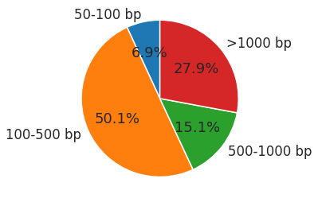

**Figure S1** Total number of deletions across seven mouse strains split across categories defined based on deletion length

a)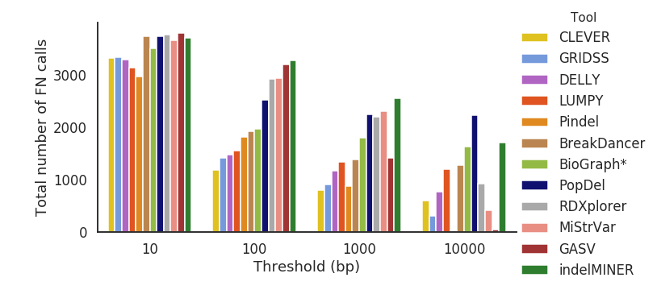

## b)

## Figure S2. (a) Total number of FN calls for different error thresholds across 7 different mouse strains (b) Total number of FP calls for different error thresholds across 7 different mouse strains

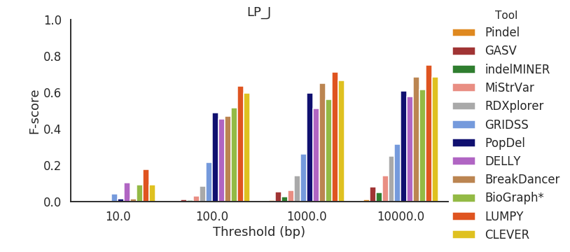

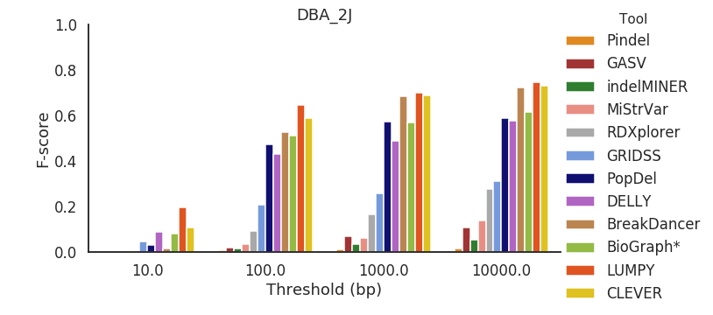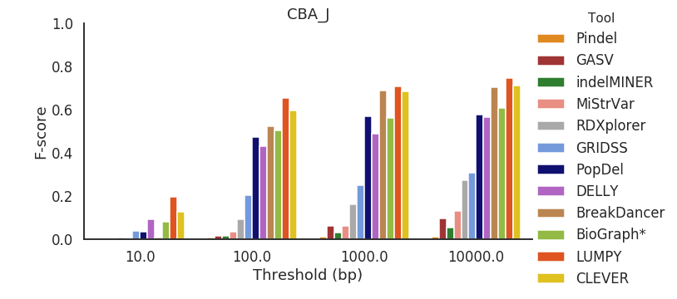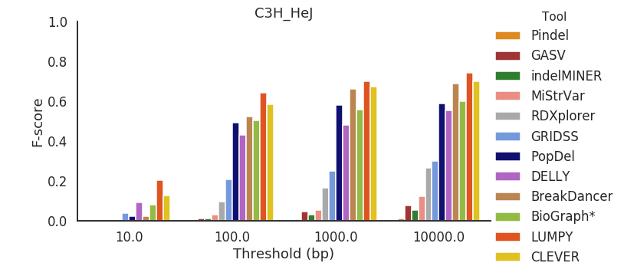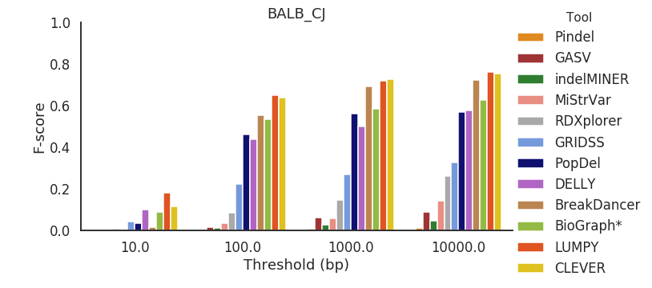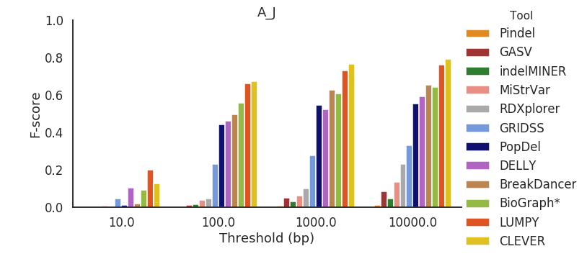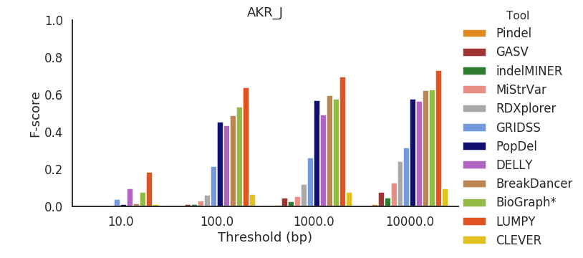

## Figure S3. F-score presented for each mouse strain across all error thresholds.

## 

## Figure S4. Precision presented for each mouse strain across all error thresholds.

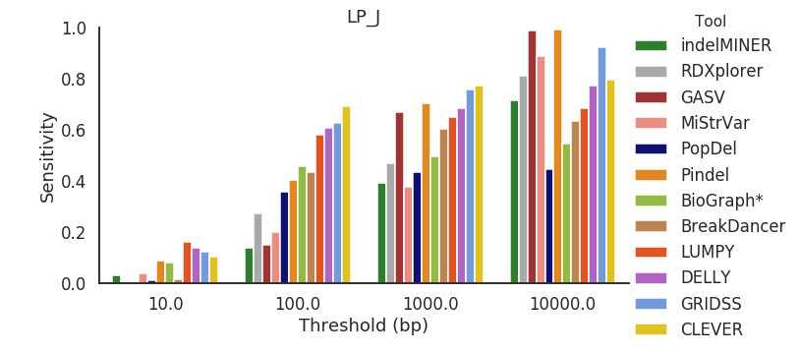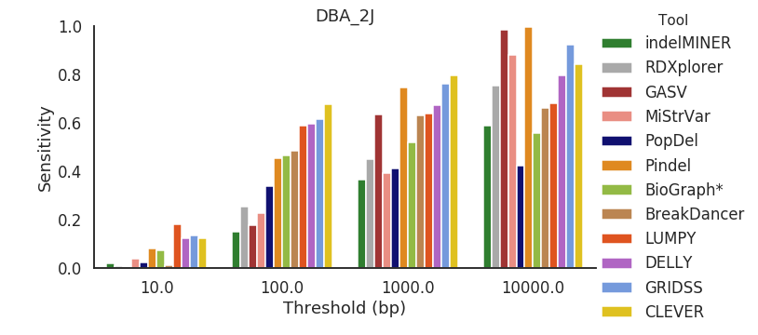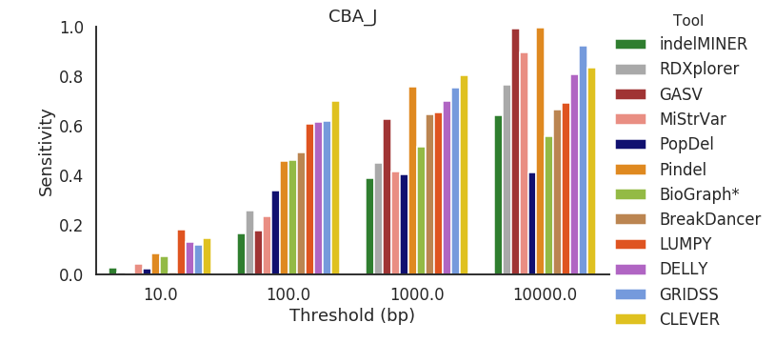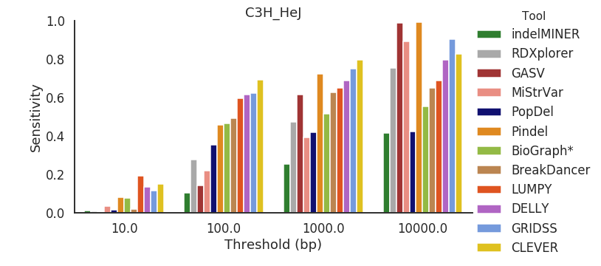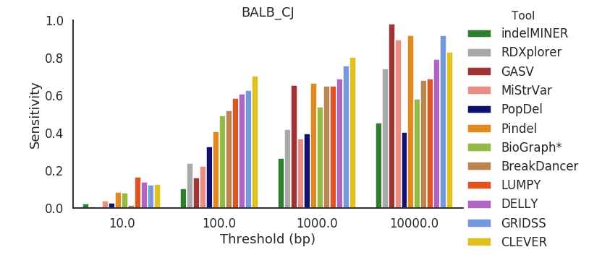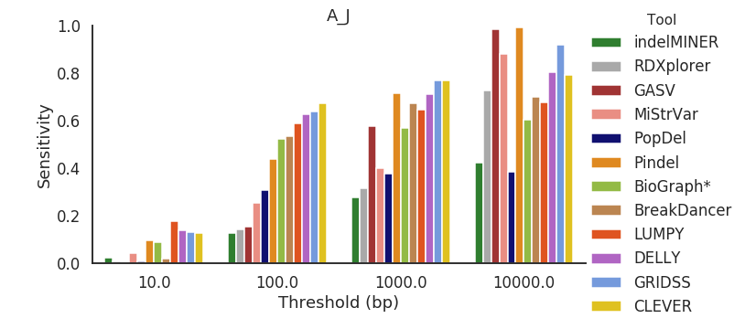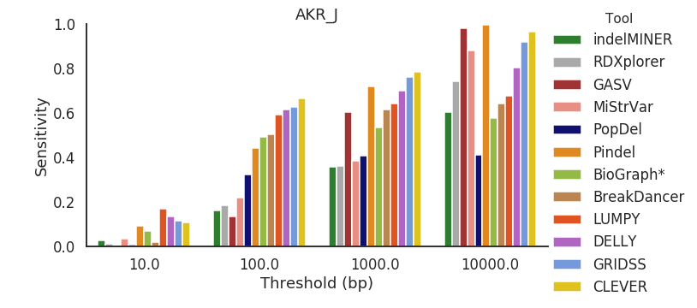

Figure S5. Sensitivity presented for each mouse strain across all error thresholds.

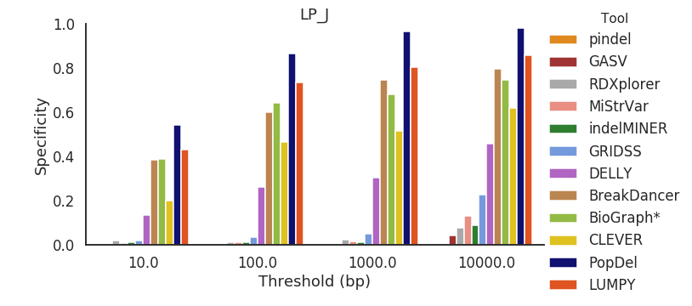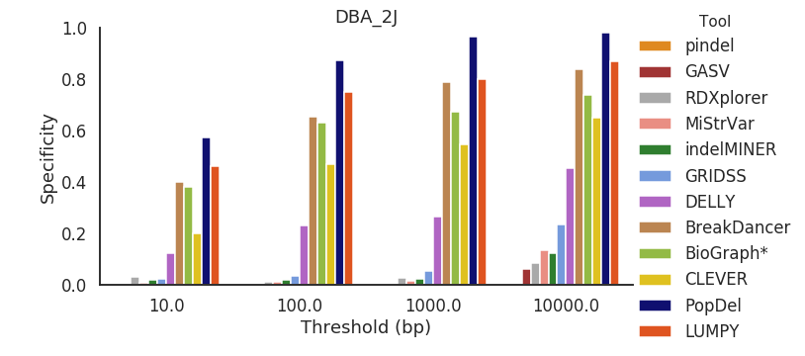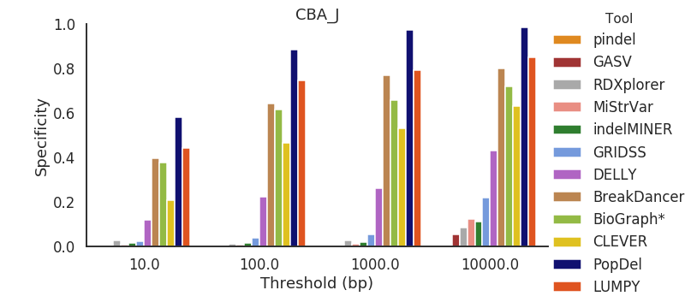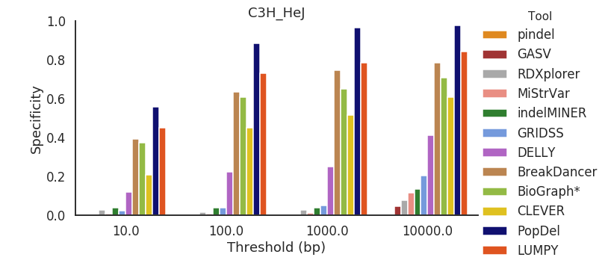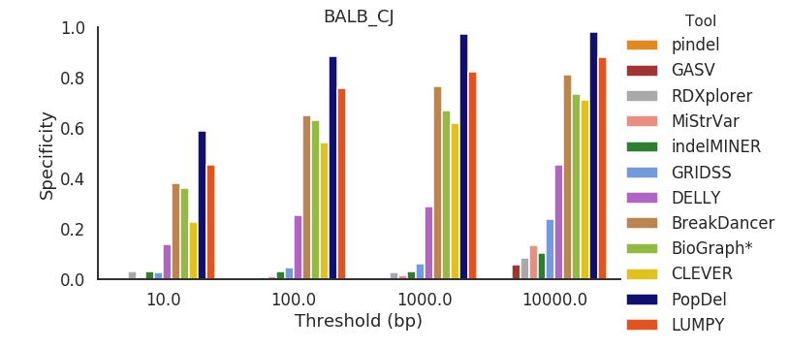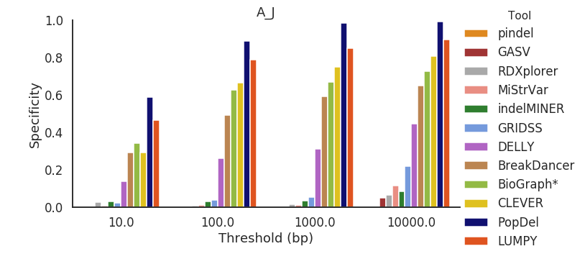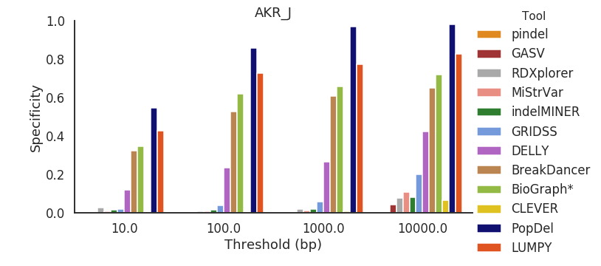

Figure S6. Specificity presented for each mouse strain across all error thresholds.

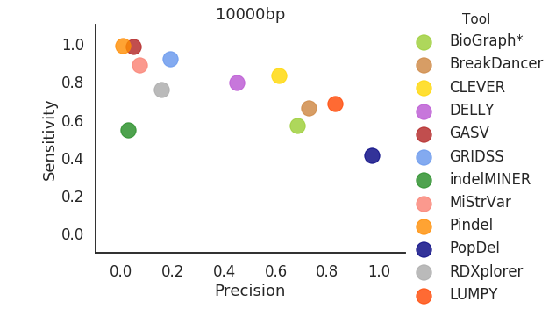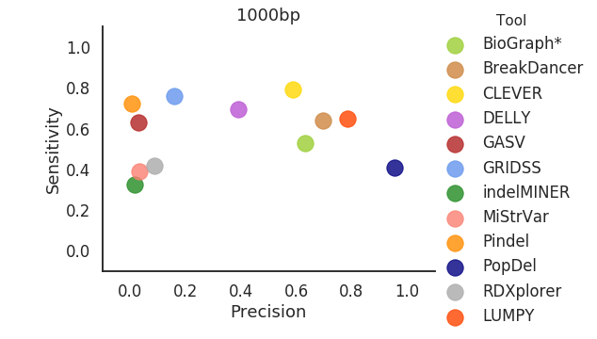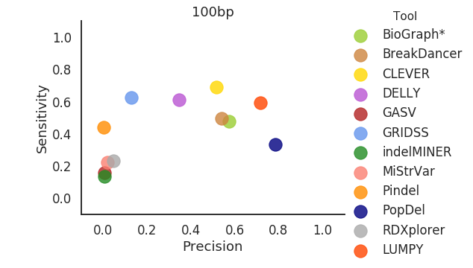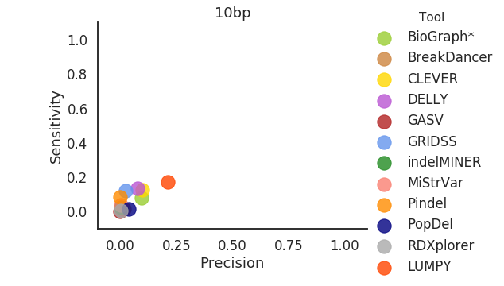

Figure S7. **S**catter plot depicting the Precision (x-axis) and Sensitivity (y-axis) for 10000 bp, 1000 bp, 100 bp, and 10 bp thresholds.

### 

### Figure S8. Scatter plot depicting the Precision (x-axis) vs Specificity (y-axis) for 10000 bp, 1000 bp, 100 bp, and 10 bp thresholds with Spearman’s correlation and p-values (0.82,0.0003; 0.94,4.44e-07; 0.9472527, 2.77e-07; 0.951648, 1.66e-07)

respectively

### 

(a)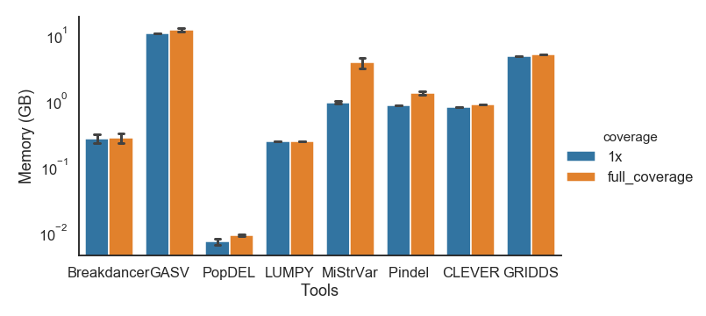

(b) 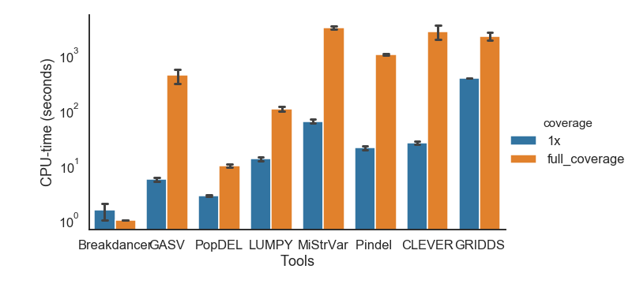

## 

## Figure S9. Comparison of computational performance of SV callers. (a) A bar-plot depicting the RAM usage across all of the tools in Table 1. (b) A bar-plot depicting the CPU-time across all of the tools in Table 1.

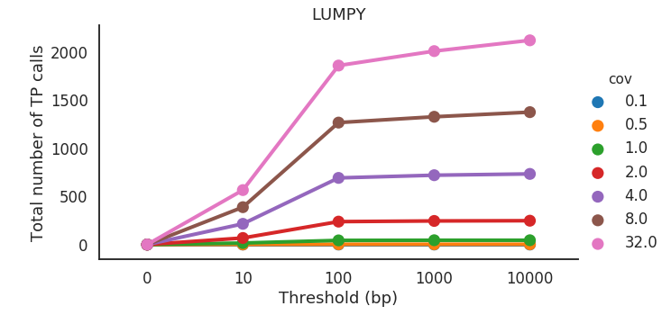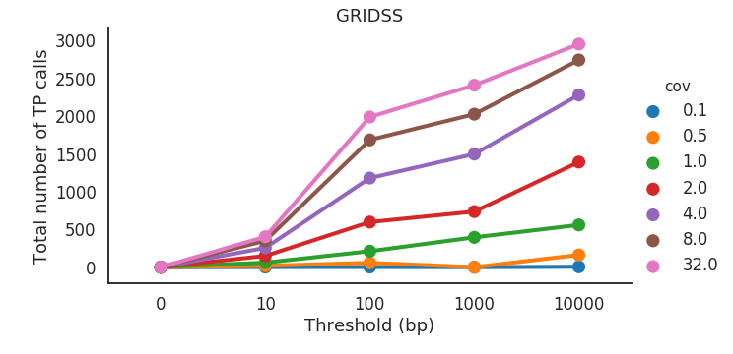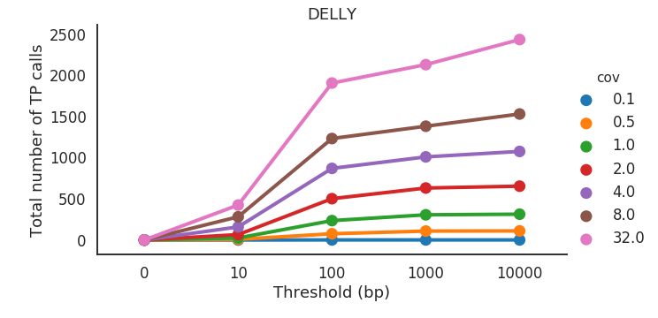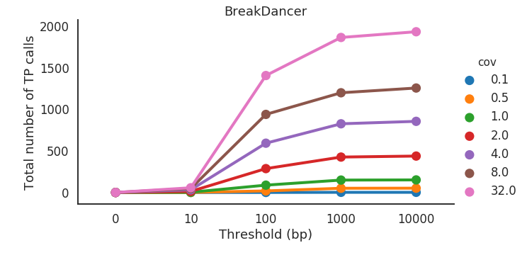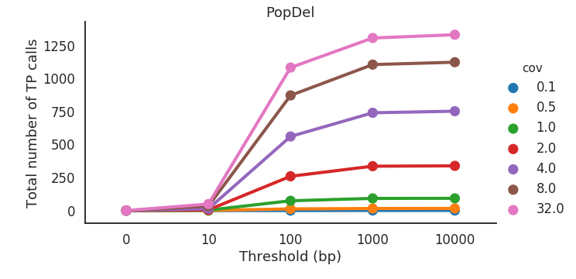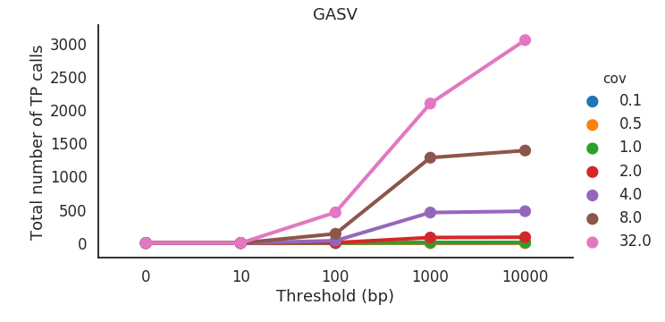

Figure S10**.** Number of correctly detected deletions (true positives - ‘TP’) by SV callers across various thresholds and genome coverages . Deletion is considered to be correctly predicted if the distance of right and left coordinates are within the given threshold from the coordinates of true deletion.

(a)

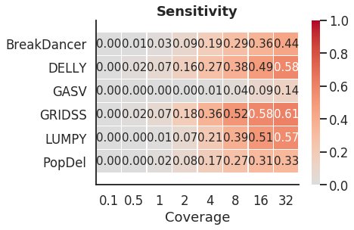

(b)

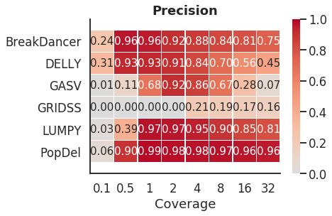

(c)

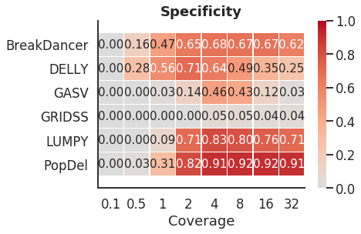

(d)

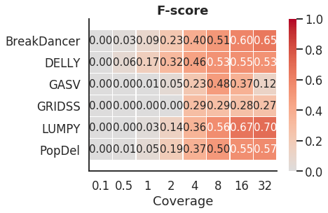

Figure S11. (a) Heatmap depicting the sensitivity based on 1000 bp threshold across various levels of coverage. (b) Heatmap depicting the precision based on 1000 bp threshold across various levels of coverage. (c) Heatmap depicting the specificity based on 1000 bp threshold across various levels of coverage. (d) Heatmap depicting the F-score based on 1000 bp threshold across various levels of coverage.

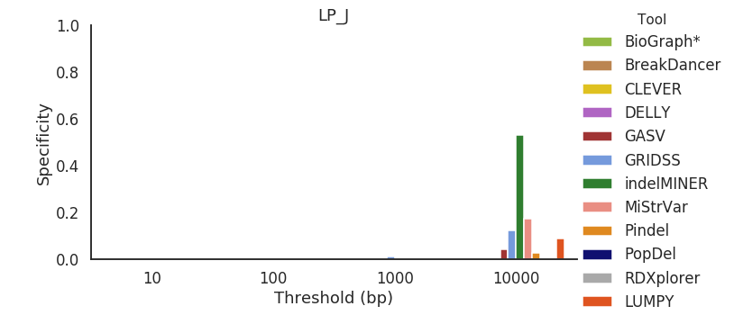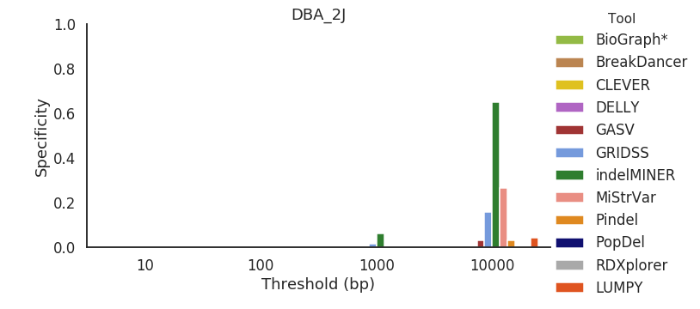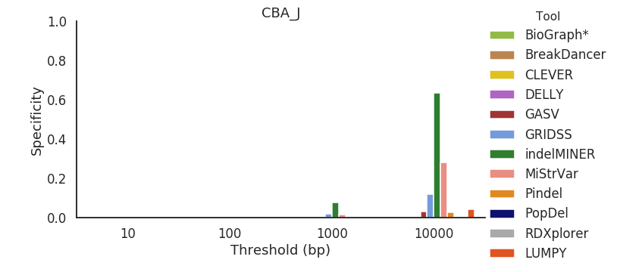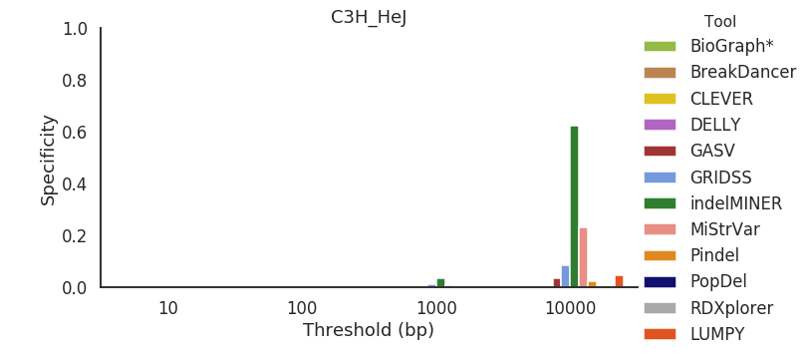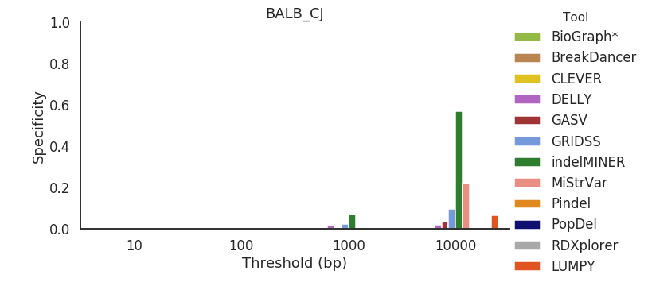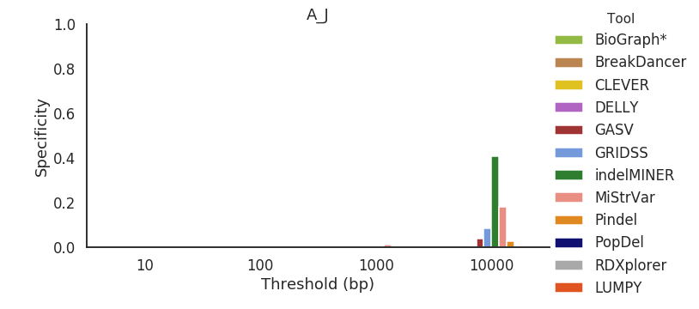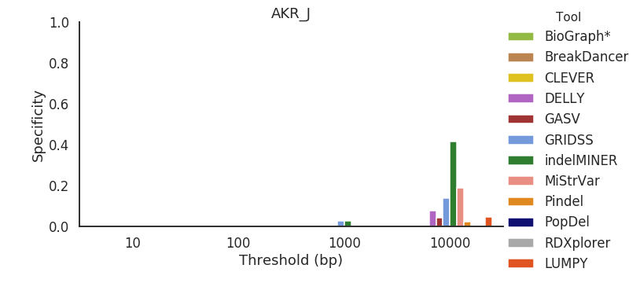

Figure S12. Specificity across all mouse strains for deletions between 50 bp and 100 bp in length.

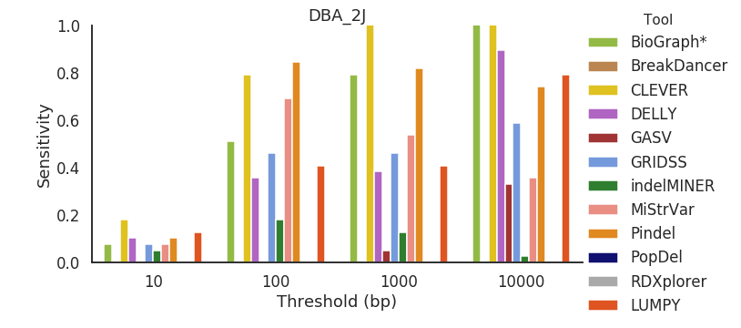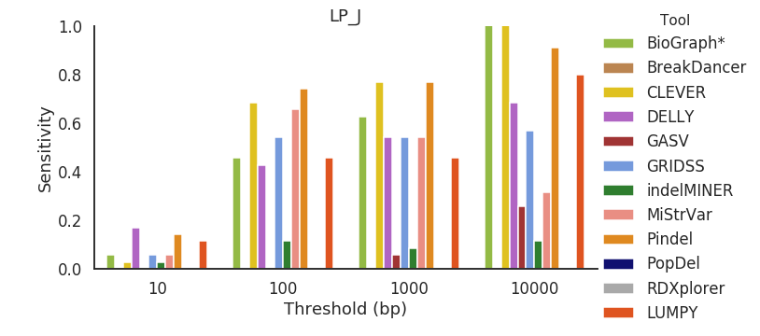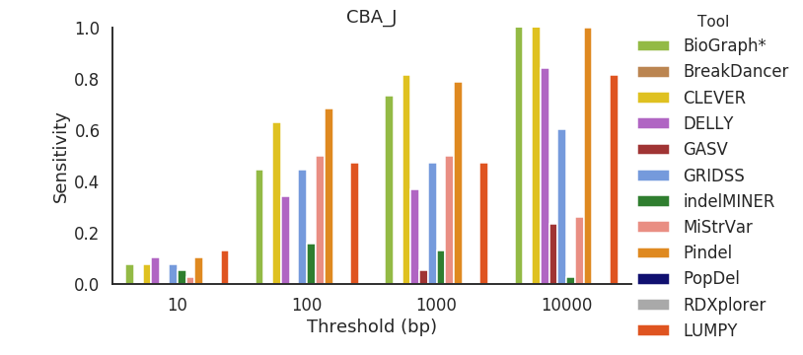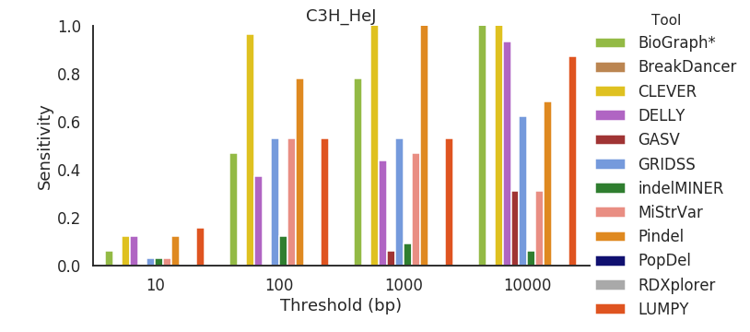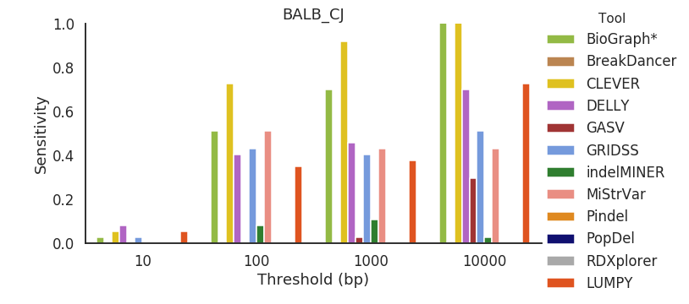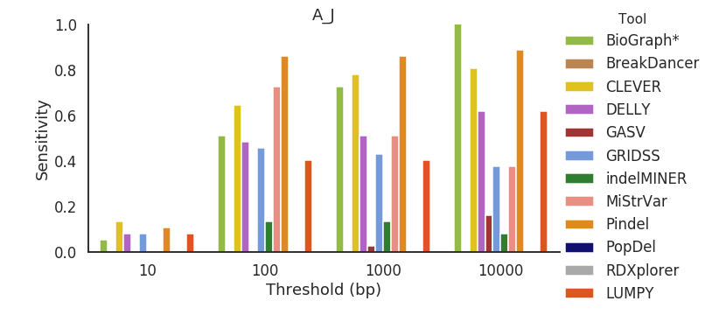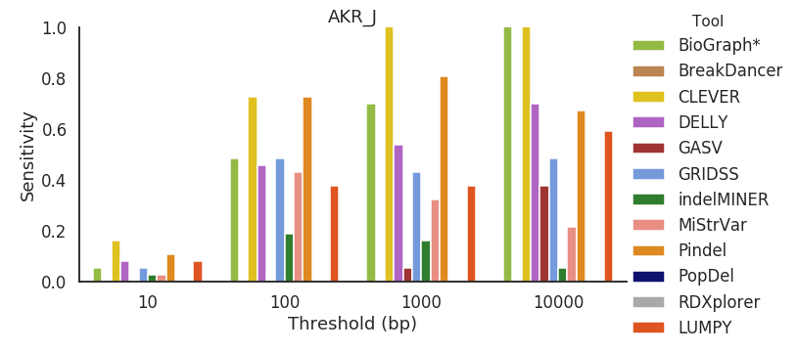

Figure S13. Sensitivity across all mouse strains for deletions between 50 bp and 100 bp in length.

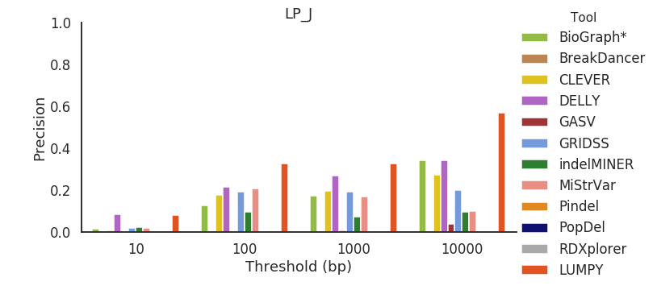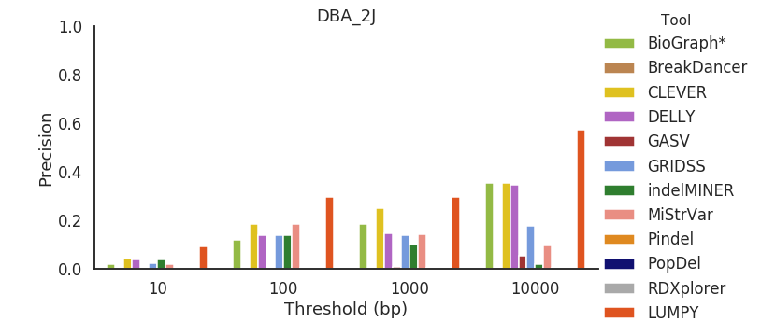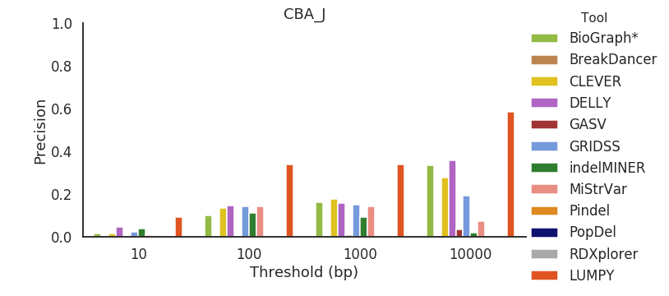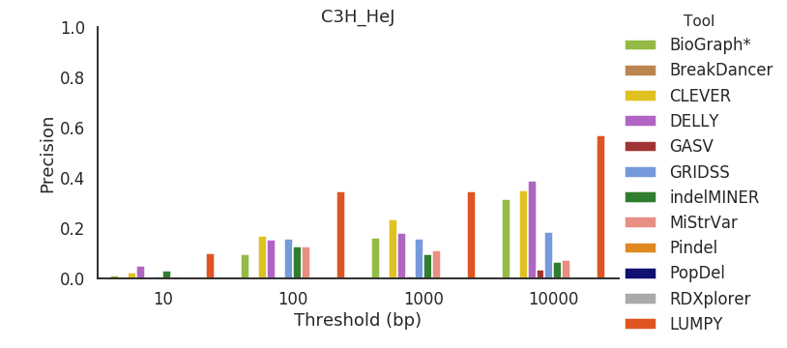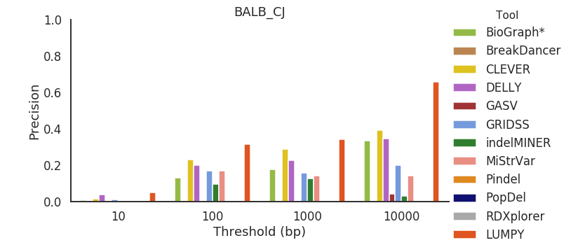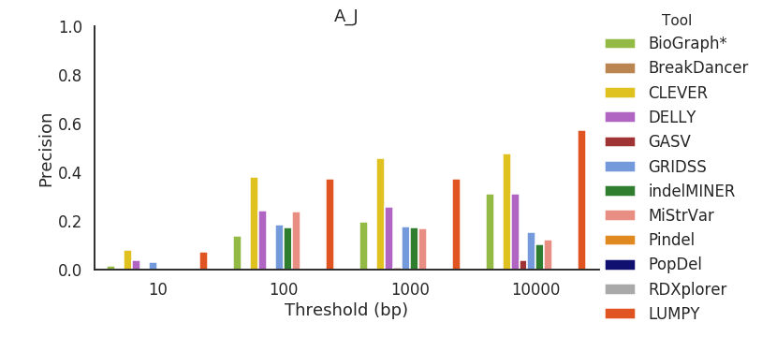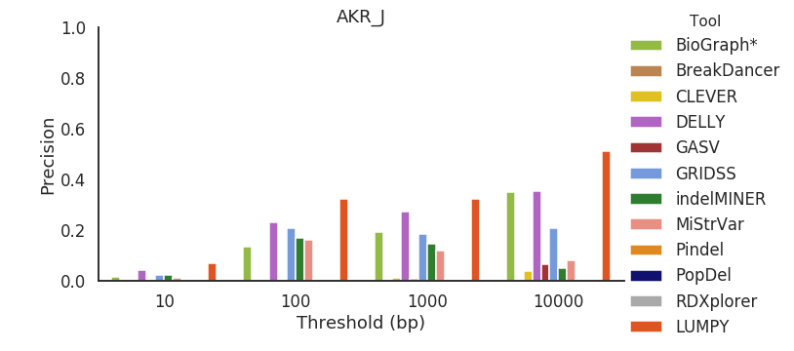

Figure S14. Precision across all mouse strains for deletions between 50 bp and 100 bp in length.

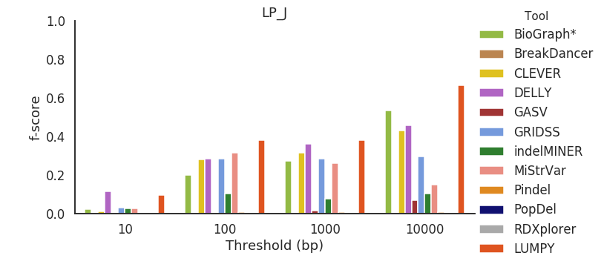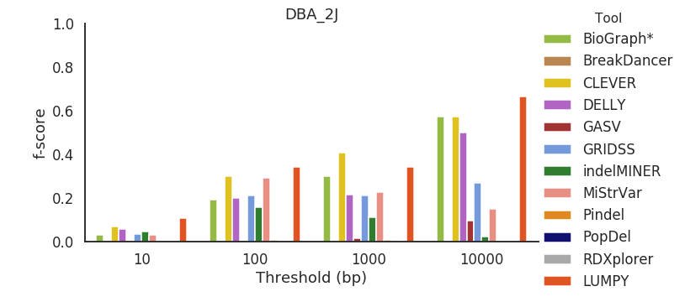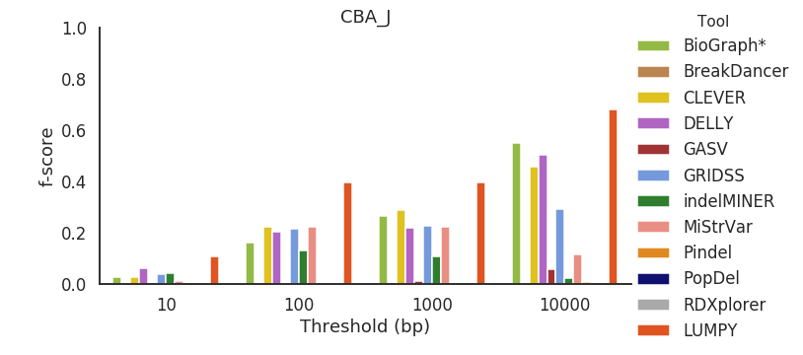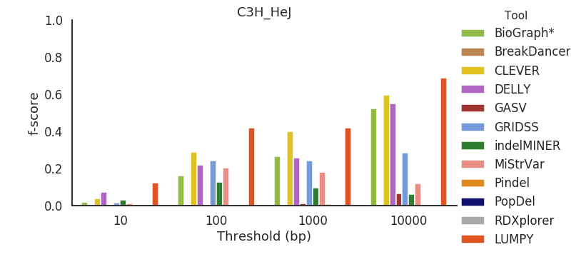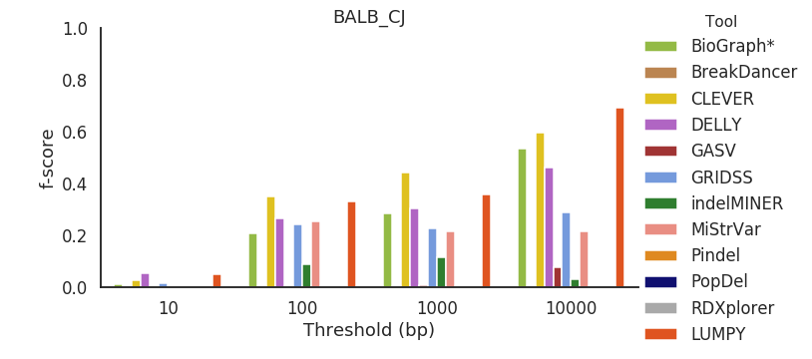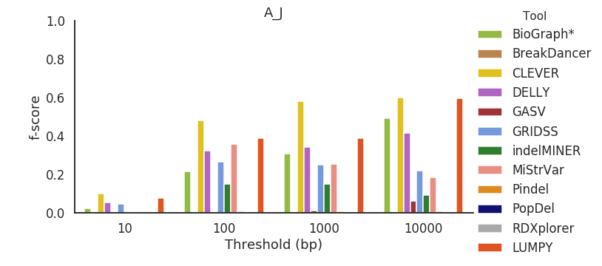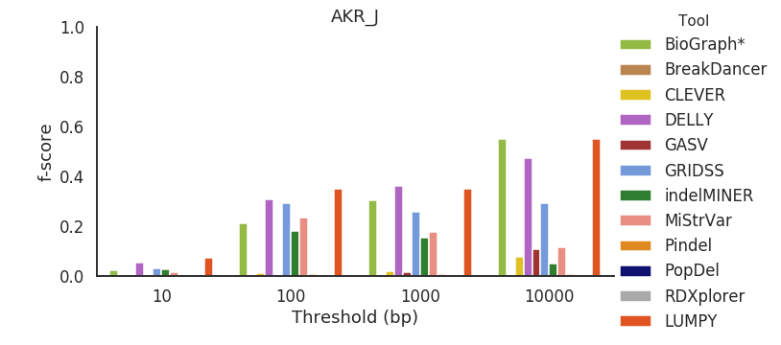

Figure S15. F-score across all mouse strains for deletions between 50 bp and 100 bp in length.



Figure S16. Specificity across all mouse strains for deletions between 100 bp and 500 bp in length.

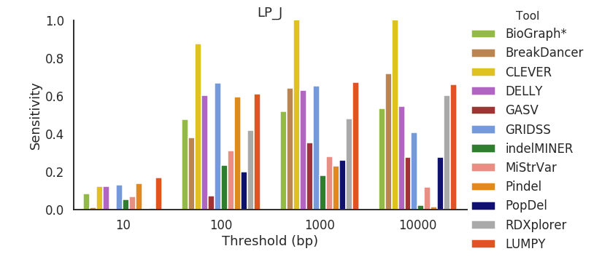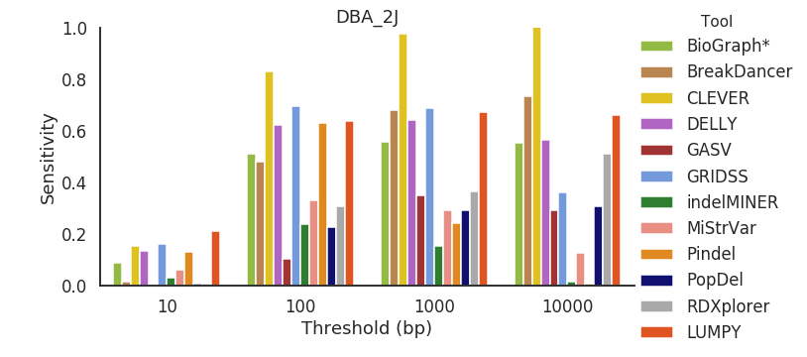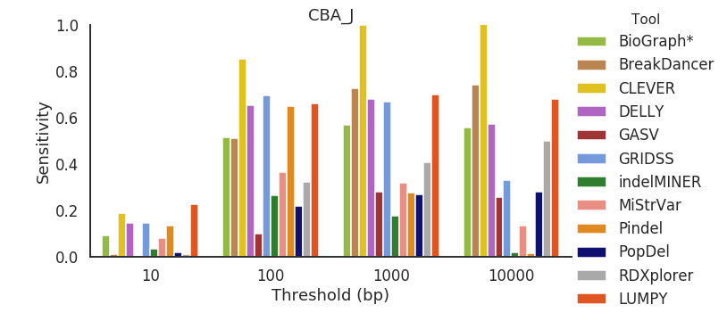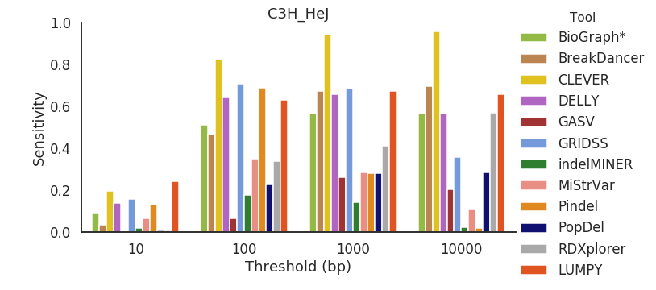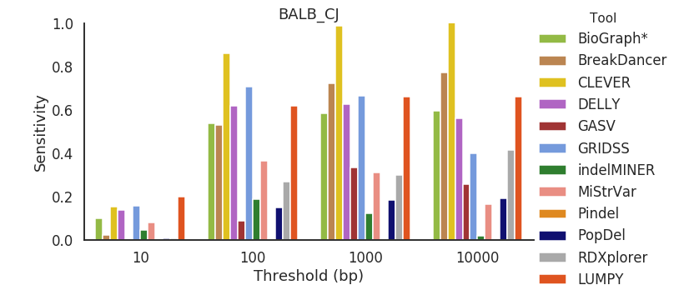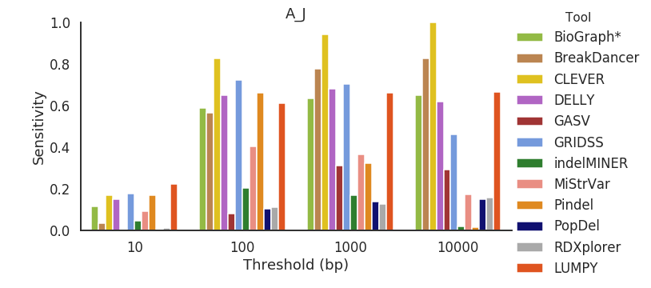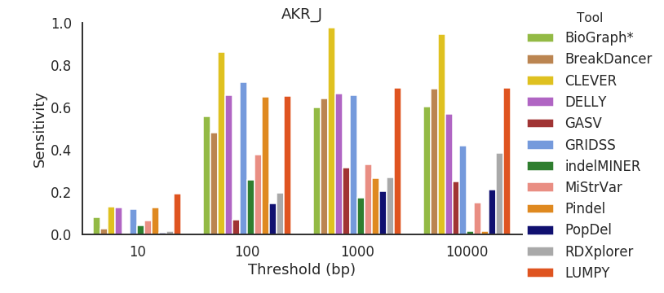

Figure S17. Sensitivity across all mouse strains for deletions between 50 bp and 100 bp in length.

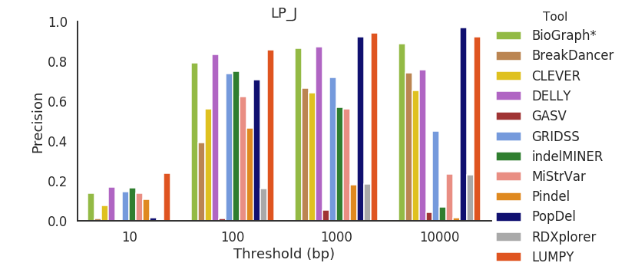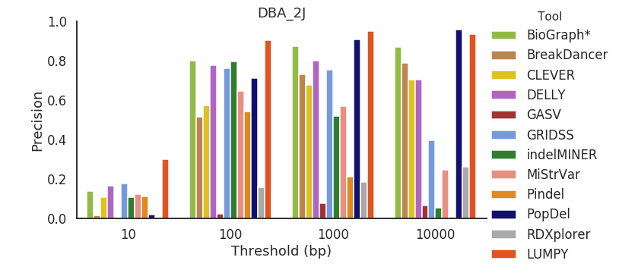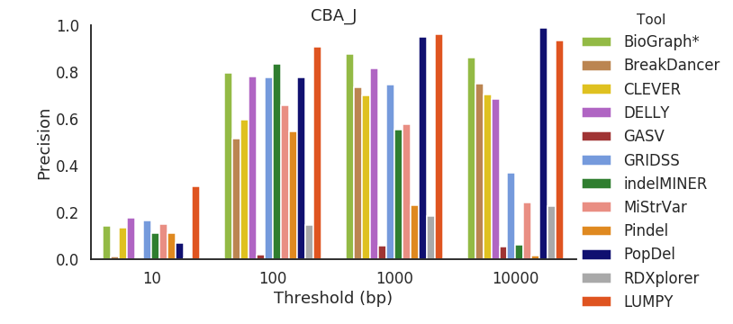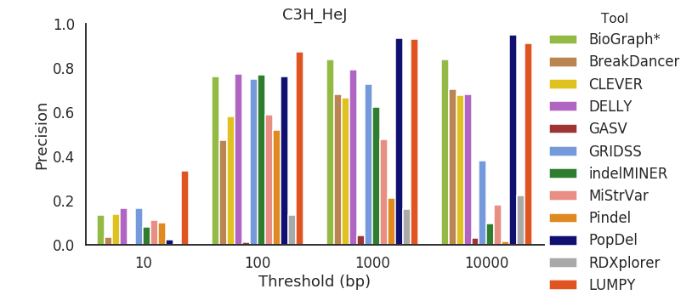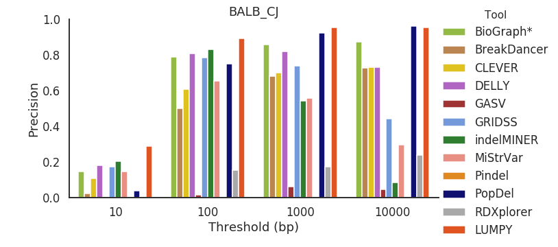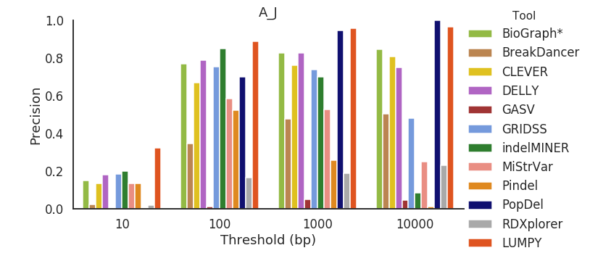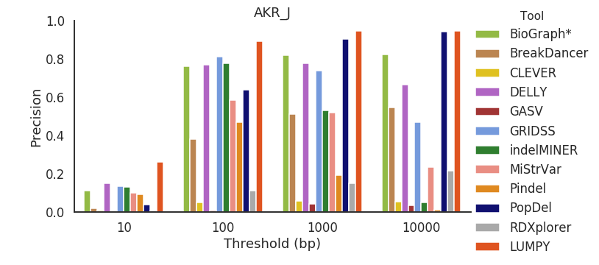

Figure S18. Precision across all mouse strains for deletions between 100 bp and 500 bp in length.

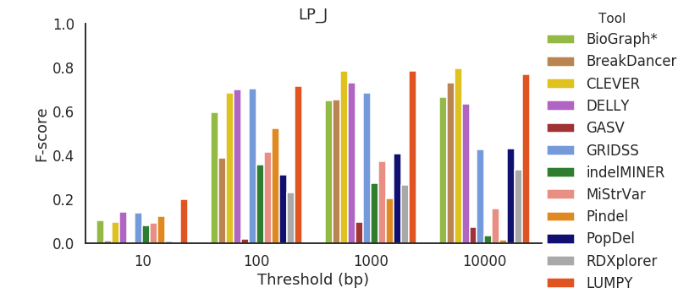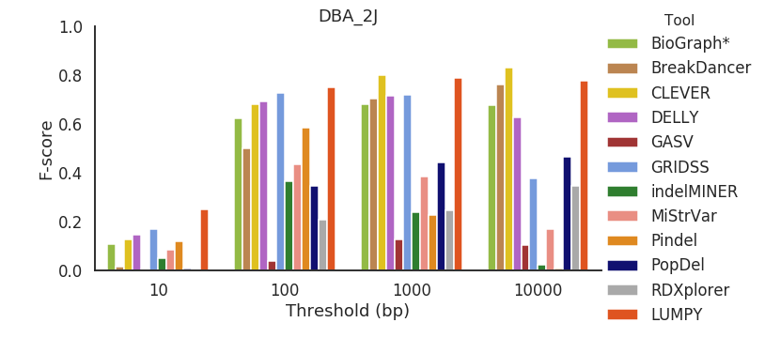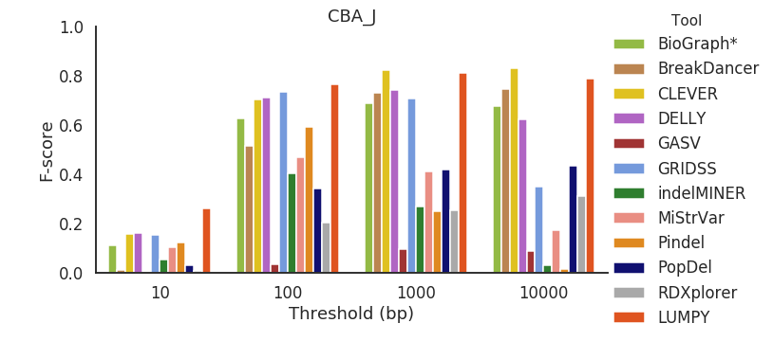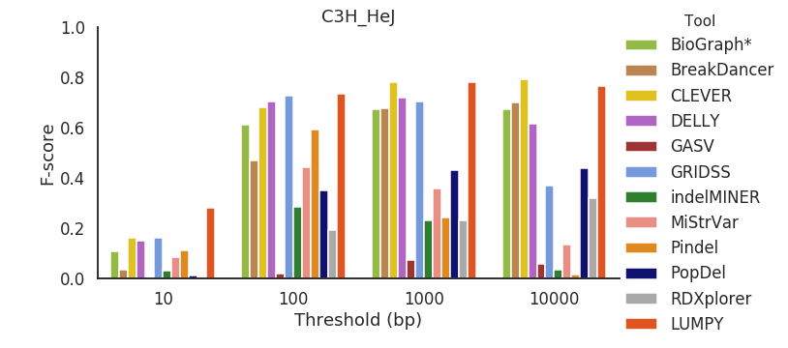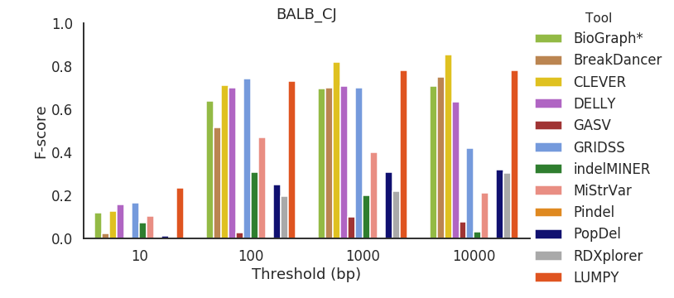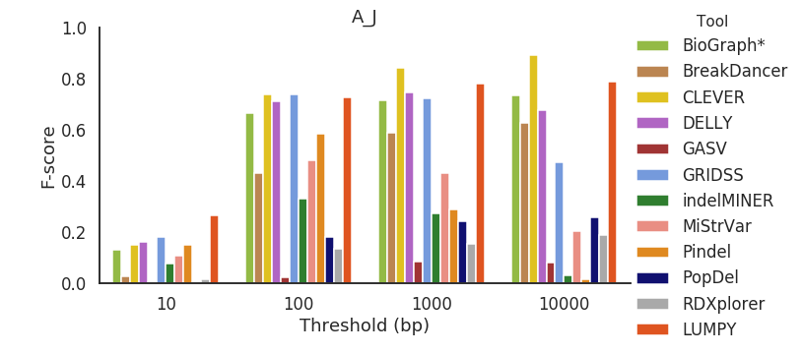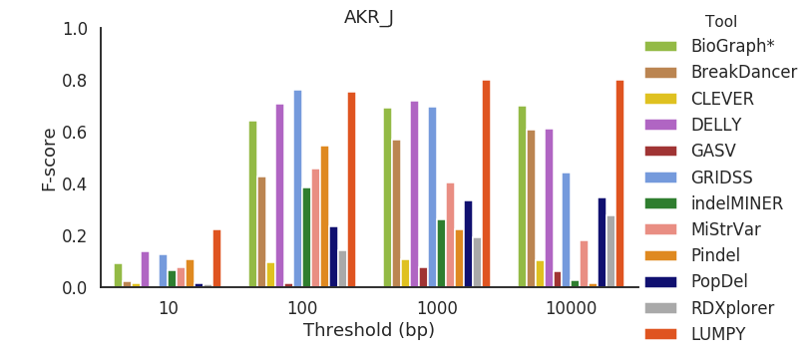

Figure S19. F-score across all mouse strains for deletions between 100 bp and 500 bp in length.

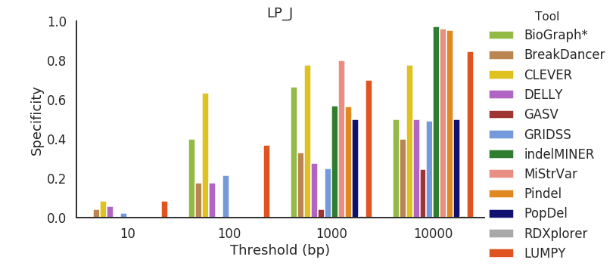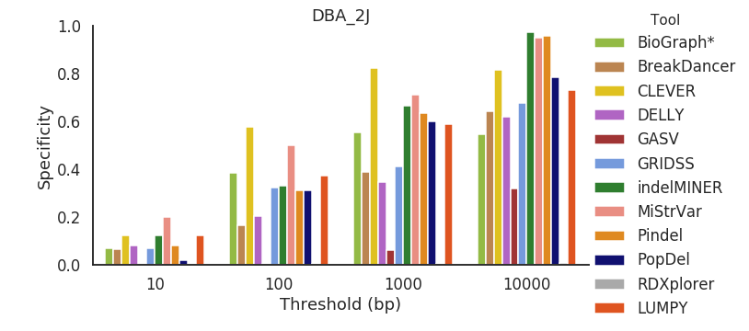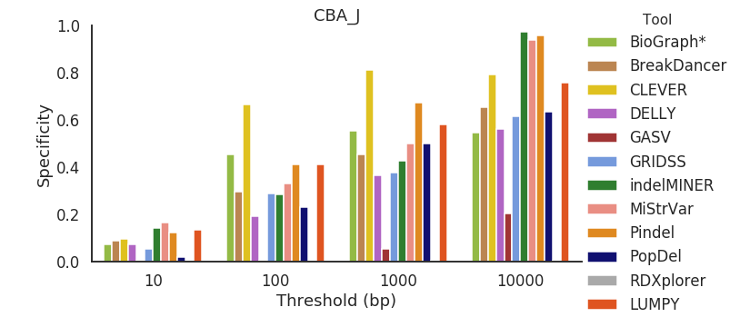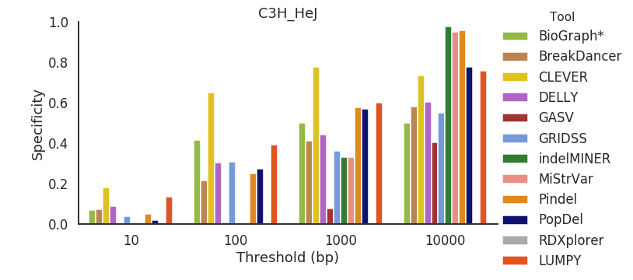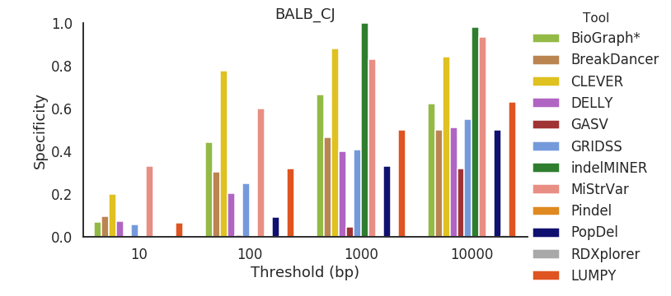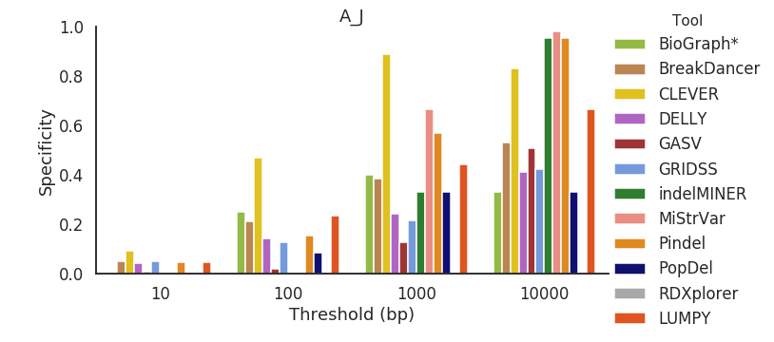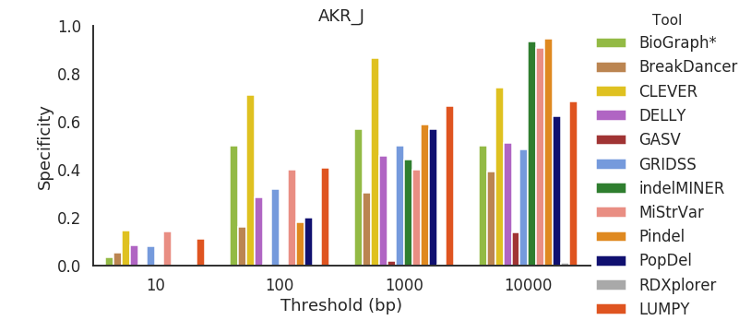

Figure S20. Specificity across all mouse strains for deletions between 500 bp and 1000 bp in length.

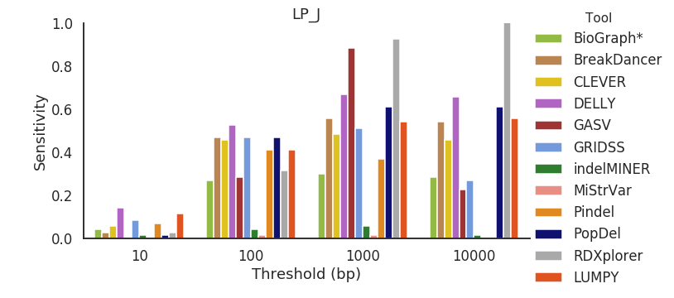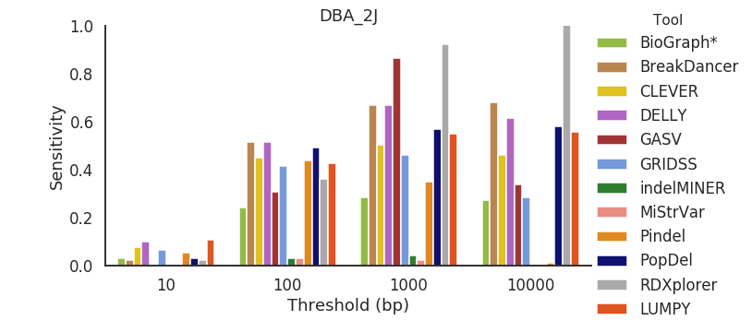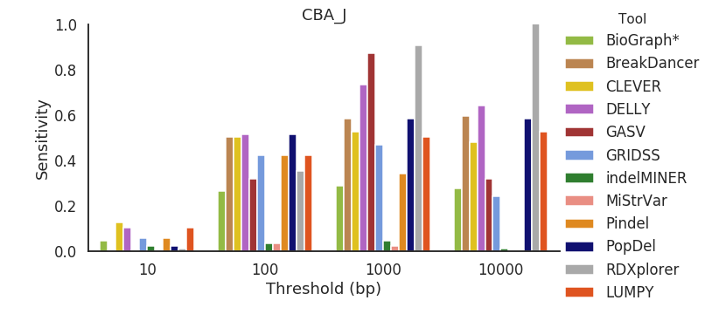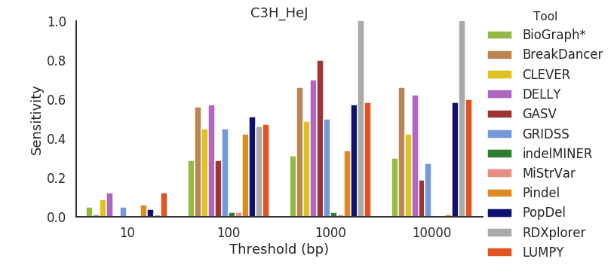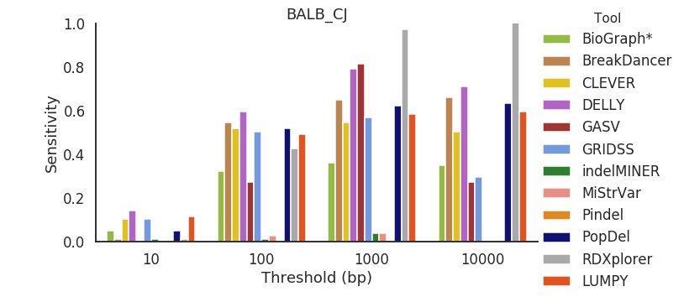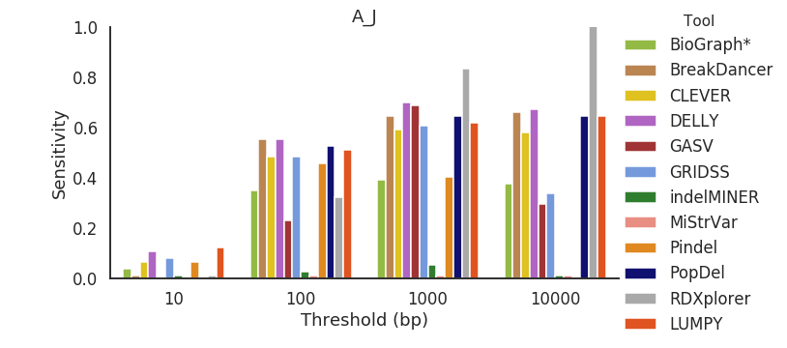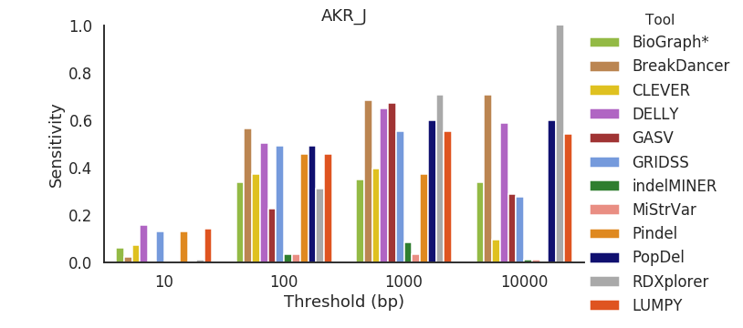

Figure S21. Sensitivity across all mouse strains for deletions between 500 bp and 1000 bp in length.

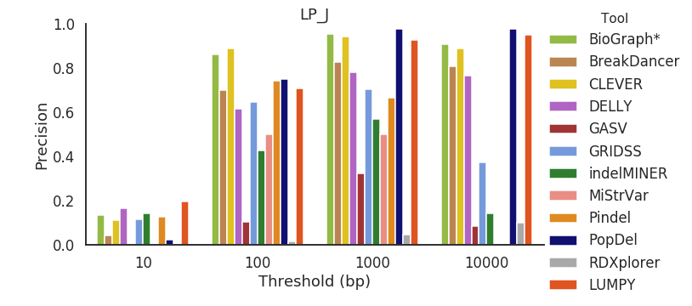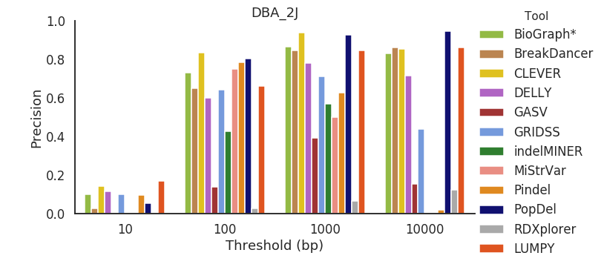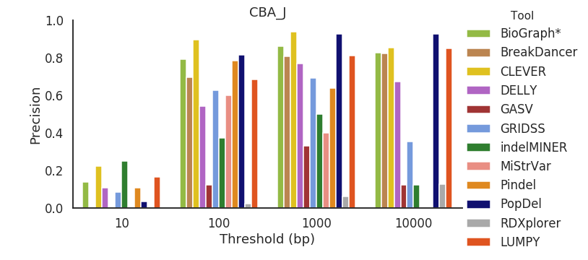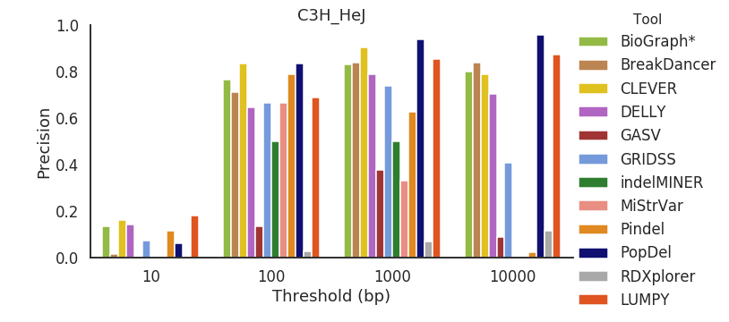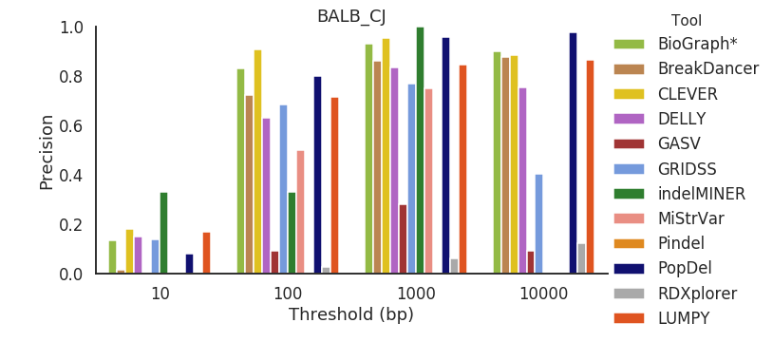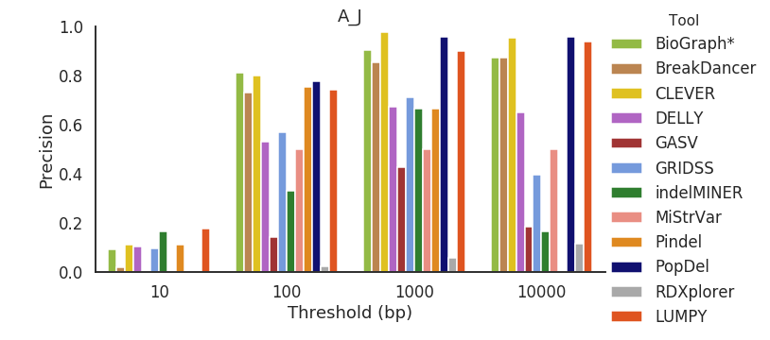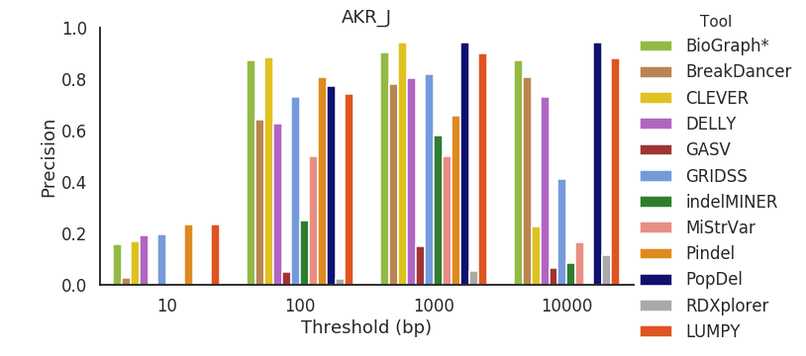

Figure S22. Precision across all mouse strains for deletions between 500 bp and 1000 bp in length.

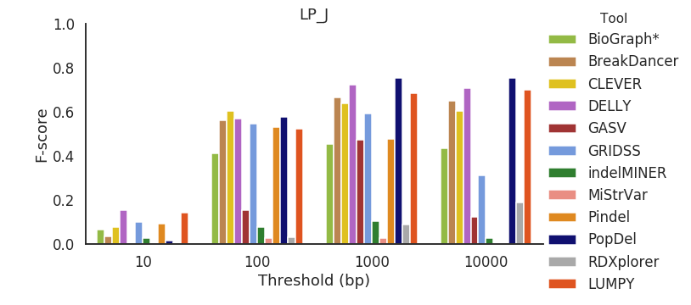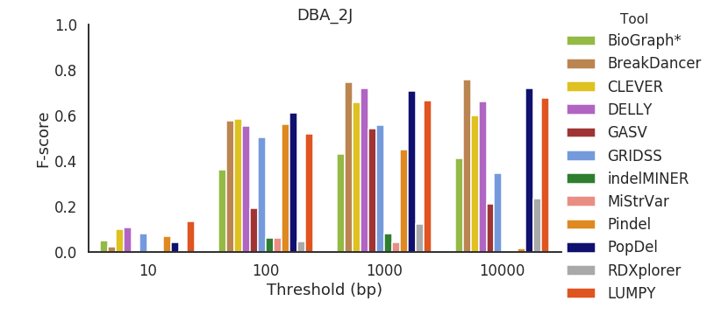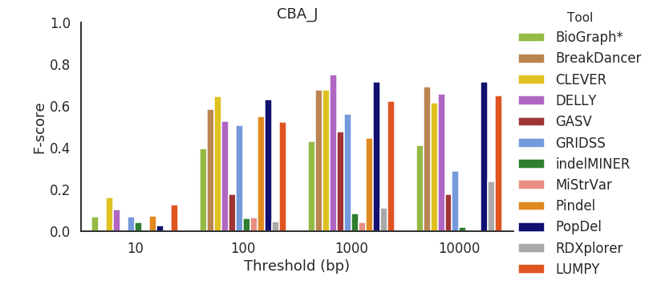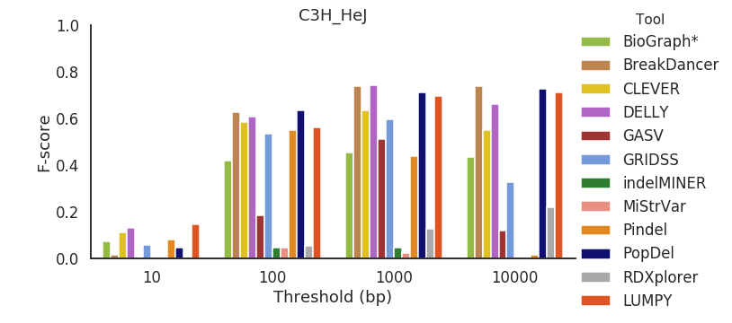

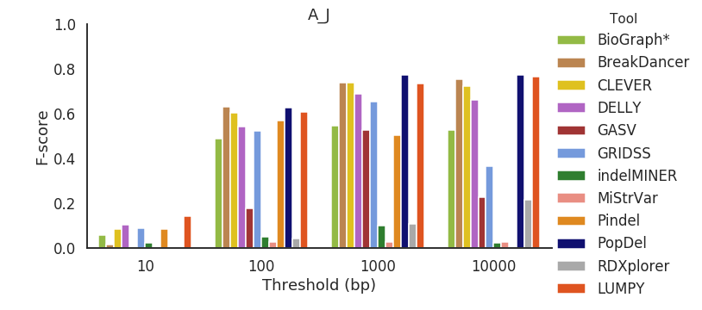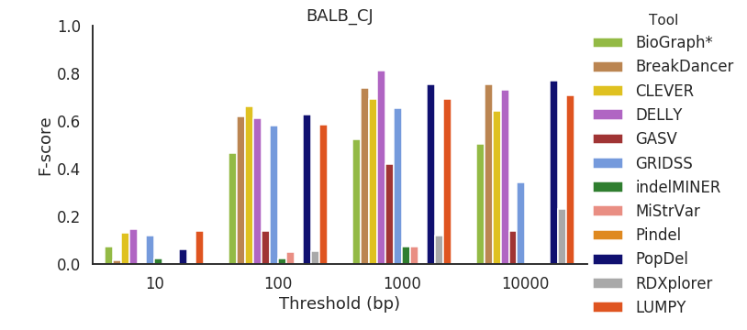

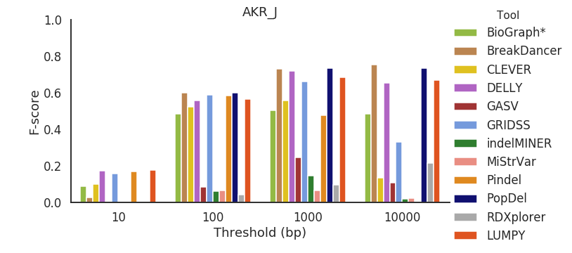

Figure S23. F-score across all mouse strains for deletions between 500 bp and 1000 bp in length.

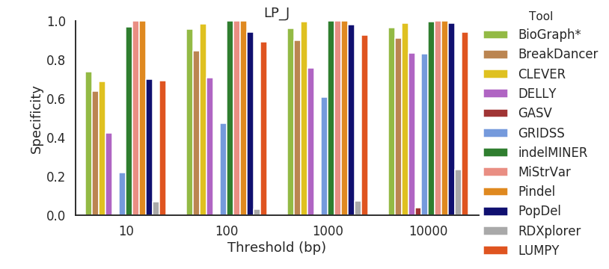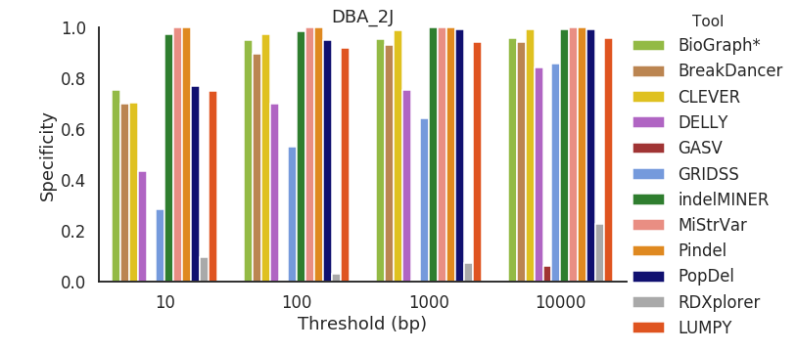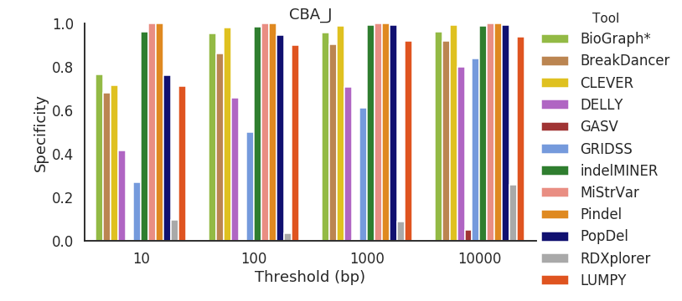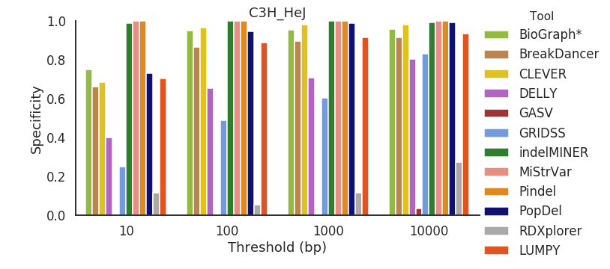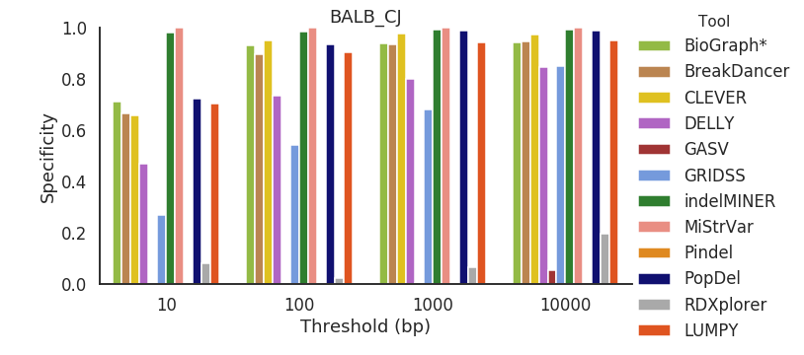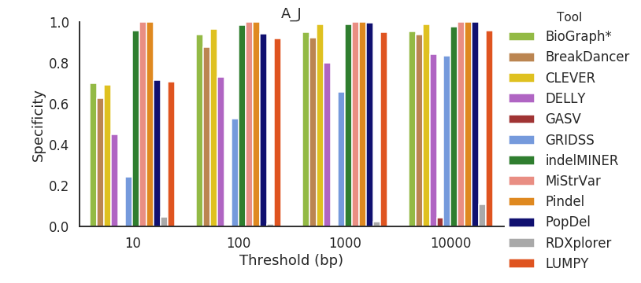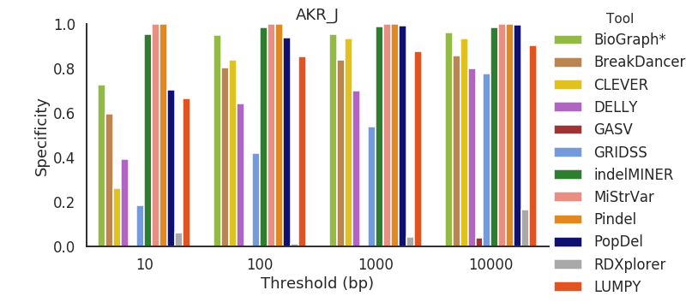

Figure S24 Specificity across all mouse strains for deletions 1000 bp and greater in length.

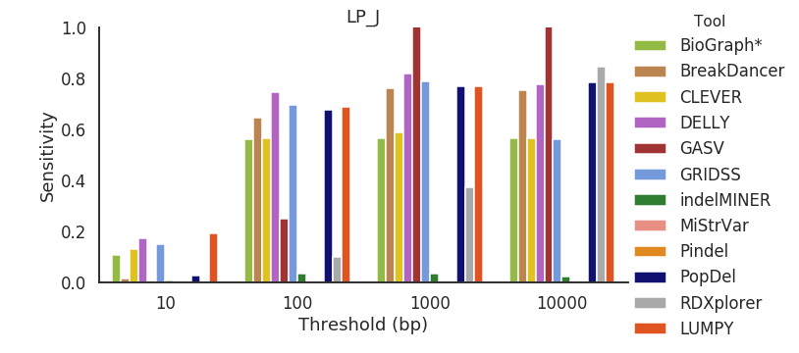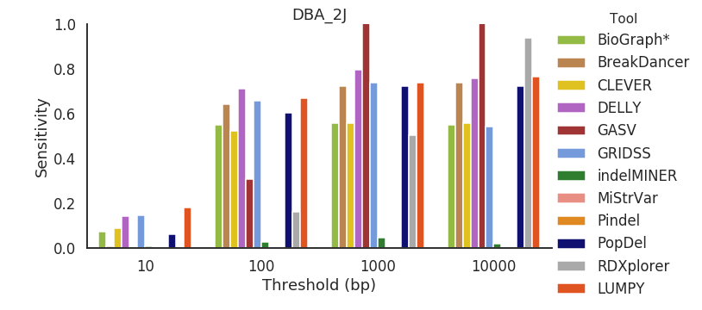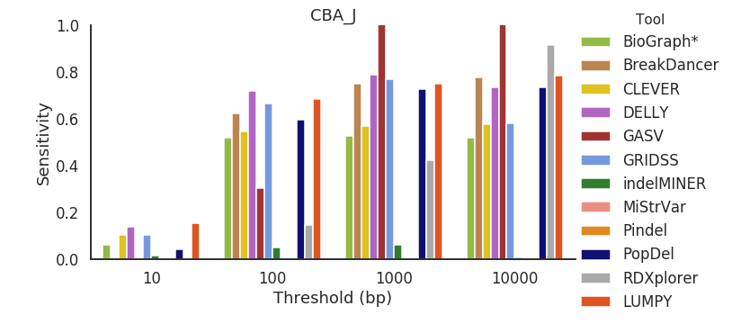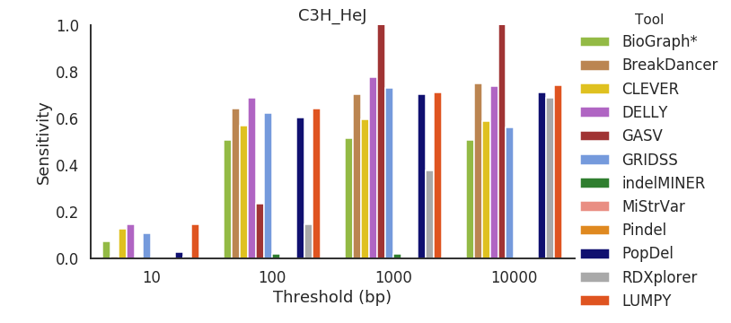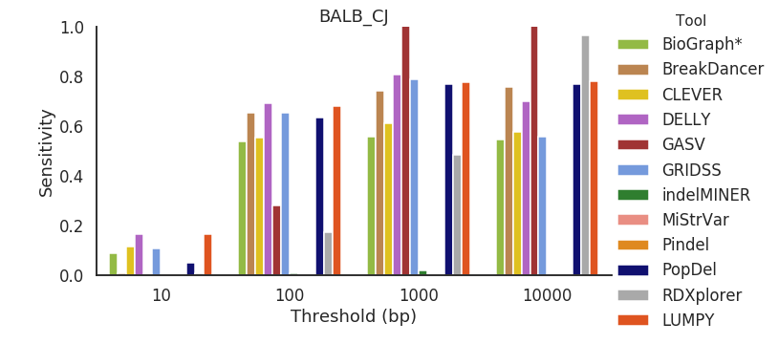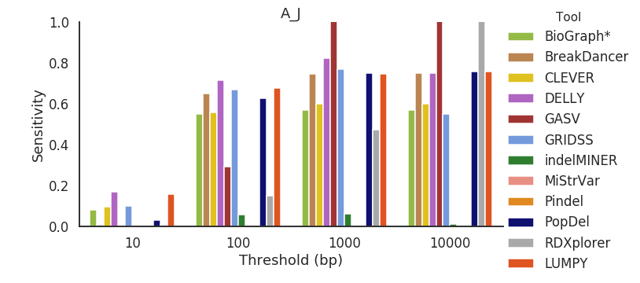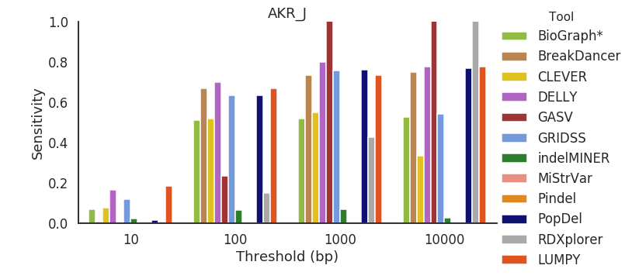

Figure S25. Sensitivity across all mouse strains for deletions 1000 bp and greater in length.

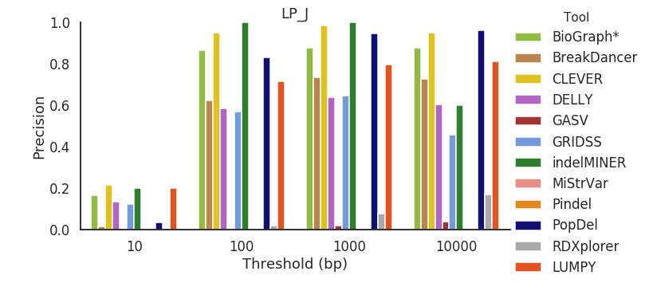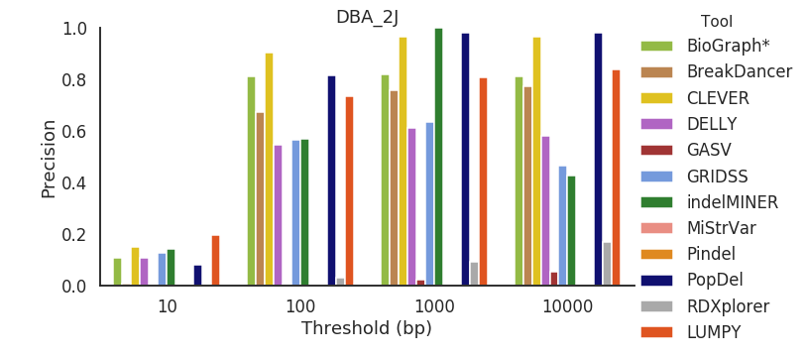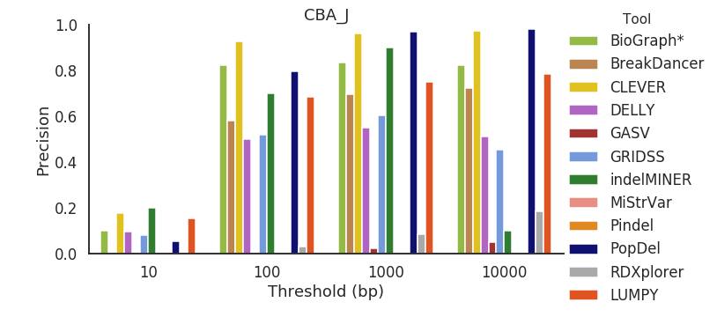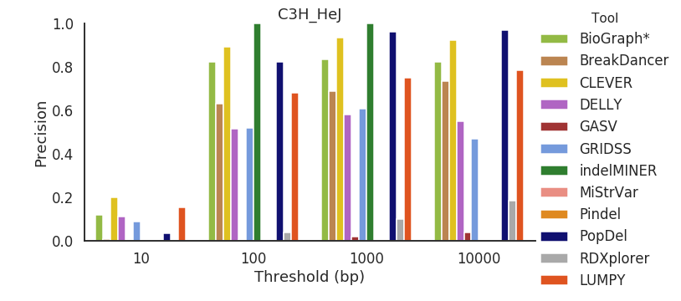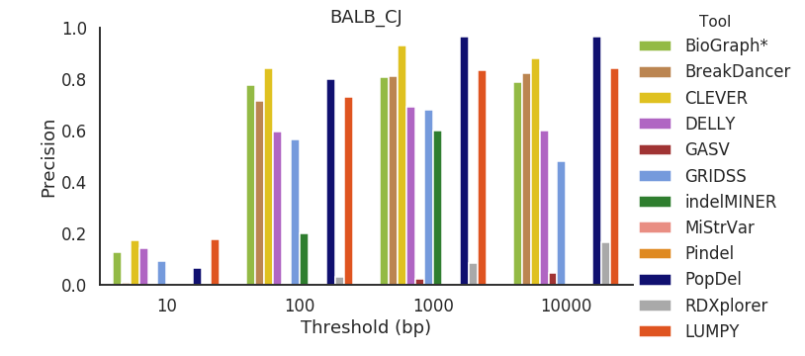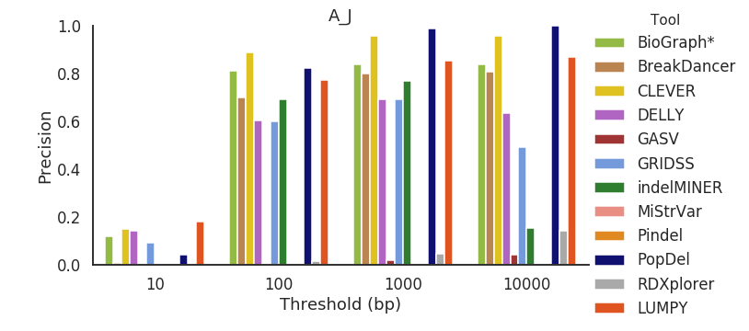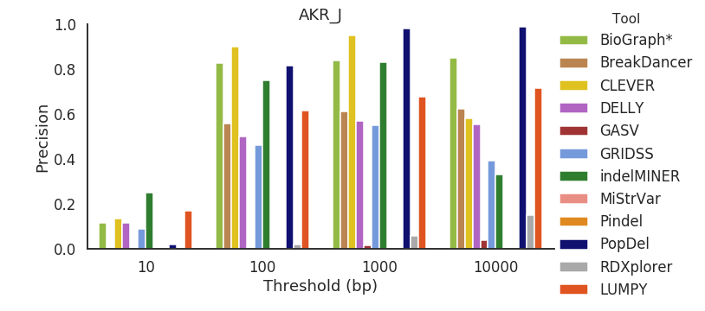

Figure S26. Precision across all mouse strains for deletions 1000 bp and greater in length.

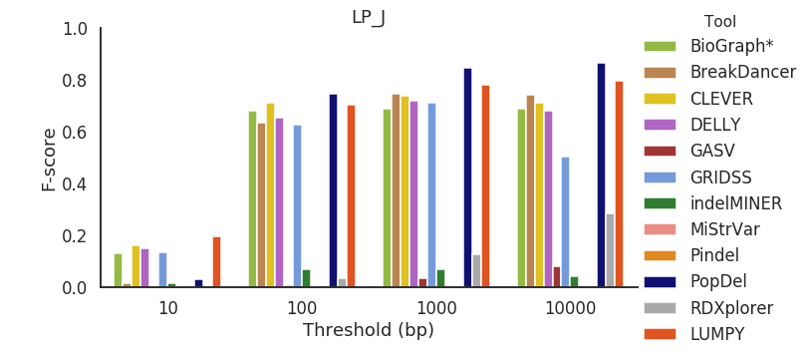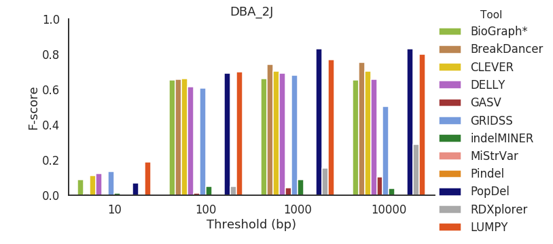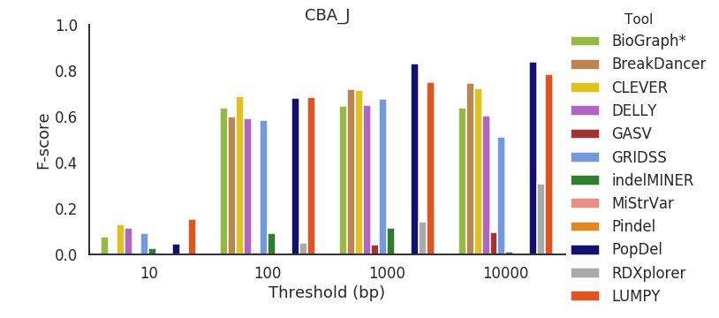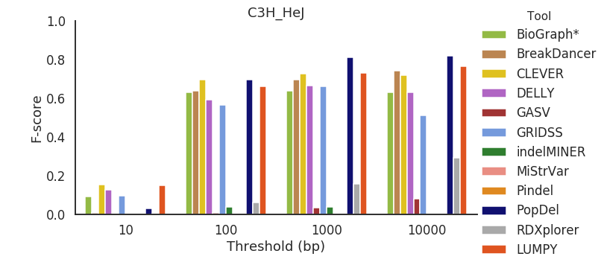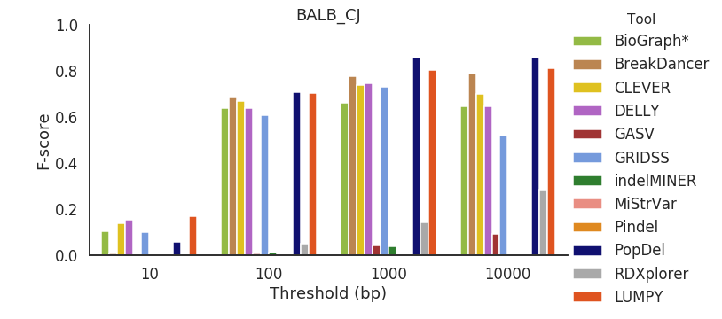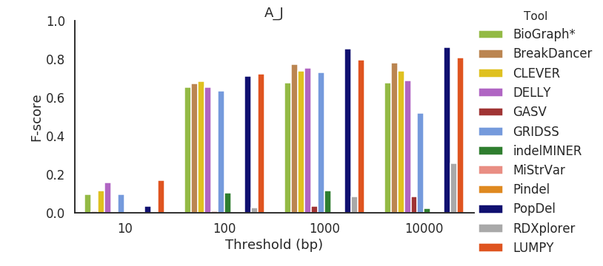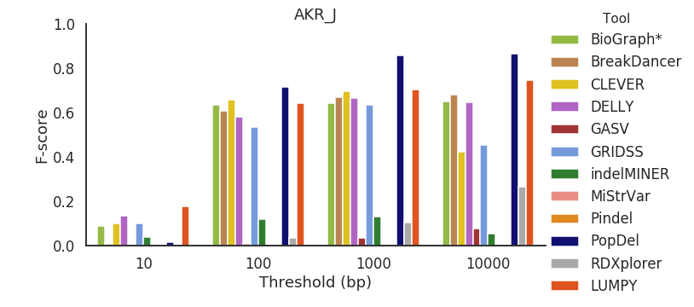

Figure S27. F-score across all mouse strains for deletions 1000 bp and greater in length.

## 