**MODULE 1:**

**AdventureWorks sample database in Azure SQL Database**

Process Flow –

**Step 1** Login to Azure Portal

**Step 2** Create Resource Group **–**

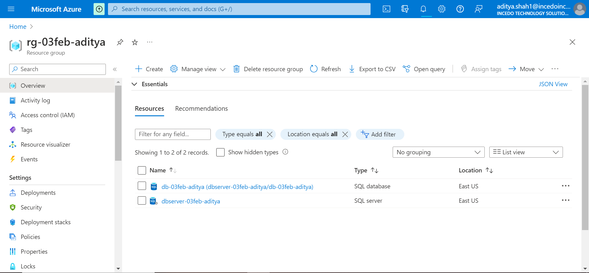

**Step 3** Create Azure SQL Database

**Step 4** In the "Restore" Option, configure Restore Options as “Sample -> AdventureWorks”

**Step 5** Review and Create the Database

**Step 6** Validation and Restore

**Step 7** Set Firewall to connect to all the Networks i.e., 0.0.0.0 to 255.255.255.255 –

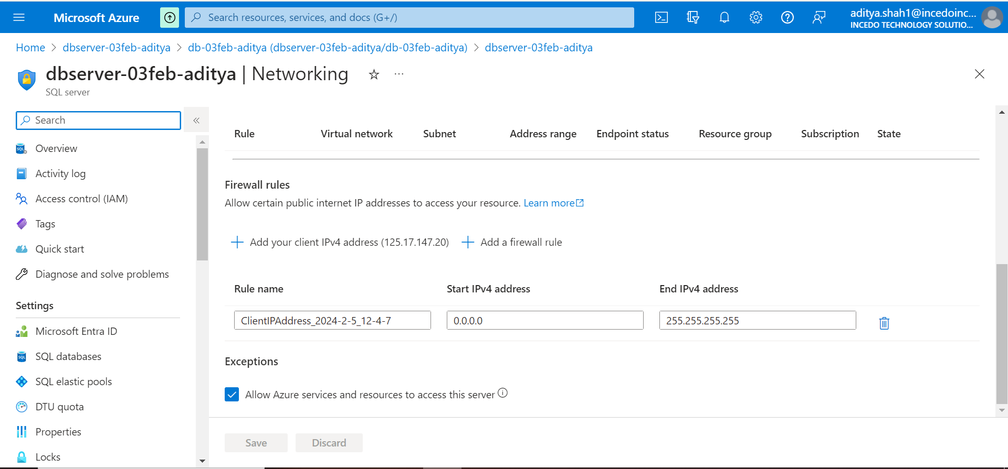

**Step 8** Monitor the Restore Progress

**Step 9** Verify the Restored Database

**Step 10** Sample Dataset Loaded on SQL Database **–**

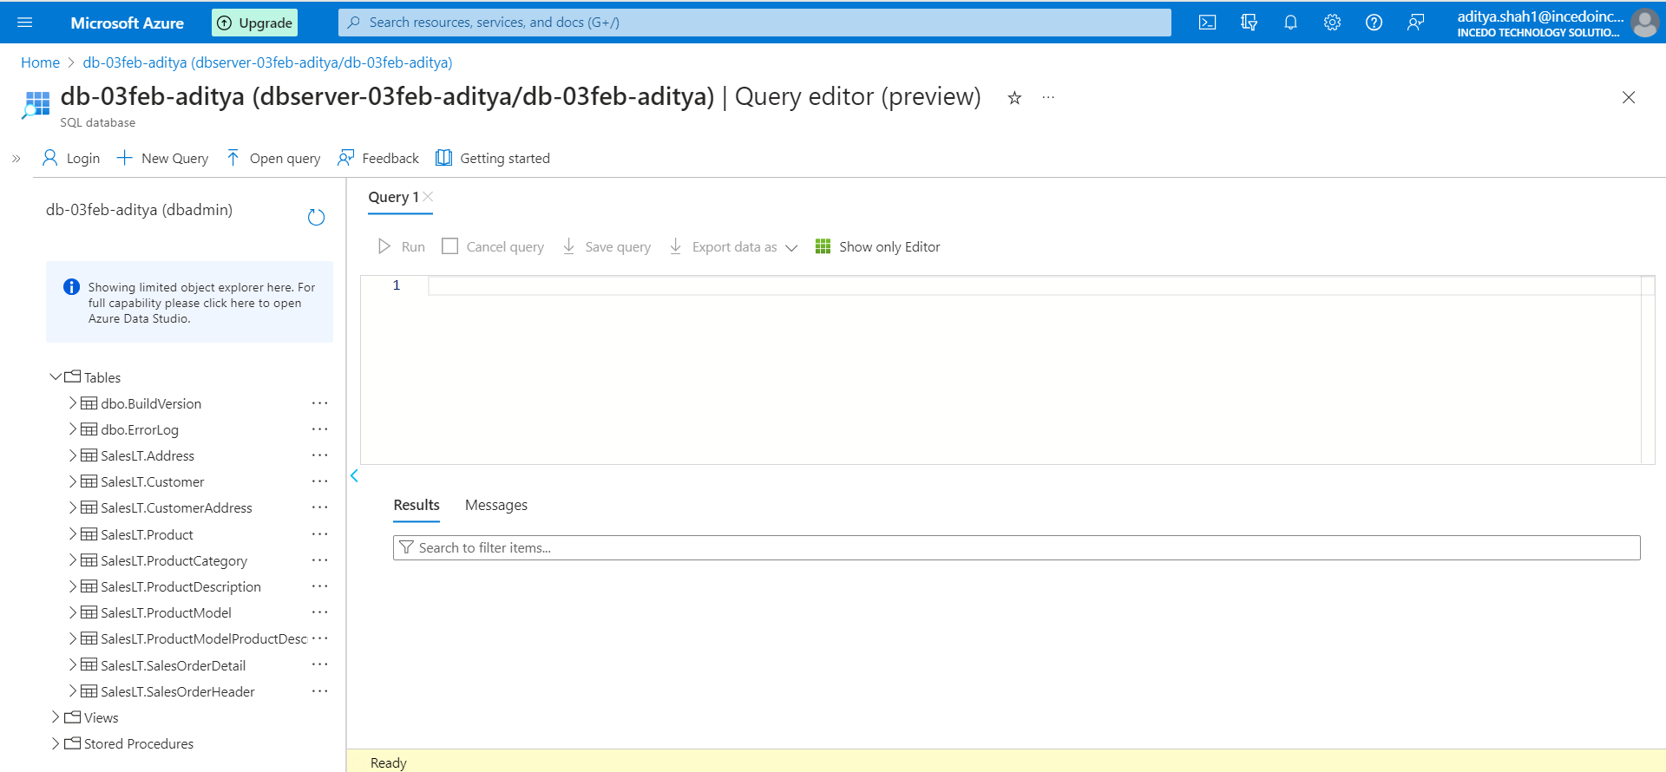

**Step 11** Connect the Restored Database to Dbeaver and Execute the Queries.

**MODULE 2:**

**T-SQL Operations/Queries**

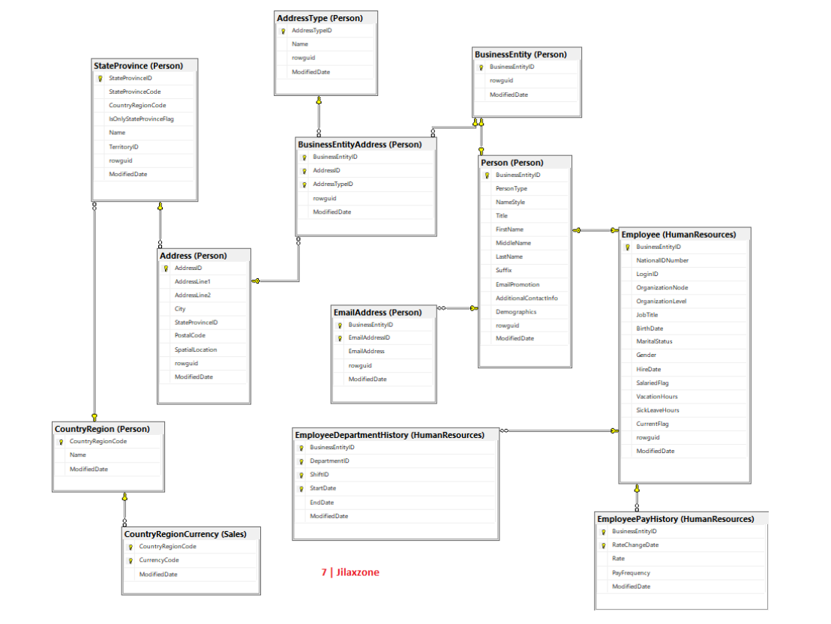

**BASIC**

**Joins:**

**1. Retrieve a list of customers along with their total order amounts.**

SELECT c.CustomerID, c.FirstName, c.LastName,

SUM(o.TotalDue) AS TotalOrderAmount

FROM SalesLT.Customer c JOIN SalesLT.SalesOrderHeader o

ON c.CustomerID = o.CustomerID

GROUP BY c.CustomerID, c.FirstName, c.LastName

ORDER BY c.CustomerID;

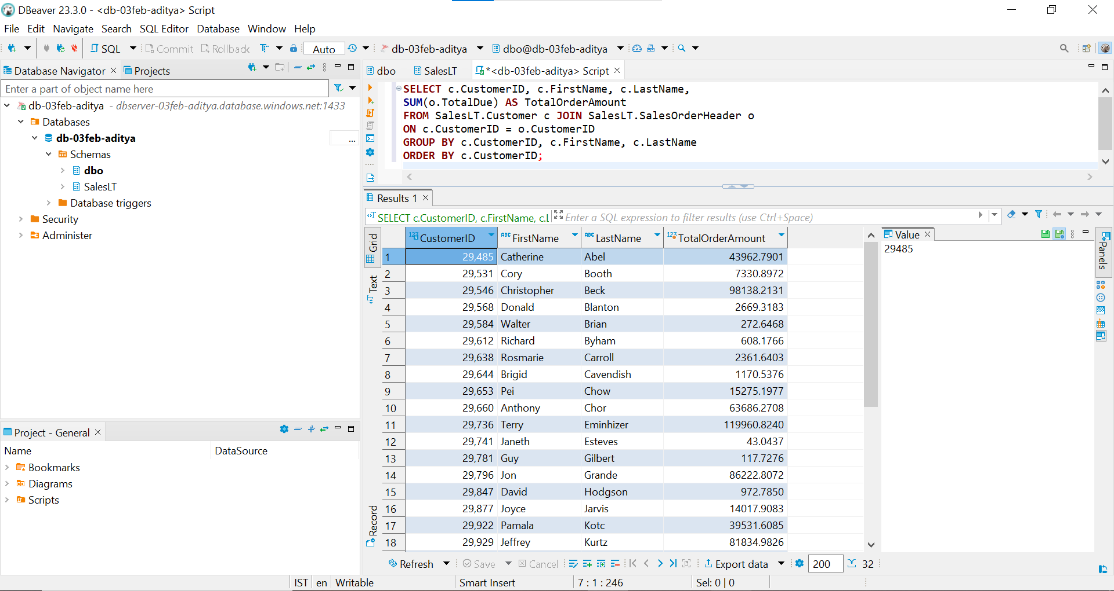

**2. Display product information along with the number of units sold for each product.**

SELECT p.ProductID, p.Name AS ProductName, p.ProductNumber, p.Color,

SUM(od.OrderQty) AS TotalUnitsSold

FROM SalesLT.Product p

JOIN SalesLT.SalesOrderDetail od ON p.ProductID = od.ProductID

JOIN SalesLT.SalesOrderHeader oh ON od.SalesOrderID = oh.SalesOrderID

GROUP BY p.ProductID, p.Name, p.ProductNumber, p.Color

ORDER BY p.ProductID;

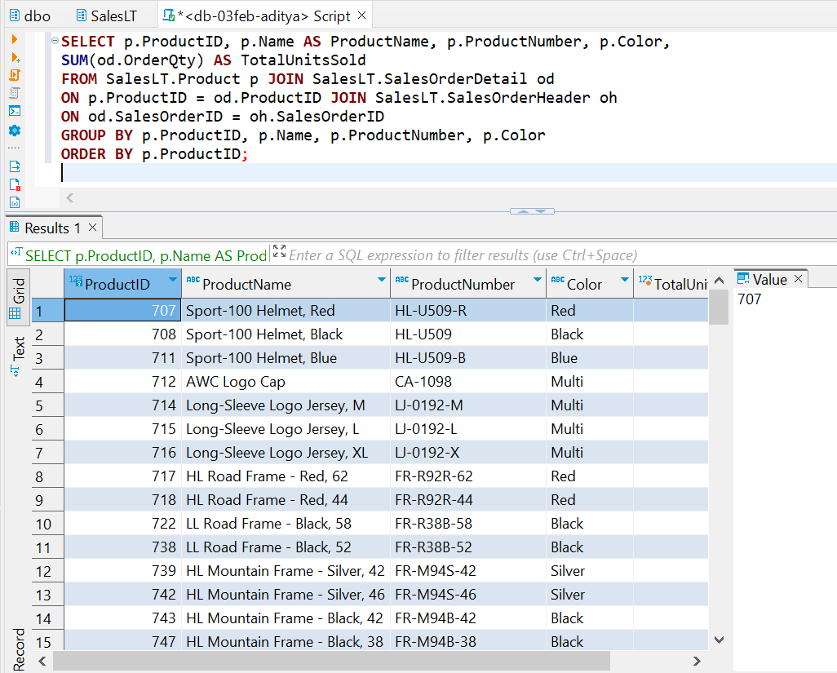

**3. Find employees who have the same manager.**

Data Insufficient

**4. List all customers who have never placed an order.**

SELECT c.CustomerID, c.FirstName, c.LastName

FROM SalesLT.Customer c LEFT JOIN SalesLT.SalesOrderHeader o

ON c.CustomerID = o.CustomerID

WHERE o.CustomerID IS NULL;

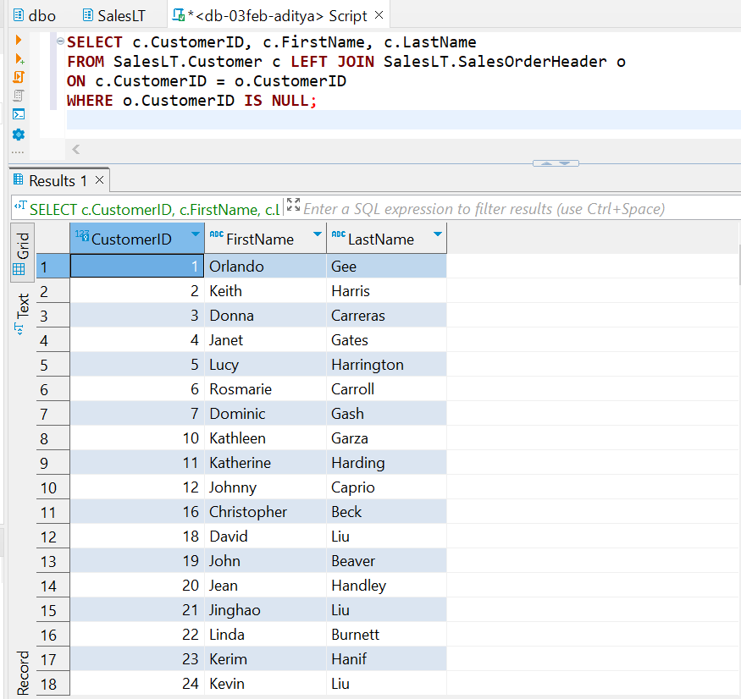

**5. Retrieve the total sales amount for each product category.**

SELECT pc.ProductCategoryID, pc.Name AS CategoryName,

SUM(od.OrderQty * od.UnitPrice) AS TotalSalesAmount

FROM SalesLT.ProductCategory pc

JOIN SalesLT.Product p ON pc.ProductCategoryID = p.ProductCategoryID

JOIN SalesLT.SalesOrderDetail od ON p.ProductID = od.ProductID

JOIN SalesLT.SalesOrderHeader oh ON od.SalesOrderID = oh.SalesOrderID

GROUP BY pc.ProductCategoryID, pc.Name

ORDER BY pc.ProductCategoryID;

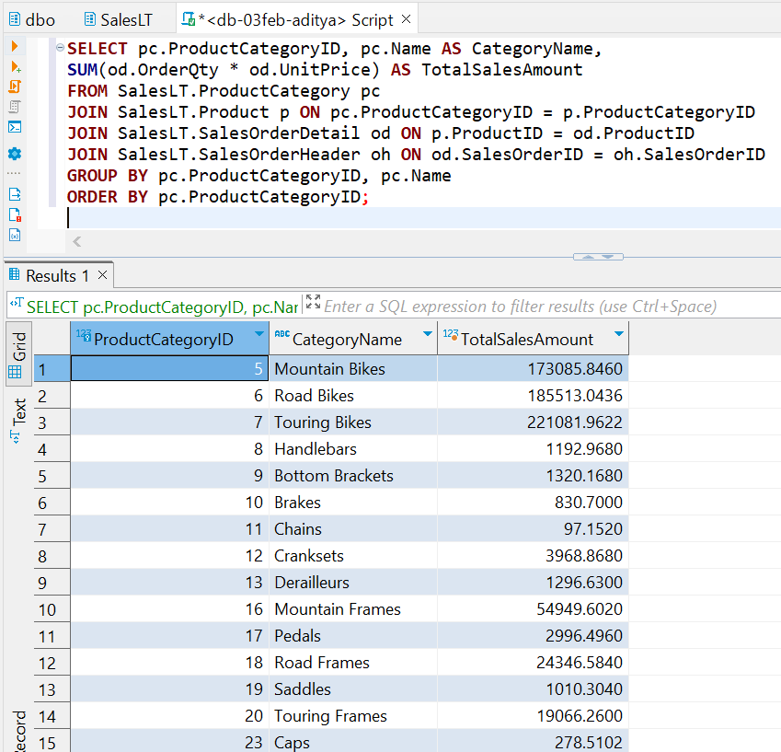

**6. Display the names of employees and their direct managers.**

Data Insufficient

**7. Show the order details with product names for a specific customer.**

SELECT oh.SalesOrderID, od.ProductID, p.Name AS ProductName, od.OrderQty, od.UnitPrice, od.LineTotal

FROM SalesLT.Customer c

JOIN SalesLT.SalesOrderHeader oh ON c.CustomerID = oh.CustomerID

JOIN SalesLT.SalesOrderDetail od ON oh.SalesOrderID = od.SalesOrderID

JOIN SalesLT.Product p ON od.ProductID = p.ProductID

WHERE c.CustomerID = 29485;

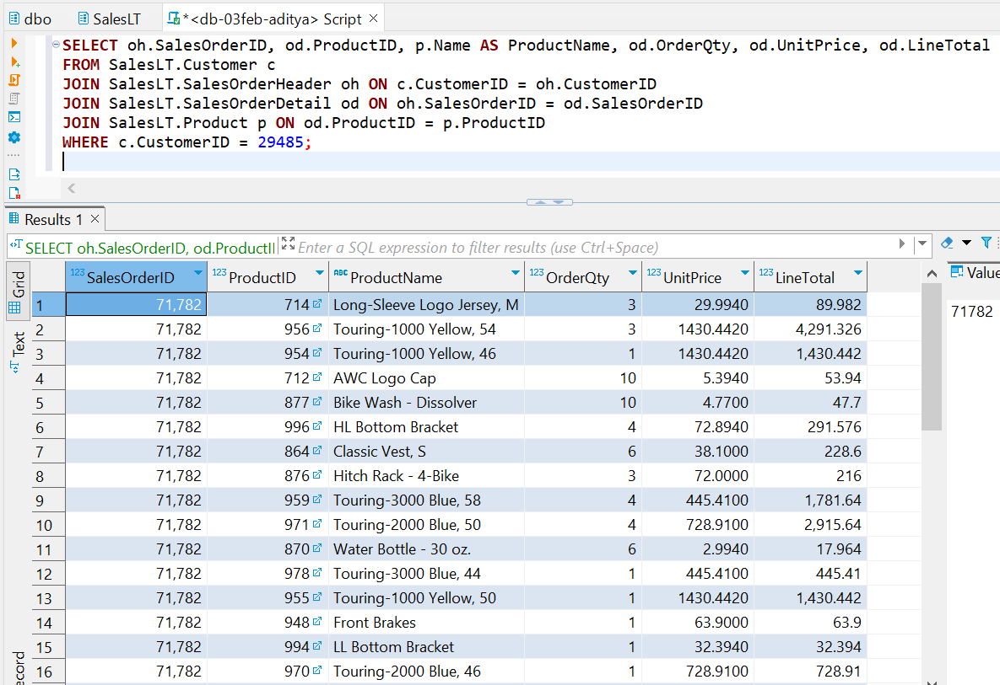

**8. List customers who have made purchases in the last 30 days.**

SELECT DISTINCT c.CustomerID, c.FirstName, c.LastName

FROM SalesLT.Customer c

JOIN SalesLT.SalesOrderHeader oh ON c.CustomerID = oh.CustomerID

WHERE oh.OrderDate >= DATEADD(day, -30, GETDATE());

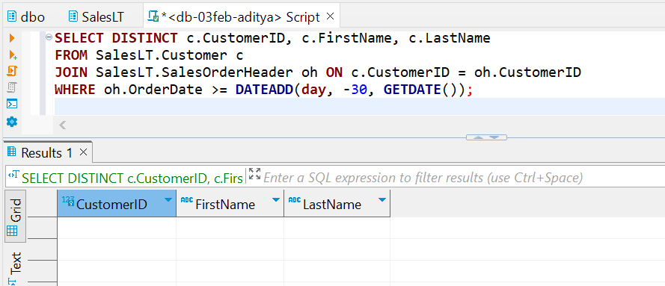

**9. Find employees who do not have any direct reports.**

Data Insufficient

**10. Retrieve all products along with their average selling prices.**

SELECT p.ProductID, p.Name AS ProductName,

AVG(od.UnitPrice) AS AverageSellingPrice

FROM SalesLT.Product p

JOIN SalesLT.SalesOrderDetail od ON p.ProductID = od.ProductID

GROUP BY p.ProductID, p.Name

ORDER BY p.ProductID;

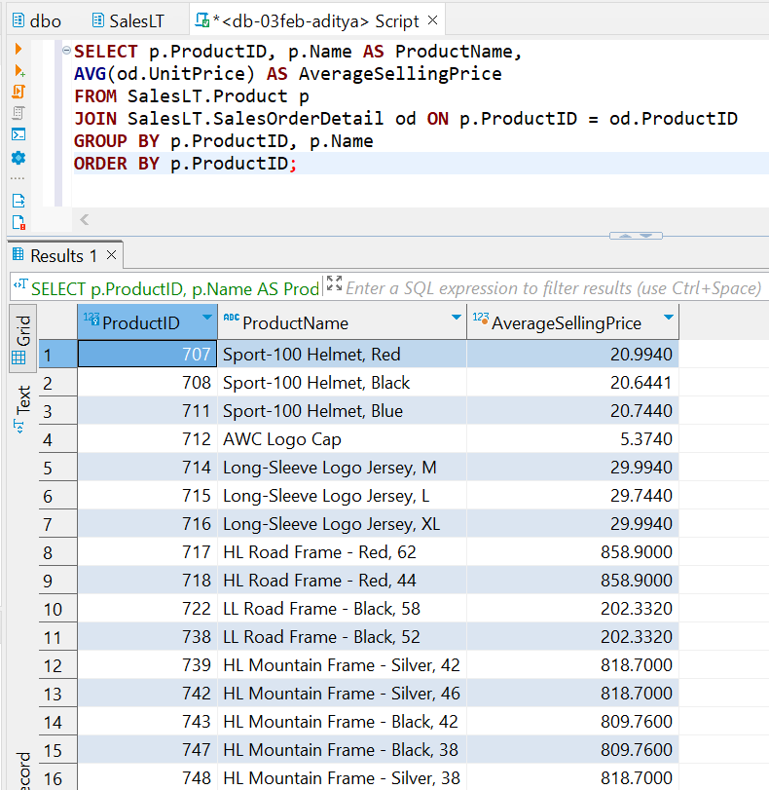

Subquery –

**11. Find the order with the highest total amount.**

SELECT TOP 1 oh.SalesOrderID, oh.OrderDate,

SUM(od.LineTotal) AS TotalAmount

FROM SalesLT.SalesOrderHeader oh

JOIN SalesLT.SalesOrderDetail od ON oh.SalesOrderID = od.SalesOrderID

GROUP BY oh.SalesOrderID, oh.OrderDate

ORDER BY TotalAmount DESC;

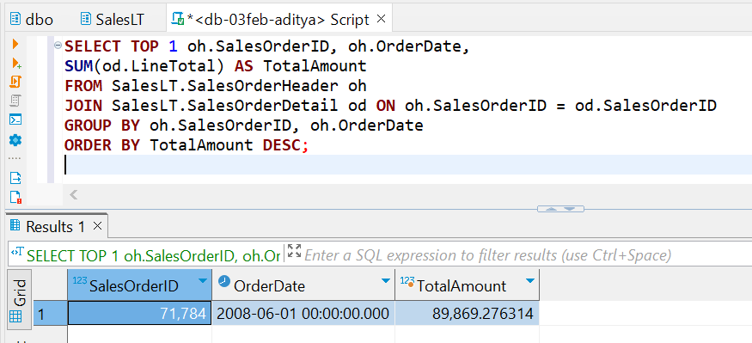

**12. Display customers who have placed orders with a total amount greater than the average.**

WITH CustomerOrderTotals AS (

SELECT c.CustomerID, c.FirstName, c.LastName,

SUM(od.LineTotal) AS TotalAmount

FROM SalesLT.Customer c

JOIN SalesLT.SalesOrderHeader oh ON c.CustomerID = oh.CustomerID

JOIN SalesLT.SalesOrderDetail od ON oh.SalesOrderID = od.SalesOrderID

GROUP BY c.CustomerID, c.FirstName, c.LastName

)

SELECT CustomerID, FirstName, LastName, TotalAmount

FROM CustomerOrderTotals

WHERE TotalAmount > (SELECT AVG(TotalAmount) FROM CustomerOrderTotals);

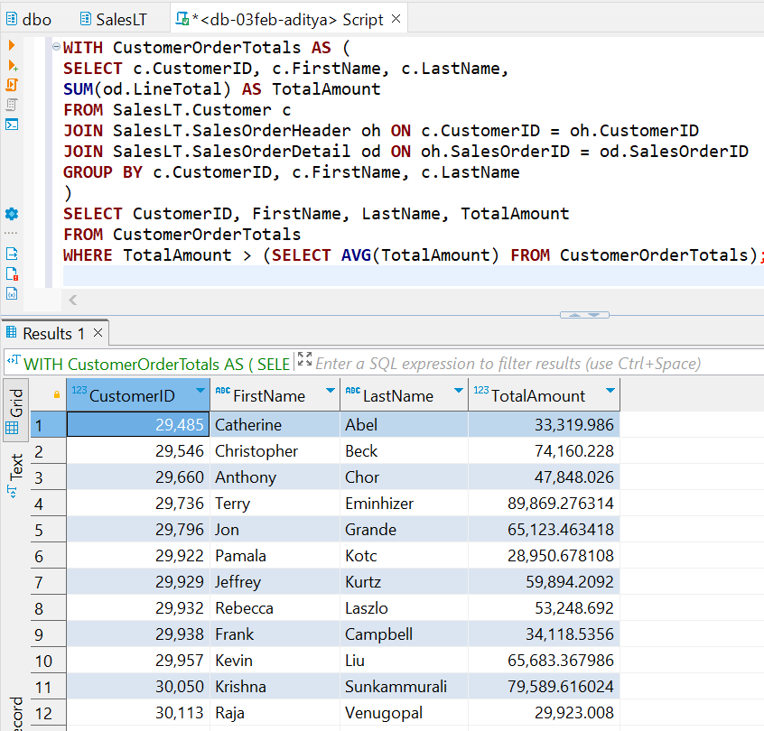

**13. List products with prices higher than the average product price.**

WITH ProductPrices AS (

SELECT ProductID, Name AS ProductName, ListPrice

FROM SalesLT.Product

)

SELECT ProductID, ProductName, ListPrice

FROM ProductPrices

WHERE ListPrice > (SELECT AVG(ListPrice) FROM ProductPrices);

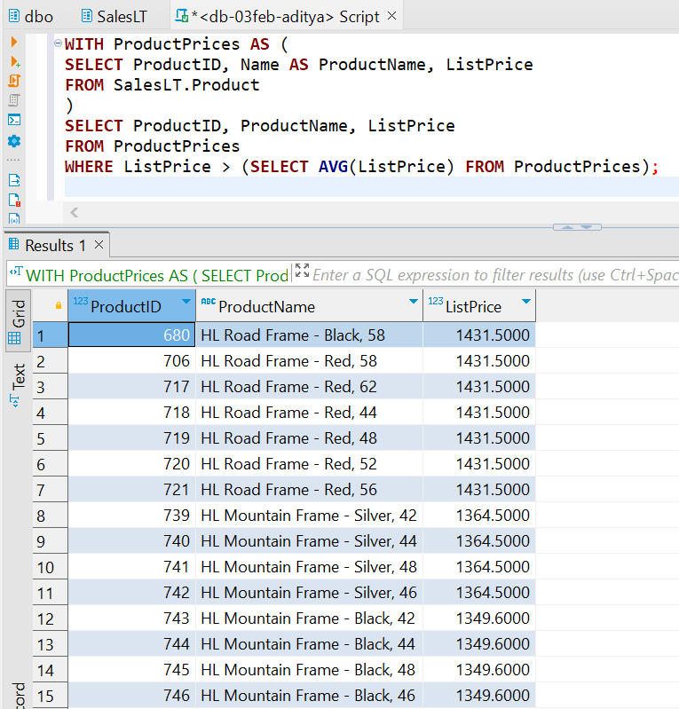

**14. Retrieve orders placed by employees who have a specific job title.**

Data Insufficient

**15. Display customers who have placed orders for a specific product category.**

SELECT c.CustomerID, c.FirstName, c.LastName

FROM SalesLT.Customer c

JOIN SalesLT.SalesOrderHeader oh ON c.CustomerID = oh.CustomerID

JOIN SalesLT.SalesOrderDetail od ON oh.SalesOrderID = od.SalesOrderID

JOIN SalesLT.Product p ON od.ProductID = p.ProductID

JOIN SalesLT.ProductCategory pc ON p.ProductCategoryID = pc.ProductCategoryID

WHERE pc.ProductCategoryID = 22;

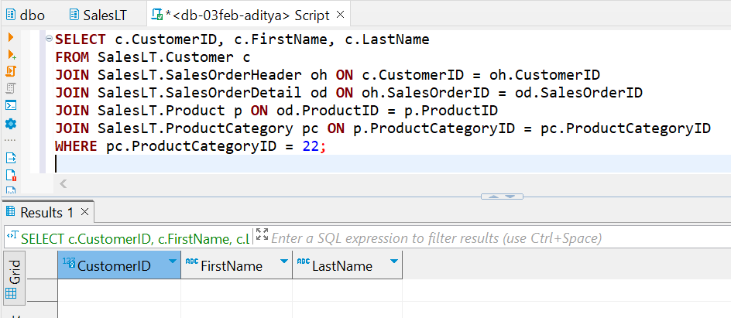

**16. Find employees with salaries greater than the average salary in their department.**

Data Insufficient

**17. List customers who have placed orders before a specific date.**

SELECT DISTINCT c.CustomerID, c.FirstName, c.LastName

FROM SalesLT.Customer c

JOIN SalesLT.SalesOrderHeader oh ON c.CustomerID = oh.CustomerID

WHERE oh.OrderDate < 2008-07-02;

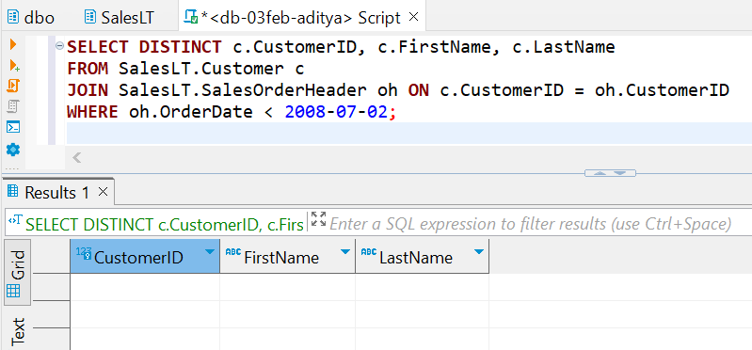

**18. Retrieve the order with the highest quantity of a specific product.**

SELECT TOP 1 od.SalesOrderID, od.ProductID, p.Name AS ProductName,

SUM(od.OrderQty) AS TotalQuantity

FROM SalesLT.SalesOrderDetail od

JOIN SalesLT.Product p ON od.ProductID = p.ProductID

WHERE od.ProductID = 714

GROUP BY od.SalesOrderID, od.ProductID, p.Name

ORDER BY TotalQuantity DESC;

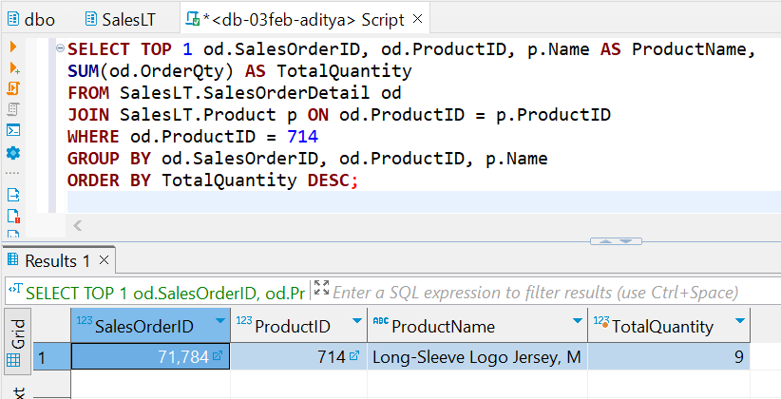

**19. Display products with prices lower than the lowest product price in a specific category.**

WITH ProductPrices AS (

SELECT p.ProductID, p.Name AS ProductName, p.ListPrice, pc.ProductCategoryID

FROM SalesLT.Product p

JOIN SalesLT.ProductCategory pc ON p.ProductCategoryID = pc.ProductCategoryID

WHERE pc.ProductCategoryID = 11

)

SELECT ProductID, ProductName, ListPrice

FROM ProductPrices

WHERE ListPrice < (SELECT MIN(ListPrice) FROM ProductPrices);

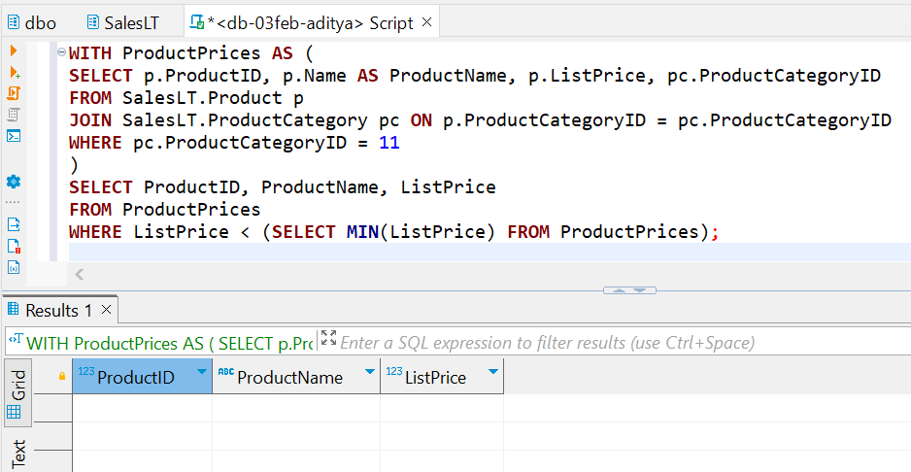

**20. Find employees who have the same job title as their manager.**

Data Insufficient

**21. Combine results from two queries to get a list of unique customer and employee names.**

Data Insufficient

**22. Retrieve product names that are common in two different product categories.**

SELECT p.Name AS ProductName

FROM SalesLT.Product p

JOIN SalesLT.ProductCategory pc1 ON p.ProductCategoryID = pc1.ProductCategoryID

JOIN SalesLT.ProductCategory pc2 ON p.ProductCategoryID = pc2.ProductCategoryID

WHERE pc1.ProductCategoryID <> pc2.ProductCategoryID;

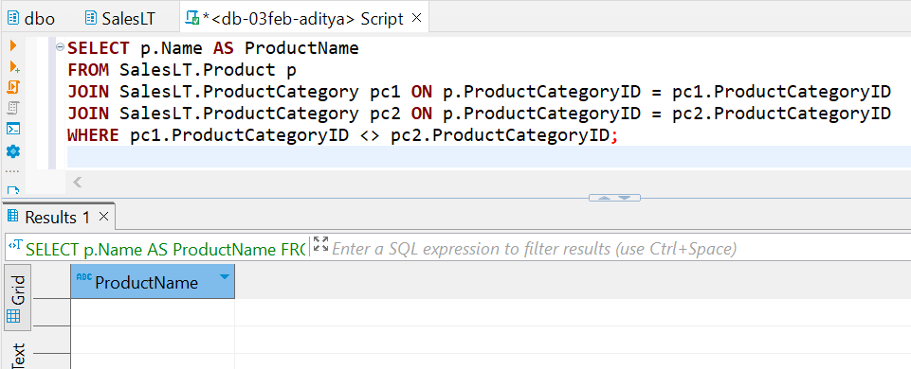

**23. Display the names of employees and customers in a single result set.**

Data Insufficient

**24. List products that are in stock or have been discontinued.**

Data Insufficient

**25. Combine the results of two queries to find unique products ordered by a specific customer.**

SELECT DISTINCT p.ProductID, p.Name AS ProductName

FROM SalesLT.Product p

JOIN SalesLT.SalesOrderDetail od ON p.ProductID = od.ProductID

JOIN SalesLT.SalesOrderHeader oh ON od.SalesOrderID = oh.SalesOrderID

WHERE oh.CustomerID = 29485

UNION

SELECT DISTINCT p.ProductID, p.Name AS ProductName

FROM SalesLT.Product p

JOIN SalesLT.SalesOrderDetail od ON p.ProductID = od.ProductID

ORDER BY ProductID;

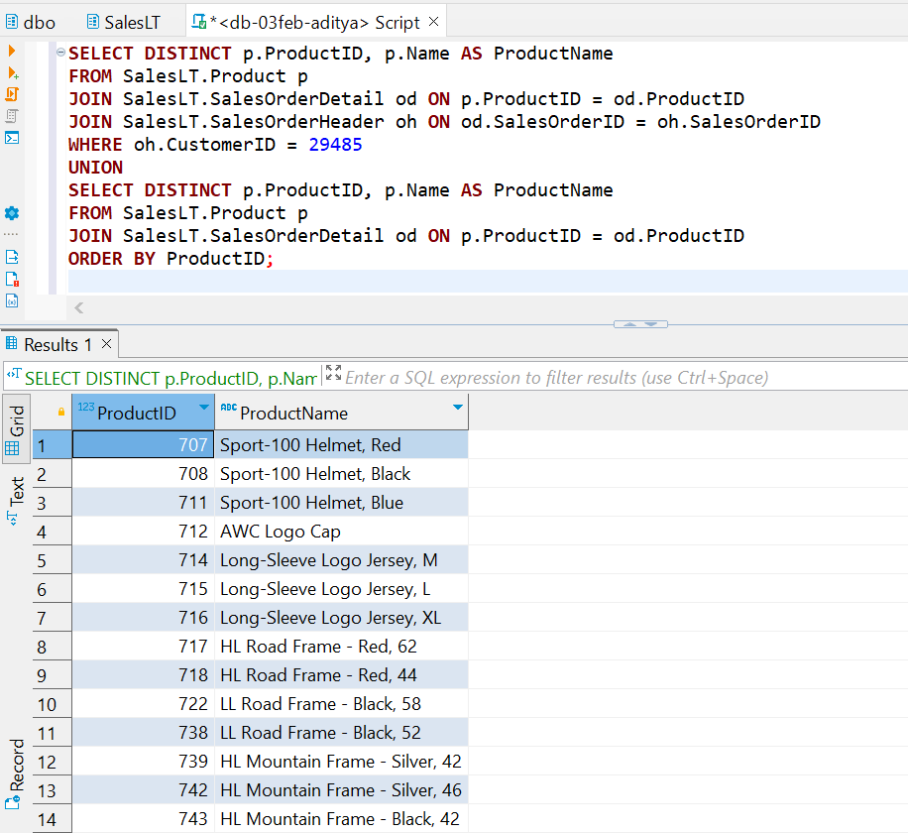

**26. Retrieve orders placed by customers and employees in a single result set.**

Data Insufficient

**27. Display products that are either in a specific category or have a specific safety stock level.**

Data Insufficient

**28. List customers who have placed orders and employees who have direct reports in a single result set.**

Data Insufficient

**29. Retrieve products that are in stock in one location and out of stock in another.**

Data Insufficient

**30. Combine information about employees who are managers and employees who have managers**

Data Insufficient

**INTERMEDIATE**

**31. Retrieve a list of customers along with the names of the products they have purchased.**

SELECT c.CustomerID, c.FirstName, c.LastName, p.Name AS ProductName

FROM SalesLT.Customer c

JOIN SalesLT.SalesOrderHeader oh ON c.CustomerID = oh.CustomerID

JOIN SalesLT.SalesOrderDetail od ON oh.SalesOrderID = od.SalesOrderID

JOIN SalesLT.Product p ON od.ProductID = p.ProductID

ORDER BY c.CustomerID, p.ProductID;

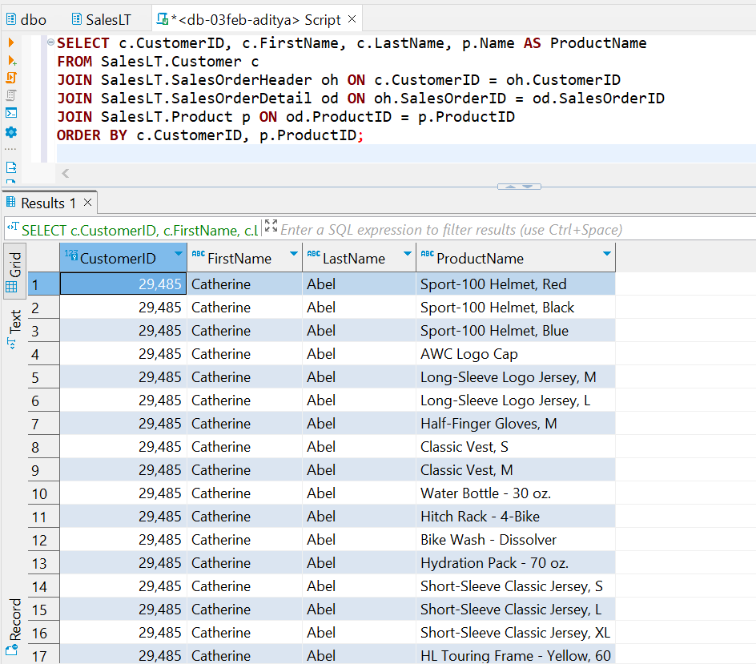

**32. Display employees who have the same manager, including indirect reports.**

Data Insufficient

**33. Find orders with multiple products and display the product names.**

SELECT oh.SalesOrderID,

COUNT(DISTINCT od.ProductID) AS NumberOfProducts, STRING_AGG(p.Name, ', ') AS ProductNames

FROM SalesLT.SalesOrderHeader oh

JOIN SalesLT.SalesOrderDetail od ON oh.SalesOrderID = od.SalesOrderID

JOIN SalesLT.Product p ON od.ProductID = p.ProductID

GROUP BY oh.SalesOrderID

HAVING COUNT(DISTINCT od.ProductID) > 1;

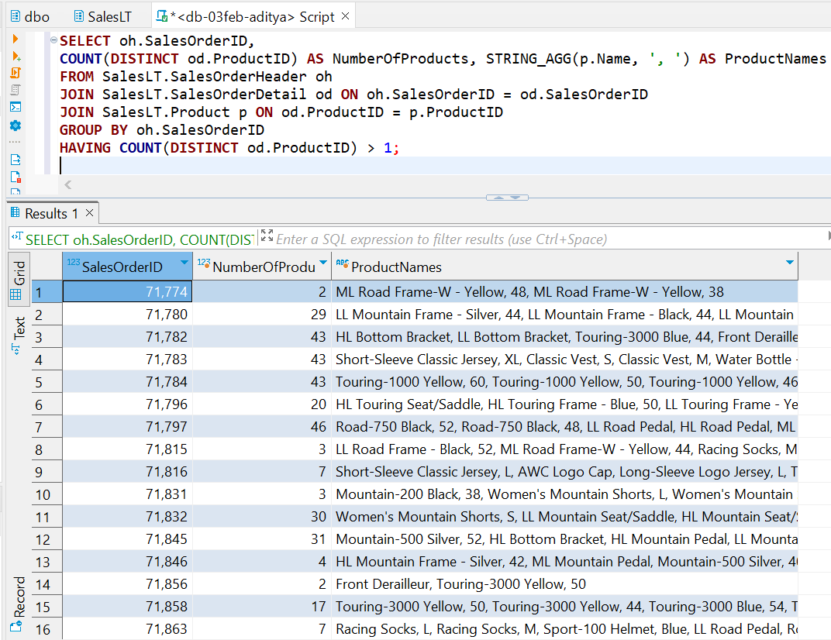

**34. List customers along with the names of the salespeople who handled their orders.**

Data Insufficient

**35. Retrieve a list of products along with the names of suppliers.**

Data Insufficient

**36. Display customers who have placed orders and the products they have purchased,** **including product details.**

SELECT c.CustomerID, c.FirstName, c.LastName, oh.SalesOrderID,

p.ProductID, p.Name AS ProductName, od.OrderQty, od.UnitPrice

FROM SalesLT.Customer c

JOIN SalesLT.SalesOrderHeader oh ON c.CustomerID = oh.CustomerID

JOIN SalesLT.SalesOrderDetail od ON oh.SalesOrderID = od.SalesOrderID

JOIN SalesLT.Product p ON od.ProductID = p.ProductID

ORDER BY c.CustomerID, oh.SalesOrderID, p.ProductID;

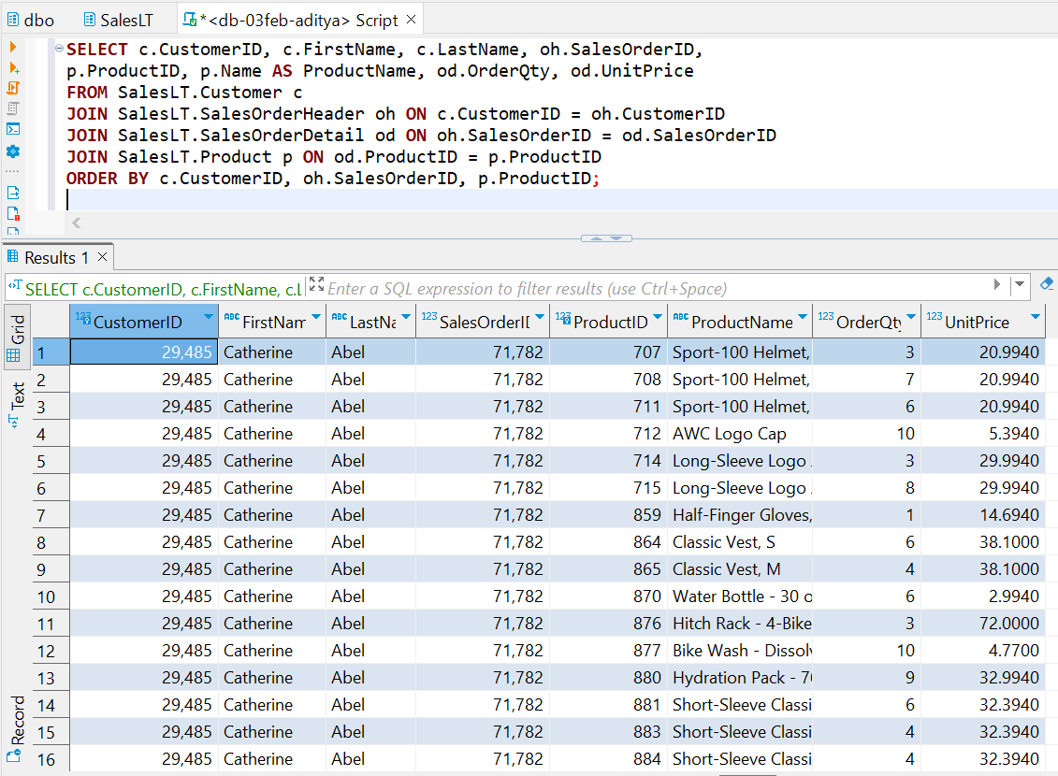

**37. Find orders where multiple employees were involved, showing the employee names.**

Data Insufficient

**38. List products that have similar names but belong to different categories.**

Data Insufficient

**39. Retrieve a list of employees along with their training courses and training dates.**

Data Insufficient

**40. Display customers who have placed orders and the total quantity of each product ordered.**

SELECT c.CustomerID, c.FirstName, c.LastName, p.ProductID, p.Name AS ProductName,

SUM(od.OrderQty) AS TotalQuantity

FROM SalesLT.Customer c

JOIN SalesLT.SalesOrderHeader oh ON c.CustomerID = oh.CustomerID

JOIN SalesLT.SalesOrderDetail od ON oh.SalesOrderID = od.SalesOrderID

JOIN SalesLT.Product p ON od.ProductID = p.ProductID

GROUP BY c.CustomerID, c.FirstName, c.LastName, p.ProductID, p.Name

ORDER BY c.CustomerID, p.ProductID;

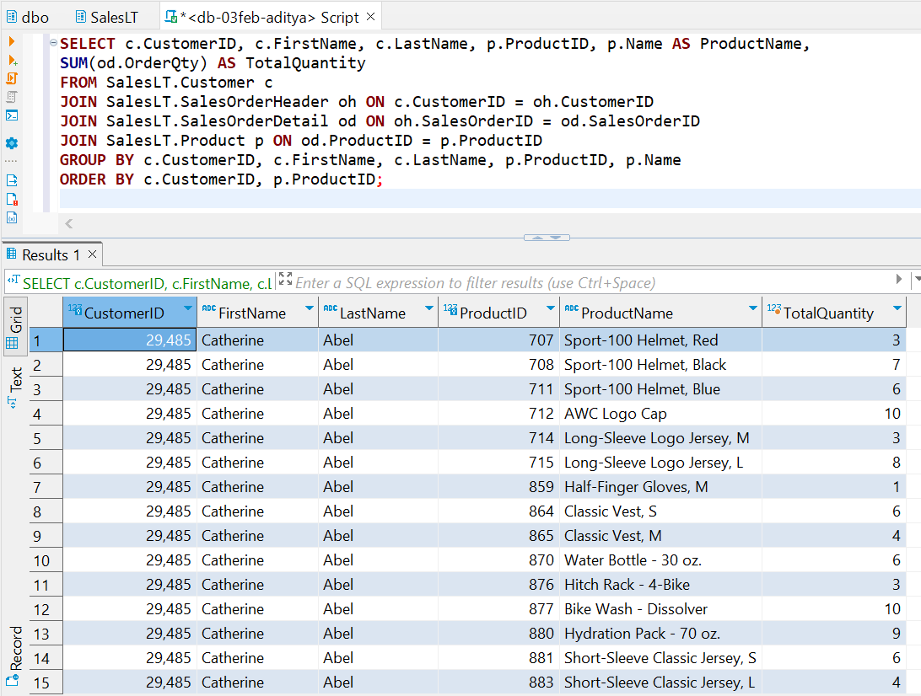

**41. Find customers who have made more purchases than the average number of purchases.**

WITH CustomerPurchaseCounts AS (

SELECT c.CustomerID,

COUNT(DISTINCT oh.SalesOrderID) AS PurchaseCount

FROM SalesLT.Customer c

JOIN SalesLT.SalesOrderHeader oh ON c.CustomerID = oh.CustomerID

JOIN SalesLT.SalesOrderDetail od ON oh.SalesOrderID = od.SalesOrderID

GROUP BY c.CustomerID

)

SELECT c.CustomerID, c.FirstName, c.LastName, c.EmailAddress, c.Phone, c.CompanyName

FROM SalesLT.Customer c

JOIN CustomerPurchaseCounts pc ON c.CustomerID = pc.CustomerID

WHERE pc.PurchaseCount > (SELECT AVG(PurchaseCount)

FROM CustomerPurchaseCounts);

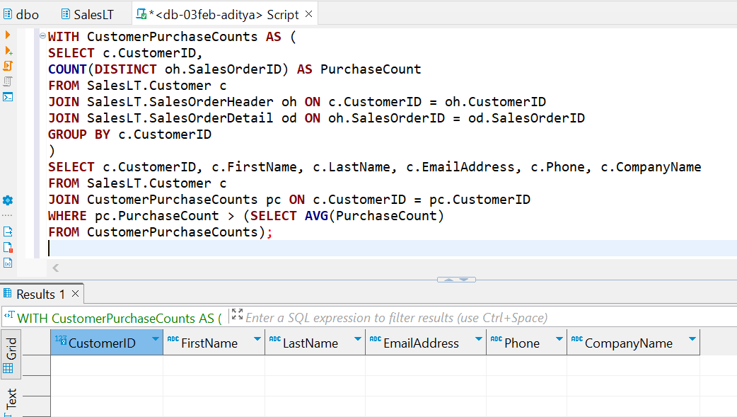

**42. Display products that have been ordered more than the average number of times.**

WITH ProductOrderCounts AS (

SELECT p.ProductID, p.Name AS ProductName,

COUNT(od.SalesOrderID) AS OrderCount

FROM SalesLT.Product p

JOIN SalesLT.SalesOrderDetail od ON p.ProductID = od.ProductID

GROUP BY p.ProductID, p.Name

)

SELECT ProductID, ProductName, OrderCount

FROM ProductOrderCounts

WHERE OrderCount > (SELECT AVG(OrderCount) FROM ProductOrderCounts);

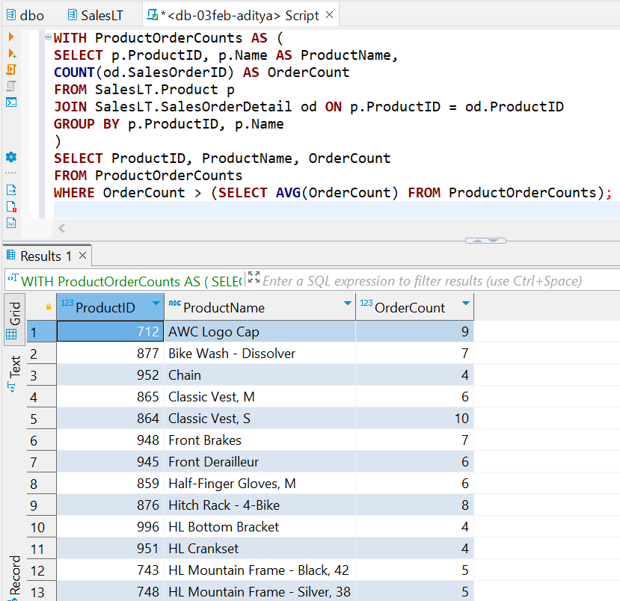

**43. Retrieve orders placed by employees who have completed a specific training course.**

Data Insufficient

**44. List employees who have a higher salary than at least one employee in another department.**

Data Insufficient

**45. Display products that have not been ordered in the last 60 days.**

Data Insufficient

**46. Find employees who have the same job title as the employee with the highest salary.**

Data Insufficient

**47. List customers who have placed orders with a total amount greater than the total amount of a specific order.**

Data Insufficient

**48. Retrieve products that have been ordered by customers with the same shipping address.**

WITH CustomerShippingAddresses AS (

SELECT ca.CustomerID, ca.AddressID, a.AddressLine1, a.AddressLine2,

a.City, a.StateProvince, a.CountryRegion, a.PostalCode

FROM SalesLT.CustomerAddress ca

JOIN SalesLT.Address a ON ca.AddressID = a.AddressID

)

SELECT p.ProductID, p.Name AS ProductName,od.SalesOrderID, csa.CustomerID,

csa.AddressID, csa.AddressLine1, csa.AddressLine2, csa.City, csa.StateProvince,

csa.CountryRegion, csa.PostalCode

FROM SalesLT.Product p

JOIN SalesLT.SalesOrderDetail od ON p.ProductID = od.ProductID

JOIN SalesLT.SalesOrderHeader oh ON od.SalesOrderID = oh.SalesOrderID

JOIN CustomerShippingAddresses csa ON oh.CustomerID = csa.CustomerID

WHERE oh.ShipToAddressID IN (

SELECT ShipToAddressID

FROM SalesLT.SalesOrderHeader

GROUP BY ShipToAddressID

HAVING COUNT(DISTINCT CustomerID) > 1

);

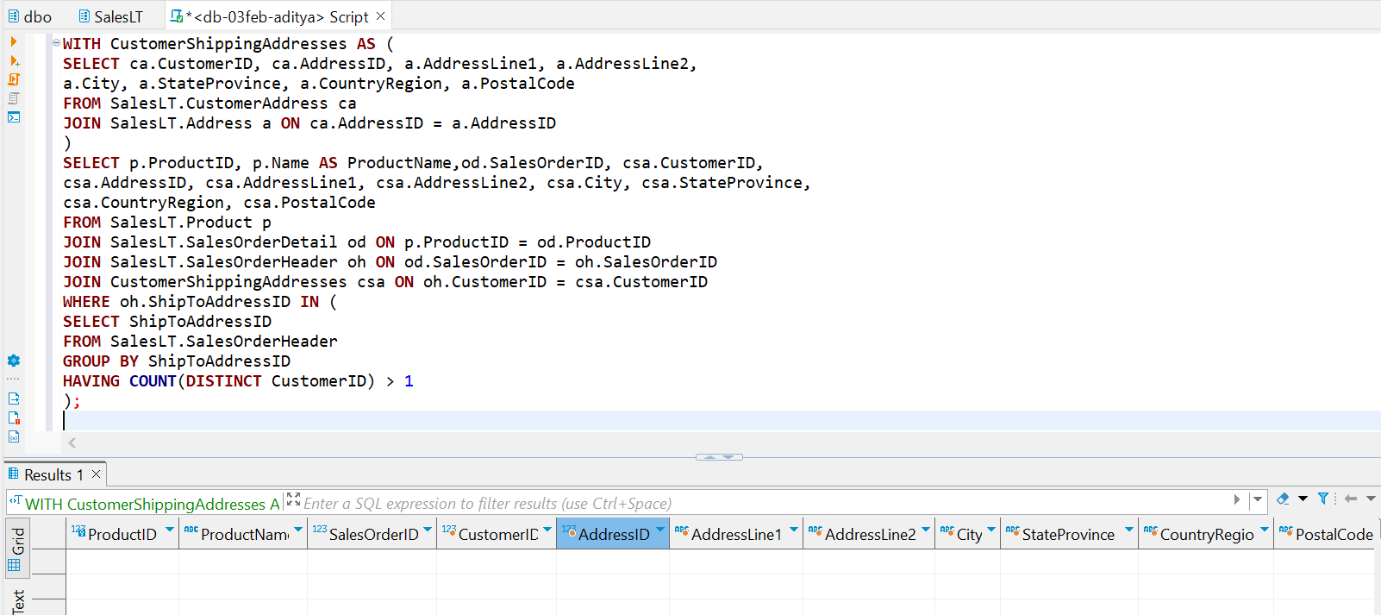

**49. Display orders with quantities higher than the average quantity for a specific product.**

WITH AvgQuantityPerProduct AS (

SELECT od.ProductID,

AVG(od.OrderQty) AS AvgQuantity

FROM SalesLT.SalesOrderDetail od

GROUP BY od.ProductID

)

SELECT od.SalesOrderID, od.ProductID, p.Name AS ProductName, od.OrderQty

FROM SalesLT.SalesOrderDetail od

JOIN SalesLT.Product p ON od.ProductID = p.ProductID

JOIN AvgQuantityPerProduct avgQ ON od.ProductID = avgQ.ProductID

WHERE od.OrderQty > avgQ.AvgQuantity

ORDER BY od.SalesOrderID, od.ProductID;

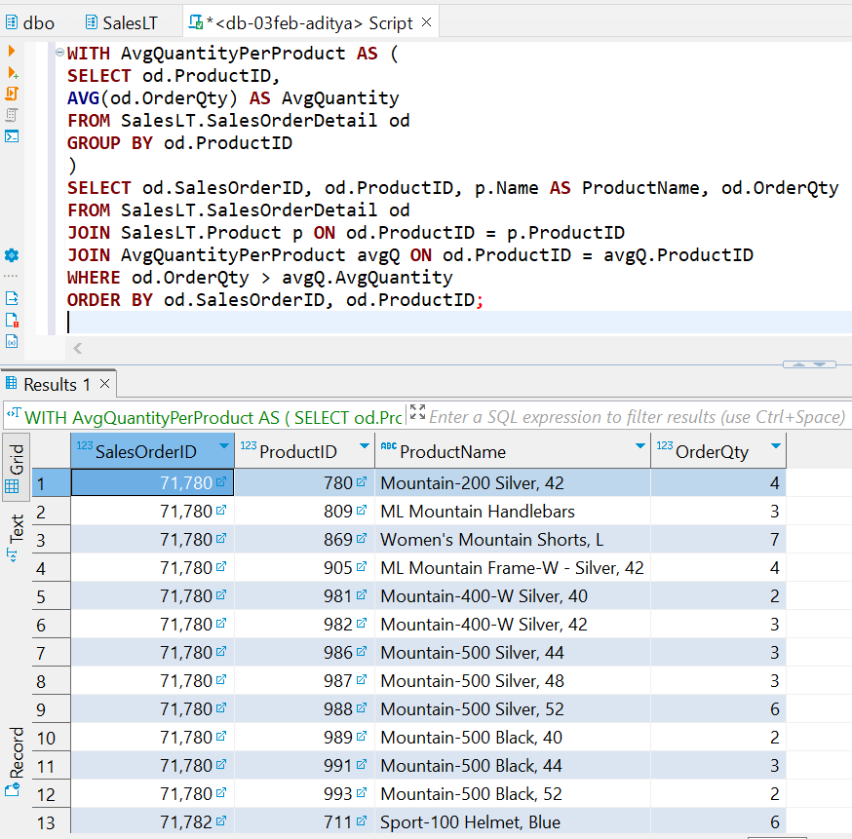

**50. Find customers who have placed orders for products that have not been ordered by any other customer**

WITH ProductsOrderedByCustomers AS(

SELECT DISTINCT od.ProductID

FROM SalesLT.SalesOrderDetail od

)

SELECT c.CustomerID, c.FirstName, c.LastName, oh.SalesOrderID, p.ProductID, p.Name AS ProductName

FROM SalesLT.Customer c

JOIN SalesLT.SalesOrderHeader oh ON c.CustomerID = oh.CustomerID

JOIN SalesLT.SalesOrderDetail od ON oh.SalesOrderID = od.SalesOrderID

JOIN SalesLT.Product p ON od.ProductID = p.ProductID

WHERE p.ProductID NOT IN (SELECT ProductID FROM ProductsOrderedByCustomers)

ORDER BY c.CustomerID, oh.SalesOrderID, p.ProductID;

