SQL assignment:

Aditya Gupta

TAS050

Questions:

1. What is the time period used?
2. How many properties have duplicate entries? Remove duplicate rows (say a row appears 3 times, remove 2 and keep 1)
3. For each property, find out the number of days the property was available and not available (create a table with listing_id, available days, unavailable days and available days as a fraction of total days)
4. How many properties were available on more than 50% of the days? How many properties were available on more than 75% of the days?
5. Create a table with max, min and average price of each property
6. Extract properties with an average price of more than $500

**Solutions**

1. **The format of date is used here as YYYY-MM-DD.**

Select * from aditya_data

Order by date ;

Select * from aditya_data

Order by date desc;

1. By running the 1st query we get to know there are many rows with the duplicate values. So in the query I write count rows that occur more than 1 .

So to get unique rows i am creating a new table consisting of unique rows.

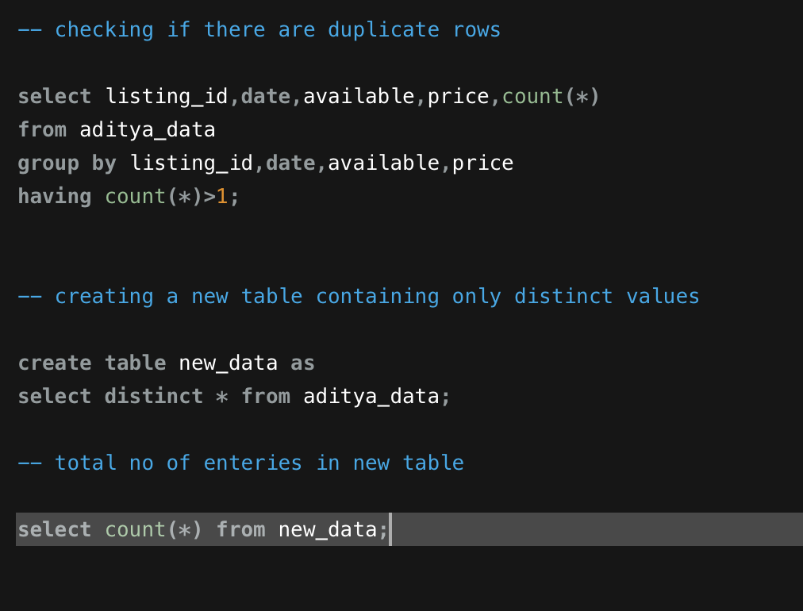 **CODE**

**OUTPUT**

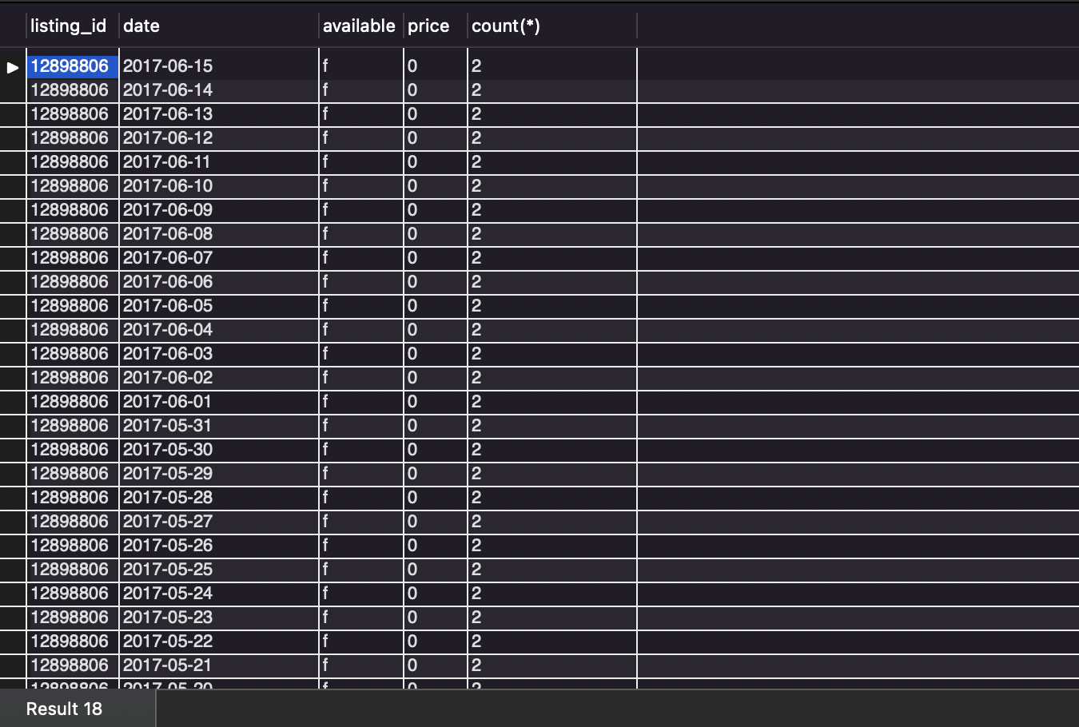

it is showing that there are multiple rows with the same data

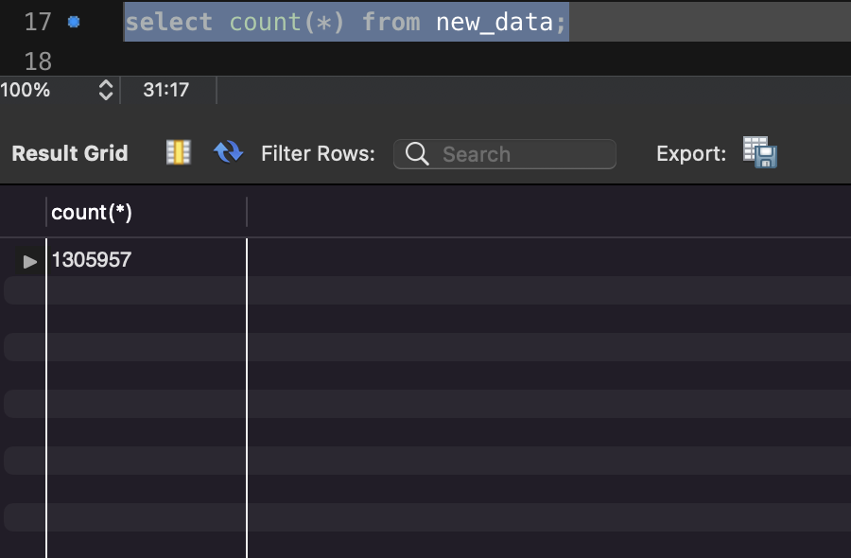

After getting only unique rows we left with 1305957 rows instead of 1308160

1. First creating a table name question3 which consist of column listing_id, available days(1 for true and 0 for false) and not available days (1 for false and 0 for true).

Now creating the required table ques3 which consist listing_id, no of available days ,

no of not available days , and the fraction of available days to total days

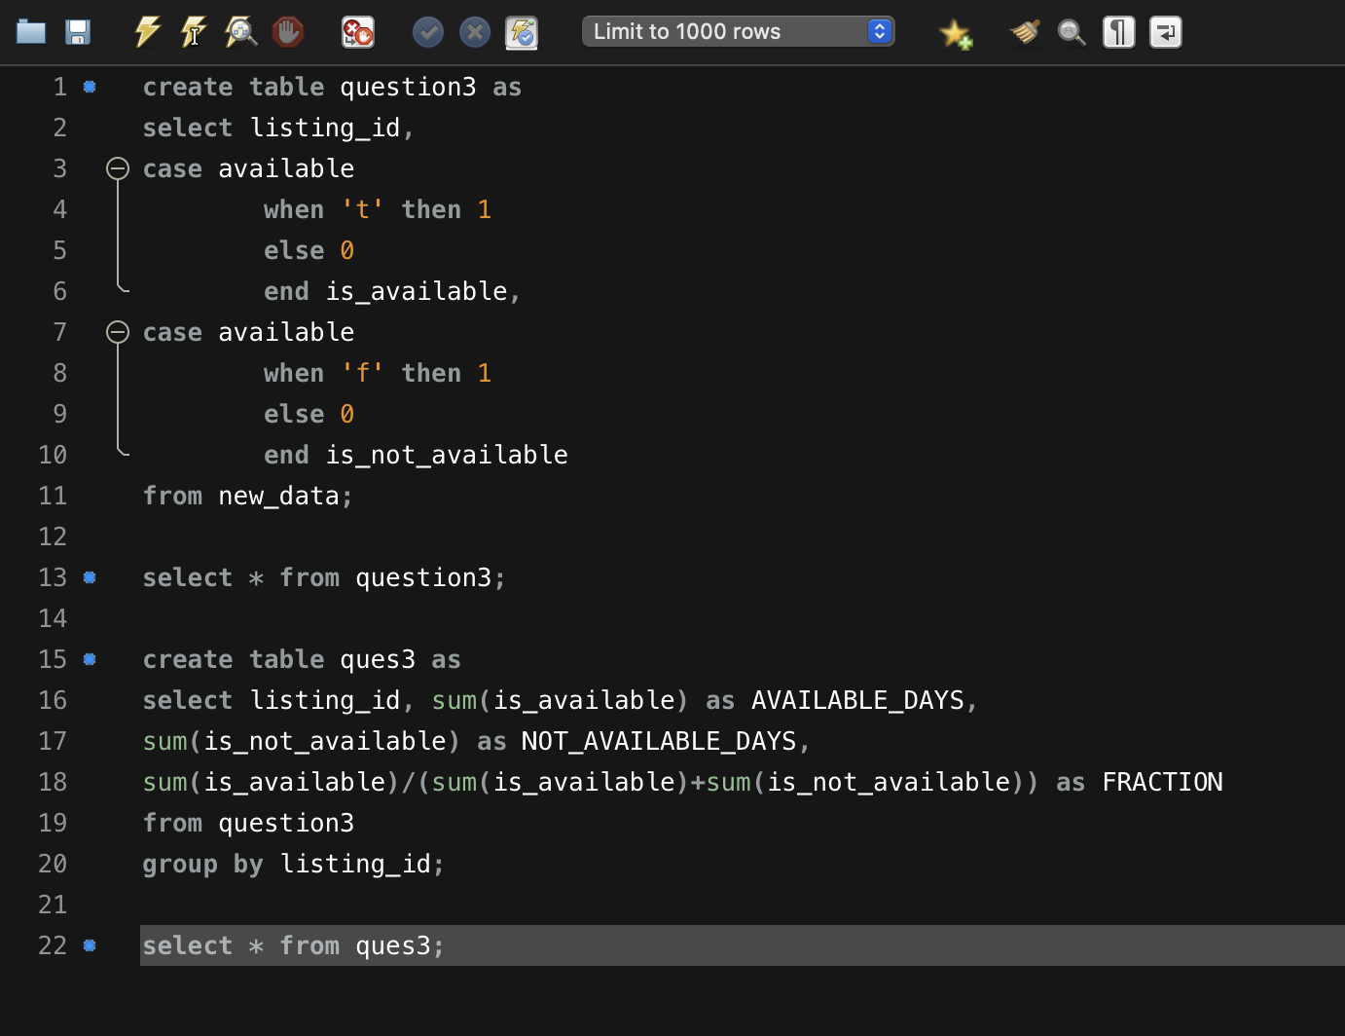  **code**

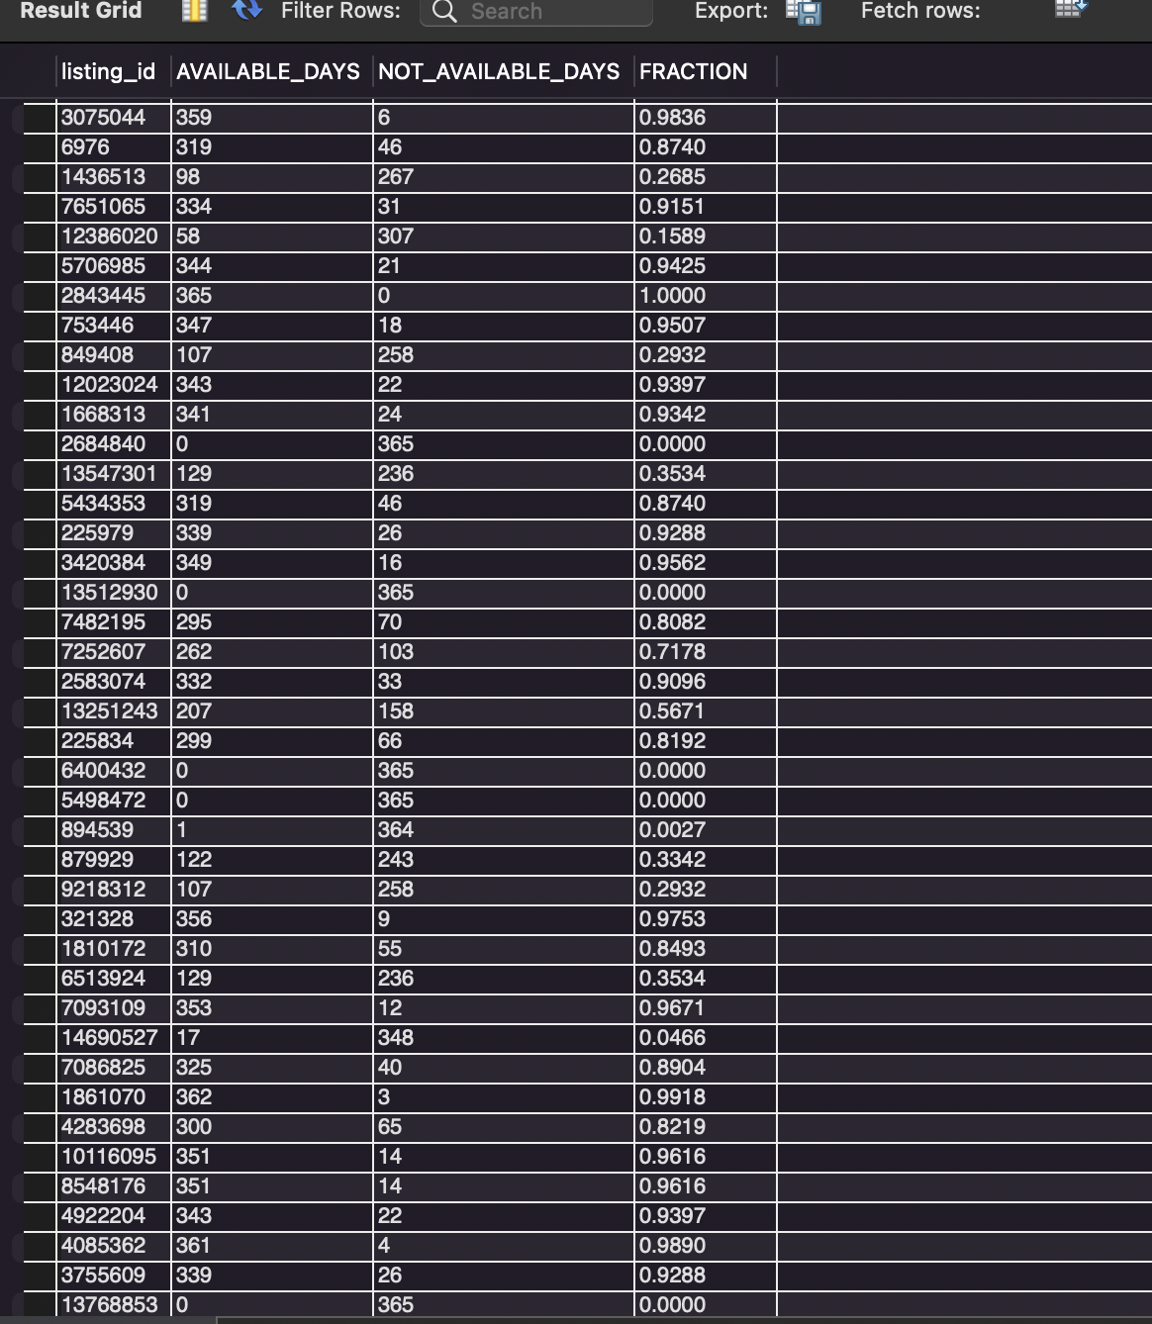 **output**

1. So from the table we made in previous table we can get the fraction and simply check it for >0.5 and >0.75

**code**

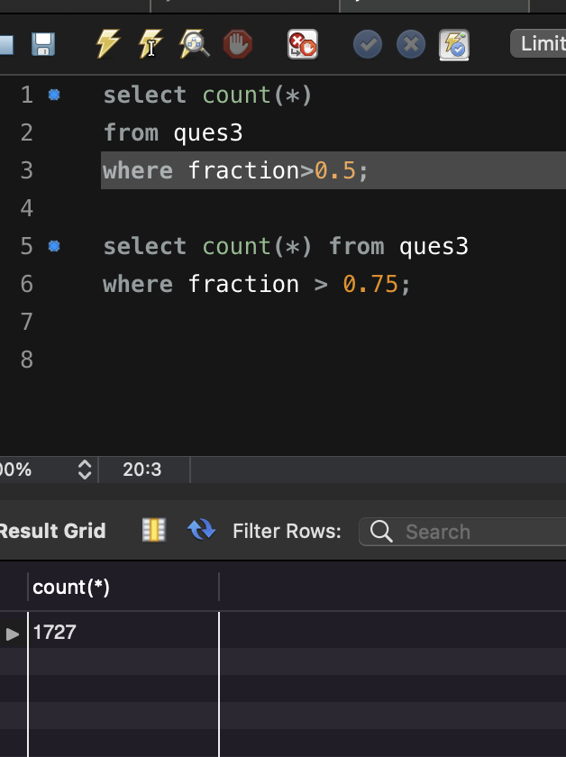

**Output**

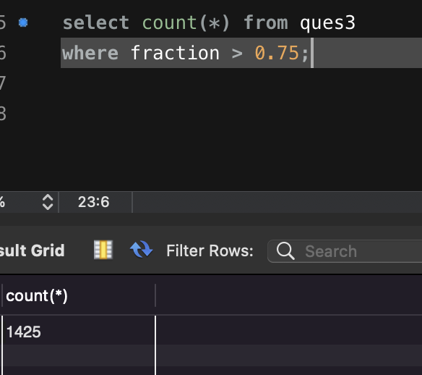

1. Creating a table with the columns listing_id, max(price),min(price),avg(price) from table new_data

**Code-**

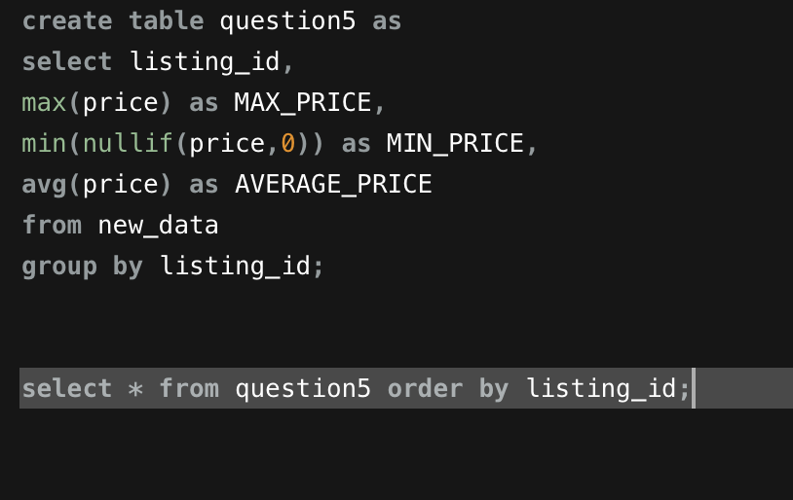

**Output-**

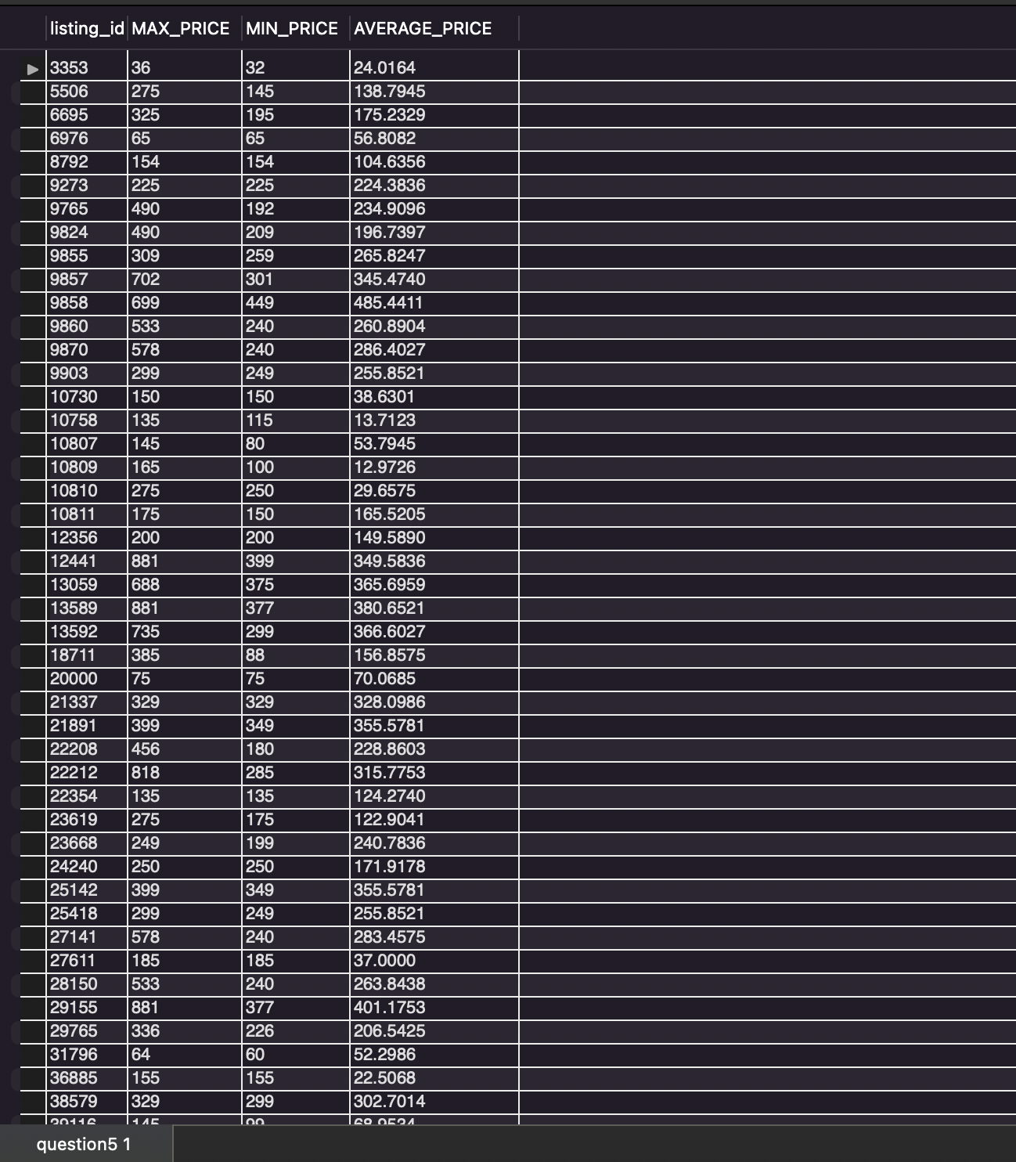

**6)**  from the table ques5 getting avg(price) and check if it is >500.

**Code and output-**

