STANCE (Sec Text and Accounting Numeric Checking Engine)

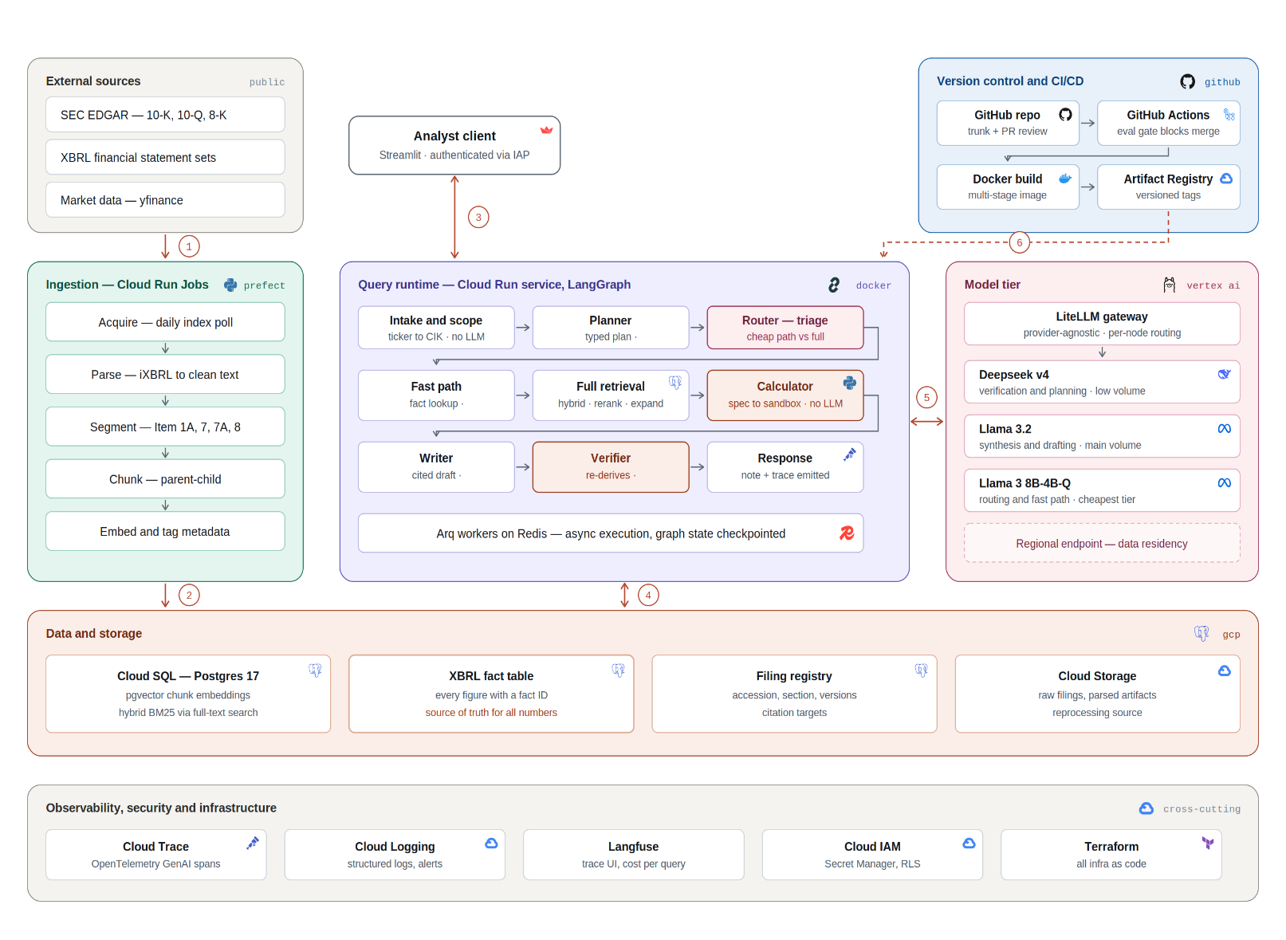

STANCE is a four-layer system built on a single governing rule: narrative comes from retrieved text, but every number comes from a structured fact table, and the language model never performs arithmetic. An offline ingestion pipeline runs as Cloud Run Jobs under Prefect, acquiring filings from EDGAR by accession number, parsing inline XBRL into clean text, segmenting by item boundaries, chunking parent-to-child, and embedding with metadata. It writes to two destinations in one Cloud SQL Postgres instance: chunk vectors in pgvector, and every tagged financial figure in an XBRL fact table with a traceable identifier. The query runtime is a LangGraph service on Cloud Run. Scope resolution maps tickers to identifiers deterministically, a planner emits a typed plan, and a router triages each request to a cheap fact-lookup path or a full hybrid-retrieval path. A calculator then emits a computation specification that a sandbox executes against the fact table, a writer drafts with citations, and a verifier re-derives every figure before publication, stripping anything untraceable. Models are routed per node through a LiteLLM gateway. GitHub Actions gates merges on evaluations, builds Docker images, and deploys to Cloud Run, with OpenTelemetry, Langfuse, IAM and Terraform cross-cutting.

