**SMART BLIND STICK**

**T. E. Information Technology**

By

**Aditya Somaiya 06**

**Dhwani Mehta 10**

**Akshay Gunjal 14**

Mentor:

**MS. PRIYANKA GONSALVES**

Assistant Professor



Department of Information Technology

St. Francis Institute of Technology

(Engineering College)

University of Mumbai

2019-2020

**DECLARATION**

We declare that this written submission represents our ideas in our own words and where others' ideas or words have been included, we have adequately cited and referenced the original sources.

We also declare that we have adhered to all principles of academic honesty and integrity and have not misrepresented or fabricated or falsified any idea/data/fact/source in this submission.

We understand that any violation of the above will be cause for disciplinary action by the Institute and can also evoke penal action from the sources which have thus not been properly cited or from whom proper permission has not been taken when needed.

1. -----------------------------------------

(Signature)

-----------------------------------------

(Name of student and Roll No.)

1. -----------------------------------------

(Signature)

-----------------------------------------

(Name of student and Roll No.)

1. -----------------------------------------

(Signature)

-----------------------------------------

(Name of student and Roll No.)

Date:

**CERTIFICATE**

This IoT Mini-project Smart Blind Stick Using IoT by Mr. Aditya Somaiya, Ms. Dhwani Mehta, Mr. Akshay Gunjal is complete in all respects and was successfully demonstrated on 25th October,2019.

Name : ---------------------------------------------

Signature :------------------------------------------

(Internal examiner)

Name : ---------------------------------------------

Signature :------------------------------------------

(External examiner)

Date:

Place:

**CONTENTS**

|  |  |  |
| --- | --- | --- |
| **Chapter No.** | **Chapter Name** | **Page Number** |
| 1 | Introduction |  |
| 2 | Literature Review |  |
| 3 | Problem Statement |  |
| 4 | System Design and Requirements |  |
| 5 | Results |  |
| 6 | Conclusion and Future Scope |  |
|  | References |  |
|  | Papers published/ Participations/ Awards |  |

**Chapter 1**

**Introduction**

The power of vision is one of the most significant parts of human physiology. Our eyes are the key to our surroundings.

According to a report by World Health Organization (WHO) and International Agency for Prevention of Blindness nearly 285 million persons around the world are visually impaired.

The purpose of this blind stick would be to make blind people more independent.We aim at providing a technical solution to a real world problem which would help society in some form or the other. This project will help blind people identify obstacles and make their next movement according to presence or absence of obstacle.A sound and touch based smart cane using ultrasonic rangers to detect obstacles or blocking object.

We also used cloud for storing data and sending message to blind persons family.The main aim of this project is to detect nearby obstacle and notify the user of the direction of the obstacle ,thereby enabling the user to determine the corrective direction to head.

**Chapter 2**

**Literature Review**

Smart Stick for the Blind is a complete solution to reach their destination. This paper uses IR sensor, Ultrasound sensor and water sensor to detect the obstacle. However, this system just gives an alert if any one of the sensor is triggered, it uses a buzzer to alert the blind person. This system does not use any location identifier or location indicator.[1] Pothole detection for visually impaired uses a camera that captures image 15 frame per second and based on the concept of image processing the pothole is detected. Problem with this system is use of camera makes it expensive, and a lot of images captured per second increases overhead and storage requirement.[2]

Another paper uses Raspberry Pi and an ultrasonic sensor to detect object**s** and intruder, the system also has a camera embedded with it, and based on the images captured the objects are detected.[3] The objects are analyzed based on the set of image datasets that are already stored. This system however, becomes costly due to the use of high-end camera and also because of storage constraints as large volume of datasets are needed to be stored.

**Chapter 3**

**Problem Statement**

People who are completely blind or have impaired vision usually have a difficult time navigating outside the spaces that they're accustomed to.

         In fact, physical movement is one of the biggest challenges for blind people, explains World Access for the Blind. Traveling or merely walking down a crowded street can be challenging. Because of this, many people with low vision will prefer to travel with a sighted friend or family member when navigating unfamiliar places. Our project uses ultrasonic sensor in our blind stick to guide visually impaired persons. Our project enables them to send messages to their relatives.

**Chapter 4**

**System Design and Requirements**

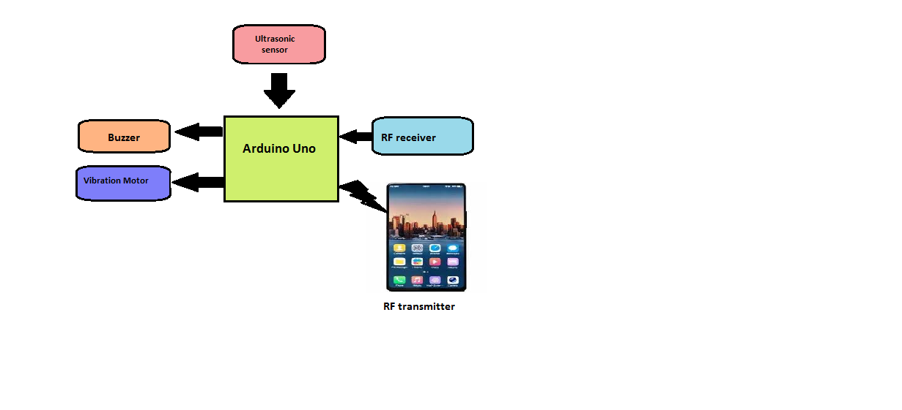

Fig. 1 System design for Smart Blind Stick

**Circuit diagram**

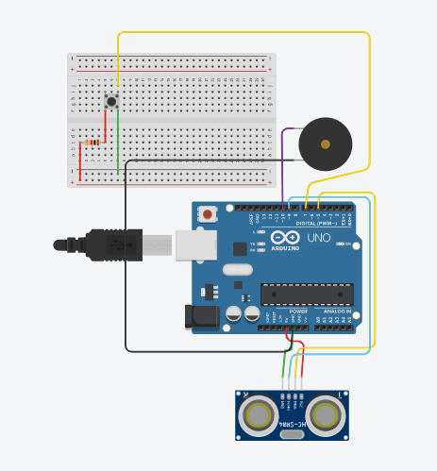

Fig. 2 Circuit Diagram for Smart Blind Stick

**System Requirements**

|  |  |
| --- | --- |
|  |  |
|  | **Hardware Requirements** |
| 1 | Arduino Uno R3 |
| 2 | Servo motor |
| 3 | ESP8266 |
| 4 | Vibration motor |
| 5 | Ultrasonic sensor |
| 6 | Jumper wires |
| 7 | Buzzer |
| 8 | RF transmitter and recevier |
|  | **Software Requirement** |
| 1 | Arduino IDE |
| 2 | Arduino Studio |

Table. 1 Hardware and Software Requirement

|  |  |  |
| --- | --- | --- |
| **Sr. No.** | **Components** | **Cost(Rs.)** |
| 1 | Arduino Uno | 400 |
| 2 | Ultrasonic sensor | 90 |
| 3 | Buzzer | 60 |
| 4 | Breadboard | 70 |
| 5 | Push button | 2 |
| 6 | Jumper wires | 15 |
| 7 | Batteries(2) | 60 |
| 8 | WiFi module | 200 |
| 9 | RF transmitter receiver | 100 |

Table. 2  Components Cost

**Chapter 5**

**Results**

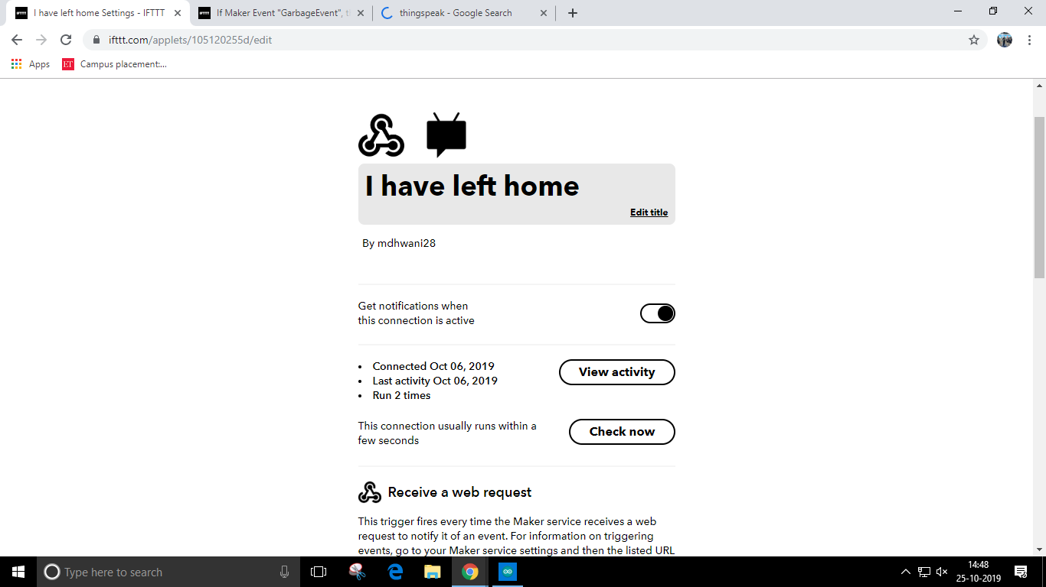

Fig. 1 Content of the Message

The settings of ifttt webhooks service that sends notification

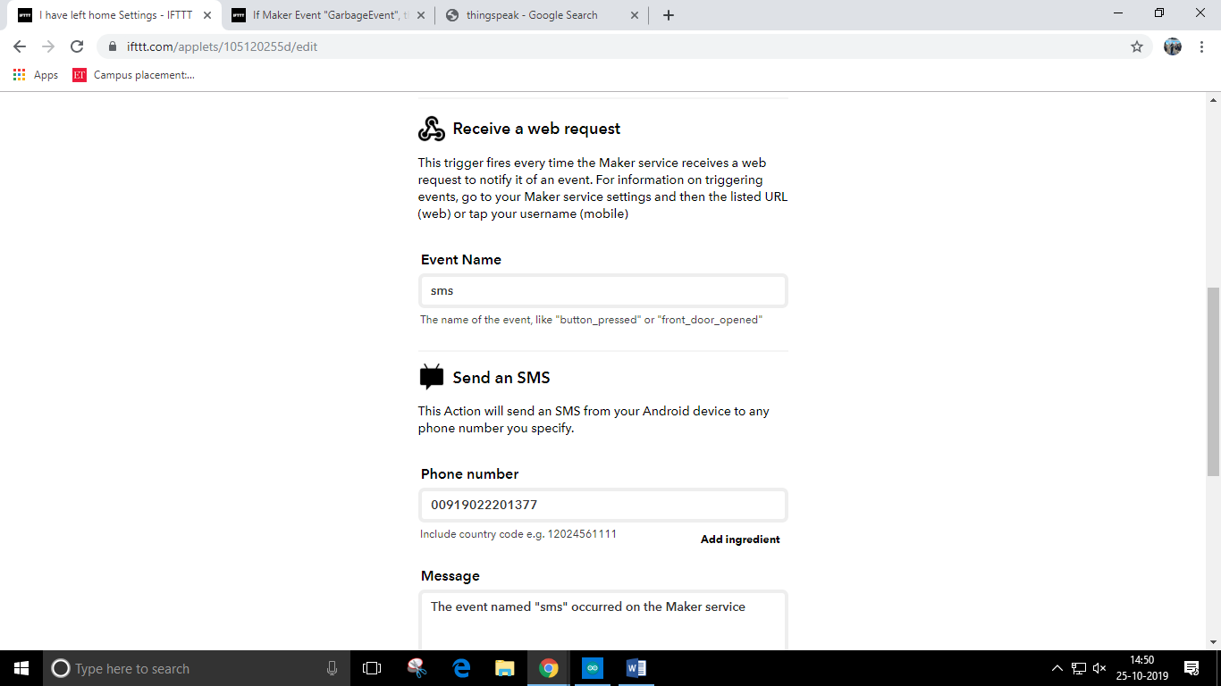

Fig. 2 Content of the Message

Configuration of the web request. The phone number to which the notification is sent is specified here, along with the message contents.

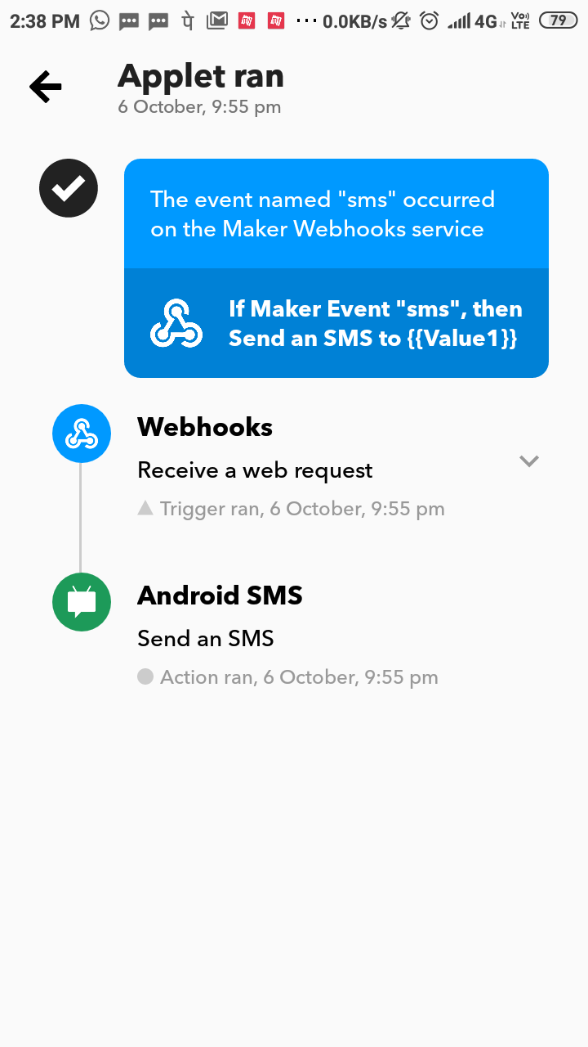

Fig. 3 Notification received on Mobile.

Screenshot of mobile app upon receiving notification. It shows webhooks being activated and a message sent.

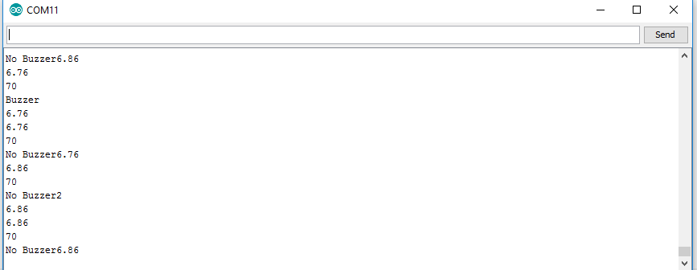

Fig. 4 Readings on Serial Monitor

Ultrasonic sensors readings and if buzzer should sound or not is shown.

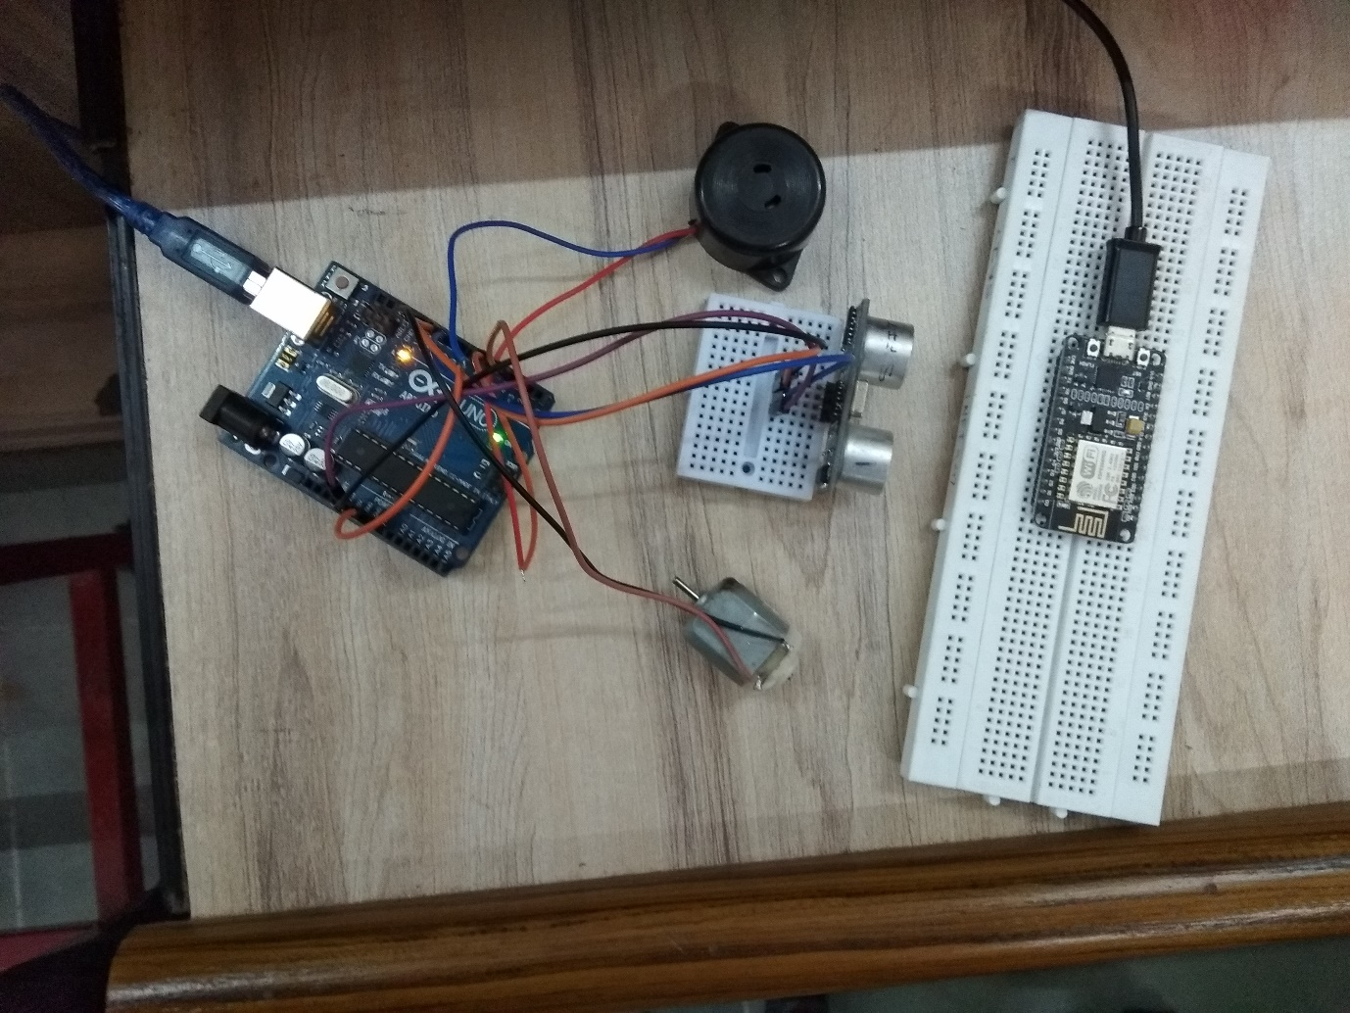

Fig. 5 All sensors working properly.

A picture of the components when all services are running.

**Chapter 6**

**Conclusion & Future Scope**

**Conclusion**

It is worth mentioning at this point that the aim of this study which is the design and implementation of a smart walking stick for the blind has been fully achieved. The Smart Stick acts as a basic platform for the coming generation of more aiding devices to help the visually impaired to navigate safely both indoor and outdoor. It is effective and affordable. It leads to good results in detecting the obstacles on the path of the user in a range of three meters. This system offers a low-cost, reliable, portable, low power consumption and robust solution

for navigation with obvious short response time. Though the system is hard-wired with sensors and other components, it's light in weight. Further aspects of this system can be improved via wireless connectivity between the system components, thus, increasing the range of the ultrasonic sensor and implementing a technology for determining the speed of approaching obstacles. While developing such an empowering solution, visually impaired and blind people in all developing countries were on top of our priorities. The device constructed in this work is only capable of detecting obstacles and moisture. Holes cannot be detected using this device nor the nature of obstacle. Therefore, a better device can be constructed using ultrasonic sensors, arduino Uno and other devices that employ audio commands to alert the user of what

is in his path of movement. A vibrator may also be added forease of use and convenience.

**Future Scope**

In the future, further modifications to enhance the performance of the system will be added. These include: A global positioning method to find the position of' the user using the GPS, and GSM modules to communicate the location to a relative or care giver. It should also accommodate wide varying grips for flexible handling**.**

**References**

 [1]. Sharma, Himanshu, Meenakshi Tripathi, Amit Kumar, and Manoj Singh Gaur. "Embedded Assistive Stick for Visually Impaired Persons." In *2018 9th International Conference on Computing, Communication and Networking Technologies (ICCCNT)*, pp. 1-6. IEEE, 2018.

 [2]. Wahab, Mohd Helmy Abd, et al. "Smart cane: Assistive cane for  visually-impaired people." *arXiv preprint arXiv:1110.5156*(2011).

[3]. Mohapatra, Saurav, Sub ham Rout, Varun Tripathi, Tanish Saxena, and Yepuganti Karuna.Smart Walking Stick for Blind Integrated with SOS Navigation System. In 2018 2nd International Conference on Trends in Electronics and Informatics (ICOEI), pp. 441-447. IEEE, 2018.

[4].[online]:https://www.tinkercad.com/

[5].[online]:<https://ifttt.com/login>/

**Code**

#define trigPin 9  
#define echoPin 10  
#define motor 7  
#define buzzer 6  
float duration, distance;  
float previous=0;  
void setup()  
{  
pinMode(trigPin, OUTPUT);  
pinMode(echoPin, INPUT);  
pinMode(motor, OUTPUT);  
pinMode(buzzer,OUTPUT);  
Serial.begin(9600);  
}  
void loop()  
{  
digitalWrite(trigPin, LOW);  
delayMicroseconds(2);  
digitalWrite(trigPin, HIGH);  
delayMicroseconds(10);  
digitalWrite(trigPin, LOW);  
duration = pulseIn(echoPin, HIGH);  
 distance = (duration*.0343)/2;  
if (distance < 70)// This is where checking the distanceyou can change the value  
{  
digitalWrite(motor,HIGH); // When the the distance below 100cm  
digitalWrite(buzzer,HIGH);  
Serial.println(distance);  
Serial.println("70");  
  
 if(previous==distance){  
    Serial.print("No Buzzer");  
    digitalWrite(buzzer,LOW);  
    Serial.println(distance);  
    delay(5000);  
  }else if(previous>distance){  
    Serial.println("Buzzer");  
    digitalWrite(buzzer,HIGH);  
    Serial.println(distance);  
  }else if(previous<distance){  
    Serial.println("No Buzzer2");  
    digitalWrite(buzzer,LOW);  
    Serial.println(distance);  
  }} else{  
    digitalWrite(motor,LOW);// when greater than 100cm  
    digitalWrite(buzzer,LOW);  
    Serial.println(distance);  
}  
 previous=distance;  
 delay(500);  
}