**ASSIGNMENT 3**

V Aditya Srikanth

2016A7PS0091H

Results obtained:

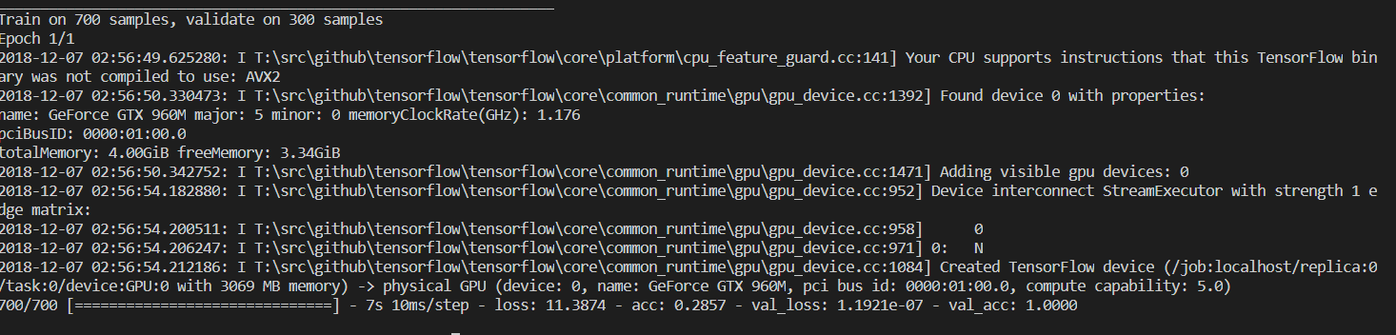

Validation Accuracy:

100%

Validation Loss:

1.1921*!)^-7

Code:

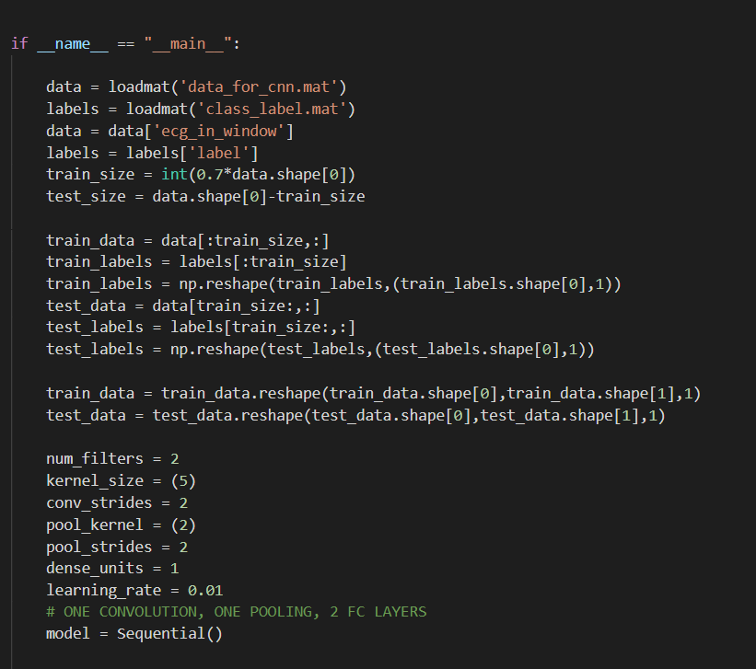

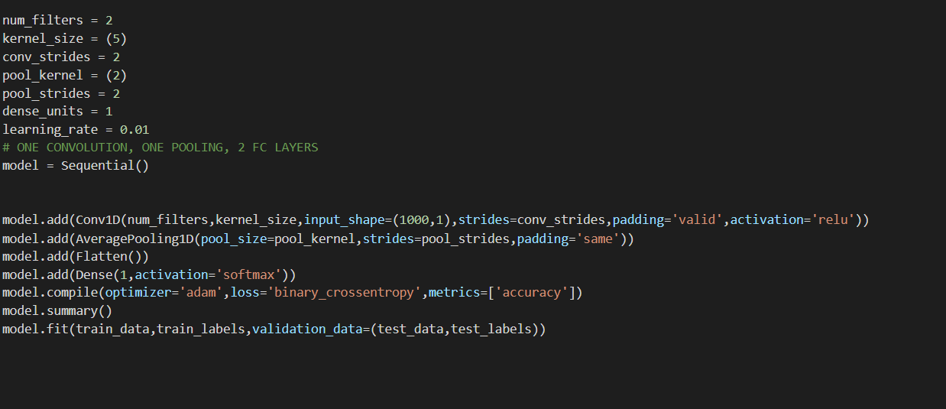

Note: This runs with Keras Python Library. Per our discussion I am submitting this implementation