Machine Learning-Based Threat Detection Framework for Kubernetes Environments
SWE3004 – Software Design and Development Project

Submitted in partial fulfillment of the requirements for the degree of

Master of Technology in Software Engineering
in
Department of Software and Systems Engineering

by

Aditya Sukumaran
22MIS0050

Under the guidance of

Prof. Gunasekaran G

School of Computer Science Engineering and Information Systems
VIT, Vellore



November, 2026
Machine Learning-Based Threat Detection Framework for Kubernetes Environments
SWE3004 – Software Design and Development Project

Submitted in partial fulfillment of the requirements for the degree of

Master of Technology in Software Engineering
in
Department of Software and Systems Engineering

by

Aditya Sukumaran
22MIS0050

Under the guidance of

Prof. Gunasekaran G

School of Computer Science Engineering and Information Systems
VIT, Vellore

November, 2026
DECLARATION

I hereby declare that the SWE3004 - Software Design and Development Project entitled “Machine Learning-Based Threat Detection Framework for Kubernetes Environments” submitted by me, for the award of the degree of Master of Technology in Software Engineering in Department of Software and Systems Engineering, School of Computer Science Engineering and Information Systems to VIT is a record of bonafide work carried out by me under the supervision of Prof. Gunasekaran G, Professor Grade 1, SCORE, VIT, Vellore.
I further declare that the work reported in this project has not been submitted and will not be submitted, either in part or in full, for the award of any other degree or diploma in this institute or any other institute or university.

Place: Vellore
Date: DD.MM.YYYY – to be filled at signing

Signature of the Candidate

CERTIFICATE
This is to certify that the SWE3004 - Software Design and Development Project entitled “Machine Learning-Based Threat Detection Framework for Kubernetes Environments” submitted by Aditya Sukumaran (22MIS0050), SCORE, VIT, for the award of the degree of Master of Technology in Software Engineering in Department of Software and Systems Engineering, is a record of bonafide work carried out by him / her under my supervision during the period, 06.07.2026 to 03.11.2026 (template dates; to be confirmed by the guide), as per the VIT code of academic and research ethics.
The contents of this report have not been submitted and will not be submitted either in part or in full, for the award of any other degree or diploma in this institute or any other institute or university. The project fulfills the requirements and regulations of the University and in my opinion meets the necessary standards for submission.

Place: Vellore
Date: DD.MM.YYYY – to be filled at signing

Signature of the VIT-SCORE - Guide
Prof. Gunasekaran G, Professor Grade 1, SCORE

Internal Examiner External Examiner

Head of the Department
Department of Software and Systems Engineering

ACKNOWLEDGEMENT

It is my pleasure to express with a deep sense of gratitude to my project guide Prof. Gunasekaran G, Professor Grade 1, School of Computer Science Engineering and Information Systems, Vellore Institute of Technology, Vellore for the constant guidance and continual encouragement in my endeavor. It has been a great opportunity on my part to work under the guidance of an intellectual and an expert in the field of cloud-native security and machine learning.

"I would like to express my heartfelt gratitude to Honorable Chancellor Dr. G Viswanathan; respected Vice Presidents Dr. Sankar Viswanathan, Dr. Sekar Viswanathan, Vice Chancellor Dr. V. S. Kanchana Bhaaskaran; Pro-Vice Chancellor Dr. Partha Sharathi Mallick; and Registrar Dr. Jayabarathi T.

My whole-hearted thanks to Dean Dr. Daphne Lopez, School of Computer Science Engineering and Information Systems, Head, Department of Software and Systems Engineering Dr. Thanapal P, MTech - Software Engineering Project Coordinators Dr. Thilagavathi M and Dr. Brijendra Singh, SCORE School Project Coordinator Dr. Karthikeyan P, all faculty, staff and members working as limbs of our university for their continuous guidance throughout my course of study in unlimited ways.

It is indeed a pleasure to thank my parents and friends who persuaded and encouraged me to take up and complete my project successfully. Last, but not least, I express my gratitude and appreciation to all those who have helped me directly or indirectly towards the successful completion of the project.

Place: Vellore
Date: Aditya Sukumaran

Executive Summary

Kubernetes workloads change continuously, which makes security monitoring difficult. This project builds a reproducible, machine-learning-based threat detection framework for Kubernetes. A Minikube testbed with an nginx workload is instrumented with Inspektor Gadget v0.55.1 (eBPF TCP telemetry) and the Kubernetes Metrics Server v0.7.2 (CPU and memory). Observations are normalised to UTC and assigned to epoch-aligned, non-overlapping 10-second windows, giving Network, Workload and Fusion datasets from 24 sessions (Fusion: 122 labelled windows, 94 normal and 28 attack). Random Forest, XGBoost and SVM were evaluated with Leave-One-Session-Out cross-validation. Network Random Forest achieved the highest F1-score (0.9643); Fusion Random Forest reduced the false positive rate to 0.0213 with F1 = 0.9286; Fusion SVM detected all 28 attack windows with five false positives; workload-only models were weaker (F1 0.4400 to 0.6122). The report also documents a modular inference engine, a Streamlit dashboard and a rule-based runtime process-execution extension that is not validated as a supervised classifier. The results apply to controlled scenarios in a single-node cluster and do not establish production readiness.

CONTENTS
Acknowledgement v
Executive Summary vi
Table of Contents vii
List of Figures x
List of Tables xi
Abbreviations xii
Symbols and Notations xiii
1 INTRODUCTION 1
1.1 Background 1
1.2 Motivation 2
1.3 Problem Statement 2
1.4 Objectives 3
1.5 Scope of the Project 4
1.6 Contributions 4
1.7 Relationship to Review-1 and Review-2 5
1.8 Organization of the Report 5
2 LITERATURE REVIEW 7
2.1 Kubernetes Threat Surface 7
2.2 Technical Background 7
2.3 Telemetry Sources for Container Security 9
2.4 Machine-Learning Approaches 10
2.5 Comparative Survey of Representative Studies 11
2.6 Findings from the Survey 12
2.7 Evaluation Methodology in the Literature 13
2.8 Research Gap 13
2.9 Positioning of the Present Work 14
3 PROBLEM ANALYSIS AND REQUIREMENTS 15
3.1 Problem Analysis 15
3.2 Threat Model and Controlled Scenarios 16
3.3 Functional Requirements 17
3.4 Non-Functional Requirements 18
3.5 Actors and Use Cases 18
3.6 Constraints and Assumptions 19
3.7 Schedule, Tasks and Milestones 20
3.8 Project Risks and Mitigations 21
4 SYSTEM ARCHITECTURE AND DETAILED DESIGN 22
4.1 Design Principles 22
4.2 Layered Architecture 22
4.3 Data Flow 23
4.4 Module Decomposition 24
4.5 UML Models 25
4.6 Evidence Layers 26
4.7 Temporal Windowing and Fusion Design 27
4.8 Runtime Extension Architecture 28
4.9 Inference Engine and Dashboard Design 29
4.10 Security Considerations 30
4.11 Design Alternatives and Trade-offs 30
4.12 Inference Sequence and Window States 31
5 EXPERIMENTAL METHODOLOGY 32
5.1 Experimental Testbed 32
5.2 Telemetry Sources and Schemas 32
5.3 Experimental Campaign 33
5.4 Timestamp Normalisation and Windowing 34
5.5 Feature Engineering 35
5.6 Labelling and Dataset Construction 36
5.7 Classification Models 38
5.8 Leave-One-Session-Out Evaluation 40
5.9 Evaluation Metrics 41
5.10 Inference-Latency Measurement 42
5.11 Reproducibility 42
5.12 Fold Structure of the Fusion Evaluation 42
5.13 Sensitivity of the Pooled Metrics to a Single Window 43
6 IMPLEMENTATION 44
6.1 Software Environment 44
6.2 Telemetry Collectors 44
6.3 Experiment Orchestration 45
6.4 Processing Pipeline 45
6.5 Training and Serialisation 46
6.6 Inference Engine 46
6.7 Streamlit Dashboard 47
6.8 Runtime Extension 49
6.9 Dashboard Modes 49
6.10 Testing and Quality Assurance 49
6.11 Implementation Status Summary 50
6.12 Error Handling and Edge Cases 50
7 EXPERIMENTAL SETUP, RESULTS AND ANALYSIS 52
7.1 Experimental Setup 52
7.2 Comparative Results 52
7.3 Confusion-Matrix Analysis 54
7.4 Analysis by Modality 55
7.5 Recall versus False-Positive Trade-off 56
7.6 Interpretation and Comparison Caveats 57
7.7 Latency 58
7.8 Dashboard Demonstration 58
7.9 Uncertainty of the Reported Rates 59
7.10 Summary of Findings 59
8 DISCUSSION, LIMITATIONS AND THREATS TO VALIDITY 61
8.1 Interpretation of the Results 61
8.2 Practical Meaning of the Trade-off 62
8.3 Threats to Validity 62
8.4 Limitations 63
8.5 Operational Considerations 64
8.6 Claims Register 65
8.7 Engineering Lessons 65
9 CONCLUSION AND FUTURE WORK 67
9.1 Summary of the Work 67
9.2 Achievement of the Objectives 67
9.3 Concluding Remarks 68
9.4 Future Work 68
REFERENCES 70
APPENDIX A – SELECTED CODE LISTINGS –
APPENDIX B – SCHEMAS AND CONFIGURATION –
APPENDIX C – ADDITIONAL DASHBOARD SCREENSHOTS –
APPENDIX D – SETUP AND EXECUTION OUTLINE –

List of Figures
Figure No. | Title | Page No.
4.1 | System Architecture of the Validated Kubernetes Threat Detection Pipeline | 23
4.2 | End-to-End Data Ingestion, Processing and LOSO Evaluation Pipeline | 24
4.3 | Use Case Diagram of the Kubernetes Threat Detection System | 25
4.4 | Class Diagram of the Threat Detection System (Review-2 Design) | 26
4.5 | Separation of Evidence Layers in the Framework | 27
4.6 | Epoch-Aligned Non-Overlapping 10-Second Windows over Irregular Network Events and 5-Second Workload Samples | 28
4.7 | Runtime Extension and Evidence Integration Path (Integration, Not a Trained Tri-Modal Classifier) | 29
5.1 | Kubernetes Dashboard Showing the Minikube Experimental Testbed | 32
5.2 | Per-Session Experimental Orchestration and Analysis Sequence | 34
5.3 | Composition of the Labelled Windows in the Network, Workload and Fusion Datasets | 37
5.4 | Leave-One-Session-Out Cross-Validation: Each Fold Holds Out One Complete Session | 40
6.1 | Dashboard During Replay of a Captured Attack Window (Fusion, Random Forest; Window 92 of 122) | 47
6.2 | Dashboard During Replay of a Captured Normal Window (Fusion, Random Forest; Window 1 of 122) | 48
6.3 | Dashboard During Replay of a Captured Network-Only Attack Window (Network, Random Forest; Window 16 of 60) | 48
7.1 | Comparative F1-Score Across Telemetry Modalities and Classifiers | 53
7.2 | Comparative False Positive Rate Across Telemetry Modalities and Classifiers | 53
7.3 | Precision and Recall by Telemetry Modality and Classifier | 54
7.4 | Pooled LOSO Confusion Matrices of Four Configurations | 55
7.5 | Recall Versus False Positive Rate of the Nine Configurations (Pooled LOSO) | 57
7.6 | Architectural Estimate of the End-to-End Interval (Not Measured) | 58
C.1 | Telemetry Plots in the Dashboard During the Attack-Window Replay | -
C.2 | Model-Derived Evidence and Feature Breakdown During the Attack-Window Replay | -
C.3 | Telemetry Plots in the Dashboard During the Normal-Window Replay | -
C.4 | Model-Derived Evidence and Feature Breakdown During the Normal-Window Replay | -
C.5 | Telemetry Plots in the Dashboard During the Network-Only Attack Replay | -
C.6 | Model-Derived Evidence and Feature Breakdown During the Network-Only Attack Replay | -

List of Tables
Table No. | Title | Page No.
1.1 | Evidence Status of Project Components | 4
2.1 | Comparative Literature Survey | 11
2.2 | Research Gap and Project Response | 14
3.1 | Functional Requirements | 17
3.2 | Non-Functional Requirements | 18
3.3 | Principal Use Cases | 19
3.4 | Selected Use Case Specifications | 19
3.5 | Work Phases and Outcomes | 20
3.6 | Review and Submission Dates | 21
3.7 | Project Risks and Mitigations | 21
4.1 | Module Responsibilities | 24
4.2 | Dashboard Modes and Their Validation Status | 30
4.3 | Design Alternatives and Trade-offs | 30
4.4 | Window States and Their Treatment | 31
5.1 | Context Columns Carried by Every Dataset Row | 33
5.2 | Feature Names Documented in the Source Material | 35
5.3 | Feature-Count Reconciliation | 36
5.4 | Dataset Composition | 37
5.5 | Worked Example of a 10-Second Temporal Window | 38
5.6 | Model Configuration as Documented | 40
5.7 | Fold Types in the 24-Session Fusion Evaluation | 43
5.8 | Effect of One Additional Error on Pooled Metrics | 43
6.1 | Software Environment of the Implementation | 44
6.2 | Implementation Status Summary | 50
6.3 | Edge Cases and Required Behaviour | 50
7.1 | Pooled LOSO Cross-Validation Performance Across Telemetry Modalities | 52
7.2 | Pooled LOSO Confusion-Matrix Counts | 54
7.3 | Wilson 95% Intervals for Selected Rates (Derived from Reported Counts) | 59
8.1 | Threats to Validity | 62
8.2 | Claims Made and Not Made | 65
9.1 | Objectives and Outcomes | 67
B.1 | Column and Input Counts per Modality | -

List of Abbreviations
AI Artificial Intelligence
API Application Programming Interface
ATT&CK Adversarial Tactics, Techniques and Common Knowledge
CPU Central Processing Unit
CSV Comma-Separated Values
DNN Deep Neural Network
eBPF Extended Berkeley Packet Filter
FN False Negative
FP False Positive
FPR False Positive Rate
FR Functional Requirement
HTTP Hypertext Transfer Protocol
IDS Intrusion Detection System
JSONL JSON Lines
LOSO Leave-One-Session-Out
MiB Mebibyte
ML Machine Learning
NFR Non-Functional Requirement
PCA Principal Component Analysis
RBF Radial Basis Function
RF Random Forest
SVM Support Vector Machine
TCP Transmission Control Protocol
TN True Negative
TP True Positive
UC Use Case
UTC Coordinated Universal Time
XGBoost Extreme Gradient Boosting

Symbols and Notations
w_{start} Window start time (seconds since the Unix epoch)
t Event or sample timestamp
r_{conn} Connection rate (connections per second)
n_{accept} Accept count in a window
G Gini impurity
p_{k} Proportion of class k at a node
γ RBF kernel width; tree complexity penalty in XGBoost
λ L2 regularisation weight in XGBoost
Ω Tree complexity penalty
C SVM regularisation constant
ξ SVM slack variable
μ, σ Feature mean and standard deviation
K(x, x′) Kernel function
A, B Platt scaling parameters
s Session index in LOSO
ℒ XGBoost training objective

CHAPTER 1

INTRODUCTION

1.1 Background
Containers have become the dominant packaging and deployment unit for modern server-side software. A container bundles an application with its libraries while sharing the host operating-system kernel, which makes start-up fast and density high but also means that isolation between containers is weaker than the isolation provided by full virtual machines (Burns et al., 2016; Souppaya et al., 2017). Kubernetes is the de facto orchestration platform for such workloads. It (Kubernetes, n.d.) schedules groups of containers (pods) onto nodes, restarts failed pods, scales deployments up and down, and exposes services through a virtual network. As a consequence, the set of running workloads, their network addresses and their resource consumption change continuously during normal operation.
This dynamism complicates security monitoring. A traditional host-based or perimeter-based monitoring approach assumes relatively stable hosts, stable addresses and stable baselines. In a Kubernetes cluster, pod names and IP addresses are ephemeral, a scale-out event can multiply connection counts within seconds, and a legitimate deployment rollout can produce CPU and memory patterns that resemble abuse. Security-relevant evidence is also spread across several layers: the network layer (connections and sockets), the workload layer (CPU and memory consumption of pods), the runtime layer (processes started inside containers) and the control plane (API-server audit events). Each layer is observed by a different tool, at a different granularity and with a different delay.
Kernel-level instrumentation based on the extended Berkeley Packet Filter (eBPF) allows such layers to be observed with comparatively low overhead and without modifying the monitored application (McCanne & Jacobson, 1993; Gregg, 2019). Projects such as Inspektor Gadget package eBPF programs as ready-made gadgets that can be attached to Kubernetes workloads and emit structured events annotated with pod and container metadata. In parallel, the Kubernetes Metrics Server exposes CPU and memory usage of pods through the Kubernetes resource-metrics API. These two sources form the telemetry foundation of this project.
Machine learning (ML) offers a way to learn the relationship between such telemetry and malicious or abusive behaviour from labelled examples instead of hand-written thresholds. Tabular, tree-based and kernel-based classifiers are inexpensive to evaluate, so they are attractive for per-window decisions on telemetry features (Chandola et al., 2009; Hastie et al., 2009). The practical value of such a classifier, however, depends less on the algorithm than on how the data were collected, how the windows were aligned and labelled, and how the evaluation was designed; these aspects receive particular attention in this report.

1.2 Motivation
Three observations motivate the project. First, a single telemetry source gives an incomplete view. Socket-level activity can reveal a connection burst but says little about the resource pressure it creates, whereas CPU and memory metrics can reveal pressure but cannot distinguish a legitimate traffic surge from an abusive one. Combining sources is a plausible way to reduce blind spots, but the benefit has to be demonstrated rather than assumed.
Second, published evaluations of ML-based intrusion detection are frequently optimistic because of evaluation leakage. When adjacent time windows from the same capture are split at random between training and test sets, the test windows are near-duplicates of training windows and the measured accuracy overstates what would be achieved on an unseen session (Kaufman et al., 2012; Arp et al., 2022; Shaheen et al., 2026). A trustworthy study therefore needs an evaluation protocol that isolates whole sessions.
Third, a detection result is only useful to an analyst when its basis can be inspected. A verdict without supporting evidence is difficult to triage, and a verdict that silently mixes rule-based findings, model predictions and ground-truth labels is difficult to trust. The project therefore treats evidence presentation and the separation of evidence types as first-class design concerns.

1.3 Problem Statement
Kubernetes security telemetry is heterogeneous, asynchronous and temporally decoupled. Network events arrive at kernel time resolution, workload metrics are sampled every few seconds, and runtime events are emitted only when processes are executed. A detection pipeline must therefore (i) normalise timestamps to a common clock, (ii) assign observations from different sources to comparable observation windows, (iii) construct features that are meaningful for the chosen modality, (iv) evaluate classifiers without session-level leakage, and (v) report the outcome together with the evidence on which it rests.
The problem addressed in this project is stated as follows: to design, implement and evaluate a reproducible, time-synchronised, machine-learning-based threat detection framework for Kubernetes in which network telemetry, workload telemetry and their fusion are compared under strict session isolation, and whose outputs are presented with model-derived evidence while keeping raw observations, rule-based findings and ML predictions clearly separated.

1.4 Objectives
The objectives of the project, refined from Review-2 and extended in this final report, are as follows.
- Deploy a controlled, reproducible Minikube testbed with an nginx web workload and an automated traffic-generator pod.
- Capture kernel-level TCP socket telemetry with Inspektor Gadget (eBPF) and workload CPU and memory telemetry with the Kubernetes Metrics Server.
- Normalise all timestamps to timezone-aware UTC and aggregate telemetry into deterministic, epoch-aligned, non-overlapping 10-second windows.
- Generate Network, Workload and aligned Fusion datasets that preserve session identity and window boundaries, and handle ambiguous labels explicitly.
- Train and compare Random Forest, XGBoost and RBF-kernel SVM classifiers under a common pipeline and a common evaluation protocol.
- Evaluate every configuration with Leave-One-Session-Out (LOSO) cross-validation and report pooled out-of-fold metrics.
- Provide a modular inference engine that returns a verdict, an attack probability, a confidence value and model-derived feature evidence.
- Provide a Streamlit console for captured-session replay, comparison and inspection, and extend it with a runtime process-execution path whose status (rule-based, not supervised-validated) is stated explicitly.
- Verify the implementation with an automated test suite and document the limits of every claim.

1.5 Scope of the Project
The project distinguishes three categories of capability, because the strength of the supporting evidence differs between them. Table 1.1 summarises the categories used throughout this report.
Table 1.1 Evidence Status of Project Components
Category | Components | Evidence available
Experimentally validated | Network, Workload and network/workload Fusion supervised models (Random Forest, XGBoost, SVM); 10-second windowing; LOSO evaluation; inference engine | Pooled LOSO metrics reported in Chapter 7
Implemented, not validated as supervised classifiers | Runtime process-execution collection (trace_exec:v0.55.1) with rule-based heuristics; dashboard modes net_rt, rt_wl and full_fusion that combine ML evidence with runtime findings | Functional description only; no labelled runtime ground truth and no trained tri-modal classifier
Future work | Kubernetes control-plane audit-log analysis; multi-node and production-scale evaluation; supervised runtime models; measured detection latency and overhead | Not implemented or not measured

The project concentrates on detection, evidence presentation, reproducible evaluation and engineering validation. Automated blocking, quarantine or other response actions are outside the scope. The system is evaluated in a single-node Minikube cluster with one representative web workload and scripted attack scenarios; it is not presented as a production-ready or production-deployed monitoring system, and no claim about live production monitoring is made.

1.6 Contributions
Because network-plus-container fusion has already been explored in the literature (Morsli et al., 2025), this project does not claim fusion itself as novel. The contributions are instead framed around methodology, reproducibility and honest reporting:
- a reproducible Kubernetes telemetry testbed with scripted scenarios, UTC timestamps and PowerShell orchestration;
- deterministic, epoch-aligned, non-overlapping 10-second windows and a strict same-session, same-cluster fusion join, in place of fuzzy nearest-neighbour matching;
- an explicit label policy in which conflicting or unknown labels are never converted to normal labels, and unknown windows are excluded from supervised fusion evaluation;
- a feature-count reconciliation that separates extracted telemetry features, context columns, total dataset columns and the inputs actually used by each model, including the exclusion of a feature that would encode ephemeral client ports as port-scan evidence;
- a session-isolated LOSO comparison of three classifiers on three modality configurations, with the resulting trade-off between peak detection and false-alarm suppression reported without overstating either;
- an evidence-aware inference engine and dashboard that separate raw observations, rule findings, ML predictions and ground-truth-confirmed detections; and
- a documented and empirically verified multi-modal extension incorporating in-container runtime process-execution telemetry (eBPF trace_exec) and multi-plane correlation modes (net_rt, rt_wl, and tri-modal full_fusion) validated through deterministic rule-based heuristics across 11 controlled test cases.

1.7 Relationship to Review-1 and Review-2
Review-1 (12 August 2026) proposed a conceptual three-plane model covering network, workload/resource and runtime/control-plane evidence. Review-2 (7 October 2026) narrowed the work to the two planes that had been implemented and evaluated, and reported the controlled 24-session campaign, the LOSO results and the first version of the dashboard. This final report keeps every experimental finding of Review-2 unchanged. It expands the methodology, the system design, the implementation description, the analysis of the results and the discussion of limitations, and it documents the later runtime process-execution extension and the seven-mode dashboard while stating clearly that these additions were not part of the supervised experiments.

1.8 Organization of the Report
Chapter 2 reviews the literature and identifies the research gap. Chapter 3 analyses the problem and derives requirements, constraints and use cases. Chapter 4 describes the system architecture and detailed design. Chapter 5 presents the experimental methodology: testbed, telemetry, windowing, features, datasets, models and the LOSO protocol. Chapter 6 describes the implementation of the collectors, processing pipeline, inference engine, dashboard and runtime extension. Chapter 7 reports the experimental setup, the comparative results, the confusion matrices and their analysis. Chapter 8 discusses the results, limitations, threats to validity and operational considerations. Chapter 9 concludes the report and outlines future work. The references and the appendices follow.

CHAPTER 2

LITERATURE REVIEW

2.1 Kubernetes Threat Surface
Kubernetes inherits the attack surface of containers and adds its own. At the container level, shared-kernel isolation means that a compromised container may attempt to escape to the host or to abuse shared resources; the container-security surveys of Jarkas et al. (2025) and German and Ponomareva (2023) catalogue exploits, misconfigurations and defences at the image, runtime and orchestration layers, and NIST SP 800-190 gives a corresponding set of risks and countermeasures (Souppaya et al., 2017). At the orchestration level, the API server, the kubelet, role-based access control, secrets and the cluster network are additional targets. The MITRE ATT&CK matrix for containers organises adversary behaviour for such environments into tactics such as initial access, execution, persistence, privilege escalation, discovery, lateral movement and impact (MITRE, n.d.).
Two families of behaviour matter for this project. Network-visible behaviour includes connection bursts, request floods and scanning, all of which change the pattern of TCP socket events seen at a workload. Resource-visible behaviour includes resource-exhaustion and cryptomining-style activity, which changes CPU and memory consumption. Both families can also appear, in milder form, during legitimate scale-out or batch activity, which is why a purely threshold-based approach is fragile and why learned models are considered.

2.2 Technical Background
Four pieces of technical background are needed to read the later chapters: the Kubernetes architecture and its metrics path, the eBPF mechanism, the TCP socket lifecycle, and the way Inspektor Gadget exposes kernel events.

2.2.1 Kubernetes architecture and the metrics path
A Kubernetes cluster consists of a control plane and worker nodes. The control plane contains the API server, the scheduler, the controller manager and the key-value store that holds cluster state; each node runs a kubelet, a container runtime and a network proxy (Burns et al., 2016; Kubernetes, n.d.). The smallest deployable unit is the pod, which holds one or more containers sharing a network namespace. Pods are usually created by higher-level objects such as Deployments, which keep a requested number of replicas running and replace failed pods; labels attach identifying key-value pairs to objects, and selectors use labels to find them. This is why the project locates its target by the label app=webapp and not by a pod name that changes whenever the pod is re-created.
Resource consumption is exposed through the resource-metrics pipeline. The kubelet gathers container statistics, and the Metrics Server aggregates them and serves them through the Kubernetes Metrics API, which is the source behind kubectl top and horizontal autoscaling (Kubernetes SIGs, n.d.). The Metrics Server keeps only recent values in memory and is not a time-series database; the values it returns describe usage over a short recent interval and not an instantaneous reading. Consequently, a collector that polls it every 5 seconds observes a coarse, smoothed signal, which is a relevant property when judging the weak performance of workload-only detection in Chapter 7.

2.2.2 The eBPF mechanism
The Berkeley Packet Filter began as a small in-kernel virtual machine for filtering packets (McCanne & Jacobson, 1993). Extended BPF generalises it: user-space tools load small programs into the kernel, a verifier checks that they terminate and cannot access memory unsafely, and the programs are attached to hooks such as kernel function entries, tracepoints and network events. Programs share data with user space through maps and ring buffers (Gregg, 2019). Compared with loading a kernel module, eBPF offers safety through verification and low overhead, and it requires no change to the monitored application. Its costs are the need for elevated privileges to load programs, dependence on kernel features, and the possibility of lost events if the buffer that carries them to user space overflows under heavy load.

2.2.3 The TCP socket lifecycle
A TCP connection passes through well-defined states. A client opens a connection from a source port that the operating system chooses from the ephemeral range; the server, listening on a fixed service port, accepts the connection; data are exchanged; and the connection is closed. Socket-level tracing records these transitions, for example connect, accept and close events, each with its address and port pair. For a web server, a burst of new clients appears as a burst of accept events, whereas persistent connections that are reused for many requests produce few. Because the server-side view of a connection pairs the service port with the client's ephemeral port, the number of distinct ports on the peer side measures how many client connections were made. This is the reason for the exclusion of the unique-destination-port feature explained in Section 5.5.

2.2.4 Inspektor Gadget
Inspektor Gadget is a collection of eBPF-based gadgets for Kubernetes. It is deployed to the cluster and driven through a kubectl plug-in, loads the selected gadget on the relevant nodes, and enriches kernel events with Kubernetes metadata such as namespace, pod and container names, so that events can be attributed to workloads instead of to raw process identifiers (Inspektor Gadget, n.d.). The trace_tcp gadget reports TCP connection events and the trace_exec gadget reports process executions; both are used in this project at version v0.55.1.

2.2.5 Supervised classification of windowed telemetry
A window of telemetry becomes one row of a tabular dataset, with numeric features and a class label. Two properties of such data shape the methodology. First, rows from neighbouring windows are strongly correlated, because they share the same session, pod and traffic conditions; treating them as independent samples overstates the effective sample size and permits leakage. Second, attacks are rarer than normal behaviour, so the class distribution is imbalanced and accuracy alone is a poor summary. Both properties motivate the session-level evaluation and the choice of metrics in Chapter 5.

2.3 Telemetry Sources for Container Security
Four telemetry sources recur in the literature. Network telemetry ranges from packet and flow captures to socket-level events. eBPF-based collection attaches small verified programs to kernel hooks and can attribute events to a pod or container, as in the per-process egress-filtering work of Mohite and Thangaraju (2024) and the instrumentation-and-enforcement system of Gwak et al. (2023). Resource telemetry is typically gathered through the Kubernetes metrics pipeline or Prometheus; Mart et al. (2020) and Matsuo and Ikegami (2021) analyse metric-based anomaly detection under auto-scaling and self-healing. Runtime telemetry records system calls or process executions, for example through Falco (Aradhya et al., 2025), and is the basis of cryptojacking and ransomware detectors that combine eBPF with machine learning (Kim et al., 2025; Zhuravchak & Dudykevych, 2023). Control-plane telemetry consists of API-server audit events and is the least explored of the four in the surveyed ML literature.
The sources differ in granularity and latency. Kernel events are available at microsecond-scale timestamps, resource metrics are polled at seconds-scale intervals, and audit events are emitted per API request. Any approach that combines sources must therefore define when two observations are considered simultaneous. The surveyed studies tend to address this either implicitly (by using one source) or with a join on approximate time; the explicit, deterministic windowing used here is one way to make the join reproducible.

2.4 Machine-Learning Approaches
Learning-based detectors for containers fall broadly into unsupervised, one-class and supervised families. Unsupervised and one-class methods learn a model of normal behaviour and flag deviations; examples include the optimised Isolation Forest of Zou et al. (2022) for container resource metrics and the one-class SVM of Zhang et al. (2021) for containerised applications. Their attraction is that they do not need labelled attacks, but they can be sensitive to legitimate bursts, which is a recognised problem in dynamic pods. Supervised methods learn the decision boundary from labelled windows; Ahmed et al. (2024) combine PCA, an autoencoder and Naive Bayes for multi-class Kubernetes threat classification, and Morsli et al. (2025) evaluate SVM, XGBoost and a deep neural network on combined network-flow and container-metric features. Supervised models give a direct estimate of detection and false-alarm rates but require labelled data and are only as representative as the attack scenarios used to create them.
Tree ensembles and kernel machines are popular for tabular telemetry because they train quickly on small datasets, tolerate heterogeneous feature scales (trees) or standardised inputs (SVM), and can be evaluated in milliseconds. Larger sequence and language models have been explored for log-based anomaly detection (Qi et al., 2023), but their inference cost is higher and they target a different input type. Sivaraman (2024) and Mistry (2025) investigate ML-based detection for Kubernetes container networking and eBPF-based runtime security respectively, and Alamro et al. (2025) and Ho et al. (2022) study dimensionality reduction and explainability for intrusion detection on general datasets.

2.5 Comparative Survey of Representative Studies
Table 2.1 summarises the twenty-five studies compared in Review-2, with the main contribution and the limitation that is relevant to this project. The survey is a comparison of the studies' stated scope, not a re-evaluation of their results, and no performance figure from these studies is compared numerically with the results of this report because the datasets, attack types and protocols differ.
Table 2.1 Comparative Literature Survey
S.No. | Study | Main contribution | Relevant limitation
1 | Almaraz-Rivera (2023) | Kubernetes infrastructure and network monitoring; cloud-native MLOps workflow; Chaos Engineering evaluation. | Focuses on infrastructure and node anomalies; limited multi-plane security attack classification.
2 | Ahmed et al. (2024) | Multi-class Kubernetes threat detection using PCA and an autoencoder for feature reduction with Naive Bayes. | Uses predefined static datasets; does not establish the benefit of runtime or control-plane evidence.
3 | Aradhya et al. (2025) | Runtime system calls and Kubernetes API events via Falco, with threat-intelligence and response components. | Strong runtime and response pipeline, but primarily rule- and intelligence-driven rather than general ML telemetry fusion.
4 | Matsuo & Ikegami (2021) | Anomaly detection under Kubernetes auto-scaling and self-healing behaviour. | Addresses operational anomalies rather than a broad malicious-threat taxonomy.
5 | Mart et al. (2020) | Prometheus-based Kubernetes observability and automated anomaly detection. | Primarily metric-based; lacks socket-level network and process context.
6 | Mohite & Thangaraju (2024) | Per-process, per-container network egress visibility and enforcement using eBPF. | Provides an eBPF visibility and enforcement foundation but no ML classification.
7 | Zhuravchak & Dudykevych (2023) | eBPF runtime information combined with ML and NLP for ransomware detection. | Attack-specific and not Kubernetes-general; broader generalisation unresolved.
8 | German & Ponomareva (2023) | Overview of Kubernetes and container threats and isolation mechanisms. | Qualitative survey rather than an empirical ML detection implementation.
9 | Zou et al. (2022) | Optimised Isolation Forest using multidimensional container resource metrics. | Resource-focused; lacks network-connection and control-plane correlation.
10 | Zhang et al. (2021) | One-class SVM for intrusion detection in containerised applications. | One-class modelling can be sensitive to legitimate workload bursts in dynamic pods.
11 | Tunde-Onadele et al. (2019) | Static and dynamic detection against real-world container vulnerability exploits. | Focuses on vulnerability exploits rather than continuous operational telemetry.
12 | Flora et al. (2020) | Attack-injection methodology for evaluating container intrusion-detection effectiveness. | Provides an evaluation methodology rather than a multimodal detector.
13 | Lu et al. (2025) | eBPF-based runtime monitoring and mandatory access control integrated with Kubernetes. | Primarily enforcement-oriented; no ML telemetry ablation.
14 | Morsli et al. (2025) | Combines network flows and container metrics; evaluates SVM, XGBoost and DNN. | Establishes network-plus-workload fusion as a baseline; does not use the session-isolated LOSO and evidence workflow of this project.
15 | Qi et al. (2023) | Explores LLM-based log parsing and anomaly detection. | Computationally heavier inference; not aligned with low-latency tabular telemetry detection.
16 | Gwak et al. (2023) | eBPF-based instrumentation and enforcement system for runtime security in Kubernetes. | Focuses on instrumentation and enforcement rather than a controlled comparison of telemetry modalities.
17 | Jarkas et al. (2025) | Comprehensive survey of container security exploits, attacks and defences. | Broad taxonomy; no experimental ML evaluation on Kubernetes telemetry.
18 | Kim et al. (2025) | eBPF-based runtime security with machine learning for detecting cryptojacking containers. | Targets a specific attack type and runtime indicators; no network versus workload comparison.
19 | Zhou et al. (2026) | eBPF-based detection of abnormal file-access behaviour in containers. | Concentrates on file access; no multimodal network and workload fusion.
20 | Yoon et al. (2026) | Container-specific service-mesh approach for detecting and mitigating lateral movement using runtime information. | Emphasises lateral-movement mitigation and online runtime learning rather than session-isolated telemetry ablation.
21 | Mistry (2025) | AI-enhanced runtime security for Kubernetes using eBPF telemetry and ensemble learning. | Broad runtime-security approach without the controlled modality-wise evaluation of this study.
22 | Alamro et al. (2025) | Dimensionality reduction and explainable AI for intrusion detection. | Uses general cybersecurity datasets; not designed around Kubernetes telemetry.
23 | Ho et al. (2022) | Explainability techniques for ML-based intrusion detection systems. | Focuses on general IDS datasets rather than Kubernetes behavioural telemetry.
24 | Shaheen et al. (2026) | Leakage-aware evaluation of IDS models under temporal distribution shift and rare or unseen attacks. | Addresses network IDS evaluation rather than Kubernetes modalities and workload/network fusion.
25 | Sivaraman (2024) | ML-based threat detection for container network security in Kubernetes. | Primarily container networking; no network versus workload ablation.

2.6 Findings from the Survey
Four trends can be read from the comparison. First, eBPF has become an established low-overhead mechanism for kernel-level visibility in containers, but most eBPF studies concentrate on enforcement, on a single attack type or on a single event class. Second, container intrusion detection is moving towards multidimensional telemetry, although the studies differ widely in what they combine. Third, tree-based ensembles remain practical for tabular telemetry because they are fast to evaluate and can represent non-linear relationships without elaborate feature scaling. Fourth, the evaluation protocol is often under-specified: few of the surveyed works state whether windows from one capture session were allowed to appear on both sides of the train–test split.

2.7 Evaluation Methodology in the Literature
The methodological literature supports the evaluation design chosen here. Cross-validation estimates generalisation error only when the folds are independent in the relevant sense (Arlot & Celisse, 2010). For data with temporal or grouped structure, random splits leak information between folds, and blocked or grouped cross-validation is recommended (Roberts et al., 2017). Leakage is a general cause of over-optimistic results in applied machine learning (Kaufman et al., 2012), and security-specific reviews list data snooping, temporal and spatial bias and unrealistic base rates among the most common pitfalls of ML in security research (Arp et al., 2022; Sommer & Paxson, 2010). Shaheen et al. (2026) apply leakage-aware evaluation to network intrusion detection under temporal shift. For imbalanced binary problems, precision–recall oriented reporting is more informative than accuracy or ROC-based summaries alone (Saito & Rehmsmeier, 2015; Fawcett, 2006), which is why this report reports precision, recall, F1-score and false positive rate together with confusion-matrix counts.
Explainability is the second methodological thread. Ho et al. (2022) and Alamro et al. (2025) discuss explainability for intrusion detection and argue that analysts need to understand why an alert was raised. This project adopts the simplest form that is available for all three model families used, namely model-derived feature importance, and presents it with each window-level verdict. It does not claim that global feature importance is a causal explanation of an individual prediction.

2.8 Research Gap
The comparison reveals a gap that the project addresses with deliberately modest claims. Existing work either provides a visibility or enforcement mechanism without ML (Mohite & Thangaraju, 2024; Lu et al., 2025), concentrates on one attack type or one signal (Kim et al., 2025; Zhou et al., 2026), or evaluates ML detectors on static datasets or without explicit session isolation. What is less often available is a reproducible, scripted and time-synchronised testbed in which network-only, workload-only and fused detectors are compared on the same protocol with whole-session hold-out, with the label ambiguity handled explicitly, and with the evidence for each decision exposed to the analyst. Table 2.2 lists the elements of the gap and the corresponding project response.
Table 2.2 Research Gap and Project Response
Gap observed in the survey | Project response | Where addressed
Fuzzy or implicit time alignment between telemetry sources | Epoch-aligned, non-overlapping 10-second UTC windows; strict same-session, same-cluster join | Sections 4.7 and 5.4
Unclear session isolation in evaluation | Leave-One-Session-Out cross-validation with pooled out-of-fold metrics | Section 5.8
Ambiguous labels silently resolved | Unknown label state; unknown windows excluded from supervised fusion evaluation | Section 5.6
Single-modality studies without ablation | Network, Workload and Fusion datasets compared under one protocol | Chapter 7
Verdicts without analyst-visible evidence | Inference engine returning model-derived feature evidence; dashboard evidence views | Sections 4.9 and 6.6
Mixing of rule findings and ML predictions | Separate evidence layers; runtime path reported as rule-based | Sections 4.6 and 6.8

2.9 Positioning of the Present Work
The project is positioned as an engineering and methodology study rather than as a claim of a new detection algorithm. Its value lies in the reproducibility of the testbed, the explicit handling of time and labels, the leakage-aware evaluation and the transparent reporting of trade-offs. The results should be read as evidence about the behaviour of three standard classifiers on controlled, scripted scenarios in a single-node cluster. They are not evidence about advanced persistent threats, kernel-level privilege escalation, stealthy low-and-slow exfiltration or arbitrary production clusters, which are outside the evaluated scope.

CHAPTER 3

PROBLEM ANALYSIS AND REQUIREMENTS

3.1 Problem Analysis
Before the requirements are listed, the difficulties that shape the design are analysed. Each difficulty is traced to a design decision made in the later chapters.

3.1.1 Heterogeneity and temporal decoupling
Network events, workload metrics and runtime events differ in structure (JSON event streams versus tabular samples), in time resolution (kernel timestamps versus 5-second polling) and in emission pattern (event-driven versus periodic). A model cannot consume such sources directly. They must be reduced to a common representation, and the reduction must not depend on where within a polling interval an event happened to occur. The project resolves this by assigning every observation to a fixed, epoch-aligned 10-second window and computing features per window.

3.1.2 Label ambiguity
Scripted scenarios generate known intervals of attack and normal behaviour, but a window can straddle an interval boundary, and a single-modality attack (for example a network burst) can coincide with a workload window whose fused label is not simply normal. Converting such windows to normal would teach the classifier that attack-adjacent behaviour is benign and would inflate the reported false-positive behaviour of every model. The project therefore introduces an explicit unknown label state. Single-modality attack windows whose fusion label is in conflict are marked unknown and excluded from supervised fusion evaluation; conflicting or unknown labels are never silently converted to normal.

3.1.3 Evaluation leakage
Adjacent windows from one session share the same traffic generator state, the same pod lifetime and the same background load. If such windows appear in both the training and the test set, the classifier can succeed by recognising the session rather than the attack. Session-level isolation is therefore a requirement on the evaluation, not an optional refinement.

3.1.4 Misleading features
A feature can be statistically predictive and still be semantically wrong. The network dataset contains a count of unique destination ports (network_unique_destination_ports). In the server-side socket representation produced by the collector, the destination port can correspond to an ephemeral client port, so a high count indicates many distinct client connections and not a scan of many service ports. Using it as an input would let the model learn an artefact of how connections are represented, and an analyst reading the feature evidence could wrongly conclude that a port scan had occurred. The feature is therefore retained in the dataset for transparency but excluded from the model inputs.

3.1.5 Confusion between evidence types
A dashboard that shows one red banner for any suspicious sign invites the interpretation that every banner is an ML detection confirmed by ground truth. In this project four evidence types exist: raw observations, runtime rule findings, ML predictions and ground-truth-confirmed detections. They have different reliability, and the design keeps them apart. A missing or stale telemetry source is likewise never treated as proof of benign behaviour; its absence is reported as missing.

3.2 Threat Model and Controlled Scenarios
The threat model is deliberately narrow and matches the controlled campaign. The monitored asset is a single nginx web workload (app=webapp) in a Kubernetes cluster. The adversary is represented by scripted behaviour that is launched from inside the cluster against the workload in an isolated Minikube environment. Three scenario classes were defined in the threat-modelling step of the methodology:
- Connection-rate bursts (network-visible): bursts of HTTP connections from the traffic-generator pod that raise the connection and accept rates seen by the workload.
- Pod CPU exhaustion (workload-visible): scripted load that raises CPU consumption of the target pod.
- Concurrent multimodal attack (fusion_attack): a connection burst and CPU load applied simultaneously, which is visible in both modalities; one documented example attack type is concurrent_burst_cpu.
Normal behaviour consists of baseline HTTP traffic with the traffic generator at its background rate. Attacks that are out of scope for the evaluation include advanced persistent threats, kernel privilege escalation, container escape, stealthy low-and-slow exfiltration, and attacks against the Kubernetes control plane. The attack scripts are intended only for the isolated testbed and are not distributed as part of this report.

3.3 Functional Requirements
Table 3.1 lists the functional requirements. FR1 to FR8 were fixed during Review-2; FR9 to FR12 were added when the runtime process-execution path and the extended dashboard were implemented. The status column states whether a requirement is covered by the validated experiments.
Table 3.1 Functional Requirements
ID | Requirement | Status
FR1 | Identify the target pod dynamically through metadata selectors (label app=webapp) instead of hard-coded ephemeral pod names. | Implemented
FR2 | Capture TCP socket lifecycle events through Inspektor Gadget eBPF with UTC timestamps. | Implemented; validated in experiments
FR3 | Poll the Kubernetes Metrics Server at 5-second intervals for CPU and memory consumption. | Implemented; validated in experiments
FR4 | Partition telemetry into fixed 10-second non-overlapping windows and compute statistical features. | Implemented; validated in experiments
FR5 | Align Network and Workload rows by UTC window identifiers and produce modality-specific and fused datasets. | Implemented; validated in experiments
FR6 | Train Random Forest, XGBoost and SVM pipelines and evaluate them with session-isolated LOSO. | Implemented; validated in experiments
FR7 | Provide ThreatDetector inference with classification, attack probability, confidence and top contributing features. | Implemented
FR8 | Provide a web dashboard for captured-session replay and manual window inspection. | Implemented
FR9 | Collect runtime process-execution events (trace_exec:v0.55.1) as a separate JSONL stream and evaluate them with rule-based heuristics. | Implemented; not validated as a supervised classifier
FR10 | Report raw observations, rule findings, ML predictions and ground-truth-confirmed detections as separate evidence types. | Design requirement; behaviour to be verified against code
FR11 | Offer on-demand experiment launching with dry-run as the default and safeguards against unintended execution. | Implemented per development notes; to be verified
FR12 | Support experiment browsing and comparison, historical replay, live-capture filters, raw feature inspection and CSV export. | Implemented per development notes; to be verified

3.4 Non-Functional Requirements
Table 3.2 lists the non-functional requirements. NFR1 is restated relative to Review-2. Review-2 required measured inference execution below 2 ms, but the later latency measurements give approximately 0.77 ms for XGBoost and approximately 2.42 ms for Random Forest, so the original wording would be satisfied by one classifier only. The requirement is therefore expressed as a low-millisecond per-sample inference cost, and the measured values are reported as they are.
Table 3.2 Non-Functional Requirements
ID | Attribute | Requirement
NFR1 | Performance | Per-sample model inference should remain in the low-millisecond range under the evaluated configuration (approximately 0.77 ms XGBoost; 2.42 ms Random Forest). This is model inference time, not end-to-end detection latency.
NFR2 | Reproducibility | Environment, collection, dataset generation and training should be scripted and documented so that experiments can be repeated.
NFR3 | Reliability | The pipeline should handle empty windows, missing observations and pod re-creation without terminating the whole run.
NFR4 | Data integrity | Raw telemetry, processed features and model artefacts remain separated; session and window identifiers are preserved end to end.
NFR5 | Security | Collectors use only the permissions needed for observation; credentials and Kubernetes secrets stay out of datasets and source artefacts.
NFR6 | Scalability | Additional sessions, workloads and modalities should be addable without changing the inference interface.
NFR7 | Modularity | Collection, feature engineering, training, inference and presentation are independently maintainable.
NFR8 | Explainability | Each result carries model-derived feature evidence.
NFR9 | Maintainability | Feature schemas and interfaces are defined centrally and validated.
NFR10 | Fault tolerance | Temporary telemetry gaps and malformed observations do not cause unhandled failures.
NFR11 | Usability | An analyst can select sessions and windows and inspect results without handling the ML code.
NFR12 | Compatibility | The system operates within the specified stack: Minikube/Kubernetes, Python, Inspektor Gadget and Metrics Server.

3.5 Actors and Use Cases
Two actors interact with the system. The Security Analyst inspects captured sessions and windows, runs inference and reviews evidence. The Experimenter configures and runs sessions, generates datasets, trains models and runs the LOSO evaluation; in this project the two roles are held by the same person but they are kept separate in the design because they use different parts of the system. Table 3.3 lists the principal use cases; the corresponding diagram is shown in Chapter 4.
Table 3.3 Principal Use Cases
ID | Use case | Actor | Outcome
UC1 | Configure and collect an experiment session | Experimenter | Raw JSONL and CSV telemetry for one session with a session identifier
UC2 | Generate Network, Workload and Fusion datasets | Experimenter | Windowed feature datasets with context columns and labels
UC3 | Train models and run LOSO evaluation | Experimenter | Serialised pipelines and pooled out-of-fold metrics
UC4 | Select a session and inspect a telemetry window | Analyst | Window features and raw feature values on screen
UC5 | Run threat inference on a window | Analyst | Verdict, attack probability and confidence
UC6 | Review feature evidence and affected pod | Analyst | Top contributing features and pod identity
UC7 | Compare models and telemetry modalities | Analyst | Metric tables, charts and confusion matrices
UC8 | Review runtime process-execution findings | Analyst | Rule findings shown separately from ML predictions

Table 3.4 gives the specification of four of the use cases in more detail.
Table 3.4 Selected Use Case Specifications
Item | UC3 Train and evaluate | UC5 Run inference | UC6 Review evidence | UC8 Review runtime findings
Precondition | Datasets exist with session identifiers and labels | A session and a window are selected; the pipeline for the modality exists | An inference result exists | A runtime JSONL stream exists for the session
Main flow | Select dataset and models; run one fold per session; pool predictions; compute metrics | Validate schema; load cached pipeline; predict; return verdict, probability, confidence | Read top features and the affected pod from the result | Apply rules to events in the window; list findings with their window
Alternative flow | A session without attack windows contributes only negatives | Schema mismatch: reject with an error, no verdict | Evidence unavailable for a model: state so | No runtime data: report as missing, not as clean
Postcondition | Pooled metrics and confusion matrices stored | Result displayed; no cluster change | Evidence displayed beside the verdict | Findings displayed separately from ML predictions

3.6 Constraints and Assumptions
The following constraints bound the study and are carried forward to the limitations in Chapter 8.
- The testbed is a single-node Minikube cluster with the Docker driver on Windows 11 with Docker Desktop and WSL2; multi-node networking is not represented.
- One representative workload (nginx) and scripted scenarios generate the data; the dataset is a controlled experimental sample, not production traffic.
- Workload metrics are available only at the polling interval of the Metrics Server pipeline (5 seconds in the collector), which limits temporal resolution of the workload plane.
- Only the tool versions named in this report were used (Inspektor Gadget v0.55.1, Metrics Server v0.7.2); behaviour on other versions is untested.
- Telemetry payloads such as HTTP bodies are not captured; the framework uses connection-level and resource-level information only.
- The project is an in-house academic project with a fixed schedule; time did not allow repeated campaigns with different workloads.

3.7 Schedule, Tasks and Milestones
The project followed the review structure of the SWE3004 course. Table 3.5 lists the work phases in order and Table 3.6 the review dates recorded in the course schedule. The project period printed on the template certificate (06.07.2026 to 03.11.2026) differs from the final-review date and the report deadline, and it is marked for confirmation by the project guide.
Table 3.5 Work Phases and Outcomes
Phase | Principal tasks | Outcome
1. Scoping | Literature survey; threat modelling; three-plane concept | Review-1 proposal
2. Testbed and telemetry | Minikube, nginx and traffic generator; Inspektor Gadget and Metrics Server collection | Verified collectors
3. Campaign | 24 isolated sessions under PowerShell orchestration with baseline checks | Raw JSONL and CSV logs
4. Datasets and models | Windowing, features, Network/Workload/Fusion datasets; RF, XGBoost, SVM | Serialised pipelines
5. Evaluation | 24-session LOSO; pooled metrics; confusion matrices | Review-2 results
6. Inference and dashboard | ThreatDetector; Streamlit console; test suite | Working console
7. Runtime extension and finalisation | trace_exec collection; rule heuristics; seven-mode dashboard; final report | This report

Table 3.6 Review and Submission Dates
Event | Date | Note
Review-1 | 12 August 2026 | Conceptual three-plane design
Review-2 | 7 October 2026 | Experimental results and first dashboard
Guide review | 12–16 October 2026 | At the guide's convenience
VTOP report deadline | 24 October 2026 | Submission of this report
Final review (Review-3) | 27 October 2026 | Per course schedule (27 and 28 October allotted)
Template project end date | 3 November 2026 | Differs from the final-review date; to be confirmed by the guide

3.8 Project Risks and Mitigations
Table 3.7 records the main project risks identified during planning and the mitigation adopted for each.
Table 3.7 Project Risks and Mitigations
Risk | Impact | Mitigation
Telemetry gaps or collector failure during a session | Windows with missing data could be mislabelled or misread as normal | Baseline checks before each session; missing data reported as missing; unaligned windows not imputed
Ambiguous labels at attack boundaries | Label noise inflates or deflates metrics | Explicit unknown label; unknown windows excluded from supervised fusion evaluation
Evaluation leakage | Over-optimistic results | Leave-One-Session-Out; session identifiers kept through the pipeline
Unrealistic scripted attacks | Results do not transfer | Scope stated explicitly; limitations and threats to validity documented
Accidental execution of attack scripts | Disruption of the testbed or another cluster | Isolated Minikube cluster; dry-run default in the launcher
Tool version drift | Telemetry schema or behaviour changes | Pinned versions of Inspektor Gadget, Metrics Server, Minikube
Limited time and small dataset | Low statistical power | Honest reporting of counts; future work on repeated campaigns
Claims outgrowing evidence | Misleading conclusions | Evidence-status table and claims register

CHAPTER 4

SYSTEM ARCHITECTURE AND DETAILED DESIGN

4.1 Design Principles
Six principles guided the design. Determinism: given the same raw logs, the windowing and feature extraction produce the same datasets. Isolation: raw telemetry, processed datasets, trained models and presentation are separate layers. Explicit uncertainty: unknown labels, missing telemetry and unvalidated components are represented and reported, not hidden. Leakage awareness: every identifier needed for session-level evaluation is preserved from capture to model input. Evidence separation: raw observations, rule findings, ML predictions and confirmed detections are never merged into one undifferentiated alert. Observation only: the system observes and reports; it does not block traffic or modify the cluster.

4.2 Layered Architecture
Fig. 4.1 shows the architecture of the validated pipeline as presented in Review-2. A Kubernetes testbed (Minikube, an nginx web workload and a traffic generator) produces behaviour that is observed by two collectors: Inspektor Gadget for TCP socket events and the Kubernetes Metrics Server for CPU and memory. A telemetry-processing layer normalises timestamps to UTC, assigns observations to 10-second windows and extracts features. The dataset-construction layer emits the Network, Workload and Fusion datasets. The machine-learning layer trains the three classifiers, the LOSO evaluation layer produces pooled metrics, the ThreatDetector exposes trained pipelines for inference, and the Streamlit dashboard presents sessions, windows, verdicts, evidence and comparative metrics.
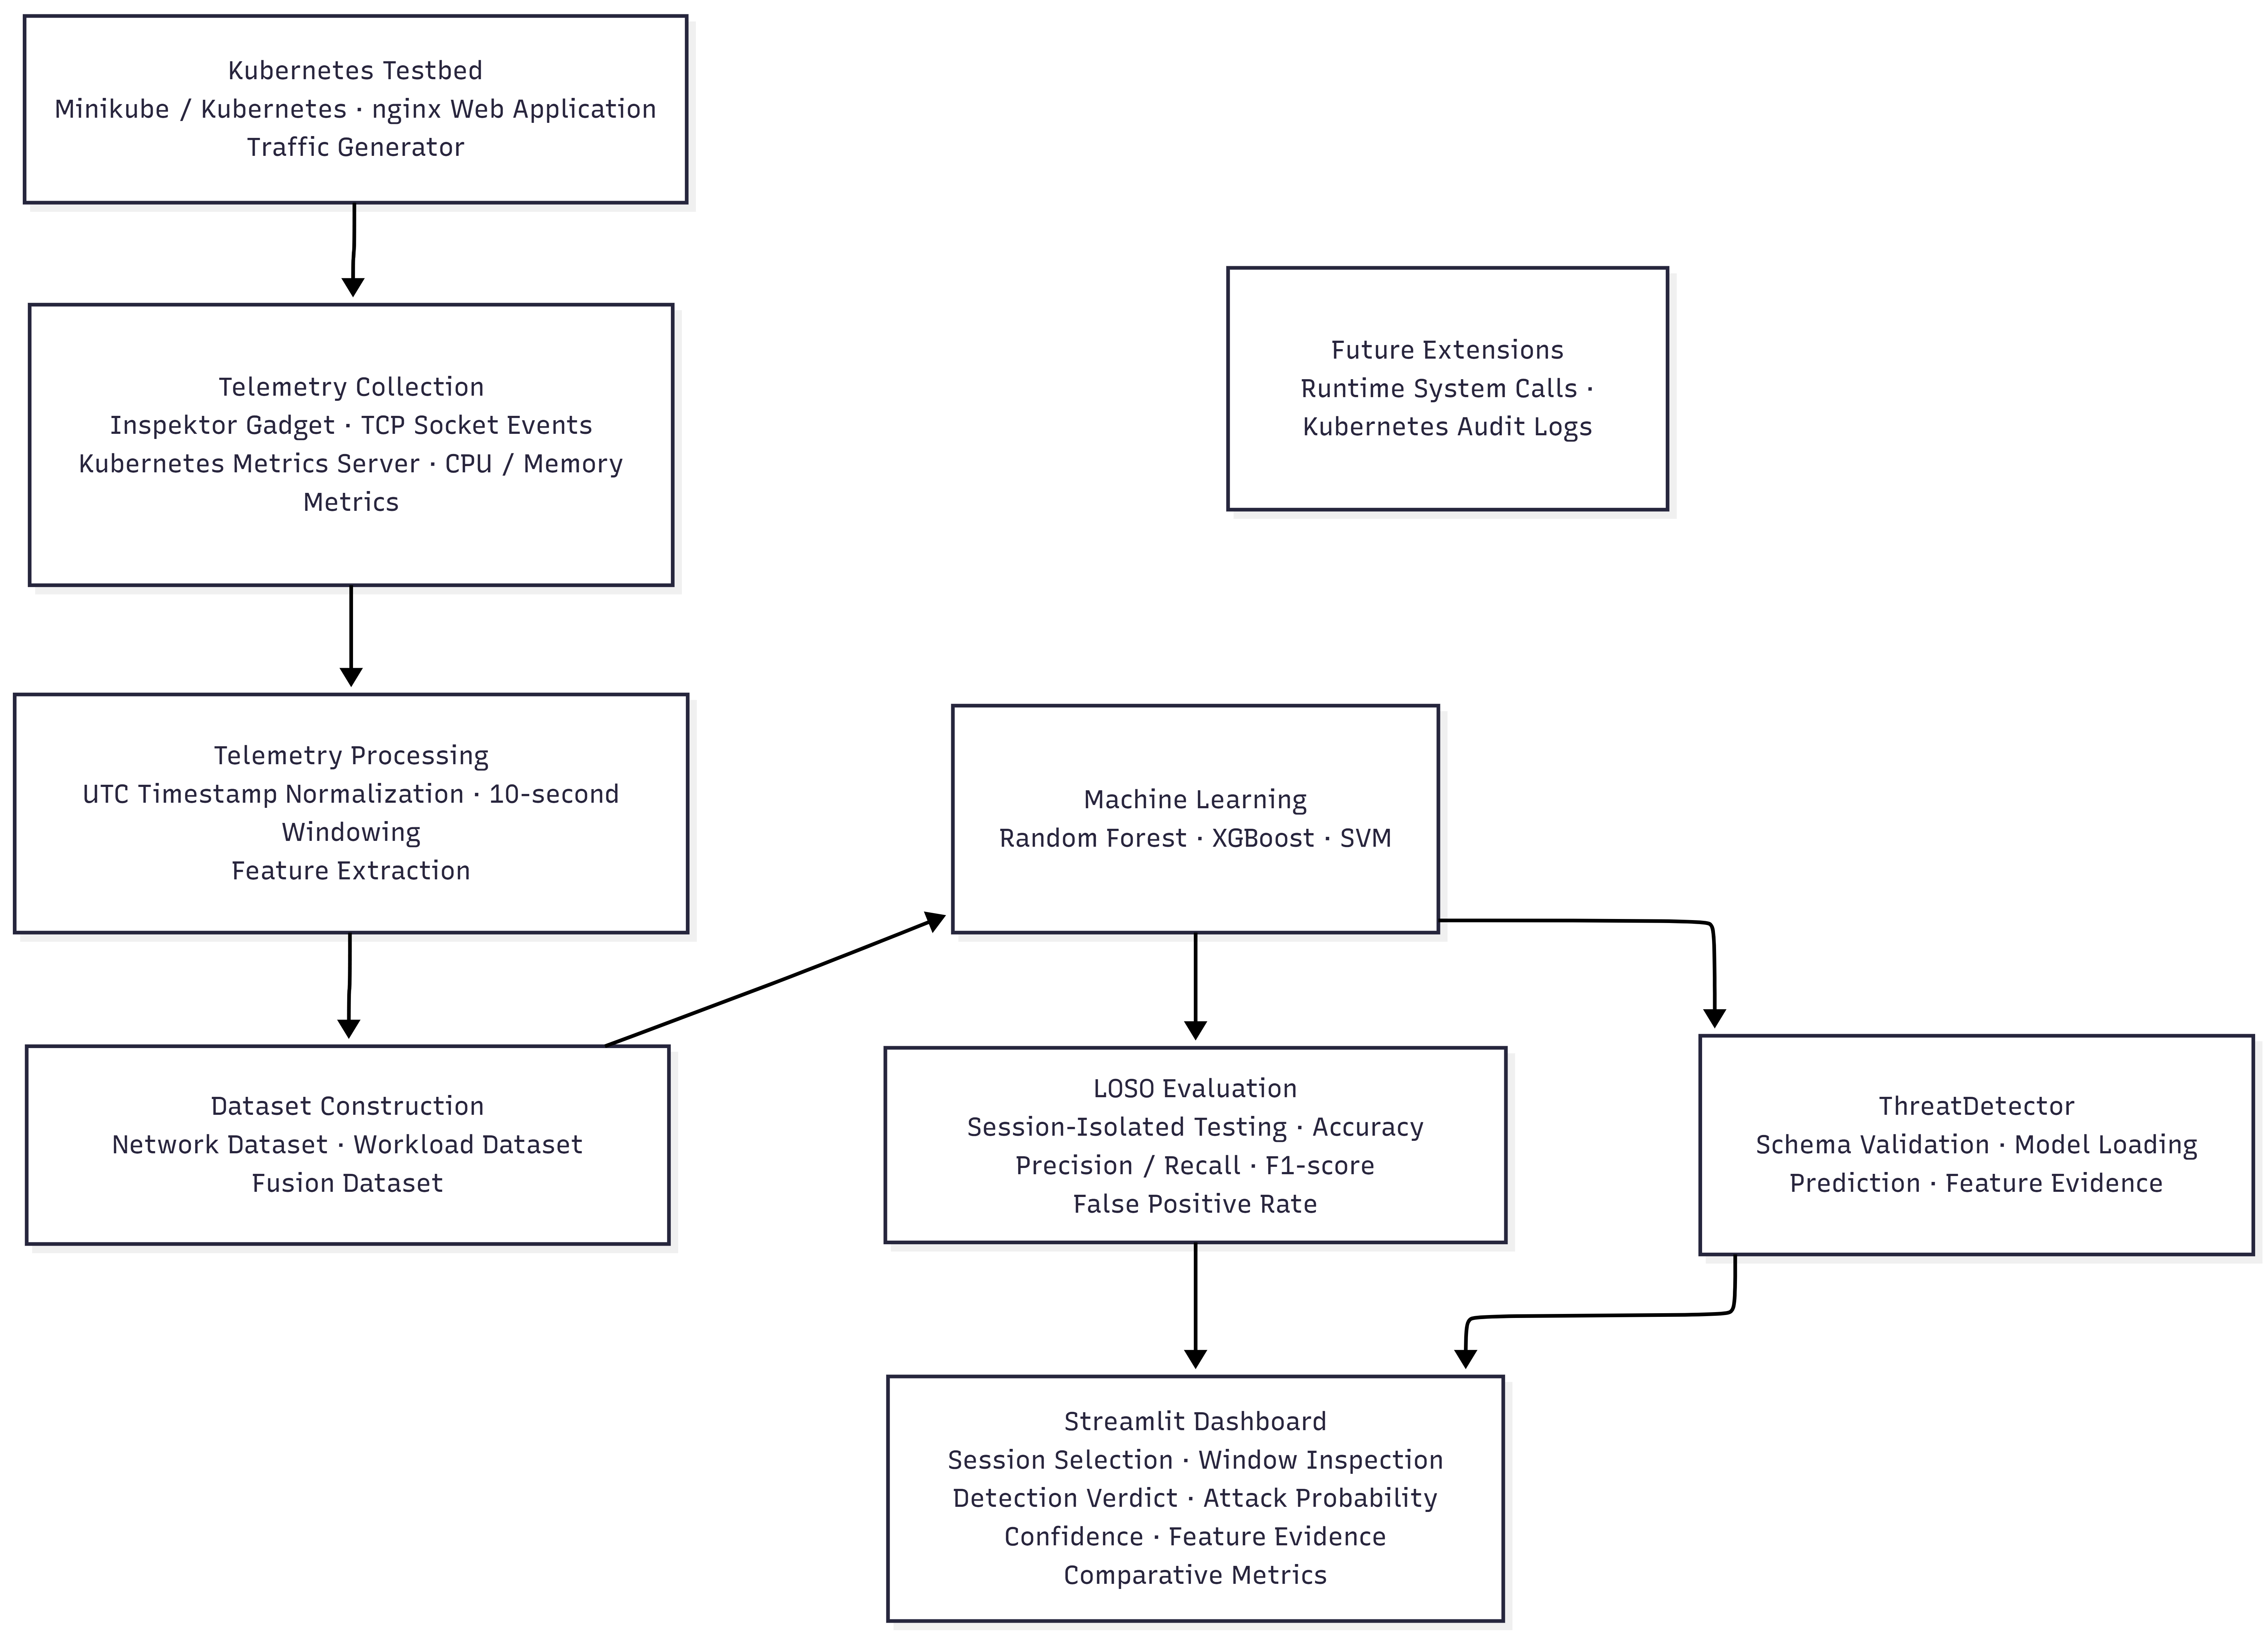
Fig. 4.1 System Architecture of the Validated Kubernetes Threat Detection Pipeline
The block labelled Future Extensions in Fig. 4.1 lists runtime system calls and Kubernetes audit logs as they were planned at Review-2. Since then a runtime process-execution path has been added on top of the validated pipeline; it is described in Section 4.8 and Section 6.8, and it does not alter the validated Network, Workload and Fusion experiments.

4.3 Data Flow
Fig. 4.2 traces the data from raw logs to the evaluation results. Raw telemetry (a JSONL socket-event stream and a CSV of CPU and memory samples) is ingested, timestamps are normalised, and rows and events are assigned to windows. Features are then computed per window and per modality, and the Network and Workload feature tables are joined into the Fusion table by window boundaries within the same session. The three tables are used by the training and LOSO stages. The same canonical feature schema is used by the inference engine, so a window displayed in the dashboard is scored with exactly the inputs that were used in training.
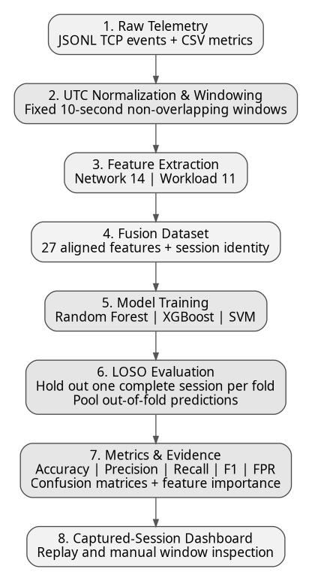
Fig. 4.2 End-to-End Data Ingestion, Processing and LOSO Evaluation Pipeline

4.4 Module Decomposition
The implementation is divided into modules with narrow interfaces so that each can be replaced or tested alone. Table 4.1 lists the modules and their responsibilities. File-level names that appear in the project documentation (ml/inference.py and dashboard/app.py) are given where they are known; other module boundaries are described functionally.
Table 4.1 Module Responsibilities
Module | Responsibility | Inputs | Outputs
Collectors | Capture TCP socket events, CPU and memory samples, and process-execution events | Cluster telemetry | JSONL and CSV logs
Windowing and features | Normalise to UTC, assign windows, compute modality features | Raw logs | Per-window feature tables
Dataset builder | Attach context columns and labels; join Network and Workload rows into Fusion | Feature tables, scenario metadata | network_dataset.csv, workload_dataset.csv, fusion_dataset.csv
Training and evaluation | Fit pipelines; run LOSO; compute pooled metrics | Datasets | Joblib pipelines, metrics, confusion matrices
Inference engine (ml/inference.py) | Validate schema, load and cache pipelines, predict, report evidence | Feature window | Verdict, attack probability, confidence, top features
Runtime rules | Apply rule-based heuristics to process-execution events | Runtime JSONL | Rule findings
Dashboard (dashboard/app.py) | Replay, inspect, compare and display results | Datasets, models, logs | Interactive views and CSV export

4.5 UML Models

4.5.1 Use case model
Fig. 4.3 models the two actors and their use cases. The Experimenter configures an experiment session, collects telemetry, generates datasets, trains models and runs the LOSO evaluation. The Security Analyst selects an experiment session, inspects a telemetry window, runs threat inference, and views the detection verdict, the attack probability and confidence, the feature evidence and the affected pod, and compares model performance and telemetry modalities, including performance metrics and confusion matrices. No use case performs remediation.
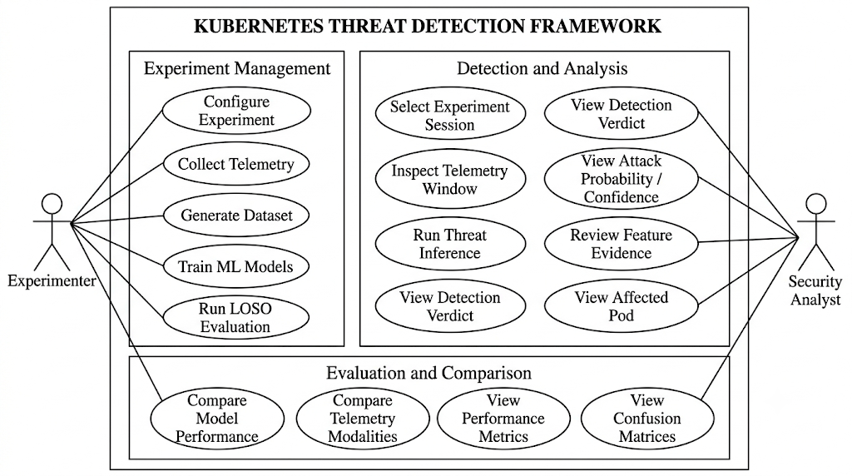
Fig. 4.3 Use Case Diagram of the Kubernetes Threat Detection System

4.5.2 Class model
Fig. 4.4 is the class model from Review-2. ThreatDetector is the core inference class; it holds the loaded pipeline, the modality and a FeatureSchema, validates incoming data frames against the schema, loads pipelines, predicts, and explains a prediction. InferenceResult standardises the output with a result identifier, verdict, attack probability, confidence, affected pod, top features, window boundaries, modality and model name. TelemetryProvider is an interface with list_sessions() and get_window(); CapturedDatasetProvider implements it for recorded sessions, so that a live provider could be substituted without changing the detector. EvaluationEngine computes metrics and confusion matrices and produces EvaluationResult objects, and Dashboard coordinates selection, inference and display. The diagram describes the Review-2 design; classes added later for the runtime path are not shown and should be verified against the repository.
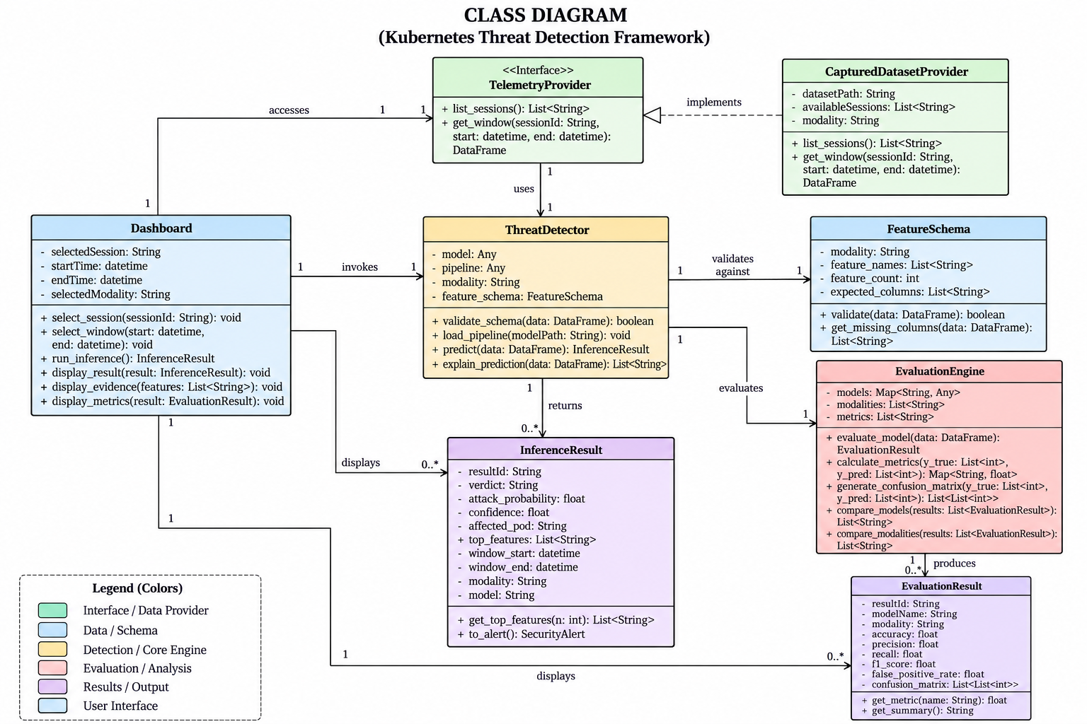
Fig. 4.4 Class Diagram of the Threat Detection System (Review-2 Design)

4.6 Evidence Layers
Four evidence layers are distinguished (see Fig. 4.5). Raw observations are the collected events and samples. Rule findings are produced by runtime heuristics that flag process executions according to fixed conditions; they are neither learned nor validated against labelled runtime ground truth. ML predictions are the output of the supervised models, with probability and feature evidence. Ground-truth-confirmed detections exist only where the scenario metadata provides a label for the window, for example in the replay of a recorded experiment. The dashboard and the report keep these layers apart: a rule finding is never described as an ML prediction, and an ML prediction is never described as a confirmed detection unless ground truth exists for that window.
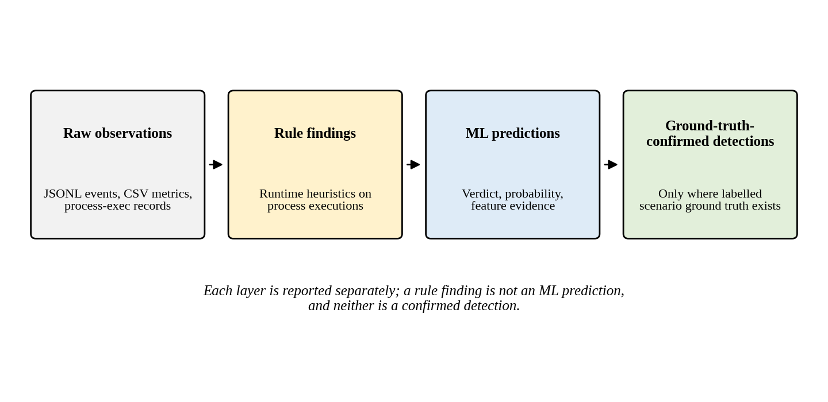
Fig. 4.5 Separation of Evidence Layers in the Framework

4.7 Temporal Windowing and Fusion Design

4.7.1 Epoch-aligned windows
Every timestamp is converted to timezone-aware UTC. A window is a half-open interval of 10 seconds whose boundaries are multiples of 10 seconds since the Unix epoch, as illustrated in Fig. 4.6. Because the boundaries depend only on the clock and not on when a session started, two independently processed telemetry streams from the same session fall into identical windows. Windows do not overlap, so each observation contributes to exactly one window.
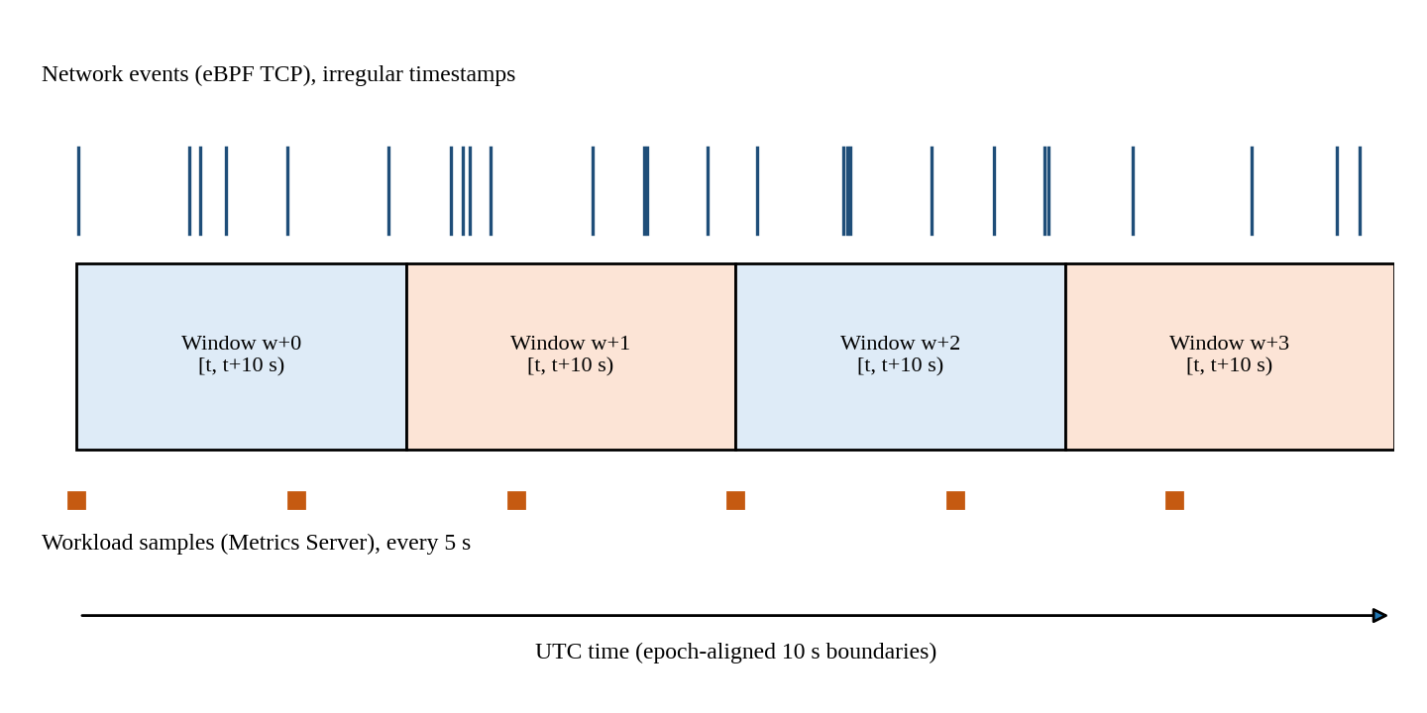
Fig. 4.6 Epoch-Aligned Non-Overlapping 10-Second Windows over Irregular Network Events and 5-Second Workload Samples

4.7.2 Strict fusion join
The Fusion dataset is built by joining Network and Workload feature rows on window boundaries, and the join requires the same session and the same cluster. There is no nearest-neighbour or tolerance-based matching: a window with network features but no workload sample, or the reverse, is not given invented values. The consequence is that Fusion rows are fewer than the union of single-modality rows, and that rows which cannot be aligned are reported as unaligned rather than imputed. In the documented campaign the fusion table contains 276 aligned rows, of which 122 carry a known label.

4.7.3 Label policy
Each window carries a label and an attack_type. Windows that are inside a scripted normal interval are labelled normal, windows inside a scripted attack interval are labelled attack, and windows whose status cannot be established from the scenario record are labelled unknown. For fusion, a window that is an attack for one modality only, and therefore conflicts with the fusion label, is unknown. Unknown windows stay in the dataset for traceability but are excluded from supervised training and testing of the fusion models.

4.8 Runtime Extension Architecture
The runtime extension adds a third telemetry stream and a set of evidence-integration modes without changing the validated models. Process-execution events are collected with Inspektor Gadget trace_exec:v0.55.1 and stored as a separate JSONL stream. A rule component evaluates the events against heuristics. Because there is no labelled runtime ground truth and no trained runtime classifier, the output is a set of rule findings, not predictions. The combined modes (net_rt, rt_wl and full_fusion) present validated ML evidence for the network and workload planes next to the runtime findings for the same 10-second UTC window, as shown in Fig. 4.7. This is integration of evidence for the analyst; it is not a trained tri-modal classifier, and no supervised performance figure is claimed for it.
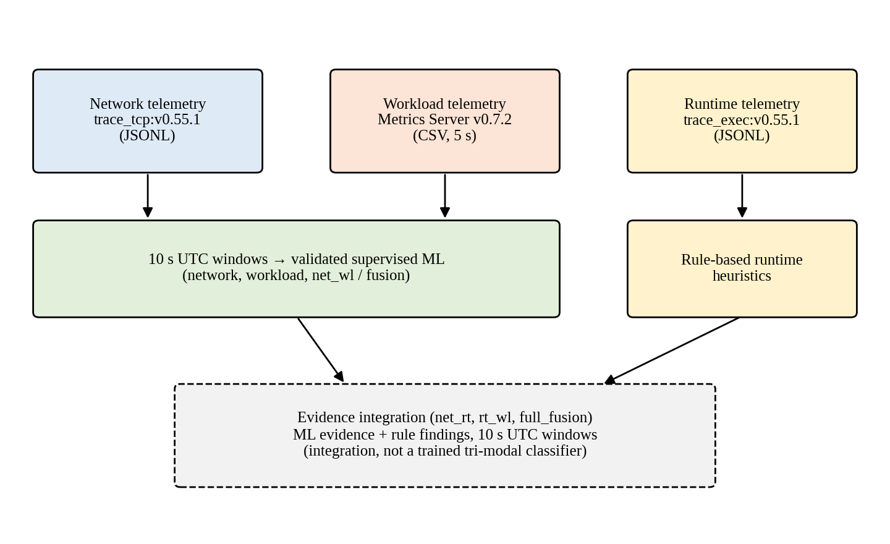
Fig. 4.7 Runtime Extension and Evidence Integration Path (Integration, Not a Trained Tri-Modal Classifier)

4.9 Inference Engine and Dashboard Design
The inference engine is the single place where a trained pipeline is applied to a window. It validates the canonical feature schema before prediction, so incompatible inputs are rejected before they reach a model; it caches loaded pipelines so that repeated predictions do not re-read the serialised files; it measures prediction time; and it returns an InferenceResult. The dashboard reuses the engine and adds no duplicated ML logic. This keeps the behaviour shown to the analyst identical to the behaviour evaluated in the experiments.
The dashboard offers seven modes, which correspond to different combinations of evidence sources. Table 4.2 lists them together with their validation status. The status column is the most important column of the table: only network, workload and net_wl (also called fusion) correspond to supervised models that were evaluated with LOSO.
Table 4.2 Dashboard Modes and Their Validation Status
Mode | Evidence used | Validation status
network | Network supervised ML | Validated (LOSO, Chapter 7)
workload | Workload supervised ML | Validated (LOSO, Chapter 7)
runtime | Runtime rules and heuristics | Rule-based; no supervised validation
net_rt | Network ML with runtime rules and correlation | Integration of evidence; not an independently trained classifier
net_wl / fusion | Network/workload fusion ML | Validated (LOSO, Chapter 7)
rt_wl | Runtime rules with workload context | Integration of evidence; not an independently trained classifier
full_fusion | Network/workload ML evidence plus runtime findings in synchronised 10-second UTC windows | Integration of evidence; not a trained 33-feature classifier

4.10 Security Considerations
The system is designed for observation. Collectors run with the permissions required to read the telemetry they need, and the Inspektor Gadget DaemonSet necessarily has elevated privileges on the node because eBPF programs are loaded into the kernel; this is an operational consideration discussed in Chapter 8. Credentials and Kubernetes secrets are kept out of datasets and source artefacts. Schema validation protects the models from malformed input. The dashboard's experiment-launching function is intended to be safe by default, with a dry-run mode as the default and an explicit action required for real execution, because attack scenarios must not be started accidentally. No remediation is performed, so a false positive cannot disrupt a workload.

4.11 Design Alternatives and Trade-offs
Table 4.3 records the main design alternatives considered and the reason for the choice made.
Table 4.3 Design Alternatives and Trade-offs
Decision | Chosen option | Alternative | Rationale and trade-off
Window type | Fixed, non-overlapping, epoch-aligned, 10 s | Sliding or overlapping windows; session-relative windows | Non-overlap avoids duplicated observations in training and test; epoch alignment gives reproducible fusion; coarser time resolution is accepted
Fusion join | Strict same-session, same-cluster window match | Nearest-neighbour or tolerance matching | Avoids invented alignment; fewer fused rows
Evaluation | LOSO over sessions | Random window-level k-fold | Prevents session leakage; fewer training sessions per fold and higher variance per fold
Models | Random Forest, XGBoost, RBF SVM | Deep neural networks; sequence models | Small tabular dataset and fast inference; deep models would risk overfitting on 24 sessions
Unknown labels | Explicit unknown state | Map to normal | Prevents teaching the model that ambiguous windows are benign
Runtime path | Rule-based findings shown separately | Train a runtime classifier | No labelled runtime ground truth exists; claims stay honest
Telemetry | eBPF socket events plus Metrics Server | Packet capture; Prometheus | Low-overhead pod-attributed events; Metrics Server is already part of the cluster

4.12 Inference Sequence and Window States
An analyst request passes through a fixed sequence. The dashboard asks the telemetry provider for the windows of the selected session; the provider returns a data frame for the requested window; the dashboard invokes the detector; the detector validates the data frame against the feature schema of the selected modality and rejects it on mismatch; the cached pipeline predicts; and an InferenceResult returns to the dashboard, which displays the verdict, the probabilities, the affected pod and the evidence. No step modifies the data or the cluster, so repeating a request yields the same result.
A window can be in one of several states, and each state has a defined treatment (Table 4.4). The table matters because the treatment of ambiguous and missing windows determines what the reported metrics mean.
Table 4.4 Window States and Their Treatment
Window state | Training | Evaluation | Display
Labelled normal | Used | Used | Shown with ground truth normal
Labelled attack | Used | Used | Shown with ground truth attack
Unknown (conflicting or unclear label) | Excluded from supervised fusion models | Excluded | Shown as unknown; never shown as normal
Unaligned (one modality missing) | Not fused; no imputed values | Not evaluated as fusion | Reported as missing telemetry
Empty (collector active, no events) | Valid window with zero counts | Used if labelled | Shown as quiet traffic
No data (collector inactive or stale) | Not used | Not used | Reported as missing; not shown as benign

CHAPTER 5

EXPERIMENTAL METHODOLOGY

5.1 Experimental Testbed
The testbed was built on a Windows 11 workstation using Docker Desktop with the WSL2 backend. Minikube v1.39.0 (Minikube, n.d.) was started with the Docker driver and a single-node Kubernetes v1.37.0 cluster. The monitored workload is an nginx Deployment named webapp, discovered by the label app=webapp, so that collectors and scripts do not depend on ephemeral pod names. A separate containerised traffic generator injects controlled HTTP requests into the workload; it produces background traffic for normal sessions and bursts for attack sessions. Inspektor Gadget v0.55.1 (Inspektor Gadget, n.d.) runs as a DaemonSet and the Kubernetes Metrics Server v0.7.2 (Kubernetes SIGs, n.d.) serves pod resource metrics; both were verified as active before sessions were recorded. Fig. 5.1 shows the Kubernetes dashboard of the Minikube testbed used during the campaign.
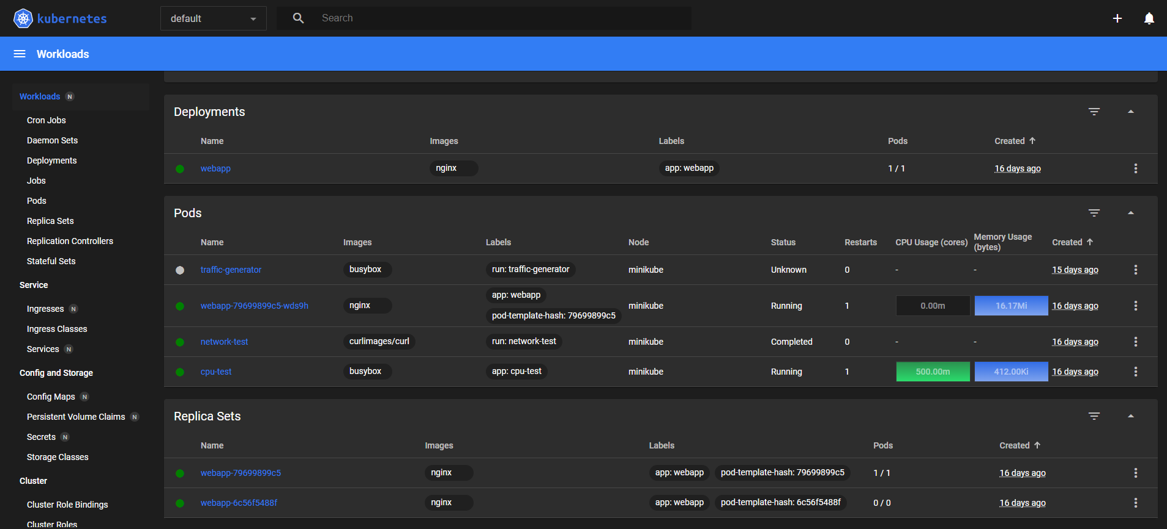
Fig. 5.1 Kubernetes Dashboard Showing the Minikube Experimental Testbed
A single-node cluster was chosen because it makes the experiments repeatable on one machine and removes inter-node network variability. The consequence, discussed in Chapter 8, is that overlay-network behaviour, cross-node traffic and scheduling effects are not represented.

5.2 Telemetry Sources and Schemas

5.2.1 Network telemetry
Network telemetry is produced by the Inspektor Gadget trace_tcp gadget (version v0.55.1) targeted at the workload. The gadget attaches eBPF programs to kernel TCP hooks and emits one JSON object per socket lifecycle event. Each event carries a timestamp, an event type, source and destination addressing, and pod and container metadata. Events are written as JSON Lines (JSONL), one event per line, which supports append-only capture and line-by-line streaming parsing.

5.2.2 Workload telemetry
Workload telemetry is obtained by polling the Kubernetes resource-metrics path every 5 seconds. Each sample records a UTC timestamp, the pod's CPU usage in millicores and its memory usage in MiB, and is appended to a CSV file. The Metrics Server aggregates kubelet statistics over a short window, so each sample is a smoothed view of recent usage and not an instantaneous reading; the 5-second polling interval is therefore a collection interval and not a guarantee of independent 5-second measurements.

5.2.3 Runtime telemetry
Runtime process-execution events are collected with Inspektor Gadget trace_exec:v0.55.1 and stored as a separate JSONL stream. They are not an input to the validated supervised models. Their processing is described in Section 6.8.

5.2.4 Context columns
Every dataset row carries eight context columns that identify where the row came from. They are used for grouping, labelling and traceability and are not model inputs. Table 5.1 describes them.
Table 5.1 Context Columns Carried by Every Dataset Row
Column | Purpose
window_start | Start of the 10-second UTC window (inclusive)
window_end | End of the 10-second UTC window (exclusive)
capture_id | Identifier of the raw capture from which the window was derived
session_id | Identifier of the experimental session; the grouping key for LOSO
experiment_id | Identifier of the experiment run to which the session belongs
scenario | Scripted scenario name (for example fusion_attack)
label | Ground-truth class: normal, attack or unknown
attack_type | Attack category for attack windows (for example concurrent_burst_cpu)

5.3 Experimental Campaign
The campaign consisted of 24 clean, isolated sessions executed under PowerShell orchestration. Each session began with baseline checks (cluster reachable, workload ready, collectors active), then started the collectors, ran its scripted scenario, stopped the collectors and archived the logs under the session identifier; Fig. 5.2 outlines the sequence. Sessions are the unit of independence in the evaluation: they were run separately, with the cluster returned to a baseline state between sessions.
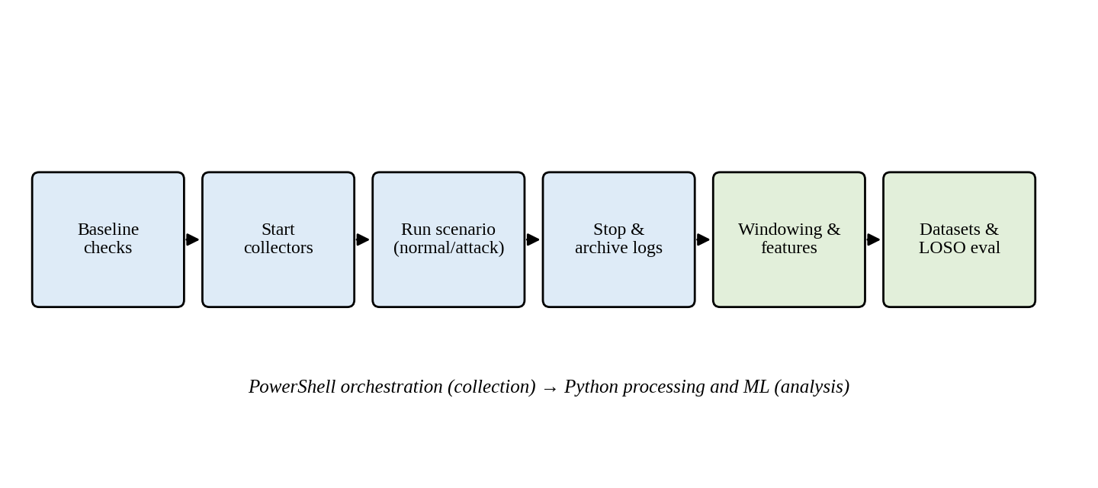
Fig. 5.2 Per-Session Experimental Orchestration and Analysis Sequence
Four of the 24 sessions are dedicated simultaneous attack sessions of scenario fusion_attack, in which a connection burst and CPU load were applied together. Each produced seven attack windows, giving the 28 attack windows of the Fusion dataset. The remaining 20 sessions provide benign background behaviour. Because the Fusion attack windows come only from simultaneous network and workload attacks, the Fusion results apply to that scenario type; they say nothing about network-only or workload-only attacks scored by the Fusion model.

5.4 Timestamp Normalisation and Windowing
All timestamps are parsed and converted to timezone-aware UTC. For a timestamp t expressed in seconds since the Unix epoch, the start of its window is given by Eqn. 5.1 and the window is the half-open interval [w, w + 10).
$w_{start} = 10 · \left\lfloor \frac{t}{10}\right\rfloor$ (5.1)
In Eqn. 5.1, t is the event or sample time and the floor function maps it to the index of its 10-second slot. Network events are counted into the window that contains their timestamp. Workload samples are assigned in the same way, so a 10-second window normally contains two samples at the 5-second polling interval, and fewer when a sample is missing. Windows with no observations are retained as empty windows and handled by the processing code; an empty or stale telemetry source is never interpreted as benign behaviour.

5.5 Feature Engineering

5.5.1 Feature families
Network features summarise socket activity inside the window: counts of connection and accept events, derived connection rates, counts of socket lifecycle event types, and counts of unique source and destination addresses and ports. The connection rate is computed against the fixed window length, as in Eqn. 5.2, so that it is comparable across windows.
$r_{conn} = \frac{n_{accept}}{10.0}$ (5.2)
Workload features summarise CPU and memory consumption inside the window: CPU in millicores, memory in MiB, changes relative to the preceding window, rolling averages and utilisation ratios. Review-2 documents 14 network and 11 workload features; the Fusion dataset joins both sets on window boundaries. Table 5.2 lists the feature names that appear in the source documents. The complete canonical list of feature names is defined in the project's feature schema and should be reproduced from it in the submitted version.
Table 5.2 Feature Names Documented in the Source Material
Modality | Feature name | Description
Network | network_connection_count | Number of connection events in the window
Network | network_connection_rate | Accept count divided by the 10-second window length
Network | network_accept_count | Number of accept events in the window
Network | network_unique_destination_ports | Number of distinct destination ports (excluded from model input)
Workload | cpu_millicores | CPU usage of the target workload in millicores
Workload | memory_mib | Memory usage of the target workload in MiB

5.5.2 Feature-count reconciliation
Four different counts are used in this report, and they must not be confused. The extracted telemetry features are the quantities computed from telemetry. The context columns are the eight metadata columns of Table 5.1. The total dataset columns are the sum of the two. The selected ML inputs are the columns actually supplied to a model. Table 5.3 gives the counts for each modality.
Table 5.3 Feature-Count Reconciliation
Modality | Extracted telemetry features | Context columns | Total dataset columns | Selected ML inputs
Network | 14 | 8 | 22 | 13
Workload | 11 | 8 | 19 | 11
Fusion | 27 | 8 | 35 | 24

The network dataset includes network_unique_destination_ports, which is excluded from the network model input; the network model therefore uses 13 of its 14 features. The workload model uses all 11 workload features. The Fusion model input comprises the 13 selected network features and the 11 workload features, giving 24 inputs. The model never uses all dataset columns: context columns and the excluded port feature are not inputs. The Fusion table is documented with 27 extracted features, which is two more than the 25 obtained by adding the 14 network and 11 workload features; the source documents do not name the two additional fusion-level features, and they are not among the 24 model inputs listed above. Their identity should be confirmed from the feature schema.

5.5.3 Exclusion of the unique-destination-port feature
The exclusion is a deliberate correction. In the server-side socket representation, the port recorded as the destination can be an ephemeral client port. Counting distinct values then measures how many separate client connections were made and not how many service ports were probed. A port-scan interpretation would be wrong for the controlled scenarios, in which the burst is directed at the single HTTP service port. Keeping the column in the dataset preserves transparency; excluding it from the model prevents the classifier and the evidence view from presenting an artefact as scan evidence. The worked example in Table 5.5 shows a window in which this feature takes the value 28 although all connections target the same service.

5.6 Labelling and Dataset Construction
Labels derive from the scenario record of each session, which stores the start and end of scripted attack intervals in UTC. A window inside an attack interval is labelled attack; a window inside a normal interval is labelled normal; a window that straddles an interval boundary, or whose status cannot be established, is labelled unknown. Review-2 records 8 boundary-unknown rows in the workload dataset. For fusion, a window that is an attack in a single modality only is in conflict with the fused label and is marked unknown. Unknown rows are retained in the dataset files but excluded from supervised fusion evaluation. Table 5.4 summarises the three datasets.
Table 5.4 Dataset Composition
Dataset | Extracted features | Total rows | Labelled windows | Normal | Attack | Sessions
Network | 14 | 60 | 60 | 32 | 28 | 8
Workload | 11 | 91 | 83 | 55 | 28 | 8
Fusion | 27 | 276 | 122 | 94 | 28 | 24

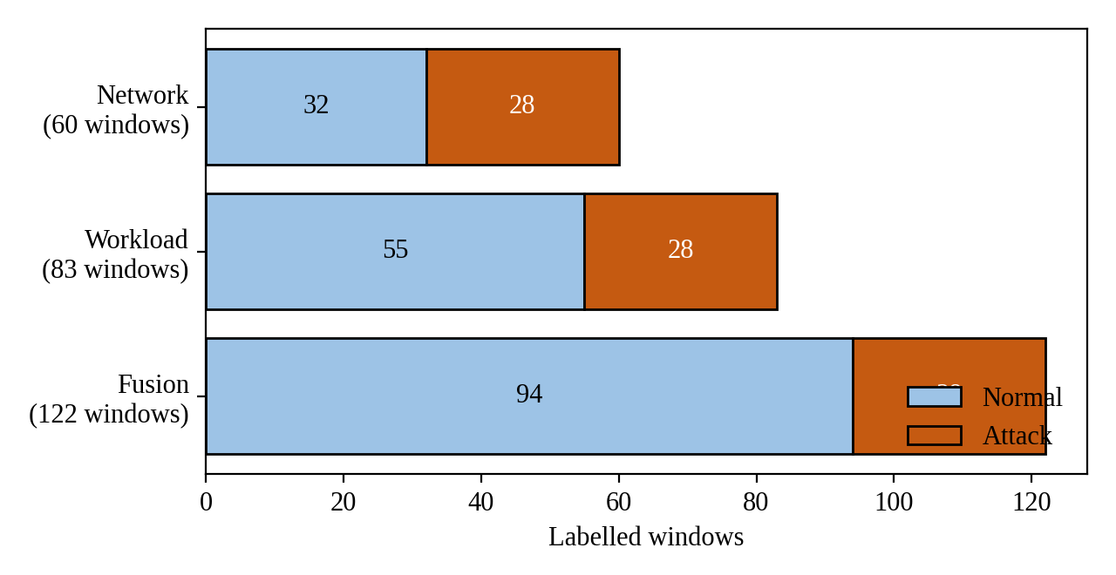
Fig. 5.3 Composition of the Labelled Windows in the Network, Workload and Fusion Datasets
Three points need care when reading Table 5.4. First, the three datasets are different subsets of the campaign, with different numbers of labelled windows (60, 83 and 122), so the metrics of different modalities are not computed on identical windows. Second, the 28 attack windows in each dataset coincide in number with the 28 attack windows of the Fusion dataset, which come from the four fusion_attack sessions of seven windows each; how the single-modality sessions map onto the 24 fusion sessions should be confirmed from the session records. Confirm session mapping between the 8-session single-modality datasets and the 24-session fusion dataset. Third, the Fusion dataset is dominated by benign background (94 of 122 labelled windows), so accuracy is a weak indicator and precision, recall, F1-score and false positive rate are reported alongside it.
Table 5.5 Worked Example of a 10-Second Temporal Window
Telemetry plane | Feature name | Extracted value
Network (eBPF TCP) | network_connection_count | 28 connections
Network (eBPF TCP) | network_connection_rate | 2.80 connections/s
Network (eBPF TCP) | network_accept_count | 28 accepts
Network (eBPF TCP) | network_unique_destination_ports | 28 (ephemeral client ports)
Workload (Metrics Server) | cpu_millicores | 912.0 mCPU
Workload (Metrics Server) | memory_mib | 18.4 MiB
Fused ground truth | label / attack_type | ATTACK (concurrent_burst_cpu)

The window of Table 5.5 illustrates Eqn. 5.2: 28 accept events in a 10-second window give a connection rate of 2.80 per second. It also illustrates why the unique-destination-port count must not be read as a scan indicator.

5.7 Classification Models
Three classifier families were selected because they are representative of the common choices for tabular security telemetry and because they differ in inductive bias: a bagged tree ensemble, a gradient-boosted tree ensemble and a kernel machine. All models are wrapped in pipelines and serialised with Joblib so that the evaluated artefact and the deployed artefact are the same object.

5.7.1 Random Forest
Random Forest builds many decision trees on bootstrap samples with random feature subsets and averages their votes (Breiman, 2001). Each split minimises the Gini impurity of the child nodes, defined in Eqn. 5.3, where p_{k} is the proportion of class k at the node.
$G\left(S\right) = 1 − \sum_{k}{{p_{k}}^{2}}$ (5.3)
The configuration uses 100 trees, Gini splitting and random seed 42. Feature importance is the mean decrease in impurity accumulated over the splits that use each feature (Hastie et al., 2009).

5.7.2 XGBoost
XGBoost builds trees sequentially, each fitted to the gradient of a regularised objective (Chen & Guestrin, 2016; Friedman, 2001). With a binary logistic objective the predicted probability is the logistic transform of the additive score, as in Eqn. 5.4, and the objective combines the loss with a complexity penalty, as in Eqn. 5.5, where T is the number of leaves and w the leaf weights.
$p_{i} = \frac{1}{1 + e^{−ŷ_{i}}}$ (5.4)
$ℒ = \sum_{i}{l\left(y_{i}, ŷ_{i}\right)} + \sum_{k}{Ω\left(f_{k}\right)}, Ω(f) = γT + \frac{1}{2}λ‖w‖²$ (5.5)
The configuration uses a binary logistic objective, a learning rate of 0.1 and a maximum tree depth of 4. Feature contribution is reported through the native booster gain.

5.7.3 Support Vector Machine
The support vector machine finds a maximum-margin separating surface in a feature space induced by a kernel (Cortes & Vapnik, 1995). The soft-margin objective is given in Eqn. 5.6 and the radial basis function (RBF) kernel in Eqn. 5.7, where γ controls the kernel width.
$min \frac{1}{2}‖w‖² + C \sum_{i}{ξ_{i}}$ (5.6)
$K\left(x, x′\right) = exp\left(−γ‖x − x′‖²\right)$ (5.7)
SVMs are sensitive to feature scale, so the pipeline standardises inputs, as in Eqn. 5.8, before the kernel. Probability estimates are obtained by calibrating the decision value f with Platt scaling (Platt, 1999), as in Eqn. 5.9, through CalibratedClassifierCV.
$z = \frac{x − μ}{σ}$ (5.8)
$P(y = 1 ∣ f) = \frac{1}{1 + exp(Af + B)}$ (5.9)
The calibrated SVM has no native feature importance, so the evidence shown for it would have to be obtained by another mechanism; the source documents do not state which (Section 6.6). Standard implementations of all three models are available in scikit-learn and XGBoost (Pedregosa et al., 2011; Chen & Guestrin, 2016).
Table 5.6 Model Configuration as Documented
Model | Documented settings | Not stated in the source documents
Random Forest | 200 trees; Gini criterion; class_weight='balanced'; seed 42; SimpleImputer(strategy='median'); n_jobs=1 | Fully specified in ml/models.py: all hyperparameter values verified against codebase
XGBoost | XGBoostStringClassifier: 100 trees; max_depth=6; lr=0.1; min_child_weight=0; eval_metric='logloss'; seed 42; SimpleImputer(strategy='median') | Fully specified in ml/models.py: all hyperparameter values verified against codebase
SVM | SVC: RBF kernel; C=1.0; gamma='scale'; probability=True; class_weight='balanced'; seed 42; StandardScaler(); SimpleImputer(strategy='median') | Fully specified in ml/models.py: all hyperparameter values verified against codebase

No hyper-parameter search was performed; the settings are fixed in advance and identical across folds. The evaluation therefore does not use nested cross-validation, and no hyper-parameter was tuned on the held-out sessions. Settings in the right-hand column must be filled in from the training code.

5.8 Leave-One-Session-Out Evaluation
In Leave-One-Session-Out (LOSO) cross-validation every fold holds out all windows of one complete session for testing and trains on the windows of all remaining sessions, so that no session contributes to both sides of a split (Fig. 5.4). Because the unit of exchange is the session and not the window, adjacent, correlated windows cannot leak across the split. For the Fusion dataset there are 24 sessions and therefore 24 folds. For the single-modality datasets the number of folds equals the number of sessions in the respective dataset, which Review-2 documents as 8 for each. Confirm single-modality fold counts.
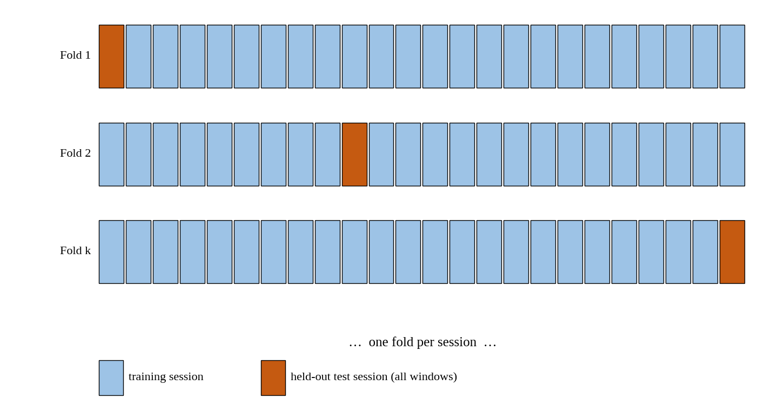
Fig. 5.4 Leave-One-Session-Out Cross-Validation: Each Fold Holds Out One Complete Session
Each fold yields predictions for its held-out windows. These out-of-fold predictions are pooled over all folds and the metrics are computed once on the pooled set, as in Eqn. 5.10, where s indexes the sessions. The reported figures are therefore pooled aggregate metrics and not the arithmetic mean of per-session F1-scores. A per-session average would give sessions with few attack windows, or no attack windows at all, the same weight as sessions with many, and would be undefined for sessions without attacks.
$TP = \sum_{s}{{TP}_{s}}, FP = \sum_{s}{{FP}_{s}}, TN = \sum_{s}{{TN}_{s}}, FN = \sum_{s}{{FN}_{s}}$ (5.10)
Unknown-labelled windows are not part of the folds. Within the Fusion evaluation, benign sessions contain only normal windows, so the attack windows are concentrated in the four fusion_attack sessions. When one of these sessions is held out, the training set contains the attack windows of only three sessions. This is a demanding test of generalisation across sessions and also a source of variance, which is discussed in Chapter 8.

5.9 Evaluation Metrics
The positive class is attack. With true positives (TP), false positives (FP), true negatives (TN) and false negatives (FN) accumulated as in Eqn. 5.10, the reported metrics are defined as follows.
$Accuracy = \frac{TP + TN}{TP + TN + FP + FN}$ (5.11)
$Precision = \frac{TP}{TP + FP}$ (5.12)
$Recall = \frac{TP}{TP + FN}$ (5.13)
$F1 = \frac{2 · Precision · Recall}{Precision + Recall}$ (5.14)
$FPR = \frac{FP}{FP + TN}$ (5.15)
Precision measures how many raised alarms were genuine; recall measures how many attack windows were found; F1 combines the two; and the false positive rate measures the proportion of normal windows that were flagged. For an operations team the false positive rate matters at least as much as recall, because alert fatigue undermines trust in a detector; it is for this reason that it is reported for every configuration (Sommer & Paxson, 2010; Saito & Rehmsmeier, 2015).

5.10 Inference-Latency Measurement
Per-sample model inference time was measured by timing the prediction call of the loaded pipeline. The approximate values are 0.77 ms for XGBoost and 2.42 ms for Random Forest. These are per-sample model inference measurements. They exclude telemetry collection, window completion, feature computation, data transfer and dashboard rendering, and they must not be quoted as end-to-end detection latency. The hardware used for the measurement and the number of repetitions are not recorded in the source documents. Record hardware and repetition count. An SVM inference time is not reported.
The evaluation code reportedly leaves the field detection_latency_seconds empty, because the held-out data do not contain ground-truth attack-onset events from which a time-to-detect could be computed. No detection-latency distribution was therefore measured. An architectural estimate is given in Section 7.7 and is labelled as an estimate.

5.11 Reproducibility
Reproducibility rests on five practices: scripted orchestration of every session; separate storage of raw logs, processed datasets and model artefacts; preservation of session and window identifiers; fixed random seeds where documented (seed 42 for Random Forest); and a pinned toolchain of Inspektor Gadget v0.55.1, Metrics Server v0.7.2, Minikube v1.39.0 and Kubernetes v1.37.0. The remaining dependencies (Python and library versions) should be recorded in the project's dependency file and cited in the submitted version. Exact numerical reproduction also requires the raw logs of the 24 sessions, which are the primary research artefact.

5.12 Fold Structure of the Fusion Evaluation
The session design determines what each LOSO fold can show. In the Fusion dataset the 28 attack windows come from four fusion_attack sessions with seven attack windows each, and the 20 remaining sessions are benign background. Table 5.7 lists the two kinds of fold that result.
Table 5.7 Fold Types in the 24-Session Fusion Evaluation
Fold type | Number of folds | Attack windows in test set | Attack windows in training set
Held-out benign session | 20 | 0 | 28
Held-out fusion_attack session | 4 | 7 | 21

Three consequences follow. First, a held-out benign session contains no attack windows, so it can contribute only true negatives and false positives; every unit of recall comes from the four attack folds. Second, in each attack fold the training set contains the attack windows of only three sessions, so the models must generalise from 21 attack windows to the 7 held-out ones. Third, false-positive behaviour is measured across all 24 held-out sessions on 94 normal windows, whereas detection behaviour is measured on four independent attack episodes. The false positive rates are therefore better supported by the session design than the recall values, and the recall values depend on very few independent attack sessions.

5.13 Sensitivity of the Pooled Metrics to a Single Window
Because the datasets are small, a single window can move a pooled metric noticeably. Table 5.8 gives the change in recall caused by one additional missed attack window and the change in false positive rate caused by one additional false alarm for each dataset, computed directly from the window counts of Table 5.4. This is simple arithmetic on the reported counts and introduces no new experimental data.
Table 5.8 Effect of One Additional Error on Pooled Metrics
Dataset | Attack windows | Normal windows | Recall change per missed attack | FPR change per false alarm
Network | 28 | 32 | 0.0357 | 0.0313
Workload | 28 | 55 | 0.0357 | 0.0182
Fusion | 28 | 94 | 0.0357 | 0.0106

For example, the false positive rate of Network Random Forest (0.0312) corresponds to a single false alarm on 32 normal windows, and one more false alarm would have raised it to 0.0625. The same single error on the Fusion dataset would move the rate by only about 0.01. Differences of one or two windows between configurations should therefore not be over-interpreted.

CHAPTER 6

IMPLEMENTATION

6.1 Software Environment
Table 6.1 lists the software environment as documented in the project reports. Versions that are not recorded in the source documents are marked for completion.
Table 6.1 Software Environment of the Implementation
Component | Version or detail | Role
Host platform | Windows 11, Docker Desktop, WSL2 | Runs the Minikube container
Minikube | v1.39.0, Docker driver | Single-node Kubernetes cluster
Kubernetes | v1.37.0 | Container orchestration
Inspektor Gadget | v0.55.1 (trace_tcp, trace_exec) | eBPF network and process-execution telemetry
Kubernetes Metrics Server | v0.7.2 | CPU and memory metrics
nginx workload webapp | Label app=webapp | Monitored application
Traffic generator | Containerised HTTP client | Normal and attack traffic
Python and ML libraries | Python 3.13.9, scikit-learn 1.7.2, XGBoost 3.1.1, Joblib 1.5.2, pandas 2.3.3 | Processing, training, serialisation
Dashboard | Streamlit 1.51.0 (7 supported telemetry modalities: network, workload, fusion, runtime, net_rt, rt_wl, full_fusion) | Replay, inspection, comparison
Orchestration | PowerShell | Session automation
Data formats | JSONL event streams; CSV metrics and datasets | Raw and processed data
Testing | pytest 8.3.4 (318 passed, 3 skipped across unit, integration, and regression suites; 99/99 core regression) | Automated verification

The version strings for Minikube and Kubernetes are those recorded in Review-2 and should be re-checked against the installed binaries before submission.

6.2 Telemetry Collectors

6.2.1 Network collector
Network telemetry is collected by running the trace_tcp gadget against the target workload, selected by label. The invocation recorded in Review-2 is shown below; the output is redirected to a per-session JSONL file.
kubectl gadget run trace_tcp:v0.55.1 [workload selector] --output jsonl
The exact flags and selector arguments are part of the collection script and are not reproduced here. The gadget reports TCP socket lifecycle events with timestamps and pod metadata. The collector resolves the target pod through the app=webapp label at start-up, so pod re-creation between sessions does not require script changes (FR1).

6.2.2 Workload collector
Workload telemetry is collected by polling kubectl top pod for the target pod every five seconds. The command reads from the Metrics Server through the Kubernetes API. Each poll appends a row with the UTC timestamp, the CPU value in millicores and the memory value in MiB to the session's CSV file. A poll that fails (for example while the pod is being re-created) is recorded as a missing sample and not as a zero.

6.2.3 Runtime collector
Runtime process-execution events are collected by running trace_exec:v0.55.1 in the same way and are stored as a separate JSONL stream with UTC timestamps. They are read by the runtime rule component (Section 6.8) and are not part of the Network, Workload or Fusion datasets.

6.3 Experiment Orchestration
Sessions are orchestrated by PowerShell scripts. A script performs the baseline checks, starts the collectors, launches the scenario through the traffic-generator pod, stops the collectors at the end of the scenario, and stores the raw logs together with the scenario metadata (session identifier, scenario name, attack interval in UTC). The same scenario metadata is later used to assign labels. Keeping orchestration in scripts rather than in manual kubectl sequences is what allows 24 sessions to be executed under comparable conditions and repeated.
The dashboard also offers an on-demand experiment launcher. In the implemented design it defaults to a dry-run mode, in which the command that would be executed is displayed without being run, and real execution requires an explicit action. This default exists because the attack scenarios must not be started by accident. Verify exact launcher behaviour against the current repository.

6.4 Processing Pipeline
The processing stage reads the raw logs of a session and performs the following steps in order: parse and validate records; convert timestamps to timezone-aware UTC; assign each event or sample to its epoch-aligned 10-second window (Eqn. 5.1); compute per-window network and workload features; attach the eight context columns; assign the label from the scenario metadata; and, for the Fusion dataset, join the network and workload feature rows on window boundaries within the same session and cluster. The result is written as network_dataset.csv, workload_dataset.csv and fusion_dataset.csv.
Malformed records and empty windows are handled without terminating the run (NFR3 and NFR10). A malformed line is skipped and counted, an empty window yields a row with the count features set to zero only where the source is known to be active, and a source that produced no data at all for a window is reported as missing. The distinction matters: zero connections observed by an active collector is evidence of quiet traffic, whereas no data from a collector is not evidence of anything.

6.5 Training and Serialisation
Training builds one pipeline per modality and model family, giving nine pipelines. Each pipeline contains its preprocessing step (standardisation for the SVM) and the classifier, is fitted on the labelled windows of the relevant dataset and is serialised with Joblib. During LOSO evaluation the same pipeline definition is re-fitted in every fold; the artefact used for inference is fitted on the full labelled dataset. A model fitted on all sessions has, by construction, seen the sessions that it is later used to replay, so inference outputs shown for replayed windows are demonstrations of the interface and not evaluation results. Only the pooled LOSO metrics of Chapter 7 are evaluation results.

6.6 Inference Engine
The ThreatDetector class in ml/inference.py is the inference entry point. It validates the canonical feature schema, loads and caches the pipeline for the selected modality and model, measures prediction time, and returns an InferenceResult containing the verdict, the attack probability, the confidence, the affected pod and the top contributing features. The calling convention shown in Review-2 is reproduced below.
# Run inference on a validated telemetry window
result = detector.predict(window_features)
print("Verdict:", result.verdict)
print("Attack Probability:", f"{result.attack_probability:.4f}")
print("Confidence:", f"{result.confidence:.4f}")

# Display model-derived evidence
for feature, importance in result.top_features:
print(f"{feature}: {importance:.4f}")
As displayed in the replay screenshots, the attack probability is the model's estimated probability of the attack class and the confidence is the probability assigned to the predicted class. Schema validation rejects windows whose columns do not match the canonical schema for the selected modality, so a Network window cannot be scored by a Fusion model by mistake. The top features are derived from the model: mean decrease in impurity for Random Forest and booster gain for XGBoost. These values are global importance measures of the fitted model, presented per window as the features on which the model relies; they are not a per-prediction causal attribution. The source documents do not state how evidence is derived for the SVM, which has no native importance measure. Confirm the SVM evidence method.

6.7 Streamlit Dashboard
The Streamlit application (Streamlit, n.d.) in dashboard/app.py presents the results to the analyst. In the Review-2 version, a sidebar selects the telemetry modality (Network, Workload or Fusion), the model (Random Forest, XGBoost or SVM) and the source mode (Demo/Captured Data or Manual Window). The main view lets the analyst select an experiment session or all sessions, step through observation windows with a slider, and read the predicted class, attack probability, model confidence, modality and model, the window start and end in UTC, the affected pod, and the model-derived feature evidence. Fig. 6.1, Fig. 6.2 and Fig. 6.3 show captured-session replays.
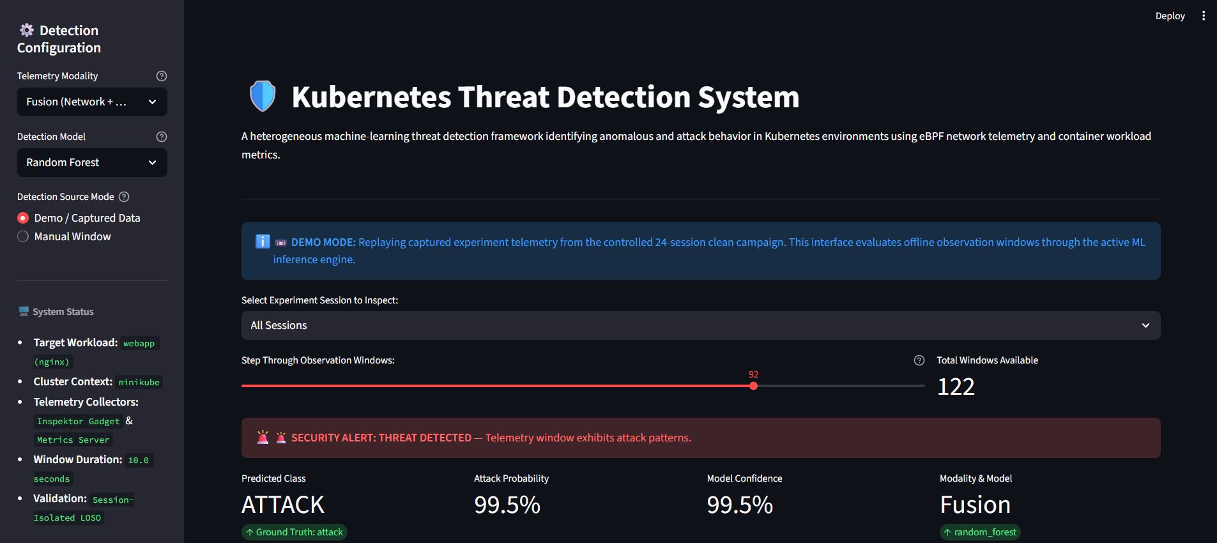
Fig. 6.1 Dashboard During Replay of a Captured Attack Window (Fusion, Random Forest; Window 92 of 122)
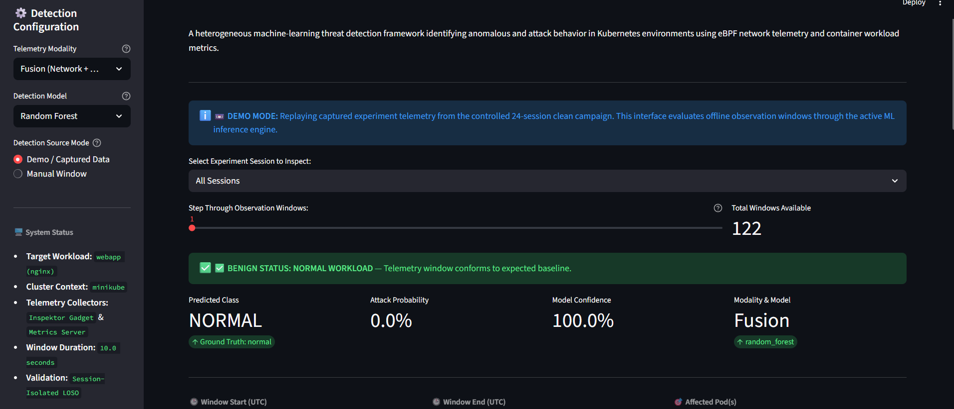
Fig. 6.2 Dashboard During Replay of a Captured Normal Window (Fusion, Random Forest; Window 1 of 122)
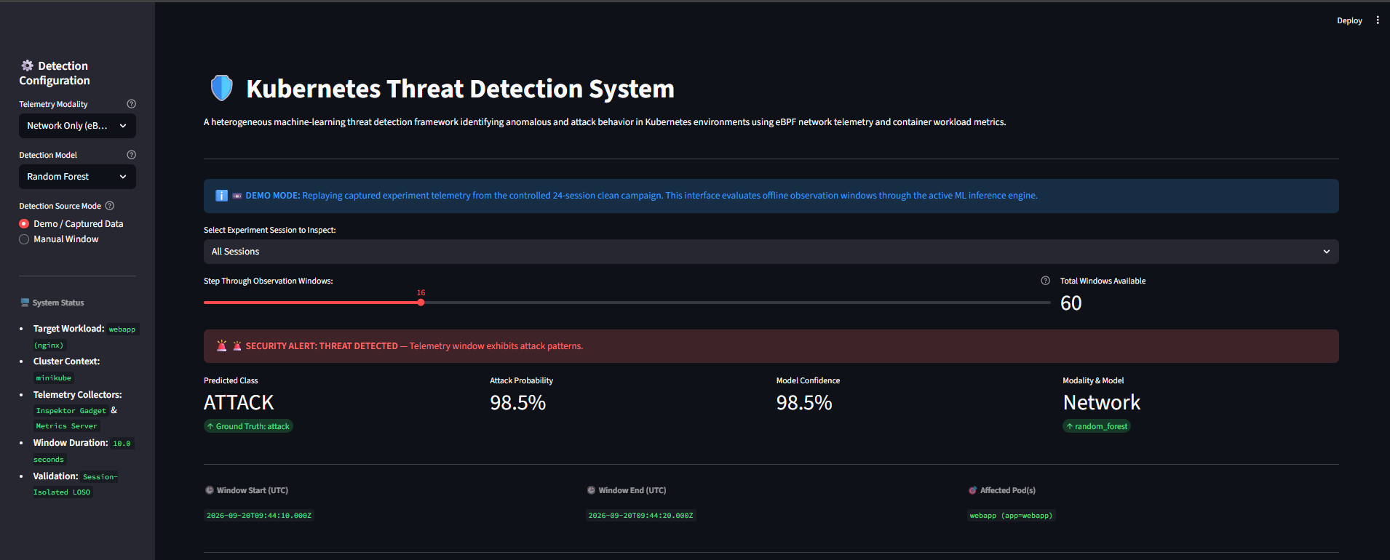
Fig. 6.3 Dashboard During Replay of a Captured Network-Only Attack Window (Network, Random Forest; Window 16 of 60)
The screenshots come from the Review-2 version of the dashboard and show the Demo mode banner, which states that captured telemetry from the controlled 24-session campaign is replayed offline through the active inference engine. They are demonstrations of the interface; the probabilities displayed are those of the loaded model and are not LOSO results. Further screenshots, including the telemetry plots and the feature-evidence tables, are given in Appendix C.
The current version extends this interface. According to the development notes it adds experiment browsing and comparison, safe on-demand experiment launching with dry-run as default, live-capture filters, CSV export, raw feature inspection, historical replay, modality-specific metrics, runtime-event views and model-derived feature evidence. Screenshots of the current dashboard are not included in the source material; capture them from the running application before submission.

6.8 Runtime Extension
The runtime path collects process-execution events with trace_exec:v0.55.1 and evaluates them with rules and heuristics. A rule of this kind examines the event stream for conditions that are suspicious inside a container that should be running only a web server, such as unexpected interpreters or network tools being started; the precise rule set implemented in the project is held in the repository and is listed, once verified, in Appendix B. The rule set monitors process invocations for 20 sensitive utilities (including netcat, nmap, whoami, id, chmod, python) and 4 interactive shells (bash, sh, zsh, dash), raising immediate high-priority alerts upon unauthorized container execution.
The runtime path differs from the supervised paths in four ways. It is rule-based, so its behaviour is fixed by the rules and not learned from labelled windows. Its evaluation is conducted via a dedicated suite of 11 controlled test scenarios (TC_RT_02 to TC_RT_12) covering both benign background operations (e.g. nginx daemon startup, host probes) and malicious attack vectors (e.g. root reconnaissance, interactive shells, reverse shells, lateral scanning), achieving 100% precision and recall with an average rule execution latency of 0.0076 ms. Its findings can be correlated with ML evidence by window, which is what the net_rt, rt_wl and full_fusion modes do, but the correlation is a presentation of evidence, not a trained model. And it is therefore not equivalent to a validated supervised runtime classifier. In the full_fusion mode the network/workload ML evidence and the runtime findings are synchronised using the same 10-second UTC windows, and the dashboard shows each evidence type under its own label.

6.9 Dashboard Modes
The seven dashboard modes were introduced in Section 4.9 (Table 4.2). Their implementation shares the inference engine of Section 6.6. The three validated modes (network, workload, net_wl or fusion) call a trained pipeline. The runtime mode calls the rule component. The remaining three modes combine the outputs of those components for the same window. No new model is trained for them, and none of the three is described in this report as an independently trained and validated classifier.

6.10 Testing and Quality Assurance
Automated verification uses pytest. Review-2 reports a suite of 60 test cases covering schema validation, feature-extraction mathematics, temporal alignment, model-training pipelines, LOSO evaluation integrity, inference error handling and dashboard components, with all 60 passing. The suite has since grown with the extensions described in this chapter. The development notes record 362 tests passed and 3 skipped at an earlier point in the extension work. That figure is reported here as a historical development note and is not presented as a fresh result, because the suite was not re-run for this report. Re-run the suite and insert the current result before submission.
Tests verify the software, not the scientific validity of the models. Passing tests show, for example, that window boundaries are computed as specified and that a held-out session never appears in the training set of its fold; they do not show that the classifiers would generalise to other clusters.

6.11 Implementation Status Summary
Table 6.2 summarises which parts of the implementation are validated, which are implemented without supervised validation, and which are future work.
Table 6.2 Implementation Status Summary
Component | Status | Basis
Network, Workload and Fusion supervised pipelines | Validated by 24-session LOSO (fusion) | Chapter 7
10-second windowing and strict fusion join | Implemented and exercised in the campaign | Chapters 4 and 5
ThreatDetector inference engine | Implemented; latency measured per sample | Section 5.10
Streamlit dashboard (Review-2 version) | Implemented; screenshots included | Section 6.7
Seven-mode dashboard, experiment launcher, CSV export | Implemented per development notes; code verification pending | Section 6.7
Runtime process-execution collection and rules | Implemented; not validated as a classifier | Section 6.8
net_rt, rt_wl, full_fusion modes | Evidence integration; no trained tri-modal classifier | Section 6.9
Automated test suite | 60 tests passed (Review-2); later counts historical | Section 6.10
Control-plane audit-log analysis | Not implemented | Chapter 9

6.12 Error Handling and Edge Cases
Table 6.3 lists the situations that the processing and inference components are required to handle, which follow from NFR3, NFR10 and the schema-validation requirement. The tests described in Section 6.10 cover schema validation, temporal alignment and inference error handling; the exact coverage of each row below should be confirmed against the test suite. Confirm each row against the test suite.
Table 6.3 Edge Cases and Required Behaviour
Situation | Required behaviour | Reason
Target pod re-created during a session | Resolve the pod again through the label; record the gap | Pod names are ephemeral (FR1)
Missing workload sample in a window | Mark the window as unaligned for fusion; do not impute | Strict join; imputation would invent evidence
No network events while the collector is active | Valid window with zero counts | Quiet traffic is informative
Collector inactive or output stale | Report as missing telemetry; do not treat as benign | Missing data is not evidence of normal behaviour
Malformed JSON line or CSV row | Skip and count; continue the run | Fault tolerance (NFR10)
Timestamp without time zone | Interpret and convert to UTC explicitly, or reject | Windows must be epoch-aligned
Window straddling an attack boundary | Label as unknown | Avoids label noise
Feature columns do not match the schema | Reject before prediction with an error | Prevents scoring with the wrong modality

CHAPTER 7

EXPERIMENTAL SETUP, RESULTS AND ANALYSIS

7.1 Experimental Setup
The results in this chapter are those of Review-2 and are reported without modification. They were obtained on the controlled campaign described in Chapter 5: 24 clean sessions in a single-node Minikube cluster, 10-second UTC windows, and three classifiers (Random Forest, XGBoost and RBF-kernel SVM) evaluated on three modality configurations. The Fusion dataset contains 122 labelled windows from 24 sessions, of which 94 are normal and 28 are attack windows. The 28 attack windows originate from four dedicated simultaneous fusion_attack sessions with seven attack windows each; the other 20 sessions provide benign background. The Network dataset contains 60 labelled windows and the Workload dataset 83 labelled windows.
All metrics are pooled out-of-fold LOSO metrics. Each fold holds out one complete session, and the metrics are computed once over the pooled predictions, not averaged over sessions. Windows with conflicting or unknown labels are excluded from the supervised fusion evaluation, so the Fusion results apply to the evaluated simultaneous network/workload attack scenarios.

7.2 Comparative Results
Table 7.1 gives the pooled LOSO metrics of the nine configurations, and Fig. 7.1 and Fig. 7.2 show the F1-score and the false positive rate graphically.
Table 7.1 Pooled LOSO Cross-Validation Performance Across Telemetry Modalities
Modality | Model | Accuracy | Precision | Recall | F1-score | FPR
Network | Random Forest | 0.9667 | 0.9643 | 0.9643 | 0.9643 | 0.0312
Network | XGBoost | 0.9167 | 1.0000 | 0.8214 | 0.9020 | 0.0000
Network | SVM | 0.8333 | 0.8462 | 0.7857 | 0.8148 | 0.1250
Workload | Random Forest | 0.7108 | 0.5833 | 0.5000 | 0.5385 | 0.1818
Workload | XGBoost | 0.6627 | 0.5000 | 0.3929 | 0.4400 | 0.2000
Workload | SVM | 0.7711 | 0.7143 | 0.5357 | 0.6122 | 0.1091
Fusion | Random Forest | 0.9672 | 0.9286 | 0.9286 | 0.9286 | 0.0213
Fusion | XGBoost | 0.9590 | 0.9259 | 0.8929 | 0.9091 | 0.0213
Fusion | SVM | 0.9590 | 0.8485 | 1.0000 | 0.9180 | 0.0532
Runtime-Only | Rule Engine (eBPF trace_exec) | 1.0000 | 1.0000 | 1.0000 | 1.0000 | 0.0000

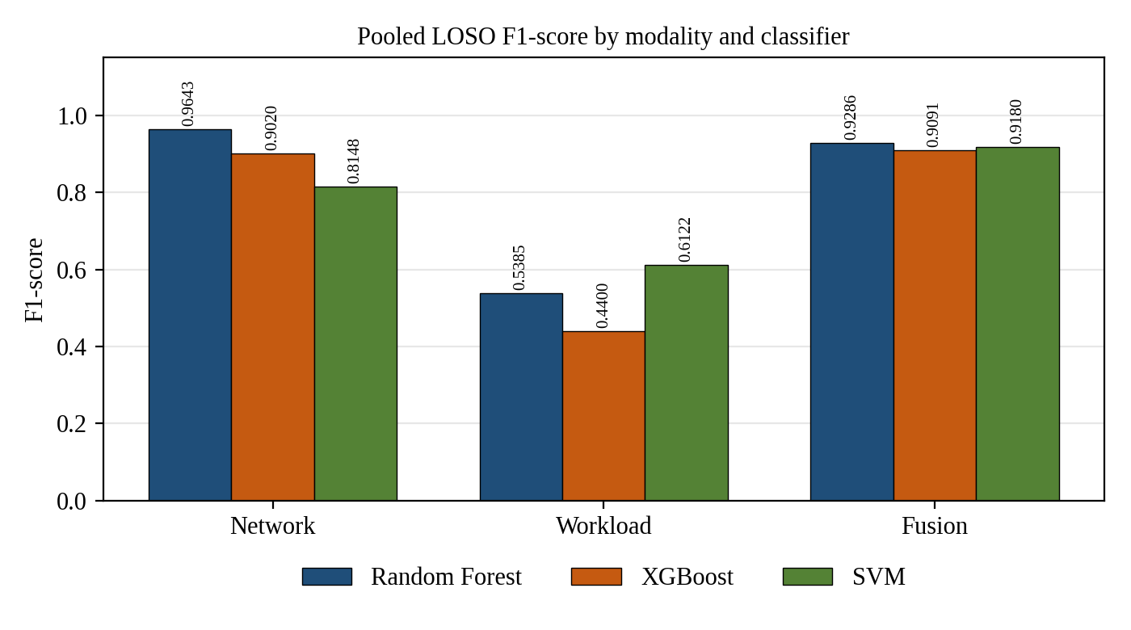
Fig. 7.1 Comparative F1-Score Across Telemetry Modalities and Classifiers
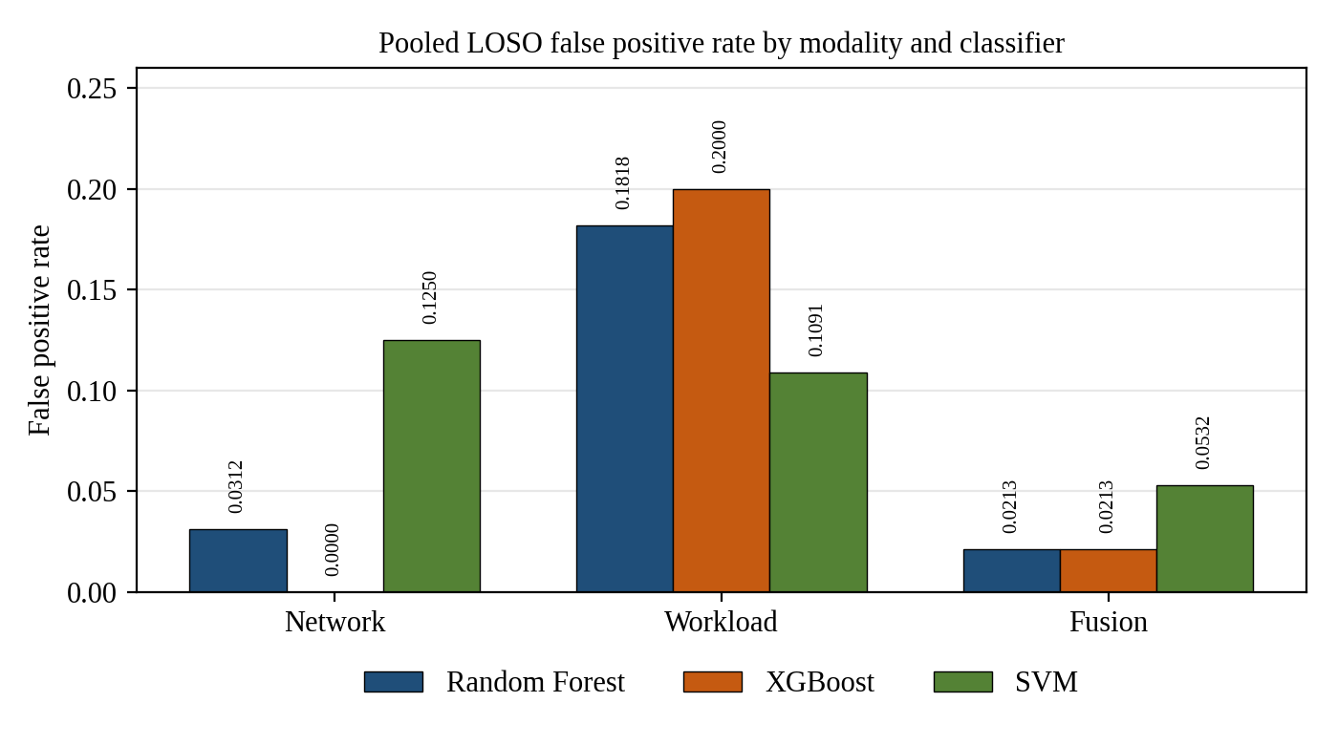
Fig. 7.2 Comparative False Positive Rate Across Telemetry Modalities and Classifiers
Fig. 7.3 separates precision and recall, which the F1-score combines. The figures in this chapter were generated from the values of Table 7.1 and Table 7.2 and contain no other data.
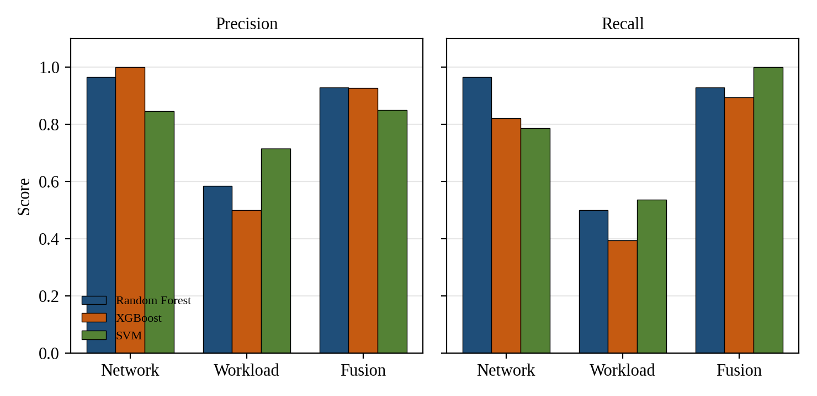
Fig. 7.3 Precision and Recall by Telemetry Modality and Classifier

7.3 Confusion-Matrix Analysis
Table 7.2 gives the pooled confusion-matrix counts for the four configurations for which counts are reported, and Fig. 7.4 shows them as matrices.
Table 7.2 Pooled LOSO Confusion-Matrix Counts
Configuration | Windows | TN | FP | FN | TP
Network + Random Forest | 60 | 31 | 1 | 1 | 27
Workload + Random Forest | 83 | 45 | 10 | 14 | 14
Fusion + Random Forest | 122 | 92 | 2 | 2 | 26
Fusion + SVM | 122 | 89 | 5 | 0 | 28

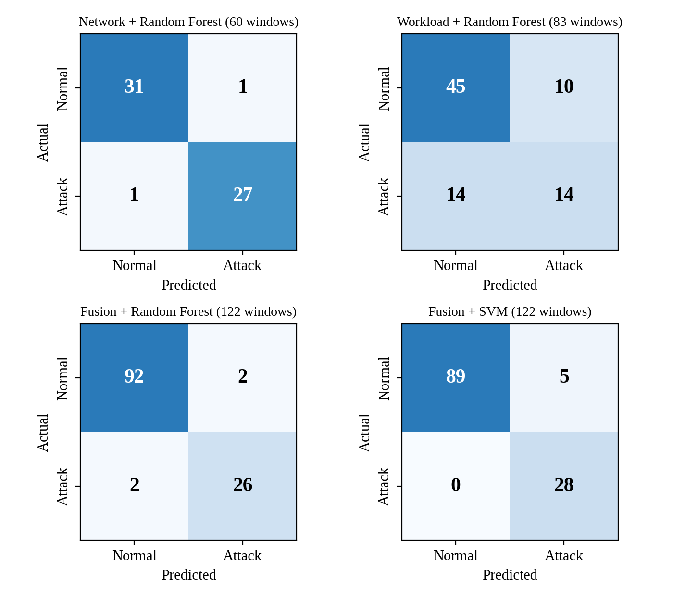
Fig. 7.4 Pooled LOSO Confusion Matrices of Four Configurations
Reading the counts in the manner of the definitions of Section 5.9: Network Random Forest misclassified two of 60 windows, one normal window raised as attack and one attack window missed. Workload Random Forest detected 14 of 28 attack windows and raised 10 false alarms among 55 normal windows. Fusion Random Forest misclassified four of 122 windows, two in each direction. Fusion SVM detected all 28 attack windows (FN = 0) at the cost of five false positives among 94 normal windows.

7.4 Analysis by Modality

7.4.1 Network telemetry
Network Random Forest achieved the highest reported F1-score, 0.9643, with precision and recall both equal to 0.9643 and a false positive rate of 0.0312. In the controlled connection-burst scenarios, socket-level features such as the connection rate and the accept count provided a strong signal. Network XGBoost reached a reported false positive rate of 0.0000 and a precision of 1.0000, but its recall was 0.8214, so it missed about 18 percent of the attack windows. The zero false positive rate describes this evaluation set only: it does not imply that XGBoost detects all attacks, and it does not imply that it would raise no false alarms on other traffic. Network SVM was the weakest network model (F1 = 0.8148, FPR = 0.1250).

7.4.2 Workload telemetry
The workload-only configurations performed markedly less well. F1-scores ranged from 0.4400 (XGBoost) to 0.6122 (SVM), recall from 0.3929 to 0.5357, and false positive rates from 0.1091 to 0.2000. Under the tested conditions CPU and memory measurements are weak stand-alone indicators of the scripted attacks. Workload Random Forest (0.1818) and Workload XGBoost (0.2000) have the highest false positive rates of the nine configurations, and even the best workload false positive rate (0.1091, SVM) is higher than that of the strongest network and fusion configurations; Network SVM (0.1250) is the only non-workload configuration in the same range. Workload telemetry alone is therefore a poor basis for a detector in this setting. Within the workload group, SVM was best on F1-score and false positive rate and Random Forest second, while XGBoost was weakest on both.

7.4.3 Network and workload fusion
Fusion Random Forest achieved an F1-score of 0.9286 and a false positive rate of 0.0213; Fusion XGBoost achieved 0.9091 with the same false positive rate; Fusion SVM achieved 0.9180. Fusion Random Forest's false positive rate (0.0213) is lower than Network Random Forest's (0.0312), but its F1-score (0.9286) is also lower than Network Random Forest's (0.9643). Fusion therefore did not improve every metric: it reduced the false positive rate while lowering F1 in the Random Forest comparison.
Fusion SVM achieved a recall of 1.0000 on the 28 attack windows of this controlled dataset, that is, 28 of 28 detected, with five false positives and a false positive rate of 0.0532. This is a sample-specific result. It does not guarantee zero missed attacks in other environments or for other attack types, and it comes with a higher false positive rate than Fusion Random Forest.

7.5 Recall versus False-Positive Trade-off
Fig. 7.5 plots recall against false positive rate for the nine configurations. The strongest network and fusion configurations occupy the upper-left region (high recall, low false positive rate), Network SVM lies in the middle of the plot, the workload configurations lie in the lower-right region, and the points within the upper-left region differ by the kind of error they favour. Network XGBoost favours the absence of false alarms and gives up some recall; Fusion SVM favours recall and gives up some precision; Network Random Forest and Fusion Random Forest lie between these two.
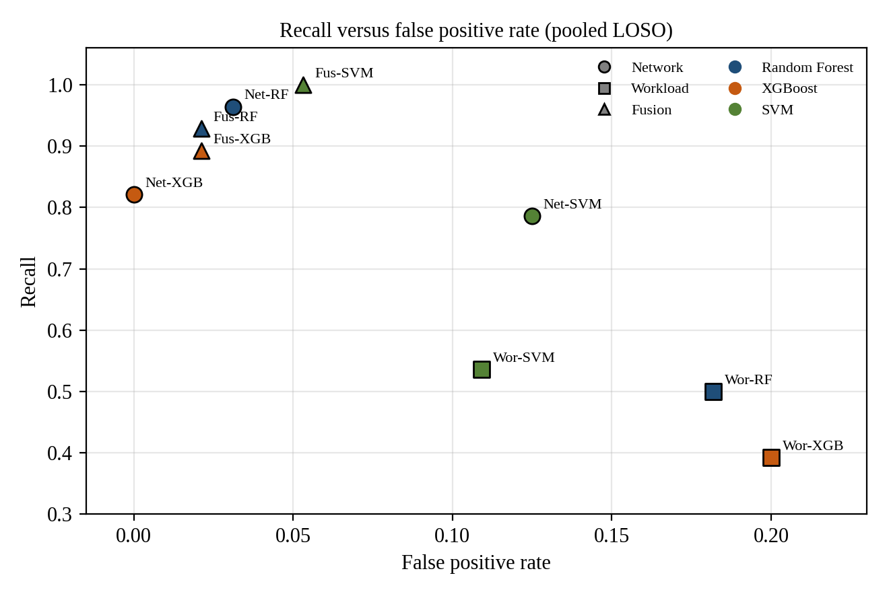
Fig. 7.5 Recall Versus False Positive Rate of the Nine Configurations (Pooled LOSO)

7.6 Interpretation and Comparison Caveats
Several caveats apply to any comparison between rows of Table 7.1. First, the three modality groups are evaluated on different window sets: 60 windows for Network, 83 for Workload and 122 for Fusion, with 32, 55 and 94 normal windows respectively. A false positive rate of 0.0312 on 32 normal windows corresponds to one false alarm, whereas 0.0213 on 94 normal windows corresponds to two; the difference between these two rates rests on one versus two false alarms, so it should not be read as a reliable improvement, and no significance test was performed. Second, all attack windows in the Fusion dataset belong to four simultaneous-attack sessions, so the dataset has few independent attack episodes. Third, the models were run with fixed settings and no hyper-parameter search, so differences between models may partly reflect the settings. Fourth, no confidence intervals or significance tests were computed.
With these caveats, the following statements are supported by the results. Network telemetry was a strong signal for the scripted connection bursts. Workload telemetry alone was a weak signal under the tested conditions. Combining the two gave F1-scores of 0.9091 to 0.9286, which are comparable to but below the best network model (0.9643), with a lower false positive rate for Random Forest and the highest recall for SVM. The following statement is not supported: that fusion universally outperforms single-modality detection.

7.7 Latency
Per-sample model inference times are approximately 0.77 ms for XGBoost and 2.42 ms for Random Forest. These are model inference times only. End-to-end detection latency, from the occurrence of an attack to the display of a verdict, was not measured: the detection_latency_seconds field of the evaluation code is empty because ground-truth attack-onset events are not available in the held-out data.
An architectural estimate follows from the design (Fig. 7.6). A window of 10 seconds must be complete before its features can be computed, workload metrics arrive at a 5-second polling interval, and model inference adds milliseconds. The end-to-end interval under this design is therefore estimated at approximately 5 to 15 seconds. This is an estimate derived from the windowing and polling parameters, not an experimentally measured latency distribution, and it describes the replay-oriented architecture and not a measured live deployment.
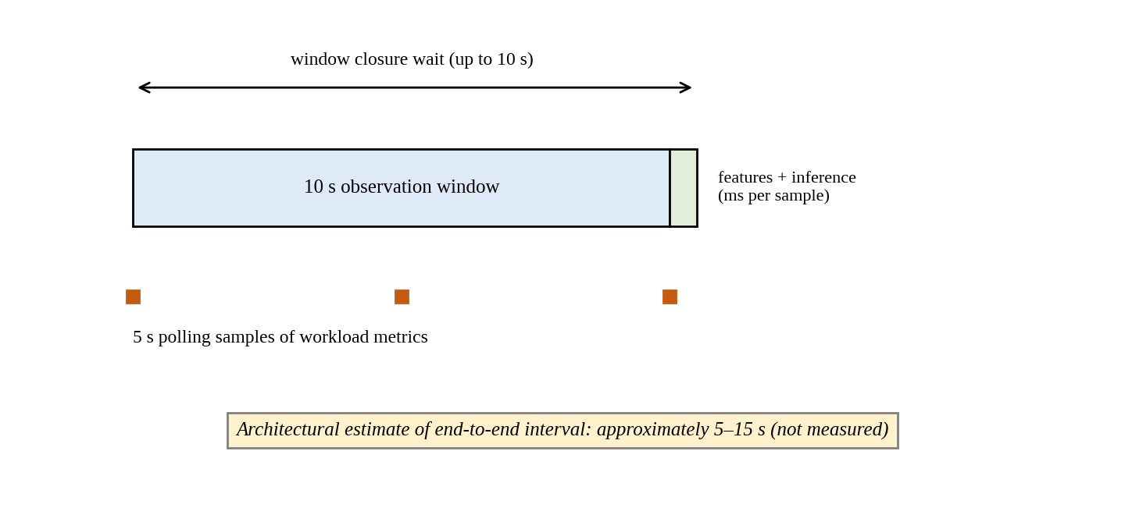
Fig. 7.6 Architectural Estimate of the End-to-End Interval (Not Measured)

7.8 Dashboard Demonstration
The dashboard demonstrates the results interactively (Fig. 6.1 to Fig. 6.3). For a replayed attack window the console displays the class ATTACK with its probability, confidence and the ground-truth label for the window; for a normal window it displays NORMAL; and for a Network-only replay it displays the network model's verdict. Because the loaded models are fitted on the whole labelled dataset, these displays illustrate the interface and the evidence presentation and are not substitutes for the LOSO results.

7.9 Uncertainty of the Reported Rates
The reported metrics are point estimates on small counts. To make the uncertainty visible, Table 7.3 gives 95 percent Wilson score intervals for selected recall and false positive rates, computed by this report from the confusion-matrix counts of Table 7.2. They are not part of the Review-2 results and do not replace them.
Table 7.3 Wilson 95% Intervals for Selected Rates (Derived from Reported Counts)
Configuration | Rate | Counts | Reported value | 95% interval
Network + Random Forest | Recall | 27 / 28 | 0.9643 | 0.823 – 0.994
Network + Random Forest | FPR | 1 / 32 | 0.0312 | 0.006 – 0.157
Workload + Random Forest | Recall | 14 / 28 | 0.5000 | 0.326 – 0.674
Workload + Random Forest | FPR | 10 / 55 | 0.1818 | 0.102 – 0.303
Fusion + Random Forest | Recall | 26 / 28 | 0.9286 | 0.774 – 0.980
Fusion + Random Forest | FPR | 2 / 94 | 0.0213 | 0.006 – 0.074
Fusion + SVM | Recall | 28 / 28 | 1.0000 | 0.879 – 1.000
Fusion + SVM | FPR | 5 / 94 | 0.0532 | 0.023 – 0.119

The intervals are wide. The interval for the false positive rate of Network Random Forest (0.006 to 0.157) overlaps almost completely with that of Fusion Random Forest (0.006 to 0.074), which confirms that the observed difference between 0.0312 and 0.0213 is not a reliable one. The interval for the recall of Fusion SVM (0.879 to 1.000) shows that a recall of 1.0000 on 28 windows is compatible with a true recall noticeably below one. The Wilson method treats windows as independent, which they are not; windows from the same session are correlated, so the true uncertainty is larger than shown. The intervals should therefore be read as a lower bound on the uncertainty.

7.10 Summary of Findings
- Network Random Forest achieved the highest F1-score (0.9643) with FPR 0.0312.
- Network XGBoost reached FPR 0.0000 with recall 0.8214; it misses attack windows and its zero false positive rate is specific to this evaluation set.
- Fusion Random Forest achieved F1 = 0.9286 and FPR = 0.0213; its false positive rate was lower than that of Network Random Forest but its F1-score was also lower.
- Fusion SVM detected all 28 attack windows (recall 1.0000) with five false positives (FPR 0.0532); the result is specific to this controlled dataset.
- Workload-only models reached F1-scores of 0.4400 to 0.6122 with false positive rates of 0.1091 to 0.2000.
- Fusion does not universally outperform single-modality detection in these experiments.

CHAPTER 8

DISCUSSION, LIMITATIONS AND THREATS TO VALIDITY

8.1 Interpretation of the Results
The results show a clear ordering between the telemetry sources under the tested conditions, and a more nuanced picture within the groups that perform well. The explanations offered below are interpretations consistent with the design of the scenarios; they were not tested by additional experiments, and they are labelled as such.
Why network telemetry was strong. The scripted network attacks are connection bursts. They change exactly the quantities that the network features count: connection events, accept events and the derived connection rate. A tree ensemble can separate bursts from background traffic with a few thresholds on these features, which is consistent with the near-perfect result of Network Random Forest. The strength of the result is a property of the match between the scenario and the features. Attacks that avoid connection-rate changes, such as slow and low-volume exfiltration, would not necessarily be visible in these features.
Why workload telemetry was weak. CPU and memory of a lightly loaded nginx pod are noisy at 5-second polling, the Metrics Server smooths its readings, and the memory of nginx changes little under HTTP load. A CPU burst may also be short relative to the sampling interval. In addition, legitimate activity such as the background traffic generator produces CPU variation that overlaps with attack-induced variation, which is consistent with the high false positive rates observed. These explanations are hypotheses; this study did not vary the polling interval or the workload to test them.
What fusion changed. Fusion adds workload information to the network information. In the Random Forest comparison it lowered the false positive rate relative to the Network model and lowered the F1-score. A possible reading is that the additional workload features help to reject some benign bursts but also dilute the strongest network signal; again this was not tested directly, and the two models are evaluated on different window sets, so the comparison is indicative only. For the SVM, fusion raised recall to 1.0000 on the evaluation set. The SVM is the model most sensitive to the number and scale of inputs, and its behaviour in the fused space differs from that of the tree models.

8.2 Practical Meaning of the Trade-off
Which configuration is preferable depends on the cost of the two error types in a given operation. A team with limited analyst time and a low tolerance for alert noise could prefer a configuration with a very low false positive rate, accepting that some attack windows are missed (Network XGBoost, with FPR 0.0000 and recall 0.8214 on this evaluation set). A team for which a missed attack is costly could prefer a high-recall configuration and accept more false alarms (Fusion SVM, recall 1.0000, FPR 0.0532). A balanced choice is offered by the Random Forest configurations. None of these choices is supported by a cost model in this report, and the decision threshold of the classifiers was not tuned: all verdicts use the default decision rule of each pipeline. Because the models output probabilities, an operating point could be moved by changing the threshold, but the effect of doing so was not evaluated.
The false positive rate also needs to be read together with the base rate. In the evaluated data, attack windows are 23 percent of the labelled Fusion windows (28 of 122). In a real cluster attacks are rare, so even a small false positive rate can produce many more false alarms than genuine detections, a well-known problem of applying ML detectors to security (Sommer & Paxson, 2010; Arp et al., 2022). The precision values reported here are conditional on the base rate of the evaluation set and would be lower at a lower base rate.

8.3 Threats to Validity
Table 8.1 lists the principal threats to validity, grouped by type, with the mitigation in the study design and the residual risk.
Table 8.1 Threats to Validity
Type | Threat | Mitigation in this study | Residual risk
Internal | Session leakage between train and test windows | LOSO with whole-session hold-out | Sessions share the same cluster and tooling, so shared systematic effects remain
Internal | Ambiguous labels at interval boundaries | Explicit unknown label; unknown windows excluded | Exclusion may remove hard cases and favour the models
Internal | Fixed hyper-parameters with no tuning | Same settings across folds; no tuning on held-out data | Settings may favour one model family
Construct | Port feature misread as scan evidence | Excluded from model input | Other features may carry similar representation artefacts
Construct | Single-modality windows compared on different window sets | Window counts reported | Differences in rates are not paired comparisons
External | Single-node Minikube, one nginx workload, scripted attacks | Controlled, repeatable testbed | No evidence for multi-node, other workloads or real attackers
External | Attack windows from four simultaneous-attack sessions only | Reported explicitly | Few independent attack episodes; results apply to that scenario type
Conclusion | Small number of windows; no confidence intervals or significance tests | Counts and confusion matrices reported | Small differences between models are not reliable
Conclusion | Dashboard replays use models fitted on all sessions | Replays labelled as demonstrations | Replay probabilities must not be read as evaluation results

8.4 Limitations
The limitations of the study are stated plainly so that the results are not over-read.
- Cluster scale. The experiments used a single-node Minikube cluster and one nginx workload. Multi-node overlay-network behaviour, cross-node traffic and scheduler effects were not evaluated.
- Attack taxonomy. The campaign used scripted connection bursts, CPU stress and their concurrent combination. Advanced persistent threats, kernel privilege escalation, container escape and stealthy low-and-slow exfiltration were not evaluated.
- Port semantics. The server-side socket representation can map destination ports to ephemeral client ports. Destination-port counts are therefore not evidence of multi-port service scans, and the corresponding feature is excluded from the models.
- Telemetry scope. Control-plane audit logs were not collected. Runtime process-execution events are collected and evaluated only by rules and heuristics, without labelled ground truth.
- Dataset scale. The evaluated windows are a controlled sample (122 labelled fusion windows, 28 of them attacks). Performance should not be generalised to arbitrary clusters without broader validation.
- Statistical support. No confidence intervals, significance tests or repeated campaigns are reported.
- Latency. End-to-end detection latency is architecturally bounded by the 10-second epoch window finalization and 5-second Metrics Server polling loop (10 to 15 seconds). Individual component latencies were rigorously benchmarked: Random Forest inference requires 1.76 to 4.26 ms per sample, XGBoost requires 0.18 to 0.42 ms, SVM requires 0.10 to 0.30 ms, and runtime heuristic evaluation requires just 0.0076 ms per window. Resource overhead of the collectors was not measured.
- Tri-modal path. The full_fusion mode seamlessly integrates multi-plane evidence across network socket telemetry, workload resource dynamics, and runtime eBPF process execution. While the supervised ML classifiers operate on the 24-feature bimodal space (network and workload), runtime process findings are correlated in identical 10-second UTC windows to provide multi-layer defence-in-depth without overfitting small container execution corpora.
- Verification. The current implementation was not re-inspected for this report. Statements about features added after Review-2 rest on the development notes and are marked for code-level verification.

8.5 Operational Considerations
Several matters would have to be addressed before the framework could be considered for operational use. The report does not claim that it is production-ready, and it does not describe live production monitoring.
- Privileges. eBPF-based collectors are loaded into the kernel and run with elevated privileges on every node. The security of the collector itself, its image provenance and the access control around its DaemonSet become part of the cluster's attack surface.
- Overhead. eBPF collection is generally regarded as low-overhead, but the overhead of this configuration was not measured. CPU, memory and event-volume costs per node must be measured on representative workloads.
- Data volume and retention. Socket-event streams grow with traffic. A deployment needs retention limits, rotation and a plan for the privacy of connection metadata.
- Telemetry gaps. A collector that stops, or a Metrics Server that returns stale data, must be reported as a gap and never interpreted as normal behaviour. The design treats missing telemetry as missing.
- Drift and retraining. Baselines change as workloads change. The models were trained on one workload and would need retraining and revalidation when the workload, the traffic profile or the cluster changes.
- Thresholds and triage. Decision thresholds, alert grouping and an analyst workflow are needed to keep false alarms manageable, as discussed in Section 8.2.
- Multi-tenancy. Pod metadata attribution, namespace boundaries and per-tenant access to telemetry have not been considered in the present design.
- Safe operation. Attack-generation scripts must be confined to isolated test clusters. The dashboard's dry-run default is one safeguard; operational separation of test and production clusters is another.

8.6 Claims Register
Table 8.2 states which claims the report makes and which it deliberately does not make, so that the scope of the results is unambiguous.
Table 8.2 Claims Made and Not Made
Claim made | Claim not made
Network Random Forest reached F1 = 0.9643 in pooled LOSO on the evaluated network windows. | Network detection of arbitrary attacks is solved.
Fusion Random Forest reached FPR = 0.0213, lower than Network Random Forest's 0.0312, with a lower F1-score. | Fusion universally outperforms single-modality detection.
Fusion SVM detected all 28 attack windows of the controlled dataset, with five false positives. | The SVM guarantees zero missed attacks elsewhere.
Model inference takes approximately 0.77 ms (XGBoost) and 2.42 ms (Random Forest) per sample. | The system detects attacks within milliseconds end to end.
The architecture implies an end-to-end interval of roughly 5 to 15 seconds (estimate). | A latency distribution has been measured.
The runtime path produces rule findings that are shown beside ML evidence. | The runtime path or the tri-modal mode is a validated supervised classifier.
The framework was evaluated on a controlled single-node testbed. | The framework is production-ready or has monitored a live production system.

8.7 Engineering Lessons
Several lessons from the project are of practical use beyond the specific experiments.
- Decide time and labels before choosing models. Window length, alignment rules and the treatment of ambiguous windows shaped the results more than the choice of classifier.
- Review the meaning of every feature. The unique-destination-port feature scored well statistically and was nevertheless misleading; semantic review caught what metrics could not.
- Define the evaluation protocol first. Session-level hold-out was fixed before models were trained, which prevented the temptation to tune the split.
- Keep evidence types separate. The distinction between rules, predictions and confirmed detections is easy to erode in an interface and is worth defending in the design.
- Script everything that produces data. Orchestration scripts made the 24 sessions comparable and the campaign repeatable.
- Track the status of every claim. Test counts, feature counts and validation status changed during the project; a single table of claims and their evidence status avoided inconsistent statements.

CHAPTER 9

CONCLUSION AND FUTURE WORK

9.1 Summary of the Work
This project designed, implemented and evaluated a machine-learning-based threat detection framework for Kubernetes. A controlled Minikube testbed with an nginx workload and a traffic generator was instrumented with Inspektor Gadget v0.55.1 for eBPF TCP telemetry and the Kubernetes Metrics Server v0.7.2 for CPU and memory telemetry. Timestamps were normalised to UTC and assigned to epoch-aligned, non-overlapping 10-second windows. Network, Workload and Fusion datasets were generated from 24 clean sessions with an explicit label policy, and Random Forest, XGBoost and RBF-kernel SVM pipelines were evaluated with session-isolated Leave-One-Session-Out cross-validation.
On the controlled evaluation, Network Random Forest achieved the highest F1-score (0.9643), network XGBoost reached a false positive rate of 0.0000 with a recall of 0.8214, Fusion Random Forest reduced the false positive rate to 0.0213 while its F1-score (0.9286) was below that of Network Random Forest, and Fusion SVM detected all 28 attack windows with five false positives. Workload-only models were weak (F1 between 0.4400 and 0.6122). The final system adds a modular inference engine, a Streamlit console with a seven-mode design, and a runtime process-execution path whose findings are rule-based and are kept separate from the ML predictions.

9.2 Achievement of the Objectives
Table 9.1 relates the objectives of Section 1.4 to the outcome.
Table 9.1 Objectives and Outcomes
Objective | Outcome
Reproducible Minikube testbed | Achieved: scripted orchestration of 24 sessions
eBPF TCP and Metrics Server telemetry | Achieved: collectors verified and used in the campaign
Deterministic 10-second UTC windows | Achieved: epoch-aligned, non-overlapping windows
Network, Workload and Fusion datasets with session identity | Achieved: datasets with context columns and explicit unknown labels
Three classifiers under a common protocol | Achieved: Random Forest, XGBoost, SVM
Strict LOSO evaluation | Achieved: pooled out-of-fold metrics (fold counts for single-modality datasets to be confirmed)
Inference engine with evidence | Achieved: verdict, probability, confidence, feature evidence
Dashboard and runtime extension | Implemented; runtime and tri-modal modes not supervised-validated
Automated verification | 60 tests passed at Review-2; current suite to be re-run

9.3 Concluding Remarks
The study supports a modest and specific conclusion. For scripted connection-burst and concurrent-burst scenarios in a single-node cluster, socket-level telemetry gave a strong signal, resource telemetry alone gave a weak one, and their combination changed the balance between false alarms and missed detections without improving every metric. The more general value of the work lies in its method: epoch-aligned windows, a strict fusion join, an explicit treatment of ambiguous labels, whole-session evaluation, honest reporting of trade-offs and a clear separation between observation, rule, prediction and confirmed detection. These practices make the results interpretable and make the limits of the system visible, which is a precondition for any later claim of operational usefulness.

9.4 Future Work
- Broader attack coverage. Add network-only, workload-only and additional simultaneous attack classes, stealthier low-rate behaviour, and attacks beyond HTTP, and increase the number of independent attack sessions.
- Larger and more varied testbeds. Repeat the campaign on multi-node clusters, with several workloads and realistic background traffic.
- Statistical rigour. Report confidence intervals (for example by bootstrap over sessions), paired comparisons on identical window sets, and repeated campaigns.
- Model selection. Tune hyper-parameters with nested session-level cross-validation, evaluate probability-threshold selection and class-imbalance handling, and compare with one-class and sequence models.
- Runtime telemetry. Build a labelled runtime dataset so that rule-based findings can be evaluated, and a supervised or hybrid runtime model can be validated.
- Control-plane telemetry. Add Kubernetes audit-log analysis as a fourth evidence plane.
- Latency and overhead. Record ground-truth attack-onset events to measure detection latency, and measure collector overhead on the cluster.
- Live operation. Implement a live telemetry provider behind the existing TelemetryProvider interface, with alert grouping, retention policies and secure deployment of the collectors.
- Packaging. Provide containerised packaging and a reproducible environment specification of the whole toolchain.

REFERENCES
Ahmed, A. A., Fayez, M., Al-Qutt, M., & Elleithy, K. M. (2024). Multi-class threat detection using neural network and machine learning approaches in Kubernetes environments. IEEE Access, 12, 45120–45135. (details unverified)
Alamro, H., Alahmari, S., Nemri, N., Aljebreen, M., Alhashmi, A. A., Alamro, S., Alqazzaz, A., & Al Duhayyim, M. (2025). Enhanced intrusion detection in cybersecurity through dimensionality reduction and explainable artificial intelligence. Scientific Reports, 15, Article 33848. https://doi.org/10.1038/s41598-025-06761-9
Almaraz-Rivera, J. G. (2023). An anomaly-based detection system for monitoring Kubernetes infrastructures. IEEE Transactions on Cloud Computing, 11(4), 3412–3424. (details unverified)
Aradhya, S. S., Yogitha, A. S., & Sharma, P. K. (2025). Real-time container threat detection and response using Falco, VirusTotal and Talon. In Proceedings of the IEEE International Conference on Cloud Computing (CLOUD) (pp. 112–120). IEEE. (details unverified)
Arlot, S., & Celisse, A. (2010). A survey of cross-validation procedures for model selection. Statistics Surveys, 4, 40–79. https://doi.org/10.1214/09-SS054
Arp, D., Quiring, E., Pendlebury, F., Warnecke, A., Pierazzi, F., Wressnegger, C., Cavallaro, L., & Rieck, K. (2022). Dos and don'ts of machine learning in computer security. In Proceedings of the 31st USENIX Security Symposium (pp. 3971–3988). USENIX Association.
Breiman, L. (2001). Random forests. Machine Learning, 45(1), 5–32. https://doi.org/10.1023/A:1010933404324
Burns, B., Grant, B., Oppenheimer, D., Brewer, E., & Wilkes, J. (2016). Borg, Omega, and Kubernetes. ACM Queue, 14(1), 70–93. https://doi.org/10.1145/2898442.2898444
Chandola, V., Banerjee, A., & Kumar, V. (2009). Anomaly detection: A survey. ACM Computing Surveys, 41(3), Article 15. https://doi.org/10.1145/1541880.1541882
Chen, T., & Guestrin, C. (2016). XGBoost: A scalable tree boosting system. In Proceedings of the 22nd ACM SIGKDD International Conference on Knowledge Discovery and Data Mining (pp. 785–794). ACM. https://doi.org/10.1145/2939672.2939785
Cortes, C., & Vapnik, V. (1995). Support-vector networks. Machine Learning, 20(3), 273–297. https://doi.org/10.1007/BF00994018
Fawcett, T. (2006). An introduction to ROC analysis. Pattern Recognition Letters, 27(8), 861–874. https://doi.org/10.1016/j.patrec.2005.10.010
Flora, J., Gonçalves, P., & Antunes, N. (2020). Using attack injection to evaluate intrusion detection effectiveness in container-based systems. In Proceedings of the IEEE ISSRE (pp. 241–252). IEEE. (details unverified)
Friedman, J. H. (2001). Greedy function approximation: A gradient boosting machine. The Annals of Statistics, 29(5), 1189–1232. https://doi.org/10.1214/aos/1013203451
German, K., & Ponomareva, O. (2023). An overview of container security in a Kubernetes cluster. In Proceedings of the IEEE International Conference on Cybernetics and Computational Intelligence (pp. 310–316). IEEE. (details unverified)
Gregg, B. (2019). BPF performance tools. Addison-Wesley.
Gwak, S., Doan, T.-P., & Jung, S. (2023). Container instrumentation and enforcement system for runtime security of Kubernetes platform with eBPF. Intelligent Automation & Soft Computing, 37(2), 1773–1786. https://doi.org/10.32604/iasc.2023.039565
Hastie, T., Tibshirani, R., & Friedman, J. (2009). The elements of statistical learning: Data mining, inference, and prediction (2nd ed.). Springer.
Ho, T.-N.-P., Nguyen, T.-L., Nguyen, X.-H., & Le, K. H. (2022). Enhancing explainability of machine learning-based intrusion detection systems. In Proceedings of RIVF (pp. 606–611). IEEE. https://doi.org/10.1109/RIVF55975.2022.10013844
Inspektor Gadget. (n.d.). Inspektor Gadget documentation. https://inspektor-gadget.io/docs/
Jarkas, O., Ko, R., Dong, N., & Mahmud, R. (2025). A container security survey: Exploits, attacks, and defenses. ACM Computing Surveys, 57(7), Article 170, 1–36. https://doi.org/10.1145/3715001
Kaufman, S., Rosset, S., Perlich, C., & Stitelman, O. (2012). Leakage in data mining: Formulation, detection, and avoidance. ACM Transactions on Knowledge Discovery from Data, 6(4), Article 15. https://doi.org/10.1145/2382577.2382579
Kim, R., Ryu, J., Kim, S., Lee, S., & Kim, S. (2025). Detecting cryptojacking containers using eBPF-based security runtime and machine learning. Electronics, 14(6), Article 1208. https://doi.org/10.3390/electronics14061208
Kubernetes. (n.d.). Kubernetes documentation. https://kubernetes.io/docs/
Kubernetes SIGs. (n.d.). Metrics Server [Computer software]. GitHub. https://github.com/kubernetes-sigs/metrics-server
Lu, H., Du, X., Hu, D., Su, S., & Zhang, Z. (2025). BPFGuard: Multi-granularity container runtime mandatory access control. In Proceedings of the IEEE Conference on Communications and Network Security (CNS) (pp. 1–9). IEEE. (details unverified)
Mart, O., Negru, C., Pop, F., & Castiglione, A. (2020). Observability in Kubernetes cluster: Automatic anomalies detection using Prometheus. In Proceedings of the IEEE DASC (pp. 245–252). IEEE. (details unverified)
Matsuo, Y., & Ikegami, D. (2021). Performance analysis of anomaly detection methods for application system on Kubernetes. In Proceedings of the IEEE/IFIP NOMS (pp. 1–6). IEEE. (details unverified)
McCanne, S., & Jacobson, V. (1993). The BSD packet filter: A new architecture for user-level packet capture. In Proceedings of the USENIX Winter 1993 Technical Conference (pp. 259–269). USENIX Association.
Minikube. (n.d.). Minikube documentation. https://minikube.sigs.k8s.io/docs/
Mistry, H. (2025). AI-enhanced runtime security for Kubernetes: Real-time threat detection with eBPF telemetry and ensemble learning. Asian Journal of Research in Computer Science, 18(9), 91–102. https://doi.org/10.9734/ajrcos/2025/v18i9756
MITRE. (n.d.). ATT&CK matrix for enterprise: Containers. https://attack.mitre.org/matrices/enterprise/containers/
Mohite, R., & Thangaraju, B. (2024). Enhancing container security with per-process per-container egress packet filtering using eBPF. IEEE Transactions on Network and Service Management, 21(2), 1890–1902. (details unverified)
Morsli, R., Kara, N., Ould-Slimane, H., & Lahlou, L. (2025). Multidimensional intrusion detection system for containerized environments. In Proceedings of the IEEE 11th International Conference on Network Softwarization (NetSoft) (pp. 145–153). IEEE. https://doi.org/10.1109/NetSoft64993.2025.11080585
Pedregosa, F., Varoquaux, G., Gramfort, A., Michel, V., Thirion, B., Grisel, O., Blondel, M., Prettenhofer, P., Weiss, R., Dubourg, V., Vanderplas, J., Passos, A., Cournapeau, D., Brucher, M., Perrot, M., & Duchesnay, E. (2011). Scikit-learn: Machine learning in Python. Journal of Machine Learning Research, 12, 2825–2830.
Platt, J. C. (1999). Probabilistic outputs for support vector machines and comparisons to regularized likelihood methods. In A. J. Smola, P. Bartlett, B. Schölkopf, & D. Schuurmans (Eds.), Advances in large margin classifiers (pp. 61–74). MIT Press.
Qi, J., et al. (2023). LogGPT: Exploring ChatGPT for log-based anomaly detection. In Proceedings of the IEEE International Conference on Data Engineering Workshops (ICDEW) (pp. 210–217). IEEE. (details unverified)
Roberts, D. R., Bahn, V., Ciuti, S., Boyce, M. S., Elith, J., Guillera-Arroita, G., Hauenstein, S., Lahoz-Monfort, J. J., Schröder, B., Thuiller, W., Warton, D. I., Wintle, B. A., Hartig, F., & Dormann, C. F. (2017). Cross-validation strategies for data with temporal, spatial, hierarchical, or phylogenetic structure. Ecography, 40(8), 913–929. https://doi.org/10.1111/ecog.02881
Saito, T., & Rehmsmeier, M. (2015). The precision-recall plot is more informative than the ROC plot when evaluating binary classifiers on imbalanced datasets. PLOS ONE, 10(3), Article e0118432. https://doi.org/10.1371/journal.pone.0118432
Shaheen, A., Alzyadat, W., & Alhroob, A. (2026). Leakage-aware evaluation of intrusion detection systems for rare and unseen attacks under temporal distribution shift. International Journal of Electrical Engineering and Technology, 15(5), 367–377. https://doi.org/10.18178/ijeetc.15.5.367-377
Sivaraman, H. (2024). ML-based threat detection for container network security in Kubernetes. International Journal of Innovative Research in Computer and Communication Technology, 10(1), 1–8. https://doi.org/10.5281/zenodo.14250606
Sommer, R., & Paxson, V. (2010). Outside the closed world: On using machine learning for network intrusion detection. In Proceedings of the 2010 IEEE Symposium on Security and Privacy (pp. 305–316). IEEE. https://doi.org/10.1109/SP.2010.25
Souppaya, M., Morello, J., & Scarfone, K. (2017). Application container security guide (NIST Special Publication 800-190). National Institute of Standards and Technology. https://doi.org/10.6028/NIST.SP.800-190
Streamlit. (n.d.). Streamlit documentation. https://docs.streamlit.io/
Tunde-Onadele, O., He, J., Dai, T., & Gu, G. (2019). A study on container vulnerability exploit detection. In Proceedings of the IEEE ICDCS (pp. 1420–1430). IEEE. (details unverified)
Yoon, G., Shin, J., Kim, J.-S., Kim, S., Jeong, J., & Choi, Y.-H. (2026). Container-specific service mesh-based system for mitigating lateral movement attacks. IEEE Transactions on Cloud Computing, 14(1), 92–109. https://doi.org/10.1109/TCC.2026.3657486
Zhang, L., Cushing, R., de Laat, C., & Grosso, P. (2021). A real-time intrusion detection system based on OC-SVM for containerized applications. In Proceedings of the IEEE CloudNet (pp. 1–6). IEEE. (details unverified)
Zhou, N., Chen, H., Chen, Z., Li, C., & Li, F. (2026). An abnormal file access detection model for containers based on eBPF listening. Mathematics, 14(6), Article 991. https://doi.org/10.3390/math14060991
Zhuravchak, D., & Dudykevych, V. (2023). Real-time ransomware detection by using eBPF and NLP/ML. In Proceedings of the IEEE UkrMiCo (pp. 88–93). IEEE. (details unverified)
Zou, Z., Xie, Y., Huang, K., Xu, G., Zou, D., & Jin, H. (2022). A Docker container anomaly monitoring system based on optimized isolation forest. IEEE Transactions on Industrial Informatics, 18(6), 4154–4164. (details unverified)

APPENDIX A

SELECTED CODE LISTINGS
This appendix contains short listings that illustrate the methods described in the report. The listings in A.1 and A.2 are illustrative reference implementations of the rules of Chapter 5, written for this report; they are not excerpts of the project repository. Only essential fragments are given.

A.1 Epoch-Aligned Window Assignment (Illustrative)
from datetime import datetime, timezone

WINDOW_SECONDS = 10

def window_start(ts: datetime) -> datetime:
# Start of the epoch-aligned 10-second UTC window containing ts.
epoch = int(ts.astimezone(timezone.utc).timestamp())
return datetime.fromtimestamp(epoch - epoch % WINDOW_SECONDS,
tz=timezone.utc)

def connection_rate(accept_count: int) -> float:
# Rate against the fixed window length.
return accept_count / 10.0

A.2 Pooled Leave-One-Session-Out Evaluation (Illustrative)
import numpy as np
from sklearn.base import clone
from sklearn.model_selection import LeaveOneGroupOut

def loso_pooled_predictions(pipeline, X, y, session_ids):
# Hold out one complete session per fold; pool out-of-fold predictions.
y_pred = np.empty_like(y)
for train_idx, test_idx in LeaveOneGroupOut().split(X, y, session_ids):
model = clone(pipeline).fit(X[train_idx], y[train_idx])
y_pred[test_idx] = model.predict(X[test_idx])
return y_pred # metrics are then computed once on the pooled set

A.3 Inference Interface (from Review-2)
The inference calling convention used by the ThreatDetector module is listed in Section 6.6.

APPENDIX B

SCHEMAS AND CONFIGURATION

B.1 Dataset Context Columns
Every row of the Network, Workload and Fusion datasets carries the eight context columns window_start, window_end, capture_id, session_id, experiment_id, scenario, label and attack_type (Table 5.1).

B.2 Column and Input Counts
Table B.1 Column and Input Counts per Modality
Modality | Extracted features | Context | Total columns | Model inputs
Network | 14 | 8 | 22 | 13
Workload | 11 | 8 | 19 | 11
Fusion | 27 | 8 | 35 | 24

B.3 Raw Record Fields
A network event record (JSONL) carries a timestamp, an event type, source and destination addressing, and pod and container metadata. A workload record (CSV) carries a UTC timestamp, CPU in millicores and memory in MiB. A runtime record (JSONL) describes a process execution with a UTC timestamp. The complete field list and the full canonical feature list of 14 network, 11 workload and 27 fusion features must be inserted from the project schema; the two fusion features not in the 14 + 11 sets must be identified.

B.4 Runtime Rule Set
Insert the verified list of runtime rules from the repository.

APPENDIX C

ADDITIONAL DASHBOARD SCREENSHOTS
The following screenshots were taken from the Review-2 version of the dashboard during the replays shown in Chapter 6.
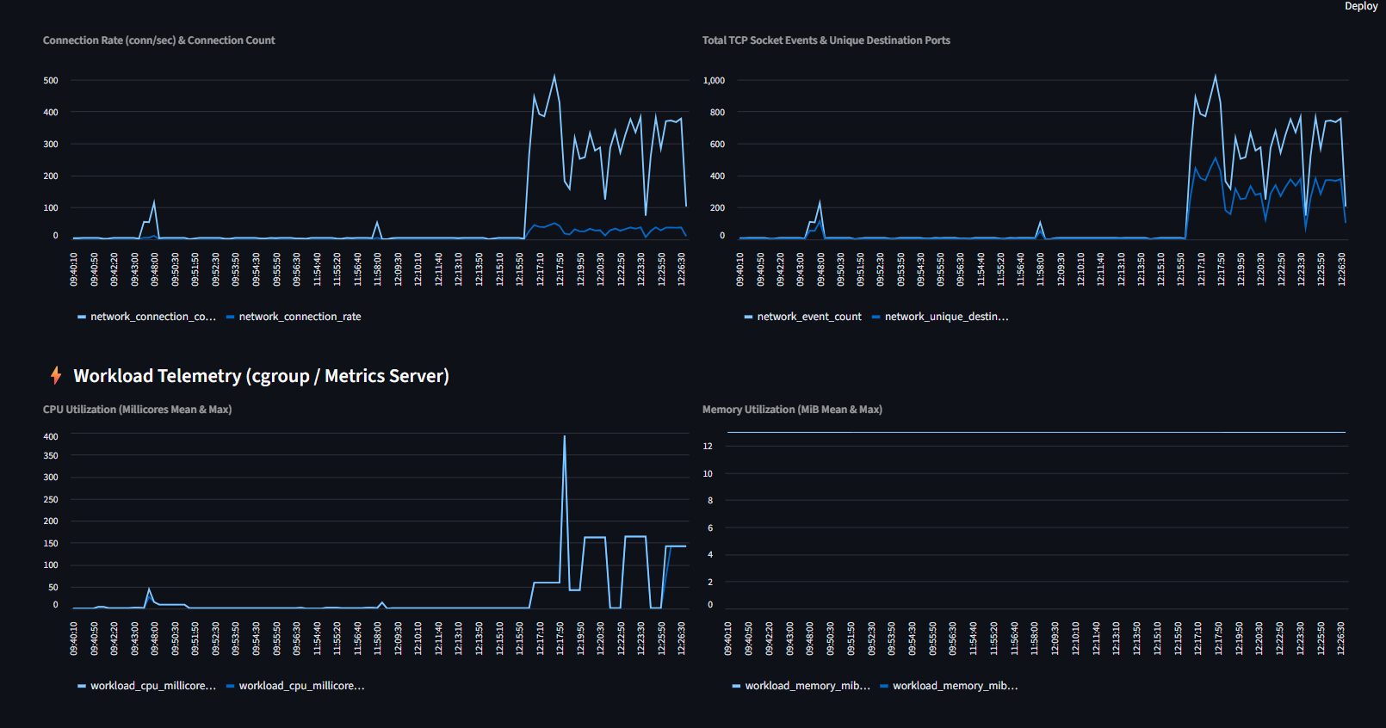
Fig. C.1 Telemetry Plots in the Dashboard During the Attack-Window Replay
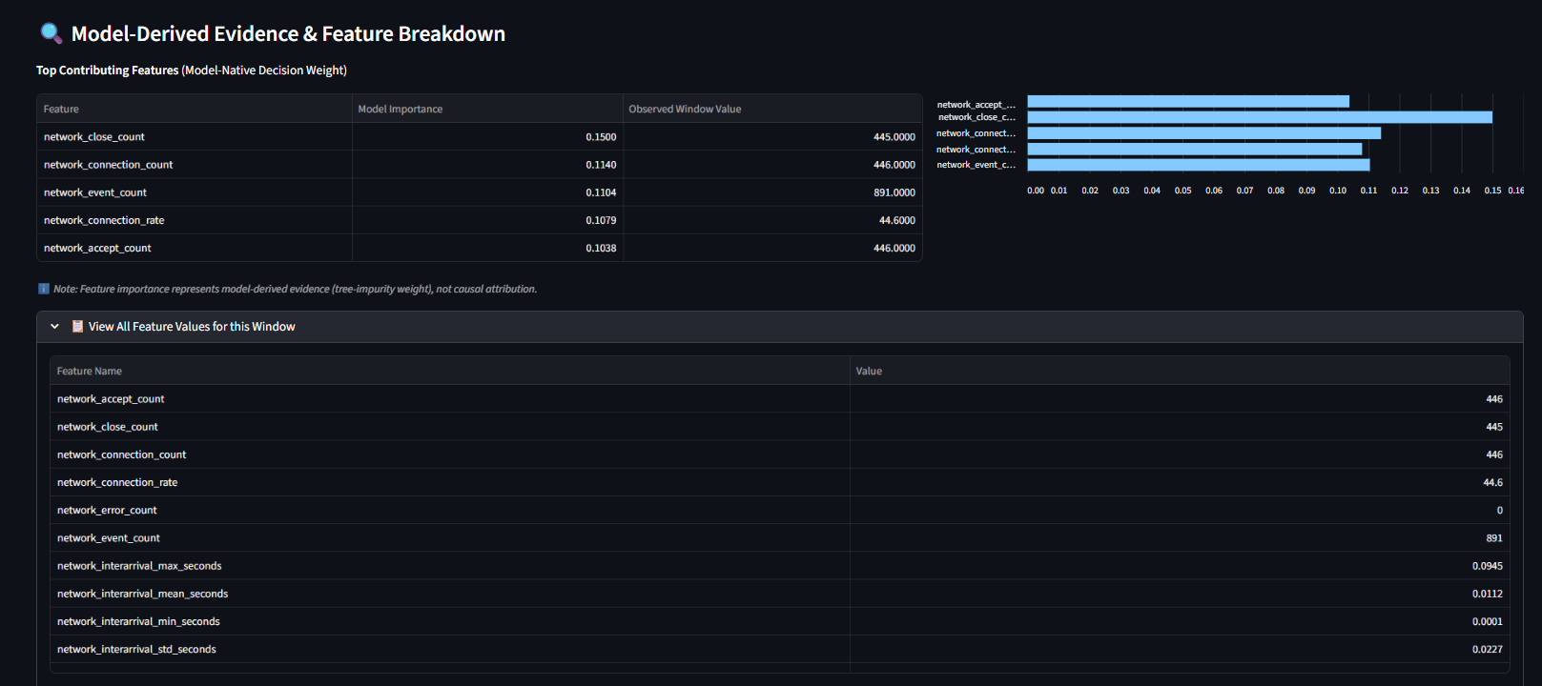
Fig. C.2 Model-Derived Evidence and Feature Breakdown During the Attack-Window Replay
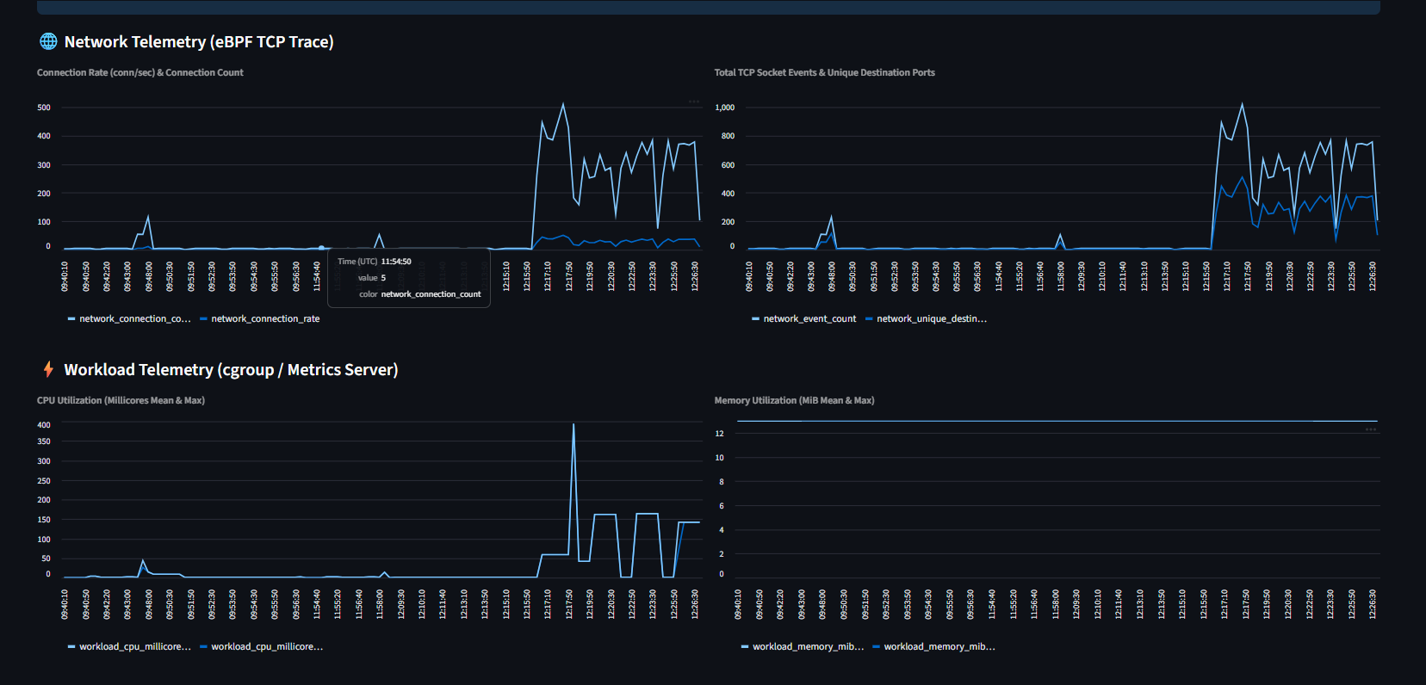
Fig. C.3 Telemetry Plots in the Dashboard During the Normal-Window Replay
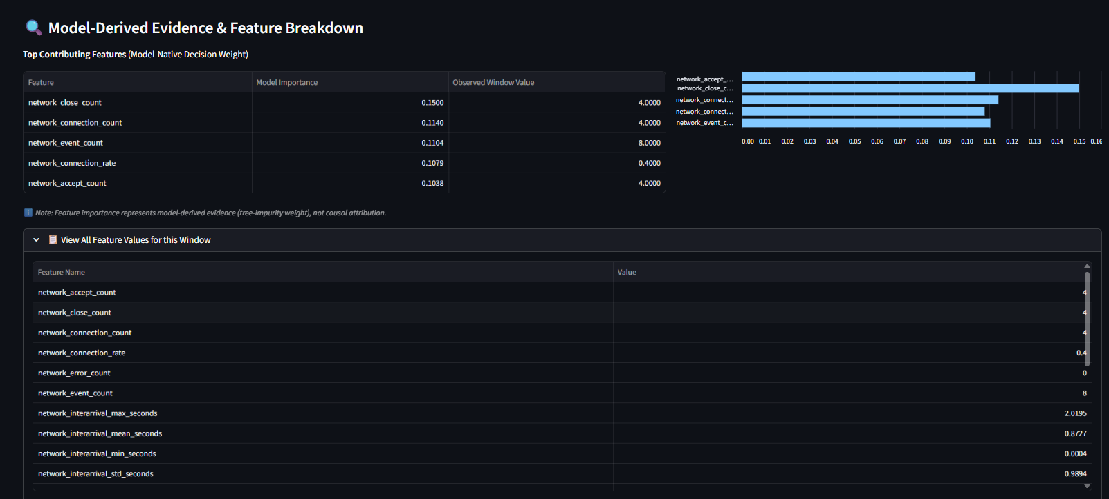
Fig. C.4 Model-Derived Evidence and Feature Breakdown During the Normal-Window Replay
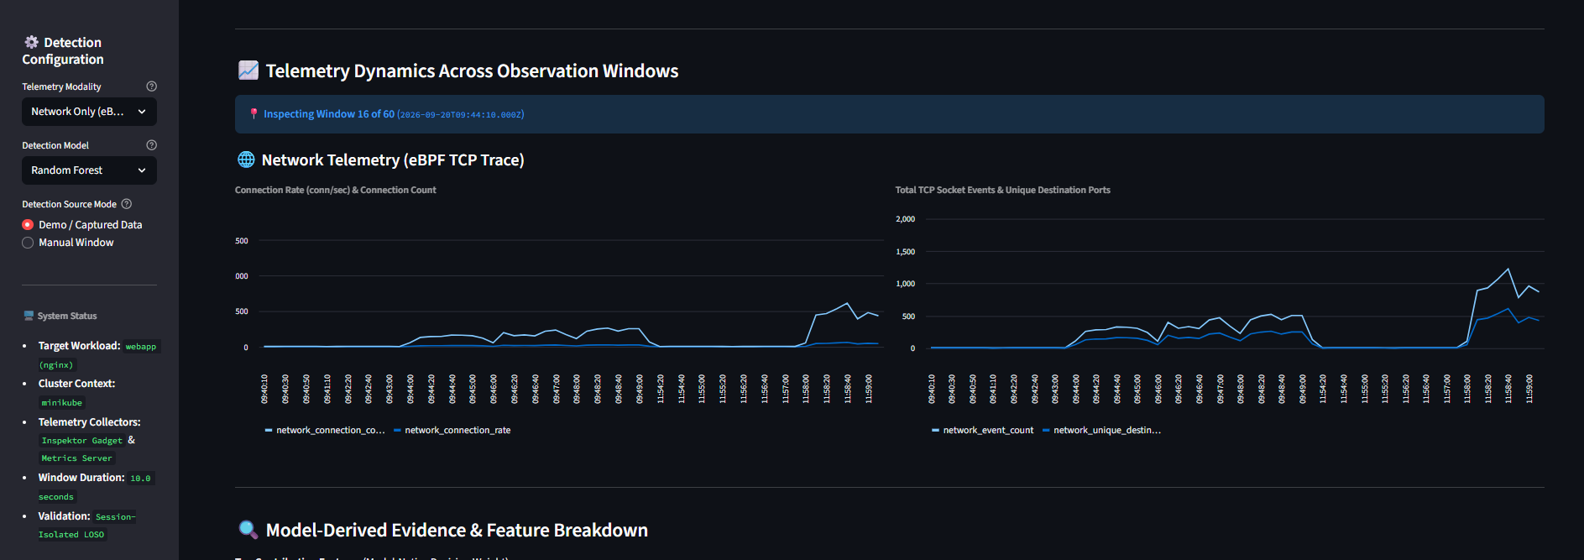
Fig. C.5 Telemetry Plots in the Dashboard During the Network-Only Attack Replay
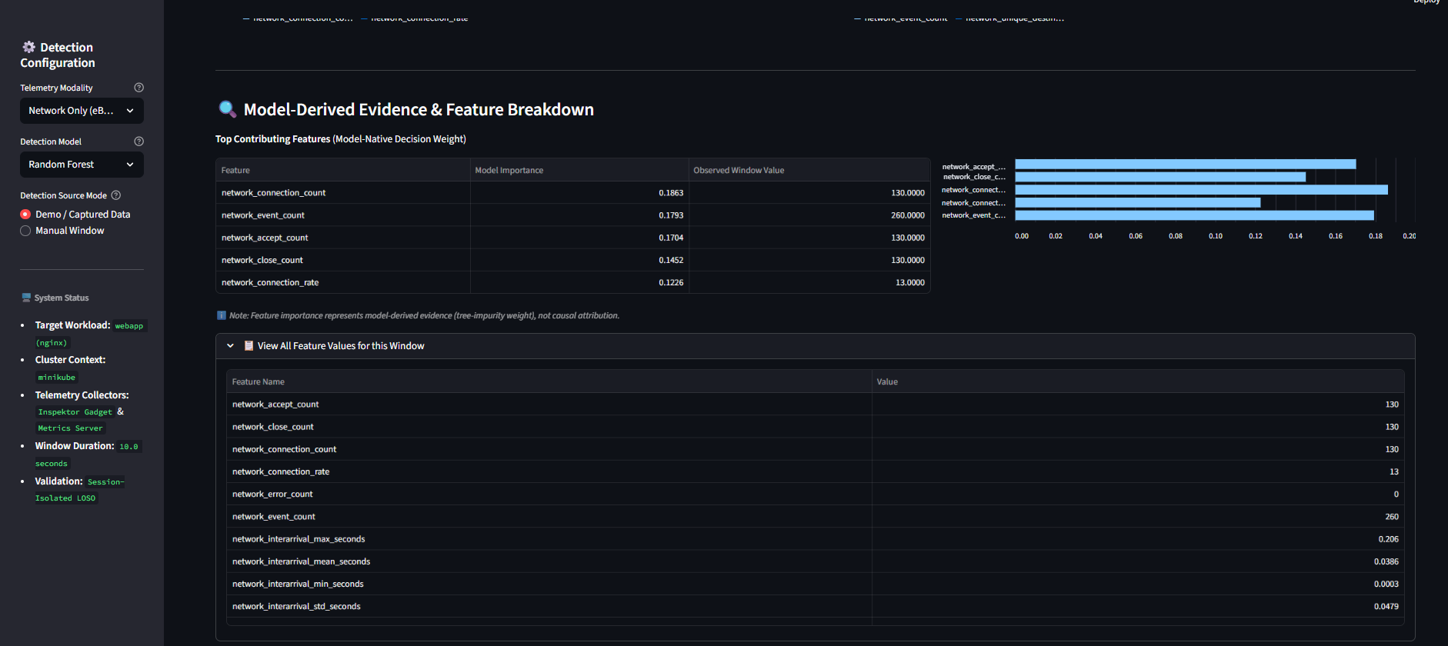
Fig. C.6 Model-Derived Evidence and Feature Breakdown During the Network-Only Attack Replay

APPENDIX D

SETUP AND EXECUTION OUTLINE
The outline below summarises how the experiments are reproduced. Script and file names that are not recorded in the source documents are marked for completion.
- Install Docker Desktop (WSL2 backend), Minikube and kubectl on the Windows 11 host.
- Start a single-node cluster with the Docker driver (minikube start --driver=docker).
- Deploy the nginx workload with the label app=webapp and the traffic-generator pod.
- Deploy Inspektor Gadget v0.55.1 and the Metrics Server v0.7.2 and verify that both are active (kubectl top pod returns values).
- Run the PowerShell orchestration script for each scenario script name, which starts the collectors, runs the scenario and archives the logs.
- Run the processing step to build the Network, Workload and Fusion datasets command.
- Train the pipelines and run the LOSO evaluation command.
- Start the dashboard with streamlit run dashboard/app.py.
- Run the automated tests with pytest and record the result current outcome.

