**DESIGN OF 8 BIT RIPPLE CARRY ADDER**

BY

Ashwini Koushik Hochihally Sudarshan (PS ID:1260747)

Sagar Malyavantham Shivaram (PS ID:1264147)

Under Guidance of: Dr.Joe E. Charlson

Contents:

1. Introduction…………………………………………………………………………………………………………………………… 3
2. Ripple Carry Adder………………………………………………………………………………………………………….. 3
3. Applications…………………………………………………………………………………………………………………….. 5
4. Subsystem……………………………………………………………………………………………………………………………… 5
5. Instances

* PMOS………………………………………………………………………………………………………………….. 5
* NMOS………………………………………………………………………………………………………………….. 6

1. NAND

* Schematic……………………………………………………………………………………………………………. 6
* Layout…………………………………………………………………………………………………………………. 7

1. Full adder

* Schematic……………………………………………………………………………………………………………. 8
* Layout………………………………………………………………………………………………………………….. 9

1. Overall System………………………………………………………………………………………………………………………… 10
2. Operation…………………………………………………………………………………………………………………………. 10
3. Layout………………………………………………………………………………………………………………………………. 10
4. Spice Code………………………………………………………………………………………………………………………… 11
5. Simulation Result and Waveforms…………………………………………………………………………………………… 21
6. Conclusion...……………………………………………………………………………………………………………………………. 24
7. **INTRODUCTION**

In [electronics](http://en.wikipedia.org/wiki/Electronics), an **adder** or **summer** is a [digital circuit](http://en.wikipedia.org/wiki/Digital_circuit) that performs [addition](http://en.wikipedia.org/wiki/Addition) of numbers. Adders are also used in other parts of the processor, where they are used to calculate addresses, table indices, and similar operations.

Adders are of several types:

1. Ripple carry adder or carry propagate adder
2. Carry look-ahead adder
3. Carry skip adder
4. Manchester chain adder
5. Carry select adders
6. Pre-Fix Adders
7. Multi-operand adder
8. Carry save Adder
9. Pipelined parallel adder

A combinational circuit that adds two bits is called a half adder. A full adder is one that adds three bits, the third produced from a previous addition operation. One way of implementing a full adder is to utilize two half adders in its implementation. The full adder is the basic unit of addition employed in all the adders.

1. **RIPPLE CARRY ADDER:**

The block diagram for a ripple carry adder implemented using full adders is as shown below:

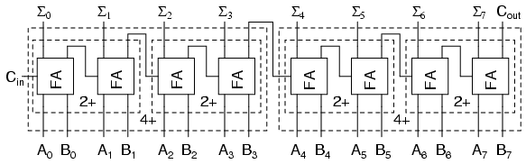

For the 1-bit full adder, the design begins by drawing the Truth Table for the three input and the corresponding output SUM and CARRY. The Boolean Expression describing the binary adder circuit is then deduced. The binary full adder is a three input combinational circuit which satisfies the truth table below.

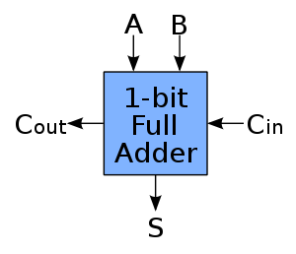

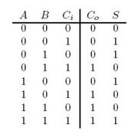

* A ripple carry adder is a logic circuit in which the carry-out of each full adder is the carry in of the succeeding next most significant full adder. It is called a ripple carry adder because each carry bit gets rippled into the next stage.
* In a ripple carry adder the sum and carry out bits of any half adder stage is not valid until the carry in of that stage occurs. Propagation delays inside the logic circuitry are the reason behind this.
* Propagation delay is time elapsed between the application of an input and occurrence of the corresponding output.
* The carry propagation delay is the time elapsed between the application of the carry in signal and the occurrence of the carry out (Cout) signal.
* The final result of the ripple carry adder is valid only after the joint propagation delays of all full adder circuits inside it.

1. **APPLICATIONS:**

* Multiple full adder circuits can be cascaded in parallel to add an N-bit number. For an N- bit parallel adder, there must be N number of full adder circuits.
* Ripple carry adder is faster than a serial adder.
* Easier to Implement.
* Flexible and can be extended by making easier modifications.

1. **SUBSYSTEM**

**INSTANCES:**

1. **Pmos:**



1. **Nmos:**



1. **NAND:**

The symbol is as follows:

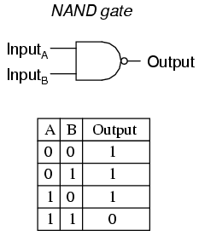

**Schematic:**



The layout is as shown below:



1. **FULL ADDER:**

The circuit diagram for the full adder using NAND gates implemented in this project is as shown below.

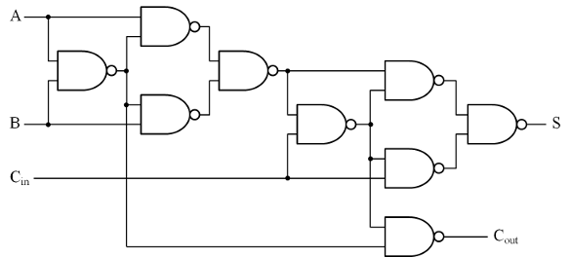

The layout diagram for the full adder is as follows:

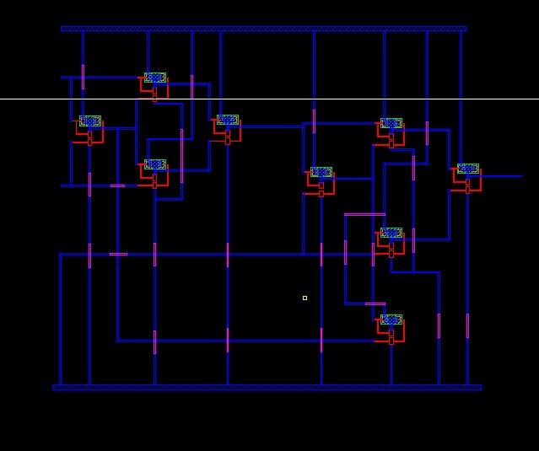

1. **OVERALL SYSTEM**
2. **Overall Operation**
   * First, we design the standard cells from the basic instances.
   * Add the newly-created standard cells to the main layout and wire them.
   * Vdd of all components need to be connected to each other, same goes for Gnd.
   * Do DRC to check the circuit.
   * If there is no error found, proceed to extract the layout. Get the Netlist using ADE L:
     + Setup – Simulator/Directory/Host, choose Spectre, OK
     + Setup – Model Libraries, select *ami06p.m* and *ami06n.m* in "Cadence/models/spectre"
     + Analysis – Choose…, trans, 200n, Moderate
     + Simulation – Netlist – Create
     + Get the SPICE code from Netlist: Use the RegEx ( **:1,$s/\\+/M/g** ) to omit the unwanted character in the Netlist. Call the ***lspect2ng*** command with the input is the Netlist file (after processed). Name the output. Rename the extension of the newly created file to *.cir.*Modify the SPICE code and simulate the circuit using LTSpice
3. The complete layout for the 8 bit ripple carry adder is as follows:

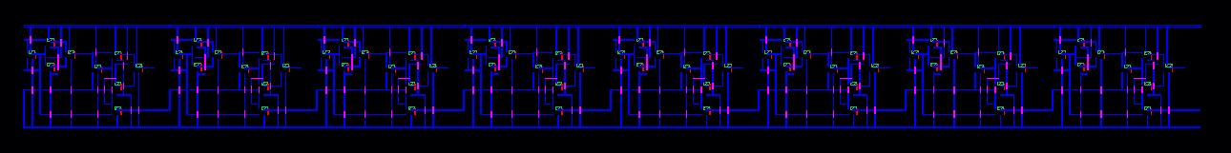

1. **The spice code:**

Look Ahead Carry Adder

v1 vdd 0 dc 5 ac 0

rgnd gnd 0 1e-6

vpulse2 a0 gnd pulse(0 0 10ns 1ns 1ns 30ns 100ns)

vpulse3 a1 gnd pulse(0 0 10ns 1ns 1ns 30ns 100ns)

vpulse4 a2 gnd pulse(0 0 10ns 1ns 1ns 30ns 100ns)

vpulse5 a3 gnd pulse(0 0 10ns 1ns 1ns 30ns 100ns)

vpulse6 a4 gnd pulse(0 0 10ns 1ns 1ns 30ns 100ns)

vpulse7 a5 gnd pulse(0 0 10ns 1ns 1ns 30ns 100ns)

vpulse8 a6 gnd pulse(0 0 10ns 1ns 1ns 30ns 100ns)

vpulse9 a7 gnd pulse(0 5 10ns 1ns 1ns 30ns 100ns)

vpulse10 b0 gnd pulse(0 0 10ns 1ns 1ns 30ns 100ns)

vpulse11 b1 gnd pulse(0 0 10ns 1ns 1ns 30ns 100ns)

vpulse12 b2 gnd pulse(0 0 10ns 1ns 1ns 30ns 100ns)

vpulse13 b3 gnd pulse(0 0 10ns 1ns 1ns 30ns 100ns)

vpulse14 b4 gnd pulse(0 0 10ns 1ns 1ns 30ns 100ns)

vpulse15 b5 gnd pulse(0 0 10ns 1ns 1ns 30ns 100ns)

vpulse16 b6 gnd pulse(0 0 10ns 1ns 1ns 30ns 100ns)

vpulse17 b7 gnd pulse(0 5 10ns 1ns 1ns 30ns 100ns)

m144 28 a0 vdd vdd ami06P w=1.5e-06 l=6e-07

m145 28 b0 vdd vdd ami06P w=1.5e-06 l=6e-07

m147 30 a0 vdd vdd ami06P w=1.5e-06 l=6e-07

m146 32 28 vdd vdd ami06P w=1.5e-06 l=6e-07

m149 30 28 vdd vdd ami06P w=1.5e-06 l=6e-07

m148 32 b0 vdd vdd ami06P w=1.5e-06 l=6e-07

m150 34 30 vdd vdd ami06P w=1.5e-06 l=6e-07

m151 34 32 vdd vdd ami06P w=1.5e-06 l=6e-07

m152 36 34 vdd vdd ami06P w=1.5e-06 l=6e-07

m153 36 gnd vdd vdd ami06P w=1.5e-06 l=6e-07

m156 38 34 vdd vdd ami06P w=1.5e-06 l=6e-07

m155 40 36 vdd vdd ami06P w=1.5e-06 l=6e-07

m154 42 36 vdd vdd ami06P w=1.5e-06 l=6e-07

m159 38 36 vdd vdd ami06P w=1.5e-06 l=6e-07

m158 40 gnd vdd vdd ami06P w=1.5e-06 l=6e-07

m157 42 28 vdd vdd ami06P w=1.5e-06 l=6e-07

m160 s0 38 vdd vdd ami06P w=1.5e-06 l=6e-07

m161 s0 40 vdd vdd ami06P w=1.5e-06 l=6e-07

m162 45 a1 vdd vdd ami06P w=1.5e-06 l=6e-07

m163 45 b1 vdd vdd ami06P w=1.5e-06 l=6e-07

m165 47 a1 vdd vdd ami06P w=1.5e-06 l=6e-07

m164 49 45 vdd vdd ami06P w=1.5e-06 l=6e-07

m167 47 45 vdd vdd ami06P w=1.5e-06 l=6e-07

m166 49 b1 vdd vdd ami06P w=1.5e-06 l=6e-07

m168 51 47 vdd vdd ami06P w=1.5e-06 l=6e-07

m169 51 49 vdd vdd ami06P w=1.5e-06 l=6e-07

m170 53 51 vdd vdd ami06P w=1.5e-06 l=6e-07

m171 53 42 vdd vdd ami06P w=1.5e-06 l=6e-07

m172 55 51 vdd vdd ami06P w=1.5e-06 l=6e-07

m174 57 53 vdd vdd ami06P w=1.5e-06 l=6e-07

m173 59 53 vdd vdd ami06P w=1.5e-06 l=6e-07

m177 55 53 vdd vdd ami06P w=1.5e-06 l=6e-07

m176 57 42 vdd vdd ami06P w=1.5e-06 l=6e-07

m175 59 45 vdd vdd ami06P w=1.5e-06 l=6e-07

m178 s1 55 vdd vdd ami06P w=1.5e-06 l=6e-07

m179 s1 57 vdd vdd ami06P w=1.5e-06 l=6e-07

m180 62 a2 vdd vdd ami06P w=1.5e-06 l=6e-07

m181 62 b2 vdd vdd ami06P w=1.5e-06 l=6e-07

m183 64 a2 vdd vdd ami06P w=1.5e-06 l=6e-07

m182 66 62 vdd vdd ami06P w=1.5e-06 l=6e-07

m185 64 62 vdd vdd ami06P w=1.5e-06 l=6e-07

m184 66 b2 vdd vdd ami06P w=1.5e-06 l=6e-07

m186 68 64 vdd vdd ami06P w=1.5e-06 l=6e-07

m187 68 66 vdd vdd ami06P w=1.5e-06 l=6e-07

m188 70 68 vdd vdd ami06P w=1.5e-06 l=6e-07

m189 70 59 vdd vdd ami06P w=1.5e-06 l=6e-07

m192 72 68 vdd vdd ami06P w=1.5e-06 l=6e-07

m191 74 70 vdd vdd ami06P w=1.5e-06 l=6e-07

m190 76 70 vdd vdd ami06P w=1.5e-06 l=6e-07

m194 72 70 vdd vdd ami06P w=1.5e-06 l=6e-07

m193 74 59 vdd vdd ami06P w=1.5e-06 l=6e-07

m195 76 62 vdd vdd ami06P w=1.5e-06 l=6e-07

m196 s2 72 vdd vdd ami06P w=1.5e-06 l=6e-07

m197 s2 74 vdd vdd ami06P w=1.5e-06 l=6e-07

m198 79 a3 vdd vdd ami06P w=1.5e-06 l=6e-07

m199 79 b3 vdd vdd ami06P w=1.5e-06 l=6e-07

m201 81 a3 vdd vdd ami06P w=1.5e-06 l=6e-07

m200 83 79 vdd vdd ami06P w=1.5e-06 l=6e-07

m203 81 79 vdd vdd ami06P w=1.5e-06 l=6e-07

m202 83 b3 vdd vdd ami06P w=1.5e-06 l=6e-07

m204 85 81 vdd vdd ami06P w=1.5e-06 l=6e-07

m205 85 83 vdd vdd ami06P w=1.5e-06 l=6e-07

m206 87 85 vdd vdd ami06P w=1.5e-06 l=6e-07

m207 87 76 vdd vdd ami06P w=1.5e-06 l=6e-07

m210 89 85 vdd vdd ami06P w=1.5e-06 l=6e-07

m209 91 87 vdd vdd ami06P w=1.5e-06 l=6e-07

m208 93 87 vdd vdd ami06P w=1.5e-06 l=6e-07

m213 89 87 vdd vdd ami06P w=1.5e-06 l=6e-07

m212 91 76 vdd vdd ami06P w=1.5e-06 l=6e-07

m211 93 79 vdd vdd ami06P w=1.5e-06 l=6e-07

m214 s3 89 vdd vdd ami06P w=1.5e-06 l=6e-07

m215 s3 91 vdd vdd ami06P w=1.5e-06 l=6e-07

m216 96 a4 vdd vdd ami06P w=1.5e-06 l=6e-07

m217 96 b4 vdd vdd ami06P w=1.5e-06 l=6e-07

m219 98 a4 vdd vdd ami06P w=1.5e-06 l=6e-07

m218 100 96 vdd vdd ami06P w=1.5e-06 l=6e-07

m221 98 96 vdd vdd ami06P w=1.5e-06 l=6e-07

m220 100 b4 vdd vdd ami06P w=1.5e-06 l=6e-07

m222 102 98 vdd vdd ami06P w=1.5e-06 l=6e-07

m223 102 100 vdd vdd ami06P w=1.5e-06 l=6e-07

m224 104 102 vdd vdd ami06P w=1.5e-06 l=6e-07

m225 104 93 vdd vdd ami06P w=1.5e-06 l=6e-07

m227 106 102 vdd vdd ami06P w=1.5e-06 l=6e-07

m226 108 104 vdd vdd ami06P w=1.5e-06 l=6e-07

m228 110 104 vdd vdd ami06P w=1.5e-06 l=6e-07

m231 106 104 vdd vdd ami06P w=1.5e-06 l=6e-07

m230 108 93 vdd vdd ami06P w=1.5e-06 l=6e-07

m229 110 96 vdd vdd ami06P w=1.5e-06 l=6e-07

m232 s4 106 vdd vdd ami06P w=1.5e-06 l=6e-07

m233 s4 108 vdd vdd ami06P w=1.5e-06 l=6e-07

m234 113 a5 vdd vdd ami06P w=1.5e-06 l=6e-07

m235 113 b5 vdd vdd ami06P w=1.5e-06 l=6e-07

m237 115 a5 vdd vdd ami06P w=1.5e-06 l=6e-07

m236 117 113 vdd vdd ami06P w=1.5e-06 l=6e-07

m238 115 113 vdd vdd ami06P w=1.5e-06 l=6e-07

m239 117 b5 vdd vdd ami06P w=1.5e-06 l=6e-07

m240 119 115 vdd vdd ami06P w=1.5e-06 l=6e-07

m241 119 117 vdd vdd ami06P w=1.5e-06 l=6e-07

m242 121 119 vdd vdd ami06P w=1.5e-06 l=6e-07

m243 121 110 vdd vdd ami06P w=1.5e-06 l=6e-07

m246 123 119 vdd vdd ami06P w=1.5e-06 l=6e-07

m245 125 121 vdd vdd ami06P w=1.5e-06 l=6e-07

m244 127 121 vdd vdd ami06P w=1.5e-06 l=6e-07

m249 123 121 vdd vdd ami06P w=1.5e-06 l=6e-07

m248 125 110 vdd vdd ami06P w=1.5e-06 l=6e-07

m247 127 113 vdd vdd ami06P w=1.5e-06 l=6e-07

m250 s5 123 vdd vdd ami06P w=1.5e-06 l=6e-07

m251 s5 125 vdd vdd ami06P w=1.5e-06 l=6e-07

m252 130 a6 vdd vdd ami06P w=1.5e-06 l=6e-07

m253 130 b6 vdd vdd ami06P w=1.5e-06 l=6e-07

m255 132 a6 vdd vdd ami06P w=1.5e-06 l=6e-07

m254 134 130 vdd vdd ami06P w=1.5e-06 l=6e-07

m257 132 130 vdd vdd ami06P w=1.5e-06 l=6e-07

m256 134 b6 vdd vdd ami06P w=1.5e-06 l=6e-07

m258 136 132 vdd vdd ami06P w=1.5e-06 l=6e-07

m259 136 134 vdd vdd ami06P w=1.5e-06 l=6e-07

m260 138 136 vdd vdd ami06P w=1.5e-06 l=6e-07

m261 138 127 vdd vdd ami06P w=1.5e-06 l=6e-07

m264 140 136 vdd vdd ami06P w=1.5e-06 l=6e-07

m263 142 138 vdd vdd ami06P w=1.5e-06 l=6e-07

m262 144 138 vdd vdd ami06P w=1.5e-06 l=6e-07

m267 140 138 vdd vdd ami06P w=1.5e-06 l=6e-07

m266 142 127 vdd vdd ami06P w=1.5e-06 l=6e-07

m265 144 130 vdd vdd ami06P w=1.5e-06 l=6e-07

m268 s6 140 vdd vdd ami06P w=1.5e-06 l=6e-07

m269 s6 142 vdd vdd ami06P w=1.5e-06 l=6e-07

m270 147 a7 vdd vdd ami06P w=1.5e-06 l=6e-07

m271 147 b7 vdd vdd ami06P w=1.5e-06 l=6e-07

m273 149 a7 vdd vdd ami06P w=1.5e-06 l=6e-07

m272 151 147 vdd vdd ami06P w=1.5e-06 l=6e-07

m275 149 147 vdd vdd ami06P w=1.5e-06 l=6e-07

m274 151 b7 vdd vdd ami06P w=1.5e-06 l=6e-07

m276 153 149 vdd vdd ami06P w=1.5e-06 l=6e-07

m277 153 151 vdd vdd ami06P w=1.5e-06 l=6e-07

m278 155 153 vdd vdd ami06P w=1.5e-06 l=6e-07

m279 155 144 vdd vdd ami06P w=1.5e-06 l=6e-07

m282 157 153 vdd vdd ami06P w=1.5e-06 l=6e-07

m281 159 155 vdd vdd ami06P w=1.5e-06 l=6e-07

m280 cout 155 vdd vdd ami06P w=1.5e-06 l=6e-07

m285 157 155 vdd vdd ami06P w=1.5e-06 l=6e-07

m284 159 144 vdd vdd ami06P w=1.5e-06 l=6e-07

m283 cout 147 vdd vdd ami06P w=1.5e-06 l=6e-07

m286 s7 157 vdd vdd ami06P w=1.5e-06 l=6e-07

m287 s7 159 vdd vdd ami06P w=1.5e-06 l=6e-07

m1 29 a0 28 gnd ami06N w=1.5e-06 l=6e-07

m0 gnd b0 29 gnd ami06N w=1.5e-06 l=6e-07

m5 31 a0 30 gnd ami06N w=1.5e-06 l=6e-07

m4 gnd 28 31 gnd ami06N w=1.5e-06 l=6e-07

m3 33 28 32 gnd ami06N w=1.5e-06 l=6e-07

m2 gnd b0 33 gnd ami06N w=1.5e-06 l=6e-07

m7 35 30 34 gnd ami06N w=1.5e-06 l=6e-07

m6 gnd 32 35 gnd ami06N w=1.5e-06 l=6e-07

m9 37 34 36 gnd ami06N w=1.5e-06 l=6e-07

m8 gnd gnd 37 gnd ami06N w=1.5e-06 l=6e-07

m15 39 34 38 gnd ami06N w=1.5e-06 l=6e-07

m14 gnd 36 39 gnd ami06N w=1.5e-06 l=6e-07

m13 41 36 40 gnd ami06N w=1.5e-06 l=6e-07

m12 gnd gnd 41 gnd ami06N w=1.5e-06 l=6e-07

m11 43 36 42 gnd ami06N w=1.5e-06 l=6e-07

m10 gnd 28 43 gnd ami06N w=1.5e-06 l=6e-07

m16 44 38 s0 gnd ami06N w=1.5e-06 l=6e-07

m17 gnd 40 44 gnd ami06N w=1.5e-06 l=6e-07

m19 46 a1 45 gnd ami06N w=1.5e-06 l=6e-07

m18 gnd b1 46 gnd ami06N w=1.5e-06 l=6e-07

m23 48 a1 47 gnd ami06N w=1.5e-06 l=6e-07

m22 gnd 45 48 gnd ami06N w=1.5e-06 l=6e-07

m21 50 45 49 gnd ami06N w=1.5e-06 l=6e-07

m20 gnd b1 50 gnd ami06N w=1.5e-06 l=6e-07

m25 52 47 51 gnd ami06N w=1.5e-06 l=6e-07

m24 gnd 49 52 gnd ami06N w=1.5e-06 l=6e-07

m27 54 51 53 gnd ami06N w=1.5e-06 l=6e-07

m26 gnd 42 54 gnd ami06N w=1.5e-06 l=6e-07

m33 56 51 55 gnd ami06N w=1.5e-06 l=6e-07

m32 gnd 53 56 gnd ami06N w=1.5e-06 l=6e-07

m31 58 53 57 gnd ami06N w=1.5e-06 l=6e-07

m30 gnd 42 58 gnd ami06N w=1.5e-06 l=6e-07

m29 60 53 59 gnd ami06N w=1.5e-06 l=6e-07

m28 gnd 45 60 gnd ami06N w=1.5e-06 l=6e-07

m35 61 55 s1 gnd ami06N w=1.5e-06 l=6e-07

m34 gnd 57 61 gnd ami06N w=1.5e-06 l=6e-07

m37 63 a2 62 gnd ami06N w=1.5e-06 l=6e-07

m36 gnd b2 63 gnd ami06N w=1.5e-06 l=6e-07

m38 65 a2 64 gnd ami06N w=1.5e-06 l=6e-07

m41 gnd 62 65 gnd ami06N w=1.5e-06 l=6e-07

m40 67 62 66 gnd ami06N w=1.5e-06 l=6e-07

m39 gnd b2 67 gnd ami06N w=1.5e-06 l=6e-07

m43 69 64 68 gnd ami06N w=1.5e-06 l=6e-07

m42 gnd 66 69 gnd ami06N w=1.5e-06 l=6e-07

m45 71 68 70 gnd ami06N w=1.5e-06 l=6e-07

m44 gnd 59 71 gnd ami06N w=1.5e-06 l=6e-07

m49 73 68 72 gnd ami06N w=1.5e-06 l=6e-07

m48 gnd 70 73 gnd ami06N w=1.5e-06 l=6e-07

m47 75 70 74 gnd ami06N w=1.5e-06 l=6e-07

m46 gnd 59 75 gnd ami06N w=1.5e-06 l=6e-07

m51 77 70 76 gnd ami06N w=1.5e-06 l=6e-07

m50 gnd 62 77 gnd ami06N w=1.5e-06 l=6e-07

m53 78 72 s2 gnd ami06N w=1.5e-06 l=6e-07

m52 gnd 74 78 gnd ami06N w=1.5e-06 l=6e-07

m55 80 a3 79 gnd ami06N w=1.5e-06 l=6e-07

m54 gnd b3 80 gnd ami06N w=1.5e-06 l=6e-07

m59 82 a3 81 gnd ami06N w=1.5e-06 l=6e-07

m58 gnd 79 82 gnd ami06N w=1.5e-06 l=6e-07

m57 84 79 83 gnd ami06N w=1.5e-06 l=6e-07

m56 gnd b3 84 gnd ami06N w=1.5e-06 l=6e-07

m60 86 81 85 gnd ami06N w=1.5e-06 l=6e-07

m61 gnd 83 86 gnd ami06N w=1.5e-06 l=6e-07

m63 88 85 87 gnd ami06N w=1.5e-06 l=6e-07

m62 gnd 76 88 gnd ami06N w=1.5e-06 l=6e-07

m69 90 85 89 gnd ami06N w=1.5e-06 l=6e-07

m68 gnd 87 90 gnd ami06N w=1.5e-06 l=6e-07

m67 92 87 91 gnd ami06N w=1.5e-06 l=6e-07

m66 gnd 76 92 gnd ami06N w=1.5e-06 l=6e-07

m65 94 87 93 gnd ami06N w=1.5e-06 l=6e-07

m64 gnd 79 94 gnd ami06N w=1.5e-06 l=6e-07

m71 95 89 s3 gnd ami06N w=1.5e-06 l=6e-07

m70 gnd 91 95 gnd ami06N w=1.5e-06 l=6e-07

m73 97 a4 96 gnd ami06N w=1.5e-06 l=6e-07

m72 gnd b4 97 gnd ami06N w=1.5e-06 l=6e-07

m77 99 a4 98 gnd ami06N w=1.5e-06 l=6e-07

m76 gnd 96 99 gnd ami06N w=1.5e-06 l=6e-07

m75 101 96 100 gnd ami06N w=1.5e-06 l=6e-07

m74 gnd b4 101 gnd ami06N w=1.5e-06 l=6e-07

m79 103 98 102 gnd ami06N w=1.5e-06 l=6e-07

m78 gnd 100 103 gnd ami06N w=1.5e-06 l=6e-07

m81 105 102 104 gnd ami06N w=1.5e-06 l=6e-07

m80 gnd 93 105 gnd ami06N w=1.5e-06 l=6e-07

m82 107 102 106 gnd ami06N w=1.5e-06 l=6e-07

m87 gnd 104 107 gnd ami06N w=1.5e-06 l=6e-07

m86 109 104 108 gnd ami06N w=1.5e-06 l=6e-07

m85 gnd 93 109 gnd ami06N w=1.5e-06 l=6e-07

m84 111 104 110 gnd ami06N w=1.5e-06 l=6e-07

m83 gnd 96 111 gnd ami06N w=1.5e-06 l=6e-07

m89 112 106 s4 gnd ami06N w=1.5e-06 l=6e-07

m88 gnd 108 112 gnd ami06N w=1.5e-06 l=6e-07

m91 114 a5 113 gnd ami06N w=1.5e-06 l=6e-07

m90 gnd b5 114 gnd ami06N w=1.5e-06 l=6e-07

m93 116 a5 115 gnd ami06N w=1.5e-06 l=6e-07

m92 gnd 113 116 gnd ami06N w=1.5e-06 l=6e-07

m95 118 113 117 gnd ami06N w=1.5e-06 l=6e-07

m94 gnd b5 118 gnd ami06N w=1.5e-06 l=6e-07

m97 120 115 119 gnd ami06N w=1.5e-06 l=6e-07

m96 gnd 117 120 gnd ami06N w=1.5e-06 l=6e-07

m99 122 119 121 gnd ami06N w=1.5e-06 l=6e-07

m98 gnd 110 122 gnd ami06N w=1.5e-06 l=6e-07

m104 124 119 123 gnd ami06N w=1.5e-06 l=6e-07

m103 gnd 121 124 gnd ami06N w=1.5e-06 l=6e-07

m102 126 121 125 gnd ami06N w=1.5e-06 l=6e-07

m101 gnd 110 126 gnd ami06N w=1.5e-06 l=6e-07

m100 128 121 127 gnd ami06N w=1.5e-06 l=6e-07

m105 gnd 113 128 gnd ami06N w=1.5e-06 l=6e-07

m107 129 123 s5 gnd ami06N w=1.5e-06 l=6e-07

m106 gnd 125 129 gnd ami06N w=1.5e-06 l=6e-07

m109 131 a6 130 gnd ami06N w=1.5e-06 l=6e-07

m108 gnd b6 131 gnd ami06N w=1.5e-06 l=6e-07

m113 133 a6 132 gnd ami06N w=1.5e-06 l=6e-07

m112 gnd 130 133 gnd ami06N w=1.5e-06 l=6e-07

m111 135 130 134 gnd ami06N w=1.5e-06 l=6e-07

m110 gnd b6 135 gnd ami06N w=1.5e-06 l=6e-07

m115 137 132 136 gnd ami06N w=1.5e-06 l=6e-07

m114 gnd 134 137 gnd ami06N w=1.5e-06 l=6e-07

m117 139 136 138 gnd ami06N w=1.5e-06 l=6e-07

m116 gnd 127 139 gnd ami06N w=1.5e-06 l=6e-07

m123 141 136 140 gnd ami06N w=1.5e-06 l=6e-07

m122 gnd 138 141 gnd ami06N w=1.5e-06 l=6e-07

m121 143 138 142 gnd ami06N w=1.5e-06 l=6e-07

m120 gnd 127 143 gnd ami06N w=1.5e-06 l=6e-07

m119 145 138 144 gnd ami06N w=1.5e-06 l=6e-07

m118 gnd 130 145 gnd ami06N w=1.5e-06 l=6e-07

m125 146 140 s6 gnd ami06N w=1.5e-06 l=6e-07

m124 gnd 142 146 gnd ami06N w=1.5e-06 l=6e-07

m126 148 a7 147 gnd ami06N w=1.5e-06 l=6e-07

m127 gnd b7 148 gnd ami06N w=1.5e-06 l=6e-07

m131 150 a7 149 gnd ami06N w=1.5e-06 l=6e-07

m130 gnd 147 150 gnd ami06N w=1.5e-06 l=6e-07

m129 152 147 151 gnd ami06N w=1.5e-06 l=6e-07

m128 gnd b7 152 gnd ami06N w=1.5e-06 l=6e-07

m133 154 149 153 gnd ami06N w=1.5e-06 l=6e-07

m132 gnd 151 154 gnd ami06N w=1.5e-06 l=6e-07

m135 156 153 155 gnd ami06N w=1.5e-06 l=6e-07

m134 gnd 144 156 gnd ami06N w=1.5e-06 l=6e-07

m137 158 153 157 gnd ami06N w=1.5e-06 l=6e-07

m136 gnd 155 158 gnd ami06N w=1.5e-06 l=6e-07

m141 160 155 159 gnd ami06N w=1.5e-06 l=6e-07

m140 gnd 144 160 gnd ami06N w=1.5e-06 l=6e-07

m139 161 155 cout gnd ami06N w=1.5e-06 l=6e-07

m138 gnd 147 161 gnd ami06N w=1.5e-06 l=6e-07

m143 162 157 s7 gnd ami06N w=1.5e-06 l=6e-07

m142 gnd 159 162 gnd ami06N w=1.5e-06 l=6e-07

.tran 1ns 400n

.model ami06N nmos(vto=0.6 kp=110e-6 cgdo=1e-12 cgso=1e-12 cgbo=1e-12)

.model ami06P pmos(vto=-1.0 kp=50e-6 cgdo=1e-12 cgso=1e-12 cgbo=1e-12)

.print dc v(s0)

.print dc v(s1)

.print dc v(s2)

.print dc v(s3)

.print dc v(s4)

.print dc v(s5)

.print dc v(s6)

.print dc v(s7)

.print dc v(cout)

.print dc v(a7)

.print dc v(b7)

.plot dc v(b7)

.plot dc v(a7)

.print dc v(vdd)

.end

1. **SIMULATION RESULT:**

The simulation waveform on LTSpice looks as shown below:

Input a: up to 20 ns A=00000001

20 ns to 50 ns A=00001001

50 to 100ns A=10101010

The input A waveform is as shown in the figure.

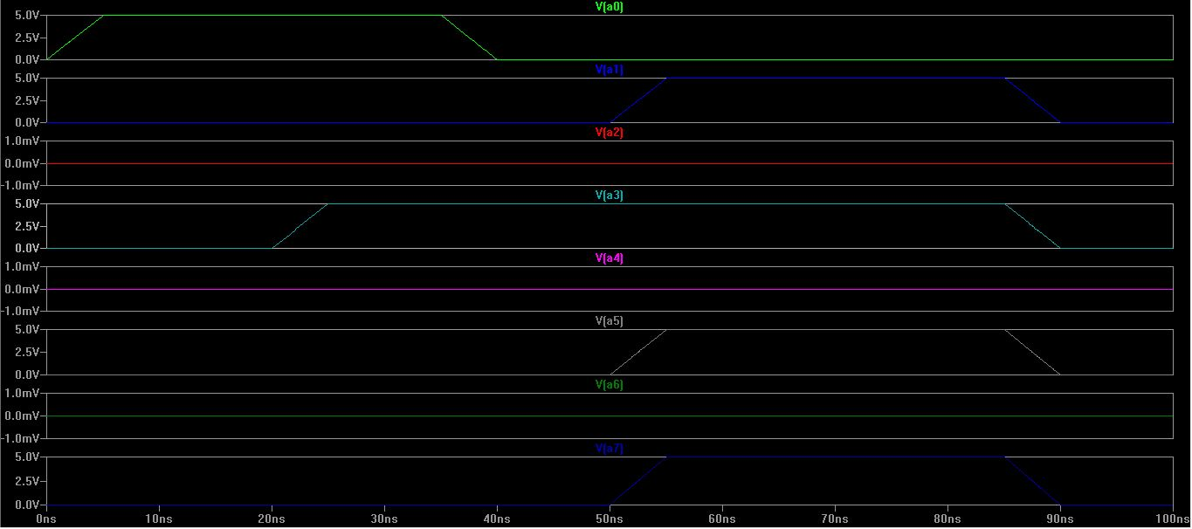

Input B: up to 20 ns B=00000001

20 ns to 50 ns B=00000001

50 to 100ns B=10110000

The input B waveform is as shown in the figure.

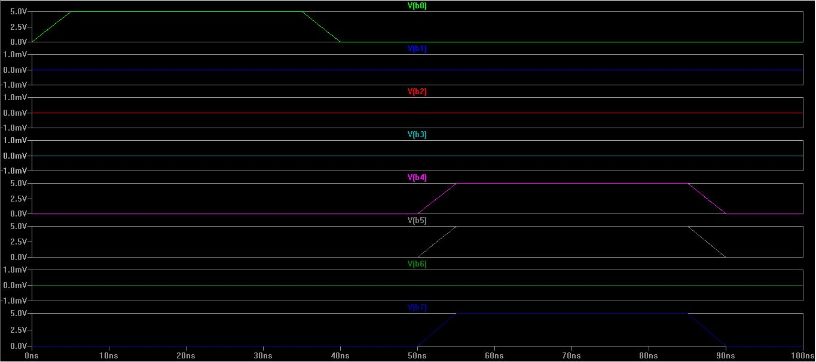

The output is as shown below,

The output is given as S and the carry out is Cout.

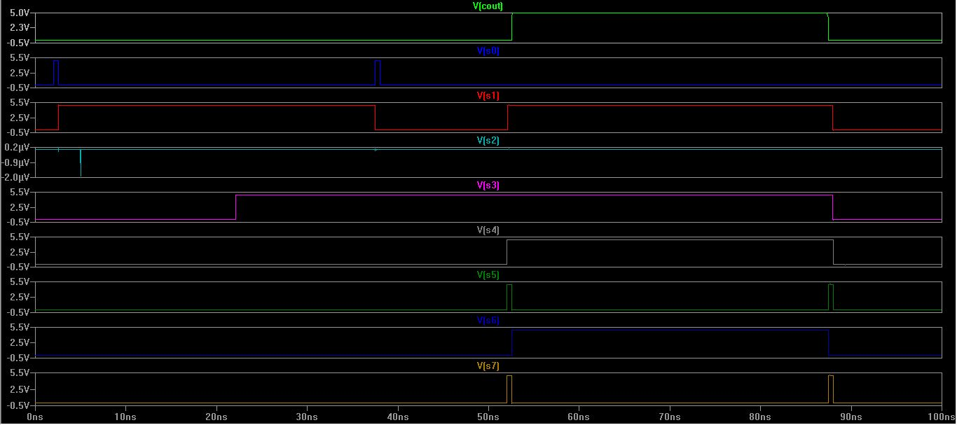

From the Waveform we can know that the output is:

0-20ns S=00000010, Cout=0

20-50ns S=00001010, Cout=0

50-100ns S=01011010, Cout=1

**Verification:**

0-20ns

00000001+00000001=000000010

20-50ns

00001001+00000001=00001010

50-100ns

10101010+10110000=01011010, Carry = 1

1. **CONCLUSION:**

Hence the design of 8 bit ripple carry adder was successfully implemented and verified using LT SPICE.