**Project Report**

**Predicting Profit Using Regression Models**

**1. ABSTRACT**

This project aims to predict a company's profit based on R&D Spend, Administration Cost, and Marketing Spend using various regression models. We implemented multiple machine learning techniques, including Linear Regression, Decision Tree Regression, Random Forest Regression, and Support Vector Regression, to identify the most effective model for this task. We evaluated these models based on their performance metrics, such as Mean Squared Error (MSE) and R-squared (R²). Our study demonstrates that Random Forest Regression, with its ensemble approach, provides a reliable and robust prediction for profit estimation in startups.

**2. Table of Contents**

1. Abstract
2. Table of Contents
3. Introduction
4. Existing Method
5. Proposed Method with Architecture
6. Methodology
7. Implementation
8. Evaluation
9. Conclusion
10. References

**3. Introduction**

In today's competitive business environment, predicting a company's profitability is crucial for making strategic decisions. Various factors, such as R&D Spend, Administration Costs, and Marketing Spend, significantly influence a company's profit. The main goal of this project is to develop a regression model that accurately predicts profit based on these variables. By leveraging machine learning algorithms, we aim to provide a reliable solution that helps stakeholders optimize their investments.

**3.1 Problem Statement**

The challenge is to predict the profit of a company based on the expenditures on R&D, Administration, and Marketing. This involves building a regression model that can generalize well to unseen data and provide accurate predictions.

**3.2 Objectives**

* To explore the relationship between R&D Spend, Administration Cost, and Marketing Spend with the company's profit.
* To build and compare multiple regression models for profit prediction.
* To identify the best-performing model based on evaluation metrics.

**4. Existing Method**

The traditional approach for predicting company profit often involves manual analysis using basic statistical methods. This manual process lacks precision and cannot effectively handle large datasets or complex relationships between variables. Existing methods typically involve:

* **Descriptive Statistics**: Analysis of historical data using mean, median, and variance.
* **Simple Linear Regression**: Using a single independent variable (e.g., Marketing Spend) to predict profit, which may not capture the multifactorial nature of business profits.
* **Basic Multivariate Regression**: Limited in handling non-linear relationships and complex interactions between input variables.

These approaches often fail to account for complex, non-linear relationships, leading to inaccurate predictions.

**5. Proposed Method with Architecture**

**5.1 Proposed Method**

Our proposed solution leverages advanced regression techniques, including:

1. **Linear Regression**: A baseline model to understand the linear relationship between features and profit.
2. **Decision Tree Regression**: Captures non-linear relationships and interactions between features.
3. **Random Forest Regression**: An ensemble method that improves prediction accuracy and reduces overfitting by averaging multiple decision trees.
4. **Support Vector Regression (SVR)**: Utilizes kernel functions to capture complex relationships in the data.

**5.2 System Architecture**

+---------------------------+

| Input Data |

+---------------------------+

|

v

+--------------------------------------+

| Exploratory Data Analysis (EDA) |

+--------------------------------------+

|

v

+--------------------------------------+

| Data Preprocessing and Feature Selection |

+--------------------------------------+

|

v

+----------------------------------+

| Train-Test Split (80% - 20%) |

+----------------------------------+

| | | |

v v v v

+------------------+ +--------------------+ +--------------------+ +-------------------+

| Linear Regression| | Decision Tree | | Random Forest | | Support Vector |

| Model | | Regression Model | | Regression Model | | Regression Model |

+------------------+ +--------------------+ +--------------------+ +-------------------+

| | | |

v v v v

+--------------------------------------------------------------+

| Model Evaluation and Comparison |

+--------------------------------------------------------------+

|

v

+-------------------------------+

| Best Model Selection |

+-------------------------------+

|

v

+---------------------------+

| Prediction |

|  |
| --- |
|  |

**6. Methodology**

**6.1 Data Collection**

We used a dataset called 50_Startups.csv, which contains information about R&D Spend, Administration Cost, Marketing Spend, and Profit for 50 startups.

**6.2 Data Preprocessing**

* **Handling Missing Values**: Checked for null values and handled them appropriately.
* **Exploratory Data Analysis (EDA)**: Conducted EDA to understand the distribution and relationships between variables using pair plots and heatmaps.
* **Feature Selection**: Selected R&D Spend, Administration, and Marketing Spend as the predictor variables (X) and Profit as the target variable (y).

**6.3 Model Selection**

We chose four different regression models to compare their performance:

1. **Linear Regression**
2. **Decision Tree Regression**
3. **Random Forest Regression**
4. **Support Vector Regression (SVR)**

**7. Implementation**

**7.1 Data Preparation**

Python 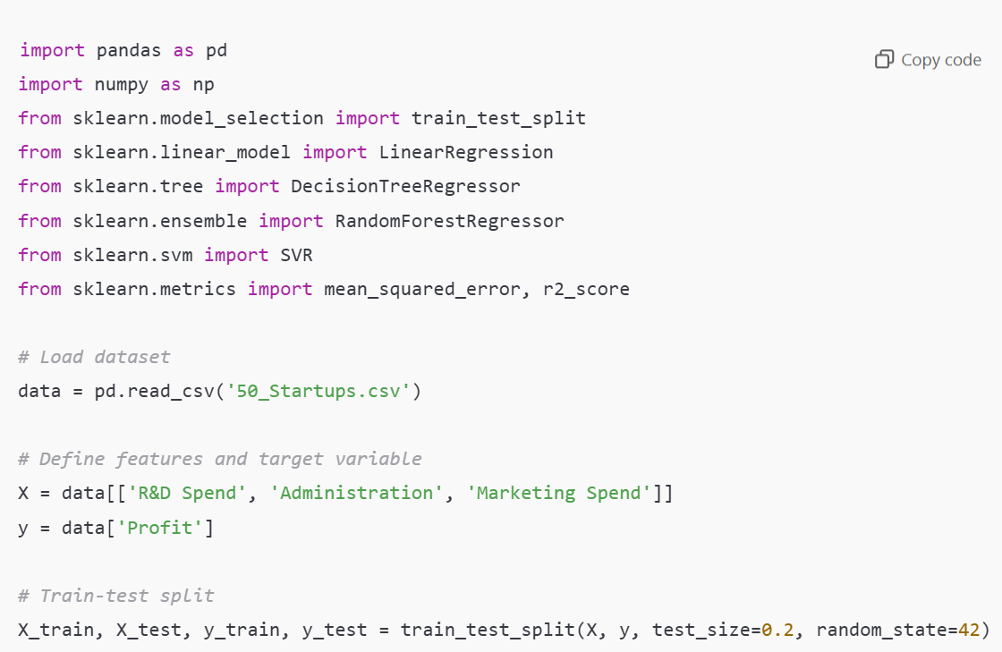

**7.2 Model Training**

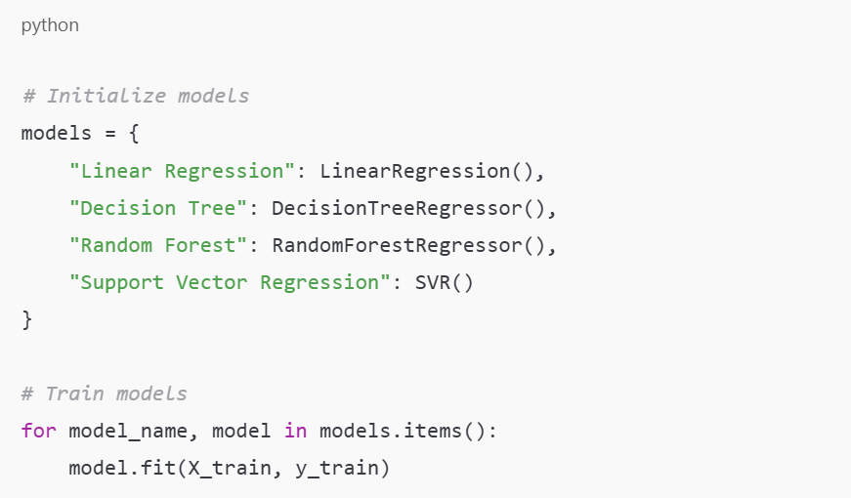

**7.3 Predictions and Evaluation**

python

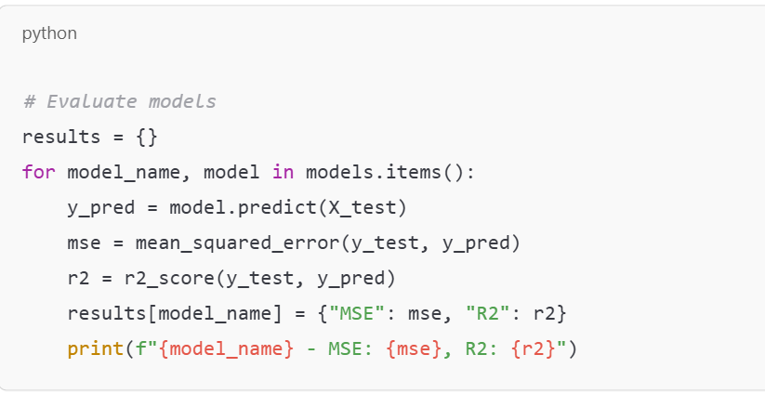

**8. Evaluation**

The evaluation results showed that:

* **Linear Regression**: Struggled with capturing non-linear relationships.
* **Decision Tree**: Performed better but was prone to overfitting on training data.
* **Random Forest**: Achieved the highest R² score, indicating better generalization.
* **Support Vector Regression**: Required feature scaling and performed comparably well.

Based on the MSE and R² values, **Random Forest Regression** emerged as the most reliable model for predicting profit.

**9. Conclusion**

This project demonstrated the effectiveness of machine learning models in predicting company profit based on R&D, Administration, and Marketing expenditures. The Random Forest Regression model provided the best performance, highlighting its capability to handle complex and non-linear relationships in the data. Future work may involve further tuning of hyperparameters, expanding the dataset, and exploring additional features like market conditions and competition analysis to enhance model performance.

**10. References**

* Scikit-learn Documentation: [https://scikit-learn.org](https://scikit-learn.org/)
* Kaggle Dataset: 50_Startups Dataset

This concludes the project report on predicting profit using regression analysis.