|  |  |  |
| --- | --- | --- |
| SR.NO | PRACTICAL NAME | PAGE NO |
| 1. | TO STUDY GUI BASED WEB DESIGN AND AN IMPORTANCE OF IT | 1 |
| 2. | PROTOTYPE OF A WEBSITE WITH A PPT | 2 |
| 3. | TO DESIGN A TIME-TABLE FOR FY BTECH USING HTML TAGS | 3 |
| 4. | TO STUDY DIFFERENCE BETWEEN HTML AND HTML 5 TAGS | 4 |
|  |  |  |
|  |  |  |
|  |  |  |

**PRACTICAL-1**

AIM: TO STUDY GUI BASED WEB DESIGN AND AN IMPORTANCE OF IT

* IMPORTANCE OF GUI IN WEB DESIN?

ANS: 1. ACQUISITION OF NEW CUSTOMERS.

2. INCREASED CUSTOMER ENGAGEMENT AND RETENTION.

3. LOWER DEVELOPMENT COST.

4. INCREASED PRODUCTIVITY.

5. LOWER CUSTOMER SUPPORT COSTS.

* WHAT PROCESs, PROTOTYPE, PRODUCT?

ANS: ONE OF THE BEST WAYS TO GAIN INSIGHTS INA DESIGN THINKING PROCESS IS TO CARRY OUT SOME FORM OF PROTOTYPING. THIS METHOD INVOLVES PRODUCING AN EARLY,INEXPENSIVE,AND SCALED DOWN VERSION OF THE PRODUCT IN ORDER TO REVEAL ANY PROBLEMS WITH THE CURRENT DESIGN.

4 WAYS TO CREATE A PROTOTYPE:

1.CREATE A CONCEPT SKETCH.

2.DEVELOP A VIRTUAL PROTOTYPE.

3.BUILD A PHYSICAL PROTOTYPE.

4.LOCATE A MANUFACTURE.

* WHAT ARE THE BENEFITS OF CREATING A PROTOTYPE?

ANS: 1. BRINGING THE USER INTERFACE DESIGN TO LIFE.

2. ALLOWING USER TO PROVIDE VALUABLE FEEDBACK.

3. HELPING REDUCE OVERALL DEVELOPMENT TIME.

4. ACTING AS A USEFUL REFERENCE TOOL FOR DEVELOPERS.

5. CONFIRMING A COMMON VISION AMONG USERS AND STAKEHOLDERS.

* WHAT ARE THE APPLICATION ORIENTED ADVANTAGES OF A GOOD GUI?

ANS: 1. EASINESS FOR NON-TECHNICAL PEOPLE.

2. DRAG AND DROP FEATURE.

3. IT LOOKS NICER THAN TEXT INTERFACE.

4. USER- FRIENDLY.

**PRACTICAL-2**

AIM: PROTOTYPE OF A WEBSITE WITH A PPT

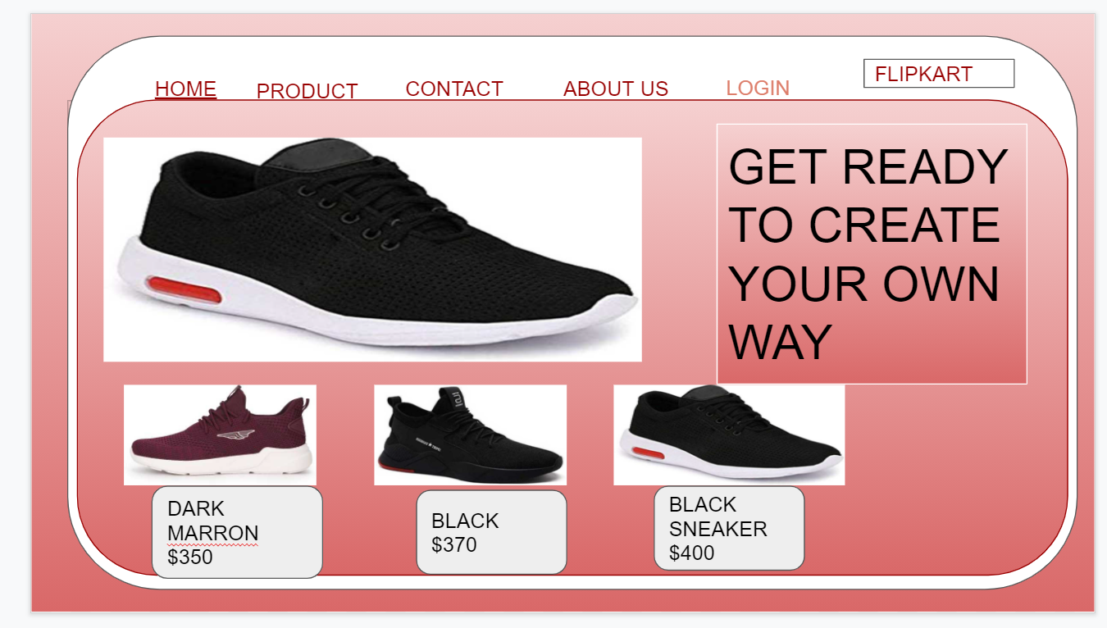

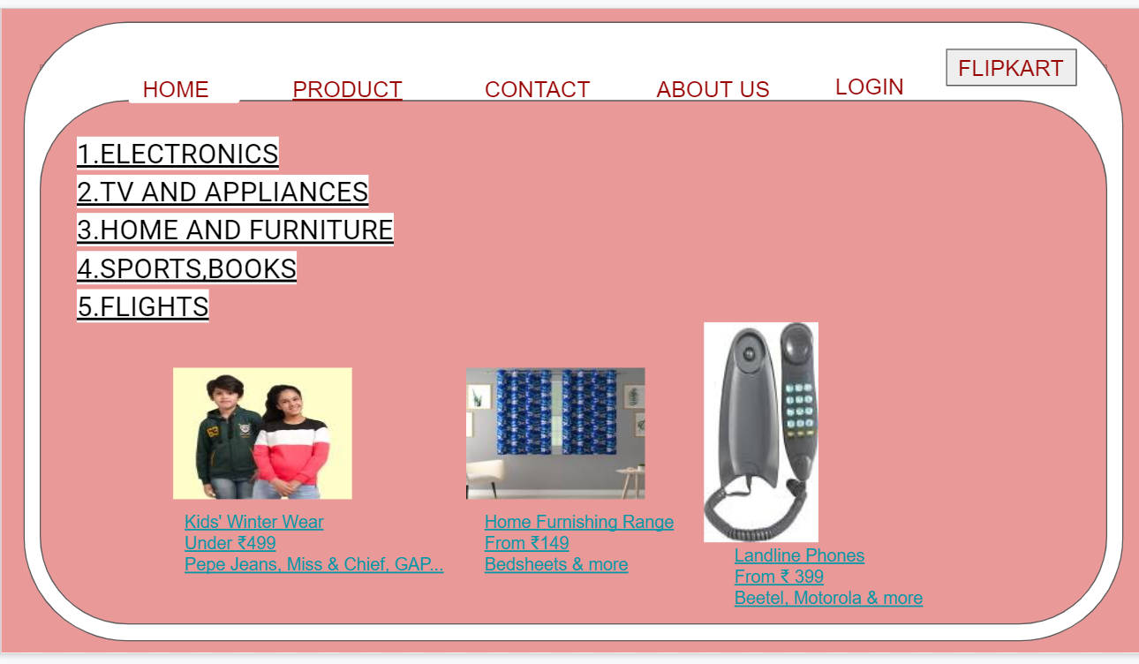

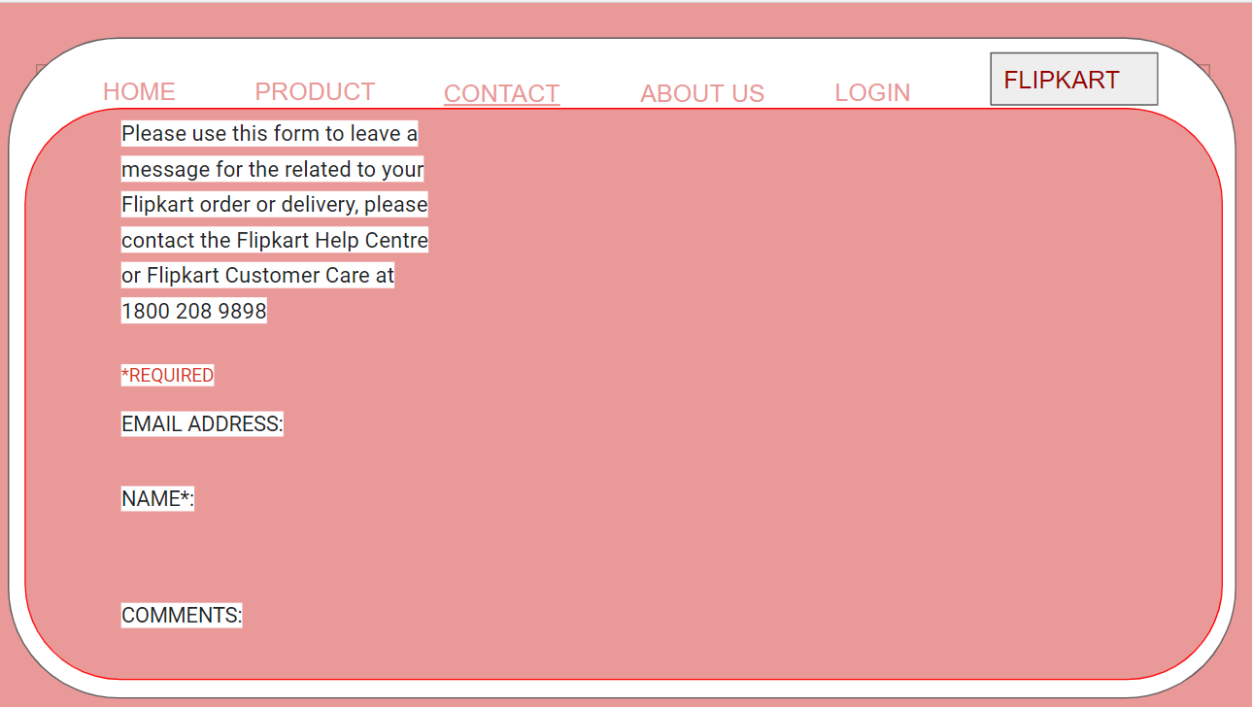

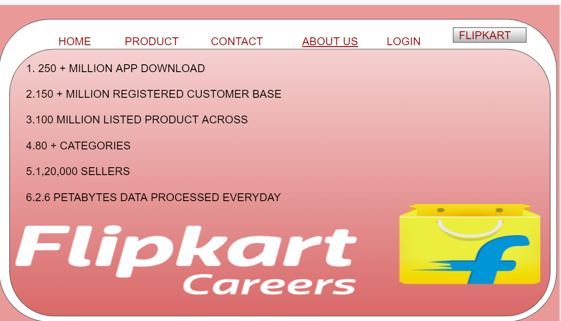

**PRACTICAL-3**

AIM: TO DESIGN A TIME-TABLE FOR FY BTECH USING HTML TAGS

## MY COLLEGE TIME TABLE

|  |  |  |  |  |  |
| --- | --- | --- | --- | --- | --- |
| **DURATION** | **MONDAY** | **TUESDAY** | **WEDNESDAY** | **THURSDAY** | **FRIDAY** |
| 9:00 to 10:00 |  | PHY-B1,B2-(AJ) | DOCUMENTARY HOUR |  | CPU |
| 10:00 to 11:00 | EM-(DRD)-502 | PHY-B1,B2-(AJ) | EM-(DRD)-502 | BEE(KB)502 | BEE(NP)-502 |
| 11:00 to 12:00 | CPU(PV)-502 | LIBRARY | BEE(KB)502 | EM(SB)511 | PHY(PG)502 |
| 12:00 to 1:00 | LUNCH | LUNCH | LUNCH | LUNCH | LUNCH |
| 1:00 to 2:00 | PHY-(PG)-502 | WORKSHOP-B1 | CPU LAB-B1,B2(VG) |  | LIBRARY |
| 2:00 to 3:00 | BEE LAB (NP,NS)-B2 CPU-B1(VG) | WORKSHOP-B1 | CPU LAB-B1,B2(VG) | WORKSHOP-B2(HP) BEE LAB-B1 | CPU-B2(VG) |
| 3:00 to 4:00 | BEE LAB (NP,NS)-B2 CPU-B1(VG) | WORKSHOP-B1(RS) | GUI LAB(JM)B1,B2 | WORKSHOP-B2(HP) BEE LAB-B1 | CPU-B2(VG) |
| 4:00 to 5:00 | GUI(SV)) | GUI(SV) | GUI LAB-B1,B2(JM) | CLUB ACTIVITY | MENTOR MEET |

**PRACTICAL-4**

AIM: TO STUDY DIFFERENCE BETWEEN HTML AND HTML 5 TAGS

|  |  |
| --- | --- |
| HTML | HTML 5 |
| * Does not allow JavaScript to run in browser. | * Allows JavaScript to run in background. This is possible due to JS Web worker API in HTML5. |
| * It does not allow drag and drop effects. | * It allows drag and drop effects. |
| * Not possible to draw shapes like circle, rectangle, triangle etc. | * HTML5 allows to draw shapes like circle, rectangle, triangle etc. |
| * It works with all old browsers. | * It supported by all new browser like Firefox, Mozilla, Chrome, Safari, etc. |
| * Older version of HTML are less mobile-friendly. | * HTML5 language is more mobile-friendly |
| * Elements like nav, header were not present. | * New element for web structure like nav, header, footer etc. |
| * Doctype declaration is too long and complicated. | * Doctype declaration is quite simple and easy. |

HTML 5 TAGS WITH SYNTAX:

* <article>

Syntax:<article>

<h1>introduction to html5</h1>

</article>

* <aside>

Syntax: <aside>

<h1>Apollo 13 Facts</h1>

<p>Apollo 13 was the seventh manned mission</p>

</aside>