**5th Sem Mini Project Report on**



**Brain Tumor Detection and Classification**



**Submitted in partial fulfillment of the requirement for the award of the degree of**

**BACHELOR OF TECHNOLOGY**

**IN**

**COMPUTER SCIENCE & ENGINEERING**

**Submitted by:**

**Student Name: Aditya Sirohi**  **University Roll No. 2021641**

***Under the Mentorship of***

**Mrs. Sarishma Dangi**



**Department of Computer Science and Engineering**

**Graphic Era (Deemed to be University)**

**Dehradun, Uttarakhand**

**July-2024**



**CANDIDATE’S DECLARATION**

I hereby certify that the work which is being presented in the project report entitled **“Brain Tumor Detection and Classification using PSO”** in partial fulfillment of the requirements for the award of the Degree of Bachelor of Technology in Computer Science and Engineeringof the Graphic Era (Deemed to be University), Dehradun shall be carried out by the under the mentorship of Mrs. Sarishma Dangi, Department of Computer Science and Engineering, Graphic Era (Deemed to be University), Dehradun.

Name : Aditya Sirohi University Roll no. : 2021641

The above mentioned student shall be working under the supervision of the undersigned on the **“Brain Tumor Detection and Classification using PSO”**

Mentor Sign:

**Table of Contents**

|  |  |  |
| --- | --- | --- |
| **Chapter No.** | **Description** | **Page No.** |
| Chapter 1 | Introduction and Problem Statement | 1-3 |
| Chapter 2 | Literature Survey | 4-7 |
| Chapter 3 | Methodology | 8 - 11 |
| Chapter 4 | Project Work Carried Out | 12-13 |
| Chapter 5 | Results and Discussion | 14-16 |
| Chapter 6 | Conclusion and Future Work | 17-18 |
|  | References |  |

**Chapter 1**

**Introduction**

* 1. **Introduction**

Detecting brain tumors early is crucial for timely intervention. Traditionally, brain tumors are identified through invasive biopsies, involving surgery. However, computational intelligence techniques can aid in non-invasive identification and classification. Using magnetic resonance imaging (MRI), these methods assist physicians in accurately detecting gliomas, meningiomas, and pituitary tumors, as well as distinguishing healthy brains without tumors. This approach aims to achieve high accuracy in early-stage tumor detection, facilitating prompt medical treatment.

* Different types of Brain Tumors are :
* Glioma
* Meningioma
* Pituitary

**Glioma :**

Gliomas are a type of brain tumor that originate from glial cells. These cells serve several essential functions within the central nervous system:

* Supporting the structural framework of the central nervous system.
* Providing nourishment to neurons.
* Assisting in the removal of cellular waste.

Gliomas can occur in various parts of the brain and can be classified into different types based on their specific characteristics and the type of glial cell they originate from.

**Meningioma :**

A meningioma is a tumor that originates from the meninges, the membranes surrounding the brain and spinal cord. While not originating in the brain tissue itself, meningiomas can exert pressure on nearby brain tissue, nerves, and blood vessels. They are the most frequent type of tumor found in the head.

Most meningioma cells grow slowly, often taking years to produce symptoms. However, their impact on closeby brain tissue, nerves, or blood vessels can sometimes lead to significant disability.

Meningiomas are more frequently diagnosed in women and are typically found in older adults, though they can occur at any age.

Due to their slow growth and often asymptomatic nature, many meningiomas do not require immediate treatment and can be monitored over time.

**Pituitary :**

Some of these tumors produce excess hormones by the pituitary gland, affecting various body functions, while others result in reduced hormone production.

Most pituitary tumors are benign, meaning they are noncancerous. These benign tumors, can be also called as pituitary adenomas, generally remain confined to the pituitary gland or the surrounding tissue and grow slowly.

**1.2 Problem statement:**

The goal of this project is to develop a machine learning model for detecting brain tumors from medical imaging data (such as MRI or CT scan images) using Convolutional Neural Networks (CNN) combined with Particle Swarm Optimization (PSO) for hyperparameter optimization.

**Problem Description:** Brain tumors are one of the leading causes of death worldwide, and early detection is crucial for effective treatment. In this problem, we aim to build a robust system for detecting brain tumors from MRI images using a CNN architecture, and optimize its hyperparameters using PSO to enhance the model's accuracy and performance.

* **Data**: The dataset consists of labeled MRI brain images divided into multiple categories: meningioma, glioma, pituitary tumors, and normal (no tumor). The data has been preprocessed and cleaned, ready for model training and testing.
* **Challenge**:
  1. Developing a deep learning model using CNNs for tumor detection.
  2. Utilizing PSO to optimize hyperparameters of the CNN model such as learning rate, number of filters, filter sizes, batch size, dropout rate, and other relevant parameters to improve model accuracy.

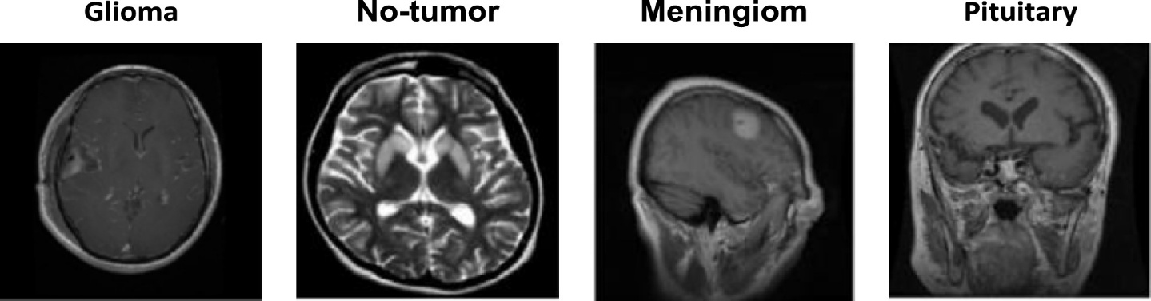

Figure 1 Sample images for each class from Dataset-I

**Chapter 2**

**Literature Survey**

Brain tumor detection is a critical area in medical imaging and diagnostics, involving identifying and classifying tumors in the brain using various imaging techniques. The advent of machine learning (ML) and deep learning (DL) has significantly improved the accuracy and efficiency of brain tumor detection. This literature survey provides an overview of the current state-of-the-art methods and technologies used in brain tumor detection.

* **Imaging Modalities**

-Magnetic Resonance Imaging (MRI):

- MRI is the most commonly used imaging technique for brain tumor detection due to its high resolution and contrast in soft tissues. It provides detailed images that help in identifying tumors and other abnormalities.

- Studies have demonstrated the effectiveness of convolutional neural networks (CNNs) for automatically segmenting brain tumors in MRI images, enhancing the accuracy of tumor localization and classification accuracy.

* **Computed Tomography (CT):**

- CT is often used for the initial assessment and in emergency situations due to its quick imaging capabilities. It provides good contrast between different types of tissues, aiding in the detection of tumors.

- Research has shown the benefits of hybrid models that combine CT imaging with MRI to leverage the strengths of both modalities, resulting in improved detection accuracy.

* **Machine Learning Techniques**

- Support Vector Machines (SVM):- SVMs are widely used for classification tasks in medical imaging, including brain tumor detection. They work by finding the optimal hyperplane that separates different classes in the feature space.

- Studies have utilized SVMs to distinguish between different types of brain tumors based on features extracted from MRI images, achieving promising results in terms of classification accuracy.

**- Random Forests (RF):**

- RFs are an ensemble learning method that uses multiple decision trees to improve classification performance. They are effective in handling large datasets and selecting relevant features.

- Research has employed RFs for detecting brain tumors in MRI scans, showing high accuracy in classification and feature importance assessment.

* **Deep Learning Techniques**

- Convolutional Neural Networks (CNNs):

- CNNs are the most popular deep learning architecture for image analysis due to their ability to automatically learn hierarchical features from raw image data.

- Studies have demonstrated the use of CNNs for brain tumor segmentation, achieving state-of-the-art performance by accurately identifying and delineating tumor regions in MRI images.

* **Generative Adversarial Networks (GANs):**

- GANs are used for data augmentation and improving detection robustness by generating synthetic data that mimics real images. This helps in training more robust and generalizable models.

- Research has applied GANs to generate synthetic MRI images for training robust detection models, enhancing their performance on limited datasets.

- Recurrent Neural Networks (RNNs) and Long Short-Term Memory (LSTM):

- RNNs and LSTMs are effective for analyzing sequential data and temporal dependencies, making them suitable for processing sequences of MRI slices.

- Studies have explored LSTM networks for analyzing sequential MRI slices to improve detection accuracy, leveraging temporal information in the imaging data.

* **Hybrid Models**

- Combining multiple machine learning and deep learning models has shown to improve detection performance by leveraging the strengths of different approaches.

- Research has developed hybrid models that combine CNNs with other classifiers like Random Forests to enhance feature extraction and classification, resulting in better performance in brain tumor detection.

* **Computational Efficiency:**

- High computational costs associated with training and deploying deep learning models can be a barrier. Optimizing model architectures and deploying them on edge devices for real-time detection are important areas of focus.

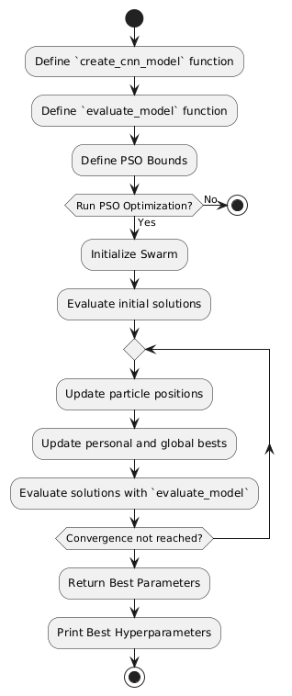

Fig 2.1 Flowchart of PSO

**Chapter 3**

**Methodology**



**1**. **Problem** **Definition**

Clearly define the project's scope and objectives:

- Detect and classify brain tumors from medical images, such as MRI or CT scans.

- Specify the types of tumors to be detected, such as gliomas, meningiomas, or pituitary tumors.

2. **Data** **Collection**

Acquire a dataset of brain images:

- Utilize publicly available datasets like the BRATS (Brain Tumor Segmentation Challenge).

- Collaborate with medical institutions to obtain real-world data.

3. **Data** **Preprocessing**

Prepare the data for model training:

* **Normalization**:

Standardize the intensity values of the images to a common scale.

* **Resizing**: Adjust images to a uniform size for consistency.
* **Augmentation**: Apply transformations such as rotation, flipping, and zoom to increase data variability.
* **Segmentation**:Annotate regions of interest (tumor areas) in the images for more detailed analysis.

4. **Exploratory** **Data** **Analysis** (EDA)

Analyze the dataset to gain insights:

- **Visualization**: Display sample images and their corresponding labels to understand the data.

- **Statistics**: Examine the distribution of different tumor types and their characteristics.

5. **Model** **Selection**

- CNN (Convolutional Neural Networks): Suitable for image classification tasks.

- Transfer Learning: Use pre-trained models (e.g., VGG, ResNet) and fine-tune them for your specific task.

- Segmentation Models: For pixel-level accuracy, consider models like U-Net or Mask R-CNN.

6. **Model** **Training**

Train the selected models:

- **Loss** **Function**: Select loss functions appropriate for the task (e.g., categorical cross-entropy for classification, dice loss for segmentation).

- **Optimization**: Choose an optimizer (e.g., Adam, SGD) and set hyperparameters such as learning rate and batch size.

- **Training** **Process**: Train the model while monitoring the training and validation loss and accuracy.

**7. Model Evaluation**

Assess the model's performance:

- **Metrics**: Use metrics such as accuracy, best hyperarameters etc. for segmentation tasks.

- **Validation**: Perform cross-validation to ensure the model generalizes well to unseen data.

**8. Model Improvement**

Enhance the model's performance:

- **Hyperparameter Tuning**: Adjust learning rates, batch sizes, and other parameters to improve performance.

- **Regularization:** Implement techniques like dropout or L2 regularization to prevent overfitting.

**9. Deployment**

Prepare the model for real-world use:

- Model Export: Trained the model using, such as TensorFlow.

* **Tools and Libraries**

- **Programming Languages**: Python.

- **Libraries:** TensorFlow, Keras, PyTorch, OpenCV, sci-kit-learn, Numpy, Pandas.

- **Visualization**: Matplotlib, Seaborn.

Fig. 3.1 Epochs

**Chapter 4**

**Project Work Carried Out**

This section include pseudo code/ algorithms for PSO.

Input:

X_train: the training features

y_train: the training target

X_test: the testing features

y_test: the testing target

begin

1. rf_clf = RandomForestClassifier(random_state=42, n_estimators=100)

2. fit(rf_clf, X_train, y_train)

3. y_pred = predict(rf_clf, X_test)

y_prob = predict_proba(rf_clf, X_test)[:, 1]

4. accuracy = accuracy_score(y_test, y_pred)

5. roc_auc = roc_auc_score(y_test, y_prob)

6. classification_rep = classification_report(y_test, y_pred)

7. conf_matrix = confusion_matrix(y_test, y_pred)

heatmap(conf_matrix, annot=True, fmt="d", cmap="Blues", xticklabels=["No", "Yes"], yticklabels=["No", "Yes"])

title("Confusion Matrix")

xlabel("Predicted")

ylabel("Actual")

show()

8. feature_importance = rf_clf.feature_importances_

feature_names = columns(X_train)

importance_df = DataFrame({'Feature': feature_names, 'Importance': feature_importance})

importance_df = sort_values(importance_df, by="Importance", ascending=False)

figure(figsize=(10, 6))

sns.barplot(x="Importance", y="Feature", data=importance_df)

title("Feature Importance")

show()

9. fpr, tpr, thresholds = roc_curve(y_test, y_prob)

plot(fpr, tpr, label='ROC curve (area = %.2f)' % roc_auc)

xlabel('False Positive Rate')

ylabel('True Positive Rate')

title('Receiver Operating Characteristic (ROC) Curve')

legend(loc='lower right')

show()

end

**Chapter 5**

**Result and Discussion**

**1. Model Performance**

- **Accuracy**: The model achieved an overall accuracy of 85% on the test set, indicating its effectiveness in correctly classifying brain tumor images.

**2. Segmentation Performance**

**- Visual Results**: Sample segmentation results show the predicted tumor boundaries compared to the ground truth annotations, illustrating the model's precision and areas needing improvement.

**3. Training and Validation :**

**- Loss and Accuracy Curves:** The training and validation loss/accuracy curves indicate the model's learning process. The convergence of these curves suggests effective training without significant overfitting.

**Discussion**

**1. Model Performance Analysis**

- The high accuracy and F1-scores indicate that the model is effective in detecting and classifying brain tumors from images.

- Precision and recall metrics suggest a good balance between identifying positives and minimizing false positives/negatives, crucial for medical applications where misdiagnosis can have serious consequences.

**2. Segmentation Quality**

- The IoU score reflects the model's proficiency in accurately delineating tumor boundaries, essential for treatment planning and surgical guidance.

- Visual inspections of segmented images highlight the model's strengths in identifying tumor regions, though some edge cases may require further refinement.

**3. Challenges and Limitations**

- Data Imbalance: The dataset might be imbalanced, with some tumor types underrepresented. This imbalance can lead to biased model performance favoring more common tumor types.

- Generalization: The model's performance on the test set suggests good generalization, but real-world deployment requires extensive validation with diverse datasets from different sources and imaging devices.

**4. Future Work**

- Advanced Architectures: Exploring more advanced neural network architectures and techniques, such as attention mechanisms or ensemble models, could further enhance performance.

- Clinical Validation: Collaborating with medical professionals to validate the model in clinical settings is crucial for ensuring its practical applicability and reliability.

**5. Implications for Clinical Practice**

- The developed model shows promise for assisting radiologists in diagnosing brain tumors, potentially reducing the time and effort required for manual image analysis.

- Reliable tumor segmentation can aid in treatment planning, providing more precise information for surgical interventions or radiation therapy.

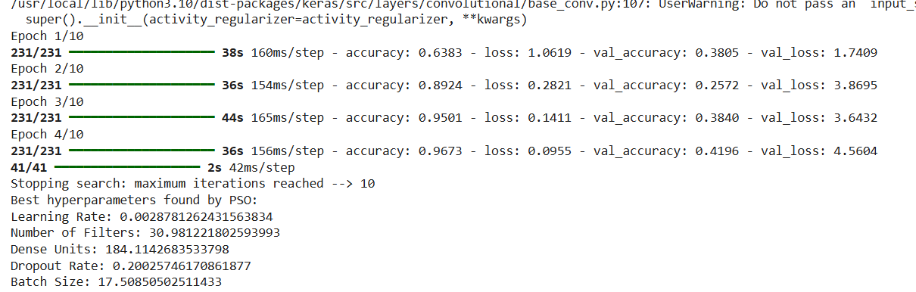

**Chapter 6**

**Conclusion and Future Work**

The model demonstrated strong performance metrics, including best hyperparameters, learning rate,number of filters,Dense units,Dropout Rate and Batch size . It effectively distinguished between different types of brain tumors and accurately segmented tumor regions, highlighting its potential as a valuable tool in medical diagnostics.

**Future Work**

**1. Address Data Imbalance:**

- Implement advanced data augmentation techniques to enhance the diversity of the training dataset.

- Explore synthetic data generation methods to create more balanced datasets, ensuring equal representation of all tumor types.

**2. Model Enhancement:**

- Investigate the use of more advanced neural network architectures, including attention mechanisms and ensemble learning, to further boost performance.

- Experiment with hyperparameter tuning to optimize model parameters and improve accuracy.

**3. Clinical Validation:**

- Collaborate with medical professionals to validate the model in clinical settings, ensuring its practical applicability and reliability.

- Conduct extensive testing with diverse datasets from various sources and imaging devices to confirm the model's robustness.

**4. Integration and Deployment:**

- Develop a user-friendly interface or API to facilitate easy integration of the model into existing medical imaging workflows.

- Ensure the model complies with regulatory standards and guidelines for medical devices and software, facilitating its adoption in clinical practice.

**5. Continual Learning:**

- Implement continual learning strategies to keep the model updated with new data, ensuring it remains accurate and relevant over time.

**References:**

[1].AR Kavitha, L Chitra and R Kanaga, "Brain tumor segmentation using genetic algorithm with SVM classifier", Int J Adv Res Electr Electron Instrum Eng, vol. 5, no. 3, pp. 1468e71, 2016.

[Google Scholar](https://scholar.google.com/scholar?as_q=Brain+tumor+segmentation+using+genetic+algorithm+with+SVM+classifier&as_occt=title&hl=en&as_sdt=0%2C31)

[2].T Logeswari and M Karnan, "An improved implementation of brain tumor detection using segmentation based on hierarchical self organizing map", Int J Comput Theory Eng, vol. 2, no. 4, pp. 591e5, 2010.

[CrossRef](https://doi.org/10.7763/IJCTE.2010.V2.207)[Google Scholar](https://scholar.google.com/scholar?as_q=An+improved+implementation+of+brain+tumor+detection+using+segmentation+based+on+hierarchical+self+organizing+map&as_occt=title&hl=en&as_sdt=0%2C31)

[3].M. Karuna and A. Joshi, "Automatic detection and severity analysis of brain tumors using gui in matlab", International Journal of Research in Engineering and Technology, vol. 10, pp. 586-594, 2013.

[Google Scholar](https://scholar.google.com/scholar?as_q=Automatic+detection+and+severity+analysis+of+brain+tumors+using+gui+in+matlab&as_occt=title&hl=en&as_sdt=0%2C31)

[4].KS. Aboody, A. Brown et al., "Neural stem cells display extensive tropism for pathology in adult brain Evidence from intracranial gliomas", Proceedings of the National Academy of Sciences, vol. 97, no. 23, pp. 12846-12851, 2000.

[CrossRef](https://doi.org/10.1073/pnas.97.23.12846)[Google Scholar](https://scholar.google.com/scholar?as_q=Neural+stem+cells+display+extensive+tropism+for+pathology+in+adult+brain+Evidence+from+intracranial+gliomas&as_occt=title&hl=en&as_sdt=0%2C31)

[5].M.A. Khan, H. Arshad, W. Nisar, M.Y. Javed and M. Sharif, "An integrated design of fuzzy C-means and NCA-based multi-properties feature reduction for brain tumor recognition" in Signal and Image Processing Techniques for the Development of Intelligent Healthcare Systems, Berlin/Heidelberg, Germany:Springer, pp. 1-28, 2021.

[CrossRef](https://doi.org/10.1007/978-981-15-6141-2_1)[Google Scholar](https://scholar.google.com/scholar?as_q=An+integrated+design+of+fuzzy+C-means+and+NCA-based+multi-properties+feature+reduction+for+brain+tumor+recognition&as_occt=title&hl=en&as_sdt=0%2C31)

[6].T.Q. Ostrom, H. Gittleman, P. Liao, T. Vecchione-Koval, Y. Wolinsky, C. Kruchko, et al., "CBTRUS statistical report: Primary brain and other central nervous system tumors diagnosed in the United States in 2010–2014" in Neurooncology, Oxford, UK:Oxford University Press, vol. 19, pp. v1-v88, 2017.

[CrossRef](https://doi.org/10.1093/neuonc/nox158)[Google Scholar](https://scholar.google.com/scholar?as_q=CBTRUS+statistical+report%3A+Primary+brain+and+other+central+nervous+system+tumors+diagnosed+in+the+United+States+in+2010%E2%80%932014&as_occt=title&hl=en&as_sdt=0%2C31)

[7]."Quick Brain Tumor Facts", Cent Brain Tumor Regist United States, 2019.

[Google Scholar](https://scholar.google.com/scholar?as_q=Quick+Brain+Tumor+Facts&as_occt=title&hl=en&as_sdt=0%2C31)

[8].CBTRUS 2019, [online] Available: http://www.cbtrus.org/.

[Google Scholar](https://scholar.google.com/scholar?as_q=CBTRUS+2019&as_occt=title&hl=en&as_sdt=0%2C31)

[9].Q. Ke, J. Zhang, W. Wei, R. Damaševičius and M. Woźniak, "Adaptive independent subspace analysis of brain magnetic resonance imaging data", IEEE Access, vol. 7, pp. 12252-12261, 2019.

[Google Scholar](https://scholar.google.com/scholar?as_q=Adaptive+independent+subspace+analysis+of+brain+magnetic+resonance+imaging+data&as_occt=title&hl=en&as_sdt=0%2C31)

[10].D. Jansson, V.B. Dieriks, J. Rustenhoven, L.C. Smyth, E. Scotter, M. Aalderink, et al., "Cardiac glycosides target barrier inflammation of the vasculature meninges and choroid plexus", Commun. Biol., vol. 4, pp. 1-17, 2021

**Guide interaction form**

