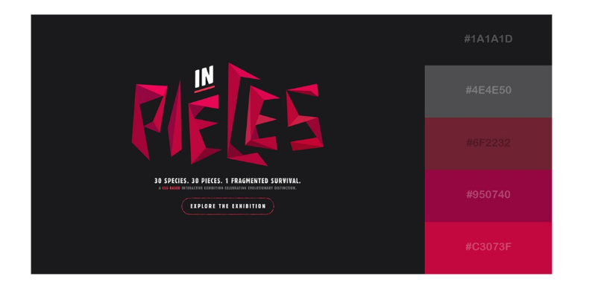

#1A1A1D

#4E4E50

#6F2232

#950740

#C3073F

