Stock Investment Automation

Goal and Design Document

# Purpose of the Project

The goal of the project is to create a software which is secure and serves as an accountant/assistant (depending on the user) for a stock investment.

## Core Capabilities of the Project

1. Applied Machine Learning algorithms to train the system to learn about stock trend
2. Secure Authentication
3. Smooth and Report ViewContinuous Upgrade
4. Non-compulsive ML assistance option
5. Fully autonomous ML option

# Functionality Flow of the Project

The given DFD-0 explains the follow of functionalities in the software.

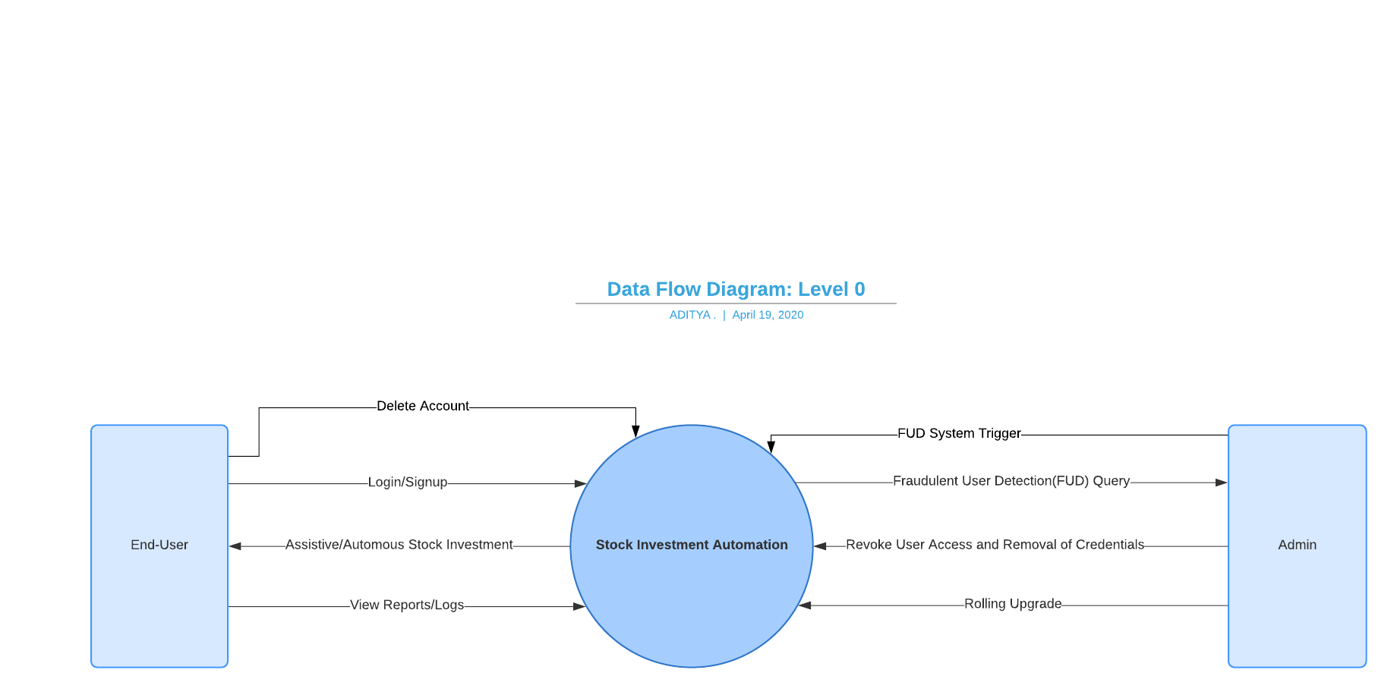

This DFD explains the high level use-cases and entity interaction with our application.