Software Requirements Specification (SRS)

Version 1.0

<<Annotated Version>>

August 15, 2017

**Social InfoTech**

Chitra Shettiyar

Shweta Singh

Submitted in partial fulfillment

Of the requirements of

CS 310 Software Engineering

# Table of Contents

**1. Introduction**

1.1. Purpose

1.2. Scope

1.3. Definitions, acronyms & abbreviations

1.4. References

1.5. Overview

**2. Overall description**

2.1. Product perspective

2.1.1. System interfaces

2.1.2. User interfaces

2.1.3. Hardware interfaces

2.1.4. Software interfaces

2.1.5. Communications interfaces

2.1.6. Memory constraints

2.1.7. Operations

2.1.8. Site adaptation requirements

2.2. Product functions

2.3. User characteristics

2.4. Constraints

2.5. Assumptions and dependencies

**3. Specific Requirements**

3.1 Specific requirements

3.1.1 Sequence diagrams

3.1.2 Classes for classification of specific requirements

3.2 Performance requirements

3.3 Design constraints

3.4 Software system attributes

3.4.1 Reliability

3.4.2 Availability

3.4.3 Security

3.4.4 Maintainability

3.5 Other requirements

# 1. Introduction

## 1.1. Purpose of SRS

The purpose of this document is to present a detailed description of the Social InfoTech. It will explain the purpose and features of the system, the interfaces of the system, what the system will do, the constraints under which it must operate and how the system will react to external events. This document is intended for both the stakeholders and the developers of the system and will be proposed to the dept of Computer Science for its approval.

## 1.2. Scope of SRS

This software system will be a Social information system for a common people living in society. This system will be designed to make people aware about their surrounding, other nature and health related organization by providing information tools to assist in updating the article review and retrieval process, which would otherwise have to be performed manually.

More specifically, this system is designed to allow an user to retrieve the information for his/her social development. The software will facilitate communication between admin and users via E-Mail. Preformatted reply forms and emails are used in every stage of the progress through the system to provide a uniform review process; the location of these forms is configurable via the application’s maintenance options. The system also contains a relational database containing a list of users_info, region, etc.

**1.3. Definitions, acronyms & abbreviations:**

SIT- Social InfoTech,

Org-Organization

|  |  |
| --- | --- |
| **Term** | **Definition** |
| Database | Collection of all the information monitored by this system. |
| Field | A cell within a form. |
| Reader | Anyone visiting the site to read articles. |
| Software Requirements Specification | A document that completely describes all of the functions of a proposed system and the constraints under which it must operate. For example, this document. |
| Stakeholder | Any person with an interest in the project who is not a developer. |
| User | One who uses the system to gain information. |

**1.4. References:**

IEEE. *IEEE Std 830-1998 IEEE Recommended Practice for Software Requirements Specifications.* IEEE Computer Society, 1998.

Web links:

* <https://www.nature.org/>
* <http://dearestnature.com/>
* <http://www.cgalvin.com/>
* <https://en.wikipedia.org/wiki/Lifestyle_disease#References>
* <https://books.google.co.in/books?id=_IlIAwAAQBAJ&pg=PR12&lpg=PR12&dq=some+books+name+giving+information+about+air+pollution&source=bl&ots=899C7J98kb&sig=xu6pI73fDrJp7S_VCvMR2gRftOI&hl=en&sa=X&ved=0ahUKEwixwK2Pgr7VAhUKr48KHUMjBjUQ6AEISDAH#v=onepage&q=some%20books%20name%20giving%20information%20about%20air%20pollution&f=false>

Books:

* **Abundance: The Future Is Better Than You Think** is a book by [Peter H. Diamandis](https://en.wikipedia.org/wiki/Peter_H._Diamandis) and [Steven Kotler](https://en.wikipedia.org/wiki/Steven_Kotler).
* **Man the unknown** by Alexis carrel.
* **Lifestyle disease.**
* **Smog Alert:** Managing Urban Air Quality.

**1.5. Overview:**

The Overall Description section, of this document gives an overview of the functionality of the product. It describes the informal requirements and is used to establish a context for the technical requirements specification.

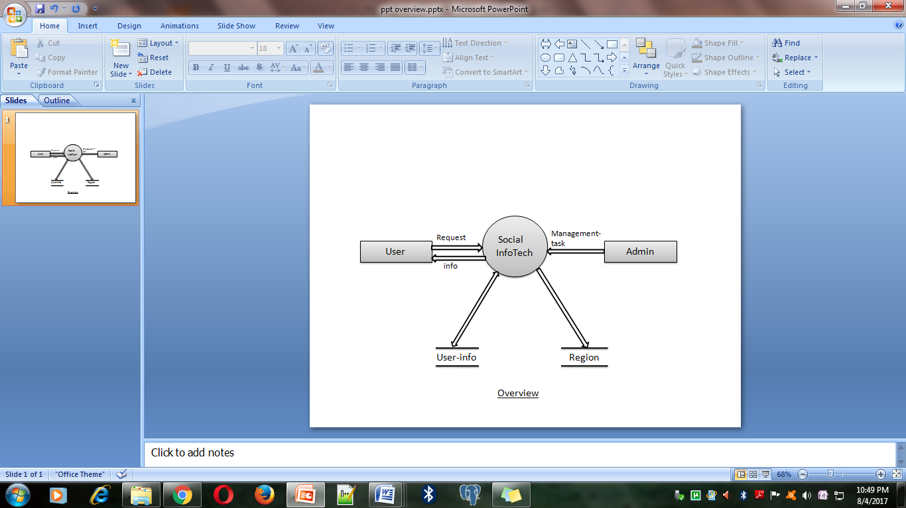

The Social InfoTech system has four major components the User, the Admin and two database consisting user-information and Region information. User can send the request and get the information where as Admin manages overall tasks.

**2. Overall description**

**2.1. Product perspective**

**2.1.1. System interfaces-** The external system from where we got the information are-

Forest department (Mumbai), NGO's(Hariyali-NGO), Hospitals.

**2.1.2. User interfaces-**

The user **interface** allows the user to communicate with the operating system,

Examples of user interface are, GUI(main page and sign up page), etc

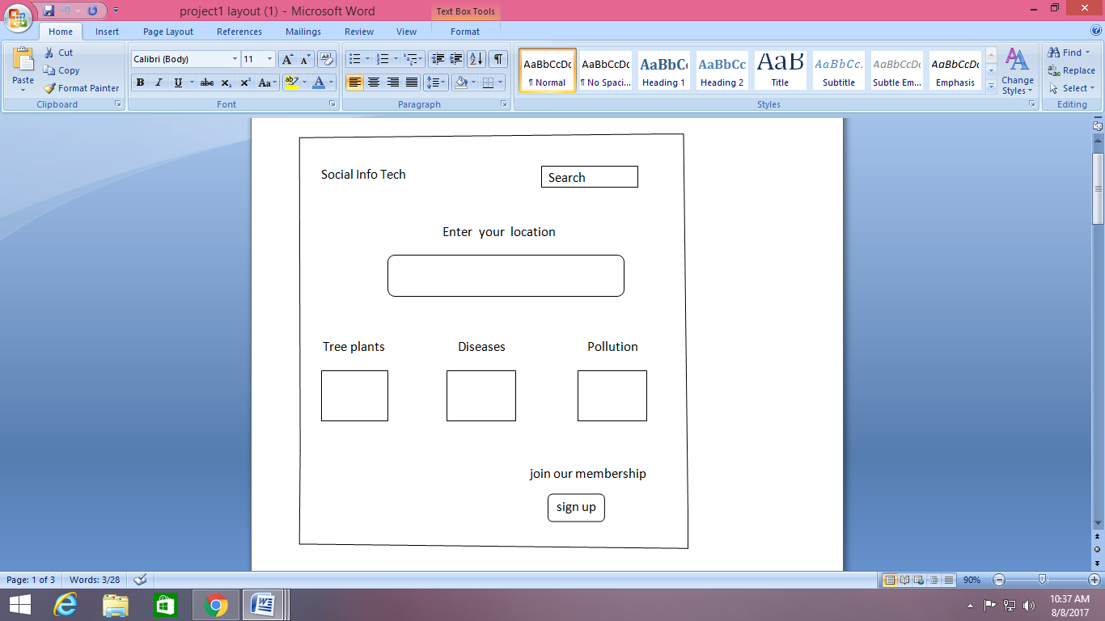

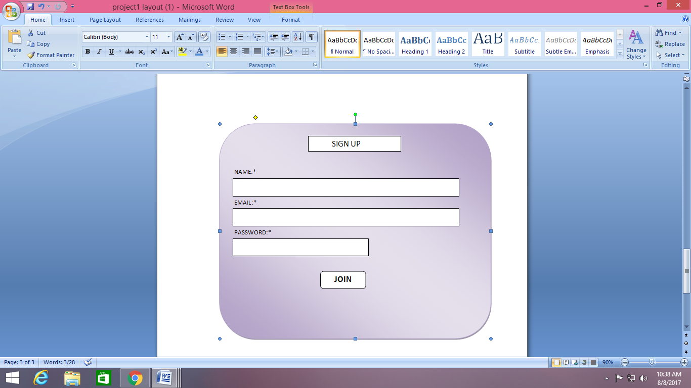

**2.1.3. Hardware interfaces-**

The different types of hardware interface used are printers, USB cable, Graphics Card, LAN card, Close-up of a Sound Card, Network Interface Card i.e. PCI interfaces.

**2.1.4. Software interfaces-**

Software interfaces are the languages and codes that the applications use to communicate with each other and with the hardware. In our project we used languages like HTML, CSS, Bootstrap, PHP and Mysql database.

**2.1.5. Communications interfaces-**

Communication interfaces used to establish communications between two devices examples are Routers, LAN cards, etc.

The Social InfoTech system shall use the HTTP protocol for communication over the internet and for the intranet communication will be through TCP/IP protocol suite.

**2.1.6. Memory constraints-**

It Specifies any applicable characteristics and limits on primary and secondary memory.

Our system uses approx 20 MB of RAM ,3% of CPU usage.

**2.1.7. Operations-**

Specify the normal and special operations required by the user such as:

* The various modes of operations in the user organization (e.g., user-initiated operations)

For example-Browsing, Log In , Sign Up.

* Data processing support functions are-
* [Validation](https://en.wikipedia.org/wiki/Data_validation) – Ensuring that supplied data is correct and relevant.
* [Sorting](https://en.wikipedia.org/wiki/Sorting) – "arranging items in some sequence and/or in different sets."
* [Summarization](https://en.wikipedia.org/wiki/Summary_statistic) – reducing detail data to its main points.
* [Aggregation](https://en.wikipedia.org/wiki/Aggregate_data) – combining multiple pieces of data.
* [Analysis](https://en.wikipedia.org/wiki/Statistical_analysis) – the "collection, [organization](https://en.wikipedia.org/wiki/Organization), analysis, interpretation and presentation of data."
* [Reporting](https://en.wikipedia.org/wiki/Business_reporting) – list detail or summary data or computed information.
* [Classification](https://en.wikipedia.org/wiki/Data_classification_%28business_intelligence%29) – separates data into various categories.
  + Backup and recovery operations.

-By keeping a copy of database server in admins pc.

-By using Oracle Database Backup and Recovery functions

2.1.8. Site adaptation requirements:

Our site is hosted under World Wide Web environment.

**2.2. Product functions**

The Functions that the software will perform are-

**1-Provide information** about no. of tree plantations going on in your region, types of diseases spread in your region(area), level of pollution, etc. along with that it provides method to prevent such diseases and steps to reduce pollution.

### 2- Provide Search facility.

The system shall enable user to enter the search text on the screen.

### 3-Provide Customer Support.

The system shall provide online help, through email customer support, and sitemap options for customer support.

### 4- Email confirmation.

The system shall maintain customer email information as a required part of customer profile.

The system shall send an order confirmation to the user through email.

**2.3. User characteristics**

We have identified five potential classifications of users of our system:

* **Software Designers:** These are the most obvious users. They will use the system as a means of laying out the design of an as yet unimplemented system.
* **Software Developers:**  These are the people that take the model generated by the designers and implement it in code.  They may also use the system to identify the design of an existing system in order to maintain it.
* **Quality Engineers:**  These users are usually responsible for ensuring that a design is feasible and/or reliable. They will therefore also need to be looking at the output from our system.
* **System Administrator**: Due to the client/server/concurrent nature of the system, some one needs to be responsible for security and maintenance of the system. This is the System Administrators role.  The Administrator of the system, project or model need not be a member of the any of the other roles identified here.
* **The Client (General user):**  More often than not, software is designed for a client. The client may wish to see the design as layed out by the system and be able to see what exactly they are buying.

**2.4. Constraints**

General design/implementation constraints include:

1) The software system will run under versions of Windows xp, 7,10 and Ubuntu only.

2) All code shall be written in HTML, CSS, Bootstrap and PHP.

3) Mysql database shall be used for all data storage and reporting.

**2.5. Assumptions and dependencies**

The software will run better in Windows 7.

**3. Specific Requirements**

3.1 Specific requirements

3.1.1 Sequence diagrams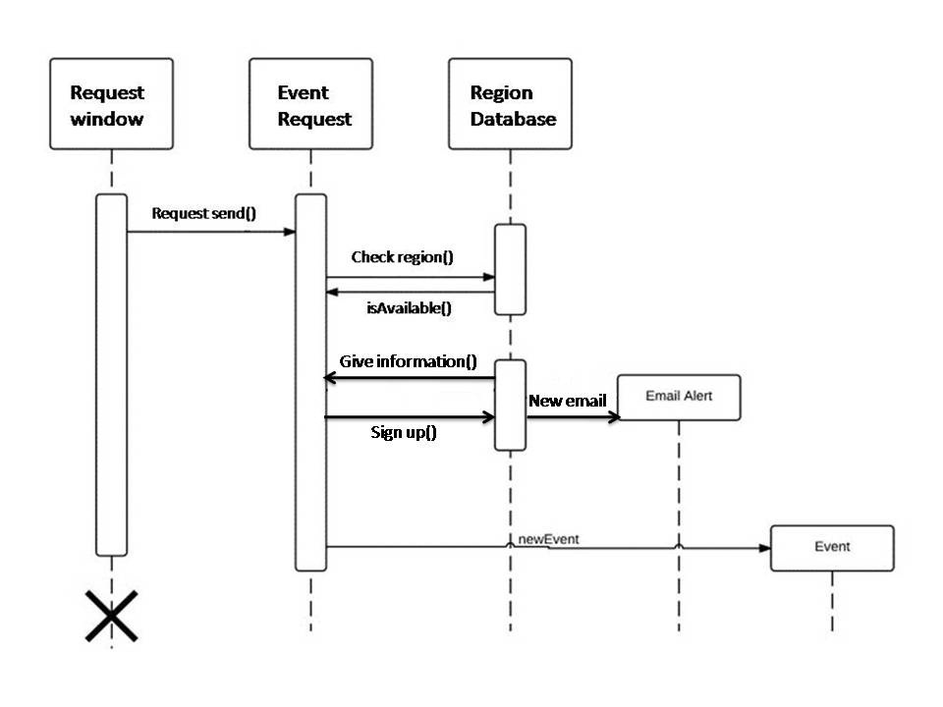

3.1.2 Classes for classification of specific requirements

3.2 Performance requirements

In order to assess the performance of a system the following must be clearly specified:  
• Response Time  
• Workload  
• Scalability  
• Platform

3.3 Design constraints

This section includes the design constraints on the software caused by the hardware.

**3.4 Software system attributes**

The requirements in this section specify the required reliability, availability, security and maintainability of the software system.

**3.4.1 Reliability**

ID: QR9

TAG: System Reliability 24

SCALE: The reliability that the system gives the right result on a search.

METER: Measurements obtained from 1000 searches during testing.

MUST: More than 98% of the searches.

PLAN: More than 99% of the searches.

WISH: 100% of the searches.

**3.4.2 Availability**

Our System is 24*7 available

SCALE: The average system availability (not considering network failing).

METER: Measurements obtained from 1000 hours of usage during testing.

MUST: More than 98% of the time.

PLAN: More than 99% of the time.

WISH: 100% of the time.

**3.4.3 Security**

The server on which the Social InfoTech data resides will have its own security to prevent unauthorized *write*/*delete* access. There is no restriction on *read* access. The use of email by an Author or Reviewer is on the client systems and thus is external to the system.

The PC on which the Social InfoTech website resides will have its own security. Only the Admin will have physical access to the machine and the program on it. There is no special protection built into this system other than to provide the Admin with Update and manage the contents.

**3.4.4 Maintainability**

The software defines minimum standard for requirements which will aid maintainability i.e

Naming conventions

Component headers

In-line document style

Control constructs

Use of global/common variables

**3.5 Other requirements**

No other requirements are needed in our system.

**4. Supporting information**

4.1 Table of contents and index

4.2 Appendixes