JMS : Java Message Service

Java Message Service is a mechanism for integrating applications in a loosely coupled, flexible manner and delivers data asynchronously across applications.

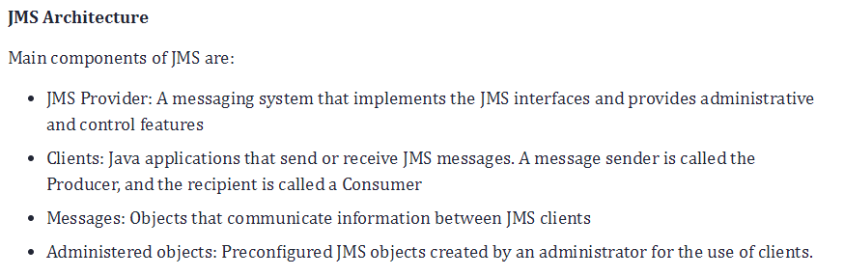

JMS Messaging model

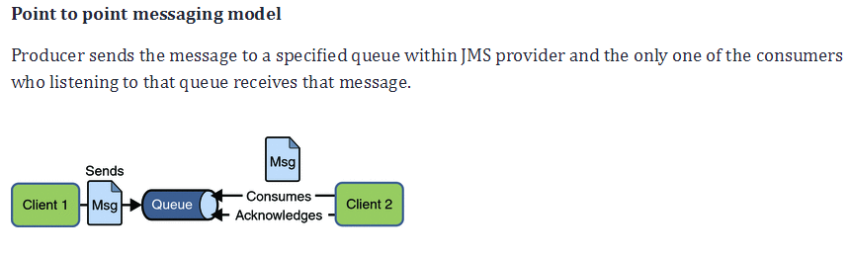

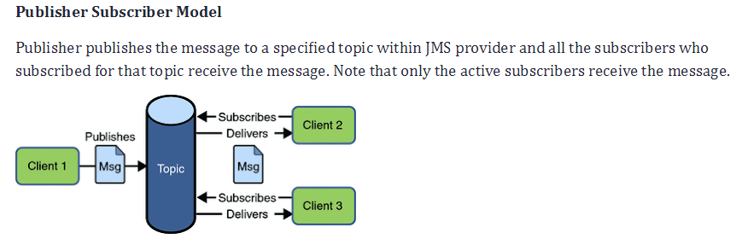

Flow Diagram of JMS

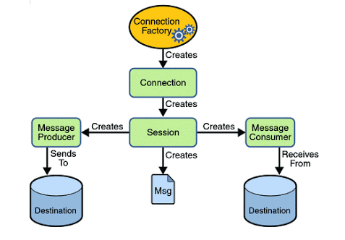

Different Type of Message available in JMS API

* Text Message :

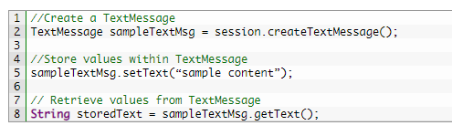

* Bytes Message :

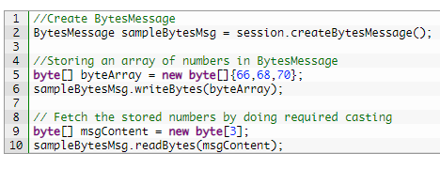

* Stream Message

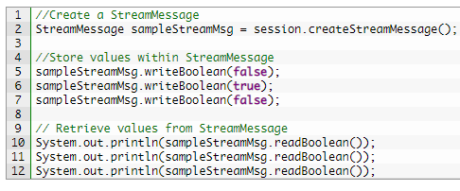

* Object Message

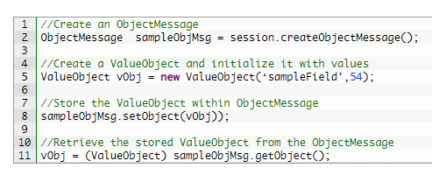

* Map Message

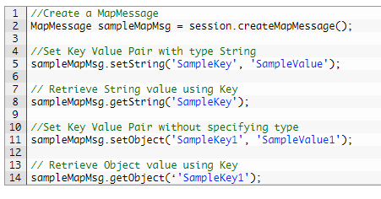

Sending and Receiving of message:

JMSTemplate is used to send any message in queue.

jmsTemplate.send(“QueueName”, MessageCreator);

MessageCreator need to override method for send respective message (Text/Bytes/Object etc).

Listeners need to create using @JMSListener annotation on method, Specify destination, connection factory and other config properties for JMSListener