**Dtalk**

**TABLE OF CONTENTS**

|  |  |  |
| --- | --- | --- |
| **CHAPTER NO.** | **TITLE** | **PAGE NO.** |
|  |  |  |
| 1 | **CHAPTER-1:**  **PROJECT DESCRIPTION AND OUTLINE** Introduction 1.2 Motivation for the work  1.3 [About Introduction to the project  including techniques]  1.5 Problem Statement  1.6 Objective of the work  1.7 Organization of the project  1.8 Summary | 8  .  .  . |
| 2 | **CHAPTER-2:**  **RELATED WORK INVESTIGATION**  2.1 Introduction  2.2 <Core area of the project>  2.3 Existing Approaches/Methods  2.3.1 Approaches/Methods -1  2.3.2 Approaches/Methods -2  2.3.3 Approaches/Methods -3  2.4 <Pros and cons of the stated Approaches/Methods >  2.5 Issues/observations from investigation  2.6 Summary | 9 |
| 3 | **CHAPTER-3:**  **REQUIREMENT ARTIFACTS**  3.1 Introduction  3.2 Hardware and Software requirements  3.3 Specific Project requirements  3.3.1 Data requirement  3.3.2 Functions requirement  3.3.3 Performance and security requirement  3.3.4 Look and Feel Requirements  3.4 Summary | 10 |
| 4 | **CHAPTER-4:**  **DESIGN METHODOLOGY AND ITS NOVELTY**  4.1 Methodology and goal  4.2 Functional modules design and analysis  4.3 Software Architectural designs  4.4 Subsystem services  4.5 User Interface designs  4.6 Summary | 12 |
| 5 | **CHAPTER-5:**  **TECHNICAL IMPLEMENTATION & ANALYSIS**  5.1Outline  5.2 Technical coding and code solutions  5.3 Prototype submission  5.4 Test and validation  5.5 Performance Analysis (Graphs/Charts)  5.6 Summary | 16 |
| 6 | **CHAPTER-6:**  **PROJECT OUTCOME AND APPLICABILITY**  6.1Outline  6.2 Significant project outcomes  6.3 Project applicability on Real-world applications  6.4 Inference | 21 |
| 7 | **CHAPTER-7:**  **CONCLUSIONS AND RECOMMENDATION**  7.1Outline  7.2 Limitation/Constraints of the System  7.3 Future Enhancements  7.4 Conclusion | 23 |
|  | References | 26 |

* 1. **Introduction**
* DtaLK is an android application/website that helps our users to connect with their doctors online.
* User can choose any of the Specialized Doctors from the list and can have a real-time chat with their doctors.
* DtaLK is also equipped with another exciting feature of Disease Prediction model which is based on ML algorithms.

**1.2 Motivation for the work**

Due to the tough time of Covid-19, health of public has been of utmost importance. Accurate disease prediction is extremely important for people. The project tries to provide just the same for its users. Reliable prediction was at the core of this project and the motivation for the entire work.

**1.3 Problem statement**

In today’s world many types of diseases are emerging which can be pretty lethal if not identified at an early stage and as people are so busy in today’s environment, they are generally not able to create time for themselves hence they take their health for granted which in many cases becomes a serious issue at a later stage of their life,

**1.4 Objective of the work**

To provide Disease Prediction models to predict from which disease our user is suffering from. To ensure that users just have to provide their symptoms into the app and ML model will predict user’s disease and provide the appropriate Doctors.

**1.5 Organization of the project**

t main Roles of this system are:

1. Machine Learning (ML).
2. Building Android App.
3. Deployment of ML model in Android App.
4. Skills required for Database management.
5. UI/UX design.

**2.1Core area of the project**

t main Roles of this system are:

1. Machine Learning (ML).
2. Building Android App.
3. Deployment of ML model in Android App.
4. Skills required for Database management.
5. UI/UX design.

**2.2Existing approaches/methods**

* **Approach -1:**
* Building of ML model (Disease Prediction Model).
* Collecting Symptoms data from Kaggle.
* Using ML algorithms for training the model from the dataset.
* **Approach-2:**
* Building of the Android App (Authentication, many more user interfaces must be built up).
* Building Real-time Messaging Feature.
* **Approach-3:**
* Connecting Firebase Database with the android app.
* **Approach-4:**
* UI/UX designing for the app, for better user experience.
* **Technology:** Kotlin Language, Firebase Database, Python language, Machine learning Algorithms.
* **Role:** Machine Learning, Android Developers, involved in UI Designing and planning, preparation & Execution.

**Requirement Artifacts**

**3.1Introduction**

Requirement artifacts refer to the resources used to create the functioning website and application. The requirement artifacts of the project are secure and optimized. Care has been taken to ensure that they are optimal in performance and also open source.

**3.2 Hardware and software requirements**

Here are some artifacts that are required to run the program:

**For implementing machine learning model:**

* **Anaconda**, which is the distributor for Python programming language. It makes it easier for importing modules and packages into Python.
* **Python 3.0** and above which provides a workspace for implementing the machine learning model and libraries.

**For creating the android application:**

* **Android studios**, which is an IDE for Google’s android operating system. It has an expansive UI environment which helps in the development if the android application.
* **Kotlin version 2.0** and above which is a useful programming language for concise and safe code.
* **Firebase** is used for storing all the data in the form of a database**.**

**For Real time Usage:**

All the user will be needing in order to access the DTalk application is a Smartphone and a secure Internet connection. Both of these components are used and available easily which contributes to the feasibility of the DTalk application.

**3.3 Specific Project requirements**

As aforementioned, the project is compatible on android devices and the website can be functional on a personal computer as well. The medical data is secure and care has been taken to ensure a reliable dataset for the users.

**Design Methodology and its novelty:**

**4.1 Methodology and goal**

These are the system of methods used in completion of the project:

* The initial step was to collect information about the project and determining the feasibility of the project. This included determining about the type of data, the type of application, the User interface of the android application etc.

* Next Data Cleaning was done from the medical data collected. This was followed by setting up the machine learning model.

* Next the Design and implementation of the UI of android application was done. This was achieved through use of resources like Kotlin, Firebase and android studios as discussed before.

* Upon successful design of the UI, the Machine learning model and the cleaned-up data was deployed into the android application. Python is easily compatible with android applications, which makes it very easy for deployment.

* Lastly connectivity of the application with the firebase database is done.

**4.2 Functional modules design and analysis**

The functional modules inside the project consist of:

Machine learning model

UI of android application

Android application backend(database)

**4.3 Software Architectural design**

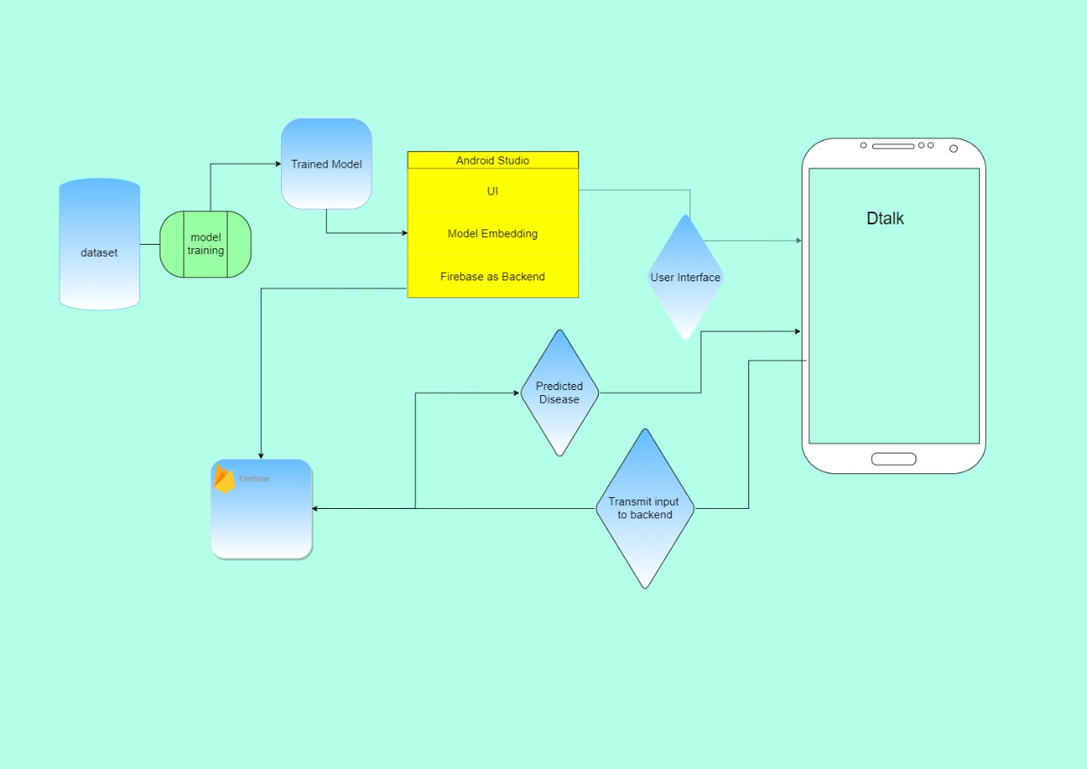

**4.4 Subsystem services**

The UI, android application and the machine learning model can also be considered as the subsystem services of the DTalk project, as together they form part of the whole. While the UI is simply straightforward in its use, ensuring a user-friendly interface to the user; the machine learning model implemented through Python into Kotlin and the firebase database ensure a reliable Backend for the project.

**4.5 User interface design**

The UI design is shown in the following images:

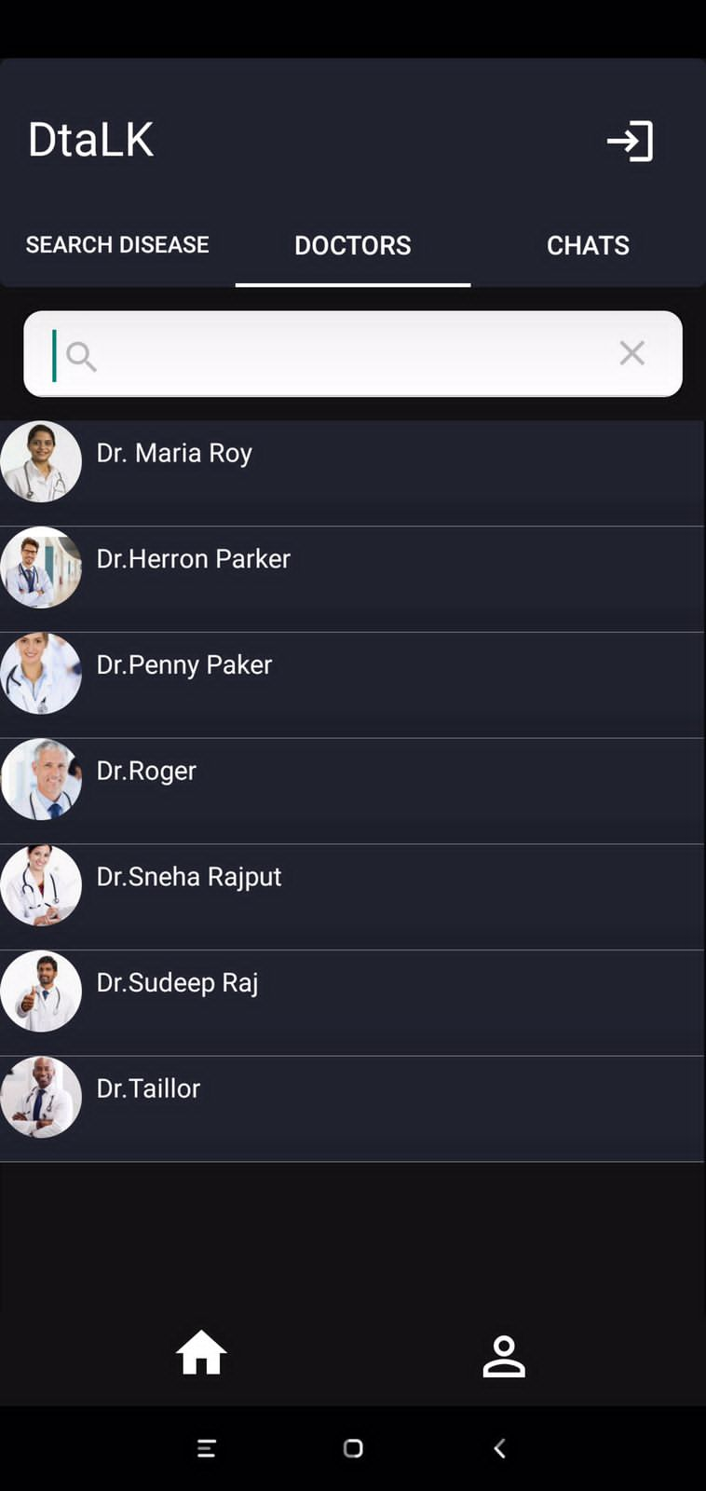

**4.6 Summary**

**Novelty** refers to the newness and originality of a project. In context, DTalk tries to be novel in its approach, in an attempt to provide reliable medical information for the users.

It's been a constant struggle to extract vast amount of data in a way that's accurate, quick, and dependable. DTalk assists in providing an accurate analytical response to patient-related questions.

On the internet, disease prediction appears to be highly unstable, with inconsistent and frequently inflated projections of the disease. DTalk helps to solve this issue as users may get reliable information with just a swipe on their device thanks to the project.

**Chapter - 5**

**Technical Implementation and Analysis**

**5.1) Outline**

Dtalk is made up on the Kotlin, Python 3.8, Firebase(database). UI/UX of the Dtalk application is made with help of Adobe XD, Python is used for prediction of the disease using a pretrained model, and the constraints of that model were stored in a binary file, that binary file was imported in Android Studio and embedded into Kotlin. All the processing and filtering of data done upon Kotlin, Kotlin fetches all the records of doctors and profile from firebase and display it to users in subtle UI.

The dataset for our Machine Learning model was taken from Kaggle, we used TensorFlow to predict the possible disease using symptoms.

On the user side the user just has to give input of their symptoms and the application will return you the predicted disease along with precautions and a recommendation of doctor from which you can have your medical help.

**5.2) Technical Coding and code solutions**

We clean our dataset in python using NumPy, pandas and matplotlib, then we used TensorFlow to train our model and create a .tflite file. Our data in raw format looks as given in the below figure:

Figure: Raw Dataset in excel format

We then transformed this data such that all unique symptoms (41) were given a specific column and they were assigned there value as 0 or 1. If true then 1 else 0, and then we created our machine learning model in two ways one using random forest classifier and one using TensorFlow and we found out that TensorFlow model was having little more accuracy then Random Forest Classifier so we dumped were model into ‘.tflite’ file.

Figure : Data after cleaning

We imported .tflite file into our Kotlin file. In parallel to this we created the UI for our application in Adobe XD. Our backend service is provided by firebase which will store all the data related to a person’s profile. Further, as features in our application we have added list of doctors which will be shown to you as per your disease, you can contact and consult those doctors and even you can have an appointment if you needed.

**5.3) Prototype Submission**

We have attached some photos of our prototype as well as link of our working demo video of LinkedIn.

**Figure: Log In interface**

**Figure: Disease Prediction Interface Figure: Predicted disease**

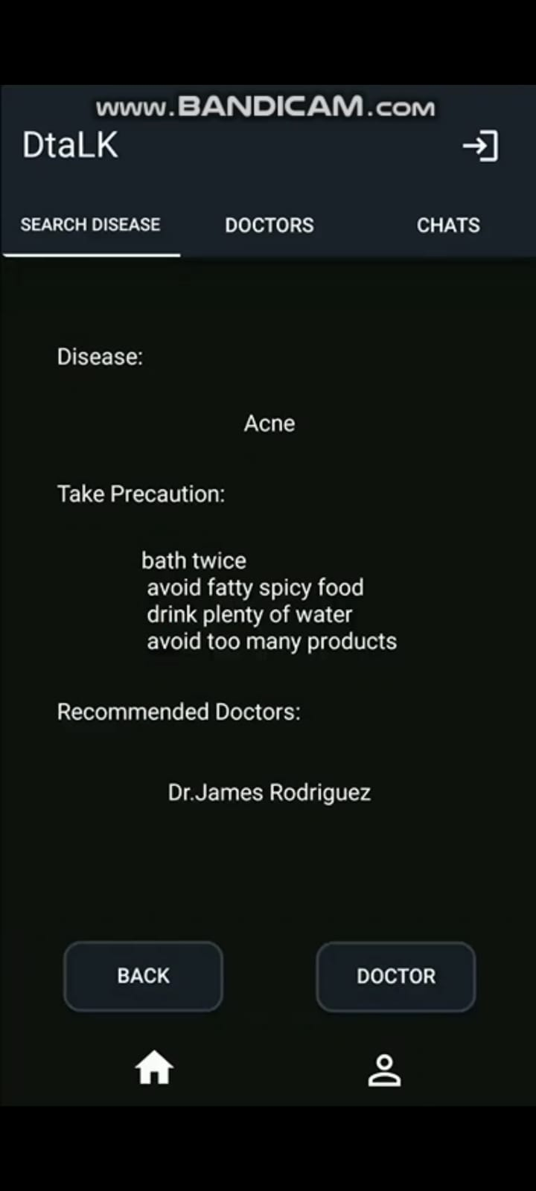

**Figure: Doctor’s Profile Figure: List of doctors**

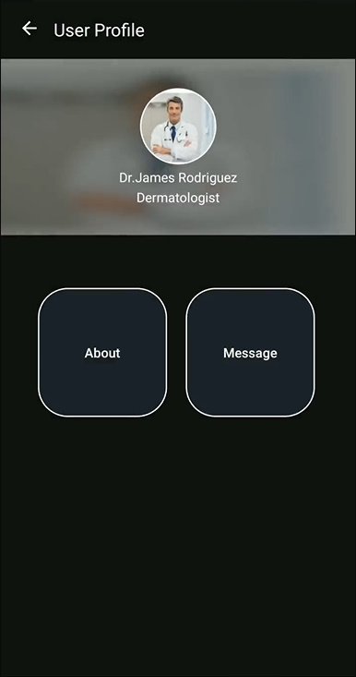 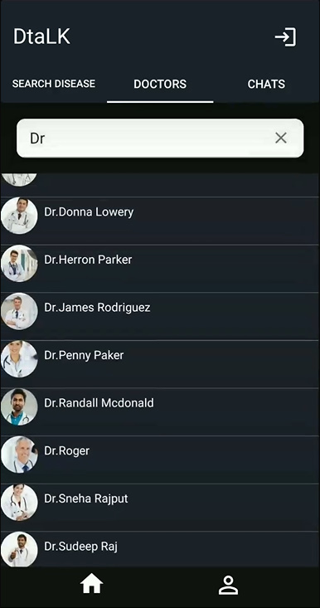

**5.4) Test and Validation**

Well, we trained our model on the 80% of the data available and used rest of 20% data for the testing purpose and we got more than 95% accuracy also we used some manual values which worked as per expectations apart from that no tests were done on the application.

**5.5) Performance Analysis**

Our accuracy was of 100% on our test data, it is because size of our data was not very big hence it predicted it well. We have plotted our predicted values against actual values as a heatmap. In which we have hot encoded our diseases into a unique numerical value from 0 to 40.

**Figure – Actual disease Vs Predicated disease Value**

**5.6) Summary**

Basically, Dtalk started from collecting data from Kaggle performing data cleaning then creating our machine learning model and embedding that model to our application, adding all the necessary features to our application, and connecting that application to firebase database which will hold all the information for user.

**Chapter – 6**

**Project Outcome and Applicability**

**6.1) Outline**

In today’s era where you can almost do everything by your mobile so let’s add one more thing to it, why shouldn’t we just become our own doctor, why to rely on someone else when we can do the thing by ourselves. Well aiming for that outcome, we have created our project which will reduces distance time and distance between people and their health.

Our project can create a lot healthier environment especially in those areas where specialized doctors are either not available or not easily reachable. It will allow them to communicate to whomsoever they trust without even taking a step out of their bed. Even a sick patient will be able to take care of themselves without any help.

**6.2) Significant project outcome**

In the today’s world of speed where everyone wants to get done quicker and always better, sometimes people take medicines on their own idea, which is very risky step to take so one of the major outcomes of our application that it predicts your disease based on your symptoms and way more accurately than an average human can do. So, our first outcome of the project is that it is quicker, better and time saving application where people can reach the doctors easily.

Second outcome is that it allows you to connect to the specialist doctor as per disease quickly. Sometimes people are unable to reach the doctor they wanted to reach, in our project we have focused on that part too so people didn’t have to worry about that anymore. In our project we have listed all the doctors as per their qualification, so you can pick anyone you want.

Third outcome of our project that it states all the precautions related to any disease you should take, so no one has to waste extra time looking for what precautions they should take, or if somehow they are unable to get their treatment at the present moment the least they can do is that they can look for precautions related to their disease and can take those precautions.

**6.3) Project applicability on Real-world applications**

Our project can be deployed on any smartphone application running platform such as play store where anyone can access it, understand it, and can explore it. In real world this application still does not exist on big scale. It can also be used in medical sector as a part of medical student’s curriculum where they will be competed against this project this not only will only improve student’s ability to understand the disease but also will improve the project itself as it also adds the new entries to itself.

**6.4) Inference**

Basically, neglecting its limitations we can concluded from its outcome and real-world applications that it can become part of people’s daily lifestyle. Our project is concerned with day-to-day life problems of people so it can used by them on great and can be expanded to more precision and accuracy as per real life.

**Conclusions and recommendations**

**7.1) OUTLINE**

The user will firstly downloads the application and install it in their mobile devices.. Once installed, this application will remain into the device permanently until the user deletes it or uninstalls it. After the installation when the user clicks on the app icon, the first thing that will appear on the screen is splash screen that contains the application’s. The patient will have to register in the application on first use. After registration, the patient will receive a username and password. For sign up, the user has to fill the given fields that are username, email, password and confirm password and then the user clicks on the signup button to register itself and then all the information provided by the user is saved in the database located on the server. The Signup screen If the user registers successfully then a notification message “successfully registered”. Different checks are also maintained while registering the user. If both the passwords are not matched then the user will be notify that the “passwords didn’t matched”. Passwords didn’t match And if email is not valid then the user cannot register itself and a notification will displayed that “email is not valid”. Email is not valid The patient has to use this username and password for logging into the app for each time usage. For signing in the user has to provide the registered username and password otherwise if the user enters such a username or password that is not registered then the user will get a notification message that “Sign in failed check your connection or contact support”. Sign in failed After logging in, the menu screen is displayed containing different option like hospitals, doctors, health schedules, about and sign out.

**7.2) Limitation/Constraints of the System**

* Trained on small scale of data.
* Not applicable for IOS devices.
* 100 percent reliable data not guaranteed as dataset is taken from varied sources

**7.3) FUTURE ENHANCEMENTS**

There are several features of the project that would be quite challenging to be added. The desirable features that **Dtalk** could have are,

* Including visual tour (location of clinics) inside the application to find clinics quickly using Google Map and Indoor Map API. It will help us in saving time and being tired too on searching for the clinics.
* Another feature is allowing the application to read the different health reports after reading and based on the reports the system will suggest the required doctor and medicine to the user.
* Moreover, implementing this application in iOS platform as an iPhone App is one of the important considerations as we have many iPhone users.

**7.4) CONCLUSIONS**

I have learned a lot from this project on how to develop Android Application and publishing it in real time, use Web Services using SOAP UI, and ADOBE XD for UI designing for the application. As mentioned, other existing applications does not help in avoiding people to stand in a long line to get a number, instantly searching about availability of time slot, paying the appointment fees online (all together in a single application). If people use **Dtalk** in the future, they have several advantages which includes, easy appointment with the doctors, payment, sharing reports instantly as it is quite easy to misplace bills, health reports and organizing them in easily, particularly helpful for elderly people by avoiding them to wait for a long time in the appointment line, providing quick information about time slot available, payments which helps users to save their cashes wisely and finally clinics can reduce scanning machinery and power consumption.

REFRENCES

[1] Arthur Hylton III and Suresh Sankaran arayanan “Application of Intelligent Agents in Hospital Appointment Scheduling System”, International Journal of Computer Theory and Engineering, Vol. 4, August 2012, pp. 625-630.

[2] Deepti Ameta, Kalpana Mudaliar and Palak Patel “Medication Reminder And Healthcare – An Android Application”, International Journal of Managing Public Sector Information and Communication Technologies (IJMPICT) Vol. 6, June 2015, pp. 39- 48.

[3] Yeo Symey, Suresh Sankaran arayanan, Siti Nurafifah binti Sait “Application of Smart Technologies for Mobile Patient Appointment System”, International Journal of Advanced Trends in Computer Science and Engineering, august 2013.

[4] Jagannath Aghav, Smita Sonawane, and Himanshu Bhambhlani “Health Track: Health Monitoring and Prognosis System using Wearable Sensors”, IEEE International Conference on Advances in Engineering & Technology Research 2014, pp. 1-5.

[5] YoeSyMey and Suresh Sankaranarayanan “Near Field Communication based Patient Appointment”, International Conference on Cloud and Ubiquitous Computing and Emerging Technologies, 2013, pp.98-103.

[6] RashmiA.Nimbalkar and R.A. Fadnavis “Domain Specific Search of Nearest Hospital and Healthcare Management System”, Recent Advances in Engineering and Computational Sciences (RAECS), 2014, pp.1-5.

[7}A. Luschi, A. Belardinelli, L. Marzi, F. Frosini, R. Miniati and E. Iadanza “Careggi Smart Hospital: a mobile app for patients, citizens and healthcare staff”, IEEE-EMBS International Conference on Biomedical and Health informatics (BHI), 2014, pp.125-128.