Deep Learning Homework 1

Aditya Sharma (adityas2)

NOTE: Only the images for the best accuracy achieved are shown here. For color maps of all node in each test, please refer to the Images directory included in the submission folder.

Part 1

I made a single layered neural network and tested it with 3, 4 and 5 hidden neurons to obtain the following results on the different datasets (500 epochs each). Out of these (3,4 and 5 nodes), the best accuracy was noted at 5 hidden nodes.

**Circle**:

3 hidden nodes

Training Set Accuracy: 98.867000

Test Set Accuracy: 98.772000

4 hidden nodes

Training Set Accuracy: 99.385000

Test Set Accuracy: 99.398000

5 hidden nodes

Training Set Accuracy: 99.449000

Test Set Accuracy: 99.467000

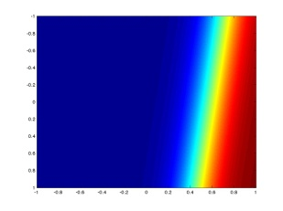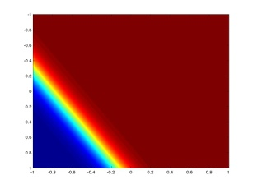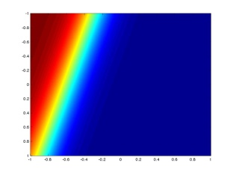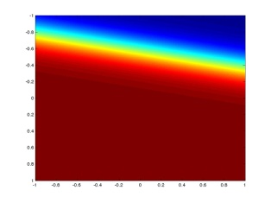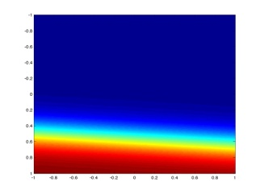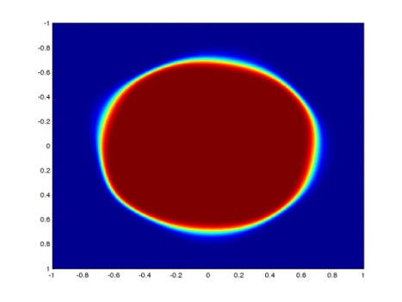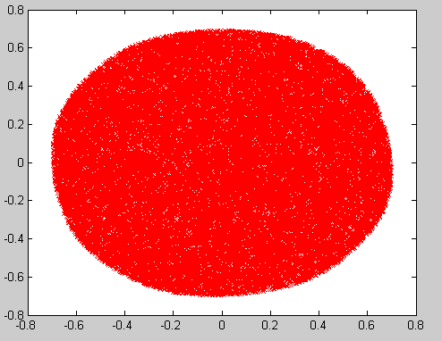

**Diamond:**

3 hidden nodes

Training Set Accuracy: 96.427395

Test Set Accuracy: 96.418000

4 hidden nodes

Training Set Accuracy: 97.193394

Test Set Accuracy: 96.891000

5 hidden nodes

Training Set Accuracy: 97.625813

Test Set Accuracy: 97.433000

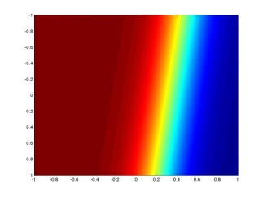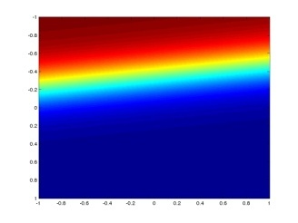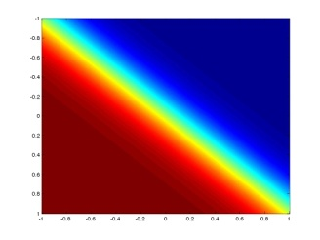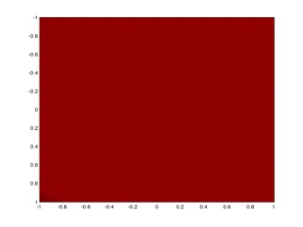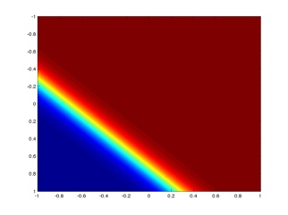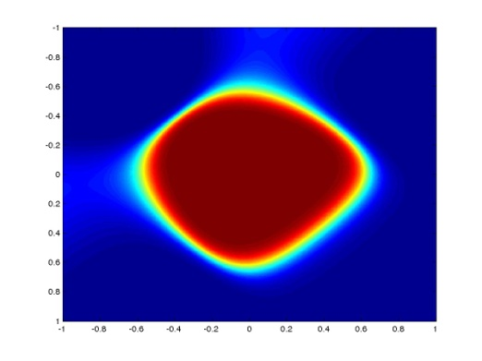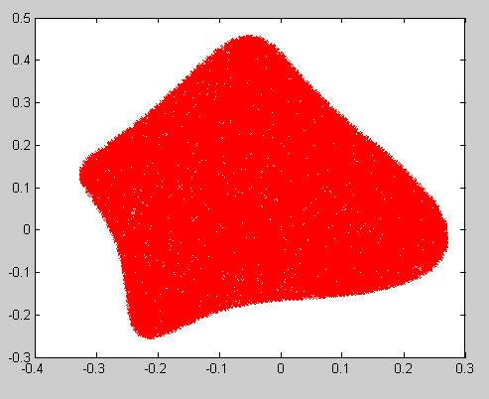

**Rshape:**

3 hidden nodes

Training Set Accuracy: 94.410455

Test Set Accuracy: 94.760000

4 hidden nodes

Training Set Accuracy: 96.403368

Test Set Accuracy: 96.494000

5 hidden nodes

Training Set Accuracy: 97.174183

Test Set Accuracy: 97.191000

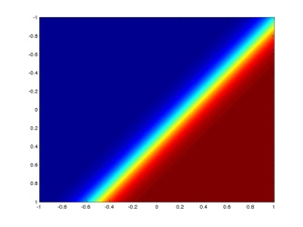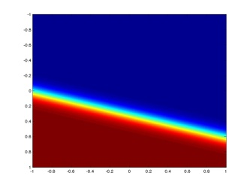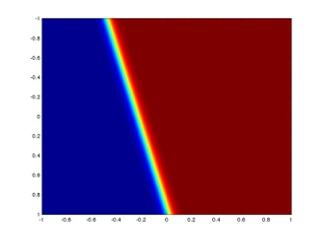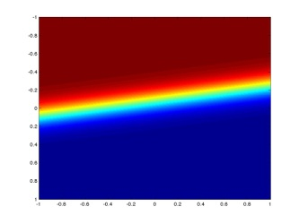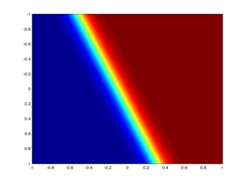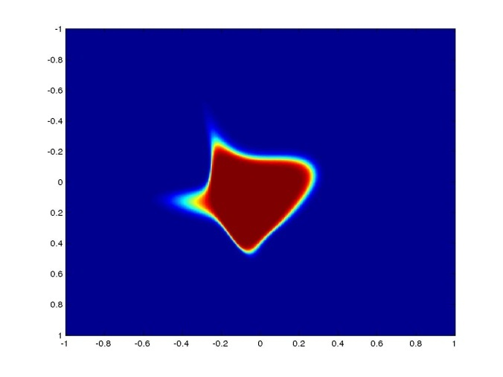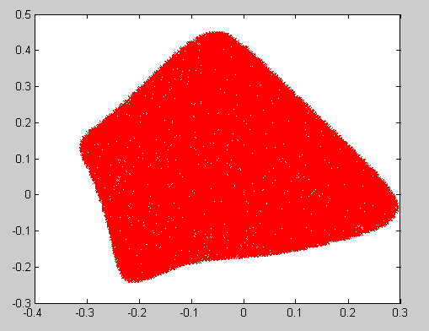

Part 2

It can be seen that the best accuracy is observed at 8 nodes each in 2 hidden layers for both the datasets.

**Rshape:**

3 nodes in 1 hidden layer

Training Set Accuracy: 94.410455

Test Set Accuracy: 94.760000

3 nodes each in 2 hidden layers

Training Set Accuracy: 95.381167

Test Set Accuracy: 95.564000

5 nodes in 1 hidden layer

Training Set Accuracy: 97.174183

Test Set Accuracy: 97.191000

5 nodes each in 2 hidden layers

Training Set Accuracy: 97.519460

Test Set Accuracy: 97.627000

8 nodes in 1 hidden layer

Training Set Accuracy: 96.442742

Test Set Accuracy: 96.560000

8 nodes each in 2 hidden layers

Training Set Accuracy: 97.676954

Test Set Accuracy: 97.643000

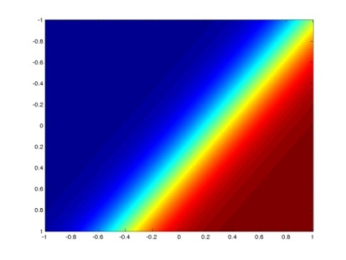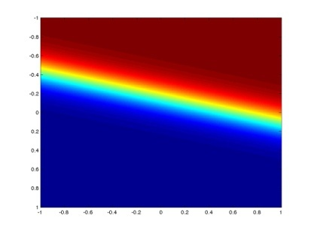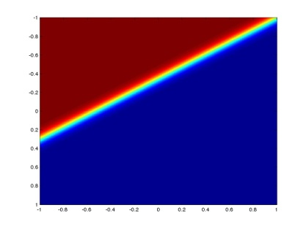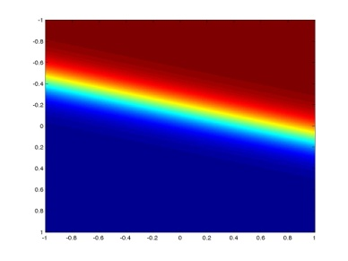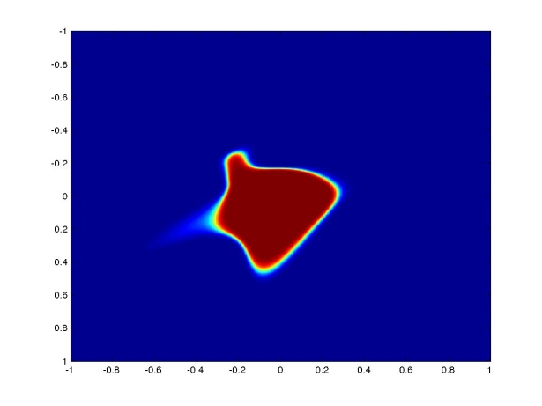

**DRshape**:

3 nodes in 1 hidden layer

Training Set Accuracy: 77.593486

Test Set Accuracy: 70.396000

3 nodes each in 2 hidden layers

Training Set Accuracy: 79.832630

Test Set Accuracy: 73.973000

5 nodes in 1 hidden layer

Training Set Accuracy: 81.843712

Test Set Accuracy: 75.710000

7 nodes each in 2 hidden layers

Training Set Accuracy: 66.049080

Test Set Accuracy: 51.936000

7 nodes in 1 hidden layer

Training Set Accuracy: 86.744195

Test Set Accuracy: 83.679000

7 nodes each in 2 hidden layers

Training Set Accuracy: 85.788601

Test Set Accuracy: 83.012000

8 nodes in 1 hidden layer

Training Set Accuracy: 86.878016

Test Set Accuracy: 84.753000

8 nodes each in 2 hidden layers

Training Set Accuracy: 87.988163

Test Set Accuracy: 85.060000

