111403003 AKASH SARDA
111403019 JASSIM ABDUL REHMAN
111403023 ADITYA MALU

Question 1
“The child “exec” call inherits the file descriptors of parent if Close_on_exec is not set“.

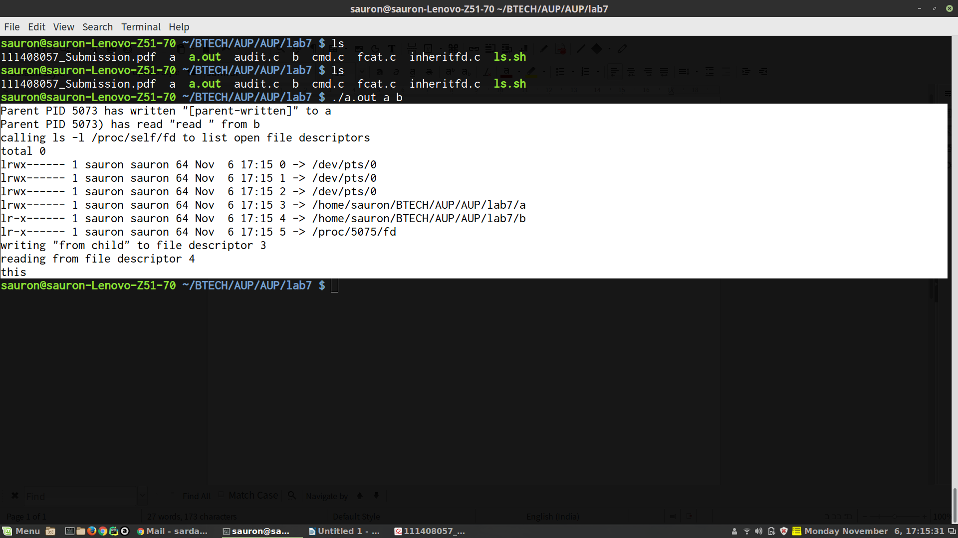
#include <stdio.h>
#include <fcntl.h>
#include <unistd.h>
#include <sys/wait.h>
#define filerr(fd,msg) if((fd) < 0){perror((msg));return 0;}

int main(int argc, char *argv[], char *envp[]) {
if (argc < 3) {
printf("Usage: %s outfile infile\n", argv[0]);
return 0;
}

int out = open(argv[1], O_RDWR | O_CREAT, 0777);
int in = open(argv[2], O_RDONLY);

char outmsg0[] = "[parent-written]";
printf("Parent PID %d has written \"%s\" to %s\n", getpid(), outmsg0, argv[1]);
write(out, outmsg0, sizeof (outmsg0));

char inmsg[16];
inmsg[1 + read(in, inmsg, 5)] = 0;
printf("Parent PID %d) has read \"%s\" from %s\n", getpid(), inmsg, argv[2]);

switch (fork()) {
case -1:
printf("Fork error");
break;
case 0:
printf("Calling exec ls.sh");
execl("ls.sh", "ls.sh", 0);
break;
default: wait(NULL);
}
}

Question 2
Write a program that takes a file name as an argument, opens the file, reads it and
closes the file. The file should contain a string with the name of another application
(e.g., 'ls' or 'ps' or any of your own applications) and the program forks a new process
that executes the application named in the file.

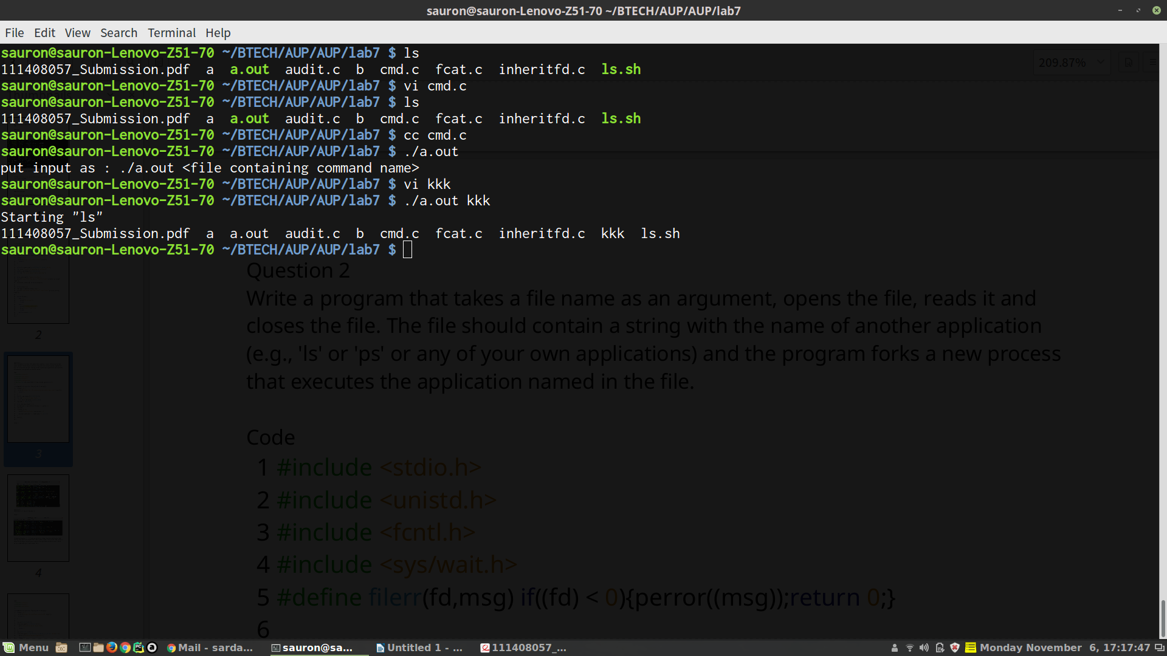
#include <stdio.h>
#include <unistd.h>
#include <fcntl.h>
#include <sys/wait.h>
#include <ctype.h>
#define filerr(fd,msg) if((fd) < 0){perror((msg));return 0;}

int main(int argc, char *argv[], char *envp[]) {
if (argc < 2) {
printf("put input as : %s <file containing command name>\n", argv[0]);
return 0;
}
int fd = open(argv[1], O_RDONLY);
filerr(fd, "could not open file");
__off_t end = lseek(fd, 0, SEEK_END);
lseek(fd, 0, SEEK_SET);
char cmdname[end + 2];
cmdname[1 + read(fd, cmdname + 1, end)] = 0;
char *c = cmdname + 1;
while (*c) {
if (isspace(*c)) {
*c = 0;
break;
}
c++;
}

close(fd);
if (fork() == 0) {
printf("Starting \"%s\"\n", cmdname + 1);
int execret = execlp(cmdname + 1, cmdname + 1, NULL);
//if error
printf("Exec returned %d", execret);
}
wait(0);
}

Question 3
Implement cat < hw.txt > hw-copy.txt

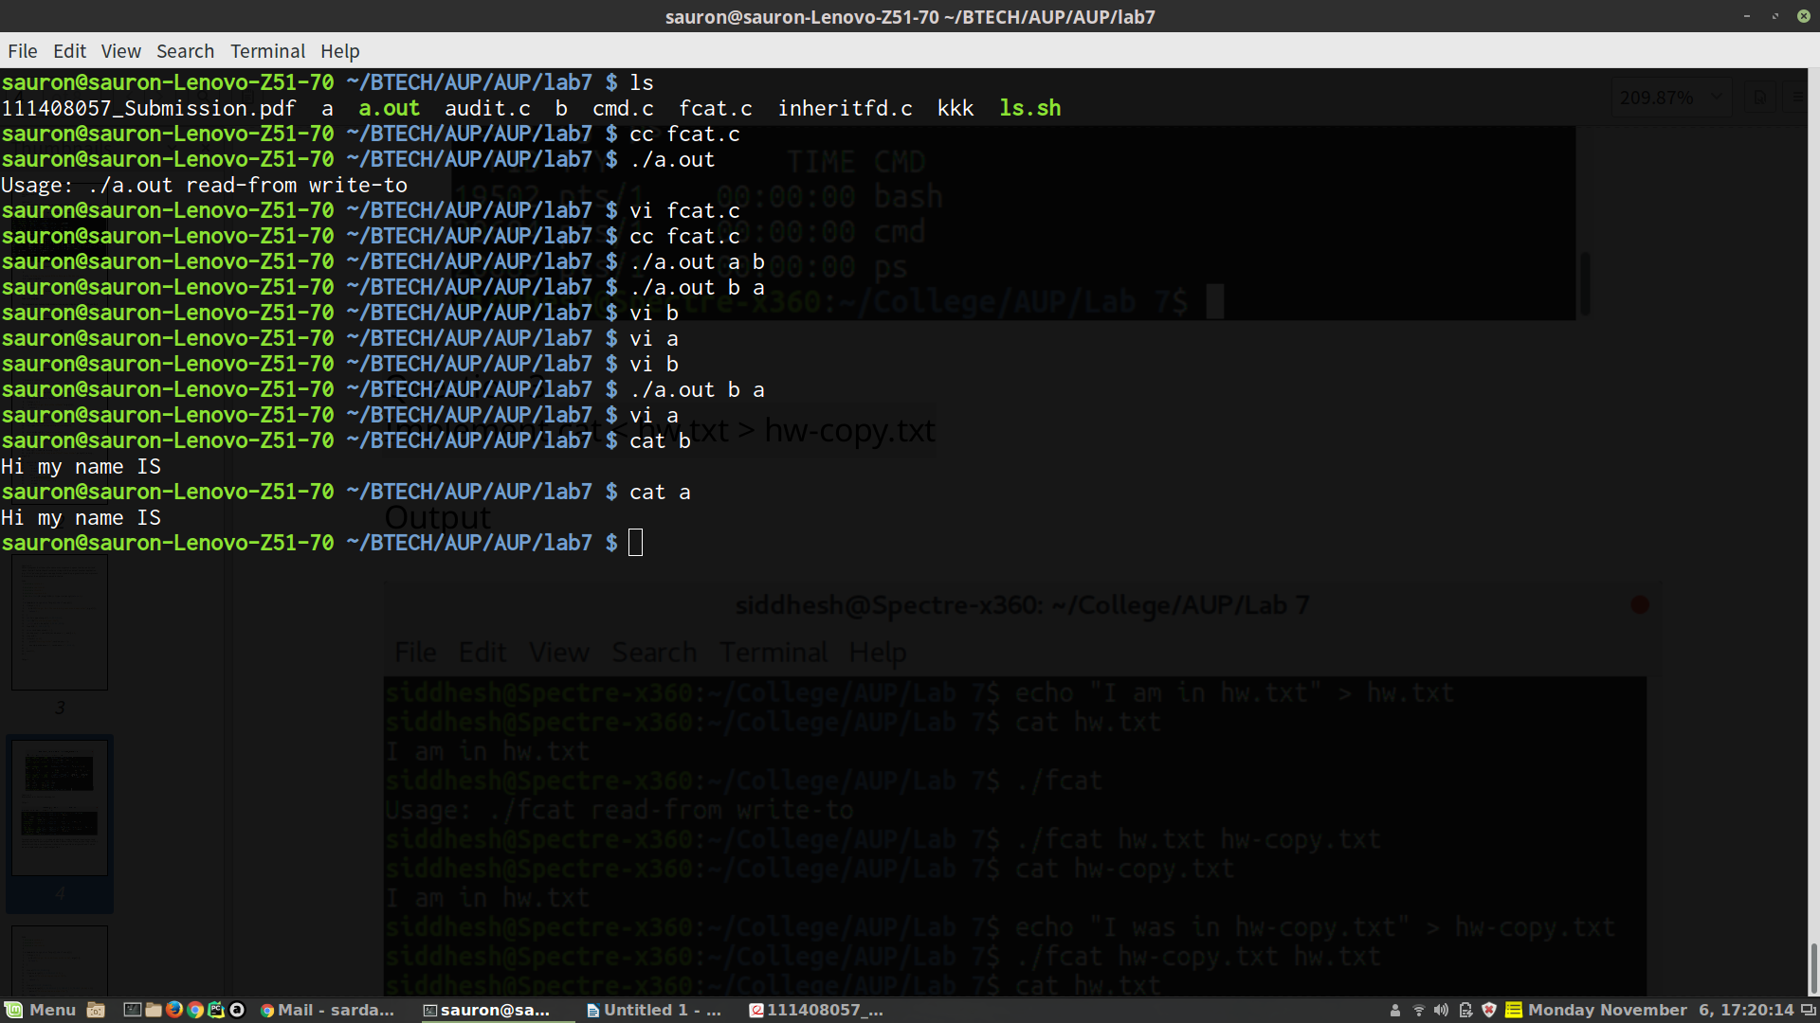
#include <stdio.h>
#include <fcntl.h>
#include <unistd.h>

int main(int argc, char *argv[], char *envp[]) {
if (argc < 3) {
printf("Input as %s read-from write-to\n", argv[0]);
return 0;
}

close(STDIN_FILENO);
if (open(argv[1], O_RDONLY) < 0) {
perror("Could not open input file");
return -1;
}
close(STDOUT_FILENO);
if (open(argv[2], O_WRONLY | O_CREAT | O_TRUNC, 0644) < 0) {
perror("Could not open output file");
return -1;
}
execl("/bin/cat", "cat", NULL);
}

4. Question 4
Bob works for an auditing agency needs to be able to read all the files in the system. The system admin has to protect the integrity of the system and should not allow Bob to modify or delete any file. Write a special SETUID program for the admin so that he can gave the executable permission of it to Bob. This program requires Bob
to type a file name at the command line and then it will run /bin/cat to display the specified file.

#include <stdio.h>
#include <fcntl.h>
#include <unistd.h>

int main(int argc, char *argv[], char *envp[]) {
if (argc < 2) {
printf("Usage: %s <file to display>\n", argv[0]);
uid_t uid = getuid();
uid_t euid = geteuid();
gid_t gid = getgid();
gid_t egid = getegid();
printf("UID:%d EUID:%d GID:%d EGID:%d\n", uid, euid, gid, egid);
return 0;
}
execvp("/bin/cat", argv);
}

