LAB 10 – AUP Lab
Akash Sarda 111403003
Aditya Malu 111403023
Jassim Rahman 111403019

1. A pipe setup is given below that involves three processes. P is the parent process, and C1 and C2 are child processes, spawned from P. The pipes are named p1, p2, p3, and p4. Write a program that establishes the necessary pipe connections, setups, and carries out the reading/writing of the text in the indicated directions.

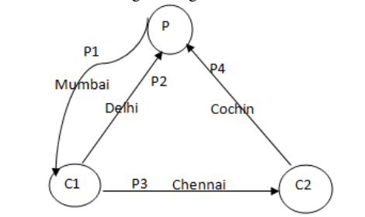

Demo :
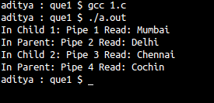

Code:
#include <stdio.h>
#include <stdlib.h>
#include <sys/types.h>
#include <sys/wait.h>
#include <sys/stat.h>
#include <fcntl.h>
#include <unistd.h>

int main(){
pid_t pid1, pid2, pid;
int p1[2], p2[2], p3[2], p4[2];
char buf1[16], buf2[16], buf3[16], buf4[16];
char cities[4][16] = {"Mumbai", "Delhi", "Cochin", "Chennai"};
if(pipe(p1) == -1 || pipe(p2) == -1 || pipe(p3) == -1 || pipe(p4) == -1){
perror("Pipe Error");
exit(1);
}

if((pid1 = fork()) < 0){ // Forking Child 1
perror("Failed to fork process \n");
exit(1);
}
else if ( pid1 > 0 ){
// Parent Here //
close(p1[0]); // Writing in Pipe 1
write(p1[1], cities[0], 16); //Writing "Mumbai" on Pipe 1
close(p1[1]);

close(p2[1]); // Reading in Pipe 2
if(read(p2[0], buf3, 16) == -1){
perror("Pipe 2, Parent: Error:");
} else {
printf("In Parent: Pipe 2 Read: %s\n", buf3);
}
close(p2[0]);
// FORKING CHILD 2 //
if((pid2 = fork()) < 0){
perror("Failed to fork process \n");
exit(1);
} else if (pid2 == 0) {
// CHILD 2 //
close(p3[1]);
if(read(p3[0], buf2, 16) == -1){
perror("Pipe 3, Child 2: Error:");
} else {
printf("In Child 2: Pipe 3 Read: %s\n", buf2);
}
close(p3[0]);

close(p4[0]);
write(p4[1], cities[2], 16); //Writing "Cochin" on Pipe 4
close(p4[1]);
// CHILD 2 DONE //
} else {
// PARENT HERE //
close(p4[1]); // Reading in Pipe 4
if(read(p4[0], buf4, 16) == -1){
perror("Pipe 4, PArent: Error:");
} else {
printf("In Parent: Pipe 4 Read: %s\n", buf4);
}
close(p4[0]);
}
}
else { // CHILD 1 (C1) //
close(p1[1]);
if(read(p1[0], buf1, 16) == -1){
perror("Pipe 1, Child 1: Error:");
} else {
printf("In Child 1: Pipe 1 Read: %s\n", buf1);
}
close(p1[0]);

close(p2[0]);
write(p2[1], cities[1], 16); // Writing "Delhi" on Pipe 2
close(p2[1]);

close(p3[0]);
write(p3[1], cities[3], 16); // Writing "Chennai" on Pipe 3
close(p3[1]);
}
}

2. Let P1 and P2 be two processes alternatively writing numbers from 1 to 100 to a file. Let P1 write odd numbers and p2, even. Implement the synchronization between the processes using FIFO.

Demo :
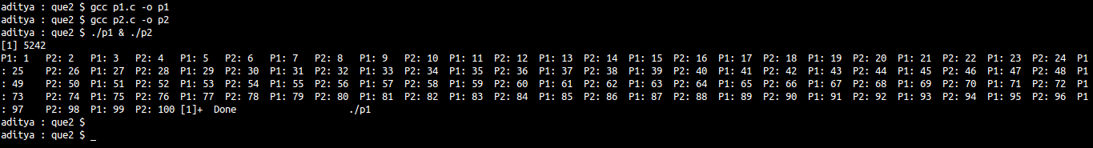
Code :
p1.c
---
#include <stdio.h>
#include <fcntl.h>
#include <sys/stat.h>
#include <sys/types.h>
#include <unistd.h>

int main()
{
int fd, num = 1;
char *fifofile = "fifofile";
mkfifo(fifofile, 0666);
char buf1[4], buf2[4];
while (1)
{
fd = open(fifofile, O_WRONLY);
snprintf (buf2, sizeof(buf2), "%d",num);
write(fd, buf2, sizeof(buf2));
close(fd);

fd = open(fifofile, O_RDONLY);
read(fd, buf1, sizeof(buf1));
printf("P2: %s\t", buf1);
fflush(NULL);
close(fd);
num = num + 2;
if(num > 100){
break;
}
}
return 0;
}

p2.c
----
#include <stdio.h>
#include <fcntl.h>
#include <sys/stat.h>
#include <sys/types.h>
#include <unistd.h>

int main()
{
int fd1, num=2;
char *fifofile = "fifofile";
mkfifo(fifofile, 0666);
char buf1[4], buf2[4];
while (1)
{
fd1 = open(fifofile,O_RDONLY);
read(fd1, buf1, sizeof(buf1));
printf("P1: %s\t", buf1);
fflush(NULL);
close(fd1);

fd1 = open(fifofile,O_WRONLY);
snprintf (buf2, sizeof(buf2), "%d",num);
write(fd1, buf2, sizeof(buf2));
close(fd1);

num = num + 2;
if(num > 100){
break;
}
}
return 0;
}

3. Implement a producer-consumer setup using shared memory and semaphore. Ensure that data doesn’t get over-written by the producer before the consumer reads and displays on the screen. Also ensure that the consumer doesn’t read the same data twice.

Code :
producer.c
---
#include<stdio.h>
#include<stdlib.h>
#include<sys/ipc.h>
#include<sys/types.h>
#include<sys/shm.h>
#include<sys/sem.h>
int main()
{
key_t key = 5678, skey = IPC_PRIVATE;
int i;
int shmid = shmget(key,10 , IPC_CREAT | 0666), semid = semget(skey, 1, IPC_CREAT | IPC_EXCL | 0666);
char *shm = shmat(shmid, NULL, 0), *ptr;
struct sembuf sb;

ptr = shm;
if(semid >= 0){

union semun{
int val;
struct semid_dss *buf;
short *array;
}arg;

arg.val = 1;
semctl(semid, 0, SETVAL, arg);
i = 0;
while(1){
if(i == 9){
ptr = shm;
i = 0;
}
sb.sem_num = 0;
sb.sem_op = -1;
semop(semid, &sb, 1);
if(*ptr == 'p'){
// buffer is full.
printf("Buffer is full it seems.\n");
sb.sem_num = 0;
sb.sem_op = 1;
semop(semid, &sb, 1);
continue;
}else{
printf("producing.\n");
*ptr = 'p';
ptr++;
i = (i + 1) % 10;
}
sb.sem_num = 0;
sb.sem_op = 1;
semop(semid, &sb, 1);
}
}
else{
printf("Semaphore error.\n");
}
shm[10] = NULL;
exit(0);
}

consumer.c
---
#include<stdio.h>
#include<stdlib.h>
#include<sys/ipc.h>
#include<sys/types.h>
#include<sys/shm.h>
#include<sys/sem.h>
int main()
{
key_t key = 5678, skey = IPC_PRIVATE;
int i;
int shmid = shmget(key,10 , IPC_CREAT | 0666), semid = semget(skey, 1, IPC_CREAT | IPC_EXCL | 0666);
char *shm = shmat(shmid, NULL, 0), *ptr;
struct sembuf sb;
ptr = shm;
if(semid >= 0){

union semun{
int val;
struct semid_dss *buf;
short *array;
}arg;

arg.val = 1;
semctl(semid, 0, SETVAL, arg);
i = 0;
while(1){
if(i == 9){
i = 0;
ptr = shm;
}

sb.sem_num = 0;
sb.sem_op = -1;
semop(semid, &sb, 1);
if(*ptr == 'c'){
// buffer is empty.
printf("Buffer is empty\n");
sb.sem_num = 0;
sb.sem_op = 1;
semop(semid, &sb, 1);
continue;
}else{
// get the semaphore
printf("Consuming\n");
*ptr = 'c';
ptr++;
i = (i + 1) % 10;
// release the semaphore
}

sb.sem_num = 0;
sb.sem_op = 1;
semop(semid, &sb, 1);

}

}
shm[10] = NULL;
exit(0);
}

