111403003 Akash Sarda
111403023 Aditya Malu
111403019 Jassim Abdul Rehman

LAB 2.

Code 1:

#include <stdio.h>
#include <sys/stat.h>
#include <string.h>
#include<stdlib.h>

void ls (char *pathname) {
struct stat sb = {0};
int s = stat(pathname, &sb);
printf("I-node number: %ld\n", (long) sb.st_ino);
printf("Mode: %lo (octal)\n",(unsigned long) sb.st_mode);
printf("Link count: %ld\n", (long) sb.st_nlink);
printf("Ownership: UID=%ld GID=%ld\n", (long) sb.st_uid, (long) sb.st_gid);
printf("Preferred I/O block size: %ld bytes\n", (long) sb.st_blksize);
printf("File size: %lld bytes\n",(long long) sb.st_size);
printf("Blocks allocated: %lld\n", (long long) sb.st_blocks);
printf("==================================================================\n");

}

int main() {
mkdir("junk", 0775);
int i;
FILE *fp;
char *dest1 = "./junk/";
char temp[20];
char dest2[20];
for(i = 1; i <= 5; i++) {
sprintf(dest2, "%d", i);
strcpy(temp, dest1);
strcat(temp, dest2);
fp = fopen(temp, "w+");
fwrite("hello" , 1 , 5 , fp );
fclose(fp);
}
ls("./junk");
char mode[100];
strcpy(mode, "0331");
char buf[100] = "junk";

i = strtol(mode, 0, 8);
chmod (buf,i);
ls("./");

strcpy(mode , "0775");
i = strtol(mode, 0, 8);
chmod(buf,i);
ls("./junk");

strcpy(mode , "0664");
i = strtol(mode, 0, 8);
chmod(buf,i);
ls("./junk");

strcpy(mode , "0775");
i = strtol(mode, 0, 8);
chmod(buf,i);
ls("./junk");

return 0;
}

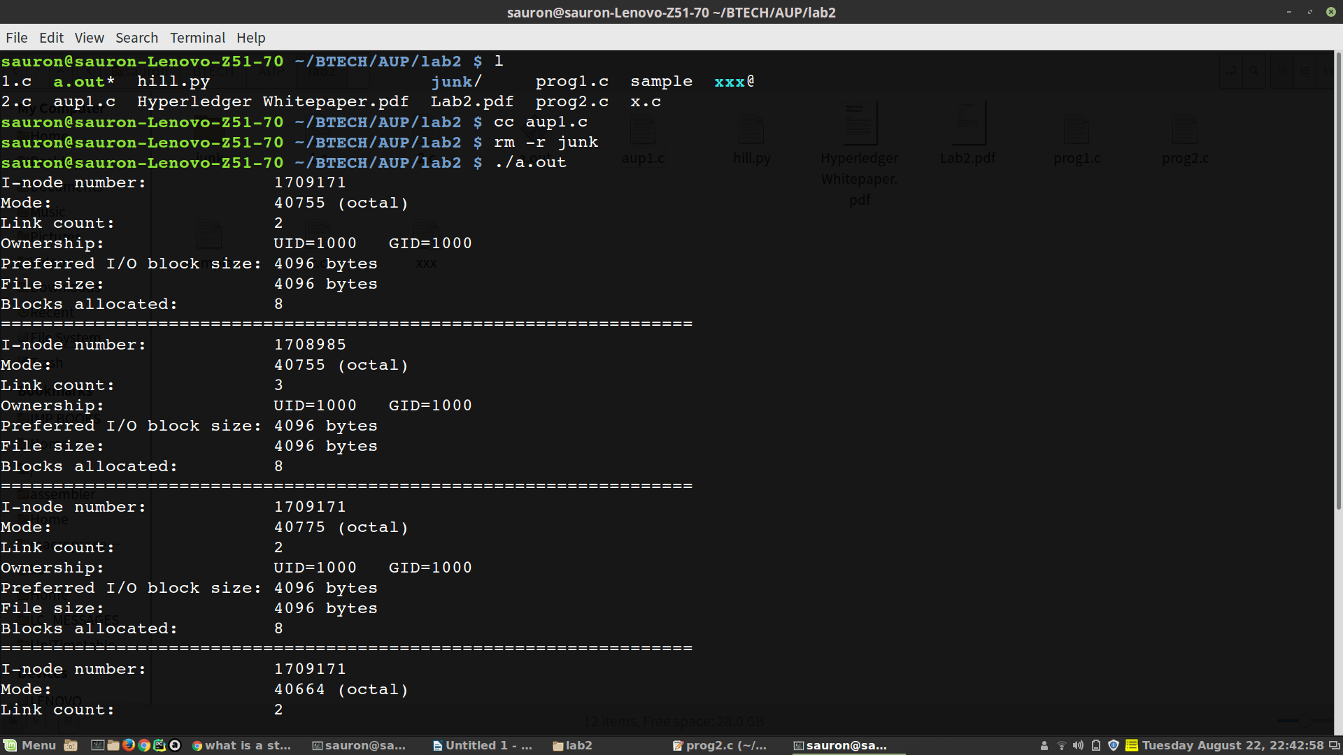

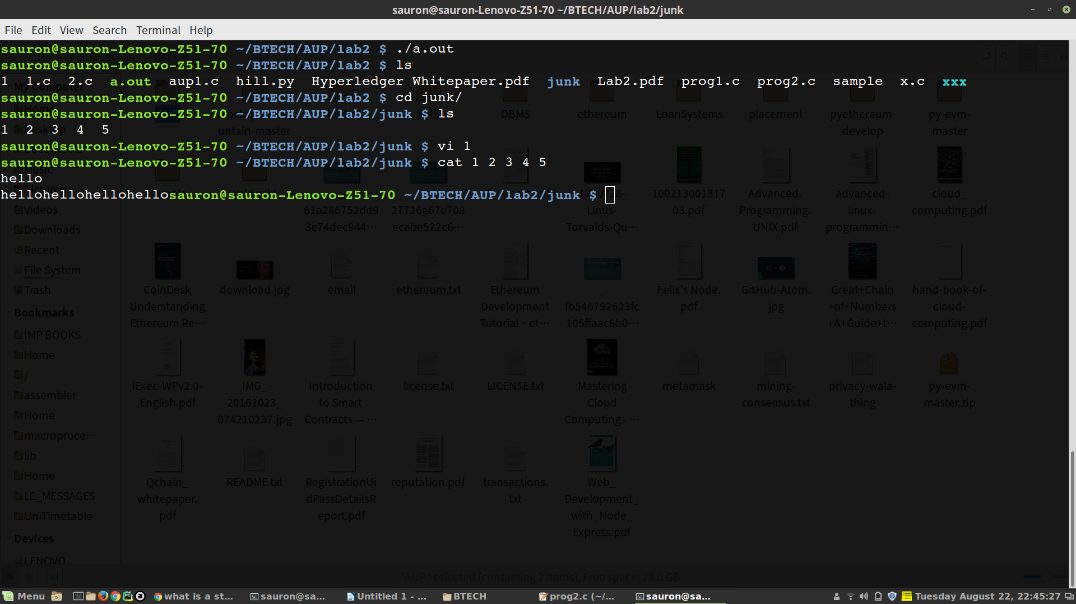

Code 2:
#include <stdio.h>
#include <sys/stat.h>
#include <sys/types.h>
#include <fcntl.h>
#include <unistd.h>
#include <dirent.h>
#include <string.h>
#include <time.h>
#include <pwd.h>
#include <grp.h>

int main(int argc, char *argv[]){
int r, n;
char dname[16], ftmp[16], fname[16], linkpar[64];
struct stat st;
mode_t mode;
DIR *dir;
struct dirent *ent;

if(argc > 1)
strcpy(dname, argv[1]);
else
strcpy(dname, ".");

strcpy(fname, dname);
strcat(fname, "/");

dir = opendir(dname);
if(!dir){
printf("Error opening directory\n");
return 0;
}
while((ent = readdir(dir)) != NULL){
if(strcmp(ent->d_name, ".") != 0 && strcmp(ent->d_name, "..") != 0){
strcpy(ftmp, fname);
strcat(ftmp, ent->d_name);
lstat(ftmp, &st);

if(S_ISLNK(st.st_mode)){
printf("%s : ", ftmp);
while(S_ISLNK(st.st_mode)){
r = readlink(ftmp, linkpar, 63);
if(r == -1){
printf("Link broken\n");
break;
}
linkpar[r] = '\0';

strcpy(ftmp, linkpar);
lstat(ftmp, &st);
}
printf("%s\n", ftmp);
}
}
}
}

problem 3:

yes it is possible by enabling the sticky bit of the directory.
A Sticky bit is a permission bit that is set on a file or a directory that lets only the owner of the file/directory or the root user to delete or rename the file. No other user is given privileges to delete the file created by some other user.

