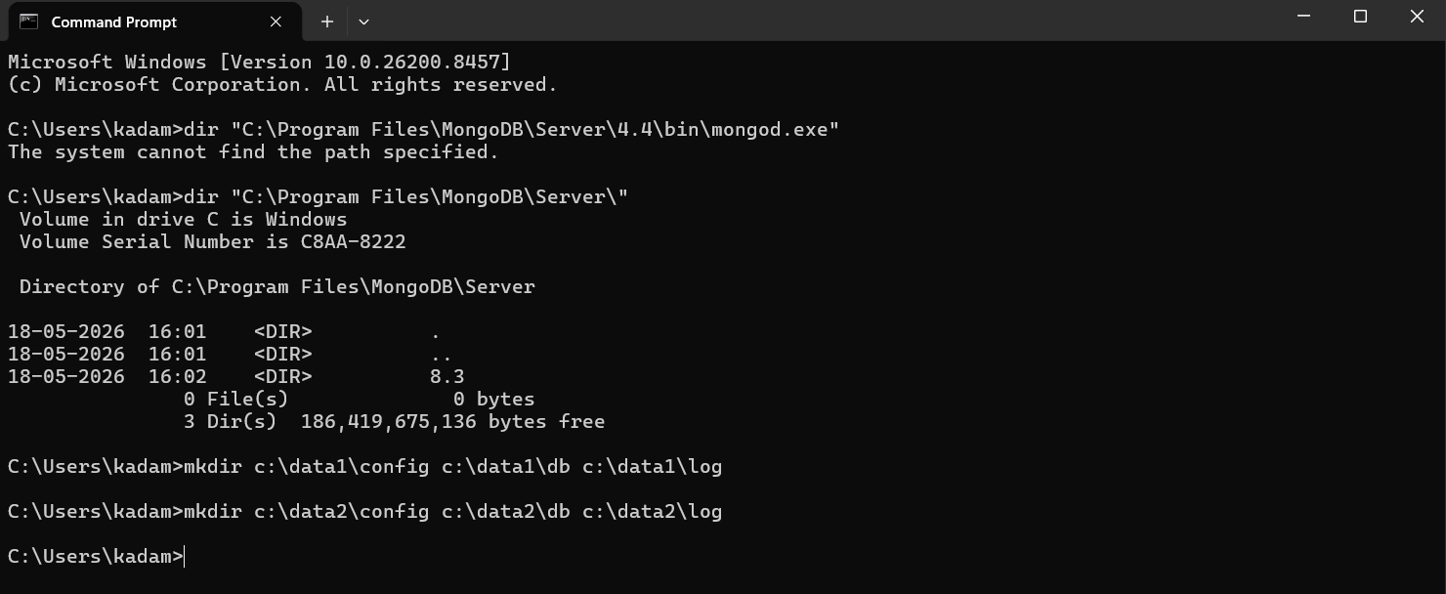

Path 1
Microsoft Windows [Version 10.0.26200.8457]
(c) Microsoft Corporation. All rights reserved.

C:\Windows\System32>"C:\Program Files\MongoDB\Server\8.3\bin\mongod.exe" --dbpath "C:\Program Files\MongoDB\Server\8.3\data" --logpath "C:\Program Files\MongoDB\Server\8.3\log\mongod.log" --port 27017 --storageEngine=wiredTiger --journal --replSet prodrep
{"t":{"$date":"2026-06-09T19:43:25.674+05:30"},"s":"I", "c":"-", "id":8991200, "ctx":"thread1","msg":"Shuffling initializers","attr":{"seed":3892783368}}
Error parsing command line: unrecognised option '--journal'
try 'C:\Program Files\MongoDB\Server\8.3\bin\mongod.exe --help' for more information

C:\Windows\System32>"C:\Program Files\MongoDB\Server\8.3\bin\mongod.exe" --dbpath "C:\Program Files\MongoDB\Server\8.3\data" --logpath "C:\Program Files\MongoDB\Server\8.3\log\mongod.log" --port 27017 --storageEngine=wiredTiger --replSet prodrep
{"t":{"$date":"2026-06-09T19:44:01.034+05:30"},"s":"I", "c":"-", "id":8991200, "ctx":"thread1","msg":"Shuffling initializers","attr":{"seed":1071031375}}
{"t":{"$date":"2026-06-09T19:44:01.055+05:30"},"s":"I", "c":"CONTROL", "id":20697, "ctx":"thread1","msg":"Renamed existing log file","attr":{"oldLogPath":"C:\\Program Files\\MongoDB\\Server\\8.3\\log\\mongod.log","newLogPath":"C:\\Program Files\\MongoDB\\Server\\8.3\\log\\mongod.log.2026-06-09T14-14-01"}}
Path 2
Microsoft Windows [Version 10.0.26200.8457]
(c) Microsoft Corporation. All rights reserved.

C:\Windows\System32>"C:\Program Files\MongoDB\Server\8.3\bin\mongod.exe" --dbpath "C:\data2\db" --logpath "C:\data2\log\mongod.log" --port 27030 --storageEngine=wiredTiger --journal --replSet prodrep
{"t":{"$date":"2026-06-09T19:44:38.145+05:30"},"s":"I", "c":"-", "id":8991200, "ctx":"thread1","msg":"Shuffling initializers","attr":{"seed":4203563202}}
Error parsing command line: unrecognised option '--journal'
try 'C:\Program Files\MongoDB\Server\8.3\bin\mongod.exe --help' for more information

C:\Windows\System32>"C:\Program Files\MongoDB\Server\8.3\bin\mongod.exe" --dbpath "C:\data2\db" --logpath "C:\data2\log\mongod.log" --port 27030 --storageEngine=wiredTiger --replSet prodrep
{"t":{"$date":"2026-06-09T19:44:55.700+05:30"},"s":"I", "c":"-", "id":8991200, "ctx":"thread1","msg":"Shuffling initializers","attr":{"seed":4139480897}}

Path 3
Microsoft Windows [Version 10.0.26200.8457]
(c) Microsoft Corporation. All rights reserved.

C:\Windows\System32>"C:\Program Files\MongoDB\Server\8.3\bin\mongod.exe" --dbpath "C:\data2\db" --logpath "C:\data2\log\mongod.log" --port 27030 --storageEngine=wiredTiger --journal --replSet prodrep
{"t":{"$date":"2026-06-09T19:48:18.706+05:30"},"s":"I", "c":"-", "id":8991200, "ctx":"thread1","msg":"Shuffling initializers","attr":{"seed":3709516518}}
Error parsing command line: unrecognised option '--journal'
try 'C:\Program Files\MongoDB\Server\8.3\bin\mongod.exe --help' for more information

C:\Windows\System32>"C:\Program Files\MongoDB\Server\8.3\bin\mongod.exe" --dbpath "C:\data2\db" --logpath "C:\data2\log\mongod.log" --port 27030 --storageEngine=wiredTiger --replSet prodrep
{"t":{"$date":"2026-06-09T19:48:26.817+05:30"},"s":"I", "c":"-", "id":8991200, "ctx":"thread1","msg":"Shuffling initializers","attr":{"seed":4007713749}}
{"t":{"$date":"2026-06-09T19:48:26.832+05:30"},"s":"I", "c":"CONTROL", "id":20697, "ctx":"thread1","msg":"Renamed existing log file","attr":{"oldLogPath":"C:\\data2\\log\\mongod.log","newLogPath":"C:\\data2\\log\\mongod.log.2026-06-09T14-18-26"}}

C:\Windows\System32>
Connecting to Primary Shell

Microsoft Windows [Version 10.0.26200.8457]
(c) Microsoft Corporation. All rights reserved.

C:\Windows\System32>"C:\Program Files\MongoDB\Server\8.3\bin\mongosh.exe" --port 27017
'"C:\Program Files\MongoDB\Server\8.3\bin\mongosh.exe"' is not recognized as an internal or external command,
operable program or batch file.

C:\Windows\System32>

