CREATE: YASH PRADHAN

package MongoDB;
import com.mongodb.client.*;
import com.mongodb.client.model.Filters;
import com.mongodb.client.model.Updates;
import org.bson.Document;

public class Mongo {

public static void main(String[] args) {

// Connect to MongoDB
MongoClient mongoClient = MongoClients.create("mongodb://localhost:27017");

// Access database
MongoDatabase database = mongoClient.getDatabase("CollegeDB");

// Access collection
MongoCollection<Document> collection = database.getCollection("Students");

// ==========================
// CREATE (Insert One)
// ==========================
Document student = new Document("id", 101)
.append("name", "John")
.append("department", "CSE")
.append("cgpa", 8.7)
.append("tempField", "toRemove");

collection.insertOne(student);
System.out.println("Document Inserted Successfully");

mongoClient.close();
}
}
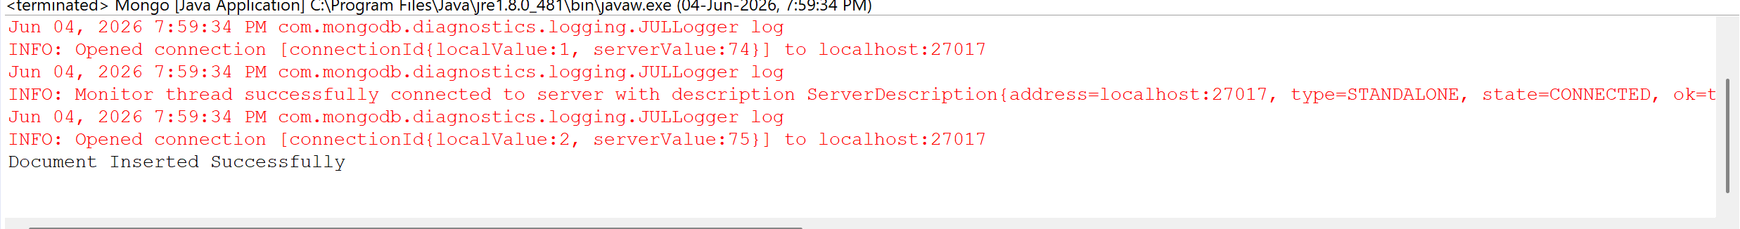

READ:

package MongoDB;
import com.mongodb.client.*;
import com.mongodb.client.model.Filters;
import com.mongodb.client.model.Updates;
import org.bson.Document;

public class Mongo {

public static void main(String[] args) {

// Connect to MongoDB
MongoClient mongoClient = MongoClients.create("mongodb://localhost:27017");

// Access database
MongoDatabase database = mongoClient.getDatabase("CollegeDB");

// Access collection
MongoCollection<Document> collection = database.getCollection("Students");

// ==========================
// READ (Find)
// ==========================
System.out.println("\nStudent Records:");
FindIterable<Document> students = collection.find();
for (Document doc : students) {
System.out.println(doc.toJson());
}

mongoClient.close();
}
}
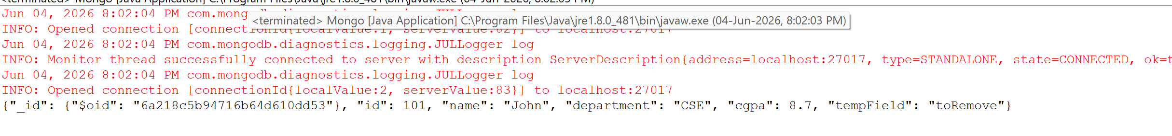

UPDATE (set,unset,rename):

package MongoDB;
import com.mongodb.client.*;
import com.mongodb.client.model.Filters;
import com.mongodb.client.model.Updates;
import org.bson.Document;

public class Mongo {

public static void main(String[] args) {

// Connect to MongoDB
MongoClient mongoClient = MongoClients.create("mongodb://localhost:27017");

// Access database
MongoDatabase database = mongoClient.getDatabase("CollegeDB");

// Access collection
MongoCollection<Document> collection = database.getCollection("Students");

// ==========================
// UPDATE ONE (set, rename, unset)
// ==========================
collection.updateOne(
Filters.eq("id", 101),
Updates.combine(
Updates.set("cgpa", 9.2), // update value
Updates.rename("department", "dept"), // rename field
Updates.unset("tempField") // remove field
)
);
System.out.println("\nDocument Updated Successfully");

// ==========================
// READ Updated Record
// ==========================
Document updatedStudent = collection.find(Filters.eq("id", 101)).first();
System.out.println("\nUpdated Record:");
System.out.println(updatedStudent.toJson());

mongoClient.close();
}
}
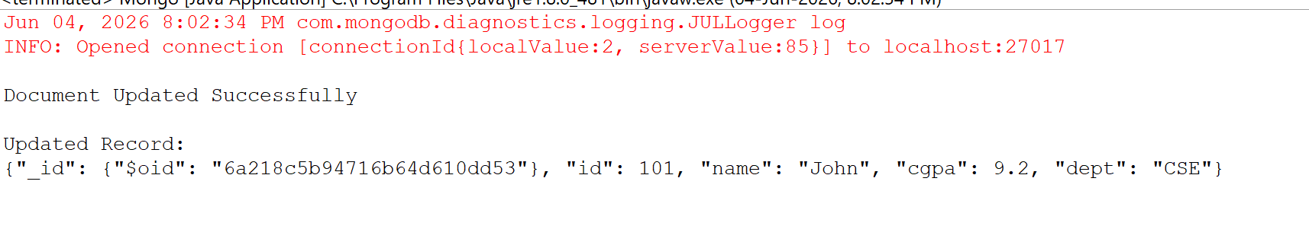

DELETE:

package MongoDB;
import com.mongodb.client.*;
import com.mongodb.client.model.Filters;
import com.mongodb.client.model.Updates;
import org.bson.Document;

public class Mongo {

public static void main(String[] args) {

// Connect to MongoDB
MongoClient mongoClient = MongoClients.create("mongodb://localhost:27017");

// Access database
MongoDatabase database = mongoClient.getDatabase("CollegeDB");

// Access collection
MongoCollection<Document> collection = database.getCollection("Students");

// ==========================
// DELETE ONE
// ==========================
collection.deleteOne(Filters.eq("id", 101));
System.out.println("\nDocument Deleted Successfully");

// Close connection
mongoClient.close();
}
}

