PROJECT REPORT
Student Management System
Python • Flask • MongoDB • Docker

Project Title | Student Management System
Type | Full-Stack Backend Application
Language | Python 3.8+
Framework | Flask (REST API)
Database | MongoDB 6.0
Interface | REST API + Console CLI
Containerization | Docker & Docker Compose
Date | 18 June 2026

1. Project Title & Introduction

Project Title: Student Management System
This project is a complete backend solution for managing student records in an academic institution. It exposes a fully-featured RESTful API built with Flask and persists data in MongoDB. A complementary console-based CLI is also provided for direct database interaction without going through the HTTP layer.
The system was designed to be production-ready from the ground up supporting authentication, pagination, filtering, bulk import/export, and containerized deployment via Docker.

2. Objectives

- Provide a robust REST API for full CRUD operations on student records.
- Enforce data integrity through unique student_id indexing at the database level.
- Support bulk data operations via CSV import and export.
- Implement token-based API authentication using an X-API-KEY header.
- Enable flexible querying with search filters, pagination, and sorting.
- Package the entire application for containerized deployment using Docker.
- Provide a console CLI for direct MongoDB interaction without the HTTP layer.

3. Outcome

The project successfully delivers a fully functional student management backend with the following outcomes:

3.1 REST API
A Flask-based HTTP API running on port 5000 that exposes all CRUD endpoints, supports query-based filtering (by student_id, name, department), paginated listing, and configurable sort order. The API returns well-structured JSON for all success and error responses.

3.2 Data Integrity
A unique index on student_id at the MongoDB collection level ensures no duplicate records can be inserted at either the API or CLI layer. Duplicate insert attempts return a clear 409 Conflict response.

3.3 Bulk Operations
POST /students/import accepts raw CSV text or a multipart file upload, parsing each row and inserting valid records while collecting per-row errors. GET /students/export streams a CSV attachment of all (or filtered) students for easy data extraction.

3.4 Authentication
Optional token-based authentication is activated by setting the API_KEY environment variable. When set, all endpoints require the X-API-KEY request header, returning 401 Unauthorized on mismatch.

3.5 Docker Deployment
A Dockerfile and docker-compose.yml together spin up the Flask API alongside a MongoDB 6.0 container in a single command (docker-compose up --build), eliminating environment dependency issues on any machine.

3.6 Console CLI
A standalone cli.py provides a menu-driven interface for Create, List, Search, Update, Delete, CSV Import, and CSV Export directly against MongoDB useful for administrative tasks and development without running the API server.

4. API Endpoints

Method | Endpoint | Description
GET | /students | List students with filter, pagination, sort
POST | /students | Create a new student record
GET | /students/<id> | Retrieve a single student by student_id
PUT | /students/<id> | Update fields of an existing student
DELETE | /students/<id> | Delete a student record
POST | /students/import | Bulk import students from CSV
GET | /students/export | Export all/filtered students as CSV

5. Tools & Technologies Used

Tool / Library | Version | Purpose
Python | 3.8+ | Core programming language for API and CLI
Flask | 3.x | Lightweight WSGI web framework for REST API
PyMongo | 4.x | Official MongoDB driver for Python
MongoDB | 6.0 | NoSQL document database for student records
python-dotenv | Latest | Environment variable management via .env files
Docker | 24+ | Application containerization platform
Docker Compose | v2 | Multi-container orchestration (API + MongoDB)
Postman | 10.x | API testing — collection and environment included
pytest | 7.x | Automated testing framework for the API
csv (stdlib) | Built-in | CSV import and export processing

6. Summary

The Student Management System is a clean, well-structured backend project that demonstrates several real-world engineering practices in a single cohesive application. At its core it provides a Flask REST API backed by MongoDB, supporting the full lifecycle of a student record creation, retrieval, update, and deletion with proper HTTP status codes and error handling at every step.
Beyond basic CRUD, the project adds meaningful features: CSV bulk import/export for data migration scenarios, optional API key authentication for access control, and MongoDB-level unique indexing to prevent duplicate records. The list endpoint supports name/department filtering, sort direction, and page-based pagination making it suitable for integration with a real frontend.
The console CLI rounds out the toolset, allowing administrators to interact with the database directly without an HTTP server, which is invaluable during development, debugging, or scripted tasks.
Docker support ensures the project can be started on any machine with a single command, solving the classic 'works on my machine' problem. The included Postman collection and environment make manual testing or onboarding of new developers fast and friction-free.

7. Conclusion

This project successfully demonstrates how to build a production-minded RESTful backend using Python and MongoDB. It goes beyond a simple tutorial by incorporating authentication, pagination, bulk data handling, automated testing support, and containerization all of which are expectations in professional software environments.
The dual-interface design (REST API + Console CLI) shows an understanding that different use cases require different tools, and the Docker packaging ensures the project is deployable anywhere without manual environment setup.
Overall, the Student Management System is a solid foundation that can be extended with features such as role-based access control, integration with a frontend framework, grade and course management modules, or deployment to a cloud platform making it a genuinely scalable starting point for an institutional management application.

8. Screen Shot of the API and Project

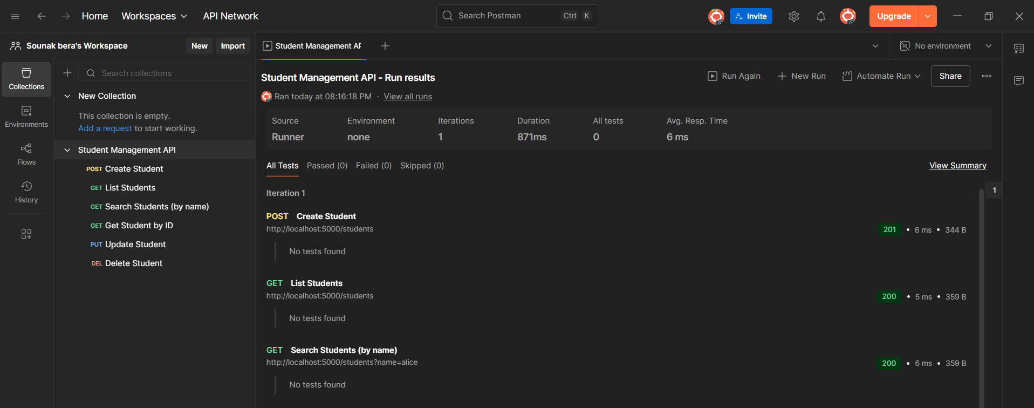

This is the student Management API console in the postman

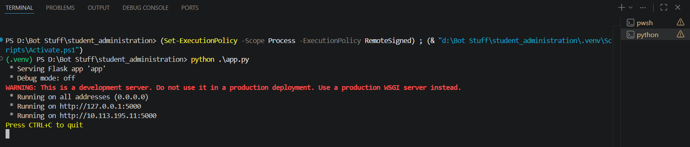

Running the development server using the management API console in the dialog box

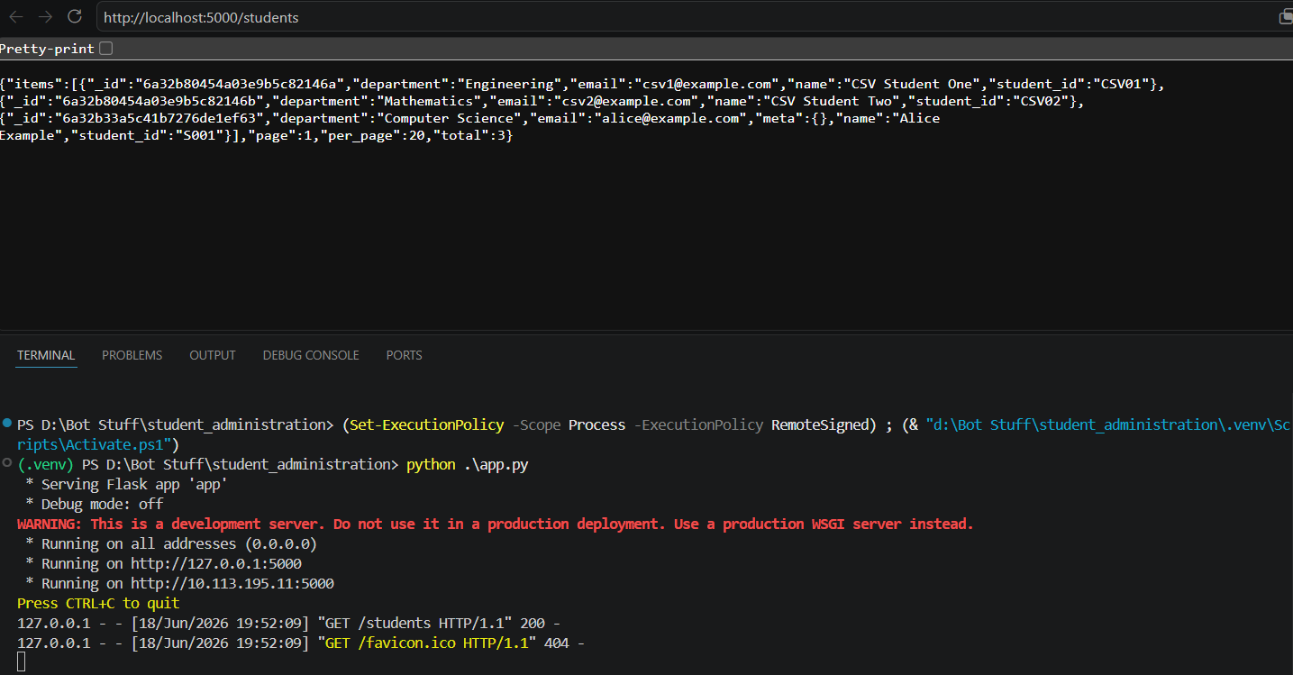

Using http://localhost:5000/students for all the student that are in the database

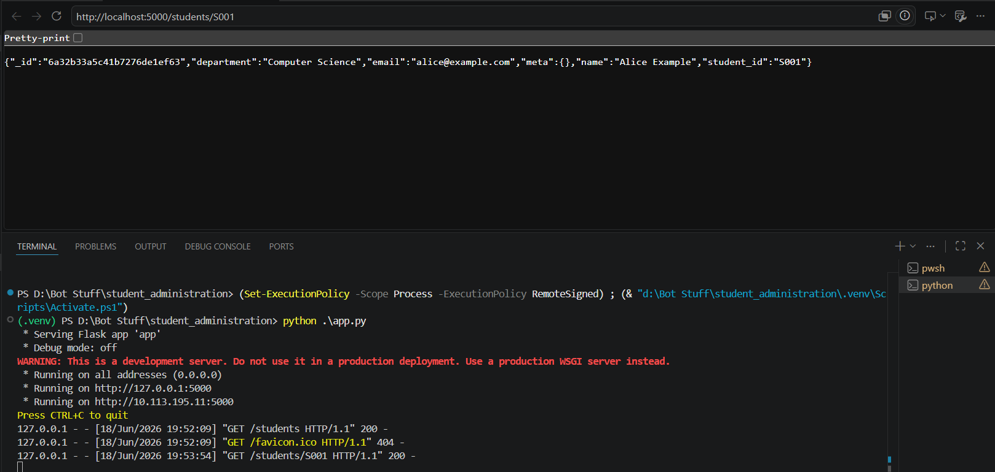

Using specific http://localhost:5000/students/S001 for some specific student are in the database

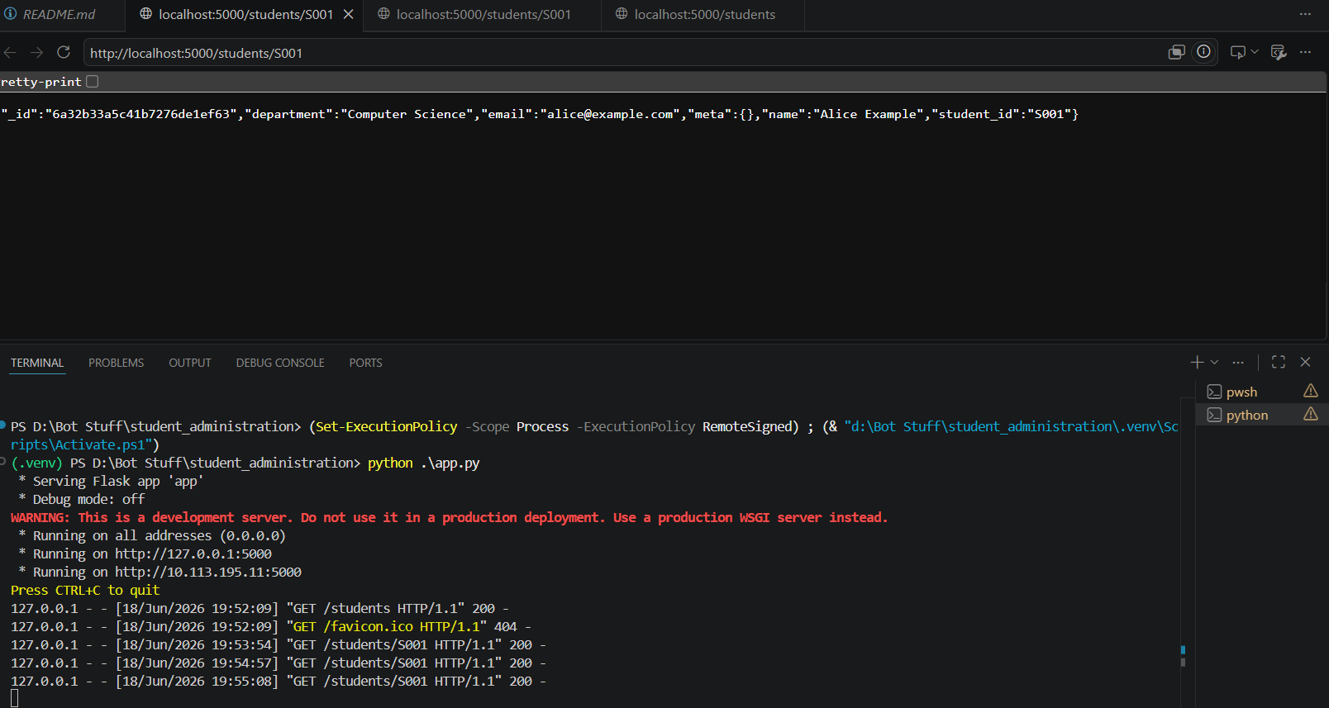

Removed using the DELETE API http://localhost:5000/students/S001

