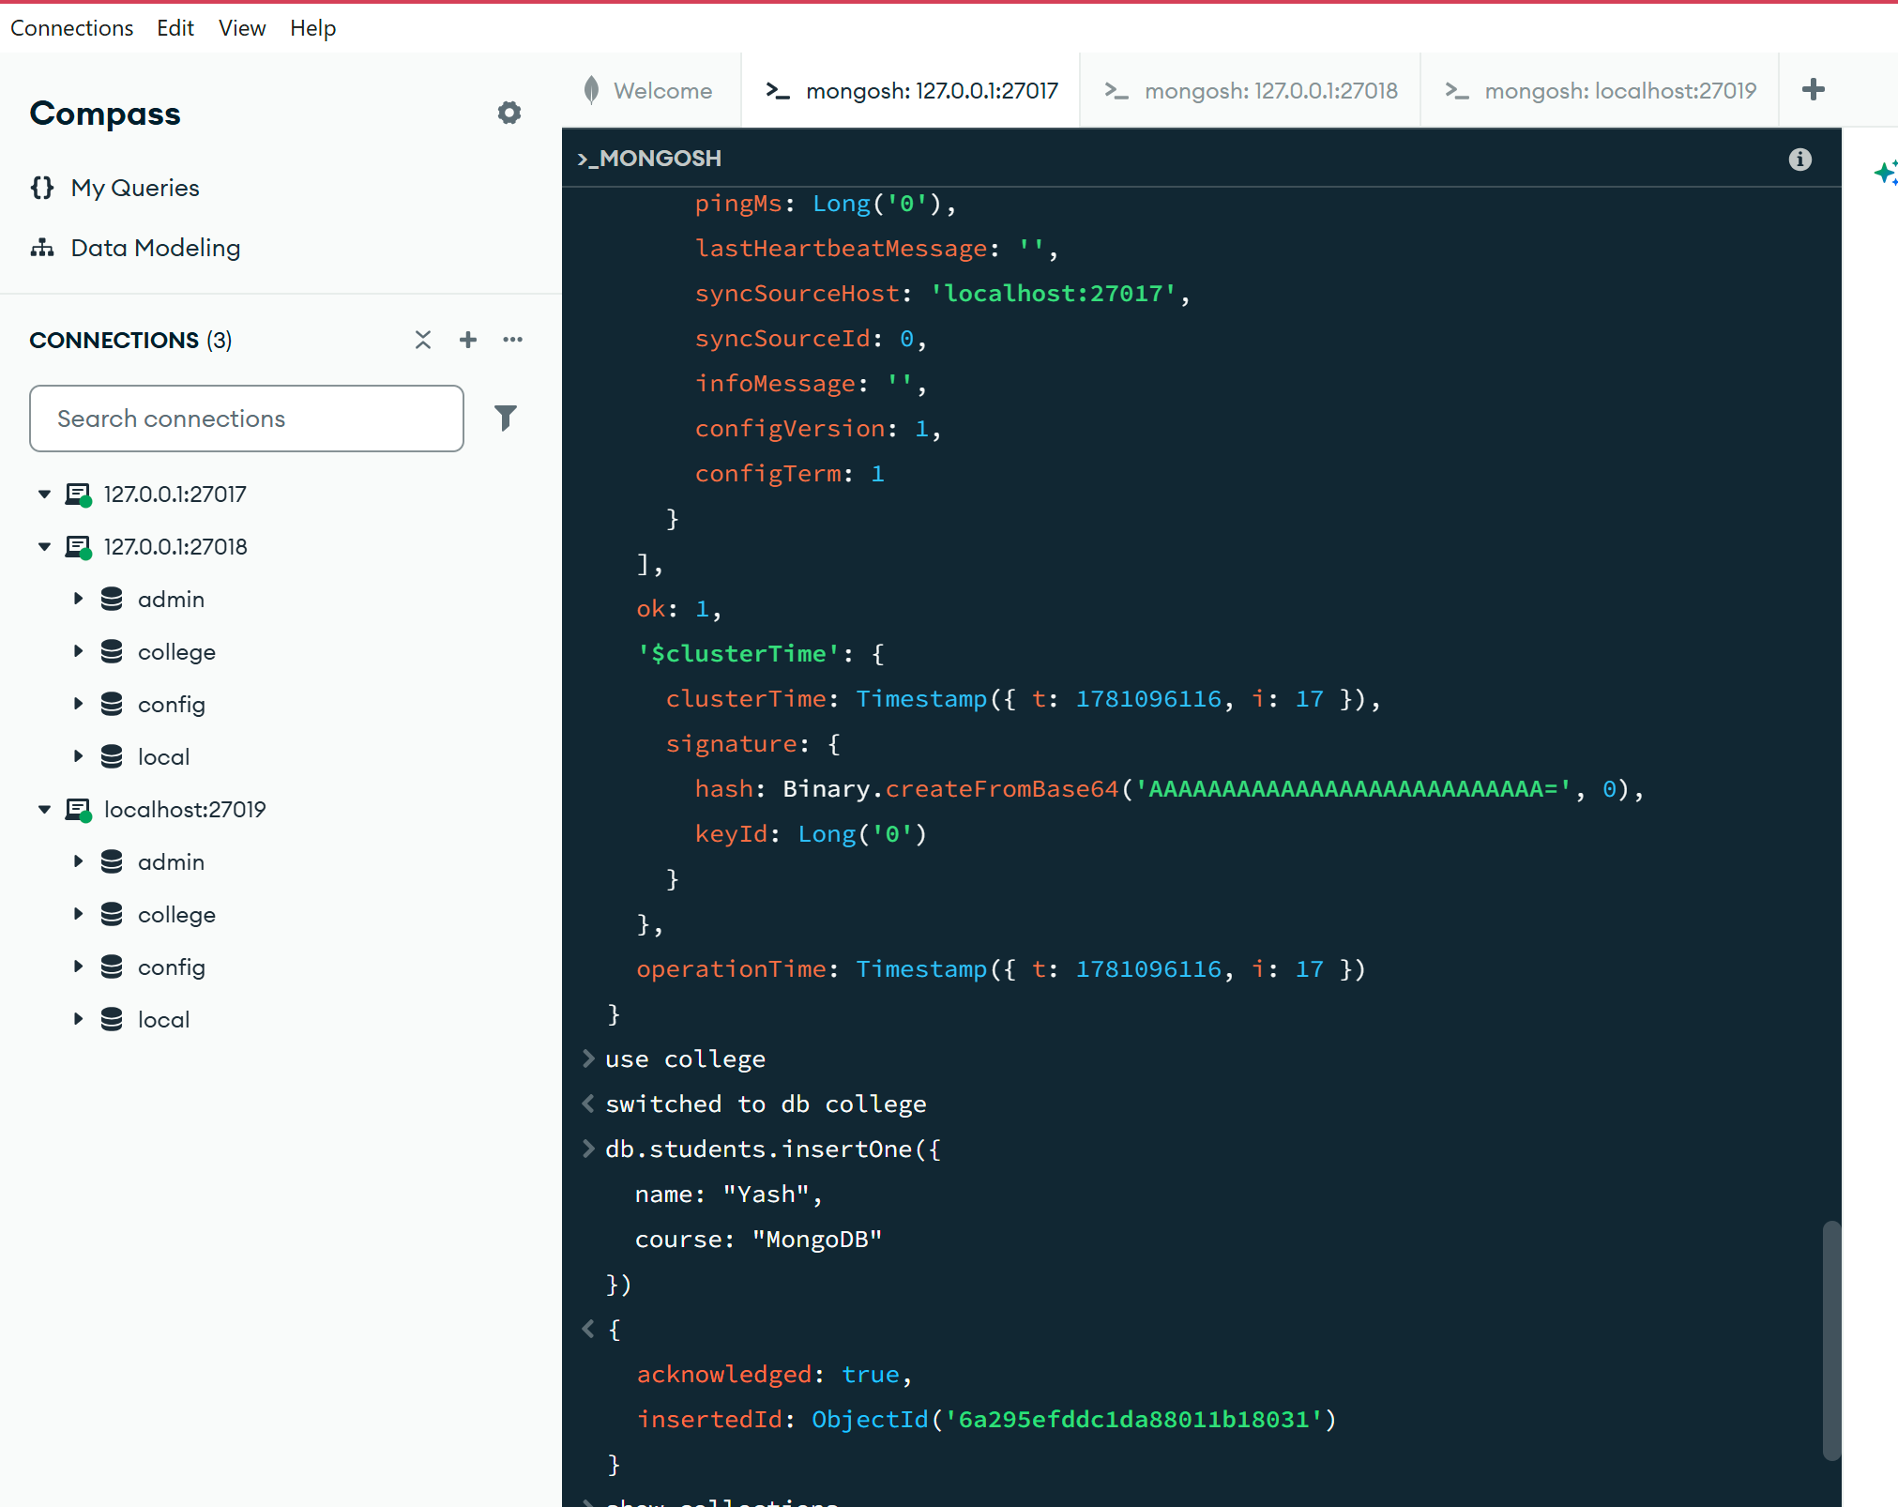
INITIATE AND ADD+(HEALTH)
rs.initiate({
_id: "myReplSet",
members: [
{ _id: 0, host: "localhost:27017" },
{ _id: 1, host: "localhost:27018" },
{ _id: 2, host: "localhost:27019" }
]
})
{
ok: 1,
'$clusterTime': {
clusterTime: Timestamp({ t: 1781096104, i: 1 }),
signature: {
hash: Binary.createFromBase64('AAAAAAAAAAAAAAAAAAAAAAAAAAA=', 0),
keyId: Long('0')
}
},
operationTime: Timestamp({ t: 1781096104, i: 1 })
}
rs.status()
{
lastHeartbeatMessage: ''
},
{
_id: 1,
name: 'localhost:27018',
health: 1,
state: 2,
stateStr: 'SECONDARY',
uptime: 19,
optime: { ts: Timestamp({ t: 1781096116, i: 17 }), t: Long('1') },
optimeDurable: { ts: Timestamp({ t: 1781096116, i: 17 }), t: Long('1') },
optimeWritten: { ts: Timestamp({ t: 1781096116, i: 17 }), t: Long('1') },
optimeDate: 2026-06-10T12:55:16.000Z,
optimeDurableDate: 2026-06-10T12:55:16.000Z,
optimeWrittenDate: 2026-06-10T12:55:16.000Z,
lastAppliedWallTime: 2026-06-10T12:55:16.811Z,
lastDurableWallTime: 2026-06-10T12:55:16.811Z,
lastWrittenWallTime: 2026-06-10T12:55:16.811Z,
lastHeartbeat: 2026-06-10T12:55:24.467Z,
lastHeartbeatRecv: 2026-06-10T12:55:23.630Z,
pingMs: Long('1'),
lastHeartbeatMessage: '',
syncSourceHost: 'localhost:27017',
syncSourceId: 0,
infoMessage: '',
configVersion: 1,
configTerm: 1
},
{
_id: 2,
name: 'localhost:27019',
health: 1,
state: 2,
stateStr: 'SECONDARY',
uptime: 19,
optime: { ts: Timestamp({ t: 1781096116, i: 17 }), t: Long('1') },
optimeDurable: { ts: Timestamp({ t: 1781096116, i: 17 }), t: Long('1') },
optimeWritten: { ts: Timestamp({ t: 1781096116, i: 17 }), t: Long('1') },
optimeDate: 2026-06-10T12:55:16.000Z,
optimeDurableDate: 2026-06-10T12:55:16.000Z,
optimeWrittenDate: 2026-06-10T12:55:16.000Z,
lastAppliedWallTime: 2026-06-10T12:55:16.811Z,
lastDurableWallTime: 2026-06-10T12:55:16.811Z,
lastWrittenWallTime: 2026-06-10T12:55:16.811Z,
lastHeartbeat: 2026-06-10T12:55:24.467Z,
lastHeartbeatRecv: 2026-06-10T12:55:23.677Z,
pingMs: Long('0'),
lastHeartbeatMessage: '',
syncSourceHost: 'localhost:27017',
syncSourceId: 0,
infoMessage: '',
configVersion: 1,
configTerm: 1
}
],
ok: 1,
'$clusterTime': {
clusterTime: Timestamp({ t: 1781096116, i: 17 }),
signature: {
hash: Binary.createFromBase64('AAAAAAAAAAAAAAAAAAAAAAAAAAA=', 0),
keyId: Long('0')
}
},
operationTime: Timestamp({ t: 1781096116, i: 17 })
}
use college
switched to db college
db.students.insertOne({
name: "Yash",
course: "MongoDB"
})

INSERT/DELETE TRY FROM SECONDARY:

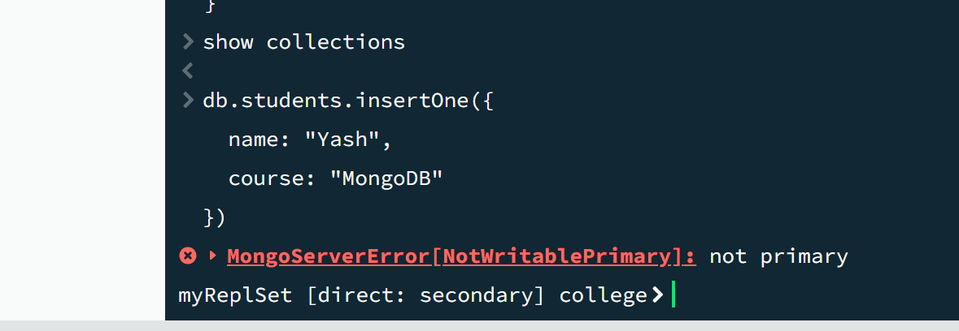

AFTER PORT 18 is primary:

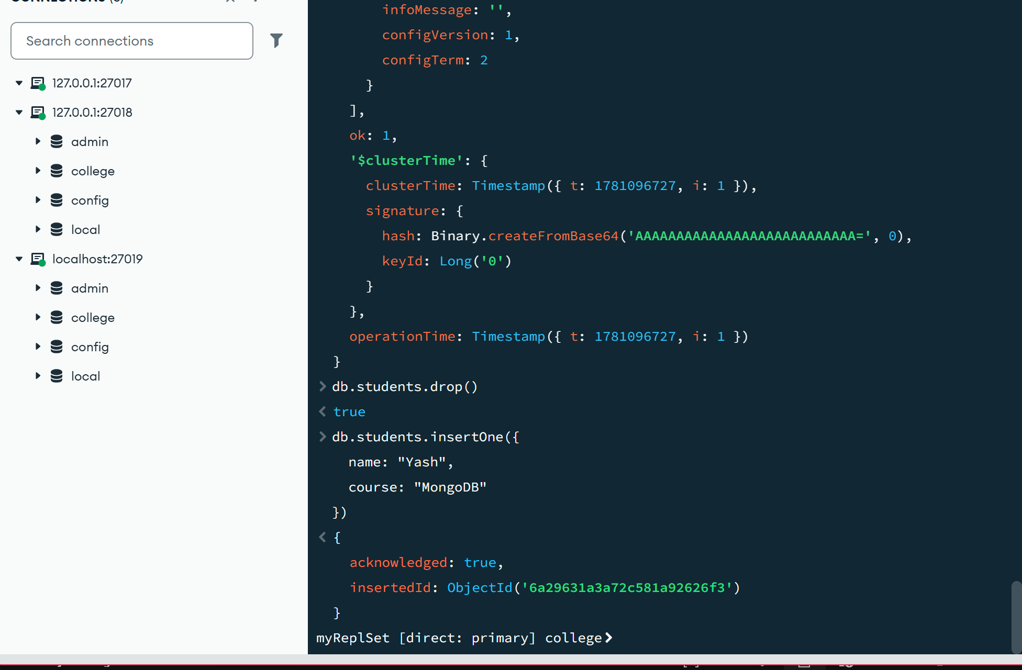

use college
switched to db college
db.students.find()
{
_id: ObjectId('6a295efddc1da88011b18031'),
name: 'Yash',
course: 'MongoDB'
}
rs.status()
{
syncSourceHost: '',
syncSourceId: -1,
infoMessage: '',
configVersion: 1,
configTerm: 2
},
{
_id: 1,
name: 'localhost:27018',
health: 1,
state: 1,
stateStr: 'PRIMARY',
uptime: 381,
optime: { ts: Timestamp({ t: 1781096326, i: 1 }), t: Long('2') },
optimeDate: 2026-06-10T12:58:46.000Z,
optimeWritten: { ts: Timestamp({ t: 1781096326, i: 1 }), t: Long('2') },
optimeWrittenDate: 2026-06-10T12:58:46.000Z,
lastAppliedWallTime: 2026-06-10T12:58:46.691Z,
lastDurableWallTime: 2026-06-10T12:58:46.691Z,
lastWrittenWallTime: 2026-06-10T12:58:46.691Z,
syncSourceHost: '',
syncSourceId: -1,
infoMessage: '',
electionTime: Timestamp({ t: 1781096306, i: 1 }),
electionDate: 2026-06-10T12:58:26.000Z,
configVersion: 1,
configTerm: 2,
self: true,
lastHeartbeatMessage: ''
},
{
_id: 2,
name: 'localhost:27019',
health: 1,
state: 2,
stateStr: 'SECONDARY',
uptime: 228,
optime: { ts: Timestamp({ t: 1781096326, i: 1 }), t: Long('2') },
optimeDurable: { ts: Timestamp({ t: 1781096326, i: 1 }), t: Long('2') },
optimeWritten: { ts: Timestamp({ t: 1781096326, i: 1 }), t: Long('2') },
optimeDate: 2026-06-10T12:58:46.000Z,
optimeDurableDate: 2026-06-10T12:58:46.000Z,
optimeWrittenDate: 2026-06-10T12:58:46.000Z,
lastAppliedWallTime: 2026-06-10T12:58:46.691Z,
lastDurableWallTime: 2026-06-10T12:58:46.691Z,
lastWrittenWallTime: 2026-06-10T12:58:46.691Z,
lastHeartbeat: 2026-06-10T12:58:52.928Z,
lastHeartbeatRecv: 2026-06-10T12:58:52.833Z,
pingMs: Long('2'),
lastHeartbeatMessage: '',
syncSourceHost: 'localhost:27018',
syncSourceId: 1,
infoMessage: '',
configVersion: 1,
configTerm: 2
}
],
ok: 1,
'$clusterTime': {
clusterTime: Timestamp({ t: 1781096326, i: 1 }),
signature: {
hash: Binary.createFromBase64('AAAAAAAAAAAAAAAAAAAAAAAAAAA=', 0),
keyId: Long('0')
}
},
operationTime: Timestamp({ t: 1781096326, i: 1 })
}
rs.status()
{
},
{
_id: 1,
name: 'localhost:27018',
health: 1,
state: 1,
stateStr: 'PRIMARY',
uptime: 780,
optime: { ts: Timestamp({ t: 1781096727, i: 1 }), t: Long('2') },
optimeDate: 2026-06-10T13:05:27.000Z,
optimeWritten: { ts: Timestamp({ t: 1781096727, i: 1 }), t: Long('2') },
optimeWrittenDate: 2026-06-10T13:05:27.000Z,
lastAppliedWallTime: 2026-06-10T13:05:27.272Z,
lastDurableWallTime: 2026-06-10T13:05:27.272Z,
lastWrittenWallTime: 2026-06-10T13:05:27.272Z,
syncSourceHost: '',
syncSourceId: -1,
infoMessage: '',
electionTime: Timestamp({ t: 1781096306, i: 1 }),
electionDate: 2026-06-10T12:58:26.000Z,
configVersion: 1,
configTerm: 2,
self: true,
lastHeartbeatMessage: ''
},
{
_id: 2,
name: 'localhost:27019',
health: 1,
state: 2,
stateStr: 'SECONDARY',
uptime: 628,
optime: { ts: Timestamp({ t: 1781096727, i: 1 }), t: Long('2') },
optimeDurable: { ts: Timestamp({ t: 1781096727, i: 1 }), t: Long('2') },
optimeWritten: { ts: Timestamp({ t: 1781096727, i: 1 }), t: Long('2') },
optimeDate: 2026-06-10T13:05:27.000Z,
optimeDurableDate: 2026-06-10T13:05:27.000Z,
optimeWrittenDate: 2026-06-10T13:05:27.000Z,
lastAppliedWallTime: 2026-06-10T13:05:27.272Z,
lastDurableWallTime: 2026-06-10T13:05:27.272Z,
lastWrittenWallTime: 2026-06-10T13:05:27.272Z,
lastHeartbeat: 2026-06-10T13:05:32.465Z,
lastHeartbeatRecv: 2026-06-10T13:05:32.431Z,
pingMs: Long('2'),
lastHeartbeatMessage: '',
syncSourceHost: 'localhost:27018',
syncSourceId: 1,
infoMessage: '',
configVersion: 1,
configTerm: 2
}
],
ok: 1,
'$clusterTime': {
clusterTime: Timestamp({ t: 1781096727, i: 1 }),
signature: {
hash: Binary.createFromBase64('AAAAAAAAAAAAAAAAAAAAAAAAAAA=', 0),
keyId: Long('0')
}
},
operationTime: Timestamp({ t: 1781096727, i: 1 })
}
db.students.drop()
true
db.students.insertOne({
name: "Yash",
course: "MongoDB"
})

SHARDING:

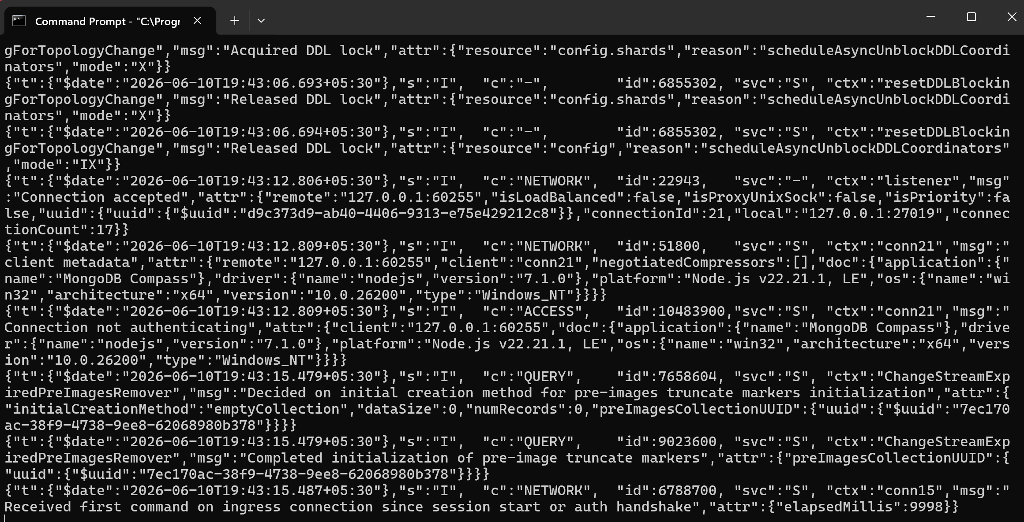
CONFIG:

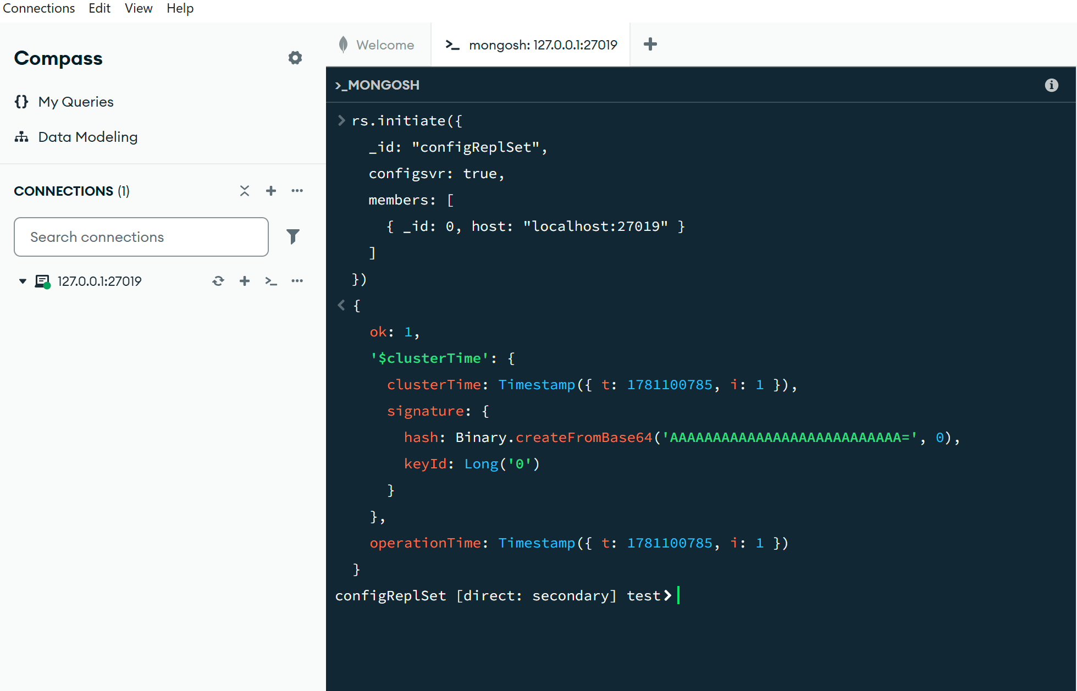

SHARD 1 AND SHARD 2:

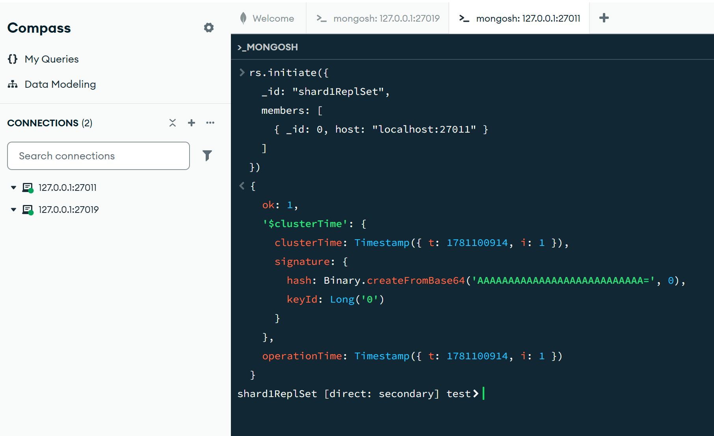

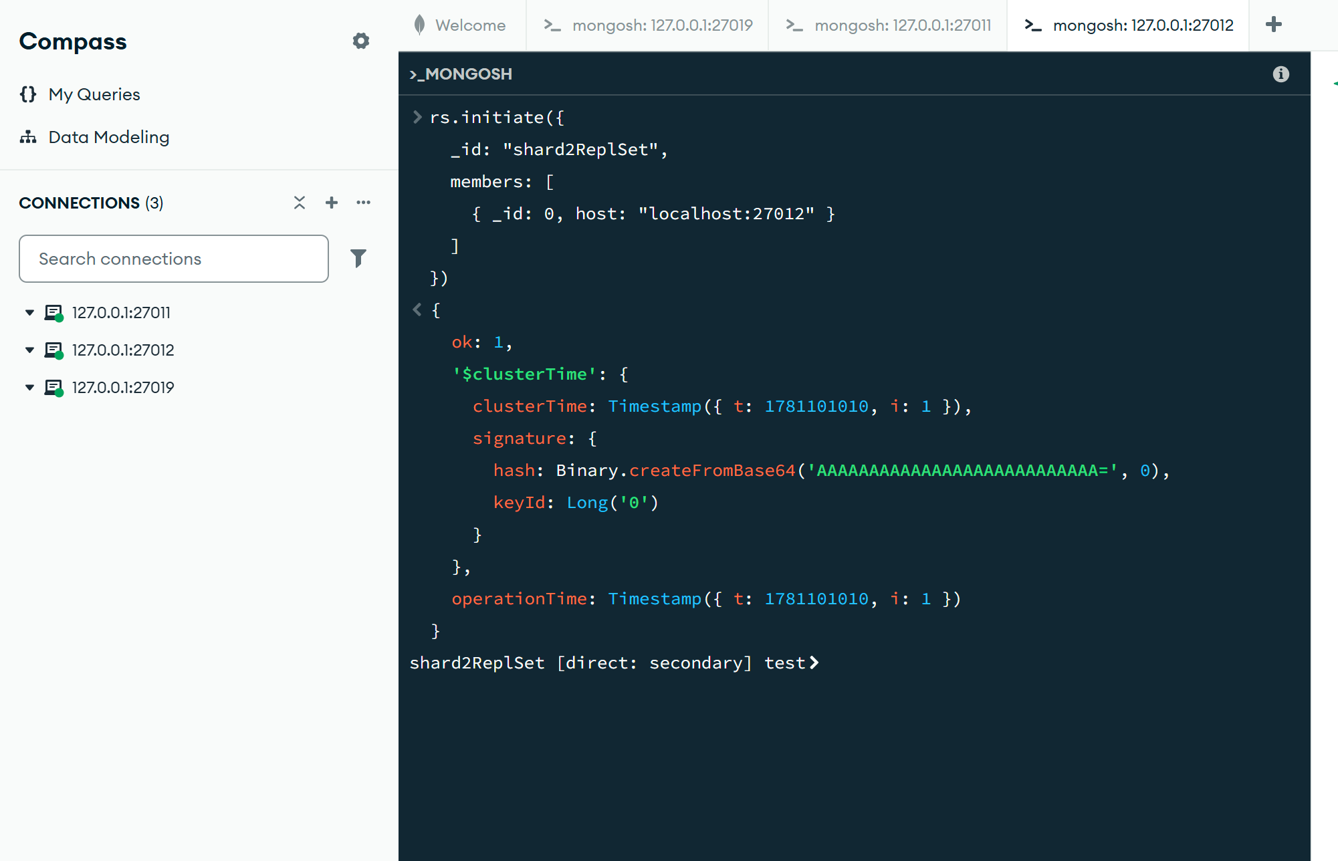
50 % SHARE in ROUTER:

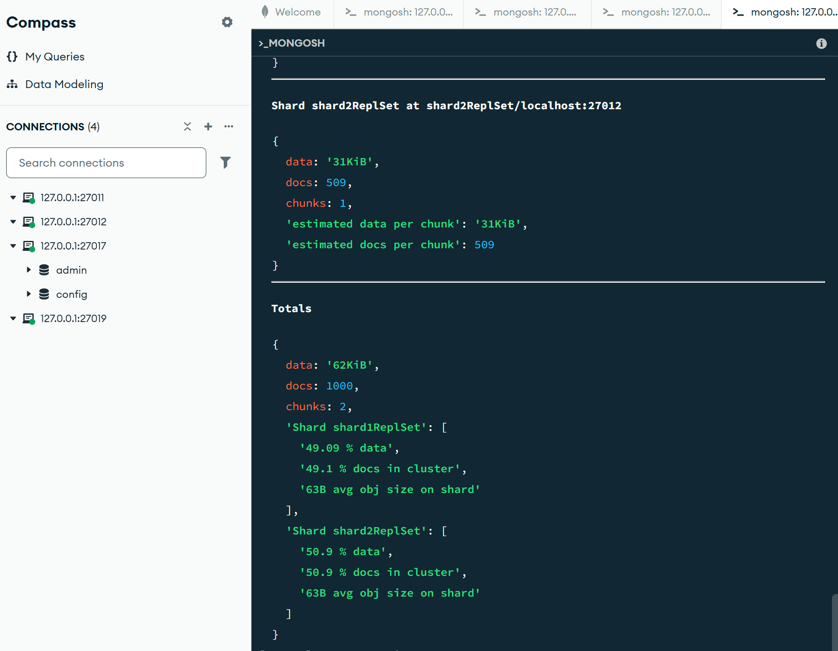
CODE:

sh.addShard("shard1ReplSet/localhost:27011")
{
shardAdded: 'shard1ReplSet',
ok: 1,
'$clusterTime': {
clusterTime: Timestamp({ t: 1781101088, i: 10 }),
signature: {
hash: Binary.createFromBase64('AAAAAAAAAAAAAAAAAAAAAAAAAAA=', 0),
keyId: Long('0')
}
},
operationTime: Timestamp({ t: 1781101088, i: 10 })
}
sh.addShard("shard2ReplSet/localhost:27012")
{
shardAdded: 'shard2ReplSet',
ok: 1,
'$clusterTime': {
clusterTime: Timestamp({ t: 1781101095, i: 23 }),
signature: {
hash: Binary.createFromBase64('AAAAAAAAAAAAAAAAAAAAAAAAAAA=', 0),
keyId: Long('0')
}
},
operationTime: Timestamp({ t: 1781101095, i: 23 })
}
sh.enableSharding("eCommerceDB")
{
ok: 1,
'$clusterTime': {
clusterTime: Timestamp({ t: 1781101104, i: 5 }),
signature: {
hash: Binary.createFromBase64('AAAAAAAAAAAAAAAAAAAAAAAAAAA=', 0),
keyId: Long('0')
}
},
operationTime: Timestamp({ t: 1781101104, i: 5 })
}
sh.shardCollection(
"eCommerceDB.orders",
{ customer_id: "hashed" }
)
{
collectionsharded: 'eCommerceDB.orders',
ok: 1,
'$clusterTime': {
clusterTime: Timestamp({ t: 1781101114, i: 51 }),
signature: {
hash: Binary.createFromBase64('AAAAAAAAAAAAAAAAAAAAAAAAAAA=', 0),
keyId: Long('0')
}
},
operationTime: Timestamp({ t: 1781101114, i: 47 })
}
use eCommerceDB
switched to db eCommerceDB
for(let i=0;i<1000;i++){
db.orders.insertOne({
customer_id: "cust_"+i,
amount: Math.random()*100
})
}
{
acknowledged: true,
insertedId: ObjectId('6a297284b262909b9a512060')
}
sh.status()
shardingVersion
{
_id: ObjectId('6a2970f12fbc5c480d5584f5'),
clusterId: ObjectId('6a2970f12fbc5c480d5584f4')
}
shards
[
{
_id: 'shard1ReplSet',
host: 'shard1ReplSet/localhost:27011',
topologyTime: Timestamp({ t: 1781101087, i: 32 }),
replSetConfigVersion: -1
},
{
_id: 'shard2ReplSet',
host: 'shard2ReplSet/localhost:27012',
topologyTime: Timestamp({ t: 1781101094, i: 33 }),
replSetConfigVersion: -1
}
]
active mongoses
[
{
'8.3.2': 1
}
]
autosplit
{
'Currently enabled': 'yes'
}
balancer
{
'Currently enabled': 'yes',
'Currently running': 'no',
'Failed balancer rounds in last 5 attempts': 0,
'Migration Results for the last 24 hours': 'No recent migrations'
}
shardedDataDistribution
[
{
ns: 'eCommerceDB.orders',
shards: [
{
shardName: 'shard1ReplSet',
numOrphanedDocs: 0,
numOwnedDocuments: 491,
ownedSizeBytes: 30933,
orphanedSizeBytes: 0
},
{
shardName: 'shard2ReplSet',
numOrphanedDocs: 0,
numOwnedDocuments: 509,
ownedSizeBytes: 32067,
orphanedSizeBytes: 0
}
]
}
]
databases
database: {
_id: 'eCommerceDB',
primary: 'shard2ReplSet',
version: {
uuid: UUID('baec446e-32d6-4493-a1d2-540b18b1a1ca'),
timestamp: Timestamp({ t: 1781101103, i: 10 }),
lastMod: 1
}
},
collections: {
'eCommerceDB.orders': {
shardKey: {
customer_id: 'hashed'
},
unique: false,
balancing: true,
allowMigrations: true,
chunkMetadata: [
{
shard: 'shard1ReplSet',
nChunks: 1
},
{
shard: 'shard2ReplSet',
nChunks: 1
}
],
chunks: [
{
min: {
customer_id: MinKey()
},
max: {
customer_id: 0
},
'on shard': 'shard2ReplSet',
'last modified': Timestamp({ t: 1, i: 0 })
},
{
min: {
customer_id: 0
},
max: {
customer_id: MaxKey()
},
'on shard': 'shard1ReplSet',
'last modified': Timestamp({ t: 1, i: 1 })
}
],
tags: []
}
}
}
]
db.orders.getShardDistribution()
Shard shard1ReplSet at shard1ReplSet/localhost:27011
{
data: '30KiB',
docs: 491,
chunks: 1,
'estimated data per chunk': '30KiB',
'estimated docs per chunk': 491
}
Shard shard2ReplSet at shard2ReplSet/localhost:27012
{
data: '31KiB',
docs: 509,
chunks: 1,
'estimated data per chunk': '31KiB',
'estimated docs per chunk': 509
}
Totals
{
data: '62KiB',
docs: 1000,
chunks: 2,
'Shard shard1ReplSet': [
'49.09 % data',
'49.1 % docs in cluster',
'63B avg obj size on shard'
],
'Shard shard2ReplSet': [
'50.9 % data',
'50.9 % docs in cluster',
'63B avg obj size on shard'
]
}

