SHARDING implement and verify: YASH PRADHAN

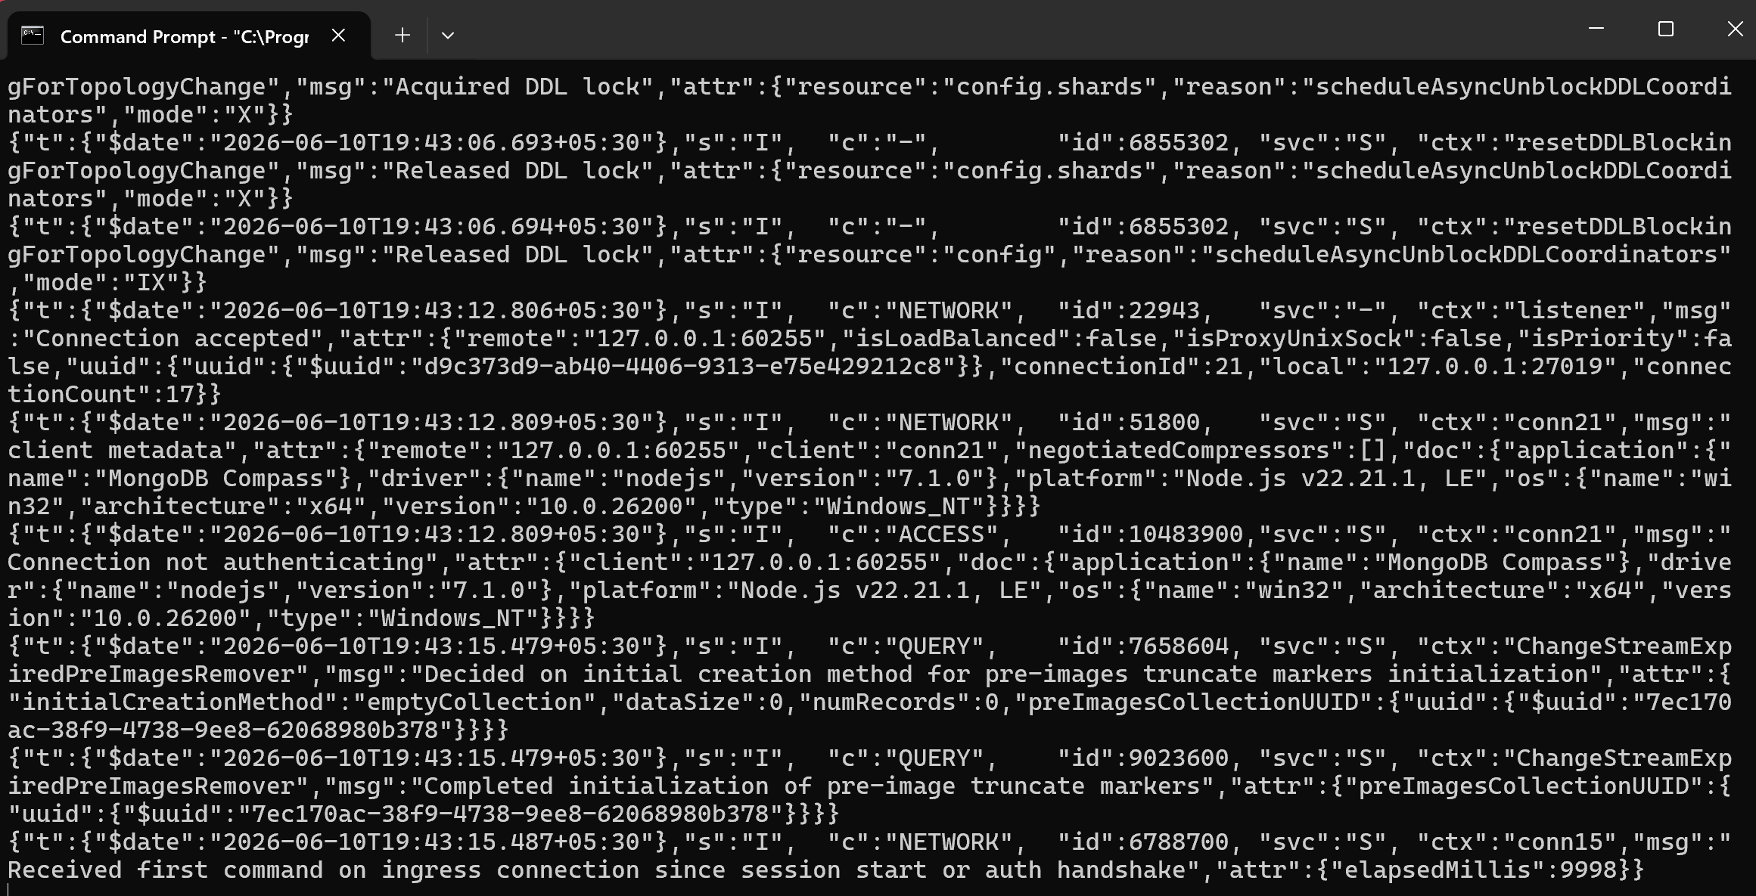
CONFIG:

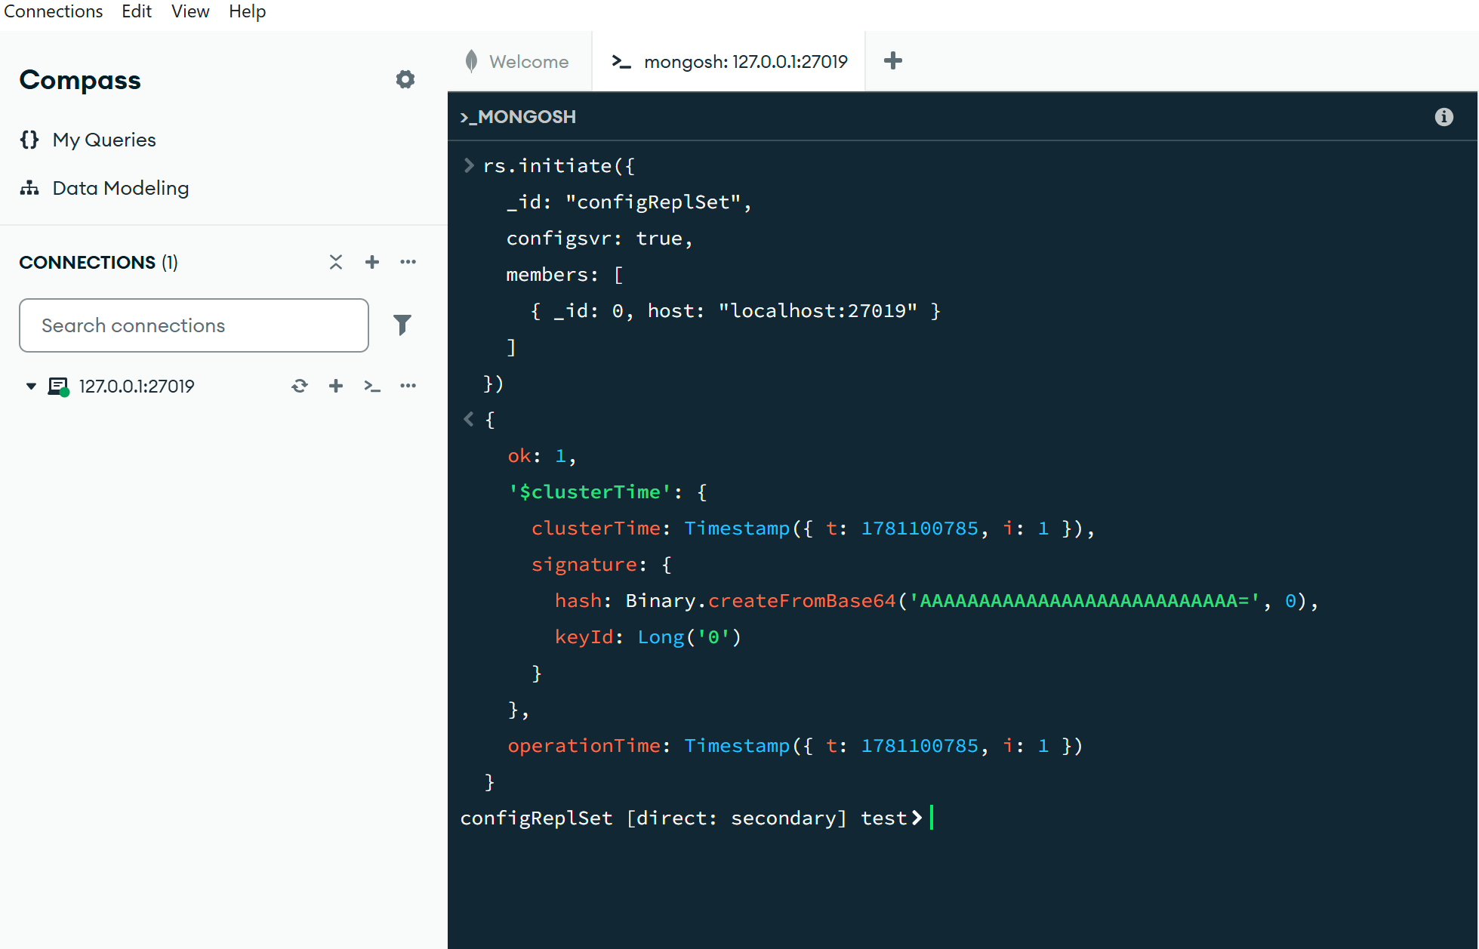

SHARD 1 AND SHARD 2:

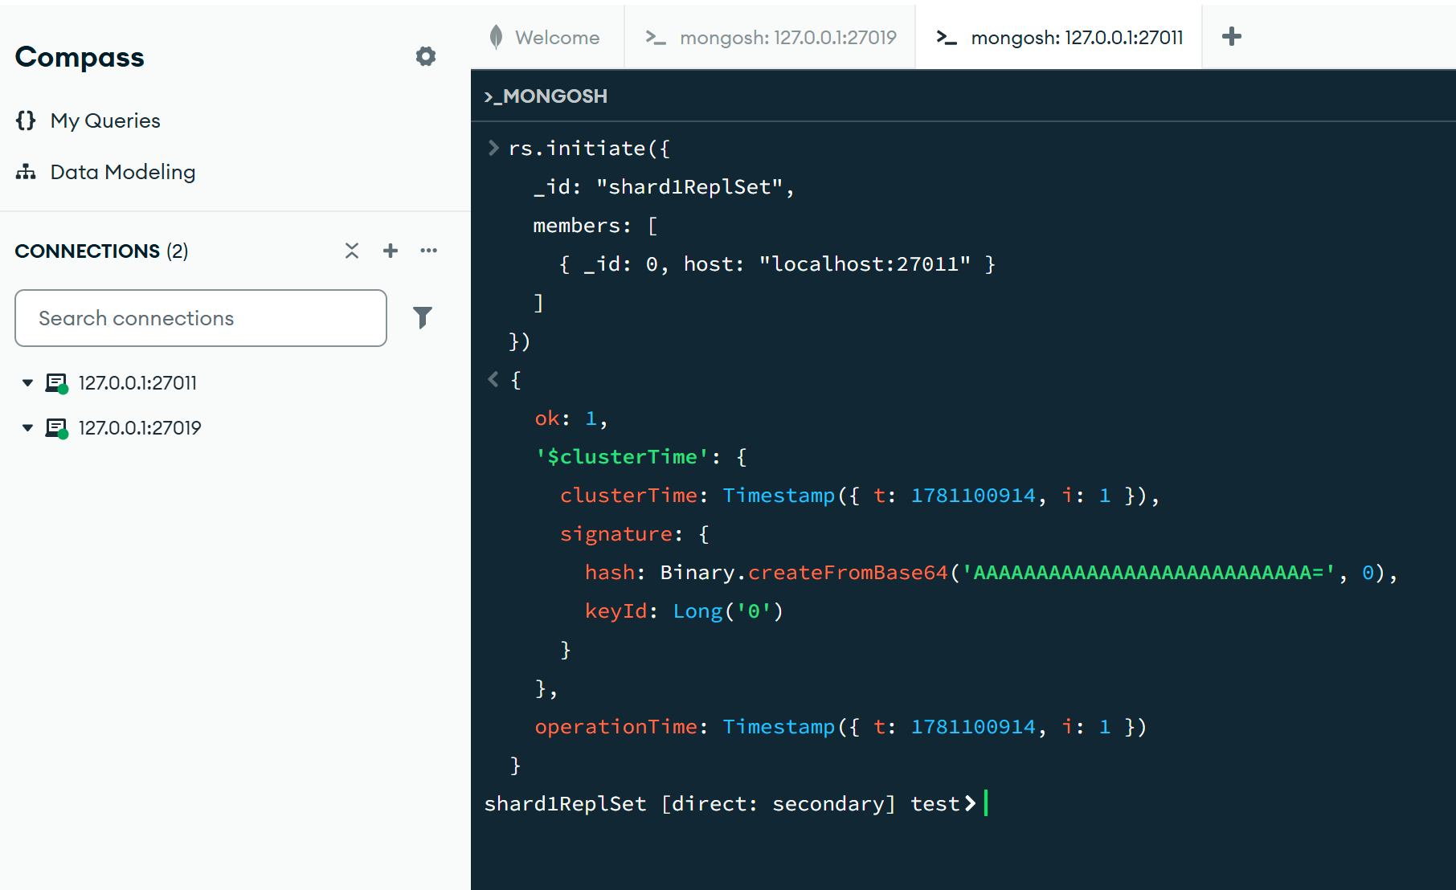

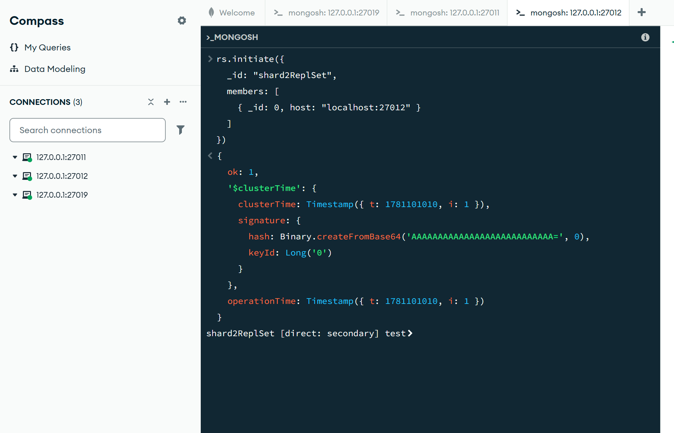

50 % SHARE in ROUTER:

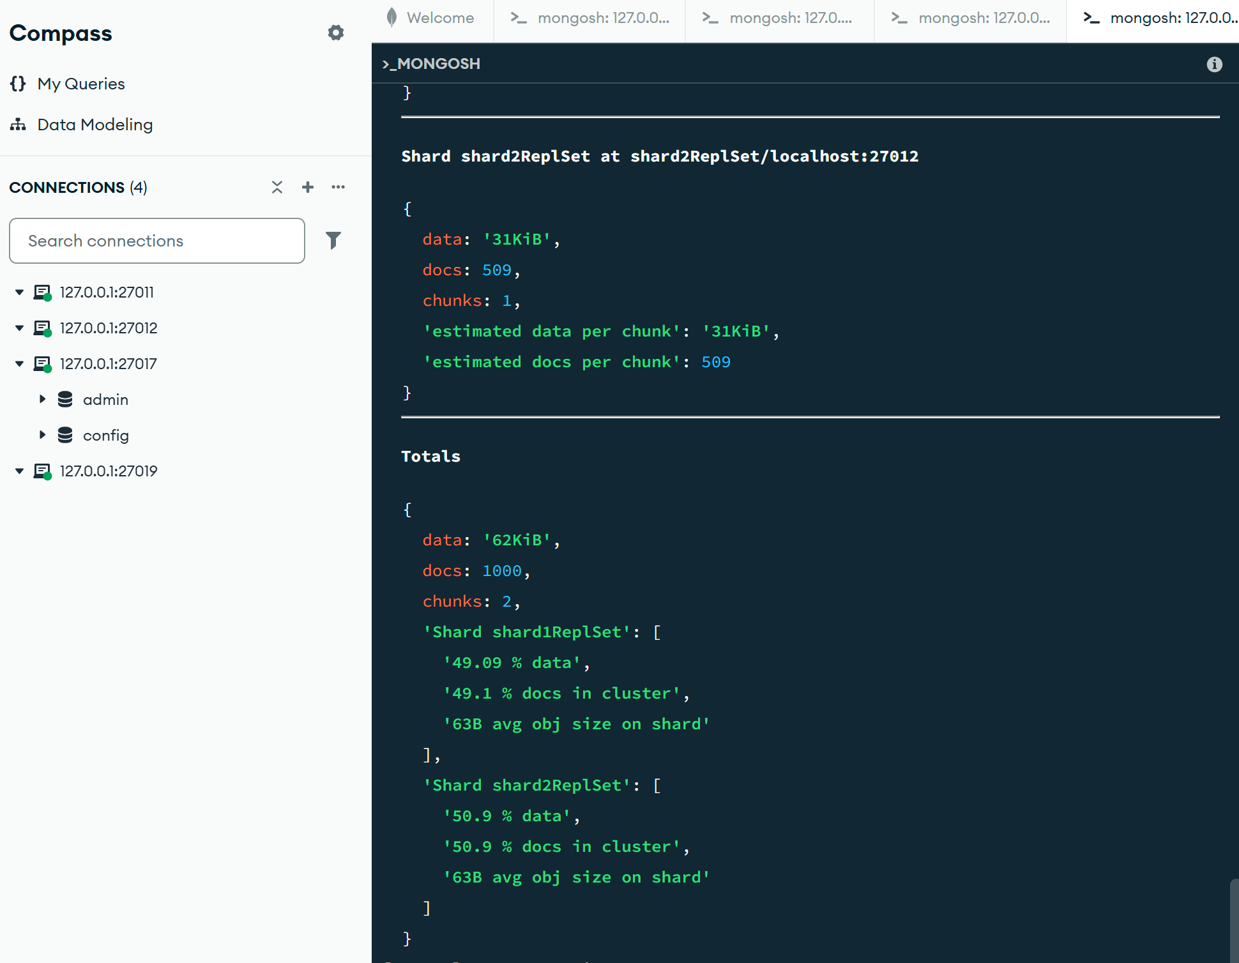
CODE:

sh.addShard("shard1ReplSet/localhost:27011")
{
shardAdded: 'shard1ReplSet',
ok: 1,
'$clusterTime': {
clusterTime: Timestamp({ t: 1781101088, i: 10 }),
signature: {
hash: Binary.createFromBase64('AAAAAAAAAAAAAAAAAAAAAAAAAAA=', 0),
keyId: Long('0')
}
},
operationTime: Timestamp({ t: 1781101088, i: 10 })
}
sh.addShard("shard2ReplSet/localhost:27012")
{
shardAdded: 'shard2ReplSet',
ok: 1,
'$clusterTime': {
clusterTime: Timestamp({ t: 1781101095, i: 23 }),
signature: {
hash: Binary.createFromBase64('AAAAAAAAAAAAAAAAAAAAAAAAAAA=', 0),
keyId: Long('0')
}
},
operationTime: Timestamp({ t: 1781101095, i: 23 })
}
sh.enableSharding("eCommerceDB")
{
ok: 1,
'$clusterTime': {
clusterTime: Timestamp({ t: 1781101104, i: 5 }),
signature: {
hash: Binary.createFromBase64('AAAAAAAAAAAAAAAAAAAAAAAAAAA=', 0),
keyId: Long('0')
}
},
operationTime: Timestamp({ t: 1781101104, i: 5 })
}
sh.shardCollection(
"eCommerceDB.orders",
{ customer_id: "hashed" }
)
{
collectionsharded: 'eCommerceDB.orders',
ok: 1,
'$clusterTime': {
clusterTime: Timestamp({ t: 1781101114, i: 51 }),
signature: {
hash: Binary.createFromBase64('AAAAAAAAAAAAAAAAAAAAAAAAAAA=', 0),
keyId: Long('0')
}
},
operationTime: Timestamp({ t: 1781101114, i: 47 })
}
use eCommerceDB
switched to db eCommerceDB
for(let i=0;i<1000;i++){
db.orders.insertOne({
customer_id: "cust_"+i,
amount: Math.random()*100
})
}
{
acknowledged: true,
insertedId: ObjectId('6a297284b262909b9a512060')
}
sh.status()
shardingVersion
{
_id: ObjectId('6a2970f12fbc5c480d5584f5'),
clusterId: ObjectId('6a2970f12fbc5c480d5584f4')
}
shards
[
{
_id: 'shard1ReplSet',
host: 'shard1ReplSet/localhost:27011',
topologyTime: Timestamp({ t: 1781101087, i: 32 }),
replSetConfigVersion: -1
},
{
_id: 'shard2ReplSet',
host: 'shard2ReplSet/localhost:27012',
topologyTime: Timestamp({ t: 1781101094, i: 33 }),
replSetConfigVersion: -1
}
]
active mongoses
[
{
'8.3.2': 1
}
]
autosplit
{
'Currently enabled': 'yes'
}
balancer
{
'Currently enabled': 'yes',
'Currently running': 'no',
'Failed balancer rounds in last 5 attempts': 0,
'Migration Results for the last 24 hours': 'No recent migrations'
}
shardedDataDistribution
[
{
ns: 'eCommerceDB.orders',
shards: [
{
shardName: 'shard1ReplSet',
numOrphanedDocs: 0,
numOwnedDocuments: 491,
ownedSizeBytes: 30933,
orphanedSizeBytes: 0
},
{
shardName: 'shard2ReplSet',
numOrphanedDocs: 0,
numOwnedDocuments: 509,
ownedSizeBytes: 32067,
orphanedSizeBytes: 0
}
]
}
]
databases
database: {
_id: 'eCommerceDB',
primary: 'shard2ReplSet',
version: {
uuid: UUID('baec446e-32d6-4493-a1d2-540b18b1a1ca'),
timestamp: Timestamp({ t: 1781101103, i: 10 }),
lastMod: 1
}
},
collections: {
'eCommerceDB.orders': {
shardKey: {
customer_id: 'hashed'
},
unique: false,
balancing: true,
allowMigrations: true,
chunkMetadata: [
{
shard: 'shard1ReplSet',
nChunks: 1
},
{
shard: 'shard2ReplSet',
nChunks: 1
}
],
chunks: [
{
min: {
customer_id: MinKey()
},
max: {
customer_id: 0
},
'on shard': 'shard2ReplSet',
'last modified': Timestamp({ t: 1, i: 0 })
},
{
min: {
customer_id: 0
},
max: {
customer_id: MaxKey()
},
'on shard': 'shard1ReplSet',
'last modified': Timestamp({ t: 1, i: 1 })
}
],
tags: []
}
}
}
]
db.orders.getShardDistribution()
Shard shard1ReplSet at shard1ReplSet/localhost:27011
{
data: '30KiB',
docs: 491,
chunks: 1,
'estimated data per chunk': '30KiB',
'estimated docs per chunk': 491
}
Shard shard2ReplSet at shard2ReplSet/localhost:27012
{
data: '31KiB',
docs: 509,
chunks: 1,
'estimated data per chunk': '31KiB',
'estimated docs per chunk': 509
}
Totals
{
data: '62KiB',
docs: 1000,
chunks: 2,
'Shard shard1ReplSet': [
'49.09 % data',
'49.1 % docs in cluster',
'63B avg obj size on shard'
],
'Shard shard2ReplSet': [
'50.9 % data',
'50.9 % docs in cluster',
'63B avg obj size on shard'
]
}

