Create Many:
package ManyMongo;
import com.mongodb.client.*;
import com.mongodb.client.model.Filters;
import com.mongodb.client.model.Updates;
import org.bson.Document;
import java.util.Arrays;

public class ManyMongo {

public static void main(String[] args) {

// Connect to MongoDB
MongoClient mongoClient = MongoClients.create("mongodb://localhost:27017");

// Access database
MongoDatabase database = mongoClient.getDatabase("CollegeDB");

// Access collection
MongoCollection<Document> collection = database.getCollection("Students");

// ==========================
// CREATE MANY (InsertMany)
// ==========================
Document student1 = new Document("id", 101)
.append("name", "John")
.append("department", "CSE")
.append("cgpa", 8.7);

Document student2 = new Document("id", 102)
.append("name", "Alice")
.append("department", "ECE")
.append("cgpa", 9.1);

Document student3 = new Document("id", 103)
.append("name", "Bob")
.append("department", "MECH")
.append("cgpa", 7.9);

collection.insertMany(Arrays.asList(student1, student2, student3));
System.out.println("Documents Inserted Successfully");

mongoClient.close();
}
}
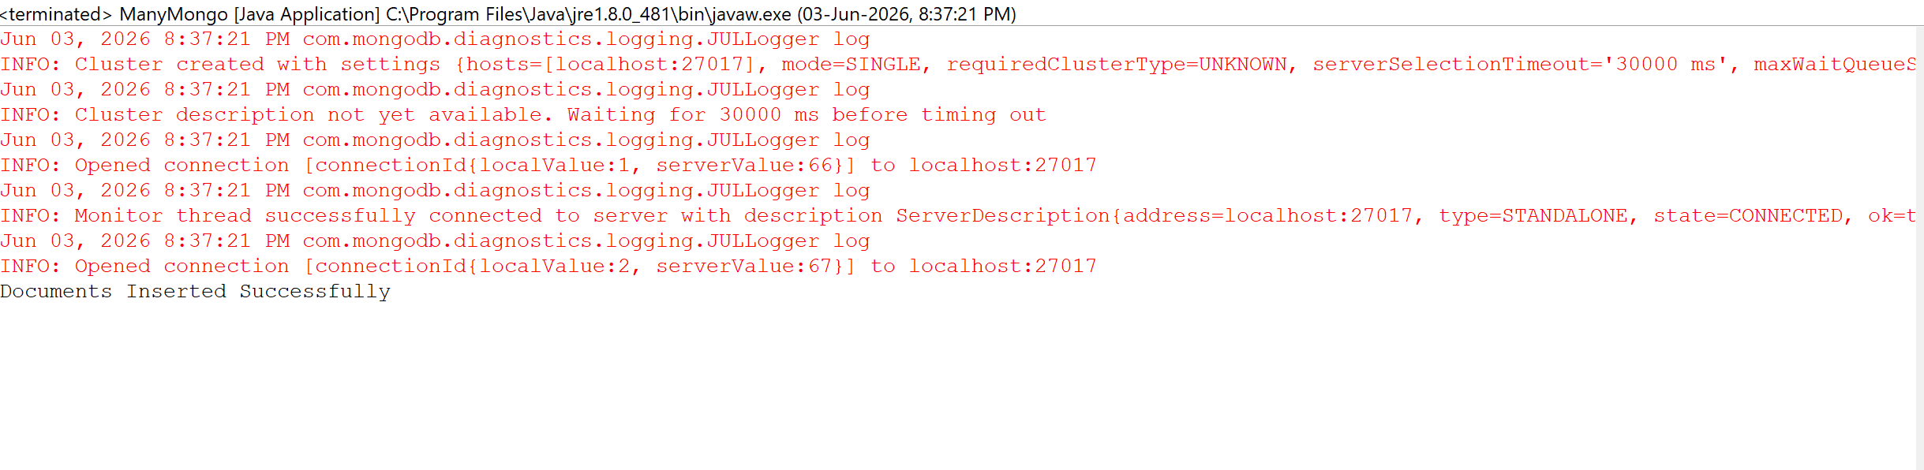

Read Many:

package ManyMongo;
import com.mongodb.client.*;
import com.mongodb.client.model.Filters;
import com.mongodb.client.model.Updates;
import org.bson.Document;
import java.util.Arrays;

public class ManyMongo {

public static void main(String[] args) {

// Connect to MongoDB
MongoClient mongoClient = MongoClients.create("mongodb://localhost:27017");

// Access database
MongoDatabase database = mongoClient.getDatabase("CollegeDB");

// Access collection
MongoCollection<Document> collection = database.getCollection("Students");

// ==========================
// READ MANY (Find)
// ==========================
System.out.println("\nStudent Records:");
FindIterable<Document> students = collection.find();
for (Document doc : students) {
System.out.println(doc.toJson());
}

mongoClient.close();
}
}
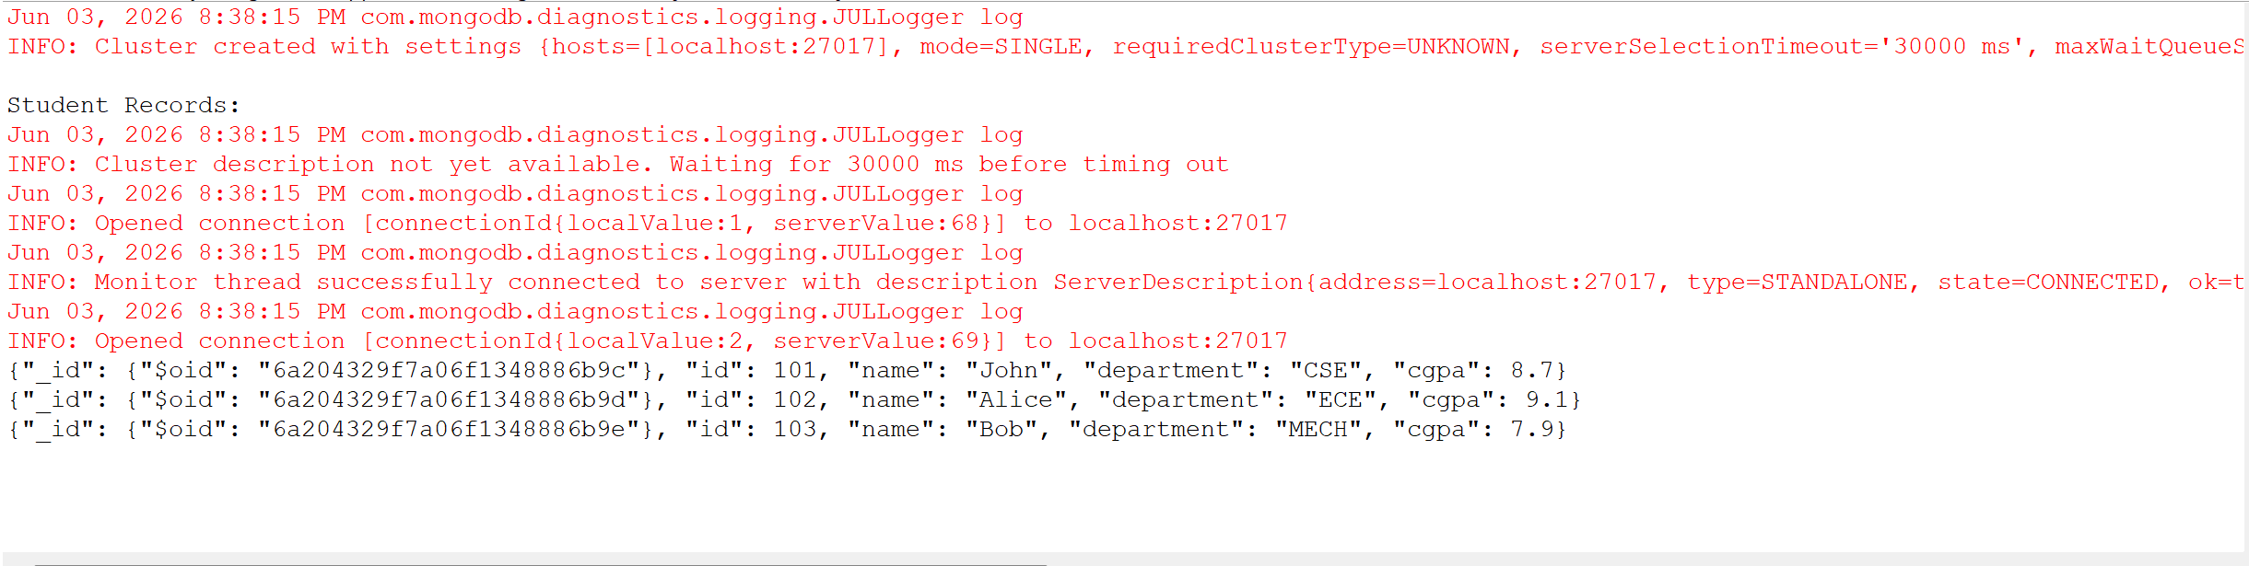
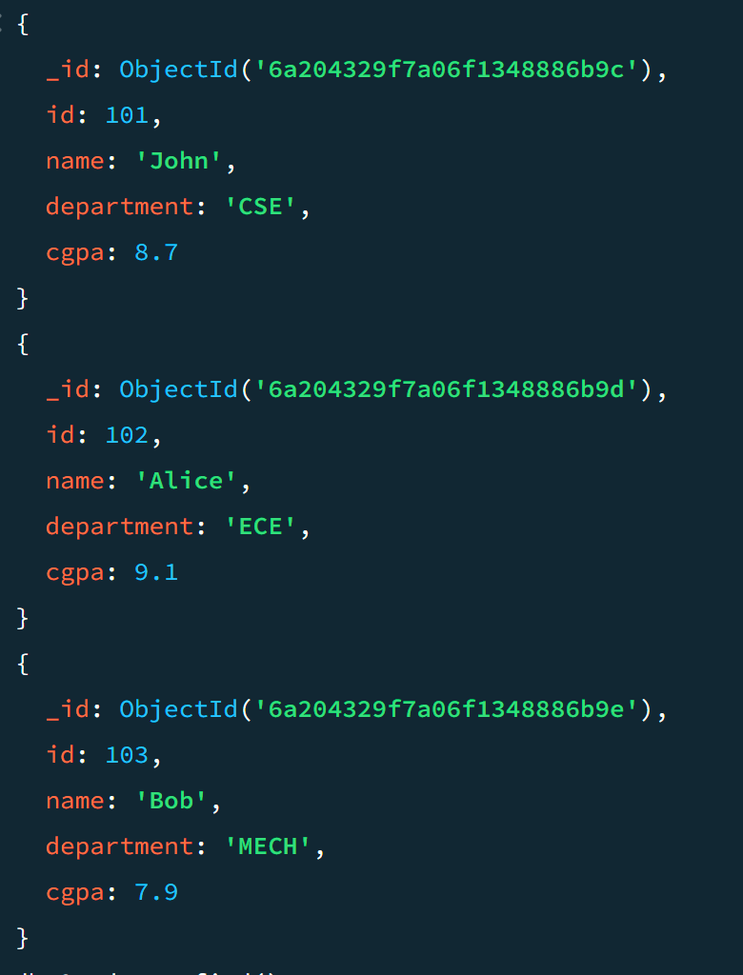
Update Many:

package ManyMongo;
import com.mongodb.client.*;
import com.mongodb.client.model.Filters;
import com.mongodb.client.model.Updates;
import org.bson.Document;
import java.util.Arrays;

public class ManyMongo {

public static void main(String[] args) {

// Connect to MongoDB
MongoClient mongoClient = MongoClients.create("mongodb://localhost:27017");

// Access database
MongoDatabase database = mongoClient.getDatabase("CollegeDB");

// Access collection
MongoCollection<Document> collection = database.getCollection("Students");

// ==========================
// UPDATE MANY
// ==========================
collection.updateMany(
Filters.gte("cgpa", 8.0), // condition: all students with cgpa >= 8
Updates.set("status", "Excellent") // update field for all matching
);
System.out.println("\nDocuments Updated Successfully");

// Close connection
mongoClient.close();
}
}
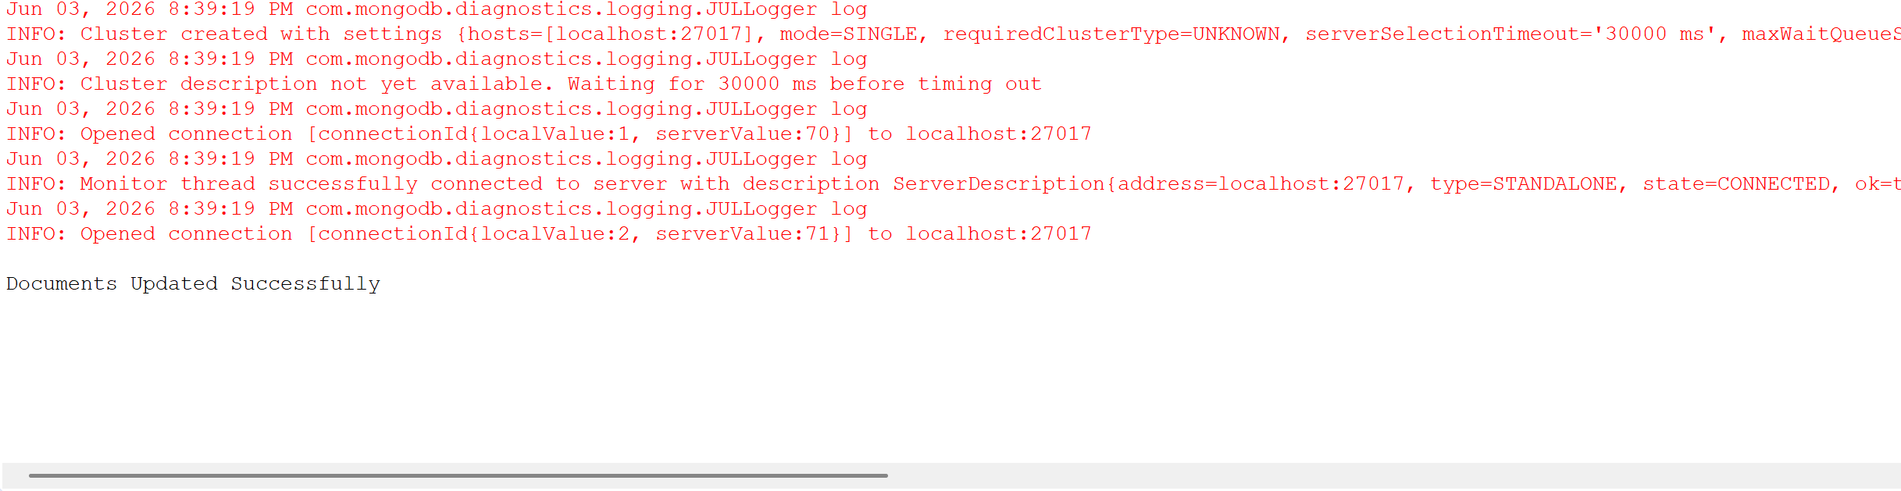
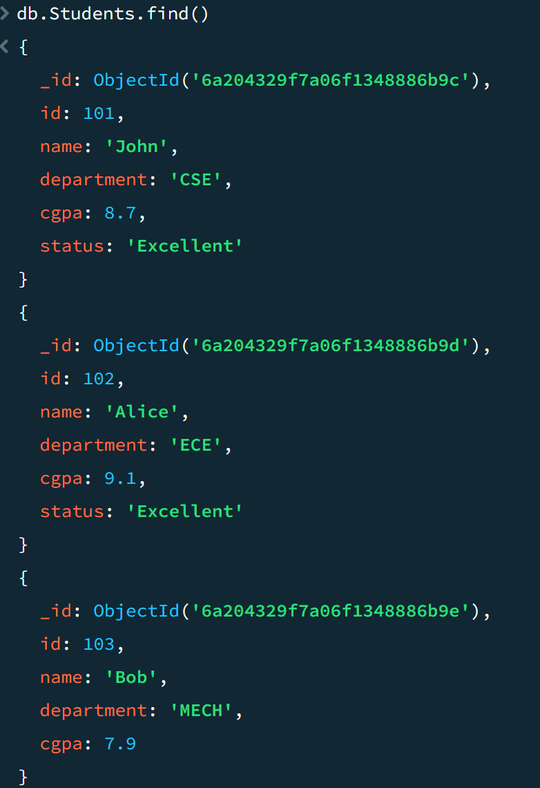

Aggregate(min and multiply):
package ManyMongo;

import com.mongodb.client.*;
import com.mongodb.client.model.Filters;
import com.mongodb.client.model.Updates;
import org.bson.Document;
import java.util.Arrays;

public class ManyMongo {

public static void main(String[] args) {

// Connect to MongoDB
MongoClient mongoClient = MongoClients.create("mongodb://localhost:27017");

// Access database
MongoDatabase database = mongoClient.getDatabase("CollegeDB");

// Access collection
MongoCollection<Document> collection = database.getCollection("Students");

// ==========================
// AGGREGATE (MIN + MULTIPLY)
// ==========================
AggregateIterable<Document> result = collection.aggregate(Arrays.asList(

new Document("$group",
new Document("_id", null)
.append("minCgpa",
new Document("$min", "$cgpa"))
),

new Document("$addFields",
new Document("minCgpaMultiplied",
new Document("$multiply",
Arrays.asList("$minCgpa", 2)))
)
));

System.out.println("\nAggregate Result:");

for (Document doc : result) {
System.out.println(doc.toJson());
}

mongoClient.close();
}
}

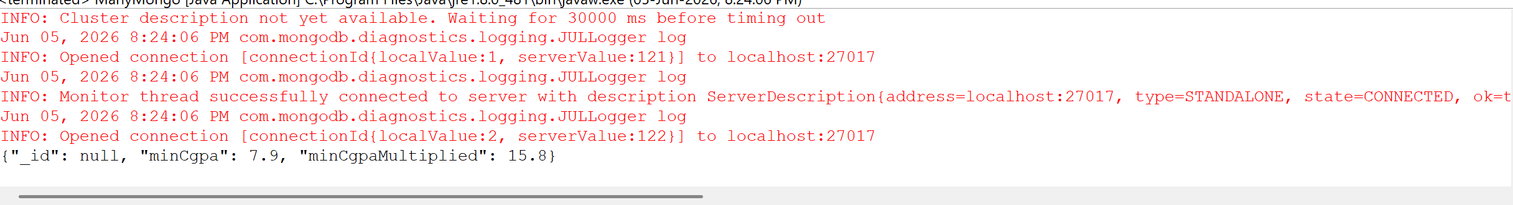
Delete Many:

package ManyMongo;
import com.mongodb.client.*;
import com.mongodb.client.model.Filters;
import com.mongodb.client.model.Updates;
import org.bson.Document;
import java.util.Arrays;

public class ManyMongo {

public static void main(String[] args) {

// Connect to MongoDB
MongoClient mongoClient = MongoClients.create("mongodb://localhost:27017");

// Access database
MongoDatabase database = mongoClient.getDatabase("CollegeDB");

// Access collection
MongoCollection<Document> collection = database.getCollection("Students");

// ==========================
// DELETE MANY
// ==========================
collection.deleteMany(Filters.lt("cgpa", 8.0)); // delete all with cgpa < 8
System.out.println("\nDocuments Deleted Successfully");

// Close connection
mongoClient.close();
}
}

