Create: YASH PRADHAN
package MongoDB;
import com.mongodb.client.*;
import com.mongodb.client.model.Filters;
import com.mongodb.client.model.Updates;
import org.bson.Document;

public class Mongo {

public static void main(String[] args) {

// Connect to MongoDB
MongoClient mongoClient = MongoClients.create("mongodb://localhost:27017");

// Access database
MongoDatabase database = mongoClient.getDatabase("CollegeDB");

// Access collection
MongoCollection<Document> collection =
database.getCollection("Students");

// ==========================
// CREATE (Insert)
// ==========================
Document student = new Document("id", 101)
.append("name", "John")
.append("department", "CSE")
.append("cgpa", 8.7);

collection.insertOne(student);
System.out.println("Document Inserted Successfully");

}
}
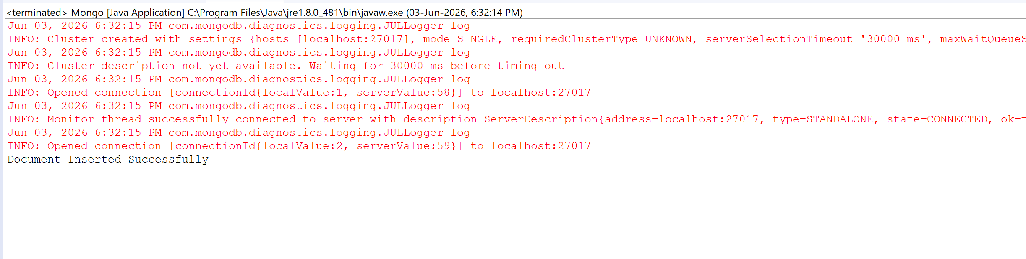

Read:
package MongoDB;
import com.mongodb.client.*;
import com.mongodb.client.model.Filters;
import com.mongodb.client.model.Updates;
import org.bson.Document;

public class Mongo {

public static void main(String[] args) {

// Connect to MongoDB
MongoClient mongoClient = MongoClients.create("mongodb://localhost:27017");

// Access database
MongoDatabase database = mongoClient.getDatabase("CollegeDB");

// Access collection
MongoCollection<Document> collection =
database.getCollection("Students");

// ==========================
// READ (Find)
// ==========================
System.out.println("\nStudent Records:");

FindIterable<Document> students = collection.find();

for (Document doc : students) {
System.out.println(doc.toJson());
}
}
}
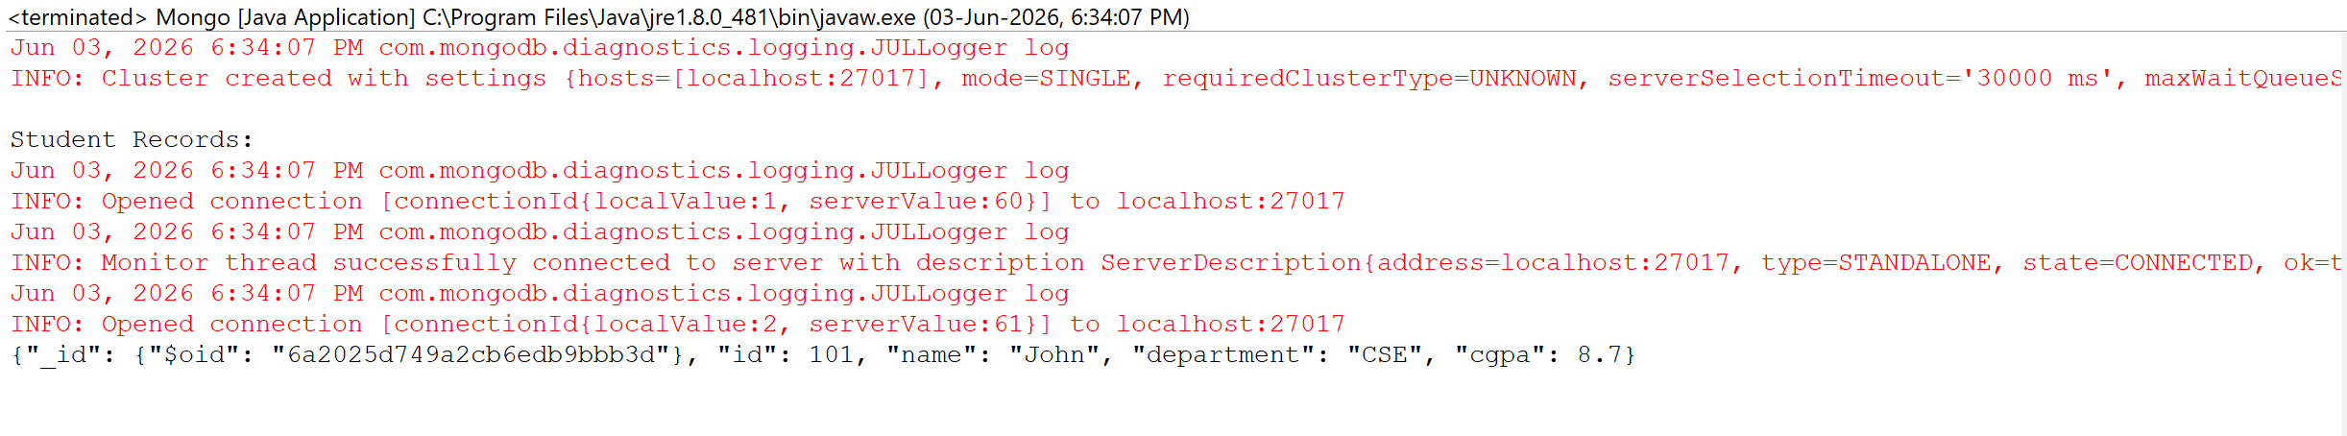

Update:
package MongoDB;
import com.mongodb.client.*;
import com.mongodb.client.model.Filters;
import com.mongodb.client.model.Updates;
import org.bson.Document;

public class Mongo {

public static void main(String[] args) {

// Connect to MongoDB
MongoClient mongoClient = MongoClients.create("mongodb://localhost:27017");

// Access database
MongoDatabase database = mongoClient.getDatabase("CollegeDB");

// Access collection
MongoCollection<Document> collection =
database.getCollection("Students");

// // ==========================
// // UPDATE
// // ==========================
collection.updateOne(
Filters.eq("id", 101),
Updates.set("cgpa", 9.2)
);

System.out.println("\nDocument Updated Successfully");
//
// // ==========================
// // READ Updated Record
// // ==========================
Document updatedStudent =
collection.find(Filters.eq("id", 101)).first();

System.out.println("\nUpdated Record:");
System.out.println(updatedStudent.toJson());
}
}

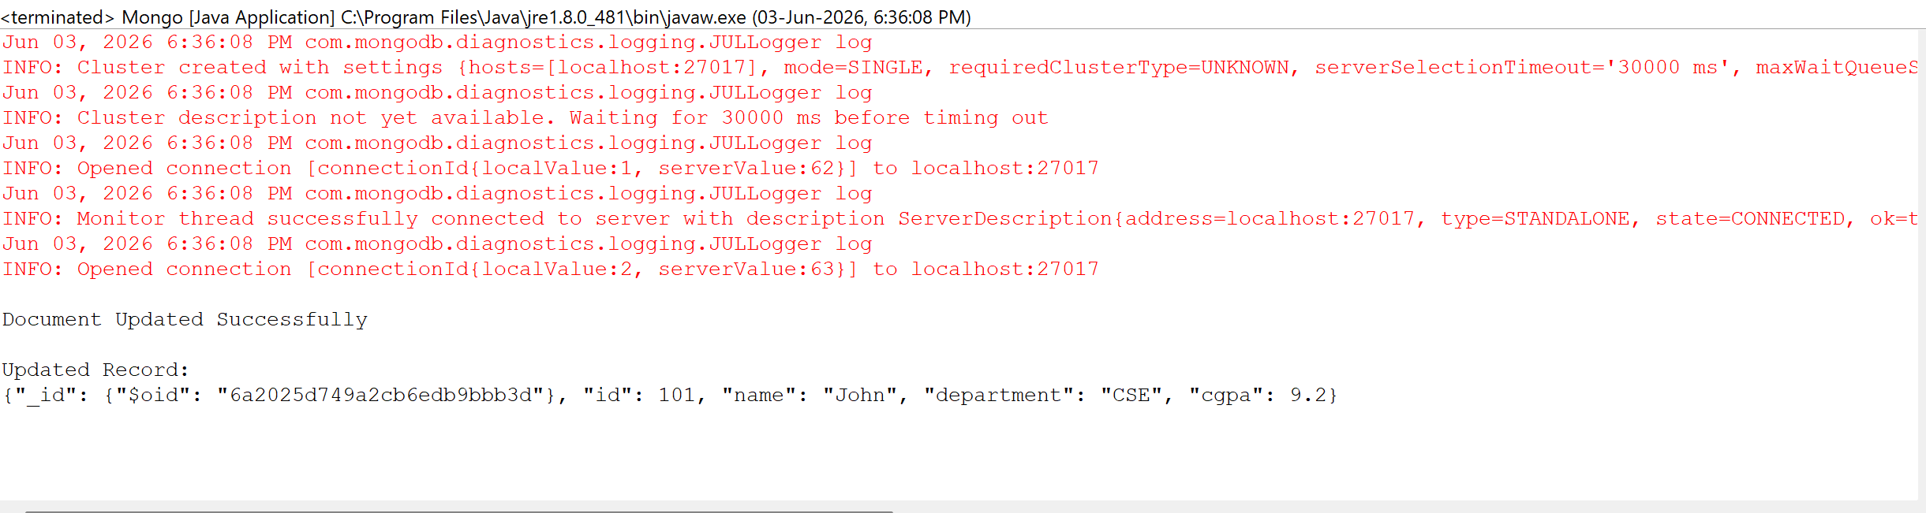
Delete:
package MongoDB;
import com.mongodb.client.*;
import com.mongodb.client.model.Filters;
import com.mongodb.client.model.Updates;
import org.bson.Document;

public class Mongo {

public static void main(String[] args) {

// Connect to MongoDB
MongoClient mongoClient = MongoClients.create("mongodb://localhost:27017");

// Access database
MongoDatabase database = mongoClient.getDatabase("CollegeDB");

// Access collection
MongoCollection<Document> collection =
database.getCollection("Students");

// // ==========================
// // DELETE
// // ==========================
collection.deleteOne(Filters.eq("id", 101));

System.out.println("\nDocument Deleted Successfully");

// Close connection
mongoClient.close();
}
}

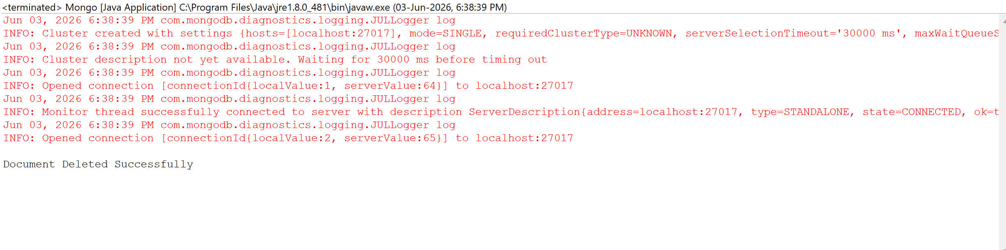
Create Many:
package ManyMongo;
import com.mongodb.client.*;
import com.mongodb.client.model.Filters;
import com.mongodb.client.model.Updates;
import org.bson.Document;
import java.util.Arrays;

public class ManyMongo {

public static void main(String[] args) {

// Connect to MongoDB
MongoClient mongoClient = MongoClients.create("mongodb://localhost:27017");

// Access database
MongoDatabase database = mongoClient.getDatabase("CollegeDB");

// Access collection
MongoCollection<Document> collection = database.getCollection("Students");

// ==========================
// CREATE MANY (InsertMany)
// ==========================
Document student1 = new Document("id", 101)
.append("name", "John")
.append("department", "CSE")
.append("cgpa", 8.7);

Document student2 = new Document("id", 102)
.append("name", "Alice")
.append("department", "ECE")
.append("cgpa", 9.1);

Document student3 = new Document("id", 103)
.append("name", "Bob")
.append("department", "MECH")
.append("cgpa", 7.9);

collection.insertMany(Arrays.asList(student1, student2, student3));
System.out.println("Documents Inserted Successfully");

mongoClient.close();
}
}
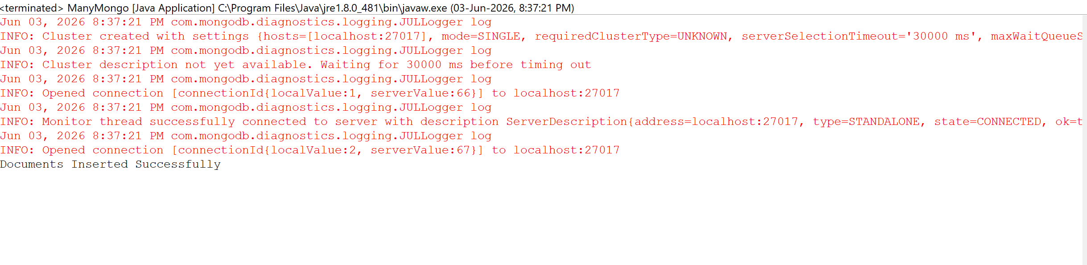

Read Many:

package ManyMongo;
import com.mongodb.client.*;
import com.mongodb.client.model.Filters;
import com.mongodb.client.model.Updates;
import org.bson.Document;
import java.util.Arrays;

public class ManyMongo {

public static void main(String[] args) {

// Connect to MongoDB
MongoClient mongoClient = MongoClients.create("mongodb://localhost:27017");

// Access database
MongoDatabase database = mongoClient.getDatabase("CollegeDB");

// Access collection
MongoCollection<Document> collection = database.getCollection("Students");

// ==========================
// READ MANY (Find)
// ==========================
System.out.println("\nStudent Records:");
FindIterable<Document> students = collection.find();
for (Document doc : students) {
System.out.println(doc.toJson());
}

mongoClient.close();
}
}
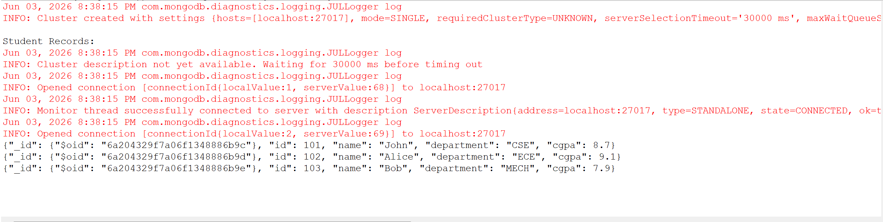
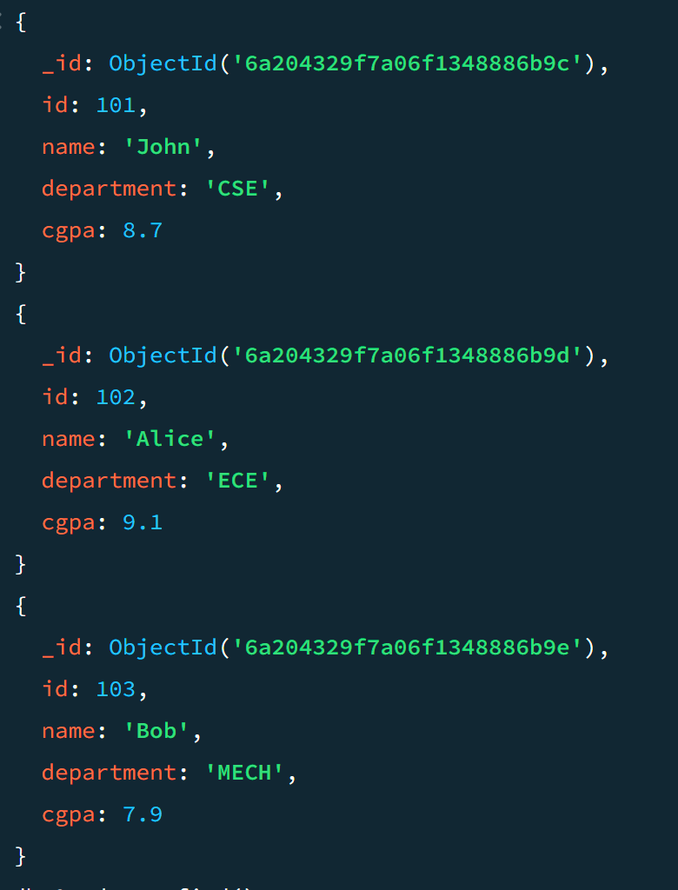
Update Many:

package ManyMongo;
import com.mongodb.client.*;
import com.mongodb.client.model.Filters;
import com.mongodb.client.model.Updates;
import org.bson.Document;
import java.util.Arrays;

public class ManyMongo {

public static void main(String[] args) {

// Connect to MongoDB
MongoClient mongoClient = MongoClients.create("mongodb://localhost:27017");

// Access database
MongoDatabase database = mongoClient.getDatabase("CollegeDB");

// Access collection
MongoCollection<Document> collection = database.getCollection("Students");

// ==========================
// UPDATE MANY
// ==========================
collection.updateMany(
Filters.gte("cgpa", 8.0), // condition: all students with cgpa >= 8
Updates.set("status", "Excellent") // update field for all matching
);
System.out.println("\nDocuments Updated Successfully");

// Close connection
mongoClient.close();
}
}
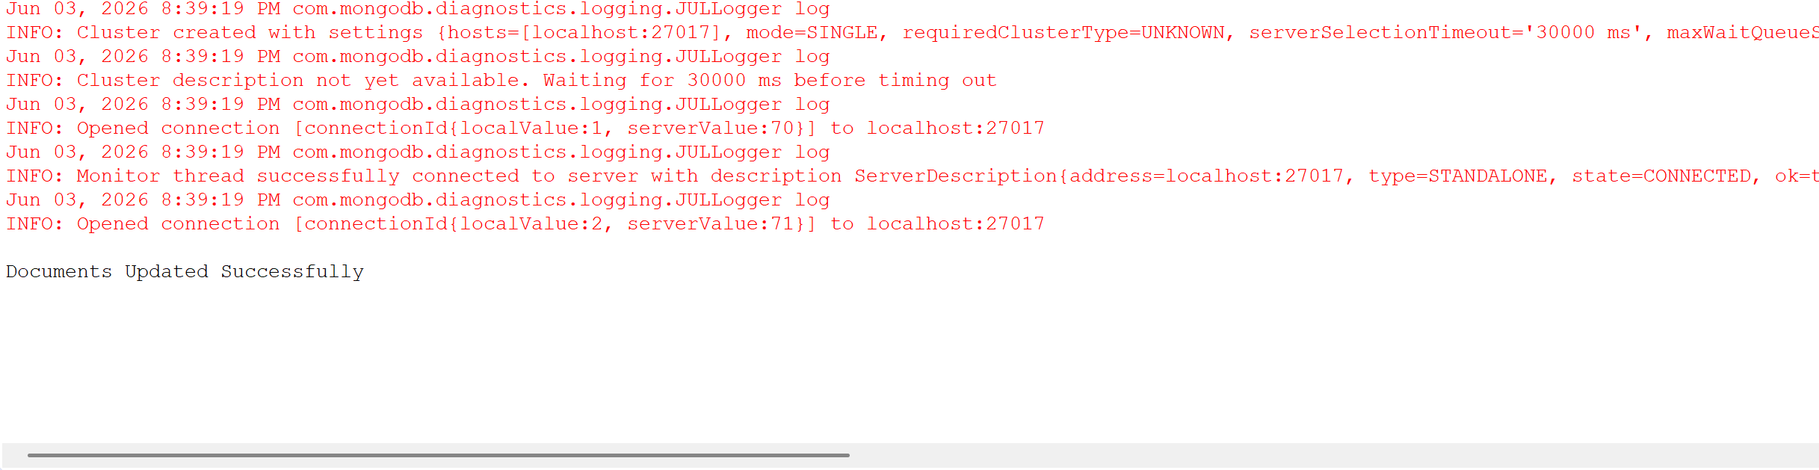
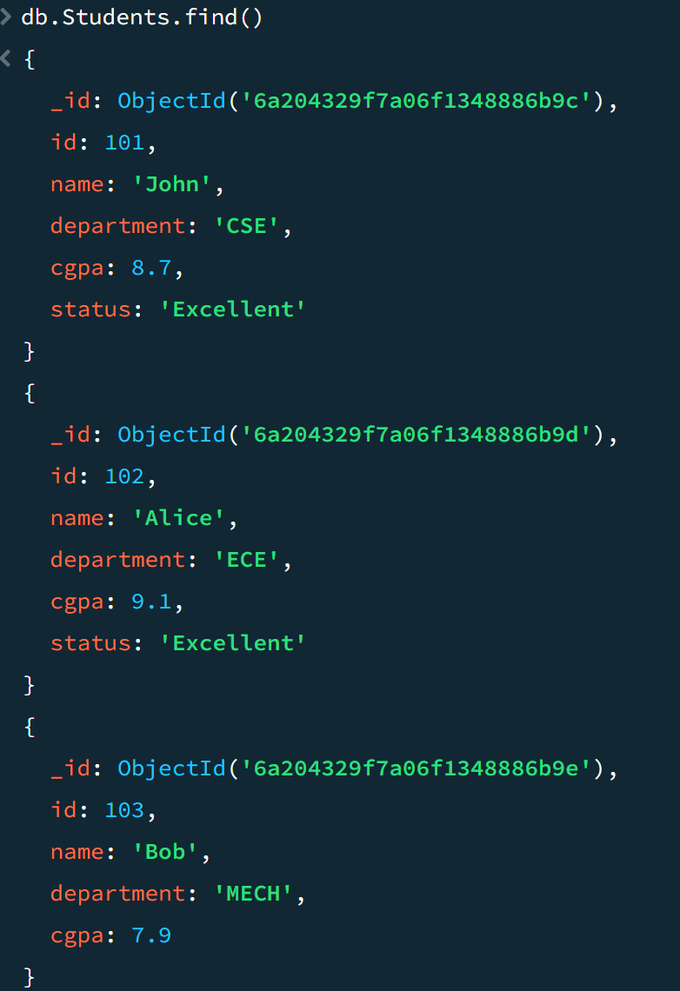

Delete Many:

package ManyMongo;
import com.mongodb.client.*;
import com.mongodb.client.model.Filters;
import com.mongodb.client.model.Updates;
import org.bson.Document;
import java.util.Arrays;

public class ManyMongo {

public static void main(String[] args) {

// Connect to MongoDB
MongoClient mongoClient = MongoClients.create("mongodb://localhost:27017");

// Access database
MongoDatabase database = mongoClient.getDatabase("CollegeDB");

// Access collection
MongoCollection<Document> collection = database.getCollection("Students");

// ==========================
// DELETE MANY
// ==========================
collection.deleteMany(Filters.lt("cgpa", 8.0)); // delete all with cgpa < 8
System.out.println("\nDocuments Deleted Successfully");

// Close connection
mongoClient.close();
}
}

