CCAR POC — PRD (Short Version)
Sep 26, 2026 · @Aditya Kumar

1. Summary
StressLens is an 4-week internal practice project. About 40 Iris people build a small, simplified version of the stress test that big US banks run every year (CCAR), using made-up data for a fictional bank.
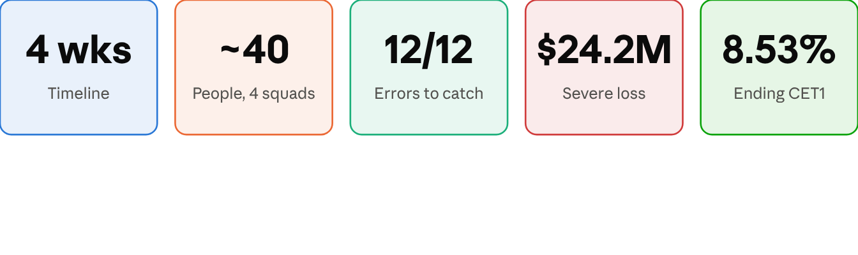
StressLens at a glance
- What we build: a pipeline that loads 40 business loans, catches data errors, calculates losses under three economic scenarios, checks the bank's capital, reconciles the totals, produces reports in the style of the Federal Reserve's FR Y-14 reports, and sends them through review, approval and an audit trail.
- Why: Iris is about to do CCAR work and most of our people have not done it. This gives them hands-on experience before a client depends on it.
- What it is not: not a real submission to the Federal Reserve, and not a real risk model. Everything is simplified and labelled.
- How it runs: 4 squads of about 10 people, each owning one layer of the pipeline, plus one shared BA. 6 hours a day for about 4 weeks, free software only.
- What management gets: a 20-minute live demo, trained people, and reusable material for real CCAR projects.
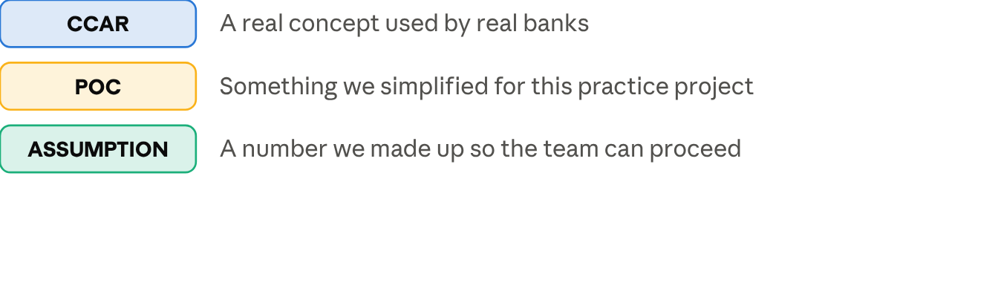
How to read the labels in this PRD

2. Why we are doing this, and how we know it worked
The problem. [CCAR] Each year the Federal Reserve asks large banks: if a severe recession hit, would you still have enough capital to keep lending? Answering takes clean loan data, transparent loss calculations, reconciled totals and a controlled sign-off. Most of the real work is the data, not the maths: missing records, wrong codes, duplicates, totals that do not match. We want our people to have met these problems before a client engagement.
The fictional bank. Iris Demo Bancorp: 26 borrowers, 40 business loans, about $287 million outstanding, as of 30 June 2026.
Success criteria
# | Criterion | Target
1 | End-to-end run from raw files to approved report | One command, under 5 minutes
2 | Planted data errors found | 12 of 12
3 | Loan count and balances reconcile | Tie out, or every difference explained
4 | Calculations match the QA answer key | Within $1 per loan
5 | Three scenarios run and compared | Baseline, Moderate, Severe
6 | Approval and audit | Preparer cannot approve own work; every action logged
7 | Delivery | Live demo at end of week 4

3. Scope
In scope | Out of scope
40 synthetic business loans (C&I and commercial real estate), one date: 30 June 2026 | Real bank or client data, live feeds
Source files, staging, cleaning, code mapping | Data warehouse or big-data design
15 data-quality rules, error log, approved overrides | Automatic anomaly detection, commercial DQ tools
Simple loss, capital and PPNR calculations under 3 scenarios | Statistical models, model validation
FR Y-14Q-style loan report and FR Y-14A-style capital summary | Real FR Y-14 layouts or submission
Reconciliation, review and approval, audit trail | Login system, SOX-grade controls, performance tuning
Simple Streamlit screens for the demo | Production user interface

4. The process, step by step
Nine steps take the quarter-end loan data to an approved report. Every step has an owner, an output and a check that must pass before the next step starts.
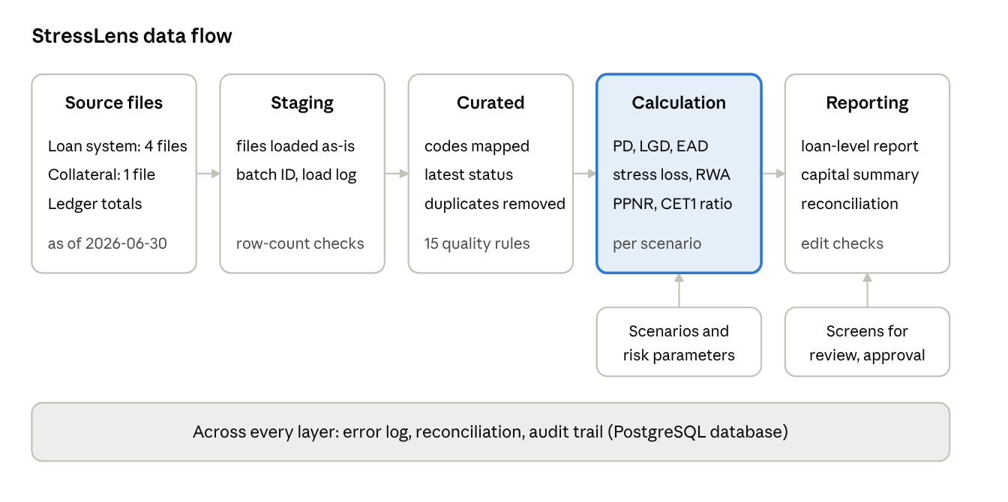
StressLens data flow · files to approved report
# | Step | What happens | Output | Check before moving on
1 | Load | Source files copied into staging | Staged tables, load log | File present; row counts match
2 | Map and transform | Codes converted to standard codes; latest status picked | Curated tables | Every code has a mapping; no row silently dropped
3 | Data quality | 15 rules run | Error log, scorecard | Serious errors must be fixed or approved by a second person
4 | Choose scenarios | Baseline, Moderate, Severe selected | Locked run settings | Only approved scenario versions
5 | Calculate | Loss, exposure and risk-weighted assets per loan | 120 results (40 loans × 3 scenarios) | Values in valid ranges; one result per loan per scenario
6 | Aggregate | Totals by portfolio; PPNR and capital ratio | Capital summary | Severe loss ≥ Moderate ≥ Baseline
7 | Reconcile | File vs system vs accounting totals | Reconciliation bridge | Every difference above tolerance has a comment
8 | Report | Two reports generated; validation checks run | Loan report, capital summary | All validation checks pass
9 | Review and approve | Reviewer approves or rejects; controller signs the capital summary | Locked, approved reports | Preparer cannot approve own work
The audit trail records every step: who, what, when, and before/after values.

5. The numbers in plain words
Under the Severe scenario the 40 loans lose about $24.2 million over 9 quarters (7.7% of exposure), and the bank's capital ratio falls from 12.0% to 8.5%. That is still above the 4.5% minimum, so the fictional bank survives.
Measure | Plain meaning | Simple formula [POC]
PD | Chance the borrower stops paying | Looked up by risk rating (1 to 10), multiplied by the scenario factor
EAD | How much is at risk when they stop paying | Amount borrowed + 50% of the unused credit line
LGD | Share we lose after selling collateral | Based on collateral value after the scenario price drop; 45% if unsecured
Stress loss | Expected loss over 9 quarters | PD × LGD × EAD
RWA | Loan amount adjusted for riskiness | EAD × risk weight (100%, or 150% for risky loans)
PPNR | Profit before loan losses | Interest earned − funding cost + fees − expenses, reduced under stress
CET1 ratio | The bank's safety cushion | (Starting capital + profit after tax − dividends) ÷ RWA
The three scenarios [POC] are invented for training, not Federal Reserve scenarios.
 | Baseline | Moderate | Severe
Unemployment peak | 4.3% | 7.0% | 10.0%
Commercial property prices | 0% | −20% | −40%
PD multiplier (business loans / property loans) | 1.0 / 1.0 | 1.8 / 2.0 | 3.0 / 3.5
Profit factor | 1.00 | 0.85 | 0.60
Expected results (the answer key)
 | Baseline | Moderate | Severe
Total stress loss | $6.52M | $11.86M | $24.18M
Ending CET1 ratio (start 11.99%) | 12.12% | 10.97% | 8.53%
One loan, by hand. LN1012 (business term loan, rating 5, no collateral): borrowed $6.25M of an $8.0M limit, so EAD = 6.25 + 0.5 × 1.75 = $7.125M. Baseline PD 2.0% × 2.25 = 4.5%; LGD 45%. Loss = 4.5% × 45% × $7.125M = $144,281. Under Severe the PD multiplier is 3, so PD = 13.5% and loss = $432,844.
[CCAR] Real banks use statistical models, project every quarter, and follow detailed Federal Reserve rules. Full formulas and parameters are in the reference workbook.

6. Reports and approval
The system produces two reports styled on the Federal Reserve's FR Y-14 reports. Neither is a real FR Y-14 submission; field names and layouts are simplified.
Report | Styled on | What it shows
R1 Loan report | FR Y-14Q (quarterly loan-level data) | One row per loan: borrower, amounts, rating, collateral, status, plus our exposure and loss figures
R2 Capital summary | FR Y-14A (annual projections) | One column per scenario: profit, losses, tax, dividends, ending capital, capital ratio
Checks on the reports. 11 validation checks (for example: amount borrowed cannot exceed the limit; rating must be 1 to 10; Severe loss must be at least Moderate loss) and 5 reconciliations (report totals must equal the system and accounting totals).
Approval. The preparer submits; a different person reviews and approves or rejects (a comment is required when rejecting); the controller signs off the capital summary. Approved reports are locked; any change creates a new version. Every exported file is logged with a fingerprint (hash).
[CCAR] Real FR Y-14 submissions have their own schedules, edit checks and senior-management attestation.

7. Data quality and controls
We planted 12 errors in the raw data. The team must find every one, fix it under control, and show the totals still tie out.
# | What is wrong | How it is caught
D01–D03 | Missing values (interest rate, borrower rating, industry code) | Blank-value checks
D04 | One balance appears twice | Duplicate check
D05 | One loan has no balance | Loan-to-balance match
D06 | A balance for a loan that does not exist | Balance-to-loan match
D07 | A loan points to a borrower who is not in the file | Loan-to-borrower match
D08 | A status code that is not valid | Code-list check
D09 | Property loans mapped as business loans | Product vs collateral check
D10 | A negative balance; a balance above the credit limit | Range checks
D11 | Several status records for one loan | Latest-record logic
D12 | A property valuation over 2 years old | Age check (warning only)
Reconciliation. The raw balance file ($279.7M, 41 rows) becomes the clean book ($286.6M, 40 loans) after removing the duplicate (−$3.9M) and the orphan (−$2.4M), fixing the negative balance (+$4.5M) and adding the missing loan (+$8.7M). The accounting ledger shows $289.0M; the $2.4M difference is the orphan loan, booked after the loan list was extracted.
Six controls that matter most
- Calculations are blocked while serious data errors are open.
- Overrides need a reason and a second person.
- Only approved scenario and parameter versions can be used.
- Every difference in reconciliation has a comment.
- Preparer and approver must be different people.
- The audit log cannot be edited or deleted.

8. Team: 4 squads and one BA
About 40 people in 4 squads of about 10. Each squad owns one layer of the pipeline, so there is no duplicate work. Every squad has 1 squad lead, about 7 developers and data engineers, and 2 QA. One BA and one Product Owner support all four.
Squad | Owns | Stories | Starts from (provided on day 1) | Hands over
A. Data Foundation | Load, map, transform, one-command run | US-01, 02, 03, 04, 16 | Raw files in data/landing/ | Curated tables (checked against data/curated/)
B. Quality & Reconciliation | 15 data-quality rules, override workflow, reconciliation, audit log | US-05, 06, 10, 13 | Curated files in data/curated/ | Error log, reconciliation bridge, audit trail
C. Risk & Capital | Scenarios, PD/LGD/EAD/loss, RWA, PPNR, capital | US-07, 08, 09 | Curated files in data/curated/ | 120 results and capital summary (checked against data/expected/)
D. Reporting & Governance | Loan report, capital summary, approval workflow | US-11, 12 | Expected results in data/expected/ | Approved reports
Because squads B, C and D start from ready-made files, nobody waits for the squad before them. In week 3 each squad switches to the real outputs of the squad upstream.
How one BA supports 40 people
- The requirements are already written; the BA does not sit inside any squad.
- Questions come only through the 4 squad leads, in one 30-minute daily slot.
- Every answer goes into one shared question log, so each question is answered once for everyone.
- Work is accepted by matching the answer-key files, so the BA reviews exceptions, not every line.
- One combined sprint review every 2 weeks (4 squads × 20 minutes).
- Estimated BA effort: 10–12 hours a week, heavier in the first two weeks.
Cross-learning. A weekly one-hour “CCAR Hour” is open to all.

9. Plan: about 4 weeks, 2 sprints
All four squads run the same two 2-week sprints in parallel. The BA checks each gate. If time runs short, drop the stretch items rather than extend the timeline.
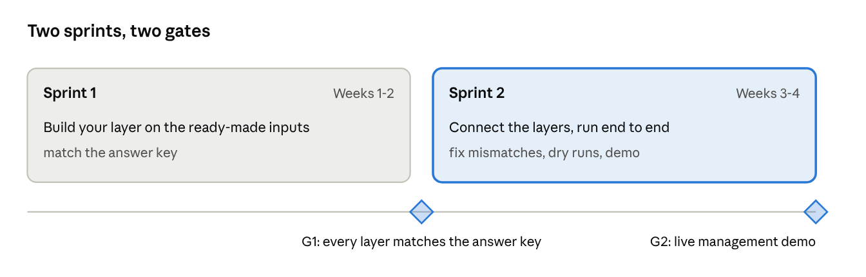
Sprint roadmap · 2 sprints, 2 gates
Sprint | What every squad does | Gate
1 (weeks 1–2) | Set up tools; build your layer against the ready-made inputs; write tests; log actions in the audit trail | G1: output matches the answer key (A: 40 curated loans; B: 12 of 12 errors found; C: 120 results within $1; D: reports produced from provided results)
2 (weeks 3–4) | Connect to the real outputs of the upstream squad; run raw files to report; fix mismatches; dry runs; demo | G2: full run works and the live demo is delivered
Stretch items (only if time allows): lineage view (US-14) and scenario dashboard (US-15).
AI assistants (such as Copilot) may be used if Iris policy allows. Anyone must be able to explain their work, and the answer key decides what counts as done.

10. Demo
A 20-minute live demo tells one story: bad data arrives, the controls catch it, the team fixes it under control, and a severe recession takes the bank's capital ratio from 12.0% to 8.5% in an approved, traceable report. Presenters come from all four squads.
Time | Segment | Show
0:00 | Why we built this | CCAR in 3 bullets; the fictional bank
2:00 | 1. Source data | Six files load; 41 balance rows
4:00 | 2. Data-quality issue | 17 errors found; property loans mapped as business loans; calculation blocked
7:00 | 3. Fix and mapping | Mapping change approved by a second person; rerun shows 0 serious errors
9:00 | 4. Scenario selection | Baseline, Moderate, Severe with their settings
10:00 | 5. Risk calculation | One loan walked through by hand; totals $6.5M / $11.9M / $24.2M
12:30 | 6. Reconciliation | Bridge from $279.7M to $286.6M to $289.0M
14:00 | 7. Reports | Loan report and capital summary; ratio 12.0% → 8.5% vs 4.5% minimum
16:00 | 8. Approval | Preparer tries to self-approve and is refused; controller signs off
17:30 | 9. Audit trail | Full log for the run
18:30 | Wrap-up | What we learned, what is missing, what we need next
Prepare a reset script, two timed dry runs and a backup screen recording.

11. Risks and assumptions
Risk | Impact | What we do about it
One BA cannot support 40 people | High | Questions only through 4 squad leads; daily Q&A; shared answer log; acceptance by answer key
People pulled onto billable work | High | Agree protected time with delivery heads before week 1; drop lower-priority stories first
Squads build layers that do not fit together | Medium | Same inputs and answer key for all; shared interface files; integration check at the start of week 3
Practice project mistaken for real CCAR expertise | High | Labels everywhere; “what real CCAR adds” slide in the demo; ask a CCAR expert to review
Scope creep | Medium | Out-of-scope list is binding; new ideas go on a Phase 2 list
Tool or environment problems | Medium | Set-up task on day 1; free cloud database as fallback
Assumptions: about 40 people available 6 hours a day for about 4 weeks; free open-source tools are acceptable (PostgreSQL, Python, Streamlit); all data and the bank are fictional; scenario settings are expert judgement, not model output; regulatory references are for orientation only and must be checked against current Federal Reserve rules before any real use.
Needed before week 1: sponsor approval and protected team time; laptops or cloud database access; a code repository and task board; ideally a CCAR expert for a 2–3 hour review.

12. Where the detail lives
This short PRD is meant to be read. The lists and tables people look things up in are kept elsewhere.
You need | Look in
Requirements, user stories, test scenarios | Reference workbook, tabs Requirements, User Stories, Test Scenarios
Tables and fields; mapping rules; code map | Reference workbook, tabs Data Dictionary, Mapping, Code Map
The 12 planted errors, 15 quality rules, reconciliation checks, controls | Reference workbook, tabs Seeded Defects, DQ Rules, Recon Checks, Controls
Scenario settings, parameters, worked examples, report fields | Reference workbook, tabs Scenarios, Parameters, Worked Examples, Report R1/R2
Raw files, clean files, fix files, answer key | Repository folders data/landing, data/curated, data/fixes, data/expected
Database scripts and SQL examples | Repository folder sql/
The complete original 73-page PRD | Repository folder docs/reference/
Repository: https://github.com/aditya2529/AI-CCAR-Internal-POC

