1. Login page   
    slider should work properly
2. Ambition page

The posting area attachment option like image video should be changed

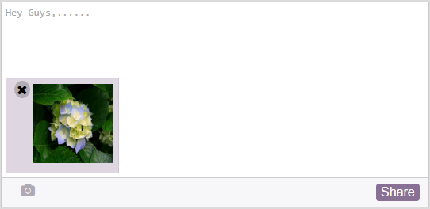

Upload file like img, video, doc should be proper.

1. Ambition group page

Cover pic upload function

Invite members UI

Adding connected group UI

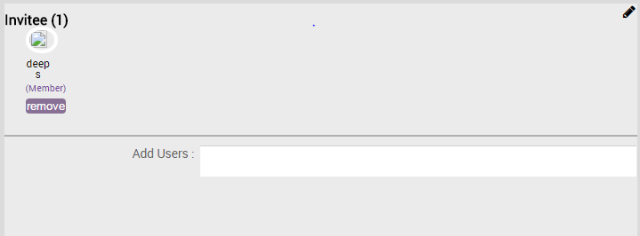

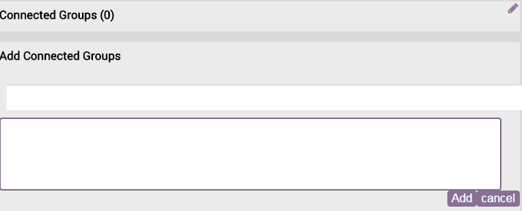

1. Ambition page

Cover pic upload function UI