STATIC WEBSITE HOSTING ON AWS

### A Project Work Synopsis

*Submitted in the partial fulfillment for the award of the degree of*

# BACHELOR OF ENGINEERING

### IN

### CSE (CLOUD COMPUTING)

### Submitted by:

### ISHITA GUPTA - 20BCS4048

### HARDIK - 20BCS4123

### ADITYA RAJ – 20BCS4140

### ANKIT KUMAR RAI - 20BCS4144

### Under the Supervision of:

### SUPERVISORS NAME

**GEETINDER SAINI**



### CHANDIGARH UNIVERSITY, GHARUAN, MOHALI - 140413,

**PUNJAB**

**FEBRUARY,2022**

**ABSTRACT**

It’s almost impossible to overstate the importance of website ownership to businesses, large and small alike. The Internet gives even the smallest of startup companies a chance to connect with millions of potential customers. A well-designed small business website is your best chance of making a lasting impression on your target audience. Nowadays mostly everyone probably knows the importance of having their business on the internet. AWS itself provides a free tier type of access for one year for new users to try different services. They provide almost all types of infrastructure services required for internet-connected audience and businesses. The simplest form of website architecture is the static website, where users are served static content. Some examples include brand microsites, marketing websites, and intranet information pages. Static websites are straightforward, but they can still have demanding requirements in terms of scalability, availability, and service-level guarantees. For example, a marketing site for a consumer brand may need to be prepared for an unpredictable onslaught of visitors when a new product is launched. This paper cover comprehensive architectural guidance for developing, deploying, and managing static websites on Amazon Web Services (AWS) while keeping operational simplicity and business requirements in mind. We also recommend an approach that provides 1) insignificant cost of operation, 2) little or no management required, and 3) a highly scalable, resilient, and reliable website. This paper first reviews how static websites are hosted in traditional hosting environments. Then, we explore a simpler and more cost-efficient approach using Amazon Simple Storage Service (Amazon S3). Finally, we show you how you can enhance the AWS architecture by encrypting data in transit and to layer on functionality and improve quality of service by using Amazon CloudFront.

# Table of Contents

Title Page Abstract

i ii

#### INTRODUCTION

* 1. Problem Definition 3
  2. Project Overview/Specifications 5
  3. Hardware Specification 5
  4. Software Specification 6

1. LITERATURE SURVEY
   1. Existing System 7
   2. Proposed System 7
2. PROBLEM FORMULATION 7
3. RESEARCH OBJECTIVES 8
4. METHODOLOGY 9
5. **RESULTS AND DISCUSSION 13**
6. **CONCLUSION AND FUTURE SCOPE 13**
7. **REFERENCES 14**

# INTRODUCTION

#### Problem Definition:

Web application is a Web site where user input (navigation through the site and data entry) affects the state of the business: beyond, of course, access logs and hit counters. In essence, a Web application uses a Web site as the front end to a business application,

A web application (web app) is any application software that runs in a web browser and is created in a browser supported programming language (such as the combination of JavaScript, HTML and CSS) and relies on a web browser to render the application. The main problem is that when multiple users need to use any type of web applications such as Blogger to watch video or to share post in the same time , they will face difficulties because the high loading on main server. To solve this problem we host this web application on Amazon Cloud to provide special server to this web application

#### Project Overview:

An explorer when leaves his home to travel to a location, he had only the belongings that he carried and the money he would all through the trip. Only when reached the location he would start looking for hotels and rent the most affordable in that locality, then go on to explore that place either with an overly expensive guide or without the guide staking the safety and full potential of exploration of that trip. This system is not efficient and needs to be changed.

There’s a need of a third-party team which can lookout a most affordable and efficient travel plan for you and not only devise that plan but provide that travelling package plan to you. The travelling system is all about the use of proper information about a location and how to organize that data in a working format which is efficient and compatible to the user. Better knowledge helps the traveler to have some ease in the journey. With their trip being taken care of by the package manager, the traveler can enjoy the trip to its full extent without any care of staying, eating, etc. They can also share their reviews about how the travelling experience was and if the feedback is bad, improvements can be made in that matter.

Also, the website that provides all these services is itself too much difficult to manage with all the traffic and hosting the website on a web server. But this can be done easily with Amazon S3(Simple Storage Service) service provided by AWS.

#### Hardware Specifications:

* Requirement: PC / Laptop
* Processor: Any (e.g., Intel Core i3 / Intel Core i5)
* RAM: 2GB or above
* Hard Disk Drive: 5 MB or more

#### Software Specifications:

* Operating System: Windows / Linux
* IDE: VS Code
* Front-end: HTML, CSS, JavaScript
* Web Browser: Any latest browser

**LITERATURE REVIEW**

Early websites were purely informational, there were some design elements from these days of antiquity that still apply today. Old web pages were very lightweight, optimized for that slow internet connection we all remember.

To host a website on the internet, an individual or company would need their own computer or server.As not all companies had the budget or expertise to do this, web hosting services began to offer to host users' websites on their own servers, without the client needing to own the necessary infrastructure required to operate the website. The owners of the websites, also called webmasters, would be able to create a website that would be hosted on the web hosting service's server and published to the web by the web hosting service.

As the number of users on the World Wide Web grew, the pressure for companies, both large and small, to have an online presence grew. For That some companies started offering free hosting then it turned to paid services.

* 1. **Existing system:**

1. Travel advisory- Advising clients
2. Travel arrangements, e.g. visas and passports
3. Keeping clients up to date with any changes and risks etc
4. Bookings
5. Arranging flights, insurance and
6. Hotel and transport booking
   1. **Proposed System:**
7. Enter the destination and no. of guests and the date of arrival and leaving.
8. User gets all the details via email. Such as Cab driver’s number, Hotel’s details, a detailed map of area .
9. User can also choose a package for the respective locations, and then follow the plan and can enjoy the whole trip without any worry.
10. Arranging Concierges / guides etc as needed.
11. Deals with complaints or refunds.
12. Collecting and processing payments.

# PROBLEM FORMULATION

A website matters more than anything, when it comes to reaching out to customers online. A website is the representation of the business online. The package tour industry is often high risk, high breakeven, high-quality product, and competitively priced. As a result, thorough tour planning and market research are necessary for tour management. However, before a tour is created, the tour manager should consider a few elements that are essential to the planning process. The satisfaction of the visitor is significantly impacted by these variables. The primary elements are:

* Purpose of Tour
* Choice of Destination
* Tourist Budget
* Legal requirement
* Types of Tourist Accommodation
* Tour Period
* Departure and Stay Information
* Tour price; inflationary condition
* Tour References Tools
* Tour features – political Study
* The relationship between the host and tourist generating nation

By offering as many specialized ideas as possible, we hope to assist tourists in finding destinations and journeys that best suit their tastes. Users won't need to compromise on their preferences or considerations thanks to this website, which also eliminates the time-consuming job of conducting online research.

# RESEARCH OBJECTIVES

Some of the objectives of our project are as: -

1. Reach to new audiences.
2. Improve Customer service and retention.
3. Increase brand awareness.
4. To collect high-quality connections.

**METHODOLOGY**

**HOSTING STAIC WEBSITE ON AWS**

**Step 1 — Create an S3 bucket**

Click on **Create bucket**. Give the bucket a unique name, the name you choose must be globally unique (for best practice, attach your AWS account ID to the name).

[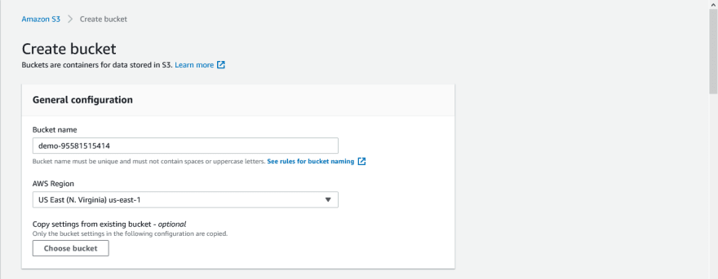](https://res.cloudinary.com/practicaldev/image/fetch/s--v0zCOAFZ--/c_limit%2Cf_auto%2Cfl_progressive%2Cq_auto%2Cw_880/https:/user-images.githubusercontent.com/33374159/119145517-9f1c3a80-ba41-11eb-9c6b-f4a17a052e82.png)

Uncheck the **Block all public access** checkbox and accept the acknowledgement.

[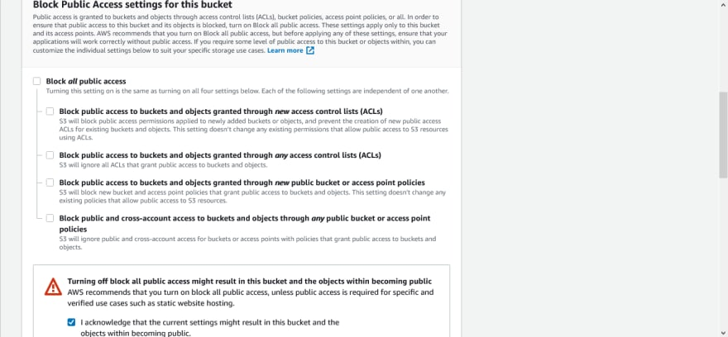](https://res.cloudinary.com/practicaldev/image/fetch/s--6HPrELCo--/c_limit%2Cf_auto%2Cfl_progressive%2Cq_auto%2Cw_880/https:/user-images.githubusercontent.com/33374159/119145647-c115bd00-ba41-11eb-8c50-b27cfa04fbbb.png)

Click on **disable** for Bucket Versioning.

Then click on **Create bucket**.

[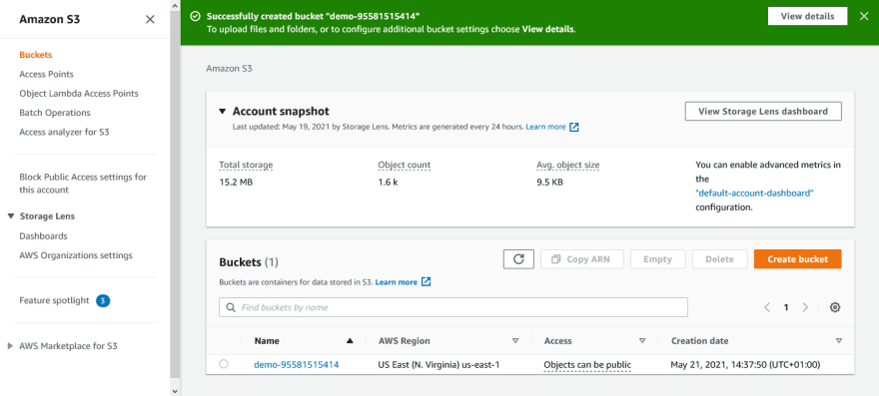](https://res.cloudinary.com/practicaldev/image/fetch/s--gYTnSFey--/c_limit%2Cf_auto%2Cfl_progressive%2Cq_auto%2Cw_880/https:/user-images.githubusercontent.com/33374159/119146169-47ca9a00-ba42-11eb-9917-5c2fb5bb7802.png)

**Step 2 — Upload web files to S3 bucket**

After creating the bucket, you need to upload your website’s files and folders into it.

[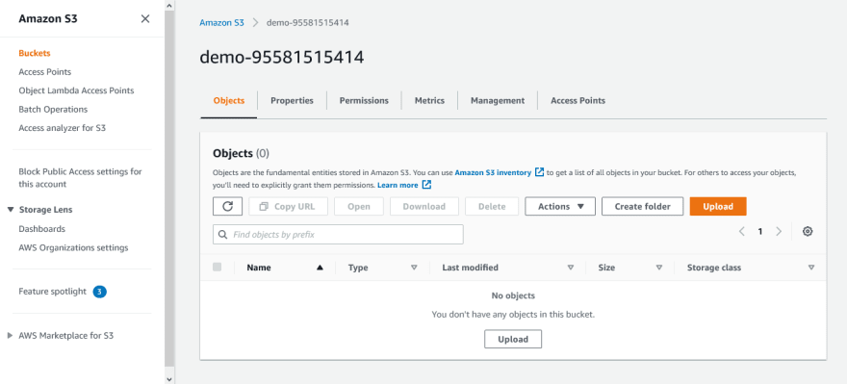](https://res.cloudinary.com/practicaldev/image/fetch/s--iW4-qjrh--/c_limit%2Cf_auto%2Cfl_progressive%2Cq_auto%2Cw_880/https:/user-images.githubusercontent.com/33374159/119146402-806a7380-ba42-11eb-903e-c24995bae41c.png)

**Step 3 — Secure S3 bucket through IAM policies**

From the **S3** dashboard, click on the **name** of the bucket, then click on **Permissions** tab. Scroll down to the **Bucket policy** section and click on its **Edit** button.

[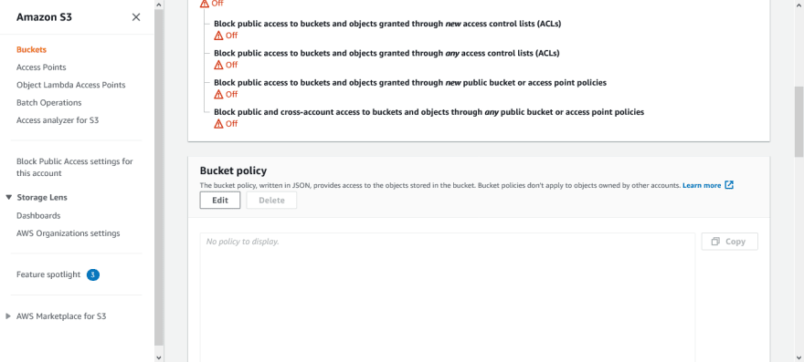](https://res.cloudinary.com/practicaldev/image/fetch/s--GjVVeV7M--/c_limit%2Cf_auto%2Cfl_progressive%2Cq_auto%2Cw_880/https:/user-images.githubusercontent.com/33374159/119147505-93ca0e80-ba43-11eb-8af4-25792cedf124.png)

**Step 4 — Configure S3 bucket**

click on the **Properties** tab.

Scroll down to the **Static website hosting** section and click on its **Edit** button.

Select **Enable** for Static website hosting.

[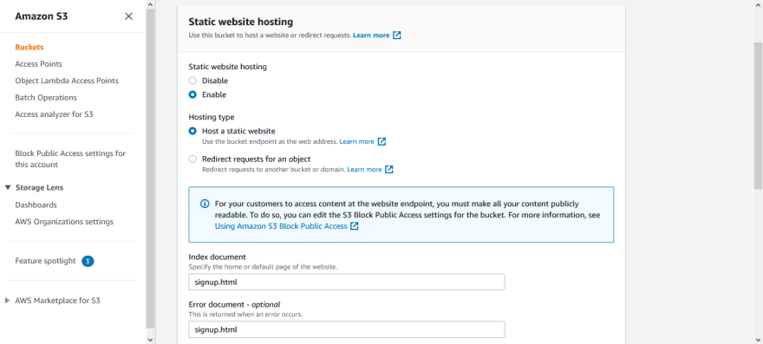](https://res.cloudinary.com/practicaldev/image/fetch/s--7YjwPae5--/c_limit%2Cf_auto%2Cfl_progressive%2Cq_auto%2Cw_880/https:/user-images.githubusercontent.com/33374159/119148824-cb858600-ba44-11eb-9556-73525506d83a.png)

**Step 4 —Bucket Policy**.

For hosting our website, we need to provide our own custom-defined policy.

[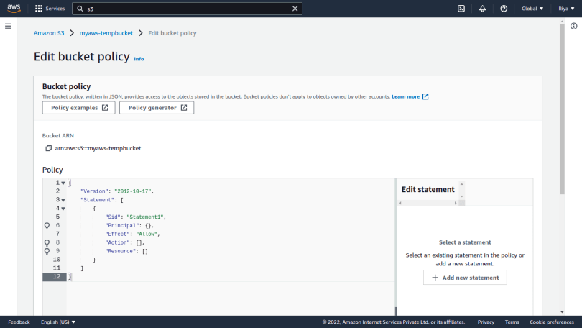](https://i0.wp.com/blog.knoldus.com/wp-content/uploads/2022/01/Screenshot-from-2022-01-09-19-56-33.png?ssl=1)

Click on the **Policy Generator** option. This page will let you define your own policy required to host the website.

Step 1, select policy type as *S3 Bucket Policy*.

In Step 2,

— Select Effect as *Allow*.

— Write * in the Principal section.

— Under Actions, select *GetObject*.

— In the Amazon Resource Name (ARN), give the ARN of your bucket which you can find under the Properties section.

— Also, add a **/\*** in the end for the policy to be applied to every object in your bucket.

Finally in Step 3, click on Generate policy and you’ll see a page like this.

[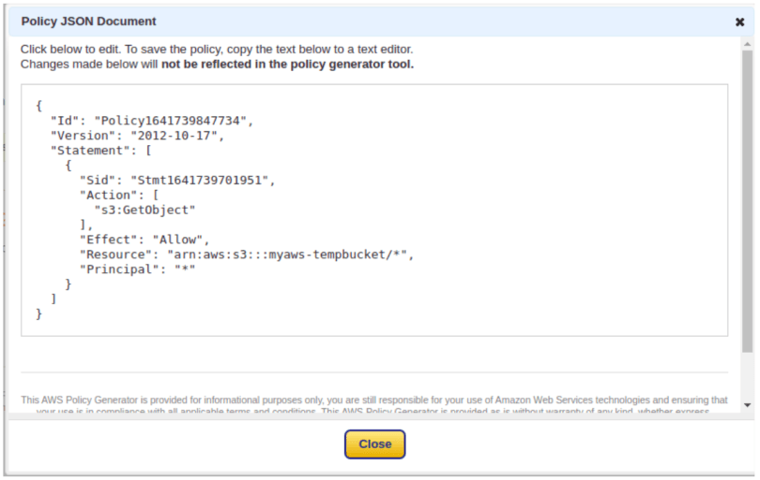](https://i0.wp.com/blog.knoldus.com/wp-content/uploads/2022/01/Screenshot-from-2022-01-10-19-19-45.png?ssl=1)

Now, copy this policy, paste it in the Edit Policy section overwrite the default one, and save your changes.

**Step 6 —** Get the link for your website

Just head over to your objects and select the home or default page of your website as specified earlier. You will see an object URL for your website as shown below.

[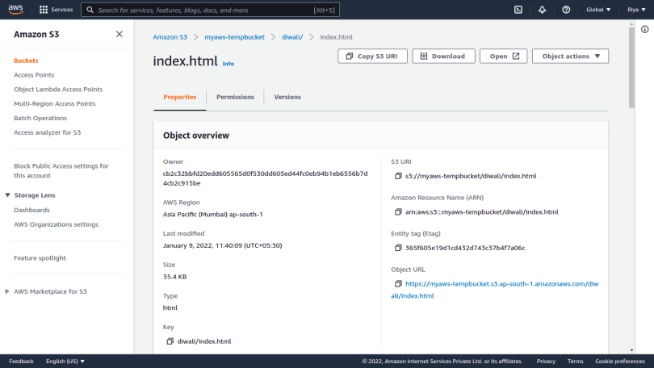](https://i0.wp.com/blog.knoldus.com/wp-content/uploads/2022/01/Screenshot-from-2022-01-09-20-28-25.png?ssl=1)

**RESULTS AND DISCUSSION**

This applied research aims to design, develop, and implement an online tourism system. This website provides:

* Travelers have great staying experience.
* To check the availability of best hotels.
* To manage the multiple days of travelling of the user.
* Respective adventurous activities included in the package.
* To display the information user needs with reviews of previous users.

**CONCLUSION AND FUTURE SCOPE**

The AWS architecture is highly available and scalable, secure, and provides for a responsive user experience at very low cost. By enabling and analyzing the available logs, you can you understand your visitors and how well the website is performing. Fewer moving parts means less maintenance is required. In addition, the architecture costs only a few dollars a month to run

The tourism industry is extremely diverse – from the size of organization; business type; sector; organization; and process. It can be taken as the collection of various industries

This type of software’s can be further extended –

* For generating reviews related to the tourist requirements.

• Can be used for generating reviews for the Online Videos provided on the software.

• Easy to find the nearby famous places, temples & monuments.

• Developer can be providing the update information of the places and also provide updates to the software for better serves.

•Provide offers for various places in budgets occasionally.

**REFERENCES**

1. "How Cloud Computing Works", [Online]. Available: <http://computer.howstuffworks.com/cloudcomputing/cloud-computing.htm>
2. Te-Shun C., 2013, "Security Threats on Cloud Computing Vulnerabilities", International Journal of Computer Science & Information Technology (IJCSIT) Vol 5, No 3.
3. Serrano N., Gallardo G., and Hernantes J., 2015, “Infrastructure as a Service and Cloud Technologies”, IEEE Softw., vol. 32, no. 2, pp. 30–36.
4. Narula S., Prachi M., Jain A., 2015, "Cloud Computing Security: AWS", In Proceedings of Fifth International Conference on Advanced Computing & Communication Technologies
5. "Nessus", [Online] Available:

<http://www.tenable.com/products/nessus/select-youroperating-system>

1. "ClamAV", [Online] Available: <https://www.clamav.net/downloads>
2. Sullivan B. (2016). “Amazon Web Services Public Cloud”, [Online]. Available: <http://www.techweekeurope.co.uk/cloud/cloudmanagement/amazon-web-services-public-cloud185687>
3. "How to secure your Amazon EC2", Amazon Inc. about Amazon web services, [Online] Available: <http://aws.amazon.com/articles/1233>