**ASSIGNMENT-2**

1.)

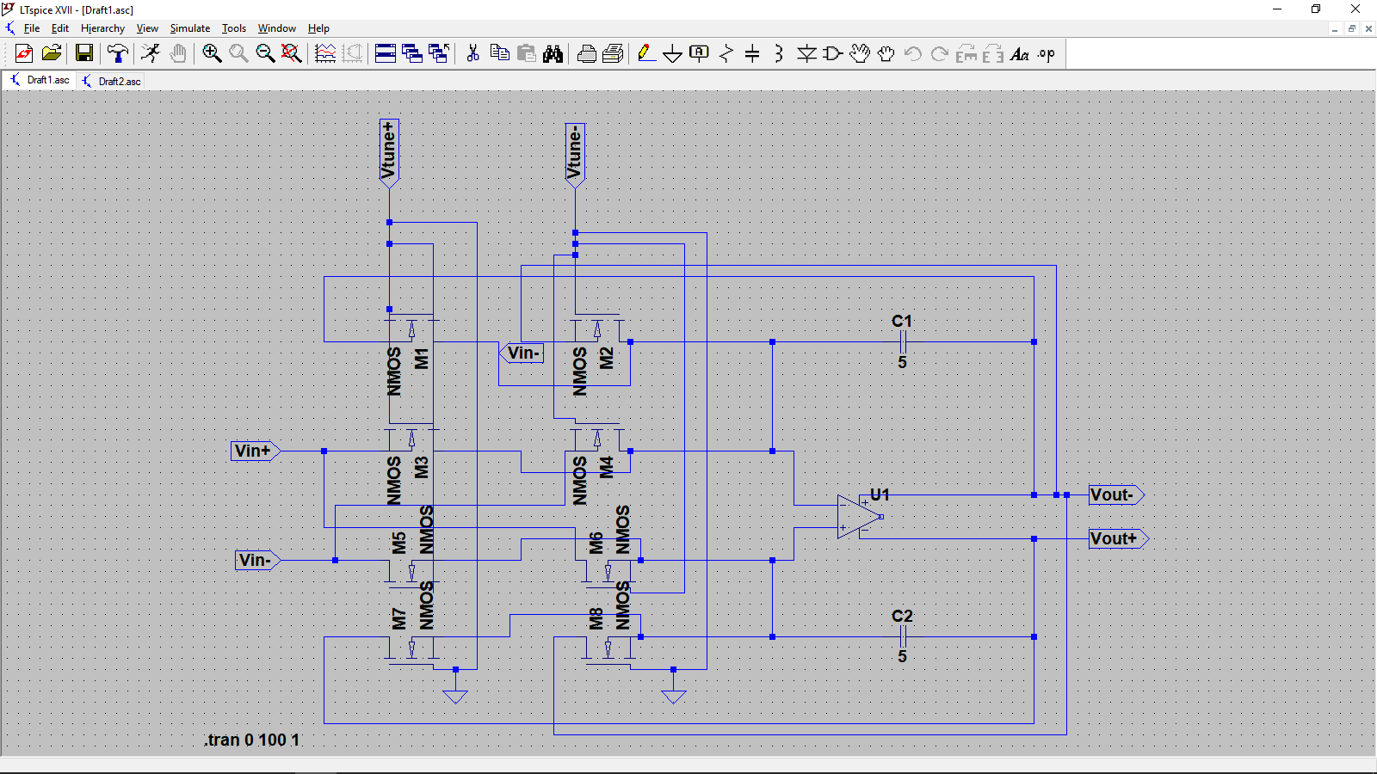

Simulation:

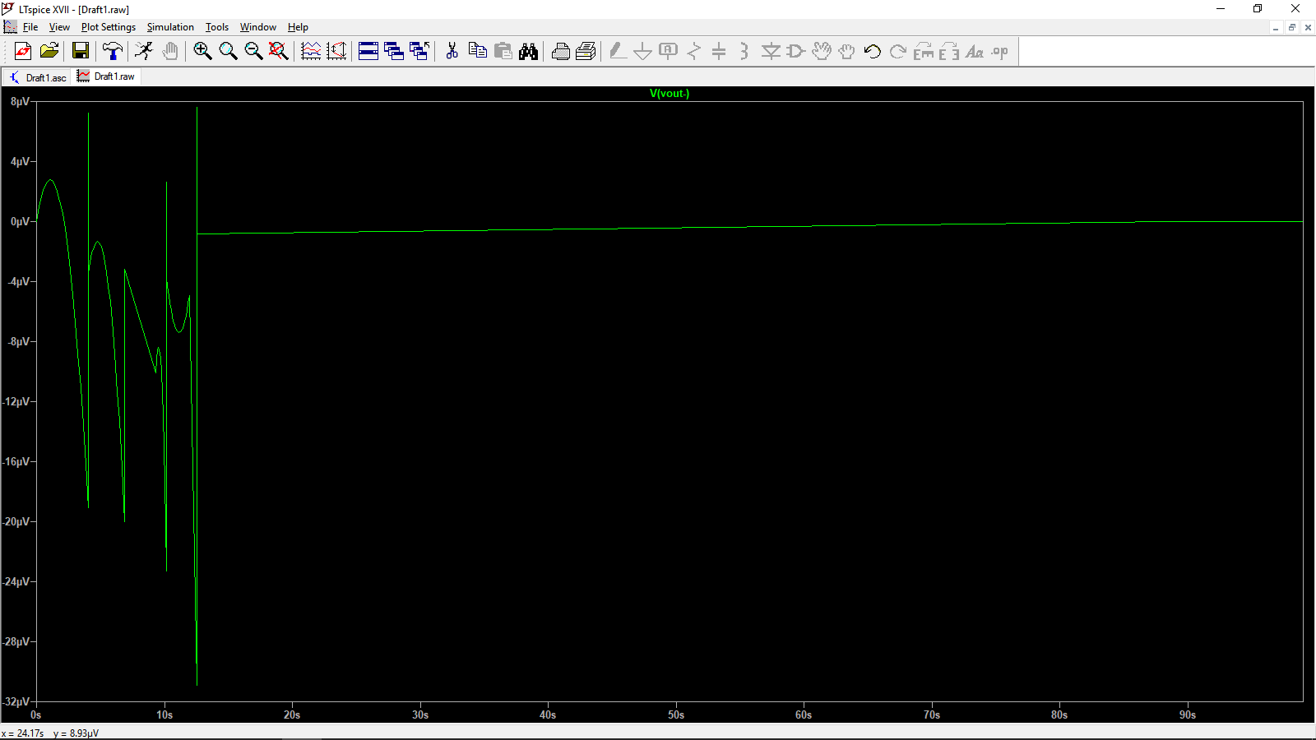

Operational input range of the above circuit :

Considering n-channel MOSET’s are used, Minimum it should be greater than pinch off voltage of the transistor and maximum it shouldn’t be above gate voltage.

Vtune+ and Vtune- which is the gate voltage cannot be higher than drain voltage and not closer to 0v , because at 0v it provides infinite resistance to the path.

**2.)**

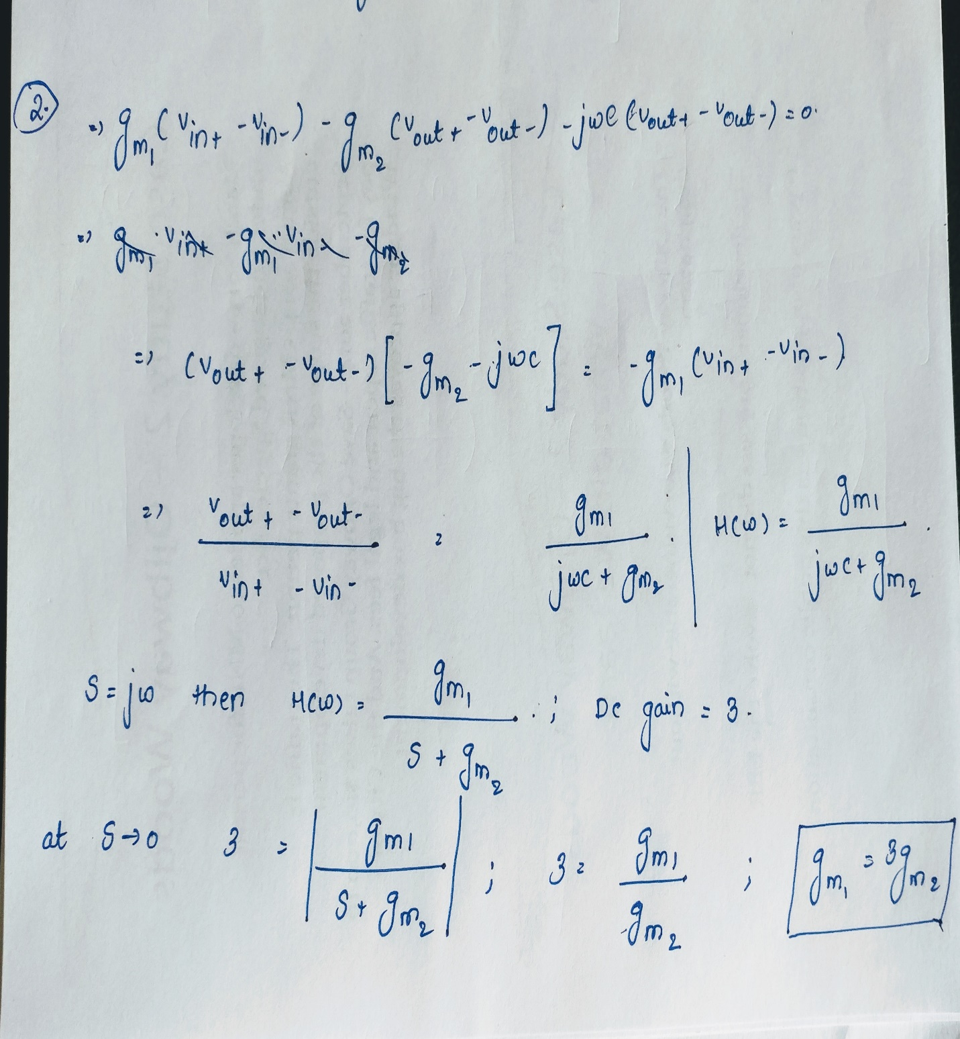

**3.)**

**Circuit;**

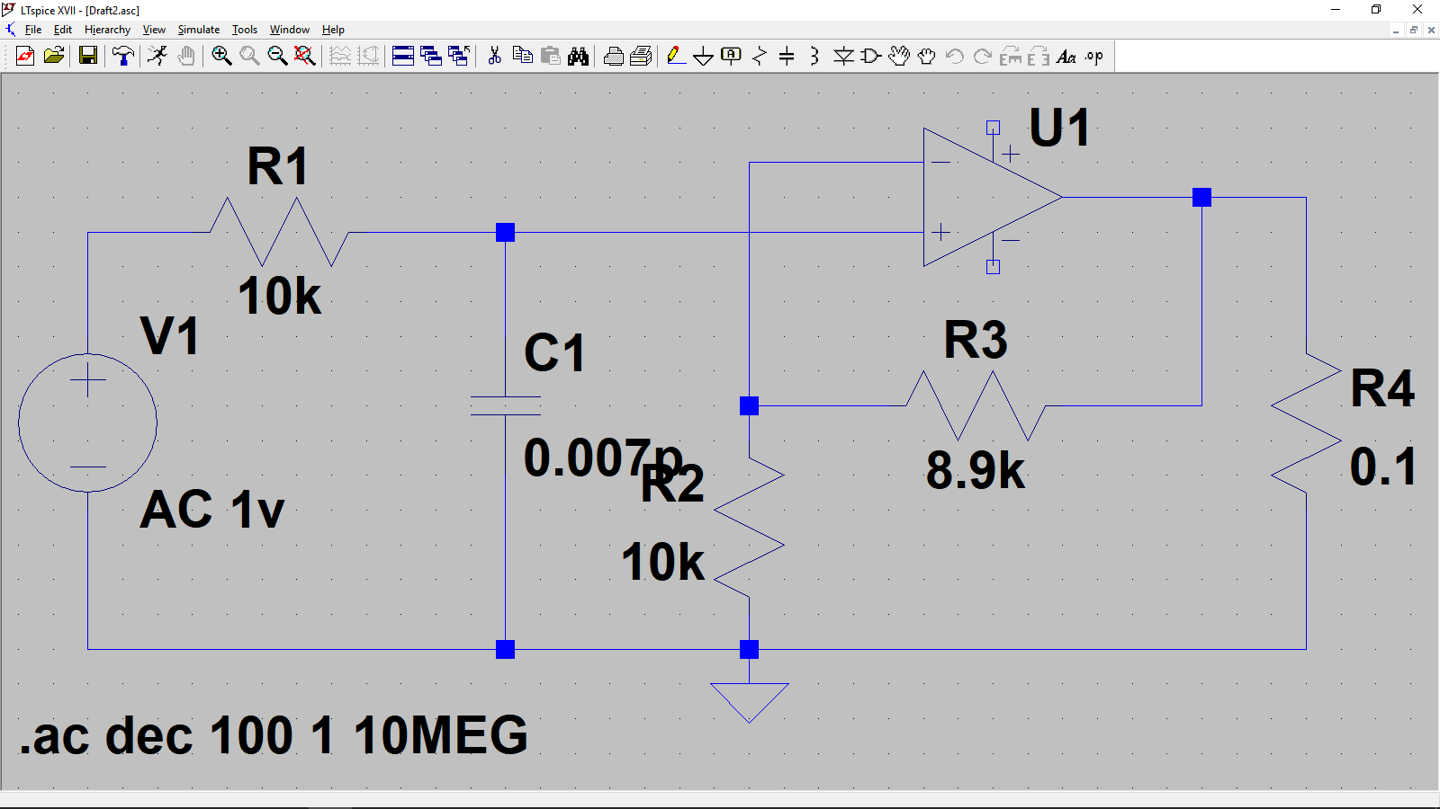

**Simulation:**

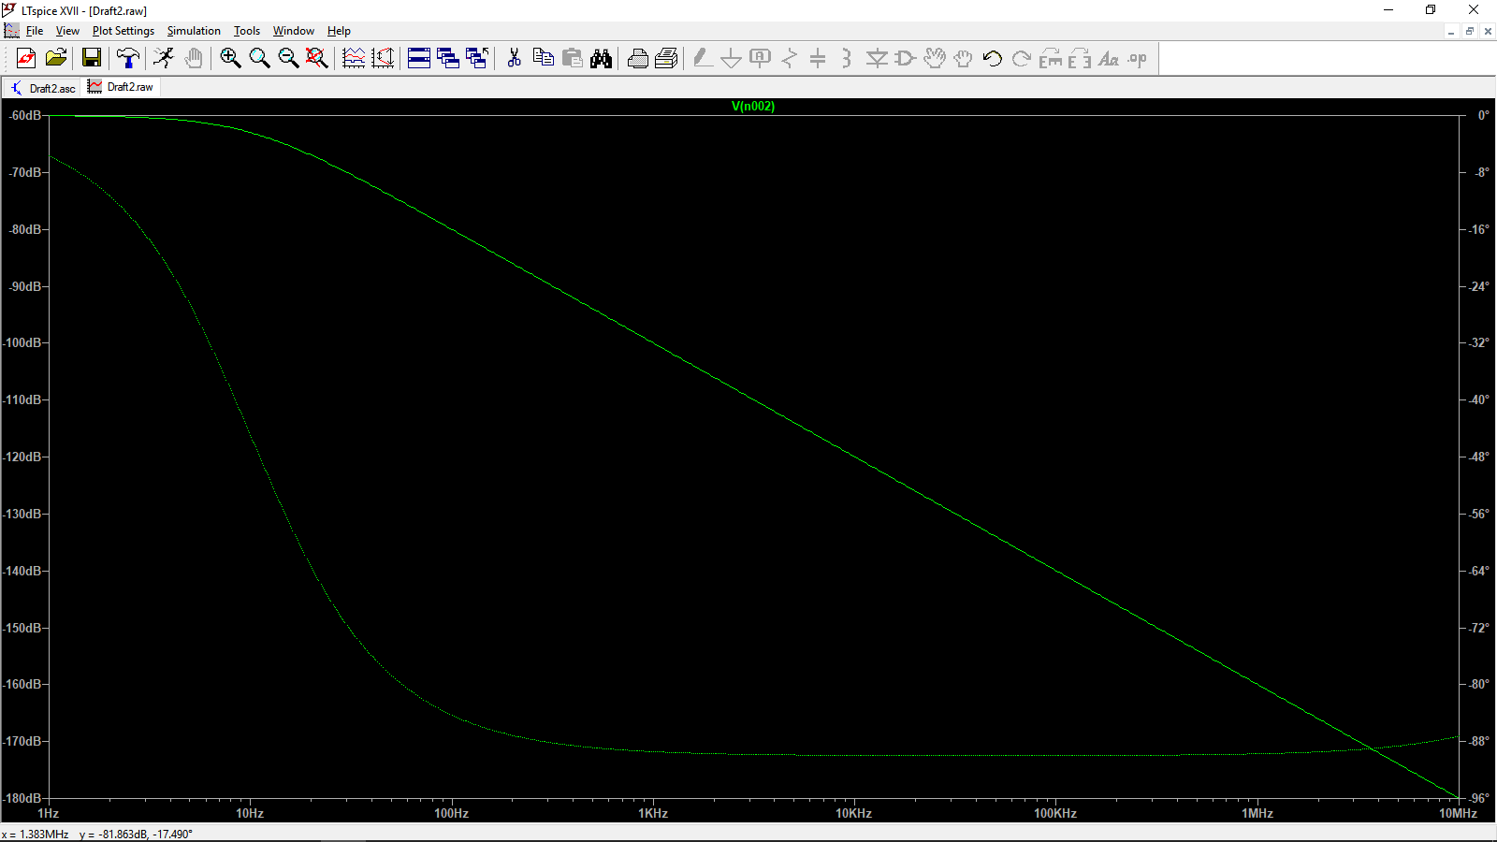

**Calculations:**

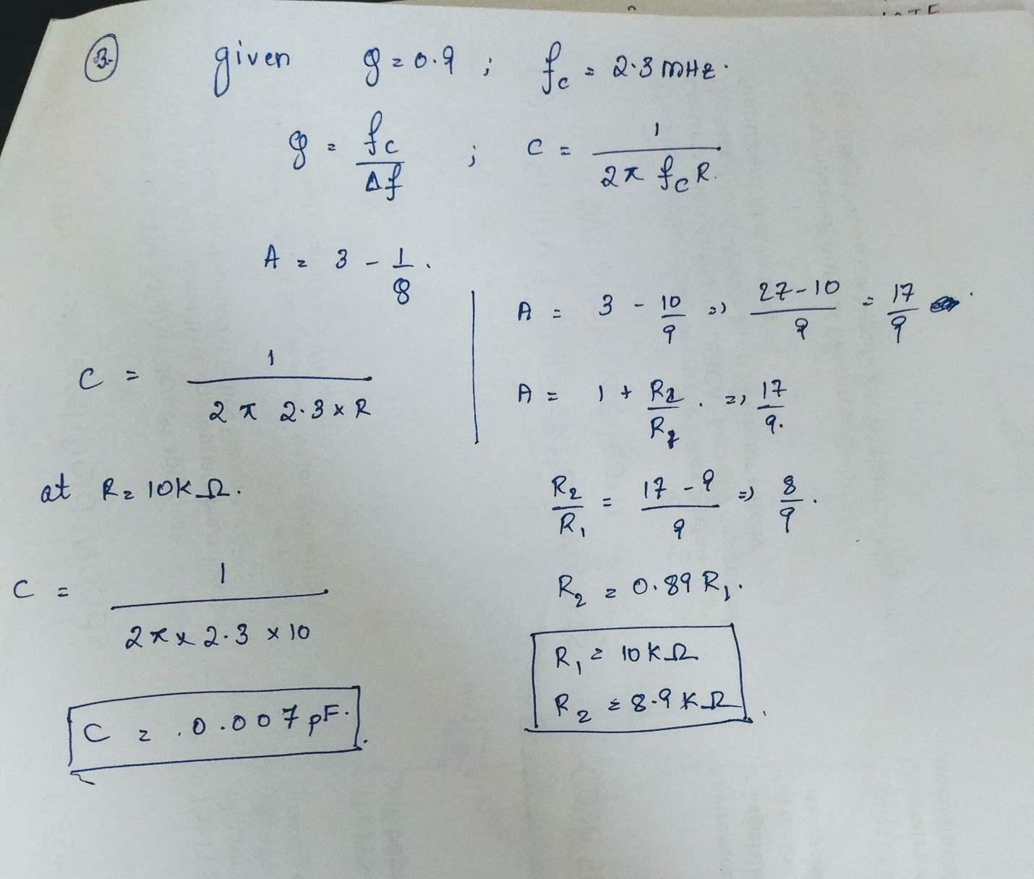

**4.)**

