Business Problem :

I would like to explore food options in the city of Toronoto.

Would like to perform clustering on all the restaurants in the city of Toronto and

analyse most frequently visited places in a neighbourhood.

It would help to find out in which neighbourhooods different types of restaurants are located.

It would be easier for a new person in the city to know all the available food options by neighbourhood and decide to try out different cuisines.

Data :

Collection of all neighbourhoods.

Assigning latitude and longitude to all neighbourhoods.

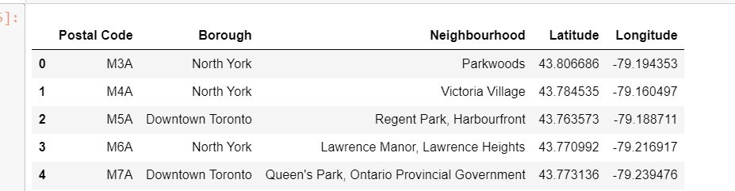

Finding all food places in those neighbourhoods.

